IARTV | 2003 | BIOLOGY | Written examination 2

SECTION A – Multiple-choice questions

Question 1
When a eukaryotic cell is not dividing, its genetic material can be found in the form of long, thin strands called
- chromatin
- chromosomes
- centrioles
- chromatids

Question 2
If a cell is observed in which a cell wall is beginning to form across the middle of the cell and distinct nuclei are forming at opposite ends of the cell, this cell is
- an animal cell in telophase
- a plant cell in anaphase
- an animal cell in metaphase
- a plant cell in telophase

Question 3
Taxol is an anti cancer drug extracted from the Pacific Yew tree. In animal cells, taxol disrupts the formation of microtubules by binding to them so they do not form from the protein tubulin. This stops mitosis and so prevents cells dividing out-of-control.
Specifically, taxol must affect
- the formation of centrioles
- the assembly of the chromatids
- the fibres in the mitotic spindle
- the replication of the chromosomes

Question 4
DNA replication
- occurs during prophase
- is semi-conservative
- occurs in all nucleated cells
- involves restriction enzymes

Question 5
Red-green colour blindness is inherited as a recessive X-linked disorder. This means that
- women never suffer from red-green colour blindness
- men can be carriers of red-green colour blindness
- unaffected women can have sons with red-green colour blindness
- fathers cannot pass on the gene for red-green colour blindness to their daughters

Question 6
In sweet peas, tall (T) is dominant to dwarf (t).
Which one of the following crosses would result in half of the offspring being tall?
- TT × tt
- Tt × tt
- Tt × Tt
- TT × Tt

Information for Questions 7, 8 and 9

In humans, one type of high blood pressure is controlled by the inheritance of two genes which can be called P and Q.

Question 7
If the alternative forms of P and Q are p and q and these two genes are independently inherited, the number of different genotypes possible is
- four
- six
- eight
- nine
The distribution of this type of high blood pressure in a population can be plotted as follows:
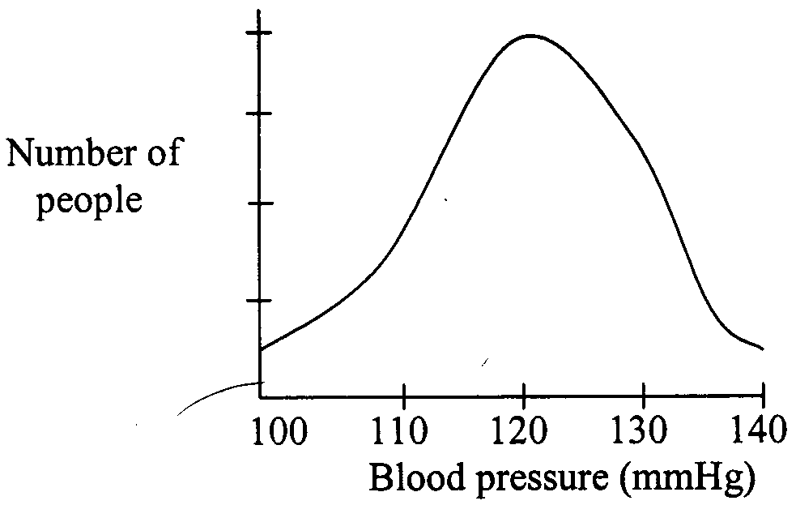

Question 8
The type of variation shown by such a graph is called
- continuous
- polygenic
- discontinuous
- monogenic

Question 9
Other factors such as diet, stress, weight and amount of exercise can affect blood pressure. This indicates that high blood pressure is determined by
- phenotype and genotype
- phenotype and environment
- genotype and environment
- phenotype, genotype and environment

Question 10
In grasshoppers, the sex-determining mechanism is XX (females) and XO (male). The females have two X chromosomes plus nine pairs of autosomes, and males have a single X chromosome plus nine pairs of autosomes. If eye-colour is determined by one of three alleles at a single locus (ie. position) on the X chromosome of this grasshopper, then
- all gametes produced by females will have ten chromosomes and one of six possible genotypes for eye-colour
- all gametes produced by females will have ten chromosomes and one of three possible genotypes for eye-colour
- all gametes produced by males will have ten chromosomes and one of six possible genotypes for eye-colour
- all gametes produced by males will have nine chromosomes and one of three possible genotypes for eye-colour

Question 11
The inheritance of coat colour in cats is influenced by a gene present on the X chromosome but not on the Y. The allele for black coat colour can be represented by the symbol X^{B} and that for ginger coat colour by X^{G}. These alleles are co-dominant and the hair of heterozygous cats show bands of both black and ginger, called tortoiseshell.
All of the following phenotypes are possible in cats, except one. Which one is not possible?
- ginger male
- black female
- tortoiseshell male
- tortoiseshell female

Question 12
In 1951, an American chemist Erwin Chargaff analysed DNA and used chromatography to separate the four bases of DNA from different species. The amounts of each base for some species are shown in the following table.

Organism | Percentage of each base present
Organism | Adenine | Cytosine | Guanine | Thymine
yeast | 32 | 18 | A | 32
TB bacterium | 16 | 34 | 34 | B
locust | C | 21 | 21 | 29
human | 31 | D | 19 | 31

The percentage values for each of the missing bases that correspond to the letters A, B, C, D in the table should read
- 32, 34, 29, 19
- 18, 16, 29, 19
- 18, 16, 21, 31
- 32, 16, 29, 19

Question 13
In a breed of domestic chickens, pea comb (a fleshy outgrowth on the top of the head) is dominant to single comb. However feather colour is black or white in the homozygous condition but a dark “blue” colour in the heterozygous condition.
If 2 birds heterozygous for both alleles were crossed, the probability of a pea-combed and blue-feathered offspring is
A. | 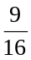 | B. | 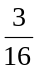 | C. |  | D.

Question 14
In guinea-pigs short hair (H) is dominant to long hair (h). Which one of the following crosses is a test cross that could show that the test animal was heterozygous?
- Hh × HH
- HH × hh
- Hh × Hh
- Hh × Hh

Question 15
The following table shows how coat colour is inherited in guinea pigs.

Phenotype | Genotype
black | CC, Cc^{k}, Ccª
sepia | c^{k}c^{k}, c^{k}cª
albino | cªcª

The predicted phenotypes and their proportions in the offspring of a cross between a homozygous sepia guinea pig and a black guinea pig whose mother was albino would be
- ½ black, ½ sepia
- ½ black, ½ albino
- all black
- ¼ black, ½ sepia, ¼ albino

Question 16
The following represents a pair of homologous chromosomes during and immediately after crossing over.
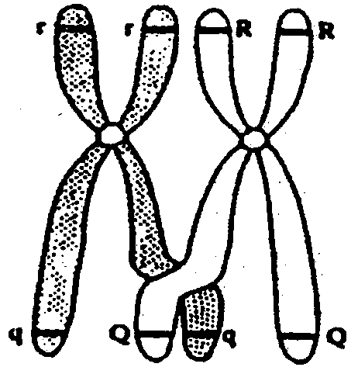 | 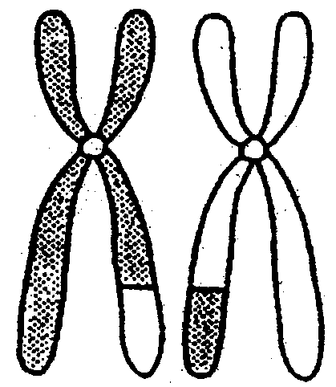
During crossing-over | Immediately after crossing-over

Which one of the following combinations of alleles would be present in the daughter cells that result from the meiotic division of this cell?
- rrQq and RRQq
- rq and rQ and Rq and RQ
- RRQQ and rrqq
- rq and rq and RQ and RQ

Information for Questions 17 and 18

One gene in poppies controls the intensity of flower colour, with intense colour (I) being dominant to pale colour (i). A second gene controls the production of white edging on the petals, with presence of white edging (W) being dominant to absence of edging (w) on petals.

Question 17
A poppy plant, heterozygous for flower colour and petal edging was crossed with a poppy plant with pale flowers lacking petal edging, and large numbers of offspring were produced.
It may be stated that
- if the gene loci are linked and no crossing over occurs, this cross would be expected to yield only one genotypic class
- if the gene loci are linked and crossing over occurs, this cross would be expected to yield four phenotypic classes
- if the gene loci are not linked, this cross would be expected to yield two phenotypic classes
- if the gene loci are not linked, this cross would be expected to yield two genotypic classes
Question 18
It has been determined that the two gene loci are linked.
The following four poppy plants were used in crosses.
Poppy plant 1 – was homozygous for intense colour and absence of edging on petals
Poppy plant 2 – was homozygous for pale colour and presence of white edging on petals
Poppy plant 3 – was produced from the cross between plants 1 and 2
Poppy plant 4 – had pale coloured flowers, lacking edging on the petals
Knowing that the gene loci are linked, it may be concluded that:
- poppy plant 1 would produce 2 different types of gametes
- plants with intense colour and absence of edging produced from the cross 3 × 4 would have been produced as a result of crossing over
- the genotype of poppy 3 is 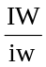
- poppy plant 4 would produce gametes of only one kind

Question 19
The pygmy possum is a very small Australian marsupial that lives in bushland. During recent severe bushfires there was considerable concern that high numbers of this endangered species would die. If the populations did increase after the fires they would probably have very reduced genetic diversity. This is an example of
- gene flow
- genetic drift
- population bottleneck
- genetic equilibrium

Question 20
DNA hybridisation is a technique used to determine how closely two species are related. This method relies on the fact that DNA
- is universal
- has weak peptide bonds
- is negatively charged
- is made up of introns and exons

Question 21
The complex eye structure of the mammalian eye is also seen in the eye of an octopus and yet these two groups show no genetic relatedness. This is an excellent example of
- analogous structures
- parallel structures
- homologous structures
- comparable structures

Question 22
If natural selection is occurring in a population, which of the following statements is correct?
- The population must be completely isolated from other groups of the same species.
- There must be variation amongst the individuals making up the population.
- Interbreeding must occur with related groups.
- Mutations must occur frequently within the population.

Question 23
The estimated life expectancy of Cro-Magnon Man was about 32 years. In the fourteenth century people living in England had a life expectancy of about 38 years. In Australia today life expectancy is in excess of 70 years. The lengthening of human life span is mainly a result of
- natural selection
- increase in brain size
- improved climatic factors
- changing culture

Question 24
The term race is used to describe a population of Homo sapiens. Which of the following statements about a race is correct?
- The gene pool of a race is completely different from those of other races.
- A race is a pure breeding population within which gene frequencies remain constant.
- A race is a continuing population with a distinct gene pool, but capable of gene exchange with other races.
- The gene frequencies within a race change only through natural selection.

Question 25
When trying to determine if a fossil skull was a pongid or a hominid a palaeontologist would be most interested in
- the size of its brow ridges
- the size of the head
- where the skull was found
- the shape of its eye sockets

SECTION B – Short-answer questions

Question 1
The following diagram shows various stages of one complete cycle of cell division in an animal cell.
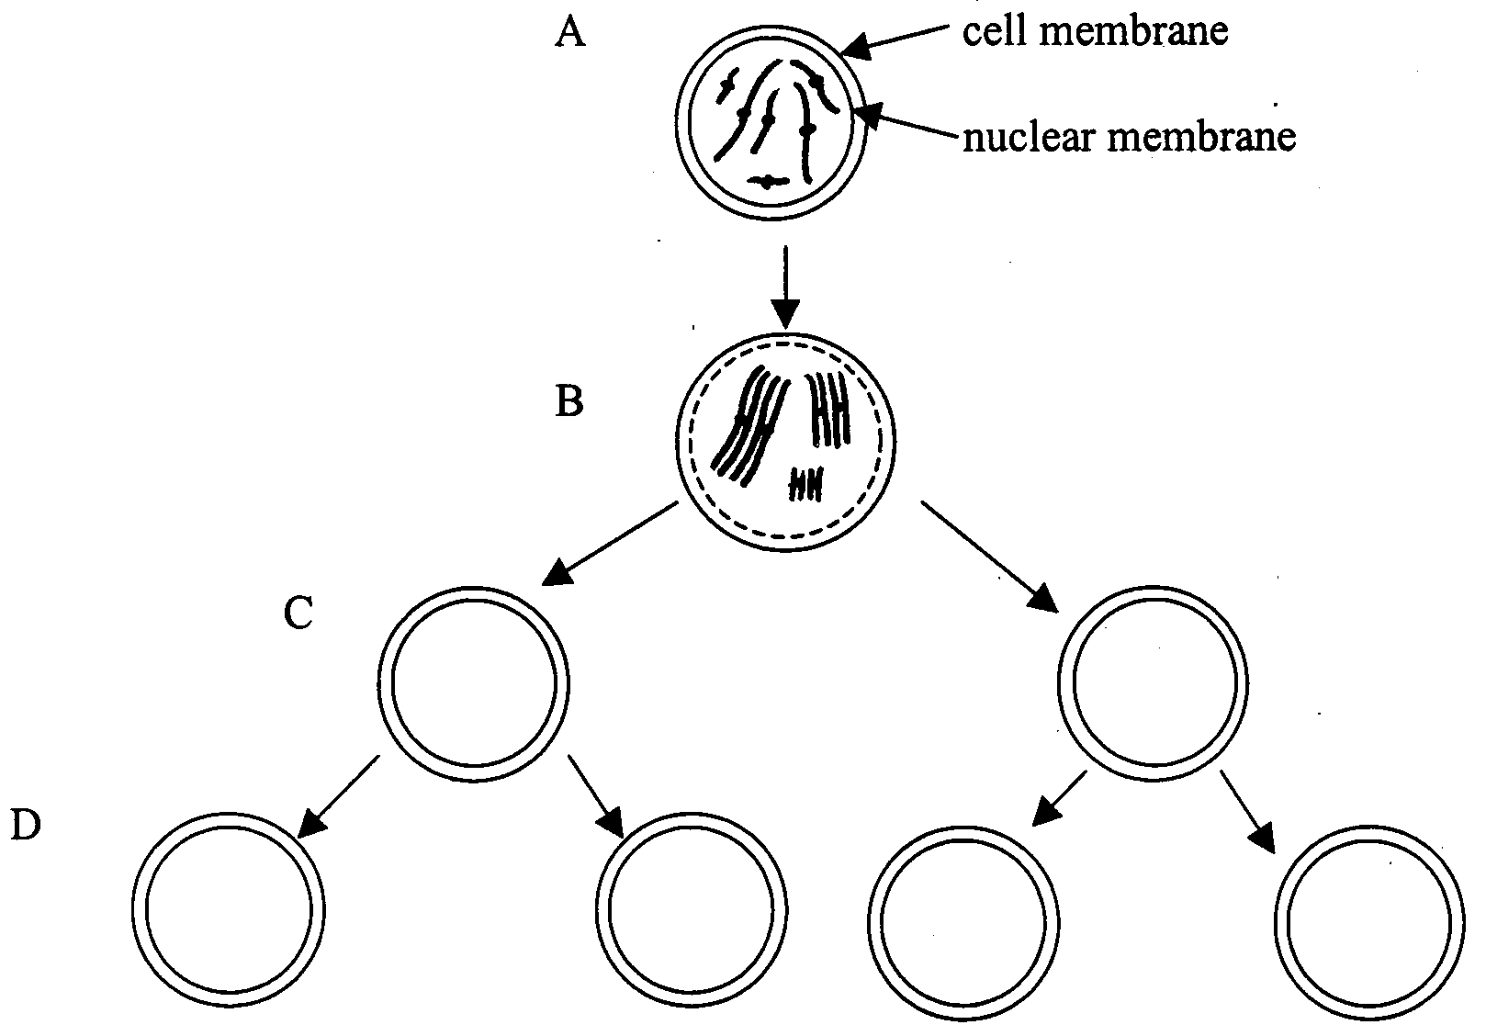

- (i) What type of cell division is shown in this diagram?
____________________________________________________________________________________
(ii) Give 2 pieces of evidence that support your answer in (i).
(1) _________________________________________________________________________________
(2) _________________________________________________________________________________
½ + 2 + ½ = 3 marks
- (i) What is the diploid number of the cell in the diagram?
____________________________________________________________________________________
(ii) What does the term diploid mean?
____________________________________________________________________________________
____________________________________________________________________________________
½ + ½ = 1 mark
- Complete the diagram of cells at C and D by drawing in the chromosomes that could be found in them.
2 marks
- What is the result of this process occurring in organisms?
_______________________________________________________________________________________
_______________________________________________________________________________________
_______________________________________________________________________________________
1 mark
- Briefly describe two processes that occur during this type of cell division that contribute to genetic variation.
(1) _________________________________________________________________________________
____________________________________________________________________________________
(2) _________________________________________________________________________________
____________________________________________________________________________________
2 marks
Total 9 marks

Question 2
In the following pedigree, shaded individuals have a rare gene defect which causes a major brain dysfunction, such that affected individuals do not survive into adulthood. Individual 7 had no family history of this rare disorder.
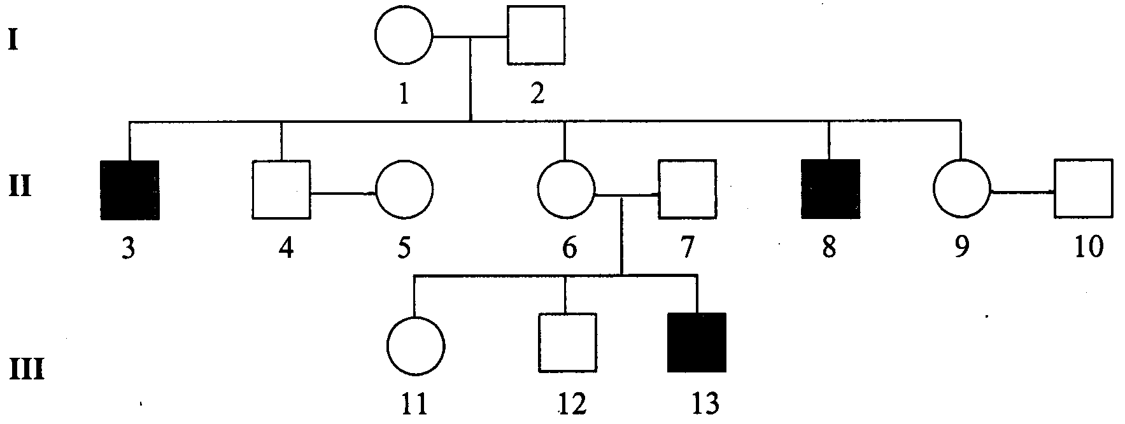

- Identify the method of inheritance of the gene which controls this characteristic (whether autosomal or sex-linked, dominant or recessive), and indicate the evidence from the pedigree which supports your answer
_______________________________________________________________________________________
_______________________________________________________________________________________
_______________________________________________________________________________________
_______________________________________________________________________________________
_______________________________________________________________________________________
_______________________________________________________________________________________
3 marks
- If additional female children were born in generation III, what would be the likelihood that one would show the trait? Explain.
_______________________________________________________________________________________
_______________________________________________________________________________________
1 mark
- Should individual II-9 be concerned that her children might be affected? Explain.
_______________________________________________________________________________________
_______________________________________________________________________________________
1 mark
- Which individuals in the pedigree must be heterozygous for the gene?
_______________________________________________________________________________________
1 mark
Total 6 marks

Question 3
The following diagrams show the karyotypes of:

Sperm of a zebra father | Egg of a donkey mother
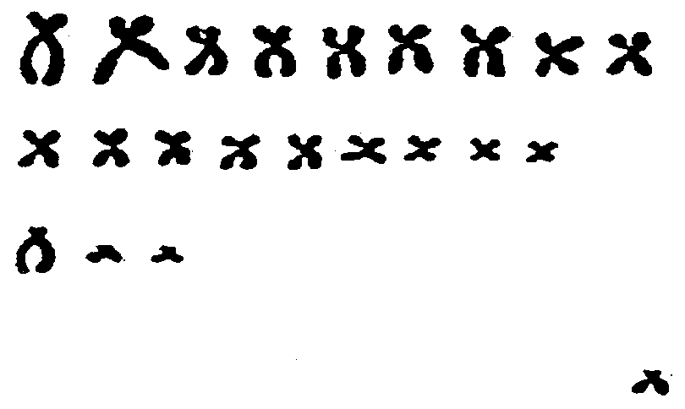 | 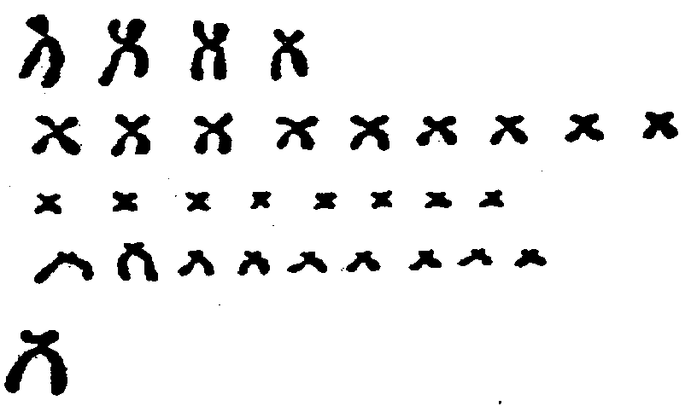

Both zebras and donkeys have an XY sex-determining mechanism as in humans.
These gametes can join and result in the production of a zebronkey offspring.

- (i) How many chromosomes in a somatic cell of a zebra?
__________________________________________________________________________________
(ii) How many chromosomes in a gamete of a donkey?
__________________________________________________________________________________
½ + ½ = 1 mark
- (i) What is the diploid number of a zebronkey offspring?
__________________________________________________________________________________
(ii) The resulting zebronkey offspring is sterile. Explain why.
__________________________________________________________________________________
__________________________________________________________________________________
__________________________________________________________________________________
½ + 1½ = 2 marks
- Zebras and donkeys are different species as they cannot interbreed successfully.
(i) Name one other different reproductive isolating mechanism that maintains species uniqueness even when there is no physical barrier between populations of the two species.
__________________________________________________________________________________
(ii) Give one example of this mechanism in nature.
__________________________________________________________________________________
½ + ½ = 1 mark
Total 4 marks

Question 4
- The diagram below shows part of a DNA molecule.
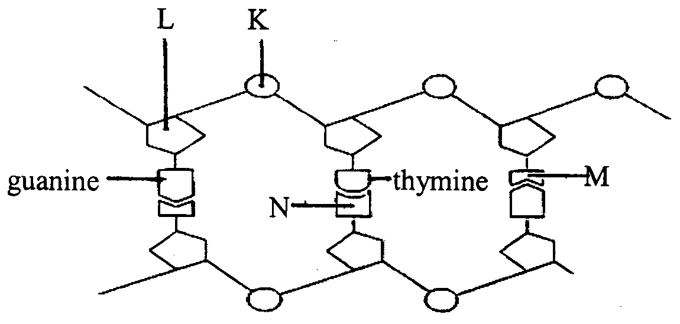
What do each of the following letters on the diagram represent?
K _____________________________________________________________________________________
L _____________________________________________________________________________________
M _____________________________________________________________________________________
N _____________________________________________________________________________________
4 × ½ = 2 marks
- The diagram below shows the sequence of bases in one strand of the DNA from part of a gene. The base sequence is read from left to right.

DNA base sequence | A C C C C A T T T C A T C C A

The table below shows the anticodons of some tRNA molecules and the specific amino acids each would carry.

Amino acid | tRNA anticodon
Alanine  Glycine  Lysine  Proline  Tryptophan  Valine  Serine | CGA  CCA  UUU  GGA  ACC  CAU  UCA

(i) Using this information, write down the amino acid sequence coded for in this part of the gene.
__________________________________________________________________________________
1 mark

The diagram below shows the original length of DNA and the same length of DNA after it has undergone a mutation.

original DNA strand | A C C C C A T T T C A T C C A

mutated DNA strand | A C C T C A T T T C A T C C A

(ii) What is the term used to describe this type of mutation?
__________________________________________________________________________________
1 mark
(iii) Suggest how this mutation might affect the protein produced, using specific data from the previous table.
__________________________________________________________________________________
__________________________________________________________________________________
1 mark
- Glyphosate is a broad-spectrum herbicide. The diagram below shows stages in the production of a crop plant that is resistant to glyphosate. C represents the gene for glyphosate resistance.
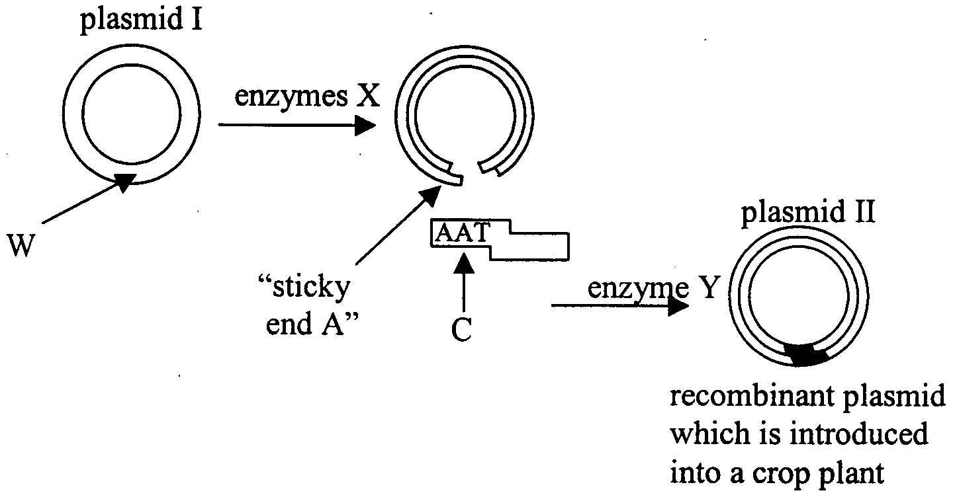
(i) Name the molecule W which forms the plasmid.
__________________________________________________________________________________
(ii) What is the general name for enzymes X?
__________________________________________________________________________________
(iii) Name enzyme Y.
__________________________________________________________________________________
(iv) The diagram in c. shows details of the “sticky ends” on C. Write down the base sequence expected on “sticky end” A of the plasmid.
__________________________________________________________________________________
4 × ½ = 2 marks
(v) Suggest why, in genetic engineering, it is preferable to use DNA with “sticky ends” not “blunt ends”.
__________________________________________________________________________________
__________________________________________________________________________________
__________________________________________________________________________________
1 mark
Total 8 marks
Question 5
Some genes are known to be located on a specific chromosome and at a particular position on a chromosome. The following diagram shows three human chromosomes and the positions of some of the genes they are known to carry.
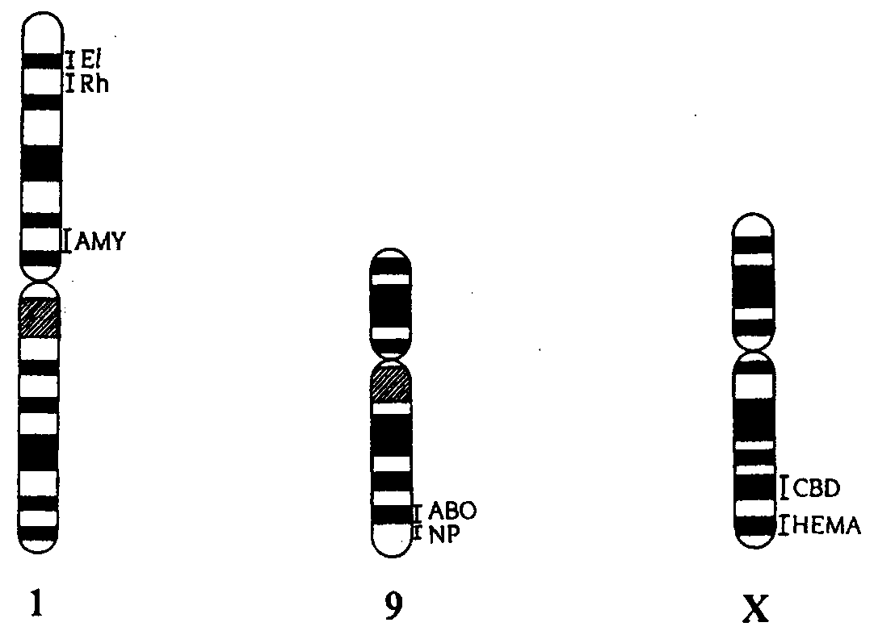
International Gene Symbol | Characteristic | Alleles
El | shape of red blood cells | E = elliptical, e = round
Rh | Rhesus blood group | D = positive, d = negative
AMY | production of amylase enzyme | A = present, a = absent
ABO | ABO blood type | I^{A}, I^{B} = antigen present, i = absent
NP | structure of nails and kneecaps | N = deformed, n = normal
CBD | colour blindness | X^{C} = normal, X^{c} = colourblind
HEMA | production of blood clotting factor | X^{H} = factor present, X^{h} = absent

- (i) What term is used to describe the 3 genes (El, Rh and AMY) all located on chromosome number 1?
__________________________________________________________________________________
(ii) What is the name given to a particular position of a gene on a chromosome?
__________________________________________________________________________________
2 × 1 = 2 marks
- Write the genotype for a man who is blood group AB and Rh negative who has round red blood cells and is heterozygous for amylase production. Use the correct notations for each gene and its position.

2 marks
- During sperm production in a male which two gene loci of the 7 gene loci shown in the diagram are most likely to produce the greatest percentage of recombinants? Explain.
_______________________________________________________________________________________
_______________________________________________________________________________________
_______________________________________________________________________________________
_______________________________________________________________________________________
2 marks
- If the man in part b. and a woman who is blood group O with elliptical red blood cells (who had a mother with round red blood cells) had a baby, what is the chance that the baby will be blood group A with round red blood cells? Show all working.
___________________________________________
___________________________________________
___________________________________________
___________________________________________
2 marks
Total 8 marks

Question 6
Extensive studies have been carried out on black tiger snake populations on the mainland and several offshore islands of South Australia – Franklin, Goat, Hareby and Roxby islands, and 5 small islets in Pelican Lagoon. They are all low lying islands covered in grasses and scrubby vegetation and have similar climates as they are in close proximity.

These continental islands were formed when the sea rose at the height of the last interglacial period.

The snake populations on the islands were formerly part of a vast interbreeding series of populations on the mainland. They were isolated 6 000 to 10 000 years ago when the sea level rose.

- Studies of a broad sample of museum specimens and living specimens from the mainland and the islands suggest that these populations belong to the same species. What does this mean?
_______________________________________________________________________________________
_______________________________________________________________________________________
_______________________________________________________________________________________
1 mark

Observations and analysis of snake gut contents showed that different food sources were available on different islands and that larger snakes ate larger prey compared to smaller snakes. On Hopkins, Goat and Franklin islands, mutton bird chicks, rats and bandicoots were eaten, whereas on Hareby and Roxby islands, small lizards and mice were eaten.
Tiger snakes on the mainland show a wide variety of sizes as in the original populations whereas snakes measured on the offshore islands have diverged towards “giants” on some islands (eg. Franklin) and “dwarfs” on other islands (eg. Roxby) during the relatively short time that these islands have been isolated.

- (i) What process has resulted in the different sized snakes on the different islands?
__________________________________________________________________________________
1 mark
(ii) Using the evidence from the observations and analysis of gut contents, explain how this process occurred on Franklin island.
__________________________________________________________________________________
__________________________________________________________________________________
__________________________________________________________________________________
__________________________________________________________________________________
__________________________________________________________________________________
3 marks

Over time these snakes on the different islands may evolve into new species.

- (i) What two factors are essential if this process of speciation is to occur?
(1) ________________________________________________________________________________
(2) ________________________________________________________________________________
2 marks
(ii) What type of evolution is this called? Explain.
__________________________________________________________________________________
__________________________________________________________________________________
__________________________________________________________________________________
__________________________________________________________________________________
2 marks
Total 9 marks

Question 7
The oldest known fossil hominid skeletons that show clear evidence of bipedal (two legged) locomotion are about 3.5 million years old.

- Describe two pieces of fossil evidence that would support this theory of upright bipedal locomotion.
(1) ____________________________________________________________________________________
_______________________________________________________________________________________
(2) ____________________________________________________________________________________
_______________________________________________________________________________________
2 marks
- Explain two reasons why this form of locomotion would have given the bipedal hominids a selective advantage.
(1) ____________________________________________________________________________________
_______________________________________________________________________________________
(2) ____________________________________________________________________________________
_______________________________________________________________________________________
2 marks
- Describe two conditions that would improve the process of fossilisation of such evidence.
(1) ____________________________________________________________________________________
_______________________________________________________________________________________
(2) ____________________________________________________________________________________
_______________________________________________________________________________________
2 marks
Total 6 marks

END OF EXAMINATION

