Board of Studies
Victorian Certificate of Education
1994

Chemistry

Common Assessment Task 1: Chemistry in a practical context

Friday 17 June 1994: 9.00 am to 10.45 am
Reading Time: 9.00 am to 9.15 am
Writing Time: 9.15 am to 10.45 am
Total Writing Time: 1 hour 30 minutes

QUESTION AND ANSWER BOOKLET

Structure of Book
Section | Number of Questions | Number of Questions to be answered
A | 1 (20 items) | 1 (20 items)
B | 5 | 5

Directions to students
Materials
Question and answer book of 20 pages, including relevant data on page 2.
Answer sheet for multiple choice items. You should have at least one HB pencil, and an eraser.
An approved calculator may be used.

The task
Please ensure that you write your student number in the space provided on this book and your name and student number in the space provided on the answer sheet for multiple choice items.
Answer all items from Section A.
Section A multiple choice items should be answered on the answer sheet provided.
Answer all questions from Section B.
Section B questions should be answered in this booklet in the spaces provided following each question.
There is a total of 67 marks available.
There is provision for rough working throughout the booklet.
All written responses should be in English.

At the end of the task
Place the answer sheet for multiple choice items inside the front cover of this booklet and hand them in.

Data

 | Symbol | Relative Atomic Mass
Barium | Ba | 137.4
Carbon | C | 12.0
Hydrogen | H | 1.00
Oxygen | O | 16.0
Potassium | K | 39.1
Sulphur | S | 32.1

Physical Constants

Ideal gas molar volume at SLC (298 K, 101.3 kPa) = 24.5 L

Gas constant, R = 8.31 J K⁻¹ mol⁻¹

Ionisation constant for water, K_{w}, at 298 K = 1.0 x 10⁻¹⁴ M²

SECTION A

Specific instructions for Section A

Section A, Question 1, consists of 20 multiple choice items. Section A is worth 20 marks or approximately 30 per cent of the marks.
You should spend approximately 28 minutes on this section.
Choose the response that is correct or best answers the question, and indicate your choice on the answer sheet according to the instructions on that sheet.
A correct answer scores 1, an incorrect answer scores 0. No credit will be given if two or more letters are marked for that item. Marks will not be deducted for incorrect answers and you should attempt every item.

Question 1

Item 1
The diagram below represents a paper chromatogram of food dyes obtained using water as a solvent. A spot of a sample was originally placed at Z. It contained components X and Y.
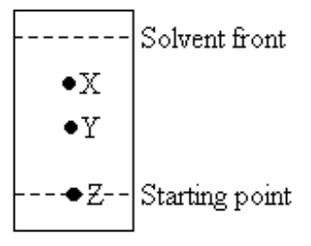
Which of the following statements regarding components X and Y is correct?
- X is more strongly absorbed by the paper than Y, and X has a larger R_{f} value than Y.
- X is more strongly absorbed by the paper than Y, and X has a smaller R_{f} value than Y.
- Y is more strongly absorbed by the paper than X, and Y has a larger R_{f} value than X.
- Y is more strongly absorbed by the paper than X, and Y has a larger R_{f} value than X.

Item 2
Which one of the following is a property of a water in oil emulsion?
- It feels greasy to the touch.
- It mixes readily with water.
- The electrical conductivity is higher that that of an oil in water emulsion.
- It can be coloured by the addition of a water soluble dye.

Item 3
The detergent CH₃CH₂)₉N⁺(CH₃)₃ is best described as
- an anionic detergent
- a non-ionic detergent
- a cationic detergent
- an amphoteric detergent

Items 4 and 5 refer to the following information

A bottle of orange juice contains 80 mg of vitamin C (M_{r} = 176) in every 200 mL of orange juice.

Item 4
The amount, in mole, of vitamin C in 200 mL of orange juice is
- 0.45
- 0.080
- 0.0023.
- 0.00045

Item 5
The concentration of vitamin C, in mol L⁻¹, in a 2.0 L bottle of the orange juice is
- 0.090
- 0.0023
- 0.000090
- 0.0000023

Item 6
When 0.50 g of cream of tartar (KHC₄H₄O₆) is mixed with water and an excess of baking soda (NaHCO₃), carbon dioxide is produced according to the equation
KHC₄H₄O₆ (aq) + NaHCO₃ (aq) → KnaC₄H₄O₆ (aq) + H₂O (l) + CO₂ (g)
The volume of carbon dioxide produced, measured at SLC, would be
- 12 L
- 0.14 L
- 0.065 L
- 0.0064 L

Item 7
In what order does the pH increase for the following substances – pure water, 0.001 M HCl, 0.001 M H₂SO₄ and 0.001 M NaOH?
- HCl > H₂SO₄ > H₂O > NaOH
- H₂O > NaOH > H₂SO₄ > HCl
- H₂SO₄ > HCl > H₂O > NaOH
- NaOH > HCl > H₂SO₄ > H₂O

Item 8
If a solution has a pH of 5, then its OH⁻ concentration is
- 10⁻⁹ M
- 10⁻⁵ M
- 5 M
- 9 M

Item 9
A 200 mL sample of 0.200 M NaOH reacts with 200 mL of 0.202 M HNO₃. The pH of the resultant solution is
- 2
- 3
- 11
- 13

Item 10
In order to determine the concentration of a solution of potassium hydroxide, 25.0 mL of KOH solution is pipetted into a conical flask. It is then titrated with 0.20 M sulphuric acid (H₂SO₄) from a burette. Choose the group of solutions that should be used to rinse each of the following pieces of apparatus.
pipette conical flask burette
- KOH solution KOH solution H₂SO₄ solution
- pure water pure water pure water
- KOH solution pure water H₂SO₄ solution
- pure water KOH solution H₂SO₄ solution

Item 11
When using the pipette correctly, which of the following diagrams represents the level of KOH solution before and after delivery?
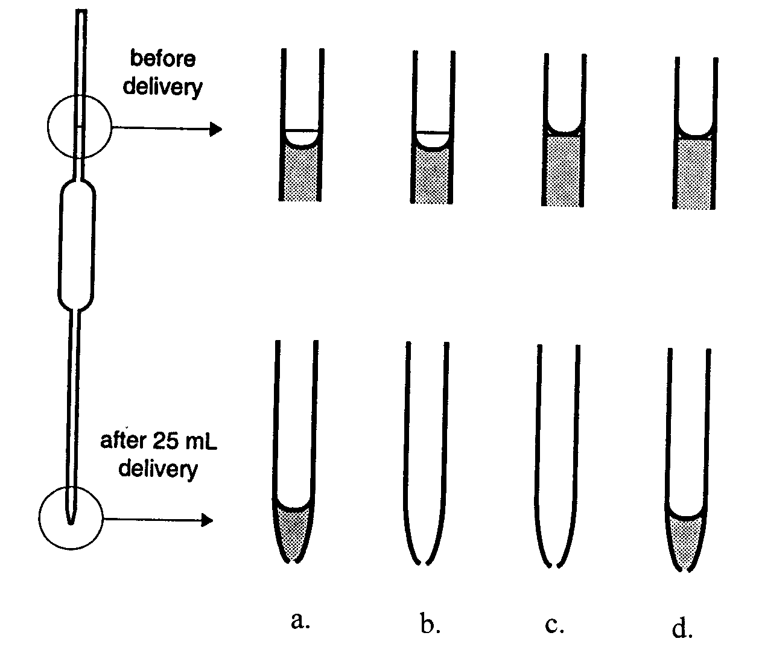

Item 12
Two students were asked to determine the concentration of acetic acid in a sample of diluted vinegar. Their task was to titrate the diluted vinegar with 0.10 M NaOH solution using phenolphthalein indicator.
Each student placed the following solutions in a conical flask.
Student 1 20.0 mL diluted vinegar 20.0 mL water 2 drops indicator
Student 2 20.0 mL diluted vinegar 60.0 mL water 4 drops indicator
They then titrated their solutions with the NaOH and from their results they calculated the concentration of acetic acid in the vinegar. It would be expected that the result obtained by student 2 would be about
- the same as that of student 1
- a quarter that of student 1
- half that of student 1
- four times that of student 1

Item 13
A dilute solution of sulphuric acid is prepared by mixing concentrated sulphuric acid with water and stirring. Which one of the following would be the safest procedure?
- The concentrated acid is carefully poured into a large beaker containing cold water.
- The concentrated acid is carefully poured into a large beaker containing hot water to help the acid to dissolve quickly.
- Cold water is carefully poured into a large beaker containing the concentrated acid.
- Hot water is carefully poured into a large beaker containing the concentrated acid.

Item 14
Magnesium reacts with hydrochloric acid to produce hydrogen gas and a solution of magnesium chloride according to the equation
Mg (s) + 2 HCl (aq) → H₂ (g) + MgCl₂ (aq)
In a number of experiments varying masses of magnesium are added to the same amount of hydrochloric acid, and the volume of hydrogen gas given off is measured at SLC. The graph below shows the volume of hydrogen released at SLC against the mass of magnesium used.
Point X on the graph most likely represents an experiment carried out with

- an excess of HCl
- an excess of Mg
- no excess of either Mg or HCl
- an incomplete reaction with some Mg and HCl remaining

Item 15
The following reaction involves hydrogen peroxide.
5 H₂O₂ (aq) + 2 MnO₄⁻ (aq) + 6 H⁺ (aq) → 5 O₂ (g) + 8 H₂O (l) + 2 Mn²⁺ (aq)
The hydrogen peroxide is acting as
- an acid
- a base
- a reductant
- an oxidant

Item 16
The reversible reaction
2 SO₂ (g) + O₂ (g)  2 SO₃ (g)
has an equilibrium constant K of 2.0 M⁻¹ at a given temperature. At that temperature a particular closed vessel contains a mixture of SO₃, SO₂ and O₂ at equilibrium.
1 mole of O₂ is added to the vessel and the temperature kept constant. At the instant the O₂ is added, the value of the concentration fraction will be
- the same as the initial concentration fraction
- higher than the initial concentration fraction
- lower than the initial concentration fraction
- equal to 2.0 M⁻¹, which is the value of the equilibrium constant

Item 17
The following reaction has an equilibrium constant of 1.47 at 1246 K and 1.81 at 1346 K.
Fe (s) + CO₂ (g)  FeO (s) + CO (g)
This would indicate that the reaction is
- fast
- slow
- exothermic
- endothermic

Item 18

Unsaturated hydrocarbons such as ethylene (ethene) are produced in industry by cracking of crude oil fractions. The process of cracking involves

the separation of the components of crude oil according to their boiling temperatures
- reducing the pressure in order to separate hydrocarbons of high molecular mass
- heating crude oil in the presence of pure oxygen to ensure complete reaction of the oil’s components
- breaking long chained hydrocarbons into shorter ones by heating crude oil in the absence of air

Item 19
Polyvinyl chloride (PVC) is a polymer widely used in packaging. Its structure can be represented by
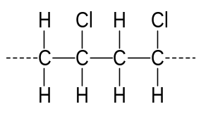
The monomer for this polymer would be
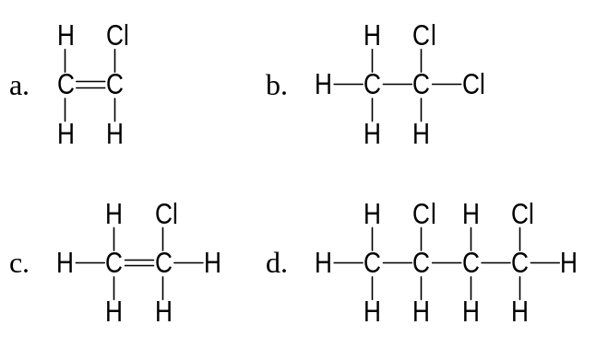

Item 20
Enzymes are different from inorganic catalysts because enzymes
- operate at a wider range of temperature and pressure
- only catalyse reactions which are specific for each enzyme
- produce a more complete reaction
- change the reaction rate to a lesser extent

SECTION B

Specific instructions for Section B
Section B consists of five short answer questions (questions 2 to 6 inclusive). You must answer all these questions. The section is worth 47 marks or approximately 70 per cent of the total. You should spend approximately 62 minutes on this section.
The marks for each question and suggested times are indicated at the end of the question.
Questions should be answered in the spaces provided in this booklet.
To obtain full marks for your responses you should
- give simplified answers with an appropriate number of significant figures to all numerical questions; unsimplified answers will not be given full marks
- show all working in your answers to numerical questions. No credit will be given for an incorrect answer unless it is accompanied by details of the working
- make sure chemical equations are balanced and that the formulas for individual substances include indications of state, for example, H₂ (g); NaCl (s).

Question 2
The sulphate requirements of different kinds of plants vary and so it is important to know the sulphate content of fertilisers. A company chemist used gravimetric analysis to determine the soluble sulphate content of the company’s product, Greenfude.
A 40.0 g sample of Greenfude was dissolved in water. Sufficient barium chloride solution was added to precipitated all the sulphate as barium sulphate according to the equation
Ba²⁺(aq) + SO₄²⁻(aq) → BaSO₄(s)
The precipitate was filtered, dried then weighed. It had a mass of 7.66 g.
- What amount, in mole, of barium sulphate was precipitated?
___________________________________________________________________________
___________________________________________________________________________
___________________________________________________________________________
- What amount, in mole, of sulphate was in the sample of Greenfude?
___________________________________________________________________________
___________________________________________________________________________
- What mass of sulphate was in the sample of Greenfude?
___________________________________________________________________________
___________________________________________________________________________
___________________________________________________________________________
- What was the percentage of sulphate in Greenfude?
___________________________________________________________________________
___________________________________________________________________________
___________________________________________________________________________
___________________________________________________________________________
- If the precipitate was not completely dry when it was weighed, what effect would this have on the calculated percentage of sulphate? Explain your answer.
___________________________________________________________________________
___________________________________________________________________________
___________________________________________________________________________
___________________________________________________________________________
- If double the volume of barium chloride solution were added, what effect would this have on the calculated percentage of sulphate? Explain your answer.
___________________________________________________________________________
___________________________________________________________________________
___________________________________________________________________________
___________________________________________________________________________
2 + 1 + 1 + 1 + 2 + 1 = 8 marks
(suggested time: 11 minutes)

Question 3
The four key stages in the production of iron in the blast furnace may be represented by the following table. Chemical reactions take place in stages B, C and D.

raw materials are placed in furnace  stage A | raw materials are blasted with hot air  stage B | iron is  produced  stage C | slag is  formed  stage D

- Give balanced equations for the reactions that occur at
- Stage B
______________________________________________________________________________________________________________________________________________________
___________________________________________________________________________
___________________________________________________________________________
- Stage C
___________________________________________________________________________
___________________________________________________________________________
- Stage D
___________________________________________________________________________
___________________________________________________________________________
___________________________________________________________________________
___________________________________________________________________________
- What is the source of energy that maintains the temperature of the blast furnace?
___________________________________________________________________________
___________________________________________________________________________
___________________________________________________________________________
- Because of their different densities, the molten slag floats on top of the molten iron. What advantage might this have in the production of iron?
___________________________________________________________________________
___________________________________________________________________________
___________________________________________________________________________
- The iron industry is now placing all the operations associated with the iron process, from the coke production to the steel making and shaping, on the one site. This type of complex is called an ‘integrated steelworks’. Describe one reason why the iron industry is now choosing to place all stages of the operations on the same site.
___________________________________________________________________________
___________________________________________________________________________
___________________________________________________________________________
___________________________________________________________________________
5 + 1 + 1 + 1 = 8 marks
(suggested time: 10 minutes)

Question 4
- Explain the existence of the property of the surface tension of a liquid in terms of the interactions between molecules. You may find it useful to include a diagram in your answer.
___________________________________________________________________________
___________________________________________________________________________
___________________________________________________________________________
___________________________________________________________________________
___________________________________________________________________________

- You are asked to perform a simple experiment to determine which has the greater surface tension, water or petrol. Describe the method you would use, the results you would expect to observe and give an explanation for these results.

Method
___________________________________________________________________________
___________________________________________________________________________
___________________________________________________________________________
___________________________________________________________________________
___________________________________________________________________________

Expected observations
___________________________________________________________________________
___________________________________________________________________________
___________________________________________________________________________
___________________________________________________________________________

Explanation of results
___________________________________________________________________________
___________________________________________________________________________
___________________________________________________________________________
___________________________________________________________________________
___________________________________________________________________________
- The surface tension of water in air is 75.6 dyne cm⁻² at 0°C but it is reduced to 67.9 dyne cm⁻² at 50°C. Give an explanation, in molecular terms, for the decrease in surface tension with temperature.
___________________________________________________________________________
___________________________________________________________________________
___________________________________________________________________________
___________________________________________________________________________
___________________________________________________________________________
- A steel needle is handled by several students in a chemistry class and then placed carefully on the surface of pure water in a shallow dish. The needle remains on the surface of the water but when a few drops of detergent are added, it sinks to the bottom of the dish.
- Explain why the needle, which is much denser than water, remains on the surface in the first part of the experiment.
___________________________________________________________________________
___________________________________________________________________________
___________________________________________________________________________
___________________________________________________________________________
- Explain the action of the detergent in causing the needle to sink.
___________________________________________________________________________
___________________________________________________________________________
___________________________________________________________________________
___________________________________________________________________________
___________________________________________________________________________
___________________________________________________________________________
___________________________________________________________________________
___________________________________________________________________________
___________________________________________________________________________
2 + 4 + 2 + 3 = 11 marks
(suggested time: 14 minutes)

Question 5
- Pure hydrogen iodide (HI) is a gas which, at high temperatures, partially dissociates into hydrogen and iodine according to the equilibrium
2 HI(g)  H₂(g) + I₂(g)
At 500 K, the equilibrium constant for the dissociation reaction is 6.25 x 10⁻³.
Some pure HI is placed into an evacuated 2.0 L vessel and heated to 500 K. In the equilibrium sample, the concentration of I₂ is 3.10 x 10⁻⁵ mol L⁻¹.
- Write an expression for the equilibrium constant for the dissociation of HI.
___________________________________________________________________________
___________________________________________________________________________
- What is the concentration of H₂(g) in this equilibrium mixture at 500 K?
___________________________________________________________________________
___________________________________________________________________________
- What is the concentration of HI(g) in this equilibrium mixture at 500 K?
___________________________________________________________________________
___________________________________________________________________________
___________________________________________________________________________
___________________________________________________________________________
___________________________________________________________________________
- How many moles of HI must have been placed into the 2.0 L vessel originally?
___________________________________________________________________________
___________________________________________________________________________
___________________________________________________________________________
___________________________________________________________________________
___________________________________________________________________________
___________________________________________________________________________
___________________________________________________________________________
- Hydrogen chloride (HCl) gas at 500 K undergoes no significant dissociation into its elements. Any dissociation of HCl can be completely ignored. What is the pressure, in kilopascal, in a 750 mL flask containing 8.20 x 10⁻² mol of pure HCl at 500 K?
___________________________________________________________________________
___________________________________________________________________________
___________________________________________________________________________
___________________________________________________________________________
___________________________________________________________________________
___________________________________________________________________________
- If the HCl in the flask in part (b) above were replaced with the same amount, in mole, of HI, what effect would this have on the pressure in the flask? Explain your answer.
Assume the temperature was maintained at 500 K.
___________________________________________________________________________
___________________________________________________________________________
___________________________________________________________________________
6 + 3 + 2 = 11 marks
(suggested time: 15 minutes)

Question 6
The paragraphs below give an outline of the production of nitric acid by the Ostwald process. Read the paragraphs and answer the questions below.
There are three main stages in the manufacture of nitric acid.

Stage 1: The catalytic oxidation of ammonia
Ammonia and preheated air are blown over a catalyst bed made of a number of layers of thin woven Pt/Rh gauze. Temperatures are maintained at approximately 900°C. The contact time of the gases with the catalyst is about 0.003 seconds.

Stage 2: Further oxidation in a cooling chamber
The product from stage 1 is cooled to approximately 30°C and reacted with more air to produce nitrogen dioxide.

Stage 3: The absorption of nitrogen dioxide
Nitrogen dioxide is reaction with water in tall absorption towers. The overall equation for this reaction is
3 NO₂ (g) + H₂O (l) → 2 HNO₃ (aq) + NO (g)

- Solid catalysts, such as the one used in stage 1 above, are used as a finely woven gauze, a powder, or in a sponge-like form. Why would these forms be more effective than using the catalyst as a solid lump?
___________________________________________________________________________
___________________________________________________________________________
___________________________________________________________________________
- The reactions in stages 1 and 2 are both exothermic.
- What is the effect of increasing the temperature on the yield of these exothermic reactions?
___________________________________________________________________________
___________________________________________________________________________
___________________________________________________________________________
- Explain why the temperature selected for stage 1 is so much higher than that selected for stage 2. In your answer, you will need to take into account the effect of increasing temperature on the yield of these reactions.
___________________________________________________________________________
___________________________________________________________________________
___________________________________________________________________________
___________________________________________________________________________
___________________________________________________________________________
___________________________________________________________________________
___________________________________________________________________________
___________________________________________________________________________
- Write a balanced equation for the reaction occurring in stage 2.
___________________________________________________________________________
___________________________________________________________________________
- In stage 3, NO (g) is produced as well as the nitric acid. How is this NO used in the process?
___________________________________________________________________________
___________________________________________________________________________
___________________________________________________________________________
___________________________________________________________________________
- The reaction in stage 3 is a redox reaction. Give the formula of the substance that has been
- reduced _________________________________________________________
- oxidised _________________________________________________________
1 + 4 + 1 + 1 + 2 = 9 marks
(suggested time: 12 minutes)

end of question and answer booklet

