VBOS 1995
Chemistry: Unit 3
Solutions

An asterisk indicates that one mark was received for that response.

Question 1

- C
- B
- B
- B
- A
- D
- C
- D
- D
- B
- C
- A
- A
- A
- D
- C
- B
- B

Question 2
a. | -3- | i. | 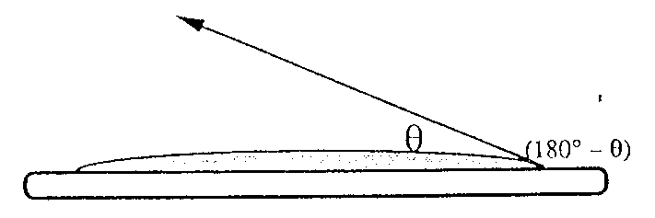
 |  | ii. | Note that the angle* defined as the contact angle above as the contact angle above is as given in ‘Chemistry 2’. You must also accept the angel defined as the supplement of the above.
 |  | iii. | zero or ‘extremely small’. * If the contact angle in the diagram drawn by the student is the supplement of eh contact angle defined here, then the correct response would be ‘180°’ or ‘close to 180°’.
b | -2- |  | * for correct shaped drop.  * θ > 90° (note that if θ has been defined as the supplement of the conventional definition, the correct response is θ < 90°) | 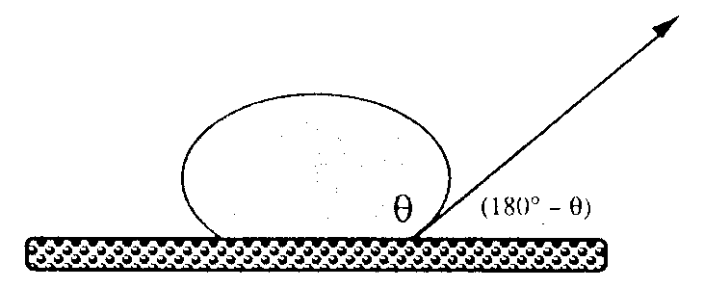
c. | -4- | i. | * Oil in water.  * High conductivity would have required that the Na⁺ and Cl⁻ were able to travel through the solution. Since this is not occurring emulsion cannot be oil in water.
 |  | ii. | * for indicating the relative positions of the oil and the water phases by labelling at least one of them  * for indicating the correct relative orientation of the hydrophilic and hydrophobic parts of the surface active agent in the surface of the emulsion particle.
(3 + 2 + 4 = 9 marks)

Question 3
a. | -2- | i. | * To separate the light from the light source into its component wavelengths (or frequencies)
 |  | ii. | * To detect the intensity of the light arriving
b. | -2- | * For correctly plotting all three points.  * For sketching or ruling a straight line through the points.  A curve resulting form incorrectly plotted points may be given one mark if the error is not gross – judgment here! |  | 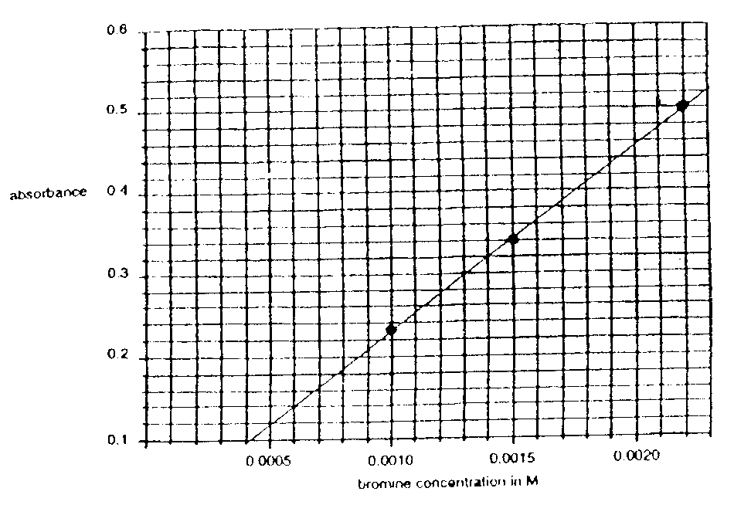

Many students obviously felt bound to draw the line through the (0, 0.1) point which they took to be the ‘origin’. That mistake cost a mark, even thought they might well get the right answer by their interpolation.

c. | -1- | 0.00117 M * (accept in the range 0.00115 – 0.00120)

Question 4
a. | -5- | i. | * [O₂] = 0.040 M  * [SO₂] = 0.080 M  * [SO₃] = 0.020 M
 |  | ii. | 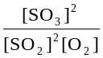*
 |  | iii. | = 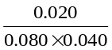 = 1.6 * M⁻¹  Give credit here if a correct numerical result is calculated from an incorrect equilibrium expression. This mark is for correct substitution and arithmetic.
b. | -1- | * 5 minutes
c. | -2- | More O₂ has been added*, hence reaction moves to the right, converting some SO₂ to SO₃*
d. | -4- | i. | Higher pressure is not needed since *conversion is close to complete at 450°C
 |  | ii. | * K at 450° > K at 600° (due to negative DH) hence better conversion at 450°C  * Combination of rate and equilibrium factors lead to *optimum conditions for formation at 450°C

Question 5
a. | -2- | 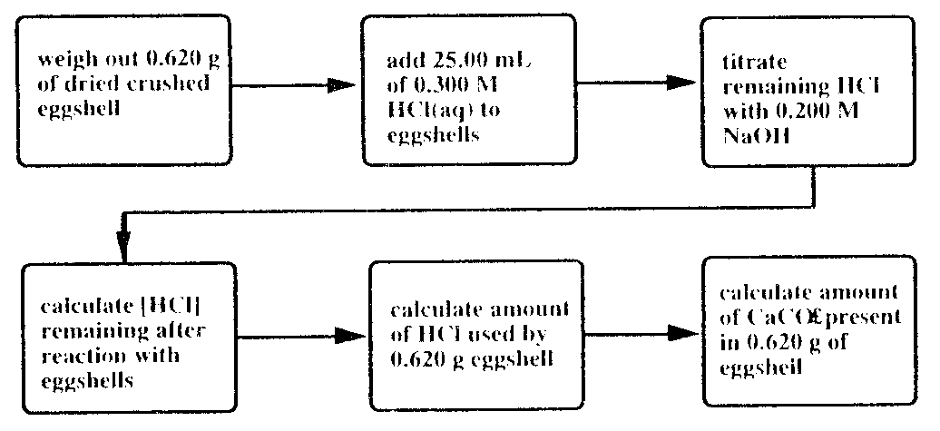
 |  | Give half-mark for each box added up to 4 × ½ = **. The information in the second and third box is essential for 1 mark, plus another two reasonable choices to make up the second mark. Round odd half-marks down.

Nothing special went wrong here although a significant number of students suggested ‘dissolving the eggshell in water’.

b. | -2- | Give half- mark for each item added up to 4 × ½ mark = **.  The list must include:  Balance; 25.00 mL pipette (volume need not be specified); burette, conical flask or beaker.  (If one of these is missing, the odd one could be made up with one of spatula; indicator; funnel)  Round odd half-marks up.
c. | -1- | Give half-mark for each item added up to 2 × ½ = *  Any two of: lab coat, safety glasses; long hair tied back; no thongs; no smoking; …  Round odd half-marks down.
d. | -7- | i. | 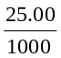 × 0.300 = 0.0075 mole of HCl *
 |  | ii. | 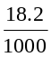 × 0.200 = 0.00364 mole of NaOH used *
 |  | iii. | 0.00364 mole * (Give credit if this response is the same as under ii., even if ii. was wrong.
 |  | iv. | 0.0075 – 0.0034 = 0.00386 mole *
 |  | v. | 0.00193 mole* (Give credit if this response is one half the value shown in iv. even if iv. was wrong.
 |  | vi. | 0.00193 × 100 = 0.193 g CaCO₃ * (note that 100 g mol⁻¹ is the molar mass of CaCO₃)  %CaCO₃ by mass is 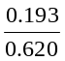 × 100 = 31.1% *

Generally this calculation was well done.

Question 6
a. | -1- | To separate crude oil into its components according to their differing volatilities (boiling points, molar masses would by acceptable) *
b. | -7- | i. | Has a carbon-carbon double bond *
 |  | ii. | CH₃CH₂CH₂ (g)  CH₃CH=CH₂ (g) + H₂ (g) * or CH₃CH₂CH₃ (g)  CH₄ (g) + CH₂=CH₂ (g)
 |  | iii. | Forms SO₂ *
 |  | iv. | Give one mark for knowing that the formula of the alkene with four carbon atoms is C₄H₈. * Then one for each correct structure:
 |  |  | 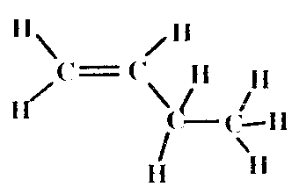* | 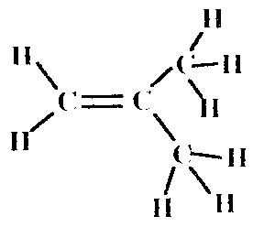* | 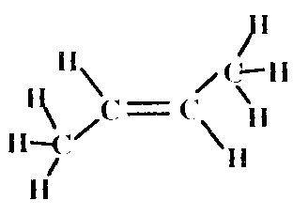*
 |  |  | There is no need to show the cis-trans isomerisation of the third structure shown – this is not required by the Study Structure.

Question 7
a. | -2- | i. | To carry or sweep the sample being analysed through the column *
 |  | ii. | To bring about a separation of a mixture into its components *
b. | -4- | butanol – D; ethanol – B; methanol – A; propanol – C.  ** for the correct sequence. No marks for any incorrect sequence. Half-mark each for an incomplete sequence with no response in an incorrect position. In this case, with an odd half-mark, round up.  Interaction with stationary phase increases with increasing molar mass*, hence molecules will emerge in the order of increasing molar mass*  Some students confused this with a mass spectrometer apparently – peak B was often assigned to the alcohol with the greatest molar mass, C to propanol & so on down the line …
c. | -1- | * for any one of the following:  - longer column  - more strongly absorbing stationary phase  - lower flow rate of carrier gas

