Board of Studies
Victorian Certificate of Education
1995

Chemistry

Common Assessment Task 1: Written Examination

Tuesday 13 June 1995: 2.45 pm to 4.30 pm
Reading Time: 2.45 pm to 3.00 pm
Writing Time: 3.00 pm to 4.30 pm
Total Writing Time: 1 hour 30 minutes

QUESTION AND ANSWER BOOKLET

Structure of Book
Section | Number of Questions | Number of Questions to be answered
A | 1 (18 multiple choice items) | 1 (18 multiple choice items)
B | 6 | 6

Directions to students
Materials
Question and answer book of 19 pages, including relevant data on page 2.
Answer sheet for multiple choice items. You should have at least one HB pencil and an eraser.
An approved calculator may be used.

The task
Please ensure that you write your student number in the space provided on this book and your name and student number in the space provided on the answer sheet for multiple choice items.
Answer all items from Section A.
Section A items should be answered on the answer sheet provided for multiple choice items.
Answer all questions from Section B.
Section B questions should be answered in this booklet in the spaces provided following each question.
There is a total of 71 marks available.
There is provision for rough working throughout the booklet.
All written responses should be in English.

At the end of the task
Place the answer sheet for multiple choice items inside the front cover of this booklet and hand them in.

Data

Relative atomic masses

H = 1.00; C = 12.0; O = 16.0; Cl = 35.5; Ca = 40.0; Fe = 56.0.

SECTION A

Specific instructions for Section A

Section A, Question 1, consists of 18 multiple choice items. Section A is worth approximately 25 per cent of the marks available. You should spend approximately 23 minutes on this section.
Choose the response that is correct or best answers the question, and indicate your choice on the multiple choice answer sheet according to the instructions on that sheet.
A correct answer scores 1, an incorrect answer scores zero. No credit will be given if two or more letters are marked for that item. Marks will not be deducted for incorrect answers and you should attempt every item.

Question 1

Items 1, 2 and 3 below refer to the operation of a blast furnace.

Item 1
The production of iron involves the injection of a gas at the base of the blast furnace. The gas is
- carbon dioxide
- carbon monoxide
- air
- steam

Item 2
The name of the gaseous reductant that operates within the blast furnace is
- carbon dioxide
- carbon monoxide
- nitrogen
- hydrogen

Item 3
Limestone is the source of a reactant within the blast furnace that reacts with any silica present. The primary purpose of this reaction is to
- provide heat for the main reaction in the blast furnace
- reduce the silicon content of the iron produced
- reduce the calcium content of the iron produced
- provide carbon for the production of steel

Item 4
The chemical formulas of two commercial detergents are C₁₂H₂₅SO₃.Na (detergent A) and C₁₀H₂₁N(CH₃)₃.Cl (detergent B). Which one of the following statements is correct?
- Both detergent A and detergent B are non-ionic detergents.
- Detergent A is an anionic detergent and detergent B is a cationic detergent.
- Detergent A is an cationic detergent and detergent B is a anionic detergent.
- Both detergent A and detergent B are anionic detergents.

Item 5
An iron catalyst is used to improve the efficiency of the Haber process for the production of ammonia according to the following equation
N₂ (g) + 3 H₂ (g)  2 NH₃ (g); ΔH = -91 kJ mol⁻¹
The effect of the catalyst is to
- decrease the activation energy of the reaction
- increase the value of the equilibrium constant for the reaction
- change the composition of the equilibrium mixture so as to increase the amount of ammonia
- reverse the sign of the ΔH for the reaction

Item 6
When 50 mL of 0.2 M HCl and 50 mL of 0.2 M Ba(OH)₂ are mixed, the pH of the resulting solution will be closest to
- 0.1
- 0.4
- 7.0
- 13.0

Items 7 and 8 below refer to the following information

The self-ionisation constant of water, derived from the reaction
2 H₂O (l)  H₃O⁺ (aq) + OH⁻ (aq); ΔH = 57 kJ mol⁻¹
can be expressed as K_{w} = [H₃O⁺][OH⁻] = 10⁻¹⁴ M² at 25°C

Item 7
In alkaline solutions at 25°C
- 10⁻¹⁴ M > [H₃O⁺] > [OH⁻]
- 10⁻¹⁴ M > [OH⁻] > [H₃O⁺]
- [OH⁻] > 10⁻⁷ M > [H₃O⁺]
- [H₃O⁺] > 10⁻⁷ M > [OH⁻]

Item 8
At 60°C the pH of pure water will be
- 14 exactly
- > 7.0
- 7 exactly
- < 7.0

Item 9
The number of mole of chloride ions in 3.85 g of FeCl₃ is closest to
- 0.0079
- 0.024
- 0.036
- 0.072

Item 10
A sample of Fe₂O₃ contains 0.60 mole of oxide ions. The total mass of the sample of Fe₂O₃ is closest to
- 29 g
- 32 g
- 64 g
- 144 g

Item 11
Hot concentrated sulphuric acid reacts with sulphur to produce sulphur dioxide and water according to the equation
S (s) + 2 H₂SO₄ (l) → 3 SO₂ (g) + 2 H₂O (l)
In this reaction, sulphuric acid is acting primarily as
- a strong acid
- a reducing agent
- an oxidising agent
- a dehydrating agent

Item 12
Hydrogen iodide decomposes according to the equation
2 HI (g)  H₂ (g) + I₂ (g); K = 0.006 at 320 K
If 2 mole of each of HI, H₂ and I₂ were mixed in a 1 L vessel at 320 K then, at equilibrium,
- the concentration of I₂ would have decreased
- the concentration of HI would be unchanged
- the value of K would have increased to 1
- the number of gas molecules present would have decreased

Item 13
Methanol may be prepared commercially from CO (g) and H₂ (g) at 400°C in the presence of a suitable catalyst according to the equation
CO (g) + 2 H₂ (g)  CH₃OH (g); ΔH = -92 kJ mol⁻¹
The amount of CH₃OH present at equilibrium could be increased by increasing the
- pressure of the reaction mixture
- temperature of the reaction mixture
- volume of the reaction chamber
- amount of catalyst present in the reaction mixture

Item 14
Which one of the following will not increase the rate of formation of hydrogen from the reaction of magnesium with hydrochloric acid?
- Add sodium chloride solution to the magnesium/acid mixture.
- Increase the temperature of the magnesium/acid mixture.
- Increase the concentration of the hydrochloric acid in contact with the magnesium.
- Use the metal in the form of finely powdered magnesium instead of as magnesium ribbon.

Item 15
Fine clean glass capillaries are place into samples of pure water and pure mercury.

The expected appearance of the liquids in the capillaries would be
- I = water; II = mercury
- II = water; III = mercury
- III = water; IV = mercury
- I = water; IV = mercury

Items 16 and 17 below refer to the following diagram

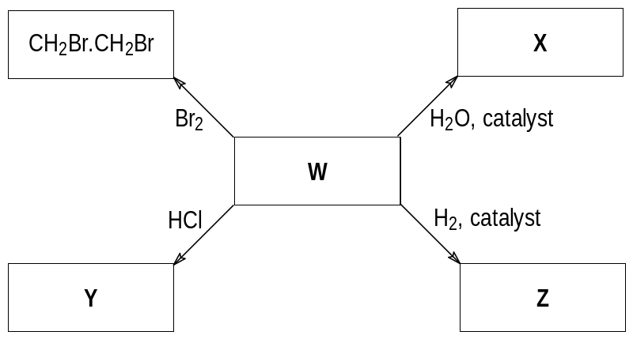

Item 16
In the above diagram, the compounds W and X may be, respectively,
- C₂H₄ and CH₃CH₂Br
- CH₃CH₂Br and HOCH₂CH₂OH
- C₂H₄ and CH₃CH₂OH
- CH₃CH₂Br and CH₃CH₂OH

Item 17
In the above diagram, the compounds Y and Z may be, respectively,
- CH₃CH₂Br and CH₃CH₂Cl
- CH₃CH₂Cl and C₂H₆
- C₂H₄ and CH₃CH₂OH
- CH₃CH₂Br and CH₃CH₂OH

Item 18

In the species SO₂ and HNO₃, the underlined atoms have oxidation numbers respectively of

+6 and +3
- +4 and +5
- +4 and +3
- -2 and +5

SECTION B

Specific instructions for Section B
Section B consists of six short answer questions (questions 2 to 7 inclusive). You must answer all of these questions. The section is worth 53 marks or approximately 75 per cent of the total. You should spend approximately 67 minutes on this section.
The marks allotted to each question and suggested time allocations are shown at the end of each question.
Questions should be answered in the spaces provided in this booklet.
To obtain full marks for your responses you should
- give simplified answers with an appropriate number of significant figures to all numerical questions; unsimplified answers will not be given full marks
- show all working in your answers to numerical questions. No credit will be given for an incorrect answer unless it is accompanied by details of the working
- make sure chemical equations are balanced and that the formulas for individual substances include indications of state, for example, H₂ (g); NaCl (s).

Question 2
- Water will wet clean glass. A drop of water is placed on a clean glass surface and begins to spread.
- A side view of a flat sheet of clean glass is shown below. Sketch on this the expected appearance of the drop a short time after it has started spreading.

- On your sketch, clearly show and label the contact angle for the drop on the glass.
- What would be the approximate size of the angle when the drop had finished spreading on a very large sheet of glass?
___________________________________________________________________________
___________________________________________________________________________
- Water does not wet plastic ‘polythene’. Sketch the expected shape of a drop of water sitting on a clean flat plate of ‘polythene’ on the side view of a flat sheet of ‘polythene’ shown below. Show the contact angle on your sketch and indicate whether it would be greater or less than 90 degrees.

- A stable emulsion is made from a mixture of a hydrocarbon oil and a dilute sodium chloride solution in the presence of an anionic detergent. The electrical conductivity of the emulsion is measured and found to be extremely low.
- Name the type of this emulsion and explain how the conductivity of the emulsion enables you to determine the type of emulsion.
___________________________________________________________________________
___________________________________________________________________________
___________________________________________________________________________
- Give a labelled sketch of the emulsion showing the orientation of the detergent molecules in the emulsion particle surface.

3 + 2 + 4 = 9 marks
(suggested time: 12 minutes)

Question 3

- Shown above is a labelled diagram of a simple ultraviolet-visible spectrometer. This instrument is used to measure the absorption of radiation by dissolved substances.
- What is the purpose of the prism?
___________________________________________________________________________
___________________________________________________________________________
- What is the purpose of the detector?
___________________________________________________________________________
___________________________________________________________________________
- Three different bromine solutions are prepared and the spectrum of each is measured in a spectrometer. The absorbances of a 1 cm thickness of each of the solutions are recorded at a wavelength of 400 nm and are shown in the table below. Use these data to sketch a graph of absorbance as a function of bromine concentration using the blank graph provided.
Br₂ concentration | 0.00100 M | 0.00150 M | 0.00220 M
absorbance | 0.230 | 0.340 | 0.500

- A solution of bromine of unknown concentration is placed in a sample cell with a path length of 1 cm. A spectrum is measured and is shown on the graph below. Use the data in the graph to estimate the concentration of bromine in the unknown solution. Place your answer in the space provided under the graph below.

[Br₂] = ________________ M
2 + 2 + 1 = 5 marks
(suggested time: 6 minutes)

Question 4
The graph below is a plot showing changes in concentrations of three gases, SO₂, O₂ and SO₃ with time over a 20 minute period in a fixed volume reaction vessel that is held at a constant temperature of 600°C throughout.
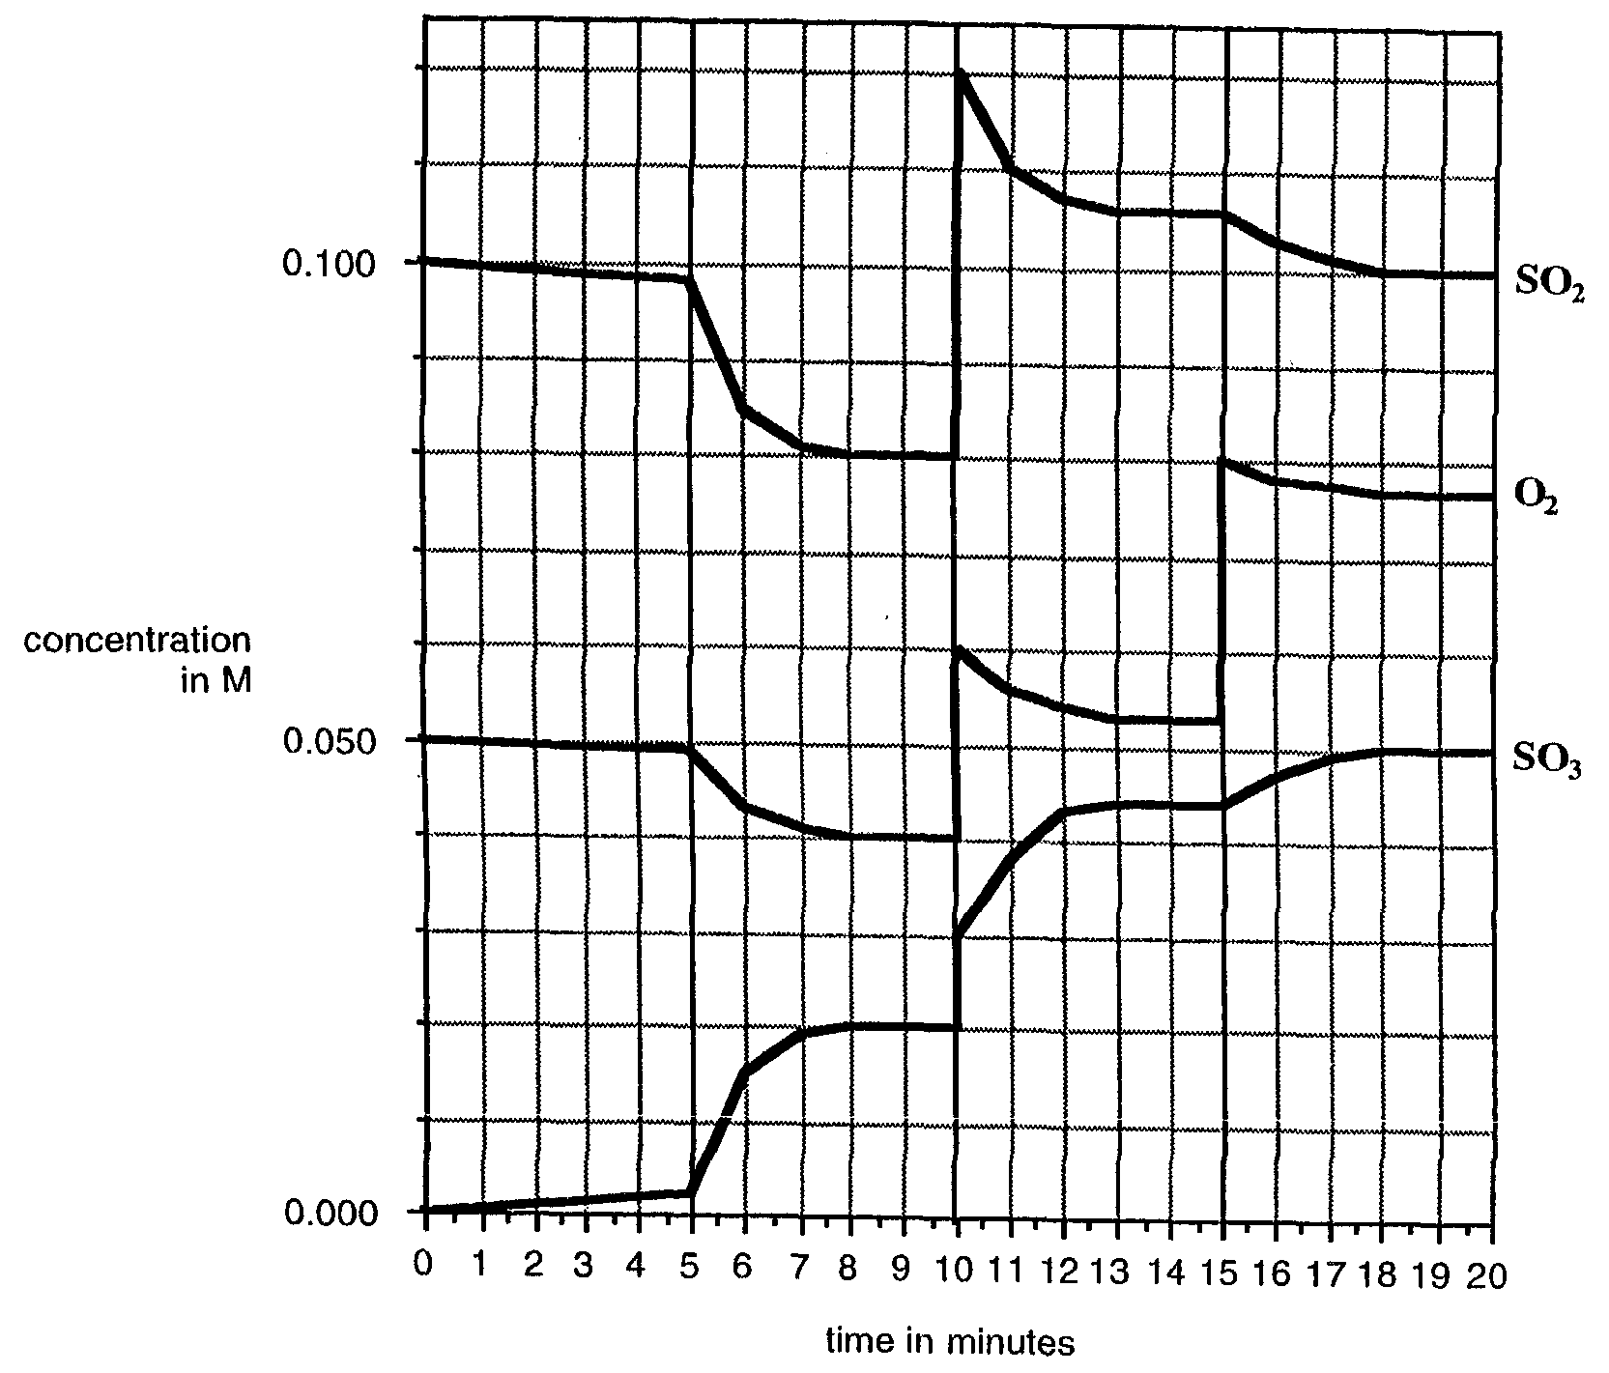
At one point during this time a catalyst is added to the gas mixture.

- The reaction occurring is represented as
2 SO₂(g) + O₂(g)  2 SO₃(g); ΔH = -200 kJ mol⁻¹
- Use the graph to determine the equilibrium concentrations of each gas at the time the gas mixture first reaches equilibrium.
- Write an expression for the equilibrium constant of the reaction.
- Use the data from (i) and (ii) to calculate the value of the equilibrium constant, K, at 600°C.
- At what time was the catalyst added?
- Explain why the concentration of SO₂ changes after the 15 minute mark.
- The reaction conditions described in this mixture of gases are not those that usually apply in the converter chamber of an industrial plant designed to produce large quantities of sulphuric acid. Normal operating temperature of about 450°C and gas pressures of one atmosphere, using a vanadium pentoxide catalyst, lead to the conversion of about 98 per cent of the sulphur dioxide to sulphur trioxide.
- Increasing the pressure of the reaction mixture increases the proportion of SO₂ converted to SO₃ at equilibrium. Yet the actual pressure used is about 1 atmosphere. Why are pressures of one atmosphere used rather than higher pressures?
- The rate of the catalysed formation of SO₃ from SO₂ and O₂ is high at 600°C. Yet modern industrial practice is to use a temperature of about 450°C where the rate of the catalysed reaction is lower. Explain why this temperature has been chosen for the industrial process.
5 + 1 + 2 + 4 = 12 marks
(suggested time: 15 minutes)

Question 5
Eggshells contain calcium carbonate. A student carried out an experiment to determine the percentage of calcium carbonate in some eggshells by reaction some crushed dried shells with 25.00 mL of 0.300 M hydrochloric acid. The equation for the reaction was
CaCO₃(s) + 2 HCl(aq) → CaCl₂(aq) + H₂O(l) + CO₂(g)
The mixture was allowed to stand until there were no more bubbles of carbon dioxide evolved. Then the hydrochloric acid that had not taken part in the reaction with the calcium carbonate eggshells was titrated against a standard solution of sodium hydroxide. The equation for this reaction was
HCl(aq) + NaOH(aq) → NaCl(aq) + H₂O(l)
Relevant data for this experiment
Mass of eggshell used 0.620 g
Concentration of HCl solution 0.300 M
Volume of HCl solution added to 0.620 g sample of eggshell 25.0 mL
Concentration of NaOH solution 0.200 M
Volume of NaOH used in the back titration 18.2 mL
- Use the above information to complete a simple flow chart showing the sequence of operations used to determine the amount of CaCO₃ in the eggshell sample.

Weigh eggshell sample

- Given bottles of standard 0.300 M HCl(aq) and 0.200 M NaOH(aq), list all the basic laboratory equipment that would be needed to carry out this determination.
___________________________________________________________________________
___________________________________________________________________________
___________________________________________________________________________
- List two important safety precautions you should take while carrying out the above procedures in the laboratory.
___________________________________________________________________________
___________________________________________________________________________
___________________________________________________________________________
- Calculate
- the number of mole of HCl that was initially added to the 0.620 g of crushed eggshell.
___________________________________________________________________________
___________________________________________________________________________
___________________________________________________________________________
- the number of mole of NaOH used in the back titration.
___________________________________________________________________________
___________________________________________________________________________
___________________________________________________________________________
- the number of mole of HCl that reacted with the NaOH.
___________________________________________________________________________
___________________________________________________________________________
- the number of mole of HCl that had reacted with the CaCO₃ in the eggshell.
___________________________________________________________________________
___________________________________________________________________________
- the number of mole of CaCO₃ in the 0.620 g sample of eggshell.
___________________________________________________________________________
___________________________________________________________________________
___________________________________________________________________________
- the percentage by mass of CaCO₃ in the eggshell sample.
___________________________________________________________________________
___________________________________________________________________________
___________________________________________________________________________
___________________________________________________________________________
___________________________________________________________________________
2 + 2 + 1 + 7 = 12 marks
(suggested time: 5 minutes)

Question 6
Ethene is an important industrial chemical obtained by processing crude oil. The first step in the process is a fractional distillation of crude oil.
- What is the purpose of the fractional distillation process?
___________________________________________________________________________
___________________________________________________________________________
___________________________________________________________________________
- Ethene and other unsaturated hydrocarbons are made by a process know as ‘cracking’. Thus, propane may be cracked to form ethene and one other molecule.
- What is meant by the term ‘unsaturated’?
___________________________________________________________________________
___________________________________________________________________________
___________________________________________________________________________
- Write a chemical equation for the cracking of propane.
___________________________________________________________________________
___________________________________________________________________________
___________________________________________________________________________
- Sulphur compounds are often removed from crude oil before processing. What happens to any sulphur in oil when the oil is burned?
___________________________________________________________________________
___________________________________________________________________________
___________________________________________________________________________
- Ethene is the first member of the alkene homologous series. The structural formula of ethene is shown below
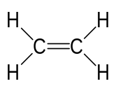
Draw similar structural formulas of all the possible isomers of the alkene with four carbon atoms.

1 + 7 = 8 marks
(suggested time: 10s minutes)

Question 6
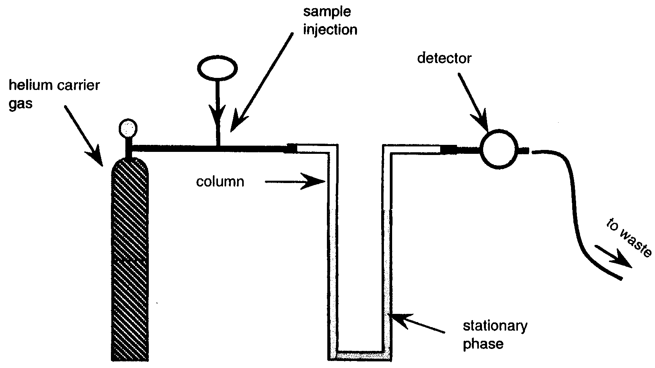
- Shown above is a labelled diagram of a simple gas chromatograph designed to be used for the measurement of some of the volatile organic components of an industrial solvent.
- What is the purpose of the helium gas?
___________________________________________________________________________
___________________________________________________________________________
___________________________________________________________________________
- What is the purpose of the stationary phase?
___________________________________________________________________________
___________________________________________________________________________
___________________________________________________________________________

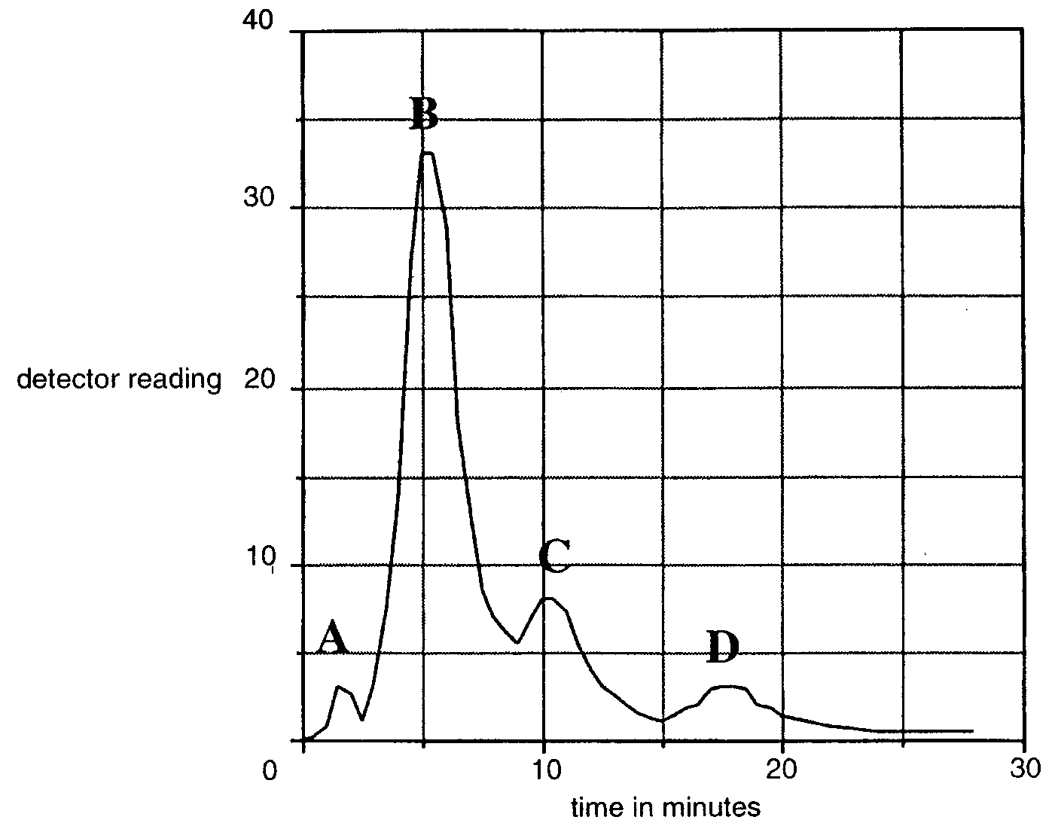
- Part of a gas chromatogram of a sample of the solvent is shown above. Four peaks, labelled A, B, C, and D are shown. The names and formulas of the four molecules corresponding to these peaks are given below in alphabetical order. The strength of the interaction between an organic alcohol and the stationary phase used in this separation increases with increasing molar mass of the alcohol. Hence, place the letters A, B, C, and D in the appropriate spaces beside these formulas so as to correctly identify the peaks.
Butanol (C₄H₉OH) ______________
Ethanol (C₂H₅OH) ______________
Methanol (CH₃OH) ______________
Propanol (C₃H₇OH) ______________
Briefly explain the reason for your answer.
___________________________________________________________________________
___________________________________________________________________________
___________________________________________________________________________
- Suggest a change you might make to the experimental arrangement in order to obtain a chromatogram in which the peaks were separated to a greater extent.
___________________________________________________________________________
___________________________________________________________________________
___________________________________________________________________________
3 + 3 + 1 = 7 marks
(suggested time: 9 minutes)

end of question and answer booklet

