STAV Publishing
1997

Chemistry

Trial CAT 3: Written Examination

ANSWERS

Question 1
a. A (**)
b. A (**)
c. (i) for example; aqueous potassium nitrate, KNO₃ (aq) (**)
other suitable examples possible but no marks available for chloride solutions because the chloride and silver ions from half cell A will react to form a precipitate of silver chloride.
(ii) to complete the electric circuit by allowing the migration of ions between the two half-cells which maintains electrical neutrality (**)
(iii) zero V (**)

Question 2
a. 4Al (s) + 3O₂ (g) + 6H₂O (l) + 4OH⁻ (aq) → 4Al(OH)₄⁻ (aq) (**)
b. an inexpensive inert material would be most suitable for the cathode, eg graphite (**)
c.
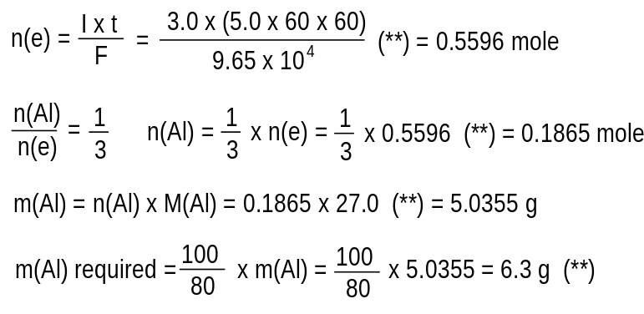
Question 3
a. (i) Nitrogen fixation is the conversion of atmosphere nitrogen, N₂, into nitrogen containing compounds and ions, eg nitrogen oxides, No_{χ}, and ammonium ions, NH₄⁺ (**)
examples include
- the reduction of atmosphere nitrogen, N₂, to ammonium ions, NH₄⁺, by bacteria such as Rhizobium found associated with the roots of leguminous plants such as peas and clover
- the oxidation of atmospheric nitrogen, N₂, to nitrogen oxides, No_{χ}, by the spark in internal combustion engines
- manufacture of ammonia via the Haber process
(**) for a suitable example
(ii) Denitrification is the conversion of nitrogen comounds or nitrogen containing ions present in the soil into atmospheric nitogen, N₂. (**)
examples include
- oxidising bacteria that convert ammonium ions, NH₄⁺, into N₂
- reducing bacteria that convert nitrate ions, NO₃⁻, and nitrite ions, NO₂⁻, into N₂
(**) for a suitable example
b. oxidising bacteria, as the oxidation number of nitrogen increases from -3 to +5 (**)
c. examples include
- using animal manure on the soil
- using synthetically produced nitrogen rich fertilisers on the soil
- planting leguminous plants such as peas or clover in paddocks
(**) for a suitable example
d. (i) carbon, hydrogen, oxygen and occasionally sulfur; (*) for each one
(ii) The two most common examples of α-amino acids are:
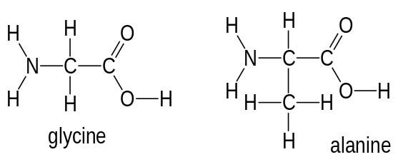
(**) for either or for any other example of an α-amino acid
(iii) both functional groups; -NH₂ and -COOH, are attached to the same carbon atom (**)
(iv) condensation (**) polymerisation
(v) water, urea, carbon dioxide, ammonia (minor amounts only); any two for (*) each

Question 4
a. glucose is a more readily available source of energy because it is a monosaccharide and so requires no further hydrolysis before it is able to be used by the cells (**)
b. glucose is very soluble in water because it has a large number of polar OH groups in its molecular structure. These are able to form H-bonds with water molecules (**)
c.
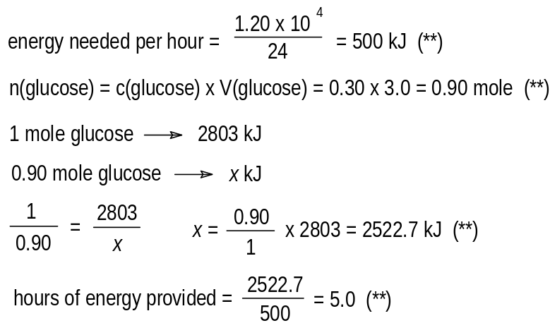
Question 5
a. for example, lecithin (**)
b. they stabilise oil and water emulsions (**) to improve the appearance, texture and taste of foods
c. emulsifying agents must have hydrophobic and hydrophilic sections to their structure (**)

Question 6
a. (i) 1s²2s²2p⁶3s²3p⁶4s¹ (**)
(ii) 1s²2s²2p⁶3s²3p⁶3d⁷4s² (**)
b. the bonding within the metallic lattice of cobalt (a transition element) is stronger than the bonding within the metallic lattice of potassium (a group I element) (**)
c. (i) ligands are polar molecules (eg H₂O and NH₃) able to form ion-dipole bonds with the central ion; or anions, (eg Cl⁻ and OH⁻) able to form ion-ion bonds with the central ion (**)
(ii) +3 (**)
(iii)
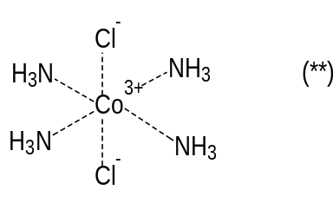
(iv) ion-dipole bonding (**)

Question 7
a. (i) G only (**)
(ii) E only (**)
(iii) C only (**)
I is not an example of fission as it does not involve a small particle, eg a neutron, bombarding a large nucleus, producing two nuclei of approximately the same size
b. G and C (**)
c. smaller (**)
because this is a nuclear fission reaction which forms more stable nuclei, releasing energy which has been converted form mass in the process (**)
d. The relative atomic mass is calculated based on the weighted mean of all naturally occurring isotopes of an element. There must be other naturally occurring isotopes of carbon besides carbon-12 (**)

Question 8
a. example flowchart
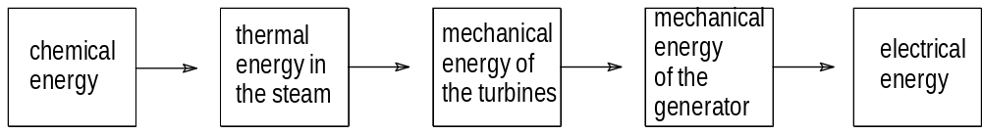
(*) for each to a maximum of 2 marks
b.
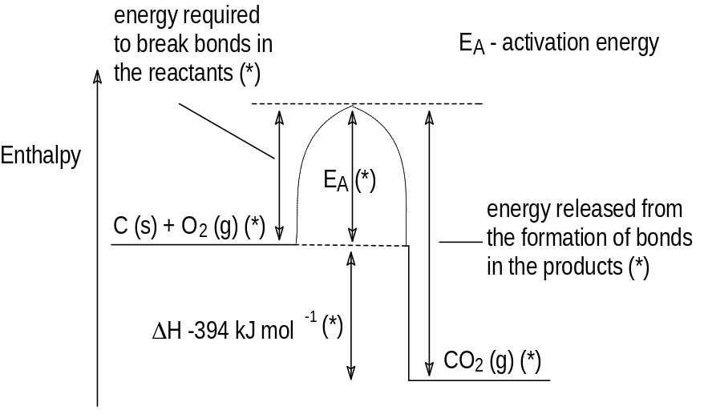
c.
- cheap and readily available;
- technology to obtain electrical energy from coal is well developed;
- hundreds of years of deposits currently known.
(**) each for two reasonable suggestions to a maximum of 2 marks
d.
- environmental impact of both the mines and the coal-fired power stations;
- pollutants produced by burning coal, specifically carbon dioxide contributing to the greenhouse effect and sulfur dioxide producing acid rain;
- large quantities of ash produced as a by-product.
(**) each for two reasonable suggestions to a maximum of 2 marks

Question 9
a.
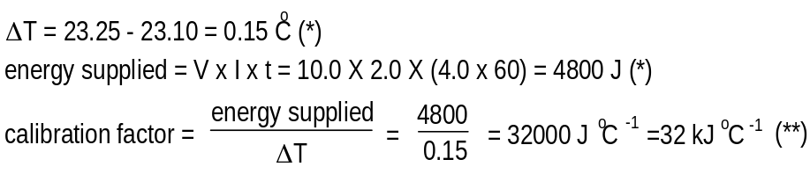
b. (i) for example, 2H₂ (g) + O₂ (g) → 2H₂O (g) (**)
(ii)
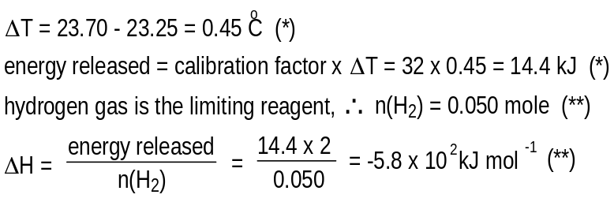
c. (i) fuel cell (**)
(ii) fuel cells largely eliminate the conversion to thermal energy, which is highly inefficient (**)

Question 10
a. B (**)
b. the first ionisation energy represents the energy required to remove the outermost ground state electron (electron with the highest energy) from an atom in the gaseous state (**) and hence form a 1+ ion
c. the number of electron shells increases as group I is descended hence the size of the atoms increase (**)
as a result the outer shell electrons are on average more distant from the nucleus and so held less strongly (**)

