STAV Publishing
1997

Chemistry

Trial CAT 3: Written Examination

Total Writing Time: 1 hour 30 minutes

QUESTION AND ANSWER BOOK

Directions to students
Materials
Question and answer book of 14 pages, including the data on pages 2 and 3.
An approved calculator may be used.

The Task
Please ensure that you write your name in the space provided on this page.
The trial CAT consists of 10 questions. Answer all questions. Questions should be answered in the spaces provided in this booklet.
The suggested time allocations and the marks allotted to each question are indicated at the end of the question. There is a total of 67 marks available.
All responses should be written in English.

At the end of the task
Hand in this question and answer book.

Instructions for students

There are 10 questions. Answer all questions.
To obtain full credit for your responses, you should
- give simplified answers with an appropriate number of significant figures to all numerical questions; unsimplified answers will not be given full credit
- show all working in your answers to numerical questions. No credit can be given for an incorrect answer unless it is accompanied by details of the working
- make sure chemical equations are balanced and that the formulas for individual substances include indications of state, for example, H₂ (g); NaCl (s).

Question 1
The following diagram represents an electrochemical cell.

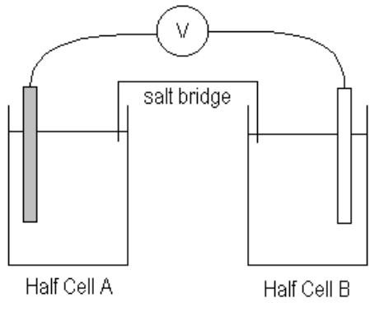
The standard half cell A contains the conjugate redox pair Ag⁺ (aq) / Ag (s).
The standard half cell B contains the conjugate redox pair Sn²⁺ (aq) / Sn (s).

a. The voltmeter reads correctly when its red terminal is connected to the positive electrode and its black terminal to the negative electrode.
To which half cell, A or B, should the red terminal be connected?
Indicate your selection by writing the letter A or B in the box.

b. In which direction, towards half cell, A or B, do the electrons flow?
Indicate your selection by writing the letter A or B in the box.

c. (i) A salt bridge is commonly made by soaking a filter paper in a solution.
Name a suitable solution.
___________________________________________________________________________
(ii) Briefly explain the function of the salt bridge.
___________________________________________________________________________
___________________________________________________________________________
___________________________________________________________________________
(iii) What would you expect the voltmeter to read if the salt bridge were removed?
___________________________________________________________________________
1 + 1 + 3 = 5 marks
suggested time: 7 minutes

Question 2
The aluminium-air cell is one cell under development that shows promise as a means of supplying the energy requirements of electric vehicles.

The reactions occurring at the electrodes in an aluminium-air cell are
Al (s) + 4OH⁻ (aq) → Al(OH)₄⁻ (aq) + 3e
O₂ (g) + 2H₂O (l) + 4e → 4OH⁻ (aq)
The cell can be renewed quickly by simply replacing the aluminium electrodes.

a. Write a balanced ionic equation for the overall reaction occurring in an aluminium-air cell during discharge.
___________________________________________________________________________

b. Name a material that could be used as the cathode.
___________________________________________________________________________

c. An aluminium-air cell is constructed which produces 3.0 A for a 5.0 hour period. The aluminium electrode needs to be replaced when 80% of the aluminium has been consumed. Calculate the mass of the aluminium electrode required for this cell.

1 + 1 + 4 = 6 marks
suggested time: 8 minutes

Question 3
An understanding of the nitrogen cycle is extremely important in food production. Nitrogen fixation and denitrification are two important aspects of this cycle.

a. Explain the meaning of each of the underlined terms and give one example to illustrate each process.
(i) Nitrogen fixation
___________________________________________________________________________
___________________________________________________________________________
___________________________________________________________________________
(ii) Denitrification
___________________________________________________________________________
___________________________________________________________________________
___________________________________________________________________________

b. Some bacteria present in the soil are able to convert ammonium ions, NH₄⁺, to nitrate ions, NO₃⁻⁻. Are these oxidising or reducing bacteria? Explain your answer.
___________________________________________________________________________
___________________________________________________________________________
___________________________________________________________________________

c. Give one example of how a farmer can intervene in the cycle in order to increase the nitrogen content of the soil.
___________________________________________________________________________
___________________________________________________________________________

d. Nitrogen is a key element in the formation of amino acids, and hence proteins.
(i) What other elements can be found in proteins? ___________________________________________________________________________
___________________________________________________________________________
(ii) Draw the structural formula of any simple α-amino acid.

(iii) Explain the significance of the symbol α in the term “α-amino acid”. ___________________________________________________________________________
___________________________________________________________________________
(iv) Name the type of reaction that α-amino acids undergo to form proteins.
___________________________________________________________________________
(v) Name two waste products formed during the breakdown of protein by the body.
___________________________________________________________________________
4 + 1 + 1 + 6 = 12 marks
suggested time: 16 minutes

Question 4
Glucose, C₆H₁₂O₆, is used by the cells of the body in the process of respiration to produce energy, as shown by the equation

C₆H₁₂O₆ (aq) + 6O₂ (g) → 6CO₂ (g) + 6H₂O (l) ΔH = -2803 kJ mol⁻¹

A patient in hospital who is unable to eat normally is often given an aueous through a vein.

a. Why is an aqueous glucose solution given rather than a solution of another sugar such as sucrose?
___________________________________________________________________________
___________________________________________________________________________
___________________________________________________________________________

b. Explain why glucose has a high solubility in water.
___________________________________________________________________________
___________________________________________________________________________
___________________________________________________________________________

c. An adult has an energy requirement of 1.20 x 10⁴ kJ per day (24 hours). If the adult is given 3.0 L of 0.30 mol L⁻¹ aqueous glucose solution, for how many hours will the energy be provided? (Assume that all the chemical energy is available for metabolic purposes.)

1 + 1 + 4 = 6 marks
suggested time: 8 minutes

Question 5
Many foods, such as icecream, contain emulsifying agents.

a. Give one example of an emulsifying agent used in food.
___________________________________________________________________________

b. What general function do emulsifying agents perform in food?
___________________________________________________________________________
___________________________________________________________________________
___________________________________________________________________________

c. What chemical features enable a substance to act as an emulsifying agent in food?
___________________________________________________________________________
___________________________________________________________________________
___________________________________________________________________________
___________________________________________________________________________
___________________________________________________________________________
1 + 1 + 1 = 3 marks
suggested time: 4 minutes

Question 6
Potassium and cobalt are elements in period 4 of the periodic table.

a. Write out the ground state electronic configurations for
(i) potassium ________________________________________________________________
(ii) cobalt ___________________________________________________________________

b. Explain why the melting temperature of cobalt (1495°C) ijs much greater than that of potassium (64°C).
___________________________________________________________________________
___________________________________________________________________________
___________________________________________________________________________

c. Transition elements form many coordination compounds; for example, cobalt forms dichlorotetraamminecobalt(III) chloride, CoCl₂(NH₃)₄Cl. This compound contains the complex ion, [CoCl₂(NH₃)₄]⁺.
(i) Use this example to explain what is meant by the term ligand.
___________________________________________________________________________
___________________________________________________________________________
___________________________________________________________________________
(ii) What is the oxidation state of cobalt in the complex ion, [CoCl₂(NH₃)₄]⁺?
___________________________________________________________________________
(iii) Draw a diagram representing the structure of the complex ion, [CoCl₂(NH₃)₄]⁺.

(iv) What type of bonding exists between the cobalt ion and the ammonia molecules?
___________________________________________________________________________
2 + 1 + 4 = 7 marks
suggested time: 9 minutes

Question 7
In stars, nuclear reactions are occurring which are producing new elements and releasing enormous amounts of energy in the process.

Consider these nuclear equations when answering the following questions.

A | 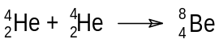
B | 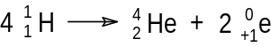
C | 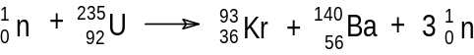
D | 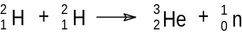
E | 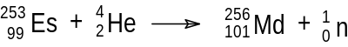
F | 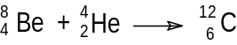
G | 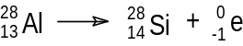
H | 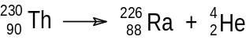

a. Which of these equations represents reactions where
(i) electrons are produced? _____________________________________________________
(ii) energy is absorbed? ________________________________________________________
(iii) fission takes place? ________________________________________________________

b. Of the equations listed, the equations representing the formation of the two most stable nuclei are most likely to be ______________ and _____________.

c. The predominant reaction occurring in the Earth’s Sun is described by equation B.
Would you expect the mass of the Sun to be getting larger, smaller or remain unchanged? Explain your answer with reference to equation B.
___________________________________________________________________________
___________________________________________________________________________
___________________________________________________________________________

d. In equation F the isotope of carbon, carbon-12 is produced. The relative atomic mass scale is based on this isotope, where one atom of carbon-12 is defined as having a mass of 12 units exactly. However, the relative atomic mass of carbon given in a data book is 12.0111. Give a reason for this.
___________________________________________________________________________
___________________________________________________________________________
___________________________________________________________________________
3 + 1 + 2 + 1 = 7 marks
suggested time: 9 minutes

Question 8
In Victoria, the majority of electricity is produced by burning brown coal in the power stations of the Latrobe Valley. The diagram is a simplified flowchart representing the processes that occur in a coal fired power station, such as those in the Latrobe Valley.

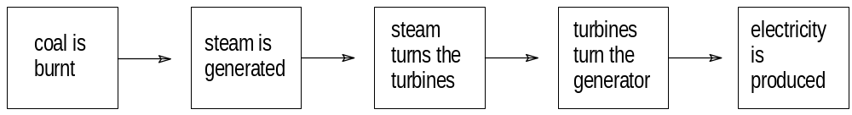

a. Complete a flowchart to show the energy conversions that are involved in a coal-fired power station such as that represented by the diagram above.

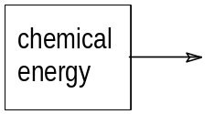

b. Assuming brown coal to be 100% (by mass) carbon, its combustion equation can be represented by
C (s) + O₂ (g) → CO₂ (g) ΔH = -394 kJ mol⁻¹

Sketch an energy profile for the combustion of carbon. Include on your sketch
- activation energy (energy of activation);
- energy released in forming bonds in the product;
- energy required to break bonds in the reactants;
- the enthalpy change for the reaction.

c. Suggest two advantages in using coal to generate electricity in Victoria.
___________________________________________________________________________
___________________________________________________________________________
___________________________________________________________________________
___________________________________________________________________________

d. Suggest two disadvantages in using coal to generate electricity in Victoria.
___________________________________________________________________________
___________________________________________________________________________
___________________________________________________________________________
___________________________________________________________________________
2 + 3 + 2 + 2 = 9 marks
suggested time: 12 minutes

Question 9
a. A bomb calorimeter was calibrated by passing a current of 2.0 amps under a potential difference of 10.0 volts through an electric heating device for 4.0 minutes. The temperature of the calorimeter rose from 23.10°C to 23.25°C.
Calculate the calibration factor for the bomb calorimeter.

b. A mixture of 0.050 mole of hydrogen gas and 0.050 mole of oxygen gas was placed in the calorimeter and ignited. As a result of the explosion the temperature of the calorimeter rose from 23.25°C to 23.70°C.

(i) Write a balanced chemical equation representing the reaction between hydrogen and oxygen.
___________________________________________________________________________
(ii) Calculate ΔH for the reaction represented by the equation given in part (i).

c. The combustion of hydrogen gas can be used to produce thermal energy which is then used to generate electricity. However the process is inefficient and typically only 25% to 45% of the chemical energy is converted to electrical energy.

(i) Name the device that can be used to make electricity using the oxidation of hydrogen with up to 80% efficiency.
___________________________________________________________________________
(ii) Briefly explain how this device improves the efficiency of this oxidation process.
___________________________________________________________________________
___________________________________________________________________________
___________________________________________________________________________
___________________________________________________________________________
2 + 4 + 2 = 8 marks
suggested time: 11 minutes

Question 10
a. Which one of the following equation represents the first ionisation of chlorine?
Indicate your selection by writing the letter A, B, C, D or E in the box.

A. Cl₂ (g) → 2Cl⁻ (g) + 2e | D. ½Cl₂ (g) → Cl⁺ (g) + e
B. Cl (g) → Cl⁺ (g) + e | E. Cl (g) + e → Cl⁺ (g)
C. ½Cl₂ (g) + e → Cl⁺ (g)

b. Explain the meaning of the first ionisation energy.
___________________________________________________________________________
___________________________________________________________________________
___________________________________________________________________________
___________________________________________________________________________

c. A VCE Chemistry student collected the following data on the first ionisation energies of group I elements.

 | Li | Na | K | Rb | Cs
First ionisation energy / kJ mol⁻¹ | 519 | 494 | 418 | 400 | 380

Explain the trend in first ionisation energy shown in this data.
___________________________________________________________________________
___________________________________________________________________________
___________________________________________________________________________
___________________________________________________________________________
1 + 1 + 2 = 4 marks
suggested time: 6 minutes

end of question and answer book

