YEAR 12 CHEMISTRY – CHAPTERS 1-6 REVISION

Section A

Answer the following true or false.

- Detection of alcohol presence in the blood is an example of quantitative analysis.

- Lysine has a small R_{f} value in a particular solvent and hence is strongly adsorbed to the stationary phase.

- The amount of mole of Fe ions in 159.6 g of Fe₂O₃ is one mole.

- The number of significant figures in 0.000100 is three.

- NaOH is a strong base because it readily accepts a proton.

- The concentration of SO₄²⁻ ions in a 2.5 M Aluminium Sulphate solution is 2.5 M.

- The titre is the volume delivered by the burette.

- The equivalence point in a titration is always when the indicator changes colour.

- The conical flask used in each titration should be rinsed with de-ionised water.

- NaOH is an excellent primary standard because it is a strong base.

Section B

- In a typical gravimetric analysis, explain why two filtrations are generally performed.

- A 5.00 g sample of washing powder is analysed for sodium carbonate by gravimetric analysis. Calcium hydroxide is added to the dissolved sample to form a precipitate of calcium carbonate.

  - Write formula and ionic equations to illustrate this.

  - If the calcium carbonate precipitate weighs 1.890 g, calculate the percentage of sodium carbonate in the washing powder.

- a) Write a balanced equation for the reaction between ammonia (NH₃) and hydrochloric acid. (HCl).

b) A 25.0 sample of “Cloudy Ammonia” was diluted to 250.0 ml in a
volumetric flask.
A 20.0 ml aliquot of the diluted solution was titrated with 0.0300M
HCl. To reach the end point, 29.25 ml of acid was required.
Calculate the concentration of (NH₃) in the original cloudy
ammonia in mol per L.
Also, express your answer in %w/v.

- Write balanced half equations and an overall equation for the reaction between
dichromate ions and magnesium metal if the products are Cr³⁺ and Mg²⁺

- Of all the techniques covered so far, which one would you use to analysis:
  - mercury in a can of tuna
  - salt in Twisties
  - carbon monoxide in natural gas.
  - barium metal in an ore sample.
  - the hormone oestrogen in urine.
  - hydrocarbons in soil.
  - aspirin in tablets.

- A sample of river water was analysed using Atomic Absorption Spectroscopy. Prior
to testing the sample, a calibration curve was constructed using 5 different standard solutions, each one containing a particular concentration of lead ions. The curve is
shown below:

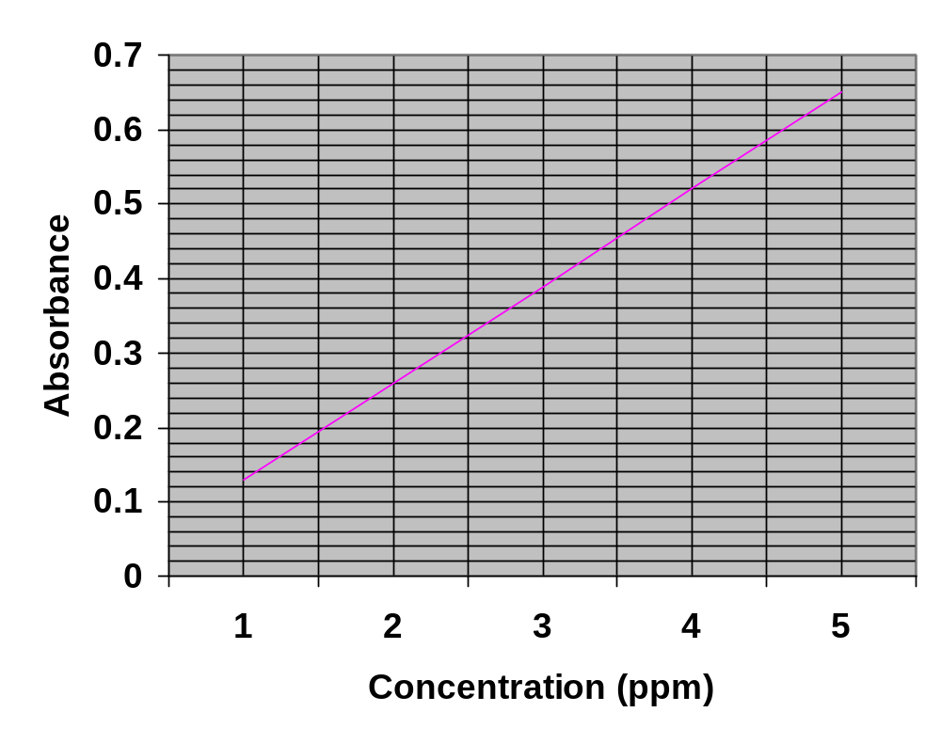

- Explain the meanings of the terms in bold above.

- If the absorbance reading of the sample was 0.445, determine the concentration
of the lead in sample in ppm.

- Convert your answer in (b) above into mol per L.

- If you were to consume a 250 ml glass of water, what mass of lead would you swallow? (Assume that 1 ml = 1 g.)

- In the AAS apparatus, what type of light source would be chosen and why?

Solutions.

Section A.

1. False 2. True 3. False 4. True 5. True.

6. False 7. True 8. False 9. True 10. False.

Section B.

- The first filtration is required to remove any insoluble solids that are in the sample. The second filtration is to collect the desired precipitate for weighing and analysis.

2. a) Na₂CO₃ (aq) + Ca(OH)₂ (aq) → CaCO₃ (s) + 2 NaOH (aq) formula

Ca²⁺ (aq) + CO₃²⁻ (aq)→ CaCO₃ (s) ionic.

- 40.0 %

3..a) NH₃ (aq) + HCl (aq) → NH₄⁺ (aq) + Cl⁻ (aq)

b) 0.439 mol per L. 0.747 % w/v

4. Cr₂O₇²⁻ (aq) + 14H⁺ (aq) + 6e⁻ → 2Cr³⁺ (aq) + 7H₂O (l) reduction

Mg (s) → Mg²⁺ (aq) + 2e⁻ oxidation.

Cr₂O₇²⁻ (aq) + 14H⁺ (aq) + 3Mg (s) → 2Cr³⁺ (aq) + 7H₂O (l) + 3Mg²⁺ (aq) overall.

5. a) AAS b) gravimetric analysis c) GLC
d) AAS e) HPLC f) GLC g) volumetric analysis.

6..a)Calibration curve – a graph constructed by measuring some aspect (eg – absorbance) of
a number of standard solutions.

Standard solution - a solution of accurately known concentration.

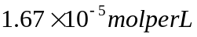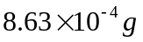 b) 3.45 ppm. c) d)

e) The light source has an energy/wavelength particular to lead.

