

Student Name……………………………………

MATHEMATICAL METHODS (CAS) UNITS 3 & 4

TRIAL EXAMINATION 2

2011

Reading Time: 15 minutes
Writing time: 2 hours

Instructions to students
This exam consists of Section 1 and Section 2.
Section 1 consists of 22 multiple-choice questions, which should be answered on the detachable answer sheet which can be found on page 24 of this exam.
Section 2 consists of 4 extended-answer questions.
Section 1 begins on page 2 of this exam and is worth 22 marks.
Section 2 begins on page 11 of this exam and is worth 58 marks.
There is a total of 80 marks available.
All questions in Section 1 and Section 2 should be answered.
Diagrams in this exam are not to scale except where otherwise stated.
Where more than one mark is allocated to a question, appropriate working must be shown.
Students may bring one bound reference into the exam.
Students may bring a CAS calculator into this exam.
A formula sheet can be found on page 23 of this exam.

This paper has been prepared independently of the Victorian Curriculum and Assessment Authority to provide additional exam preparation for students. Although references have been reproduced with permission of the Victorian Curriculum and Assessment Authority, the publication is in no way connected with or endorsed by the Victorian Curriculum and Assessment Authority.

© THE HEFFERNAN GROUP 2011
This Trial Exam is licensed on a non transferable basis to the purchasing school. It may be copied by the school which has purchased it. This license does not permit distribution or copying of this Trial Exam by any other party.
SECTION 1

Question 1

The maximal domain of the function 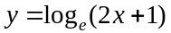 is

- 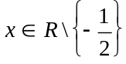
- 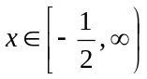
- 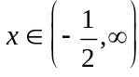
- 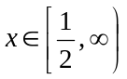

Question 2

The range of the function 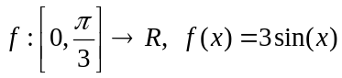 is

- 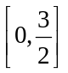
- 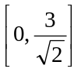
- 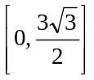
- 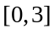
- 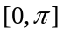

Question 3

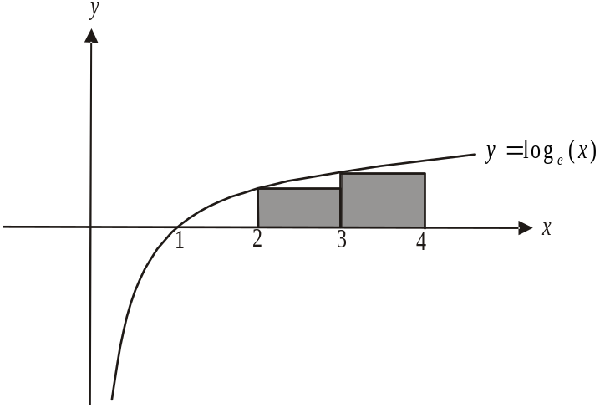

The area under the curve is approximated by the two shaded rectangles shown above. This approximate area in square units is

- 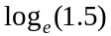
- 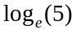
- 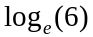
- 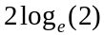
- 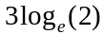

Question 4

The average rate of change of the function is

- – 1
- 0
- 1
- 7

Question 5

The simultaneous linear equations
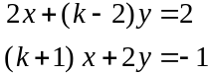

have no solutions for

- 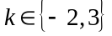
- 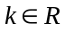
- 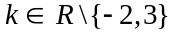
Question 6

The graph of 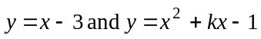 do not intersect for

- 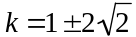
- 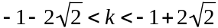
- 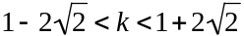
- 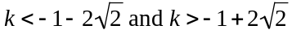
- 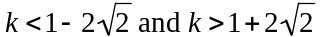

Question 7

Let .

The domain of 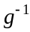, the inverse function of g, is

- 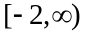
- 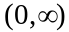
- 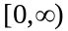
- 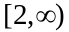
- R

Question 8

The rate of change of the function 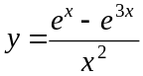 with respect to x, at the point where is

- 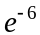
- 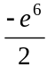
- 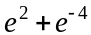
- 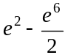
- 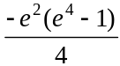

Question 9

Let 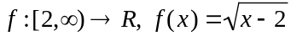. The inverse function 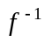 is given by

- 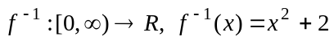
- 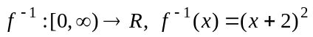
- 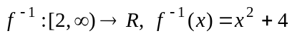
- 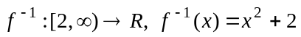
- 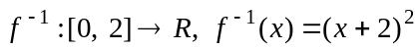
Question 10

The average value of the function 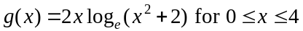 is closest to

- 4.33
- 6.07
- 8.66
- 22.62
- 34.64

Question 11

A fair die is rolled 10 times. The probability that a 4 appears less than 3 times is closest to

- 0.2093
- 0.4845
- 0.6372
- 0.7752
- 0.9303

Question 12

The times (in minutes) taken for an on-line survey to be completed are normally distributed with a mean of 23 minutes and a standard deviation of 2 minutes. The percentage of people completing the survey who did so in less than 20 minutes is closest to

- 6.5%
- 6.7%
- 9.25%
- 65%
- 67%

Question 13

The discrete random variable X has the following probability distribution.

X | 0 | 2 | 5
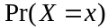 | 0.4 | 0.1 | 0.5

Given that the mean of X is 2.7, the variance of X is

- 1.64
- 2.37
- 5.61
- 7.29
- 14.38
Question 14

The continuous random variable X has a probability density function given by

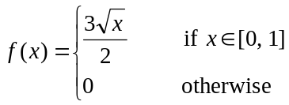

The median of X is closest to

- 0.50
- 0.60
- 0.63
- 0.67
- 1

Question 15

Let 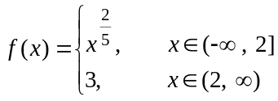

The derivative function 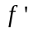 is defined for
- 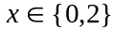
- 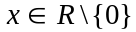
- 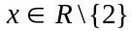
- 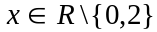

Question 16

The equation of the tangent to the curve with equation 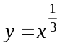at the point 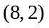 is given by

- 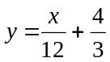
- 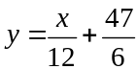
- 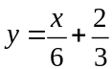
- 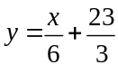
- 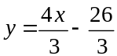
Question 17

The graphs of 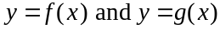 are shown below.
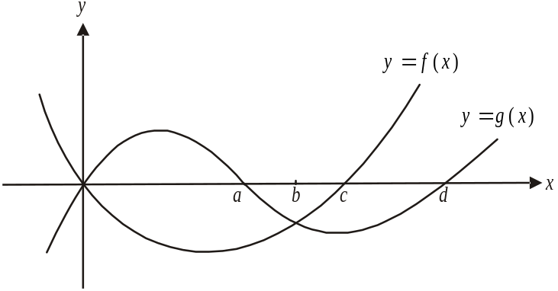

The area enclosed by these two graphs is given by
- 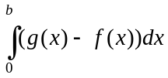
- 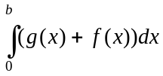
- 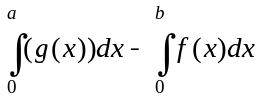
- 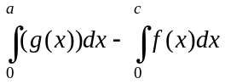
- 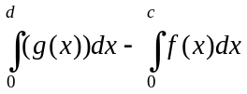

Question 18

A transformation 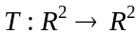, which maps the curve with equation 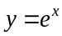 onto the curve with equation 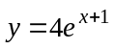 could be given by

- 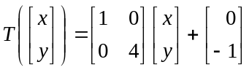
- 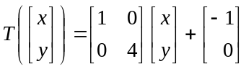
- 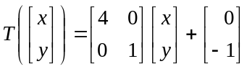
- 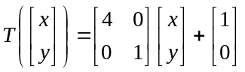
- 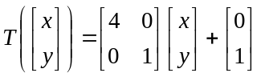
Question 19

The function g is continuous and differentiable for . The function g satisfies the following conditions.
- 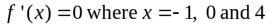

It is true to say that the graph of 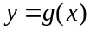 has

- a stationary point of inflection where
- a point of inflection where
- a local maximum where
- a local minimum where
- two local minimum

Question 20

For the mutually exclusive events A and B that occur in a sample space, . Which one of the following statements is not true?

- 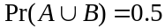
- 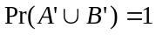
- 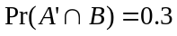
- 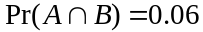
- 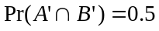

Question 21

The graph of 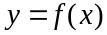 is shown below.

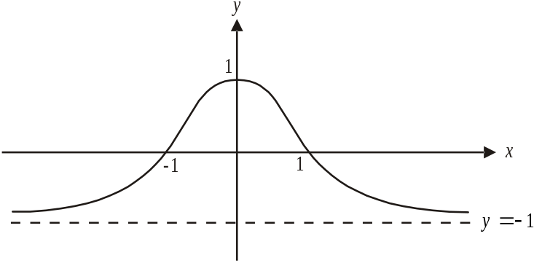

The graph of 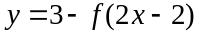 is given by

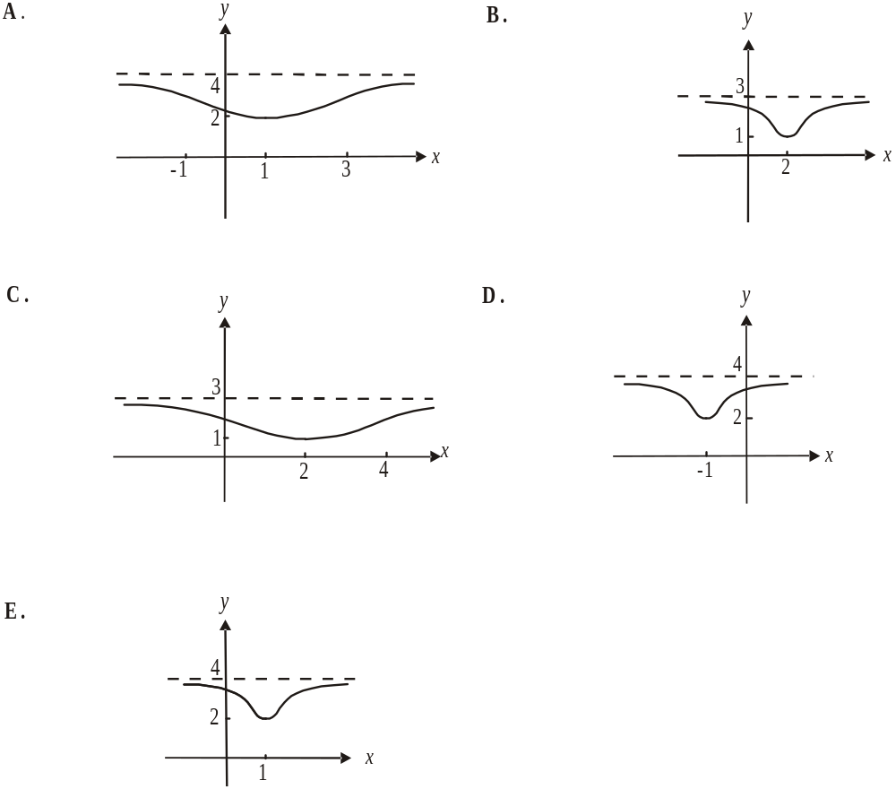

Question 22

The function g is a smooth, continuous function for and 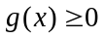 for 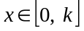.
Given that 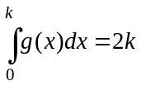, then 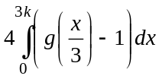 is equal to

- 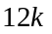
- 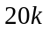
- 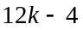
- 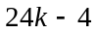
SECTION 2

Answer all questions in this section.

Question 1

- Let 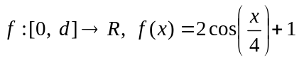 where d is a constant.
The graph of is shown below.
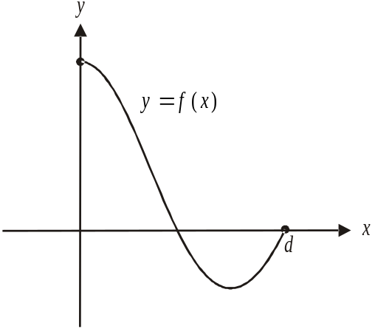

- Find the value of d.

- Sketch the graph of 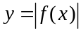 on the set of axes shown above.

- State the maximum value of 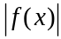.

- Find the value(s) of p for which the equation 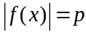 has three solutions.

- Let 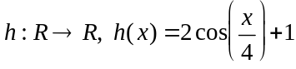
Find the general solution for x of the equation 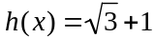

3 marks
c. Let , where n is a real constant and q is the largest
possible value so that the inverse function g⁻¹ exists.

- Find q in terms of n and hence sketch the graph of on the set of axes below. Label the coordinates of the endpoints clearly. It is not necessary to find the x-intercept.
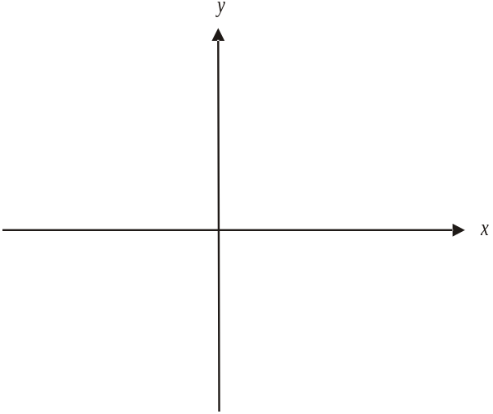

- On the same set of axes sketch the graph of 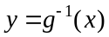. Label the coordinates of the endpoints clearly. It is not necessary to find the y-intercept.

The function g passes through the point 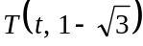

- Show that 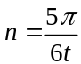.

- Find the equation of the normal to the graph of at the point 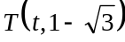 which involves the variables x and y and the parameter t.

Total 18 marks

Question 2

Sam is a tennis player. She has a machine that serves tennis balls to her forehand side or to her backhand side. The machine has settings so that the order in which the forehand serves and backhand serves are delivered can be mixed up. On Tuesday, if Sam received a serve to her forehand then the probability that the next serve would be to her backhand was 0.6. If she received a serve to her backhand then the probability that the next serve would be to her backhand was 0.3.

On Tuesday the first serve that Sam received was to her forehand.

- Find the probability that the next four serves received by Sam on Tuesday were all to her forehand.

1 mark

- Find the probability that the third serve received by Sam on Tuesday was to her forehand.

2 marks

- The first ball after lunch on Tuesday was served to Sam’s forehand. For the first three balls served after lunch, what is the expected number to be served to Sam’s backhand?

4 marks
- In the long term what percentage of serves Sam received were to her backhand? Express your answer to the nearest whole percent.

1 mark

On Wednesday, the machine is set so that the probability of Sam receiving a backhand after the previous serve was a backhand is twice as likely as her receiving a forehand after the previous serve was a forehand.

Let the probability of Sam receiving a forehand after the previous serve was a forehand be p.

The machine’s first serve on Wednesday is to Sam’s forehand and the probability that the third serve is to the forehand is 0.73.

- Find p.

3 marks

The time, in hours, spent by Sam each week doing weights training is a continuous random variable X with probability density function given by

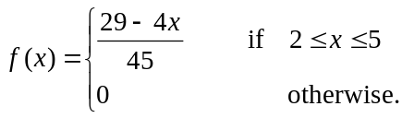

- i. Find the probability that Sam spends less than 4 hours a week doing weights training. Express your answer as an exact value.

- Find 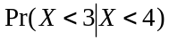. Express your answer as an exact value.

Total 14 marks

Question 3

Victoria James is a spy.
She is trapped in a space where poisonous gas is leaking.
The concentration C, in mg/m³, of the gas t minutes after Victoria became trapped is given by the continuous function
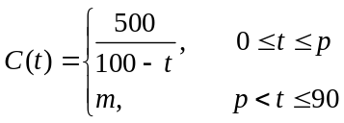
where m and p are constants.

A graph of the function is shown below.
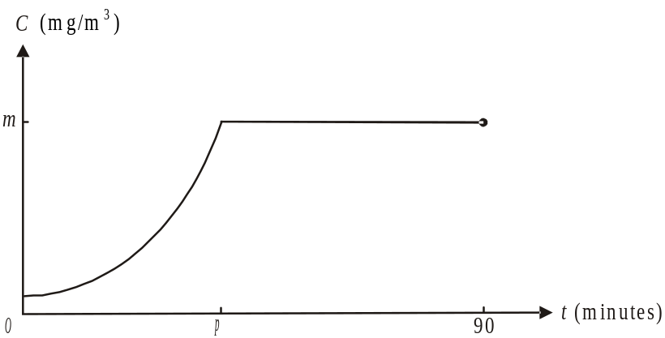

- What is the initial concentration of the gas in mg/m³?

1 mark

- Find an expression for m in terms of p.

1 mark

- Find the minimum and maximum values of m.

2 marks
  - Find the function 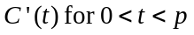.

1 mark

  - If the rate at which the concentration of the gas is increasing was 1 mg/m³ per minute, find the value of t. Express your answer in minutes correct to 2 decimal places.

2 marks

  - If 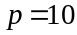, find the average concentration of the gas between 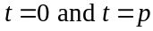, correct to 2 decimal places.

2 marks

If the concentration of the gas reaches 6 mg/m³ then a human cannot survive.

  - Given that Victoria is trapped for 90 minutes in this space, find the possible values of p in order for her to survive.

2 marks
Total 11 marks

Question 4

- Consider the functions

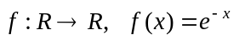

and 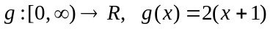

- Write down the rule for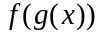.

- Find the domain and range of . Express values as exact values where appropriate.

- Find the area enclosed by the function 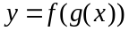, the x and y axes and the line with equation . Express your answer as an exact value.

- Describe the two transformations that the graph of undergoes to become the graph of .

- The graph of the function 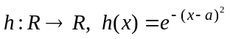 where a is a constant and is shown below.

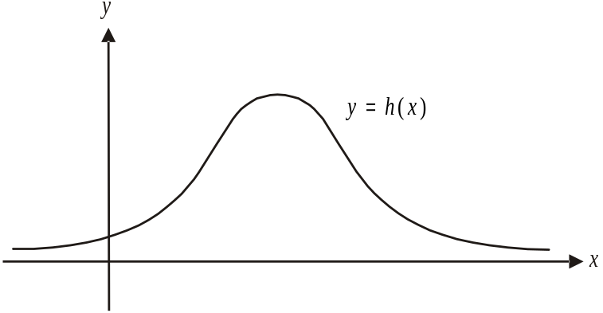

- Show that the stationary point of this graph occurs at 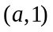.

- Find the values of x for which 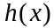 is strictly increasing.

The diagram below shows the graph of 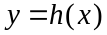 where 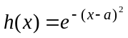and the rectangle MNPQ.

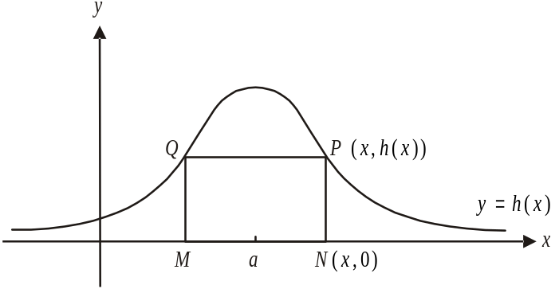

The sidelength MN lies on the x-axis, points P and Q lie on the graph of and the line bisects the rectangle.

The coordinates of points N and P are 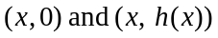 respectively.

- Show that the area A, in square units, of the rectangle is given by

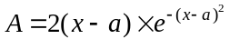.

- Find the maximum area of rectangle MNPQ. Express your answer as an exact value.

Total 15 marks

Mathematical Methods (CAS) Formulas

Mensuration
area of a trapezium: 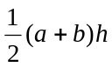 volume of a pyramid: 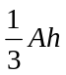
curved surface area of a cylinder: 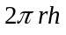 volume of a sphere: 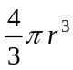
volume of a cylinder: 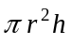 area of a triangle: 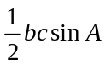
volume of a cone: 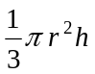

Calculus
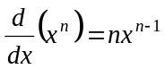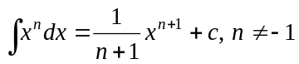
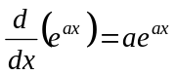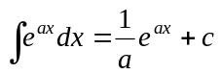
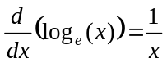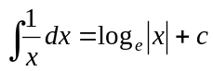
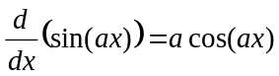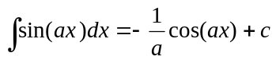
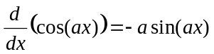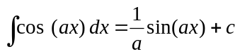
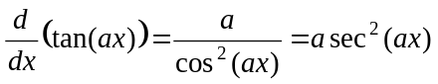
product rule: 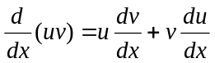 quotient rule: 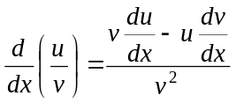
chain rule: 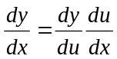 approximation: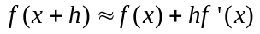

Probability
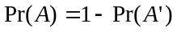
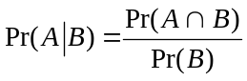 transition matrices: 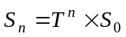
mean: 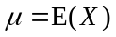 variance:

probability distribution |  | mean | variance
discrete | 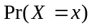=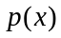 | 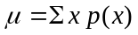 | 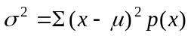
continuous | 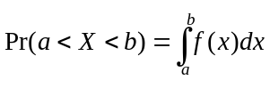 | 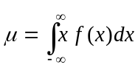 | 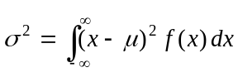
Reproduced with permission of the Victorian Curriculum and Assessment Authority, Victoria, Australia.
This formula sheet has been copied in 2011 from the VCAA website www.vcaa.vic.edu.au
The VCAA publish an exam issue supplement to the VCAA bulletin.

