
MATHS METHODS (CAS) 3 & 4
TRIAL EXAMINATION 2
SOLUTIONS
2013

SECTION 1 – Multiple-choice answers
- E 9. B 17. B
- A 10. B 18. D
- A 11. C 19. D
- C 12. C 20. C
- B 13. A 21. B
- E 14. C 22. E
- D 15. D
- E 16. C

SECTION 1 – Multiple-choice solutions

Question 1

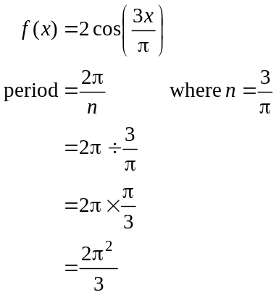
The answer is E.

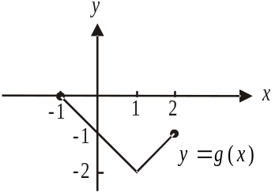

Question 2

Do a quick sketch noting the restricted domain of g.
So 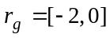
The answer is A.

Question 3
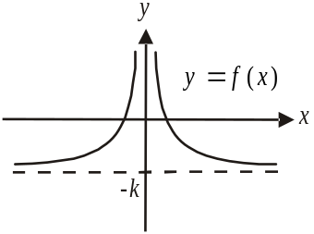

Do a quick sketch.
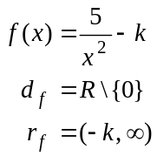
The answer is A.
Question 4

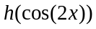 is a composite function – so we use the chain rule to differentiate it.

Chain rule – fast way
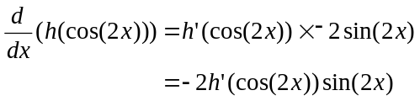

Chain rule – not so fast way

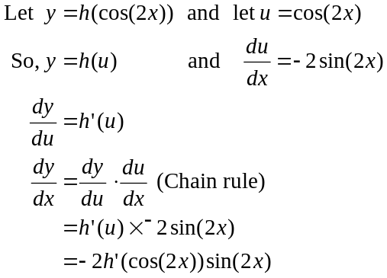
The answer is C.

Question 5

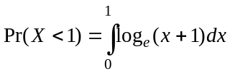
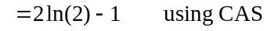
The answer is B.

Question 6

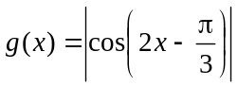
The average rate of change between 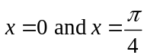 is given by
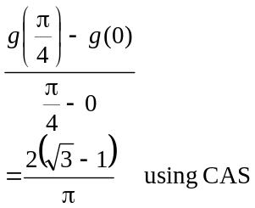
The answer is E.

Question 7

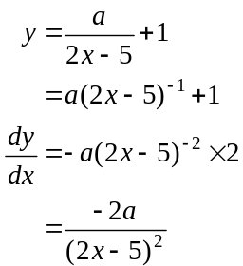

At ,
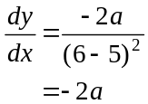
So the gradient of the tangent at 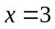 is 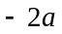 and therefore the gradient of the normal is 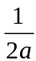.
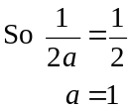
The answer is D.

Question 8

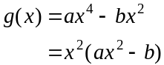
Since a is positive the graph is an upright quartic.
Also, since 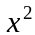 is a repeated factor, then the graph of g touches rather than cuts the x-axis at the origin.
Do a quick sketch.
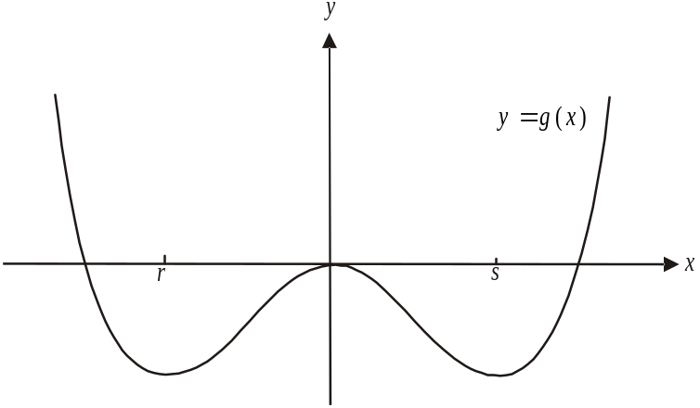

At 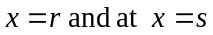 there are stationary points which must be local minima and since , r must be to the left of the y-axis. So, the gradient of g is positive for 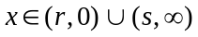.
Note that at the gradient is zero, hence the round brackets rather than square brackets.
The answer is E.

Question 9

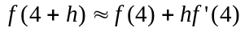
We want an approximation for 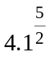 so .
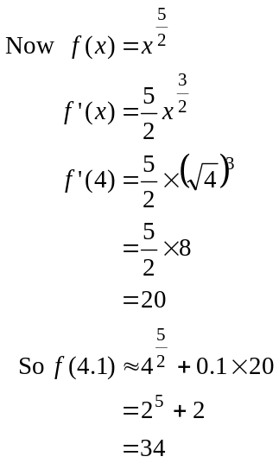
The answer is B.

Question 10

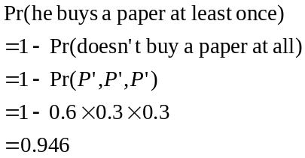
The answer is B.

Question 11

We require 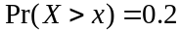
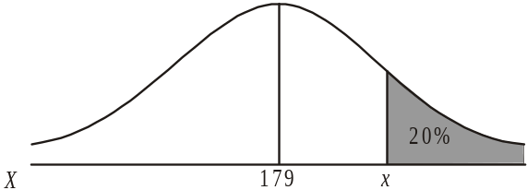
Typically CAS’s find the area less than x.
So we require 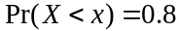, that is, the
area is 0.8 when using the Inverse Normal
function on your CAS.
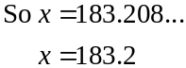
The answer is C.

Question 12

Solve 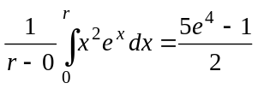 for r using CAS.
The answer is C.

Question 13

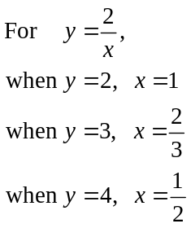
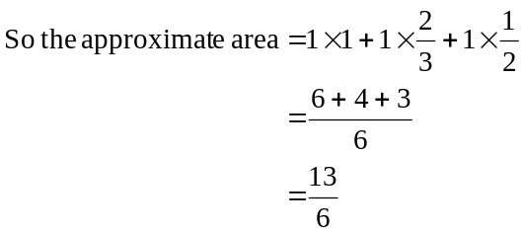
The answer is A.

Question 14

The volume of a sphere is given by 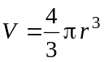 (formula sheet).
The rate at which the volume of the spherical piece of ice is changing with respect to the radius is given by
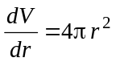

The rate at which the volume of the spherical piece of ice is changing with respect to time is given by
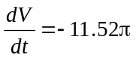 (negative because it’s decreasing)

The rate at which the radius of the spherical piece of ice is changing with respect to time is given by 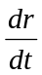
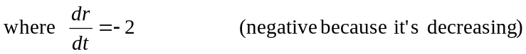

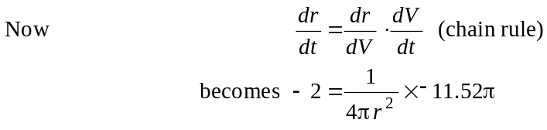
Solve for r using CAS.

The answer is C.

Question 15

The period of the graph is 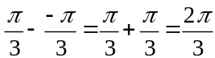.
This eliminates options A and B because their periods are both .
The graph has a range from – 5 to 1 and this eliminates option C.
The graph of 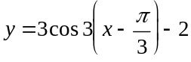 is obtained when the graph of 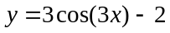 is translated 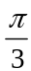 units to the right which would not have the local maximum at the point 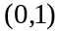 so we can eliminate option E.
Alternatively, after options A and B have been eliminated, options C and E can be eliminated by substituting 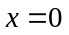 into the respective equations. Neither give a y-value of 1 which is the required y-intercept shown on the graph.
The answer is D.

Question 16

Draw a possible graph.
For example
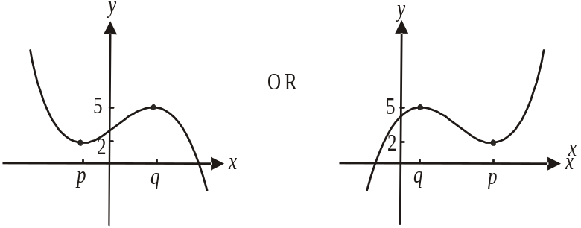

Consider 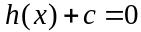
If , then both these graphs will be translated 2 units down and will have a turning point sitting on the x-axis as well as having one other point on the x-axis (where the graph cuts the x-axis). Therefore there will be 2 solutions to the equation.
This is also the case if whereby the other turning point will be sitting on the x-axis. For values of c between – 2 and – 5, the graph will cut the x-axis three times and hence there will be three solutions to the equation.
So we want .
The answer is C.

Question 17

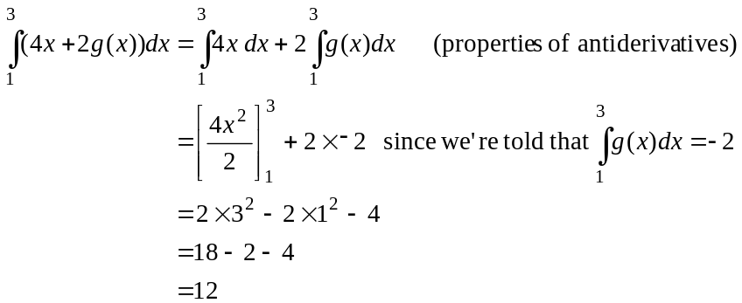
The answer is B.

Question 18

This is a binominal distribution where .
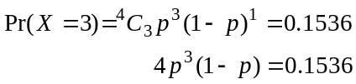

Solve for p using CAS.
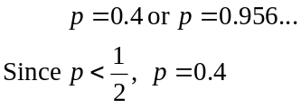
The answer is D.

Question 19

Since 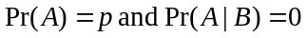 then A and B must be mutually exclusive.

Draw a Venn diagram.
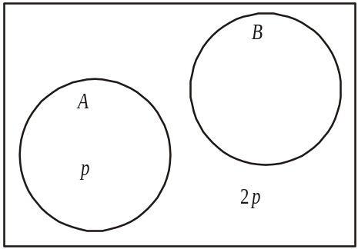

Since
The answer is D.
Question 20

Do a quick sketch.
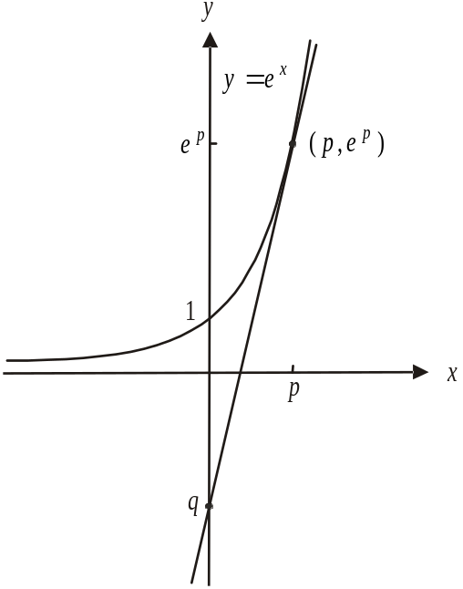
Note that we’re told that the tangent crosses the
y-axis at 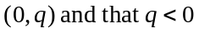, that is, q is a
negative number so the y-intercept is below the
x-axis.

Let’s consider when the tangent
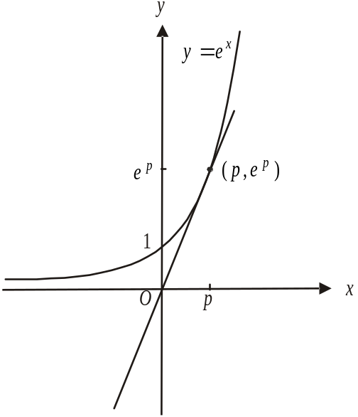
passes through the origin (shown in
the diagram to the right).
From the diagram we see that the
gradient of the tangent 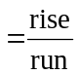
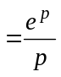
Also, for the graph of 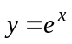,
the gradient of the tangent at any point is
given by 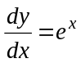 and the gradient
at the point where 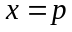 is 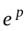.
Therefore 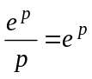
Solving this for p gives 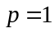.

So the tangent at passes through the origin.
From the graph therefore, if , then the
tangent will be steeper and it will cross the y-axis
below the x-axis; that is, q will be negative.
So we require 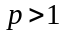.
The answer is C.

Question 21

Do a quick sketch of h.
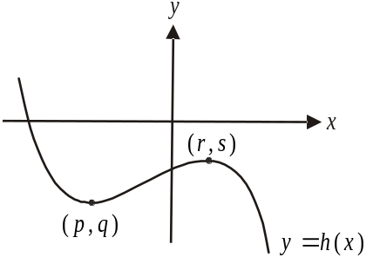

The graph of 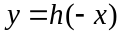 is shown below. It is a reflection of h in the y-axis.
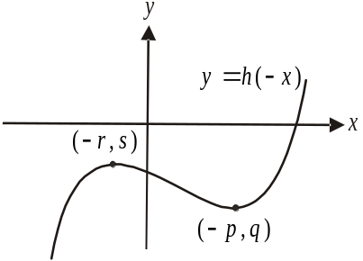

The graph of 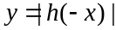 is shown below.
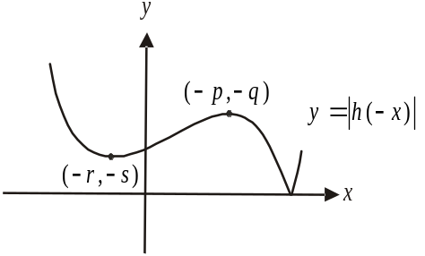

The graph of 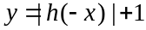 is shown below.
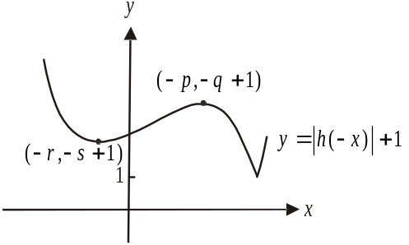

The minimum turning point is 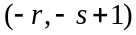.
The maximum turning point is 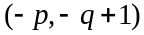.
The answer is B.

Question 22

If 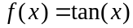
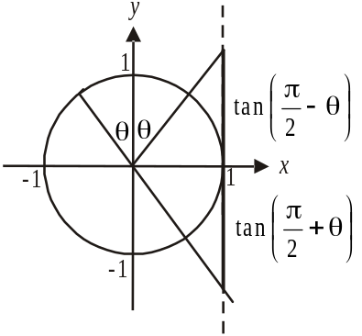

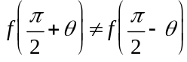

and this is also the case if 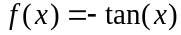

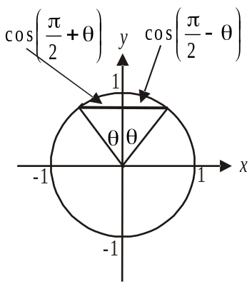

If 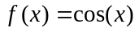,

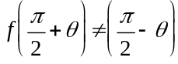

and this is also the case if 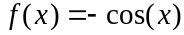

This eliminates options A – D so option E must be correct. To confirm this,
if 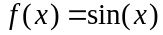,
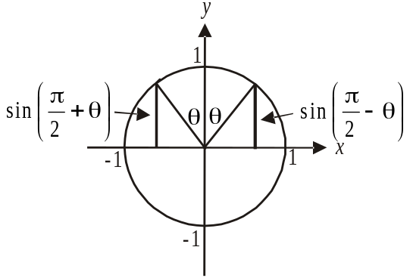

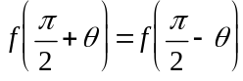

and 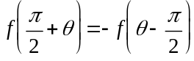
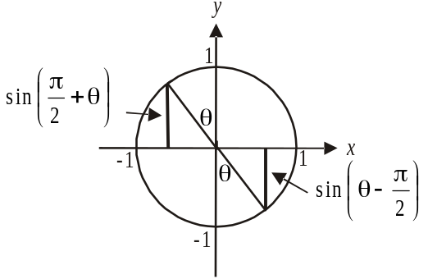

The answer is E.

SECTION 2

Question 1 (9 marks)

- Since 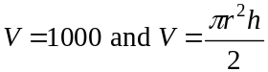
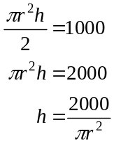
(1 mark)
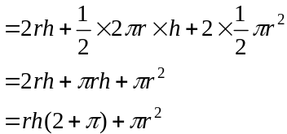
(1 mark)

From part a., 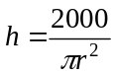
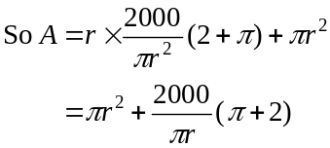
as required
(1 mark)
- 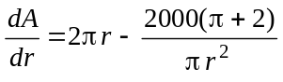 using CAS (1 mark)
Solve 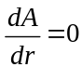 for r (for minimum surface area)
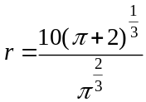
(1 mark)
- Using CAS, evaluate
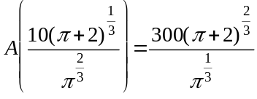
(1 mark)

- Since the surface area is to be 800cm², then
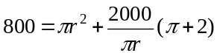 (1 mark)
Solve for r using CAS.
Since 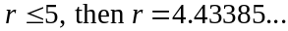 (1 mark)
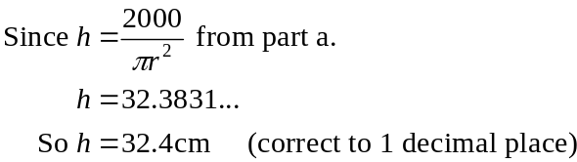
(1 mark)
Question 2 (13 marks)

- Do a quick sketch of f noting that it has a restricted domain.
Also, it has a turning point located at the point 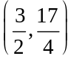.
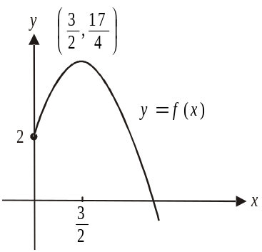

A function is strictly increasing if, for all a and b, where 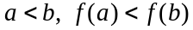.
So f is strictly increasing for 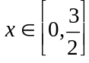
(1 mark) – correct left endpoint
(1 mark) – correct right endpoint

- The matrix 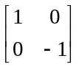 tells us that the graph of f doesn’t undergo any dilations, but does undergo a reflection in the x-axis as shown in the diagram.

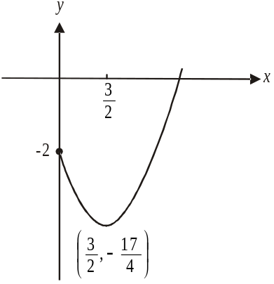

This graph needs to be translated left units and up 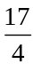 units so that its turning point will be at the origin.
So 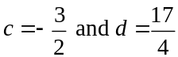.
(1 mark) - for c
(1 mark) - for d
c. Note that the point 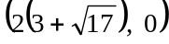 is an x-intercept on the image graph.
The x-intercepts of the graph of 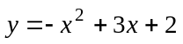occur when
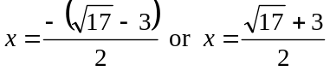
Since 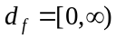, the only x-intercept of f occurs at 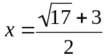.
(1 mark)
If the graph of f is dilated by a factor of 4 from the y-axis then the x-intercept of the image graph would occur at 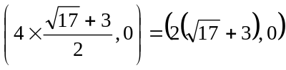
So .
(1 mark)
Note that the dilation cannot be from the x-axis because the x-intercept of f; that is, the point 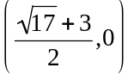 would be the x-intercept of the image of f. That is, points lying on the x-axis do not move when the dilation is from the x-axis.

- i. Method 1 – using CAS
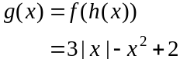
(1 mark)
Method 2 – by hand
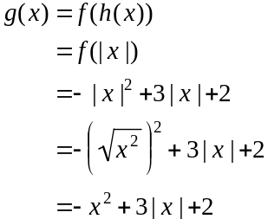
(1 mark)

- 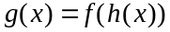
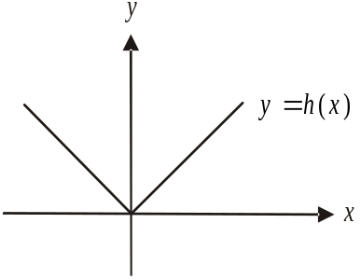
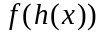 exists iff
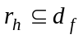
Now 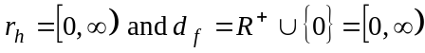.
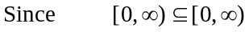
then , and therefore 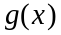, exists.

(1 mark)

- Method 1 – using CAS
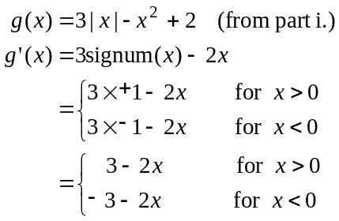
Note that at , the gradient function 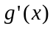 is not defined since at the point where , the graph of g has a sharp point and is therefore not “smoothly” continuous.
(1 mark) – top branch
(1 mark) – bottom branch

Method 2 – by hand
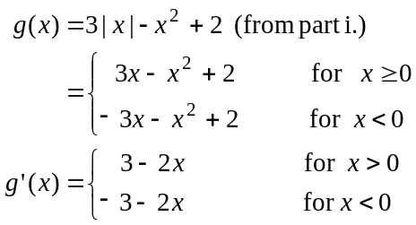
Note that at , whilst the function g is defined, the gradient function is not defined since at the point where , the graph of g has a sharp point and is therefore not “smoothly” continuous.
(1 mark) – top branch
(1 mark) – bottom branch

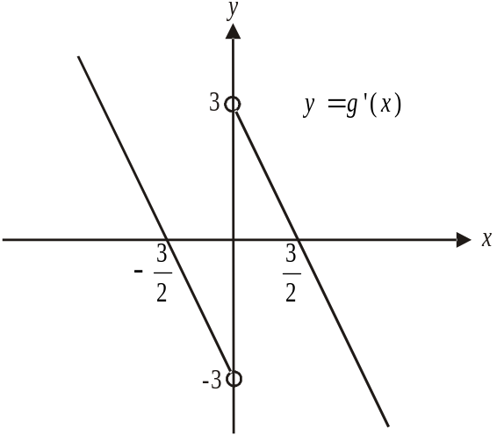

(1 mark) – correct right branch with intercepts
(1 mark) – correct left branch with intercepts
(1 mark) – correct endpoints excluded

Question 3 (14 marks)

- i. 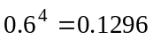
(1 mark)
- Since 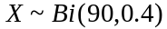
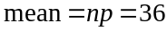
(1 mark)
- 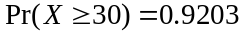 (correct to 4 decimal places) using CAS.
(1 mark)
- Let the random variable Y represent the number of customers who have deli items in their purchase.
(1 mark)
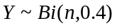
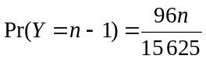
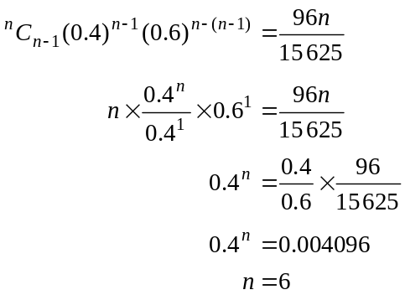
(1 mark)
(1 mark)

- i. (1 mark)
(1 mark)
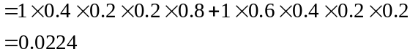
(1 mark)
- Using the transition matrix:
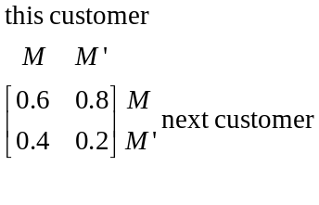
and the initial state matrix:
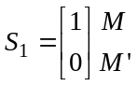
we have
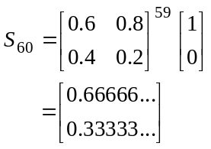
(1 mark)

The probability that Chris’s last customer purchased milk is 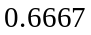 (correct to four decimal places). (1 mark)

- This is a conditional probability question.
(1 mark)

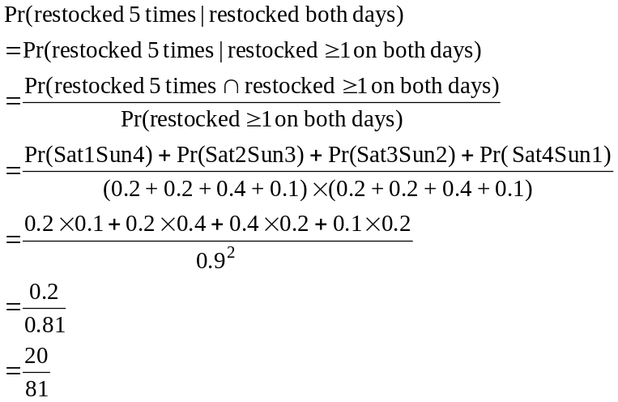
(1 mark)
(1 mark)

Question 4 (12 marks)

- Since the function h is a continuous function, the two branches of the hybrid function must meet at .
Solve 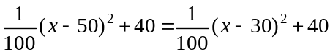 for x.
(1 mark)

So and therefore 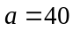.
(1 mark)
- 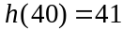. Note that is substituted into the top branch of the rule for h.
Note that substituting into the other branch will however give the same answer since the function h is continuous.
So Victoria is 41 metres above the ground.
(1 mark)

- We’re told that 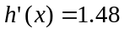 at point C.
Define 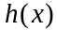 on your CAS if you haven’t already and solve
(1 mark)
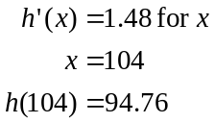
(1 mark)
C is the point 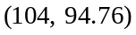
(1 mark)

- i. 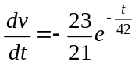
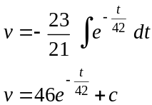
(1 mark)
When 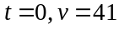
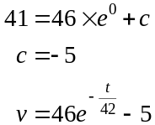
(1 mark)

- when Victoria is on the ground.
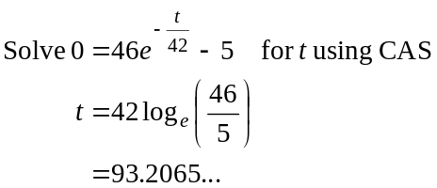
It takes 93.207 seconds for Victoria to reach the ground.
(1 mark)

- i. The spy starts at point B which is 5m vertically below point
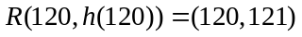.
So point B is 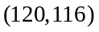.
Point C is 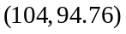 from part c.
So the vertical drop is 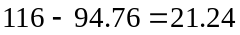 metres. (1 mark)
The enemy spy drops 0.24m/sec vertically.
So it takes to get from B to C.
It takes n seconds to cut the cable.
So .
(1 mark)

- From part d. ii., it takes 93.207 seconds for Victoria to reach the ground.
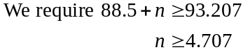
(1 mark)
Question 5 (10 marks)

- Method 1
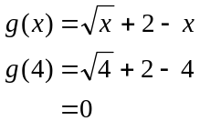
(1 mark)
So 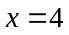 is an x-intercept and therefore 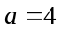. (1 mark)

Method 2
x-intercepts occur when 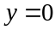
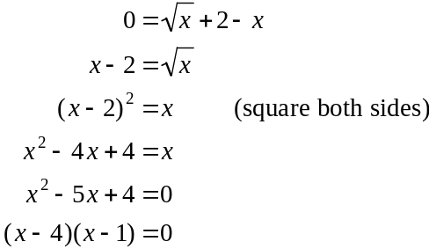
(1 mark)
So as required.
(1 mark)
b. The graph of g has a y-intercept at the point 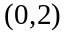.
It has a turning point where
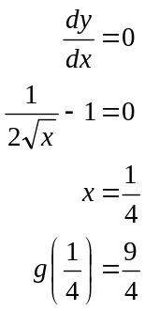
So the graphs of 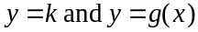 intersect just once when 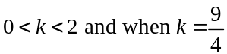.
(1 mark) for
(1 mark) for 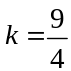
c. Method 1
If the area enclosed by the lines 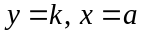 and the x and y axes is equal to the shaded region, then k represents the average value of function g over the interval 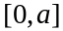.
Therefore we can use the average value formula to find k.
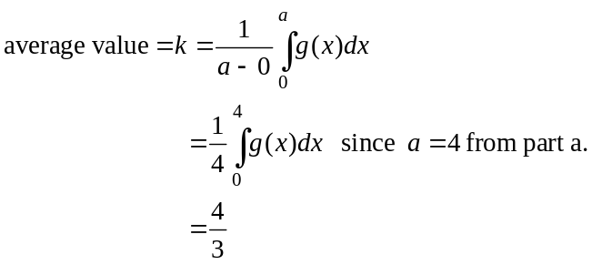
(1 mark) – recognition of
average value by name or
just use of formula

(1 mark)
c. (cont’d)
Method 2
The area enclosed by the lines , and since from part a., the area is equal to 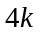.

So 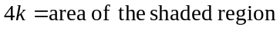 (1 mark)
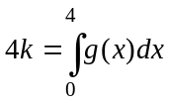
Solve for k using CAS.
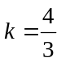 (1mark)

- 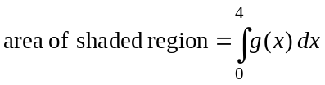
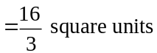
(1 mark)

- From part d. the area of the shaded region is 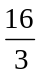. So if the area of the shaded region above the line 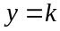 is to equal the area below the line then each of these areas must equal 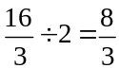.
For the area above the line , we have

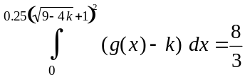 which we solve for k using CAS.

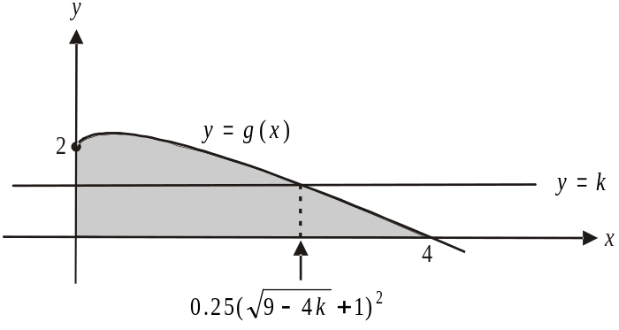

(1 mark) – correct terminals of equation
(1 mark) – correct integrand i.e. 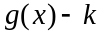
(1 mark) – correct answer

