SACRED HEART GIRLS’ COLLEGE
OAKLEIGH


Mathematical Methods CAS 2013

Unit 3 SAC 2: TEST
Part B

Name: ________________________________

Teacher (please circle): Ms Gates Mr Smith Mrs Mak

Part B: 5 multiple choice questions and 2 extended response questions.
CAS and a bound reference of summary notes permitted

Writing Time: 30 minutes
Marks: 20

MULTIPLE CHOICE

Instructions:
Answer all questions in pencil on the answer sheet provided for multiple-choice questions.
Choose the response that is correct for that question.
A correct answer scores 1, an incorrect answer scores 0.
Marks will not be deducted for incorrect answers.
No marks will be given if more than one answer is completed for any question.
Only the answers on the Answer Sheet will be marked.

Question 1
The expression 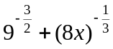 equals
- 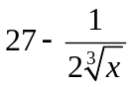

- 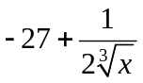
- 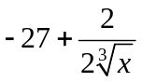
- 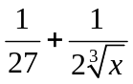
Question 2
The range of the function 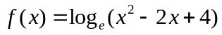is

- 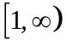
- 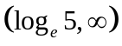

- 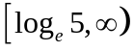
- 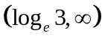

Question 3
A certain radioactive isotope is decaying exponentially so that its mass is given by 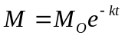 and has a half life of two seconds (i.e. after 2 seconds only half of the initial mass remains).
The approximate time, in seconds, it will take to lose 80% of its original mass is closest to
- 0.6
- 4.0
- 4.3
- 4.6
- 8.1
Question 4
The period and amplitude of the function 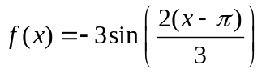 respectively are
- and 
- 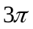and

- and
Question 5
The equation of the graph shown could be

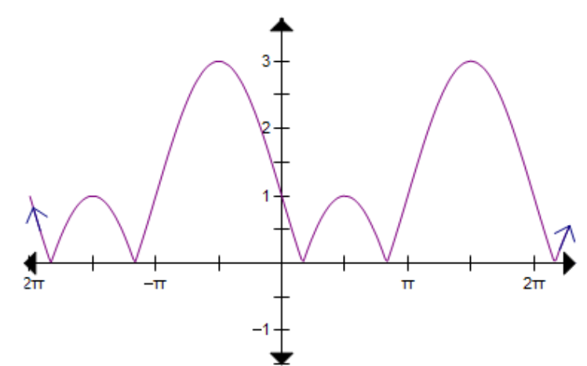

- 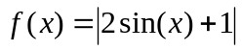
- 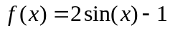
- 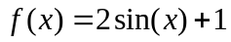
- 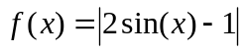
- 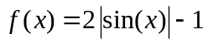
EXTENDED RESPONSE
Instructions:
Answer all questions in the spaces provided.
In all questions where a numerical answer is required an exact value must be given unless otherwise specified.
In questions where more than one mark is available, appropriate working must be shown.
Unless otherwise indicated, the diagrams in this test are not drawn to scale.

Question 1
A study is being conducted on the population of a particular species of possum.
The population, , at time months after the study started is assumed to follow the model
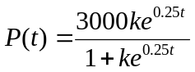
- Given that there are 750 possums when the study started, show that 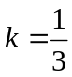.
2 marks

- Determine the possum population after 18 months to the nearest whole number.

1 mark
- Sketch the graph of the possum population over the first two years. Label the endpoints with coordinates.
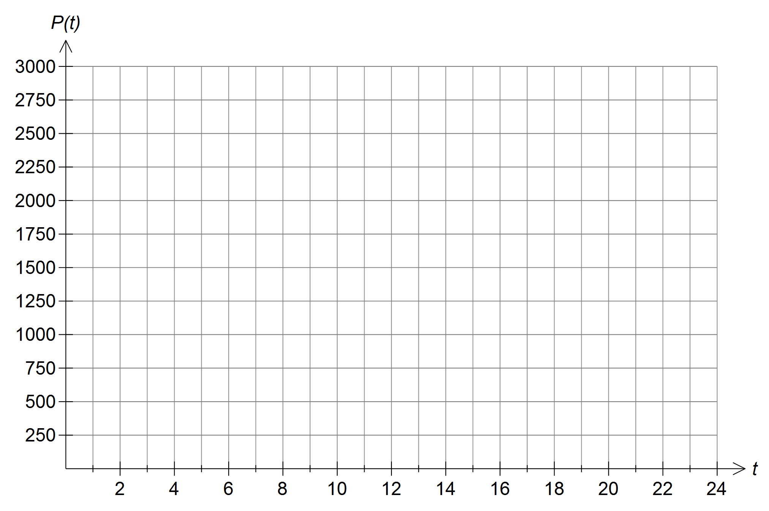 2 marks
d. In which month will the possum population have increased by 150%?

2 marks
Question 2
One of the largest earthquakes of the twentieth century was in Japan on March 2, 1933. It measured 8.9 on the Richter scale. This scale is a logarithmic scale and the relationship between the magnitude, , of an earthquake and the amplitude, , of the seismic wave is given by the formula:

where

the amplitude of the seismic wave (vertical motion relative to normal ground level) in microns
the period of the seisic wave in seconds

The San Francisco earthquake in 1906 had magnitude of 8.3 on the Richter scale.
- If the period of this wave was 2.5 seconds find the amplitude to the nearest micron.

1 mark
Another earthquake has a seismic wave which is given by the formula
where
the vertical motion relative to normal ground level of the wave measured in cm
the time, in seconds, since the earthquake started.
- Sketch the graph of for one period. Label endpoints and intercepts as coordinates.
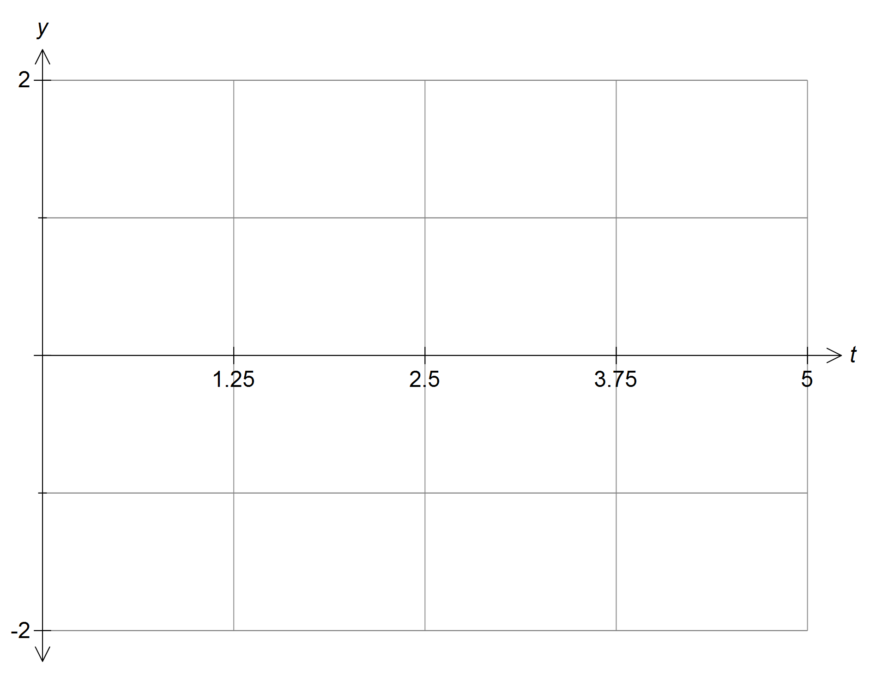
3 marks

A “critical time” is when the ground rises or falls by more than 1 cm.

- i Find, correct to two decimal places, between what times the ground first rises and first falls by more than1 cm.

- marks
ii Find the proportion of time during the first period that is “critical time”.

- mark
iii If the wave continues for 12.5 seconds, find the proportion of time that is “critical time”.

1 mark
END OF SAC

