
MATHS METHODS (CAS) 3 & 4
TRIAL EXAMINATION 1
SOLUTIONS
2014

Question 1 (4 marks)

- 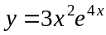
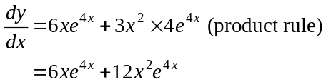
(1 mark) – correct first term
(1 mark) – correct second term

- 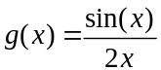
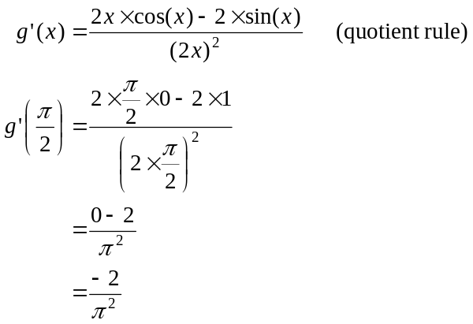
(1 mark)
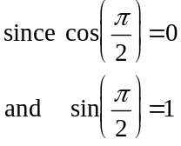
(1 mark)

Question 2 (2 marks)

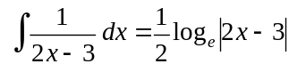
Note, because we were asked for ‘an’ antiderivative c is not required (because c could, in this case, equal zero)
(1 mark) – recognition that a logarithm was required
(1 mark) – correct answer
Question 3 (2 marks)

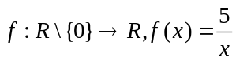
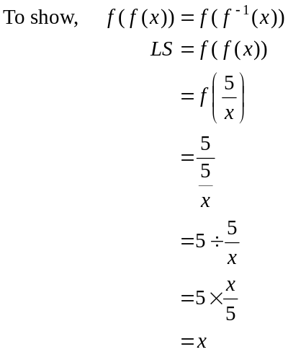
(1 mark)
Now find 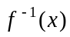.
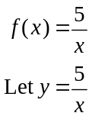
Swap x and y for inverse.
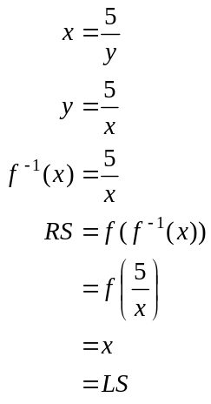
Have shown.
(1 mark)
Question 4 (5 marks)

- 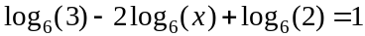
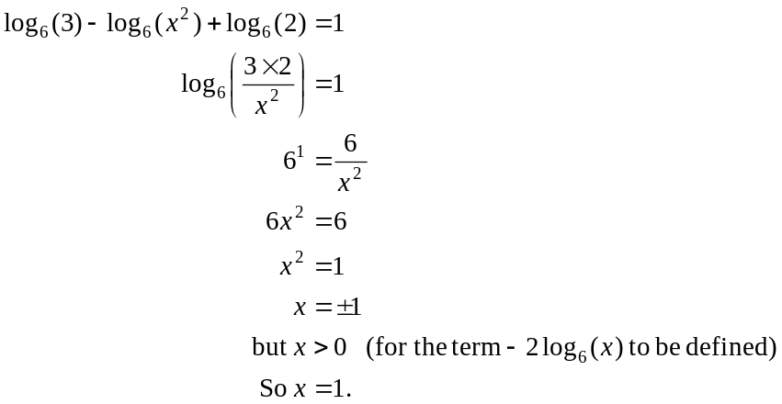
(1 mark)
(1 mark)
(1 mark)

- 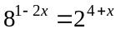
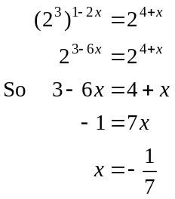
(1 mark)
(1 mark)

Question 5 (2 marks)

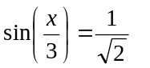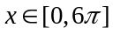
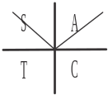
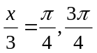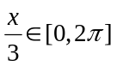
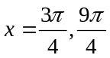
sin is positive in the 1st and 2nd quadrants

(1 mark) – one correct answer
(1 mark) – second correct answer
Question 6 (5 marks)

and, 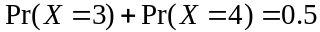.
The median of X is therefore halfway between 2 and 3 so the median of X is 2.5
(1 mark)

- Method 1 – using intuition and the table.
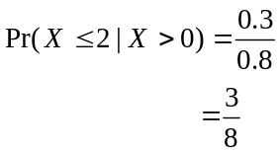
(1 mark)
(1 mark)
Since we’re told , then we eliminate 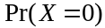 which gives us a denominator of 0.8.
We want 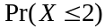, so we want 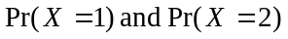. Remember that is eliminated.
So the numerator is .

Method 2 – using the conditional probability formula
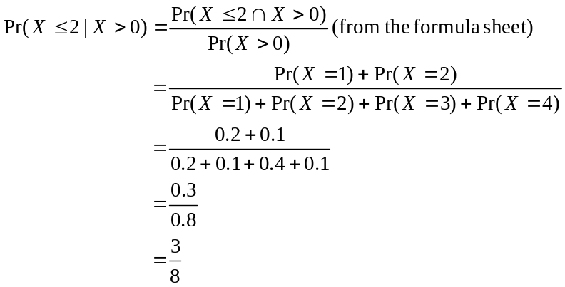
(1 mark)
(1 mark)

- 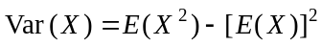
(1 mark)
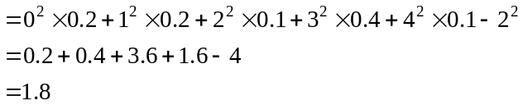
(1 mark)
This formula is not given on the formula sheet. It is easier to use than the one on the formula sheet so therefore worth remembering.
Question 7 (4 marks)

- Since f is a probability density function,
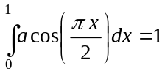
(1 mark)
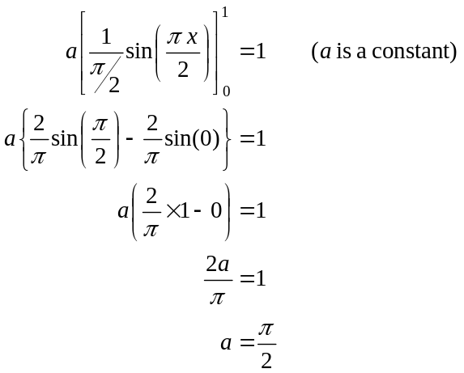
(1 mark)
(1 mark)

- The mode of X is the value of x for which 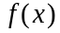 is a maximum.
Do a quick sketch.

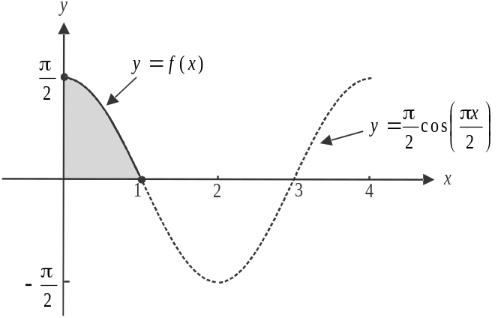

The maximum value of 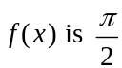 and it occurs when .
The mode is zero.
(1 mark)

Question 8 (6 marks)

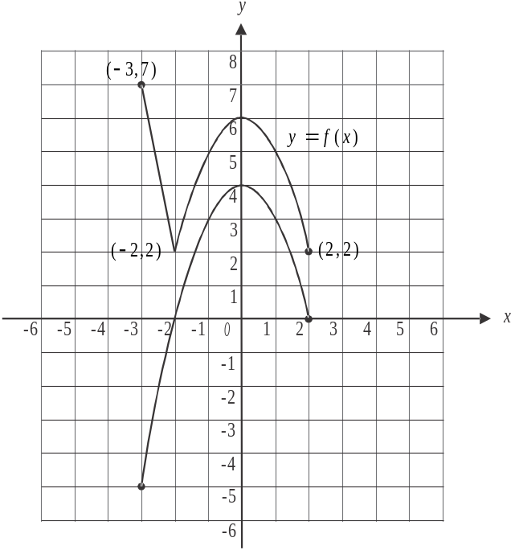

(1 mark) – correct shape
(1 mark) – correct position
including endpoints

- i. 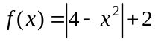
When the graph of f is translated 2 units in the negative direction of the y-axis, its rule becomes
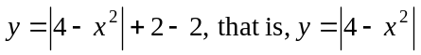
When this graph is then translated 2 units in the positive direction of the x-axis, its rule becomes 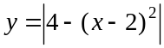
When this graph is then dilated from the y-axis by a factor of , its rule becomes 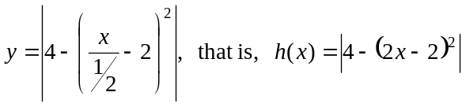.
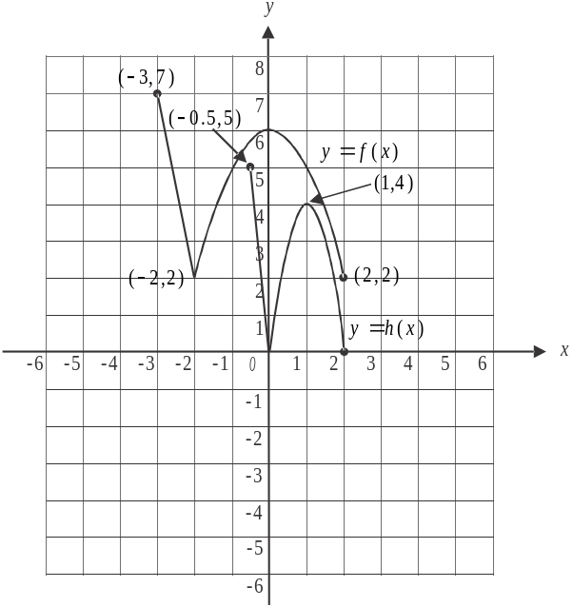
(1 mark) – for 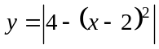
(1 mark) – for 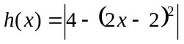

ii. Method 1 – drawing a graph

To find the domain, do a quick
sketch of 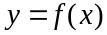 after it has
undergone the two translations
and the dilation to become
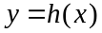.

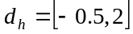 (1 mark)

Method 2 – using the rule
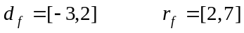 from part a.
After a translation 2 units in the negative direction of the y-axis, we have:
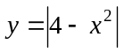
After a translation 2 units in the positive direction of the x-axis, we have:
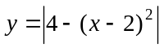
After a dilation from the y-axis by a factor of , we have:
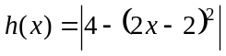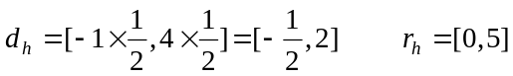
So 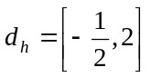 (1 mark)

iii. Using either method in part ii., 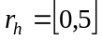 (1 mark)

Question 9 (4 marks)

- 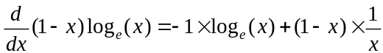 (product rule)
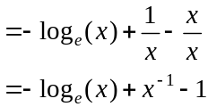
(1 mark)
- The area of the shaded region is given by the integral 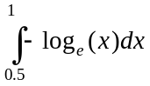.
From part a., we have
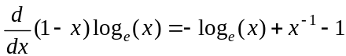

Rearrange this.
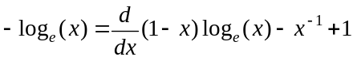
Finding the antiderivative of each and every term on both sides of the equation gives:
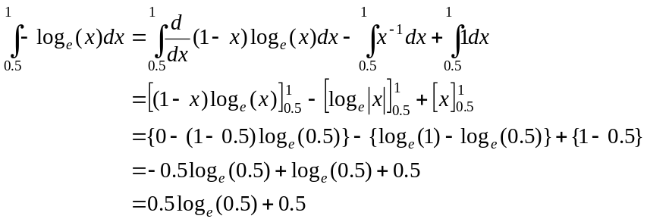
(1 mark)
(1 mark)
(1 mark)
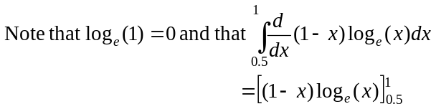
because the antiderivative ‘undoes’ the derivative.
Question 10 (6 marks)
- i. 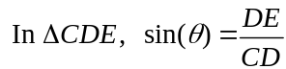
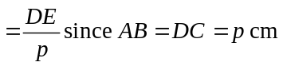
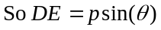 (1 mark)
- 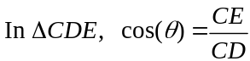
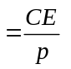
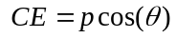 (1 mark)
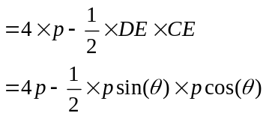
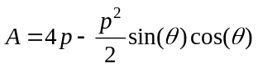 (1 mark)
- 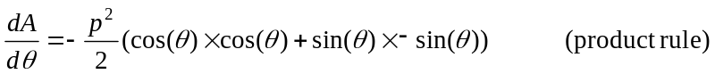
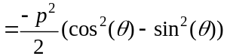
(1 mark)
Min occurs when 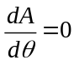 so
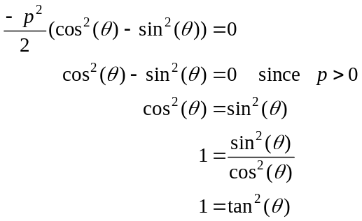
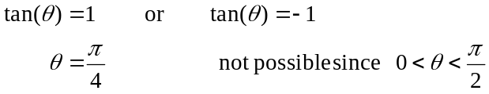
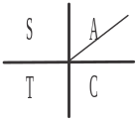
(1 mark)
- From part c., the minimum area occurs when 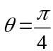. From part b.,
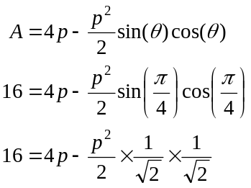
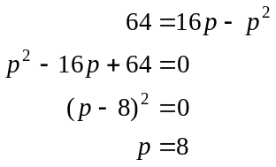
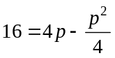 (1 mark)

