

Student Name……………………………………

MATHEMATICAL METHODS (CAS) UNITS 3 & 4

TRIAL EXAMINATION 2

2015

Reading Time: 15 minutes
Writing time: 2 hours

Instructions to students
This exam consists of Section 1 and Section 2.
Section 1 consists of 22 multiple-choice questions, which should be answered on the detachable answer sheet which can be found on page 23 of this exam.
Section 2 consists of 5 extended-answer questions.
Section 1 begins on page 2 of this exam and is worth 22 marks.
Section 2 begins on page 10 of this exam and is worth 58 marks.
There is a total of 80 marks available.
All questions in Section 1 and Section 2 should be answered.
Diagrams in this exam are not to scale except where otherwise stated.
Where more than one mark is allocated to a question, appropriate working must be shown.
If a question requires a numerical answer then an exact value must be given unless a decimal approximation is specifically asked for.
Students may bring one bound reference into the exam.
Students may bring into the exam one approved CAS calculator (memory does not need to be cleared) and, if desired, one scientific calculator.
A formula sheet appears on page 22 of this exam.

This paper has been prepared independently of the Victorian Curriculum and Assessment Authority to provide additional exam preparation for students. Although references have been reproduced with permission of the Victorian Curriculum and Assessment Authority, the publication is in no way connected with or endorsed by the Victorian Curriculum and Assessment Authority.

© THE HEFFERNAN GROUP 2015
This Trial Exam is licensed on a non transferable basis to the purchasing school. It may be copied by the school which has purchased it. This license does not permit distribution or copying of this Trial Exam by any other party.
SECTION 1

Question 1

The range of the function 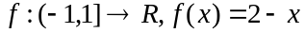 is

- 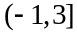
- 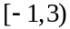
- 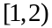
- 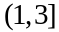
- 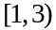

Question 2

The function 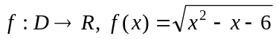 has a maximal domain so

- 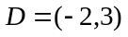
- 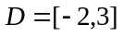
- 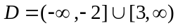
- 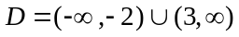
- 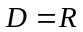

Question 3

The graph of the function 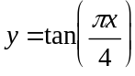 is dilated by a factor of 2 units from the y axis.
The period of this transformed graph is

- 2
- 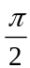
- 4
- 8
Question 4

Part of the graph of the function g is shown below.
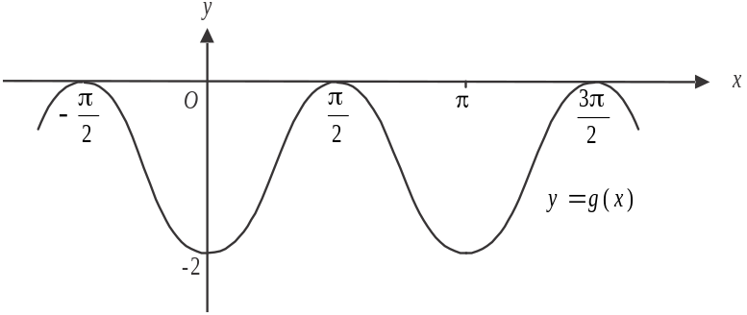

The rule for g could be

- 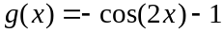
- 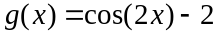
- 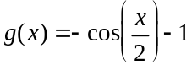
- 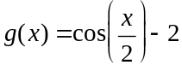
- 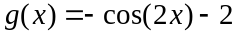

Question 5

For the function f with domain R,
- 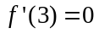
- 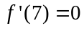
- 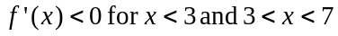
- 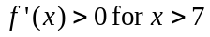
The graph of f must have

- a local minimum at
- a stationary point of inflection at
- an x intercept at
- a local maximum at
- a stationary point of inflection at

Question 6

Let . An inverse function 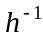 will exist if

- 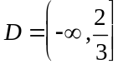
- 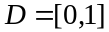
- 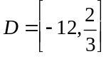
- 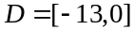
- 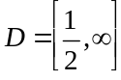
Question 7

If 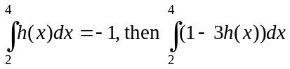 is equal to

- 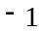
- 2
- 4
- 5
- 7

Question 8

Given that 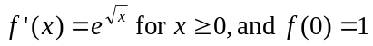, then

- 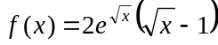
- 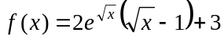
- 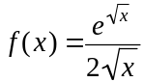
- 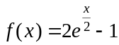
- 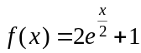

Question 9

The discrete random variable X has the following probability distribution.

X | 0 | 2 | 3 | 5
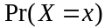 | 0.1 | a | b | 0.2

The mean of X is 2.6.
The values of a and b are given by

Question 10

Inside a container there are four black balls, five white balls and one red ball. Two balls are taken from the container, one after the other without replacement. The probability that no black balls are taken out is

- 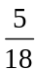
- 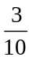

Question 11

The normal to the graph of 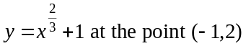 has a y-intercept of

- 2

Question 12

Let 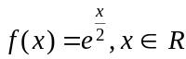.

The equation that is true for all real values of x is

- 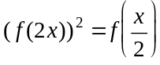
- 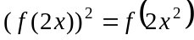
- 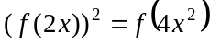
- 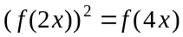
- 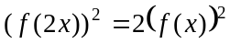
Question 13

For two independent events A and B in a sample space, .
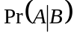 is equal to

- 0.2
- 0.3
- 0.4
- 0.5
- 0.8

Question 14

The continuous random variable X has a probability density function given by

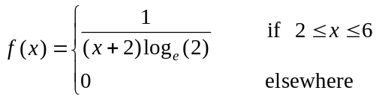

The probability that is closest to

- 0.1068
- 0.2224
- 0.2630
- 0.4150
- 0.5850

Question 15

The graph of the function g is shown below.
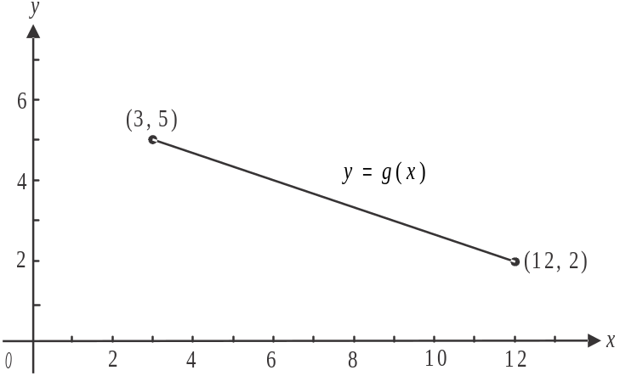

The average value of g is

- 2
- 2.5
- 3
- 3.5
- 4
Question 16

Let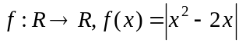.
Which one of the following statements is not true about f ?

- 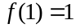
- The graph of f is continuous for .
- 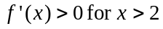.
- 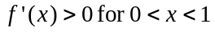.
- The function f is differentiable for .

Question 17

For the simultaneous linear equations , there will be infinitely many solutions for

- only
- only
- 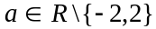
- 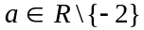
- both

Question 18

The random variable X is normally distributed with a mean of 54. The random variable Z follows the standard normal distribution.
Given that 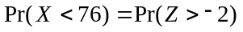, the variance of X is

- 11
- 22
- 38
- 121
- 484

Question 19

The graphs of 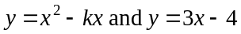 intersect at two distinct points when

- 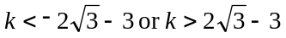
- 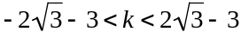
- 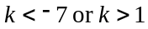

Question 20

Part of the graph of 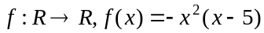 is shown below.
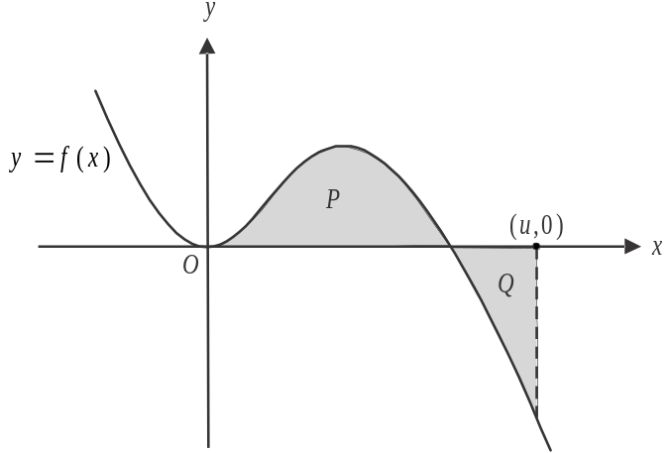

The shaded region labelled P is equal in area to the shaded region labelled Q.
The value of u is

- 5
- 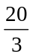
- 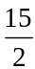
- 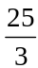

Question 21

The relationship 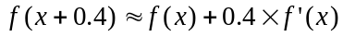 is used to find an approximation for 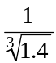.
That approximation is

- 0.6667
- 0.8667
- 0.8939
- 0.9181
- 1.3333
Question 22

The shaded region enclosed by the triangles ABE and CDE is shown below.

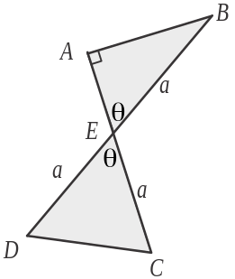

The sides BE, DE and CE are all of length a. The angles AEB and CED are of equal magnitude where 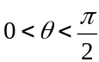.
The shaded area is a maximum when the value of is

- 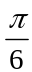
- 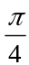
- 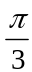
- 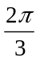
- 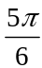

SECTION 2

Answer all questions in this section.

Question 1 (6 marks)

The temperature inside a greenhouse changes according to the rule

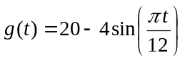

where g is the temperature, in degrees Celsius, t hours after midnight on Sunday.

- Find the temperature inside the greenhouse at midnight on Sunday. 1 mark

- Find the period of the function g. 1 mark

- Find the maximum temperature and the average temperature inside the greenhouse. 2 marks

- The cost of heating the greenhouse is $5.20 per hour when the temperature is below 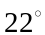C and $6.80 per hour when the temperature is above 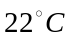. Find the cost of heating the greenhouse for one week. 2 marks

Question 2 (15 marks)

At George’s garage, the time, X hours, taken to service a car follows the probability density function f where
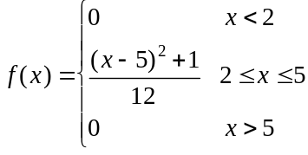

- Find the mean time taken to service a car at George’s garage. 1 mark

Last week there were 40 cars serviced at George’s garage. Andrew’s car was among the fastest 25% of cars to be serviced there last week.

- What was the maximum time that Andrew’s car could have taken to be serviced? Express your answer in hours, correct to 3 decimal places. 2 marks

The diameters, in mm, of a consignment of 700 cylindrical filters used at the garage are normally distributed with a mean of 24mm and a standard deviation of 0.3mm.
George has found that the widest 20% of these filters cannot be used in Mini cars.

- What is the maximum diameter of a filter that can be used in a Mini car? Express your answer in mm correct to 2 decimal places. 1 mark

Filters with a diameter of less than 23.5 mm will fit in any car.

- How many filters in this consignment will fit in any car? Express the answer correct to the nearest whole number. 2 marks

The services George performs at his garage are classified as major or minor services depending on the number of km a car has done.
George starts each service and often hands over to another mechanic to finish a service. He has found over time that if a service he starts is major then the probability that the next service he starts is also major is 0.4.
If a service he starts is minor then the probability that the next service he starts is minor is q where 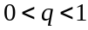 and q can vary from day to day.
The first service George starts with each day is a minor service.

- i. Find the probability, expressed in terms of q, that the third service George starts in a day is a major service. 2 marks

  - On a particular day the probability that the third service of the day was a major one was 0.2. Find the value of q on this day expressing your answer correct to 3 decimal places. 2 marks

  - On a different day, 8 cars were serviced and on that day 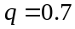. Find the probability that the last car serviced had a minor service. 2 marks

The garage receives a daily delivery of parts. The probability that this delivery occurs before noon is 0.8 and the time that the delivery takes place one day is independent of the time it takes place the next day.

- i. The probability that over an n day period the delivery occurred each day before noon is 0.32768. Find the value of n. 1 mark

- Find the probability that over a 20 day period, the delivery arrives before noon on more than 16 days given that on at least half of the 20 days it arrives before noon. Express your answer correct to 4 decimal places. 2 marks

Question 3 (11 marks)

At a garden supply business different soils and stones are stored in rectangular bays which have a depth of 10m and a width of 3m. Each bay has a back wall and two side walls with the remaining side left open to enable access by the bobcat.
One of these bays contains top soil. The cross-section of the top soil contained in this bay on a particular day is shown in the diagram below.
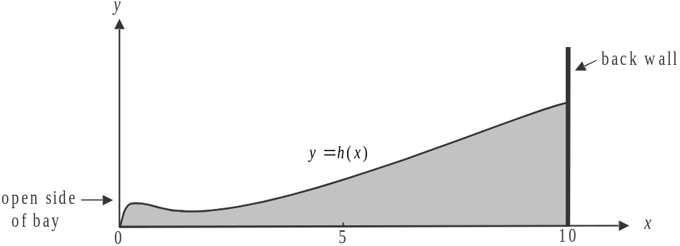

The height, in metres, of the top soil in this diagram is given by the function

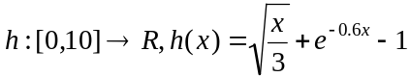

where x represents the horizontal distance, in metres from the front (open side) of the bay.

- Find the maximum height of the top soil in this bay. Express your answer in metres correct to 2 decimal places. 1 mark

- Write down the interval over which the graph of h is strictly decreasing. Express the endpoints of the interval correct to 2 decimal places. 2 marks

The gradient of the function h is equal to the actual height of the top soil at one point.

- Find the height of the top soil at this point. Express your answer in metres correct to 2 decimal places. 2 marks

Between the points 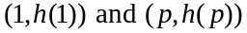, where p is a constant and 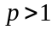, the average rate of change in the height of the top soil is zero.

- Find the value of p. Express your answer correct to 2 decimal places. 2 marks

In order to get an estimate of the volume of top soil in the bay, it is to be assumed that the height of the cross section, as shown in the diagram, is constant across the 3 metre width of the bay.

- Find the volume of top soil in the bay using this estimate. Express your answer in cubic metres correct to 2 decimal places. 2 marks

- If the top soil in this bay were to be levelled flat, what would the height of the top soil be? Express your answer in metres correct to 2 decimal places. 2 marks

Question 4 (12 marks)

Let 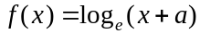 where a is a positive constant.

- Write down the domain of f in terms of a. 1 mark

- Find the values of a such that the graph of f has

- a negative x-intercept. 1 mark

- a positive x-intercept. 1 mark

- Let 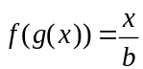 where b is a constant.
i. Show that 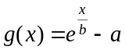. 1 mark

- Explain why 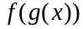 is defined. 1 mark

- i. Find the rule and domain of 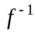, the inverse function of f. 2 marks

- Describe the transformation required to transform the graph of to the graph of g. 1 mark

- If , find the area enclosed by the graph of 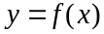 and the x and y-axes. 3 marks

- If , show that the area enclosed by the graph of and the x and y axes equals zero. 1 mark

Question 5 (14 marks)

Victoria James is a spy.
She is on a surveillance mission over an island, travelling in a hot air balloon. Her flight path is observed from a stationary naval ship nearby.
The height, b, in metres, of her balloon above sea level when it is x metres from the western edge of the island is given by

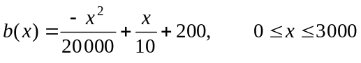.

The graph of 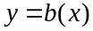 is shown on the diagram below.

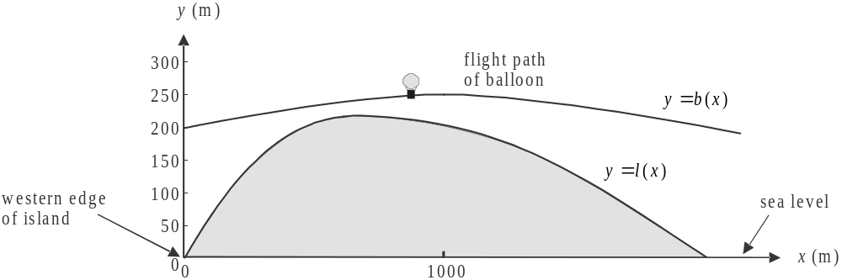

From the naval ship, the height l, in metres, of the land above sea level on the island, x metres from the western edge of the island is given by

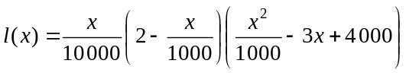

which is also shown on the diagram.

- What is the width of the island, in metres, as observed from the naval ship? 1 mark

- Find the coordinates of the point where the height of the island is a maximum. Express these coordinates correct to 4 decimal places. 2 marks

- i. Find an expression for 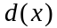 which gives the difference in height between the balloon and the land on the island, x metres from the western edge of the island. 1 mark

  - Write down the domain of d. 1 mark

- Find the minimum vertical distance between the balloon and the land on the island. Express
this distance in metres correct to 2 decimal places. 2 marks

The enemy fire a missile from a launch site located at the point 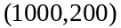, hoping to hit the balloon. The path of the missile is a straight line following the line of the tangent to the graph of 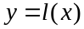 at this same point.

- Find the equation of the path of the missile. 2 marks

- Find the coordinates of the point where the missile will cross the flight path of Victoria’s balloon. 2 marks

When the missile crosses the flight path of Victoria’s balloon, the balloon is at the same height above sea level as the missile but at a different point on the flight path.
At this instant, Victoria fires a missile from the balloon which travels in a straight line to hit the launch site at the point .

- Let be the angle which the path of Victoria’s missile makes with the horizontal.
Given that 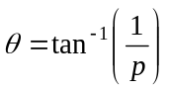, where p is a constant, find the value of p. 3 marks

Mathematical Methods (CAS) Formulas

Mensuration

area of a trapezium: 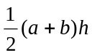 volume of a pyramid: 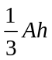
curved surface area of a cylinder: 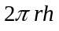 volume of a sphere: 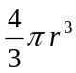
volume of a cylinder: 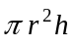 area of a triangle: 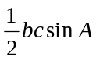
volume of a cone: 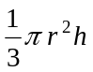

Calculus
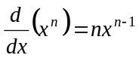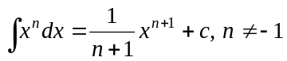
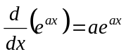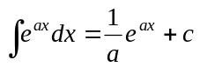
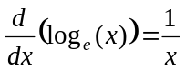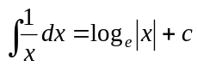
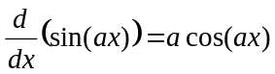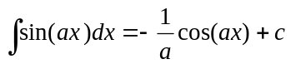
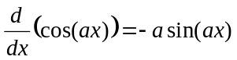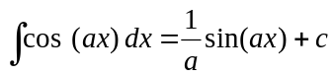
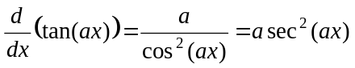
product rule: 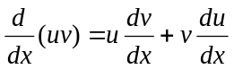 quotient rule: 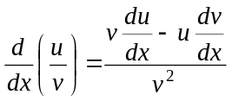
chain rule: 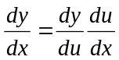 approximation: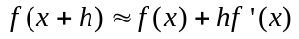

Probability
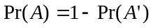
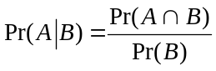 transition matrices: 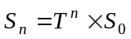
mean: 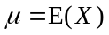 variance:

probability distribution |  | mean | variance
discrete | 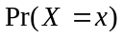=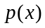 | 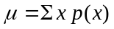 | 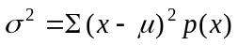
continuous | 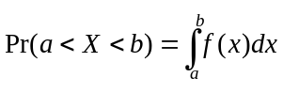 | 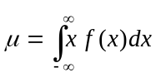 | 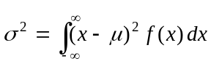
Mathematics Formula Sheets reproduced by permission; © VCAA 2014. The VCAA does not endorse or make any warranties regarding this study resource. Current and past VCAA VCE® exams and related content can be accessed directly at www.vcaa.vic.edu.au

