

Student Name……………………………………

MATHEMATICAL METHODS UNITS 3 & 4

TRIAL EXAMINATION 2

2017

Reading Time: 15 minutes
Writing time: 2 hours

Instructions to students
This exam consists of Section A and Section B.
Section A consists of 20 multiple-choice questions, which should be answered on the detachable answer sheet which can be found on page 25 of this exam.
Section B consists of 4 extended-answer questions.
Section A begins on page 2 of this exam and is worth 20 marks.
Section B begins on page 10 of this exam and is worth 60 marks.
There is a total of 80 marks available.
All questions in Section A and Section B should be answered.
In Section B, where more than one mark is allocated to a question, appropriate working must be shown.
Where a numerical answer is required, an exact value must be given unless otherwise directed.
Diagrams in this exam are not to scale except where otherwise stated.
Students may bring one bound reference into the exam.
Students may bring into the exam one approved technology (calculator or software) and, if desired, one scientific calculator. Calculator memory does not need to be cleared. For approved computer-based CAS, full functionality may be used.
A formula sheet can be found on pages 23 and 24 of this exam.

This paper has been prepared independently of the Victorian Curriculum and Assessment Authority to provide additional exam preparation for students. Although references have been reproduced with permission of the Victorian Curriculum and Assessment Authority, the publication is in no way connected with or endorsed by the Victorian Curriculum and Assessment Authority.

© THE HEFFERNAN GROUP 2017
This Trial Exam is licensed on a non transferable basis to the purchasing school. It may be copied by the school which has purchased it. This license does not permit distribution or copying of this Trial Exam by any other party.
SECTION A – Multiple-choice questions

Question 1

Let 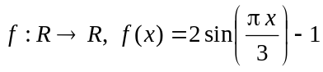.
The period and range of this function are given respectively by

- 6 and 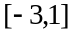
- 6 and 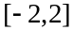
- 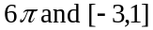
- 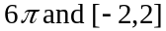
- 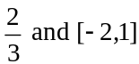

Question 2

Let 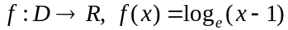.
The domain D could be

- 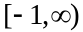
- 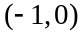
- 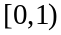
- 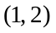
- 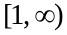

Question 3

Part of the graph of f is shown below.
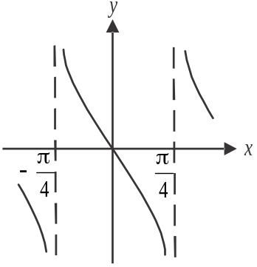

The rule of f could be

- 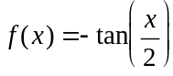
- 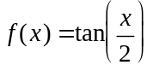
- 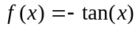
- 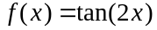
- 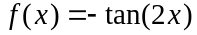
Question 4

The average rate of change of the function g with rule 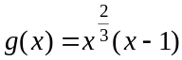 between is

- 16
- 28
- 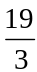
- 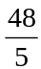

Question 5

Part of the graph of the polynomial function f is shown below.

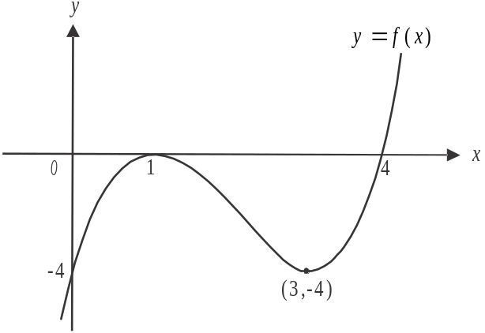

The complete set of values for which the function f is strictly decreasing is

- 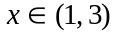
- 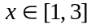
- 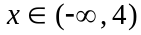
- 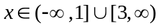
- 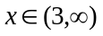

Question 6

Which one of the following is the inverse function of 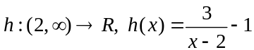?

- 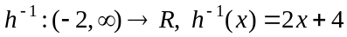
- 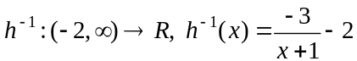
- 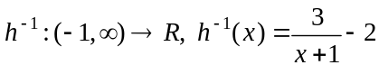
- 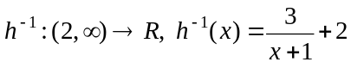
- 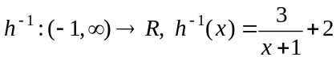

Question 7

The discrete random variable X has a probability distribution shown in the table below.

x | −2 | 0 | 3 | 5
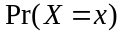 | 0.3 | 0.1 | 0.4 | 0.2

The standard deviation of X is closest to

- 1.6
- 2.69
- 2.86
- 7.24
- 9.8

Question 8

The graph of 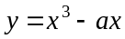 where a is a positive constant, has stationary points where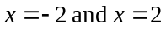.
The value of a is

- 4
- 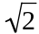
- 8
- 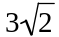
- 12

Question 9

The graph of 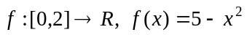 is shown below.
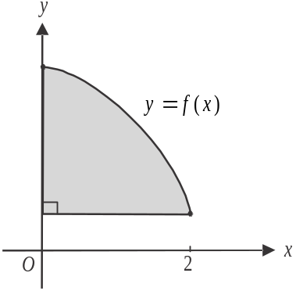

The area of the shaded region is given by

- 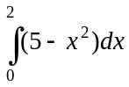
- 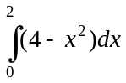
- 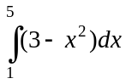
- 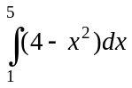
- 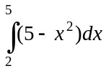

Question 10

The equation 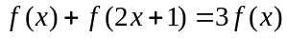 is true for all real values of x. The rule for f could be

- 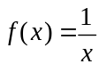
- 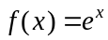
- 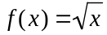
- 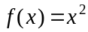
- 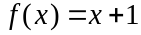

Question 11

The graph of the function f with rule 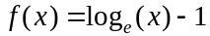 is reflected in the y-axis and then dilated from the x-axis by a factor of to become the graph of g.
The rule for the graph of g is

- 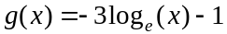
- 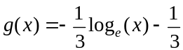
- 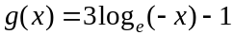
- 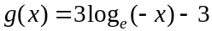
- 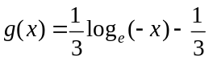

Question 12

The simultaneous linear equations 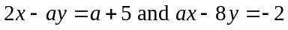 have infinitely many solutions for
- 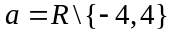
- 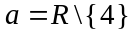

Question 13

A right-angled triangle is formed by connecting the origin, the point 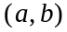, where , and the point 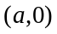. The point 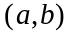 lies on the parabola 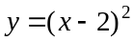.
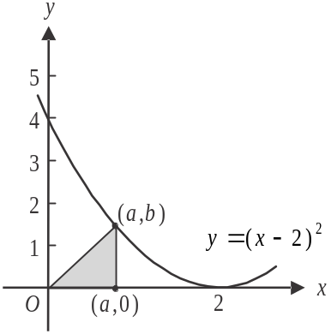

The maximum area of this triangle is
- 4
- 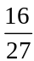
- 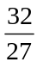
Question 14

If 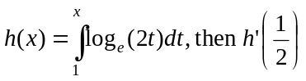 is equal to

- 0
- 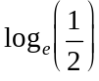
- 1
- 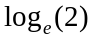
- 2

Question 15

A country has 40% of its population vaccinated against influenza. For samples of 600 citizens of this country, is the random variable of the distribution of sample proportions of citizens who are vaccinated against influenza. The mean and standard deviation of are given respectively by

- 0.4 and 0.0004
- 0.4 and 0.02
- 0.6 and 0.008
- 0.6 and 0.02
- 0.67 and 0.004

Question 16

A silo contains an estimated ten billion grain seeds. It is understood that 5% of these would not germinate were they to be sown.
A sample of 200 seeds is taken from the silo. For samples of 200 seeds, is the random variable of the distribution of sample proportions of seeds that would not germinate.
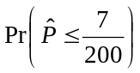, when calculated not using a normal distribution, is closest to

- 0.0067
- 0.1237
- 0.1652
- 0.2133
- 0.3167
Question 17

The continuous random variable X has a probability density function given by

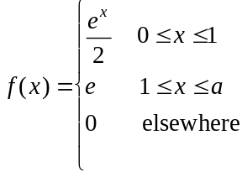
The value of a is

- 2
- 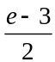
- 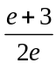
- 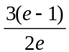

Question 18

Last Tuesday before midday, a hotel reception checked in 20 guests whose rooms were ready and 35 guests whose rooms weren’t ready. For those guests whose rooms were ready, 5 were from overseas and for those guests whose rooms weren’t ready, 20 were from overseas.
An overseas guest who checked in to the hotel last Tuesday before midday is randomly selected.
The probability that this guest had their room ready is

- 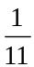
- 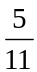

Question 19

Eight per cent of items purchased at the retail outlets of a sports clothing company are returned for exchange.
The company samples sales of 400 items purchased across its retail outlets.
Using a normal approximation, the probability that between five and ten percent of these sampled items are returned for exchange is closest to

- 0.0136
- 0.0702
- 0.9163
- 0.9573
- 0.9759

Question 20

The transformation 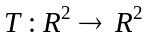 with rule 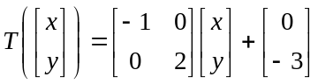 maps the graph of 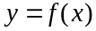 onto the graph of 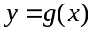.

Given that 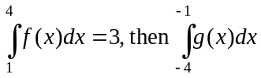 is equal to

- – 3
- 0
- 6
- 9
- 12

SECTION B

Answer all questions in this section.

Question 1 (13 marks)

Let 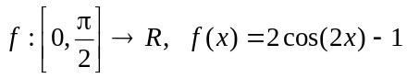.

The graph of f is shown below.
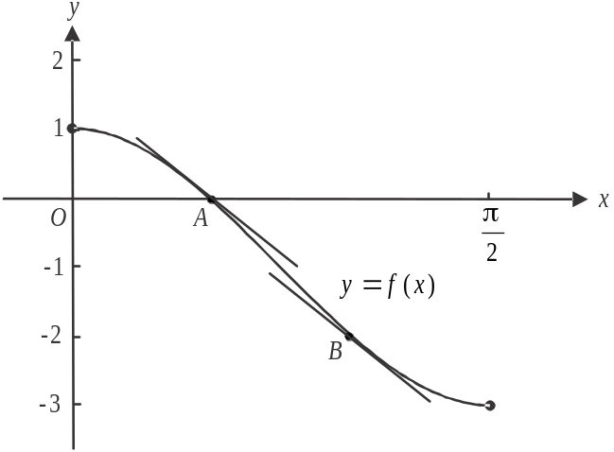

Parallel tangents are drawn to f at points A and B. Point A lies on the x-axis.

- Find the range of f. 1 mark

- Find the coordinates of point A. 1 mark

- The gradient of the two tangents is 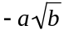. Find the values of a and b. 2 marks

- Hence find the coordinates of point B. 2 marks

- The tangent to f at point A is translated r units in the negative direction of the x-axis to coincide with the tangent at point B.
Find the exact value of r. 2 marks

- Let 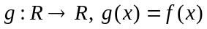.
Find the general solution for x of the equation 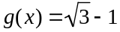. 2 marks

g. Let 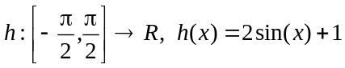.

The graph of h can be obtained by applying the transformation T to the graph of f where

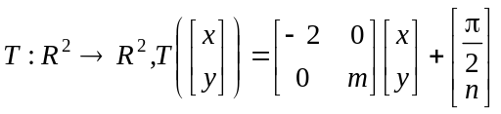.

Find the value of m and the value of n. 3 marks

Question 2 (14 marks)

Consider the functions .

- i. Show that 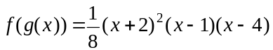. 2 marks

  - Explain why 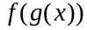 exists. 1 mark

Let 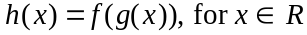.
The stationary points of h occur at the points where 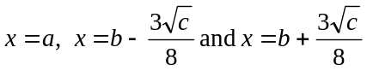.

- Find the values of a, b and c. 3 marks

A tangent is drawn to the graph of h at the point A with coordinates 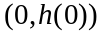.
This tangent intersects the graph of h at the points B and C as shown on the diagram below.
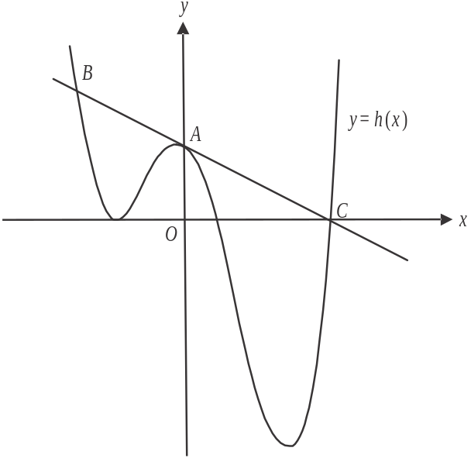

- i. Show that the equation of the tangent to h at the point A is given by . 1 mark

  - Find the length of BC. 3 marks

Point X lies on the tangent found in part c. i.
Point D is a stationary point on the graph of h as shown on the diagram below.
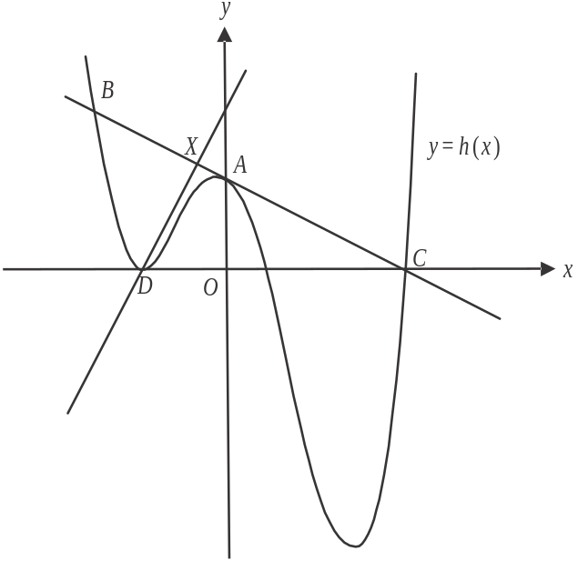

The line that passes through points D and X is perpendicular to the tangent.

- i. Find the coordinates of point X. 2 marks

  - Hence find the area of triangle BCD. 2 marks

Question 3 (16 marks)

A logistics company operates a parcel delivery service. Thirty percent of parcels that the company delivers require a signature at the delivery address.
The requirement of a signature for any one parcel is independent of the requirement for any other parcel.
A sample of 50 parcels is taken at one of the company’s warehouses.

- i. Find the probability that at least 10 of these parcels require a signature.
Give your answer correct to four decimal places. 2 marks

- Find the probability that more than 15 of these parcels require a signature given that at least 10 require a signature. Give your answer correct to four decimal places. 2 marks

The company is able to track the delivery time of each parcel, that is, the time a parcel spends in transit between one of the company’s warehouses and the delivery address. The delivery time of one parcel is independent of the delivery time of any other parcel.
The delivery time of a parcel is normally distributed with a mean of 4 hours and 20 minutes and a standard deviation of 50 minutes.

  - Let S represent the probability that the delivery time of a parcel is more than six hours.
Show that , correct to four decimal places. 1 mark

The company takes a sample of 50 parcels from across its warehouses and analyses the delivery time of each of these parcels, one after the other.

  - Find the probability that exactly one of the first three parcels analysed has a delivery time of more than six hours. Give your answer correct to four decimal places. 2 marks

The company takes further samples of 50 parcels from across its warehouses. For these samples of 50 parcels, is the random variable of the sample proportion of parcels that have a delivery time of more than six hours.

- Find the probability that 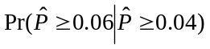. Give your answer correct to four decimal places. Do not use a normal approximation. 3 marks

In a separate investigation, the company finds that in a random sample of 100 parcels, four of them have damaged packaging.

e. Find an approximate 95% confidence interval for the population proportion corresponding
to this sample proportion of damaged parcels.
Give values correct to three decimal places. 1 mark

f. The company also operates an express delivery service for documents. The probability
density function for the delivery time, x minutes, of a document is

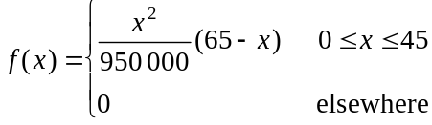

- Find the median delivery time, in minutes, of a document, correct to one decimal place. 2 marks

- Twenty minutes after a document has been dispatched, the document has not been delivered and a customer contacts the company to enquire about when it will be delivered.
Find the probability that the document is delivered within 10 minutes of the customer having contacted the company. Give your answer correct to three decimal places. 3 marks

Question 4 (17 marks)

Let 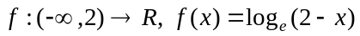.

The graph of f is shown below.

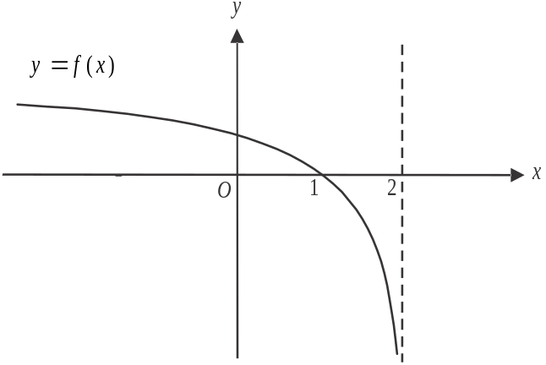

- The graph of f is reflected in the y-axis to become the graph of g.

- Find the rule and domain of g. 2 marks

- Find the area enclosed by the graphs of f and g and the x-axis. 1 mark

Let .
The graph of h is shown below.
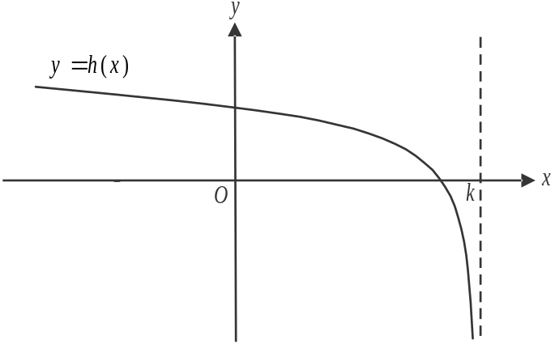

- i. Find, in terms of k, the coordinates of the x and y intercepts of the graph of h. 2 marks

- Show that if . 2 marks

- Find the equation of the tangent to h at the point 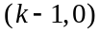. 1 mark

- Part of the graph of h and the tangent to h at the point , are shown in the diagram below.

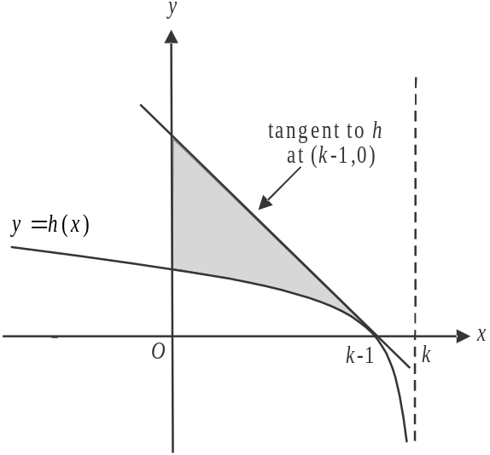

The area of the shaded region is given by the function A and the domain of A is .
Show that the rule , 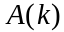 of this function is given by 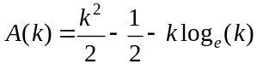. 2 marks

- Find the value of k for which the shaded area from part iv. equals the area enclosed by the graph of h and the x and y axes.
Give your answer correct to 2 decimal places. 3 marks

- i. Find the rule and domain of 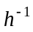, the inverse function of h. 2 marks

- The tangent to h at the point 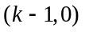 found in part b. iii. is also a tangent to 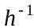 at the point 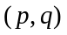.
Find the values of p and q. 2 marks

Mathematical Methods formulas

Mensuration
area of a trapezium | 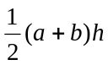 | volume of a pyramid | 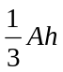
curved surface area of a cylinder | 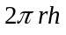 | volume of a sphere | 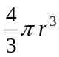
volume of a cylinder | 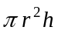 | area of a triangle | 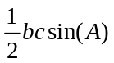
volume of a cone | 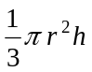

Calculus
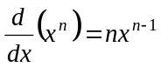 |  | 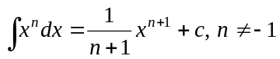
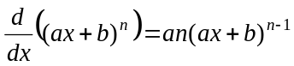 |  | 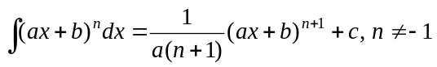
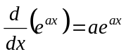 |  | 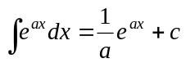
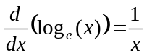 |  | 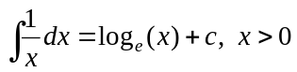
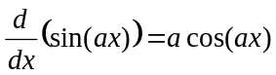 |  | 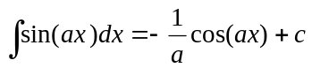
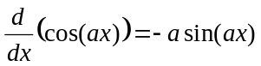 |  | 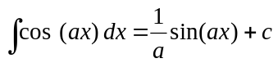
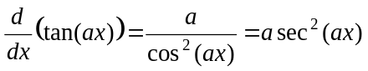
product rule | 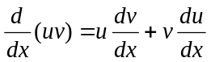 | quotient rule | 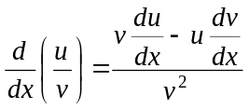
chain rule | 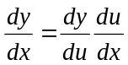
Mathematics Formula Sheets reproduced by permission; © VCAA 2016. The VCAA does not endorse or make any warranties regarding this study resource. Current and past VCAA VCE® exams and related content can be accessed directly at www.vcaa.vic.edu.au
Probability

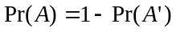
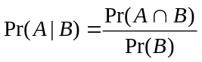
mean | 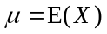 | variance

Probability distribution |  | Mean | Variance
discrete | 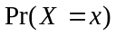=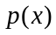 | 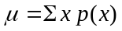 | 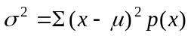
continuous | 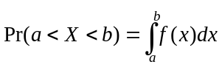 | 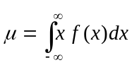 | 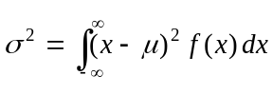

Sample proportions

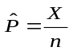 |  | mean | 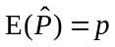
standard  deviation | 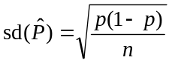 | approximate  confidence  interval | 