Year 2017
VCE
Mathematical Methods
Trial Examination 1



KILBAHA MULTIMEDIA PUBLISHING  PO BOX 2227  KEW VIC 3101  AUSTRALIA | TEL: (03) 9018 5376  FAX: (03) 9817 4334  kilbaha@gmail.com  http://kilbaha.com.au

IMPORTANT COPYRIGHT NOTICE

- This material is copyright. Subject to statutory exception and to the provisions of the relevant collective licensing agreements, no reproduction of any part may take place without the written permission of Kilbaha Multimedia Publishing.
- The contents of this work are copyrighted. Unauthorised copying of any part of this work is illegal and detrimental to the interests of the author.
- For authorised copying within Australia please check that your institution has a licence from Copyright Agency Limited. This permits the copying of small parts of the material, in limited quantities, within the conditions set out in the licence.

Reproduction and communication for educational purposes The Australian Copyright Act 1968 (the Act) allows a maximum of one chapter or 10% of the pages of this work, to be reproduced and/or communicated by any educational institution for its educational purposes provided that educational institution (or the body that administers it) has given a remuneration notice to Copyright Agency Limited (CAL) under the Act.

For details of the CAL licence for educational institutions contact
CAL, Level 15, 233 Castlereagh Street, Sydney, NSW, 2000
Tel: (02) 9394 7600
Fax: (02) 9394 7601
Email: info@copyright.com.au
Web: http://www.copyright.com.au

- While every care has been taken, no guarantee is given that these questions are free from error. Please contact us if you believe you have found an error.

Victorian Certificate of Education
2017

STUDENT NUMBER
Letter
Figures
Words

MATHEMATICAL METHODS

Trial Written Examination 1

Reading time: 15 minutes
Total writing time: 1 hour

QUESTION AND ANSWER BOOK

Structure of book
Number of Number of questions Number of
questions to be answered marks
8 8 40
- Students are permitted to bring into the examination room: pens, pencils, highlighters, erasers, sharpeners, rulers.
- Students are NOT permitted to bring into the examination room: any technology (calculators or software) notes of any kind, blank sheets of paper, and/or correction fluid/tape.
Materials supplied
- Question and answer book of 18 pages.
- Detachable sheet of miscellaneous formulas at the end of this booklet.
- Working space is provided throughout the booklet.
Instructions
- Detach the formula sheet from the end of this book during reading time.
- Write your student number in the space provided above on this page.
- Unless otherwise indicated, the diagrams in this booklet are not drawn to scale.
- All written responses must be in English.

Students are NOT permitted to bring mobile phones and/or any other unauthorised electronic devices into the examination room.

Instructions

Answer all questions in the spaces provided.
In all questions where a numerical answer is required an exact value must be given unless otherwise specified.
In questions where more than one mark is available, appropriate working must be shown.
Unless otherwise indicated, the diagrams in this book are not drawn to scale.

Question 1 (4 marks)
a. Let 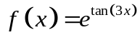, find 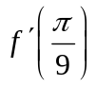 2 marks
________________________________________________________________________________________________________________________________________________________________________________________________________________________________________________________________________________________________________________________________________________________________________________________________________________________________________________________________________
b. Consider the function 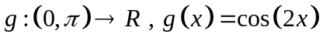. If the tangent to the graph
of at the point where 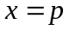 makes an angle of 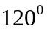 with the positive x-axis,
find the possible value(s) of p.
2 marks
____________________________________________________________________________________________________________________________________________________________________________________________________________________________________________________________________________________________________________________________________________________________________________________________________________________________________________________________________________________________________________________________________________________

Question 2 (3 marks)

Sam is a frequent flyer and occasionally gets a free upgrade. In a sample of ten flights, he
found that once he got a free upgrade.
Let 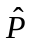 represent the distribution of the sample proportion, on flights when he gets a free upgrade.

i. Sam wants to find the smallest value of the sample size n, such that the standard deviation of is less than or equal to 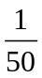. Determine the value of n.
2 marks
________________________________________________________________________________________________________________________________________________________________________________________________________________________________________________________________________________________________________________________________________________________________________________________________________________________________________________________________________________________________________________________________________________________________________________________________________________________________

ii. Find the probability that when Sam takes five flights, he gets three upgrades.

1 mark
____________________________________________________________________________________________________________________________________________________________________________________________________________________________________________________________________________________________________________________________________________________________________________________________________________________________________________________________________________________________________________________________________________________

Question 3 (4 marks)
a. State the amplitude, period and range of the function 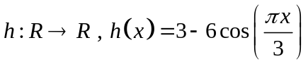
1 mark
________________________________________________________________________________________________________________________________________________________
b. Find the general solution of 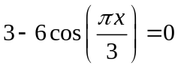
1 mark
____________________________________________________________________________________________________________________________________________________________________________________________________________________________________
c. Sketch the graph of the function 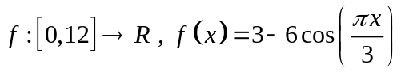, on the axes below, stating coordinates of all axial intercepts and endpoints.
2 marks
____________________________________________________________________________
____________________________________________________________________________

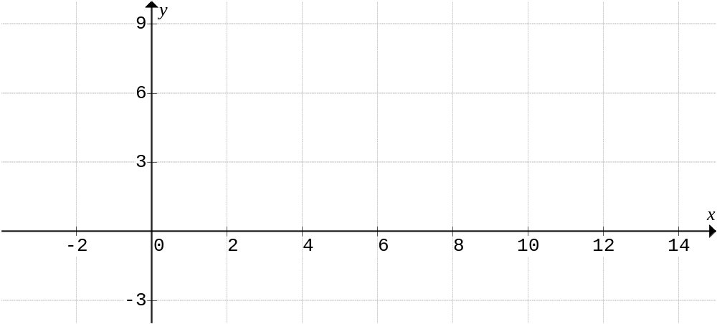
Question 4 (9 marks)

Consider the function 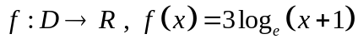
a. Sketch the graph of the function on the axes below, clearly showing axial intercepts,
and stating the equations of any asymptotes. State the maximal domain D and range
of the function.
2 marks

____________________________________________________________________________
____________________________________________________________________________
____________________________________________________________________________

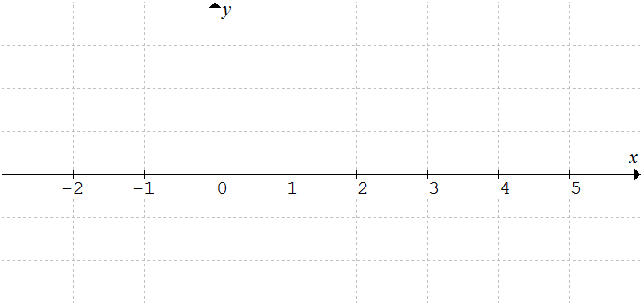

Mia wants to calculate the area bounded by the graph of 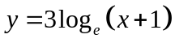, the x-axis and the ordinates  and 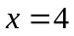.

b.i. As a first approximation, she decides to use four equally spaced upper rectangles.
Draw these rectangles on the diagram above.
1 mark
ii. The area using these four upper rectangles can be expressed as 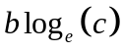,
find the values of b and c. 1 mark

________________________________________________________________________________________________________________________________________________________________________________________________________________________________________________________________________________________________________________________________________________________________________________________________________________________________________________________________________

c. Find the rule for the inverse function 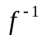.
2 marks

________________________________________________________________________________________________________________________________________________________________________________________________________________________________________________________________________________________________________________________________________________________________________________________________________________________________________________________________________________________________________________________________________________________________________________________________________________________________

d.i. Evaluate 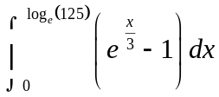
2 marks

________________________________________________________________________________________________________________________________________________________________________________________________________________________________________________________________________________________________________________________________________________________________________________________________________________________________________________________________________

ii. Hence find the area bounded by the graph of , the x-axis and the ordinates and .
1 mark

________________________________________________________________________________________________________________________________________________________________________________________________________________________________________________________________________________________________________________________________________________________________________________________________________________________________________________________________________

Question 5 (4 marks)

Consider the function 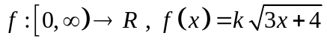

a. If the average rate of change of f between and is equal to 9,
find the value of k. 2 marks
____________________________________________________________________________________________________________________________________________________________________________________________________________________________________
____________________________________________________________________________________________________________________________________________________________________________________________________________________________________

b. Find the average value of f between and . 2 marks

________________________________________________________________________________________________________________________________________________________________________________________________________________________________________________________________________________________________________________________________________________________________________________________________________________________________________________________________________________________________________________________________________________________________________________________________________________________________________________________________________________________________________________________________________________________________________________________

Question 6 (3 marks)
A transformation 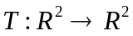 is defined by 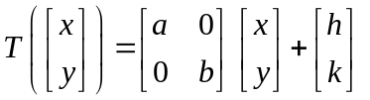
The image of the curve 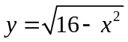 under the transformation T, has the equation
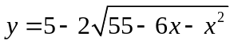. Find the values of a, b, h, and k.

________________________________________________________________________________________________________________________________________________________________________________________________________________________________________________________________________________________________________________________________________________________________________________________________________________________________________________________________________________________________________________________________________________________________________________________________________________________________________________________________________________________________________________________________________________________________________________________________________________________________________________________________________________________________________________________________________________________________________________________________________________________________________________________________________________________________________________________________________________________________________________________________________________________________________________________________
Question 7 (4 marks)

The diagram shows part of the function 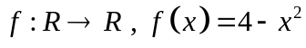. A point P with coordinates
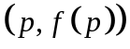 where 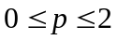 is shown.

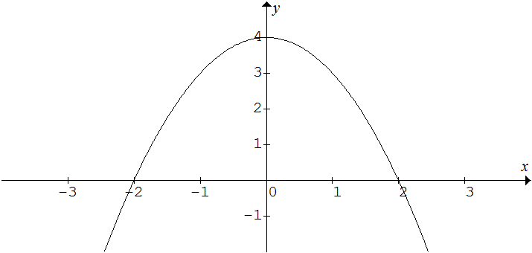
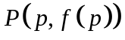

Determine the value of p, for which the distance from the origin O to the point P is a minimum.
________________________________________________________________________________________________________________________________________________________________________________________________________________________________________________________________________________________________________________________________________________________________________________________________________________________________________________________________________________________________________________________________________________________________________________________________________________________________________________________________________________________________________________________________________________________________________________________________________________________________________________________________________________________________________________________________________________________________________________________________________________________________________________________________________________________________________
Question 8 (9 marks)

a. Determine 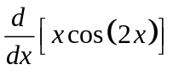
1 mark
____________________________________________________________________________________________________________________________________________________________________________________________________________________________________________________________________________________________________________________________________________________________________________________________

Let be a continuous random variable with probability density function
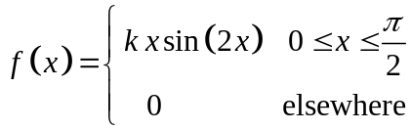
b.i Show that 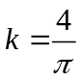
2 marks
____________________________________________________________________________________________________________________________________________________________________________________________________________________________________________________________________________________________________________________________________________________________________________________________________________________________________________________________________________________________________________________________________________________________________________________________________________________________________________________________________________________________________________

ii. The median of X is m, and satisfies the equation 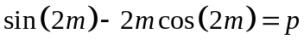.
Find the value of p.
2 marks
____________________________________________________________________________
____________________________________________________________________________________________________________________________________________________________________________________________________________________________________________________________________________________________________________________________________________________________________________________________
iii. The mode of X is M, and satisfies the equation 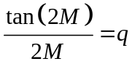. Find the value of q.
2 marks
________________________________________________________________________________________________________________________________________________________________________________________________________________________________________________________________________________________________________________

iv. Sketch the graph of f, on the axis below, clearly showing the relative positions of the median m, the mode M.
2 marks
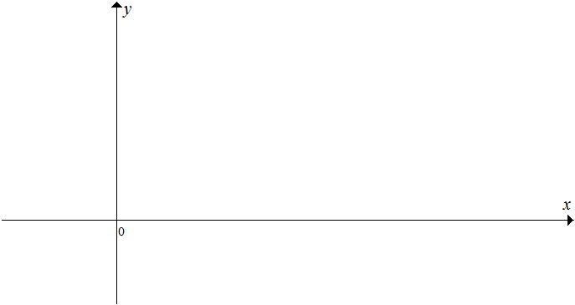
END OF QUESTION AND ANSWER BOOKLET
END OF EXAMINATION
EXTRA WORKING PAGE

________________________________________________________________________________________________________________________________________________________

____________________________________________________________________________

____________________________________________________________________________

____________________________________________________________________________

____________________________________________________________________________

____________________________________________________________________________

____________________________________________________________________________

____________________________________________________________________________

____________________________________________________________________________

____________________________________________________________________________

____________________________________________________________________________

____________________________________________________________________________

____________________________________________________________________________

____________________________________________________________________________

____________________________________________________________________________

____________________________________________________________________________

____________________________________________________________________________

____________________________________________________________________________

MATHEMATICAL METHODS

Written examination 1

FORMULA SHEET

Directions to students

Detach this formula sheet during reading time.

This formula sheet is provided for your reference.

Mathematical Methods formulas

Mensuration

area of a trapezium | 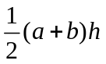 | volume of a pyramid | 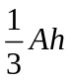
curved surface area  of a cylinder | 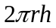 | volume of a sphere | 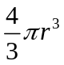
volume of a cylinder | 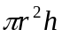 | area of triangle | 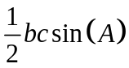
volume of a cone | 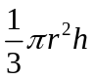

Calculus

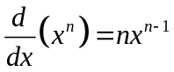 |  | 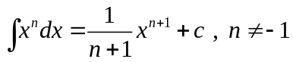
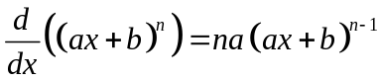 |  | 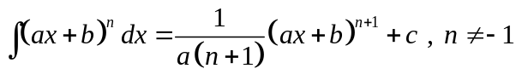
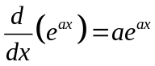 |  | 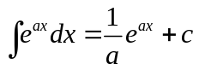
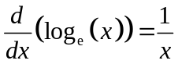 |  | 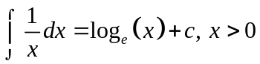
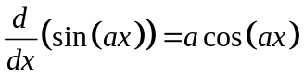 |  | 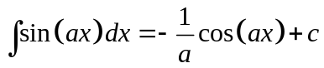
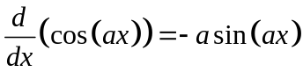 |  | 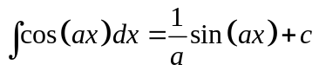
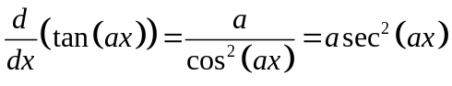
product rule | 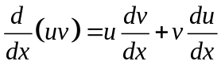 | quotient rule | 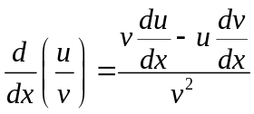
chain rule | 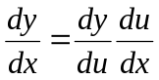

Probability

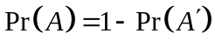 |  | 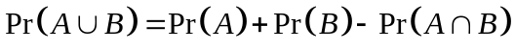
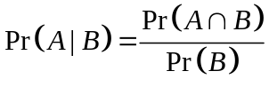
mean | 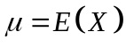 | variance | 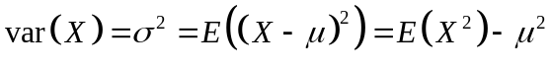

Probability distribution |  | Mean | Variance
discrete | 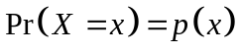 | 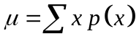 | 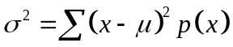
continuous | 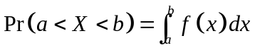 | 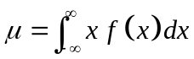 | 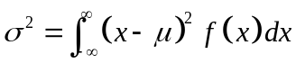

Sample proportions

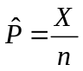 |  | mean | 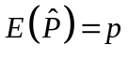
standard  deviation | 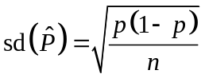 | approximate  confidence  interval | 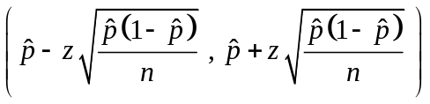

END OF FORMULA SHEET

