
MATHS METHODS 3 & 4
TRIAL EXAMINATION 1
SOLUTIONS
2018

Question 1 (4 marks)

- Let 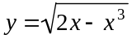
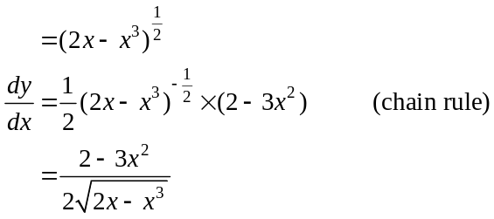
(1 mark)

- 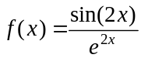
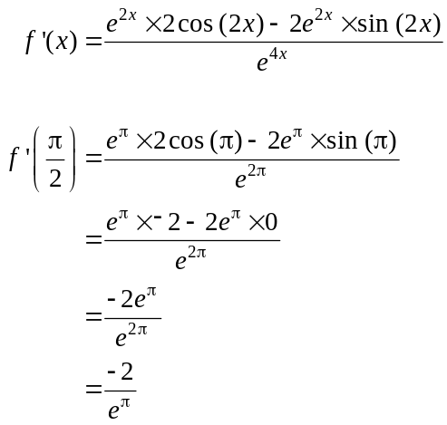
(1 mark)
(1 mark)
(1 mark)

Question 2 (4 marks)

- 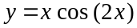
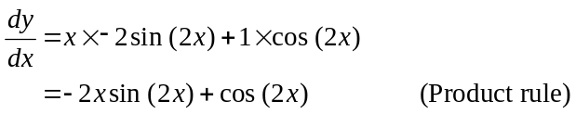
(1 mark) – correct first term
(1 mark) – correct second term
Question 2 (cont’d)

- Since 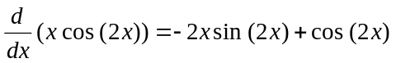
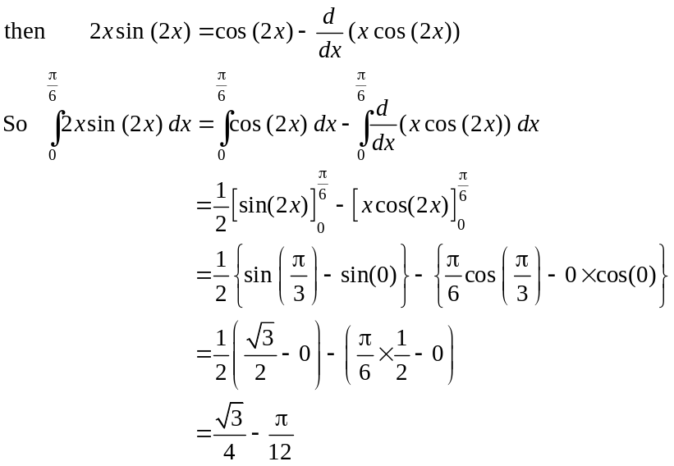
(1 mark)
(1 mark)
Question 3 (2 marks)

- The number of female students who could be present is 0, 1, 2 or 3.
Therefore the sample proportion of female students could be 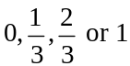.
(1 mark)
- 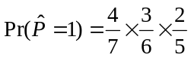
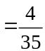
(1 mark)
Question 4 (5 marks)

- 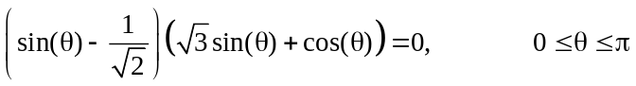
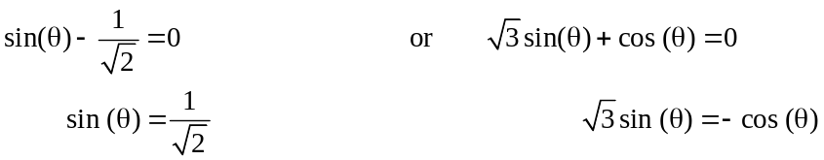

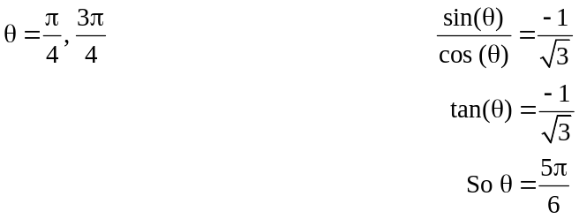
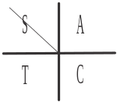
base angle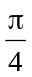

base angle 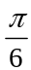
So 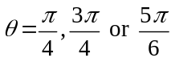. (1 mark) - first two answers (1 mark) – third answer
Question 4 (cont’d)

- 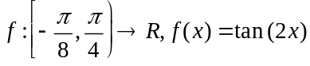
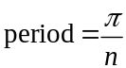
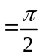
Over the domain of f, there is an asymptote at 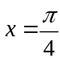.

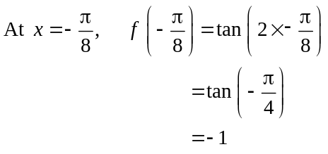
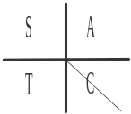
The endpoint is located at 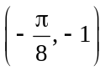.

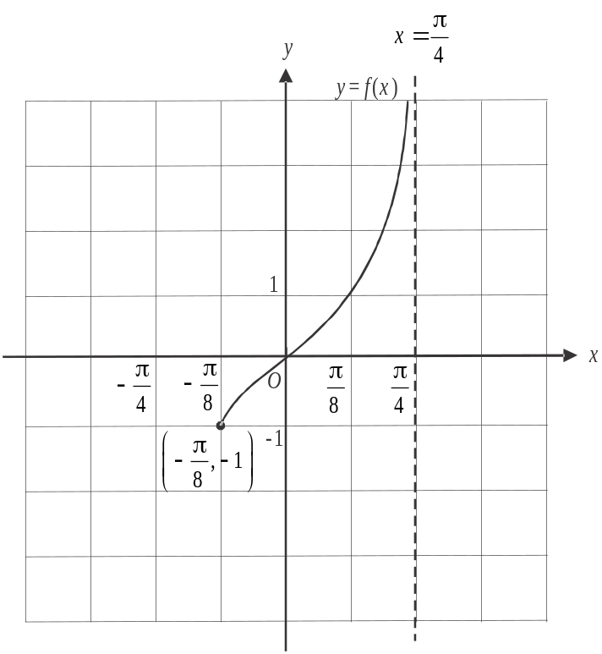

(1 mark) – correct asymptote
(1 mark) – correct endpoint
(1 mark) – correct shape
Question 5 (4 marks)

- 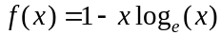
Stationary points occur when 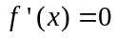.
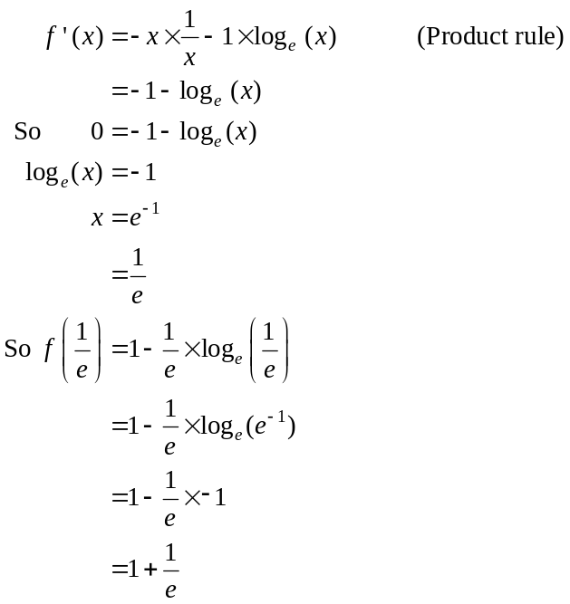
(1 mark)
(1 mark)
Stationary point is 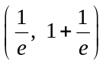 (1 mark)
- Using the graph, f is strictly decreasing for 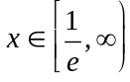.
(1 mark)

Question 6 (5 marks)

- i. 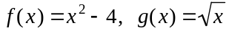
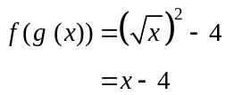
(1 mark)
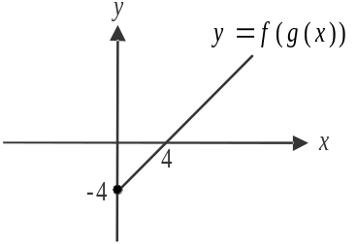
  - 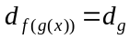
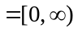 (1 mark)

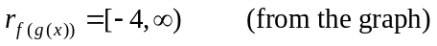
(1 mark)

- 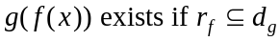 (1 mark)
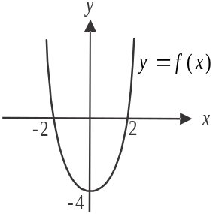
Since 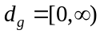, we need
to find a, so that 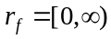.
Using the graph, 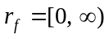 if
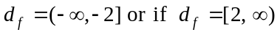.
So the smallest possible value
of a is 2, i.e. . (1 mark)
Question 7 (5 marks)
- Since 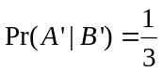,
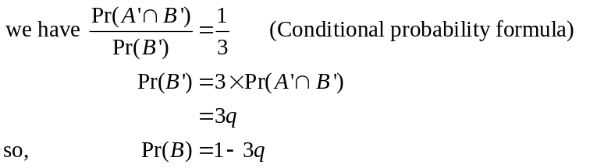
(1 mark)
- Draw a Karnaugh map.

 | A | 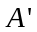
B | q | 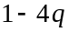 | 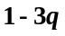
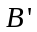 | 2q | q | 3q
 | 3q | 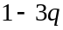 | 1
(1 mark)

The values in bold we are given (or we know i.e. 1). The rest can be calculated from these.
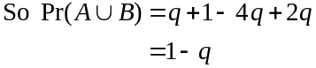
(1 mark)
- 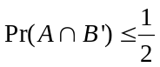
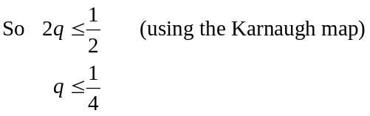
(1 mark)
In part a. we saw that 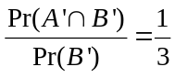.
So 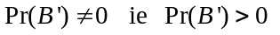.
We also saw that 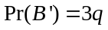. So 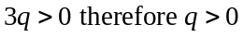.
Alternatively, since , then 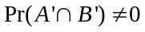 and since 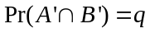
(from the table above) then 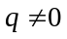.
Since 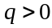, the possible values of q are 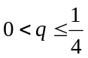.
(1 mark)

Question 8 (4 marks)

- 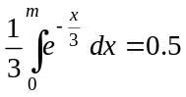
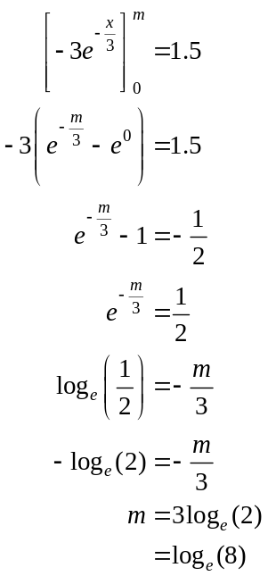
(1 mark)
(1 mark)

- We know that 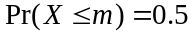.

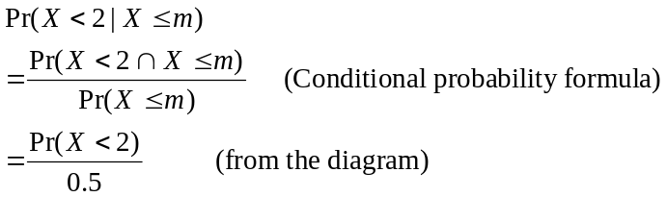
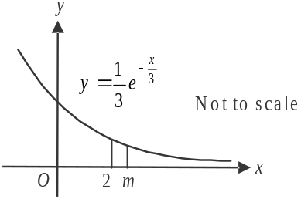
(1 mark)
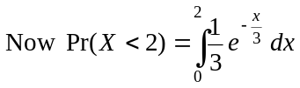
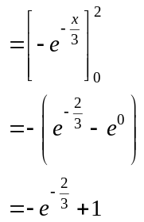
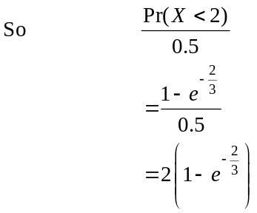
(1 mark)
Question 9 (7 marks)

- f is a quadratic function. The x-intercepts of the graph of f occur when
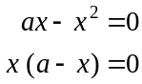
i.e. when
So the x-coordinate of the turning point occurs when 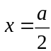.
(1 mark)

- From the graph, the tangent is the steepest (i.e. is at a maximum) when 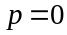, i.e. we are looking at the tangent to f at the origin. (1 mark)
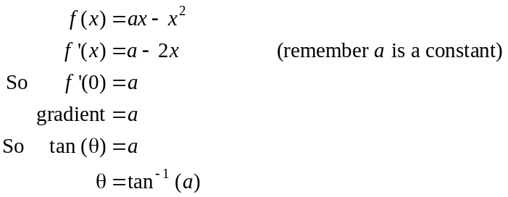
The maximum value of is 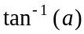.
(1 mark)

- Find the equation of the tangent.
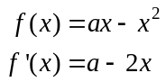
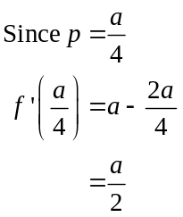
Gradient of tangent is .
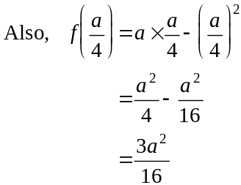
P is the point 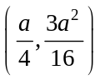
Question 9 (cont’d)

Equation of tangent is
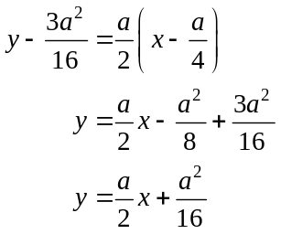
(1 mark)
The area required is shaded in the diagram below.

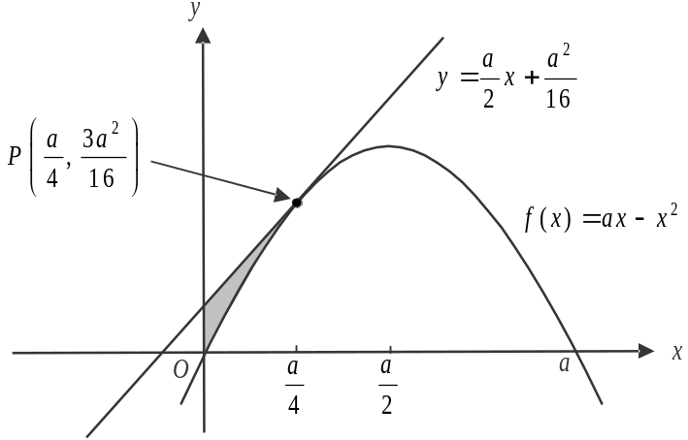

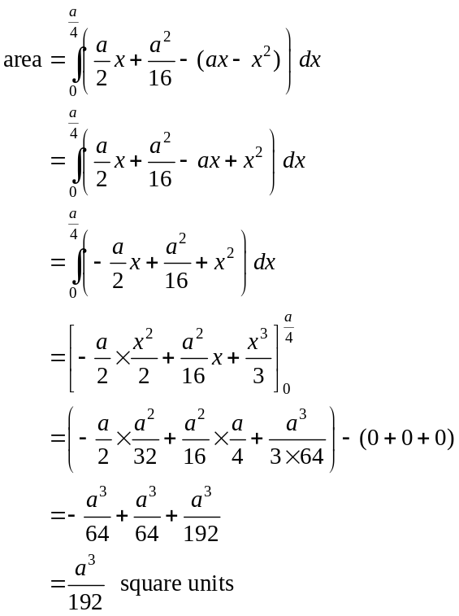
(1 mark)
(1 mark)
(1 mark)

