

Student Name……………………………………

MATHEMATICAL METHODS UNITS 3 & 4

TRIAL EXAMINATION 1

2018

Reading Time: 15 minutes
Writing time: 1 hour

Instructions to students
This exam consists of 9 questions.
All questions should be answered in the spaces provided.
There is a total of 40 marks available.
The marks allocated to each of the questions are indicated throughout.
Students may not bring any calculators or notes into the exam.
Where a numerical answer is required, an exact value must be given unless otherwise directed.
Where more than one mark is allocated to a question, appropriate working must be shown.
Diagrams in this trial exam are not drawn to scale.
A formula sheet can be found on pages 12 and 13 of this exam.

This paper has been prepared independently of the Victorian Curriculum and Assessment Authority to provide additional exam preparation for students. Although references have been reproduced with permission of the Victorian Curriculum and Assessment Authority, the publication is in no way connected with or endorsed by the Victorian Curriculum and Assessment Authority.

© THE HEFFERNAN GROUP 2018
This Trial Exam is licensed on a non transferable basis to the purchasing school. It may be copied by the school which has purchased it. This license does not permit distribution or copying of this Trial Exam by any other party.
Question 1 (4 marks)

- Differentiate 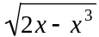 with respect to x. 1 mark

- Let 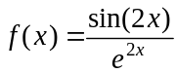.

Evaluate 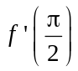. 3 marks

Question 2 (4 marks)

Let 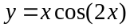.

- Find 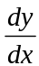. 2 marks

- Hence, evaluate 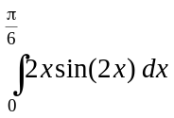. 2 marks

Question 3 (2 marks)

The Year 12 leadership team at a school is made up of four female and three male students. Three of these students are rostered at random to be present at the Junior assembly each week.
Let represent the sample proportion of female students who are rostered to be present at next week’s Junior assembly.

- Write down the possible values of . 1 mark

- Find 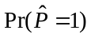. 1 mark

Question 4 (5 marks)

- Solve 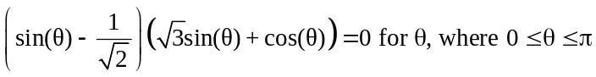. 2 marks

- Let 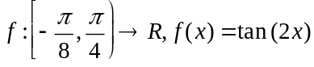.
Sketch the graph of f on the axes below. Label any asymptotes with the appropriate equation, and label any endpoints with their coordinates. 3 marks

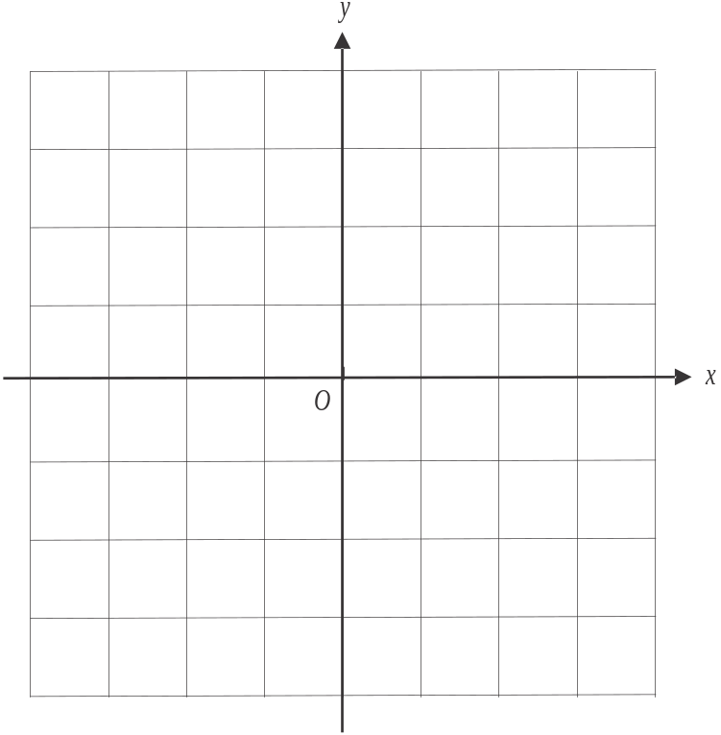

Question 5 (4 marks)

Let 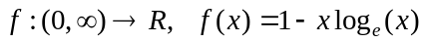.
The graph of f is shown below.

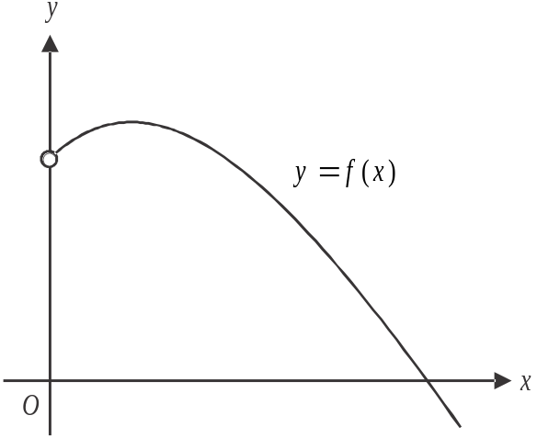

- Find the coordinates of the stationary point of f, expressed in simplest form. 3 marks

- Find the values of x for which f is strictly decreasing. 1 mark

Question 6 (5 marks)

Let 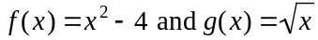 where f and g have maximal domains.

- i. Find the rule for 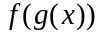. 1 mark

______________________________________________________________

______________________________________________________________

  - State the domain and range of . 2 marks

The domain of f is to be restricted to 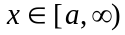 where a is the smallest possible value such that 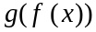 exists.

- Find the value of a. 2 marks

Question 7 (5 marks)

In a sample space with two events A and B, 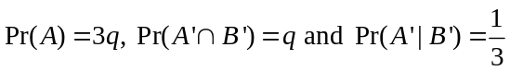.

- Find 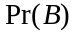 in terms of q. 1 mark

- Find 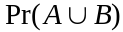 in terms of q. 2 marks

- If 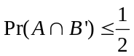, find the possible values for q. 2 marks

Question 8 (4 marks)

A continuous random variable X has a probability density function given by

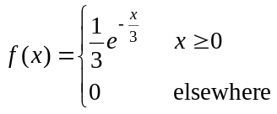

The median of X is m.

- Find the value of m. 2 marks

- Given that , find 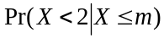. 2 marks

Question 9 (7 marks)

Let 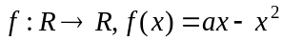, where a is a positive constant.
A tangent is drawn to the graph of f at the point 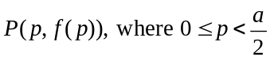, as shown below.

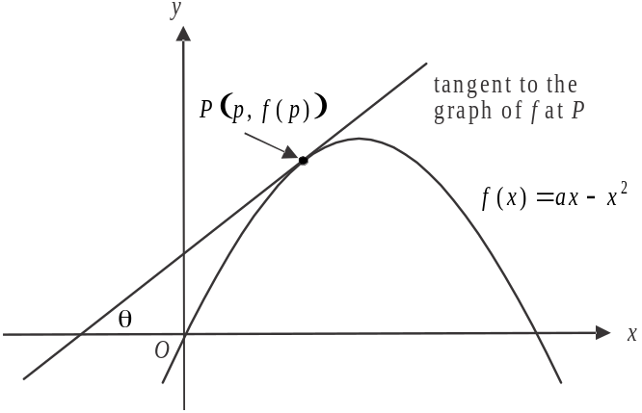

The tangent makes an angle of with the positive direction of the horizontal axis as shown.

- Show, without using calculus, that the turning point of the graph of f is located at the point where 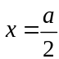. 1 mark

- Find, in terms of a, the maximum value of . 2 marks

- If 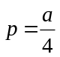, find in terms of a, the area enclosed by the tangent, the graph of f and the y-axis. 4 marks

Mathematical Methods formulas

Mensuration
area of a trapezium | 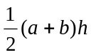 | volume of a pyramid | 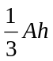
curved surface area of a cylinder | 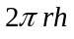 | volume of a sphere | 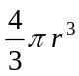
volume of a cylinder | 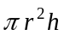 | area of a triangle | 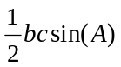
volume of a cone | 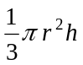

Calculus
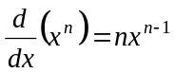 |  | 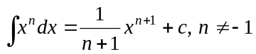
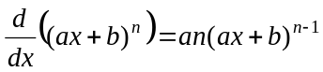 |  | 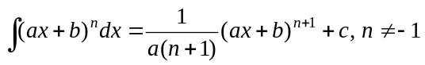
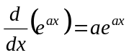 |  | 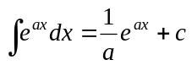
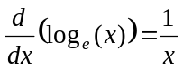 |  | 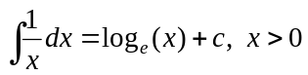
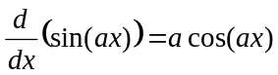 |  | 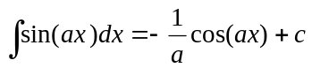
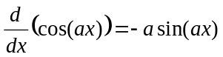 |  | 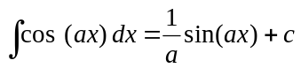
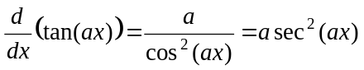
product rule | 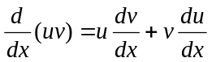 | quotient rule | 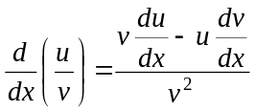
chain rule | 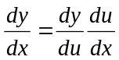
Mathematics Formula Sheets reproduced by permission; © VCAA 2017. The VCAA does not endorse or make any warranties regarding this study resource. Current and past VCAA VCE® exams and related content can be accessed directly at www.vcaa.vic.edu.au

Probability

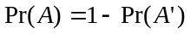
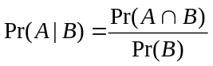
mean | 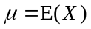 | variance

Probability distribution |  | Mean | Variance
discrete | 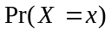=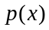 | 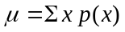 | 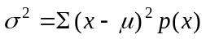
continuous | 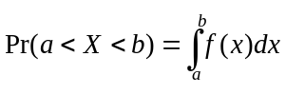 | 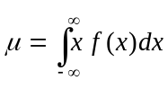 | 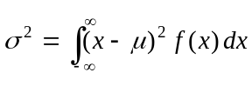

Sample proportions

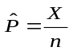 |  | mean | 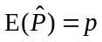
standard  deviation | 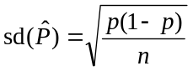 | approximate  confidence  interval | 