IARTV | 2005 | BIOLOGY | Written examination 2

SECTION A – Multiple-choice questions

Question 1
When a cell is in the stage called interphase
- the chromosomes are not visible and are dispersed throughout the nucleus as chromatin
- the DNA doubles as the chromosomes split into two which are called chromatids
- the cell is in the first stage of cell division of either mitosis or meiosis
- the cell is in the shortest stage of the cell cycle

Question 2
The following table shows the number of chromosomes found in different plant and animal species.

Species | Number of chromosomes
fruit fly | 8
broad bean | 12
onion | 16
locust | 24
lily | 24
yeast | 34
cat | 38
mouse | 40
human | 46
potato | 48
chimpanzee | 48
horse | 64
dog | 78

From this table and your knowledge it can be concluded that
- the bigger the organism the greater the number of chromosomes it possesses
- different species can have the same chromosome number but would have different gene loci
- lily and locust must be closely related as they have the same chromosome number
- all the numbers of chromosomes are even numbers as the chromosomes occur in identical pairs

Question 3
The following diagram shows the reproductive cycle of a sexually-reproducing animal.
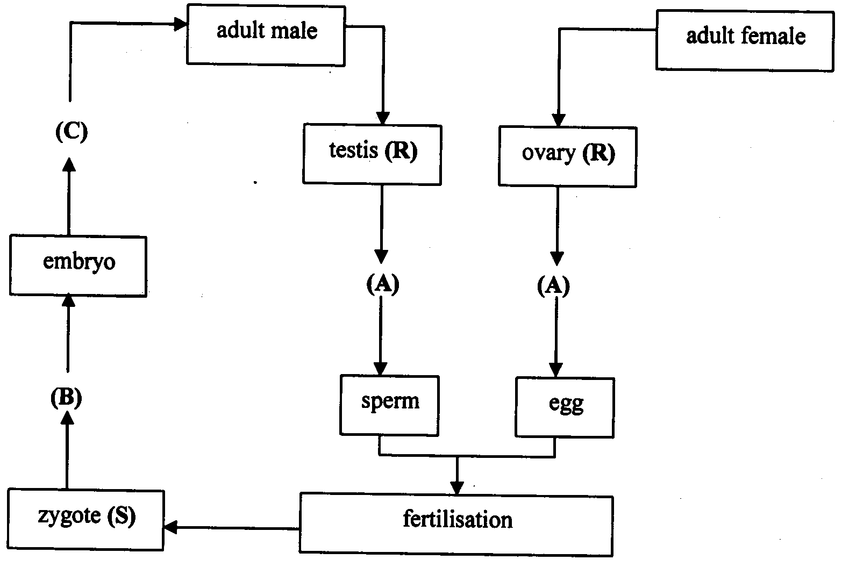
In this diagram, which of the following combinations is correct?

 | Process at A | Process at B | Cell in R | Cell S
A. | mitosis | meiosis | diploid | haploid
B. | mitosis | meiosis | haploid | diploid
C. | meiosis | mitosis | diploid | diploid
D. | meiosis | mitosis | haploid | diploid
Question 4
Which of the following is the correct combination?

 | Name of process | Uses DNA polymerase | Occurs in every living cell | Is semi-conservative
A. | Protein synthesis | yes | yes | no
B. | DNA replication | yes | yes | no
C. | Protein synthesis | no | yes | yes
D. | DNA replication | yes | no | yes

Question 5
The following photographs are karyotypes of a normal female and a normal male.

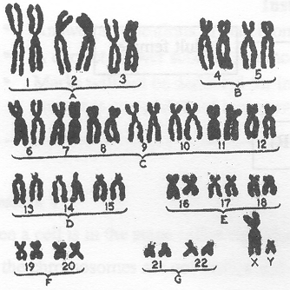 | 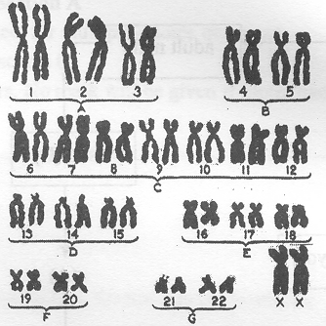
Normal male karyotype | Normal female karyotype

From these two karyotypes it can be said that
- all human chromosomes occur in pairs called homologous pairs
- the chromosomes in pairs 1 to 22 are called somatic chromosomes
- human female somatic cells contain more DNA that human male somatic cells
- the diploid number of chromosomes in a human somatic cell is 23

Question 6
The pattern of sex determination is not the same in all animals. For example, tiger snakes (Notechis sp) have a total of 34 chromosomes with males having two long Z chromosomes and females having one long Z chromosome and one short W chromosome. A gene for colour banding id located on the Z chromosome and has two alleles – one for dark banding (D) and one for light banding (d). This would mean that
- female tiger snakes could have 3 genotypes for this sex-linked gene
- male tiger snakes could have 2 phenotypes for this gene
- female tiger snakes could be carriers of this sex-linked gene
- the W chromosome determines maleness in the tiger snake

Information for Questions 7, 8 and 9

In Cherry flies normal body (N) is dominant to fat body (n) and red eye (R) is dominant to purple eye (r). Crosses between flies with the genotype NnRr and nnrr produced the offspring:
50 % - normal body, red eye
50% - fat body, purple eye

Question 7
This type of cross is called a
- monohybrid cross
- test cross
- recombinant cross
- variation cross

Question 8
The results of this cross best illustrate
- linkage
- sex linkage
- crossing-over
- independent assortment
Question 9
The genotype of the breeding fly with the genotype NnRr should have been written

Question 10
Which of the following is a correct statement about DNA?
- DNA is a protein made up of two polynucleotide chains.
- The double helix of DNA is made up of two DNA molecules bonded together.
- The molecular shape of DNA is maintained by hydrogen bonding between complementary base pairs.
- DNA contains four types of nitrogen bases – adenine, guanine, uracil and cytosine.

Question 11
Transcription ends in the production of
- a DNA molecule
- a protein
- a tRNA molecule
- an mRNA molecule

Information for Questions 12, 13 and 14

The action of a cutting enzyme on DNA produces a mixture of fragments. These DNA fragments can be sorted using the technique of gel electrophoresis.

Question 12
This technique relies on the fact that the DNA fragments are
- different lengths
- positively charged
- invisible until stained
- made up of nucleotides

Question 13
To decipher the results of gel electrophoresis the bands on the gel are examined for
- the thickness of each band
- the length of each band
- the position of each band
- the colour intensity of each band

Question 14
Red-green colour blindness is inherited as a sex-linked recessive characteristic. If the DNA for the gene for red-green colour blindness was analysed for a variety of people using gel electrophoresis the following gel patterns would be obtained.
- The gel for a colour blind male would have two bands.
- The gel for a colour blind male would be similar to that for a colour blind female.
- The gel for a female who was a carrier for colour blindness would have only one band.
- The gel for a male unaffected by colour blindness would always be the same as the gel for an unaffected female.

Question 15
The Genetic Code is said to be redundant as
- there is one start codon and three stop codons
- more than one triplet of bases codes for one amino acid
- the code is essentially the same in all living organisms
- several amino acids may be encoded by the same codon

Question 16
In his studies of patterns of inheritance, Mendel chose characters that were clear-cut and easy to tell apart. Such a character is the colour of goldfish.
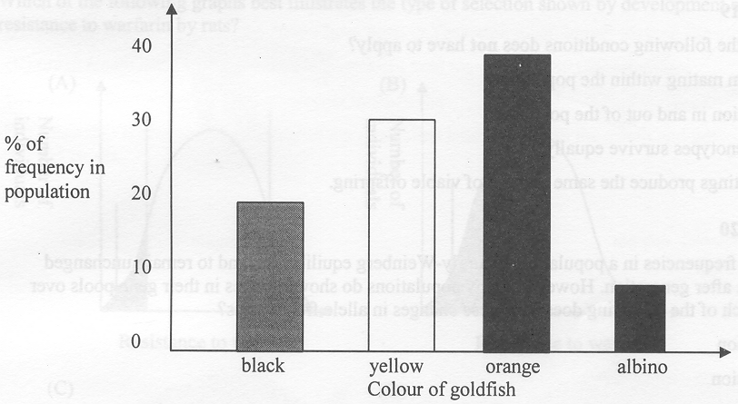
This is an example of
- discontinuous variation
- continuous variation
- disjointed variation
- cumulative variation

Question 17
The earliest fossil animals known, found as impressions in sandstone, are complex, multicellular, soft-bodied forms, including jellyfish and segmented worms.
The formation of such fossil impressions could occur if there was
- rapid decomposition by microbes
- rapid burial by sediments
- consumption by scavengers
- disturbance by wave action

Question 18
A 12 kb length of DNA was cut with the restriction enzyme EcoR1 in 3 places. Which of the following would be correct?
- There would be 3 fragments of DNA after cutting.
- Each DNA fragment would be 3 kb in length.
- The base sequence at each cutting point would be the same.
- A similar result would be obtained if the restriction enzyme HindIII was used.

Information for Questions 19 and 20

In 1908 Hardy-Weinberg put forward the theory that allele frequencies in a population will remain constant from generation to generation providing a particular set of conditions applies.

Question 19
Which of the following conditions does not have to apply?
- random mating within the population
- migration in and out of the population
- all phenotypes survive equally
- all matings produce the same number of viable offspring

Question 20
The allele frequencies in a population in Hardy-Weinberg equilibrium tend to remain unchanged generation after generation. However, many populations do show changes in their gene pools over time. Which of the following does not cause changes in allele frequencies?
- selection
- migration
- chance event
- interbreeding

Information for Questions 21 and 22

A typical example of natural selection is shown by the development of resistance by rats to warfarin, which is used as a poison to kill rats. It is an anti-coagulant and kills them by inducing internal bleeding. Within several years of the introduction of warfarin, rats had become resistant to it.

Question 21
In the following graphs the shaded area marked with the arrows show the individuals in the population which are being selected against.
Which of the following graphs best illustrates the type of selection shown by development of resistance to warfarin by rats?
 | 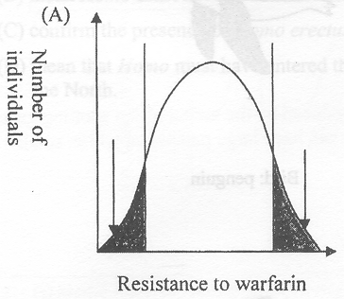 |  | 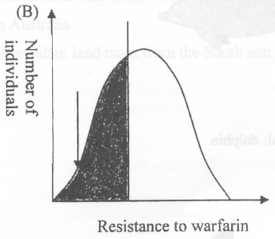
 | 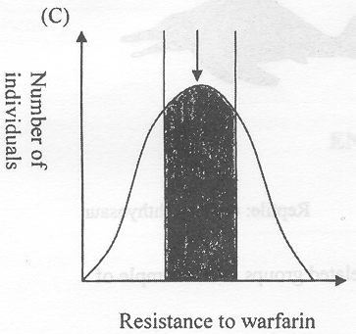 |  | 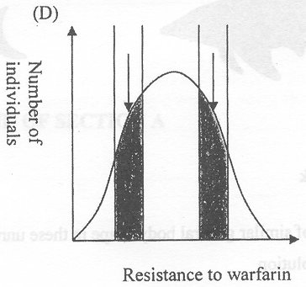

Question 22
The selective pressure in this example of natural selection is the
- different species of rats
- effect of the warfarin
- way the poison was administered
- presence of warfarin

Question 23
The following diagrams show the body shapes in four unrelated vertebrate groups that all live in an aquatic environment. The ichthyosaur, penguin and dolphin each evolved from a terrestrial species that changed to an aquatic lifestyle whereas the shark has always been aquatic.

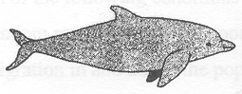 | 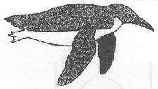
Mammal: dolphin | Bird: penguin
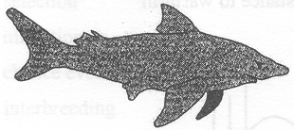 | 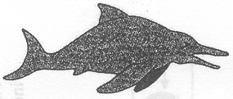
Fish: shark | Reptile: extinct ichthyosaur

The development of similar general body shape in these unrelated groups is an example of
- convergent evolution
- divergent evolution
- analogous evolution
- homologous evolution

Question 24
Several human features have been identified as responses to local climatic conditions. Which one of the following evolved as a climatic adaptation?
- decreased body size in cooler climates
- longer limbs in hotter climates
- larger sinuses and less fat padding on the faces of the Asiatic races from colder climates
- reduced body surface area in relation to body volume in hotter climates

Question 25
A mound of shellfish remains left after many meals by a group of ancient humans was discovered in a Tasmanian cave. These remains have been tentatively dated at 80,000 years old. If this date is accurate, these shellfish remains would
- mean members of the genus Homo have been in Tasmania much longer than on the mainland
- mean Homo must have entered the Australian land mass before 80,000 years ago
- confirm the presence of Homo erectus in Australia
- mean that Homo must have entered the Australian land mass from the South and not the North

SECTION B – Short-answer questions

Question 1 (3 marks)
Some cats have white patches on their coats. This effect is produced by the action of the spotting gene S. The gene has two codominant alleles, S₁ and S₂. The coats can have large patches of white; small white patches; or no patches at all.

- Explain the meaning of the term codominance.
_______________________________________________________________________________________
_______________________________________________________________________________________
1 mark
- A cat with no white patches homozygous for S₁ was mated with a cat with small white patches. Some of the offspring produced had coats with small white patches and the rest had no patches.
Use the allele symbols given to draw a genetic diagram to show this cross and include the expected ratio of phenotypes.

Parental genotypes: ____________________ × ____________________

Expected ratio of phenotypes in offspring: _____________________________
2 marks

Question 2 (12 marks)
The following diagram shows the amount of DNA (measured in arbitrary units) during several cell divisions in animal tissue.
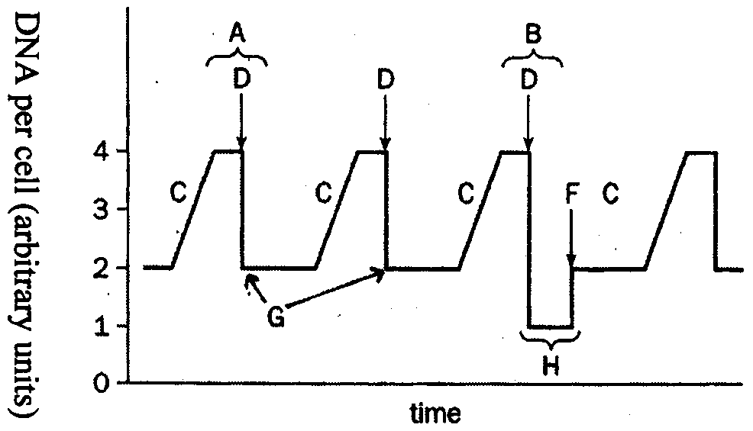
Figure 1

- (i) Name the type of cell division occurring at B.
____________________________________________________________________________________
(ii) Using the data in the diagram, give a reason for your answer in (i).
____________________________________________________________________________________
____________________________________________________________________________________
1 + 1 = 2 marks
- Explain what is occurring in the cells of this animal tissue that has caused the change in the amount of DNA at the following points on the diagram:
(i) At points C ______________________________________________________________________________
____________________________________________________________________________________
____________________________________________________________________________________
(ii) At points G ______________________________________________________________________________
____________________________________________________________________________________
____________________________________________________________________________________
1 + 1 = 2 marks
- What term is used to describe the chromosome number of the type of cell produced at G?
_______________________________________________________________________________________
1 mark
The following diagram shows four cells from the same animal tissue as in Figure 1 at different stages of one type of cell division.
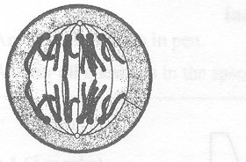 | 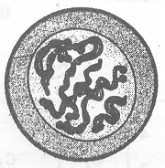
Cell 1 | Cell 2
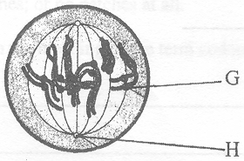 | 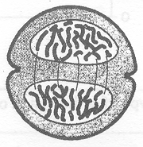
Cell 3 | Cell 4
Figure 2

- (i) Place a letter X on the place(s) on Figure 1 where you would expect to see a cell which looks like Cell 3 in Figure 2.
1 mark
(ii) Use the number of each cell to arrange the stages in the correct sequence for this type of cell division.
__________________________________________________________________________________
1 mark
- (i) Name the structure labelled H.
____________________________________________________________________________________
(ii) What is the function of structure G?
____________________________________________________________________________________
____________________________________________________________________________________
1 + 1 = 2 marks
- Mitosis maintains genetic stability in an organism whereas meiosis contributes to greater variation in a species. Explain this statement by:
(i) explaining how mitosis maintains genetic stability in an organism.
____________________________________________________________________________________
____________________________________________________________________________________
____________________________________________________________________________________
(ii) describing two ways in which meiosis contributes to greater variation in a species.
____________________________________________________________________________________
____________________________________________________________________________________
____________________________________________________________________________________
____________________________________________________________________________________
____________________________________________________________________________________
1 + 2 = 3 marks

Question 3 (6 marks)
Rickets is a bone disease in which the growing bones soften, bend and are deformed. It is usually caused by a deficiency of vitamin D. However one rare form of rickets is hereditary. The following pedigree shows the pattern of inheritance for this rare form of rickets in a human family. The phenotypes of individuals 1-4 had not been recorded.
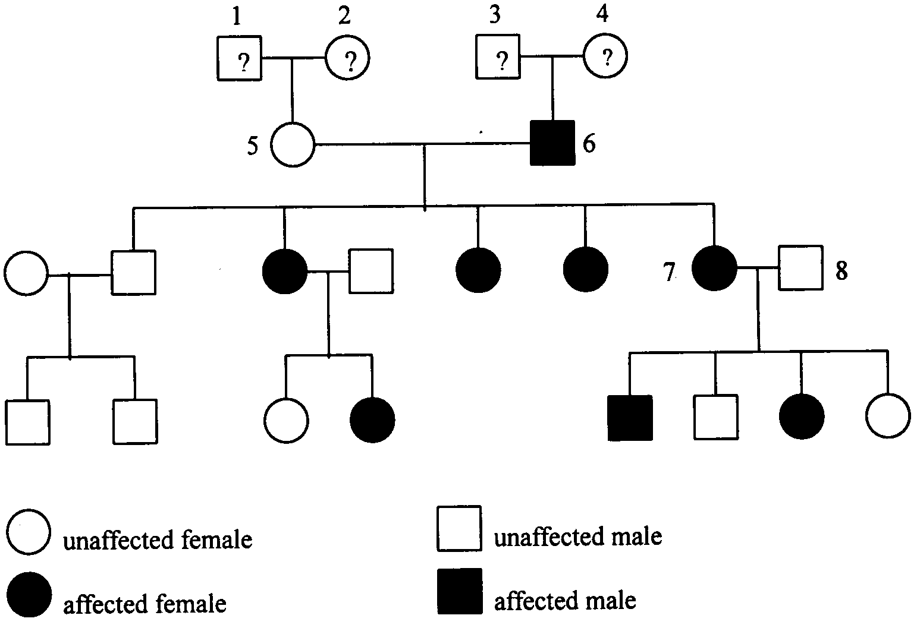

- On the basis of the five children produced by parents 5 and 6, a student suggested that this form of rickets is inherited as a sex-linked dominant characteristic. Give one feature of this part of the family pedigree that would support this student’s suggestion.
_______________________________________________________________________________________
_______________________________________________________________________________________
1 mark
- If the student was correct what are the possible phenotypes of individuals 1, 2, 3 and 4 – do they have rickets, not have rickets, or cannot decide?

Individual 1 _________________________ Individual 2 _________________________
Individual 3 _________________________ Individual 4 _________________________
2 marks
- If the student was correct and using the appropriate symbols for a sex-linked dominant characteristic, complete the following genetic diagram to explain how this type of rickets was inherited by the children of parents 7 and 8.

 | Parent 7 |  | Parent 8
Parental phenotype: | Female with rickets | × | Male without rickets
Parental genotype: |  | ×
Genotypes of gametes: |  | ×

Genotypes
of children
Phenotypes  of children | Male with rickets | Male no rickets | Female with rickets | Female no rickets

3 marks

Question 4 (5 marks)
In mice, the dominant allele B for a gene coat colour gives a black coat, the recessive allele b of this gene gives a brown coat. A second gene determines the density of the coat colour. The dominant allele D of this gene allows expression of coat colour while its recessive allele d dilutes the colour converting black to grey and brown to cream. These two genes are inherited independently.

- (i) On the chromosomes (shown at prophase) drawn below, mark in and label the positions of the two genes for a mouse which is heterozygous for both the coat colour gene and the colour density gene.
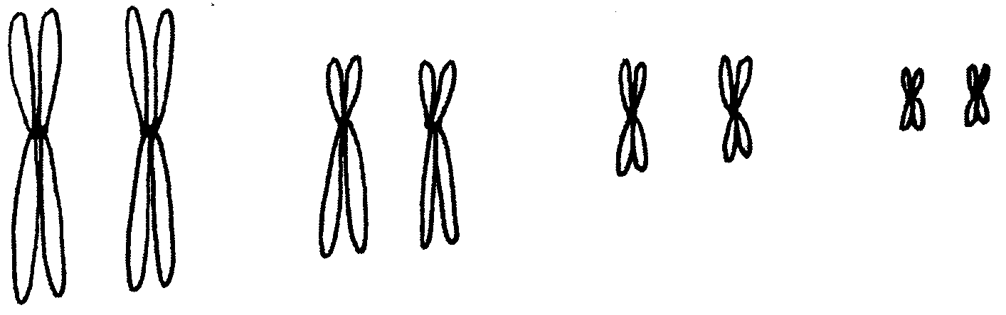
(ii) Explain how you have shown that these 2 gene loci are inherited independently.
__________________________________________________________________________________
__________________________________________________________________________________
1 + 1 = 2 marks
- A breeder crossed a male black mouse with a female cream mouse. The offspring produced showed four different coat colours: black, grey, brown, and cream, in approximately equal numbers.
(i) State the genotypes of the two parents.
Black male mouse: ________________________________________________________________
Brown female mouse: ________________________________________________________________
(ii) How do the resulting numbers of offspring further support the fact that the two gene loci are independently inherited?
__________________________________________________________________________________
__________________________________________________________________________________
__________________________________________________________________________________
2 + 1 = 3 marks

Question 5 (5 marks)
One of the processes in gene technology involves the synthesis of DNA, using messenger RNA (mRNA) as a template. This is shown in the diagram below.
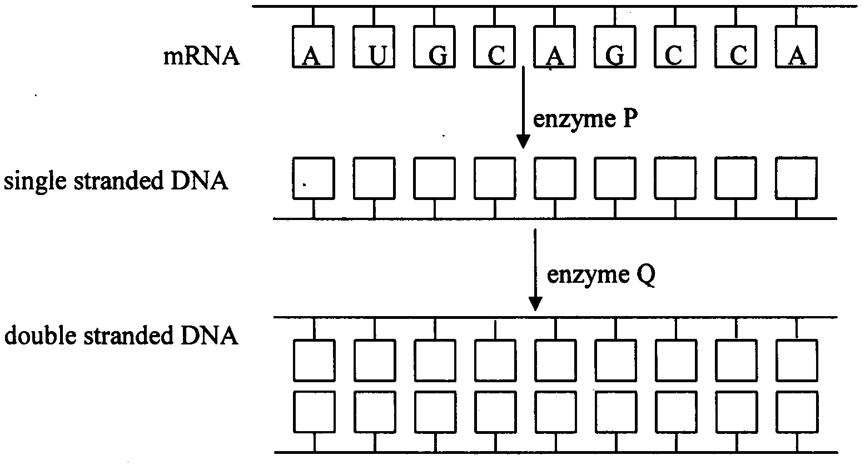

- Name enzyme P.
_______________________________________________________________________________________
1 mark
- Write in the sequence of bases which would be present in the single-stranded DNA by filling in the boxes along the strand.
1 mark
- Name enzyme Q.
_______________________________________________________________________________________
1 mark

The double-stranded DNA can be inserted into a bacterial cell which will then synthesise a protein which is coded for by this DNA.

- Name one protein which is produced this way on an industrial scale and explain why it is beneficial to manufacture this protein.
_______________________________________________________________________________________
_______________________________________________________________________________________
_______________________________________________________________________________________
_______________________________________________________________________________________
2 marks

Question 6 (8 marks)
Sometimes “instant speciation: can occur if a malfunction occurs during meiosis and chromosomes fail to separate. A new species can be formed which, although still in contact with the “parent species” is reproductively isolated from it.

- Why is reproductive isolation necessary to produce a new species?
_______________________________________________________________________________________
_______________________________________________________________________________________
_______________________________________________________________________________________
1 mark

A successful example of this type of “instant speciation” can be seen in the cord grass Spartina. The following diagram shows how it is formed.
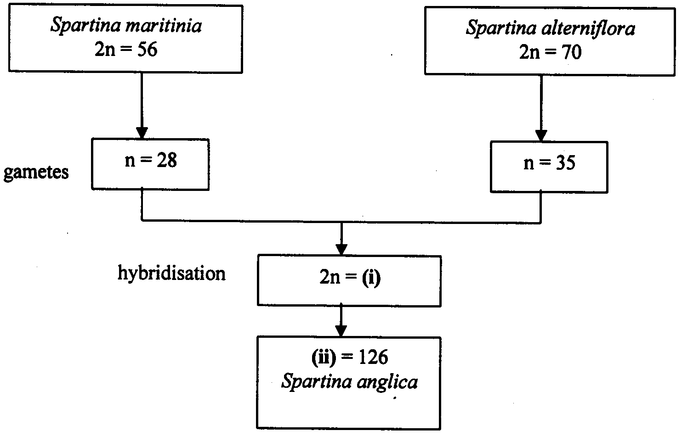

- Complete the missing information in the diagram by filling in the space below to indicate
(i) the number that should by in (i) _________________________________________________________
(ii) the number that should by in (ii) _________________________________________________________
1 mark
- What is the term used to describe such a condition in which there are more than the normal number of sets of chromosomes?
_______________________________________________________________________________________
1 mark

Spartina anglica grows vigorously and is tolerant to varying saltwater concentrations so it is able to grow well in mudflats around the mouths of rivers and can reach pest proportions.

- Why are plants able to form new species in this way whereas it is rare for animals to develop into a new species in this way?
_______________________________________________________________________________________
_______________________________________________________________________________________
_______________________________________________________________________________________
1 mark

Another interesting example of speciation appears to be a new species of mosquito developing in the tunnels of the London underground. When the underground tunnels were being constructed around 100 years ago, a population of the bird-biting mosquito Culex pipiens found its way underground. Subsequently a new species of the mosquito evolved. It is called Culex molestus and feeds on rats and mice.

- (i) What type of isolation has resulted in speciation in this example?
____________________________________________________________________________________
(ii) Briefly explain how this new species of mosquito Culex molestus evolved.
____________________________________________________________________________________
____________________________________________________________________________________
____________________________________________________________________________________
____________________________________________________________________________________
____________________________________________________________________________________
1 + 2 = 3 marks

In this example, speciation seems to have taken place over a far shorter time scale than in most cases of natural selection.

- Suggest why such rapid evolution of this new species has been possible.
_______________________________________________________________________________________
_______________________________________________________________________________________
_______________________________________________________________________________________
1 mark

Question 7 (6 marks)
The evolution of horses can be followed through a series of fossils obtained from successively younger rock strata. The series starts with a small animal called Hyracotherium which lived in North America about 50 million years ago (Eocene epoch) and then spread to Europe and Asia. There are many intermediate forms and numerous branches from the main line, finishing up with modern horse Equus.

- (i) What is a rock stratum?
____________________________________________________________________________________
____________________________________________________________________________________
(ii) Why is the study of fossils in rock strata useful?
____________________________________________________________________________________
____________________________________________________________________________________
____________________________________________________________________________________
1 + 1 = 2 marks
- How could the original species of horses that lived in North America have “spread” to Europe and Asia?
_______________________________________________________________________________________
_______________________________________________________________________________________
_______________________________________________________________________________________
1 mark

Compared with fossil sequences for most organisms the record for horses is quite complete. Fossil remains of Hyracotherium have been obtained from Eocene rocks in North Africa and indicate it was very much smaller and had well developed digits on both its hind and forefeet instead of a hoof. These spreading toes would have provided better support in the swampy woodlands in which it lived.

- Considering this information, suggest two reasons why good fossils of Hyracotherium have been found.
1. _____________________________________________________________________________________
_______________________________________________________________________________________
2. _____________________________________________________________________________________
_______________________________________________________________________________________
2 marks
- Which method would have been used to date the horse fossils most accurately from 55 million years ago to today?
_______________________________________________________________________________________
1 mark

Question 8 (5 marks)
The development of genetic techniques to identify proteins has made it possible to measure the degree of genetic relationship that exists between humans and their closest relatives. The measurements are based on proteins that are known to evolve over time as do the organisms to which they belong.

The following table shows the reactivity of various primate proteins with antisera compared against hominid protein (1.0 represents complete similarity).

 | Index of similarity
Species of protein | Antiserum to Homo | Antiserum to Pan | Antiserum to Hylobates
Homo sapiens  (humans) | 1.00 | 1.09 | 1.29
Pan troglodytes  (chimpanzee) | 1.14 | 1.0 | 1.40
Gorilla gorilla  (gorilla) | 1.09 | 1.24 | 1.31
Ponga pygmaeus  (orang-utan) | 1.22 | 1.25 | 1.29
Symphalangus  (siamang) | 1.30 | 1.25 | 1.07
Hylobates lar  (gibbon) | 1.28 | 1.25 | 1.00
Cercopithecoidea  (Old World monkeys) | 2.46 | 2.22 | 2.29

- Using the information from this table explain which primate is the most closely related to Homo.
_______________________________________________________________________________________
_______________________________________________________________________________________
_______________________________________________________________________________________
1 mark
- Using the immunological data given on the previous page, complete the following phylogenetic tree to show the evolutionary relationships between the primates by filling in the names of the primates in the boxes.
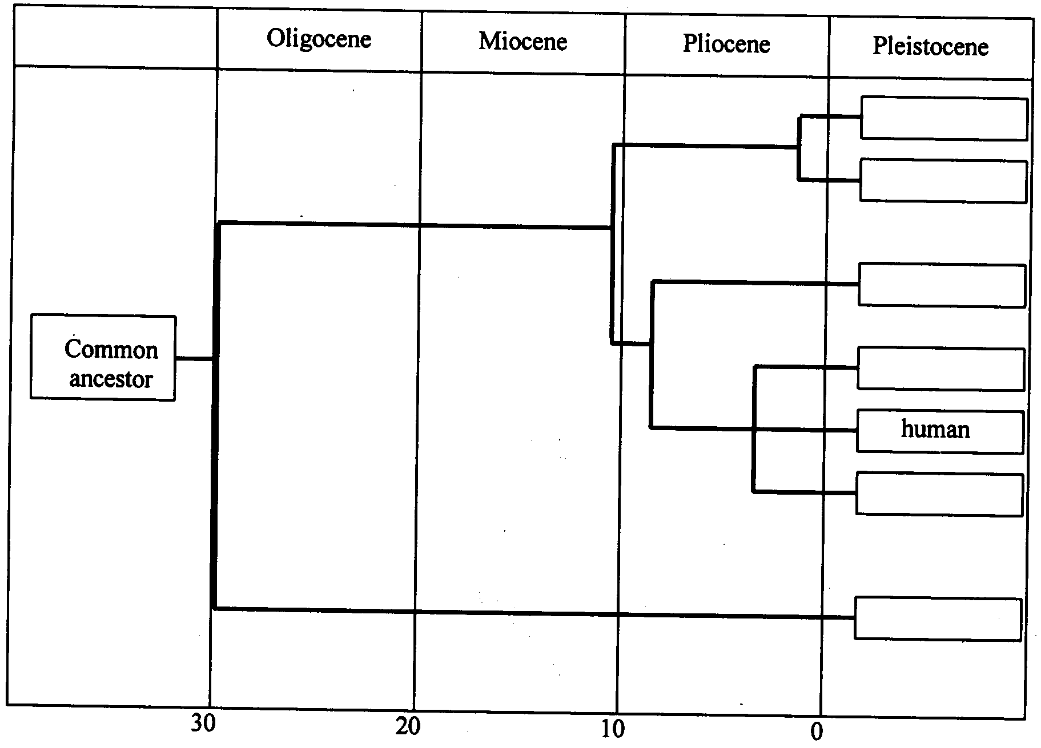
2 marks

The following is a picture of a fossil hominid skull.
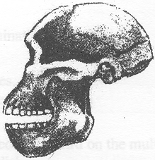

- A student said this was a modern skull of Homo. Give two reasons why the student was wrong.
1. _____________________________________________________________________________________
_______________________________________________________________________________________
2. _____________________________________________________________________________________
_______________________________________________________________________________________
2 marks

END OF EXAMINATION

