

SPECIALIST MATHS
TRIAL EXAM 1
2002
SOLUTIONS

___________________________________________________________________________

Part I – Multiple-choice answers

1. B 7. B 13. D 19. B 25. D
2. E 8. A 14. E 20. E 26. C
3. D 9. C 15. E 21. E 27. E
4. C 10. B 16. E 22. A 28. D
5. B 11. A 17. D 23. D 29. B
6. E 12. C 18. E 24. E 30. E

___________________________________________________________________________

Part I- Multiple-choice solutions

Question 1

The graph has asymptotes given by 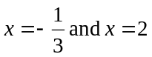.
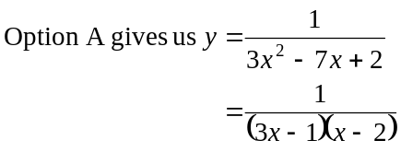
This graph has asymptotes at 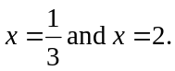
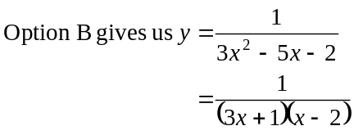
This graph has asymptotes at 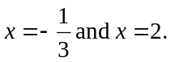
This is the correct option.
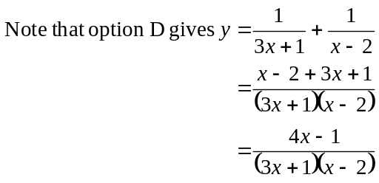
This graph has the correct asymptotes but the wrong shape as shown on the graph on page 2.
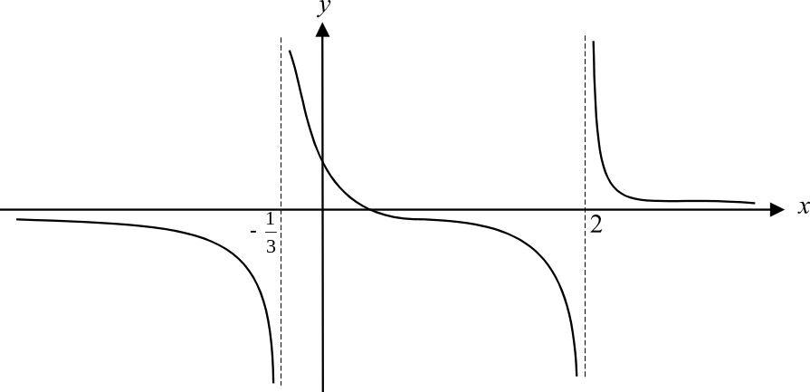

The answer is B

Question 2
The graph is that of a hyperbola which has its centre at 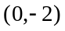. Looking along a line given by 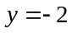, we note that 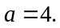 Looking at the asymptotes, we note that their gradients are 1 and –1 respectively. So, 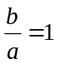 and 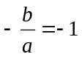. Therefore 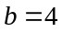.
So the correct equation for this hyperbola is 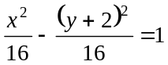.
The answer is E.
Question 3
Now 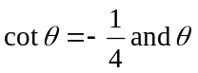 is a second quadrant angle.
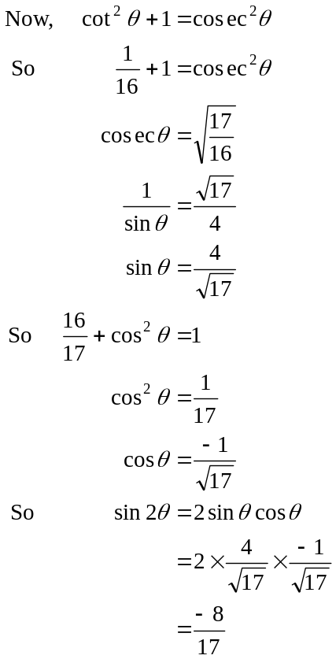
(positive since 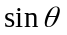 and hence 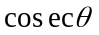 is positive in the second quadrant)
(negative since is a second quadrant angle)
The answer is D.
Question 4
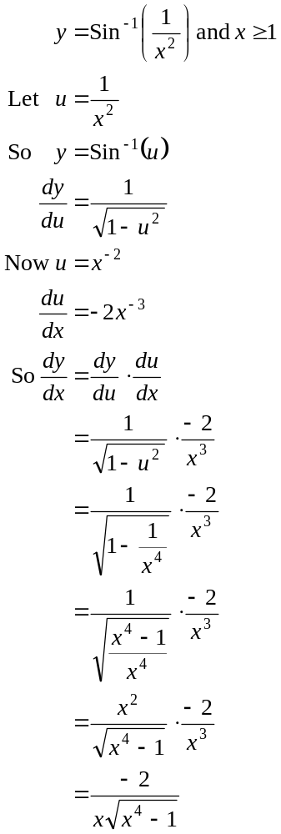
The answer is C.

Question 5
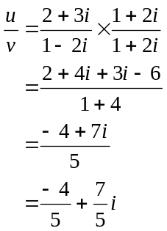
The answer is B.

Question 6
When a complex number is multiplied by i, the effect is to rotate it through an angle of 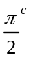 anticlockwise about the origin. Multiplying a complex number by has the effect of rotating it through an angle of 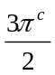 anticlockwise about the origin.
The answer is E.
Question 7
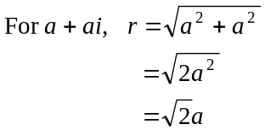
Now, since a is a positive or negative whole number, then r could equal 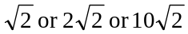. It cannot equal 2 since that can only be the case when 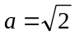 and a has to be a whole number.
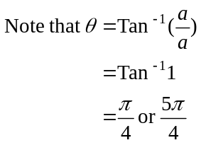
So, the polar form of 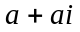 cannot be 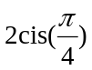.
The answer is B.

Question 8
Since 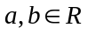, then according to the conjugate root theorem, any non-real roots must occur in conjugate pairs. So, if 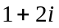 is a solution then so is 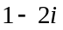. So, two factors are 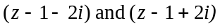
Now,
or 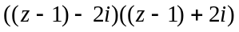
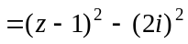
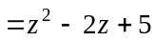
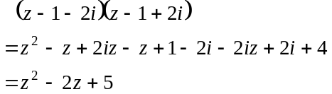
The third root must be a real number since if it were a complex number it would need a conjugate pair and there can only be three roots.
Since –10 is the constant term in the equation, the third factor must be 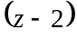.
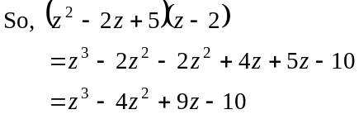
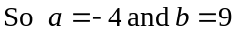.
The answer is A.
Question 9
Consider the region of the complex plane described by 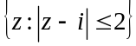.
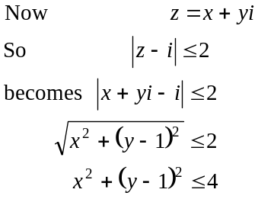
The region includes all the points on and inside the circle with centre 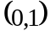 and radius 2 units. This eliminates options A, B and E.
Consider the region of the complex plane described by 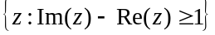.
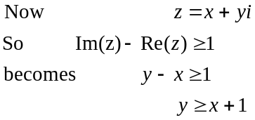
The region includes all the points on and above the line 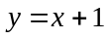. Only option C shows the intersection of these two regions.
The answer is C.

Question 10

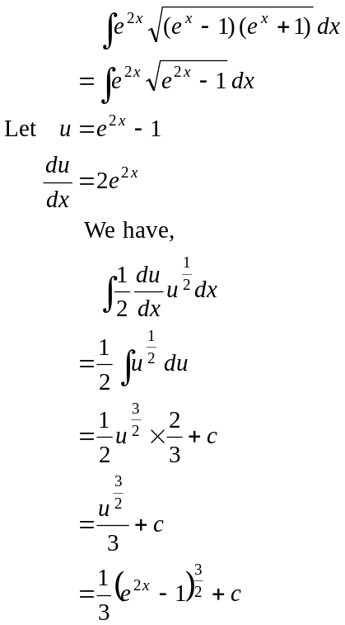
An antiderivative is 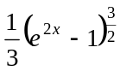.
The answer is B.

Question 11

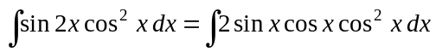
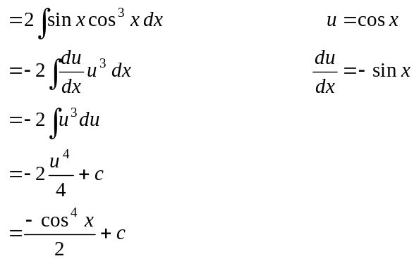
The answer is A.
Question 12

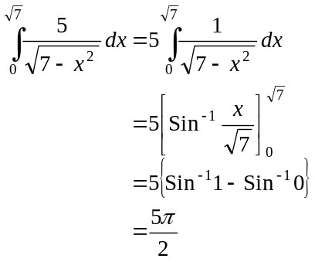
The answer is C.

Question 13

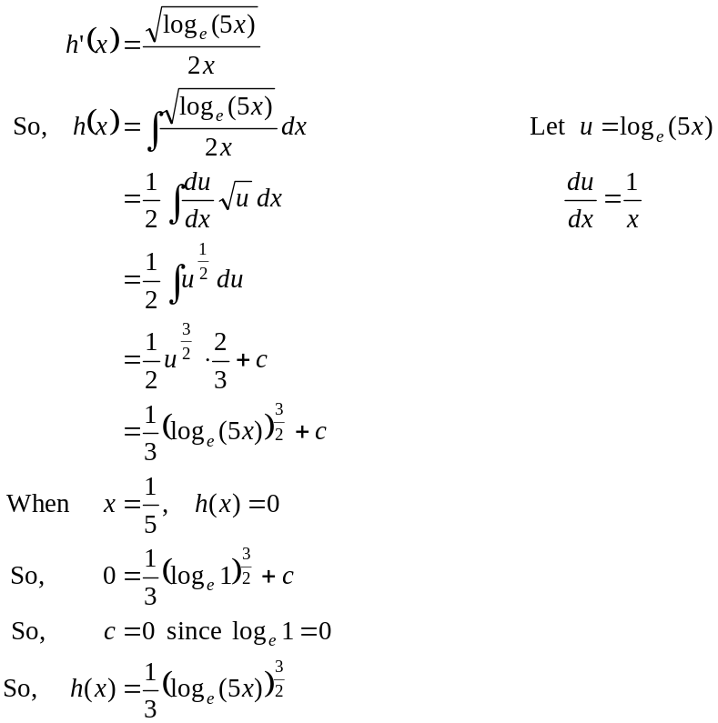
The answer is D.

Question 14

Area required is given by
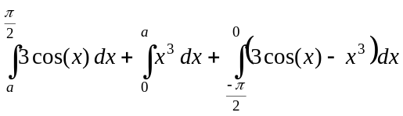
The answer is E.
Question 15
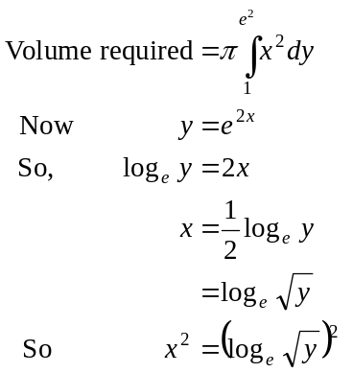
So volume required is given by 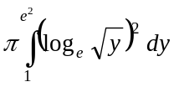 The answer is E.
Question 16
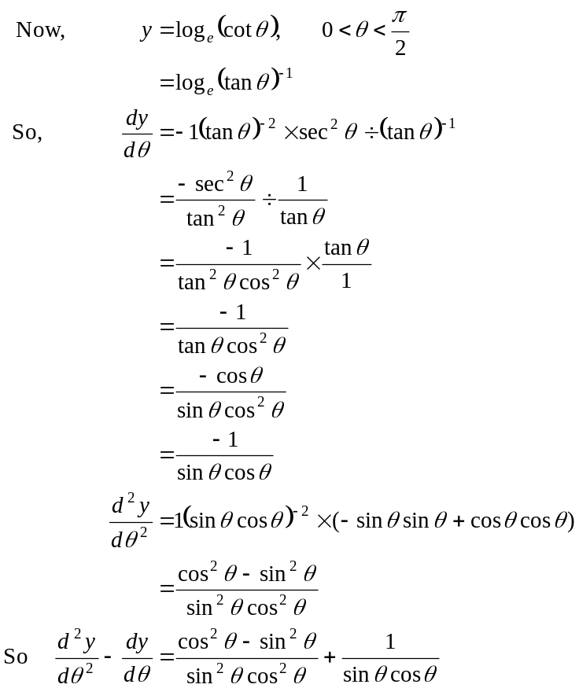The answer is E.

Question 17
For option A,
For option B,
For option C,
For option D,
For option E, 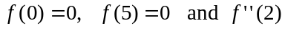<
Note that at a local maximum, 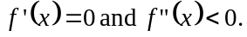 At a local minimum, 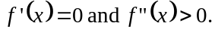
The answer is D.
Question 18

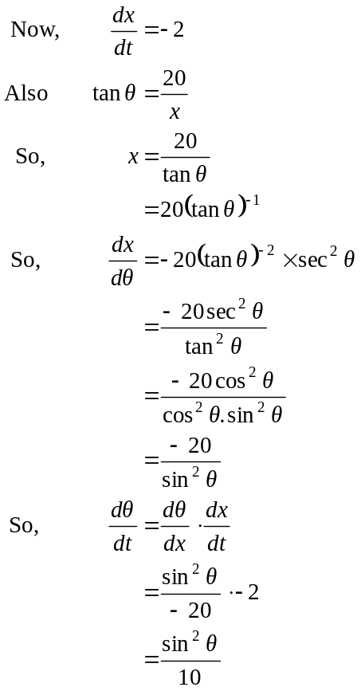
since the distance x is reducing as the man approaches the building.
The answer is E.

Question 19

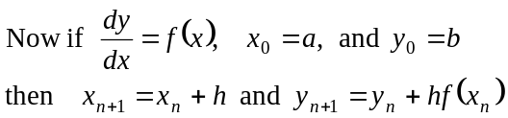
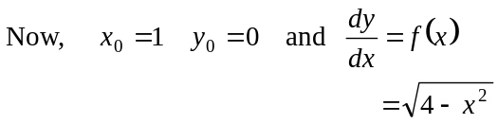
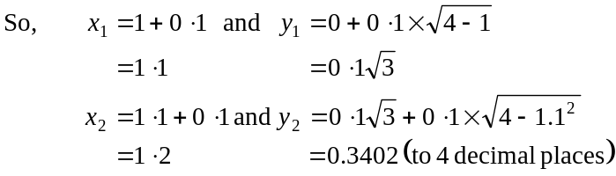
The answer is B.
Question 20

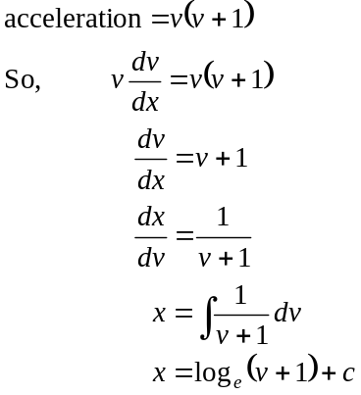
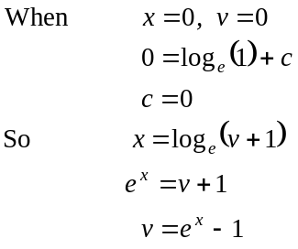
The answer is E.

Question 21

Let m be the latest time when the velocity of the particle was 10 m/s.
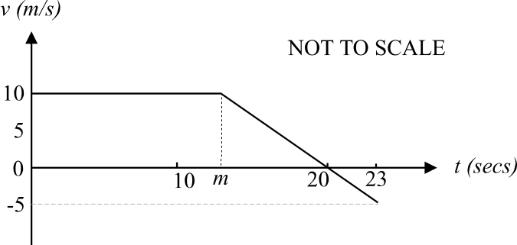

Between 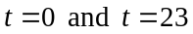, the displacement of the particle is given by
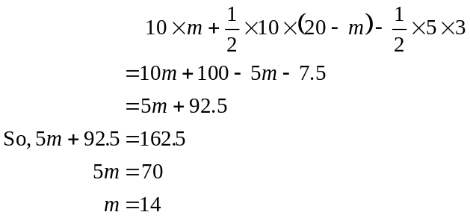
The answer is E.
Question 22
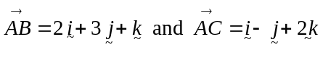
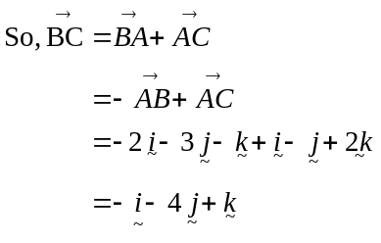
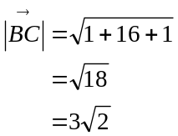
The answer is A.
Question 23
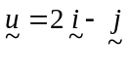 and 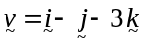
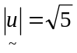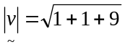
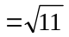
So 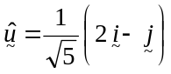 and 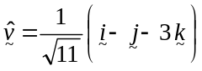
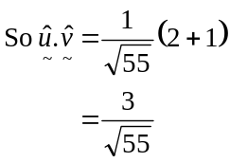
The answer is D.
Question 24
Option A - and are linearly dependent since 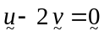
Option B - , and are linearly dependent since 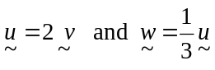 and
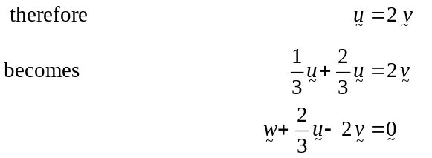
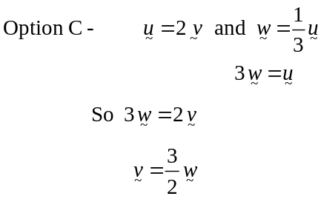
So is one and a half times the length of .
Option D – since 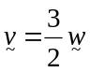, is parallel to .
Option E - 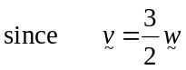
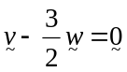
So and are linearly dependent.
So Option E is false.
The answer is E.

Question 25
Now, in 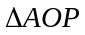,
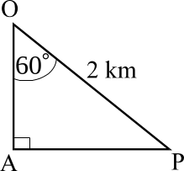
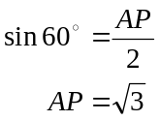
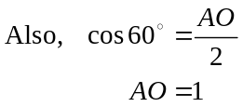
So, 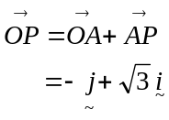
Note that the unit vector runs in the north direction.
The answer is D.

Question 26
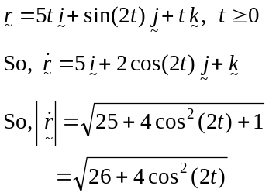
The speed will be a maximum when 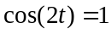 and hence 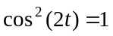.
The maximum speed is 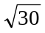.
The answer is C.

Question 27
momentum = mass velocity

Momentum is a vector quantity.
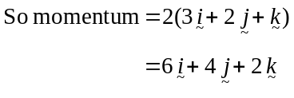
The answer is E.
Question 28
Let the direction of the force be in the direction.
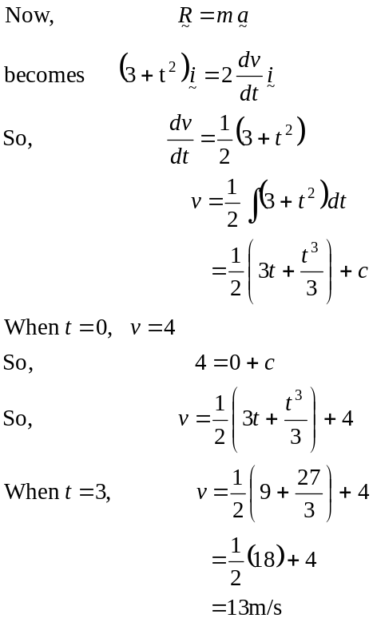
The answer is D.
Question 29

Draw a diagram.
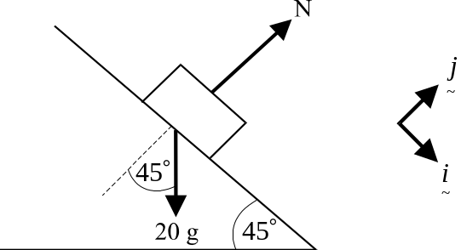

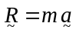
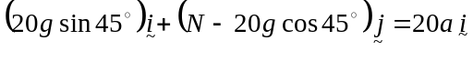
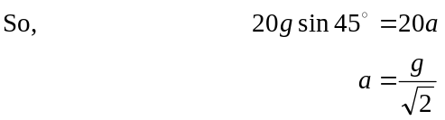
The answer is B.
Question 30
Draw a diagram.
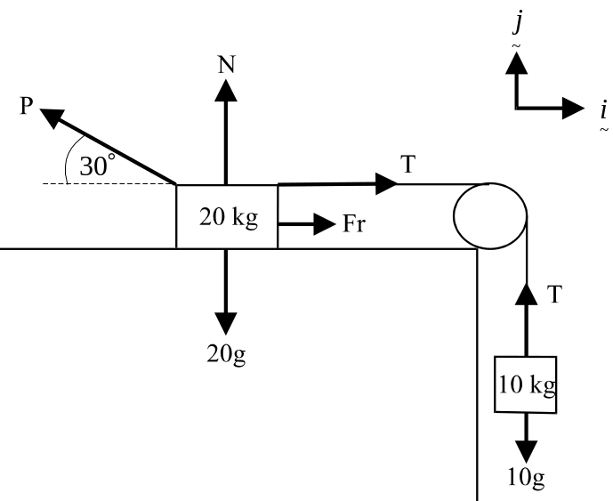

Resolving forces around the 10kg mass, we find that 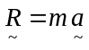
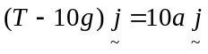
So, 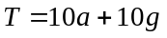
Around the 20kg mass, we have,
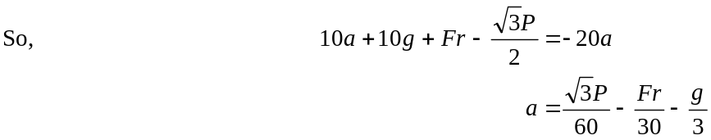
The answer is E.
PART II – Solutions
Question 1
i.
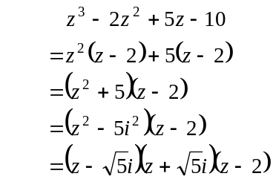
(1 mark)
ii.
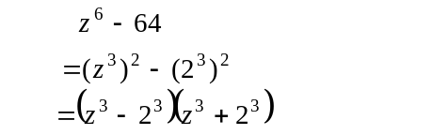
(1 mark)
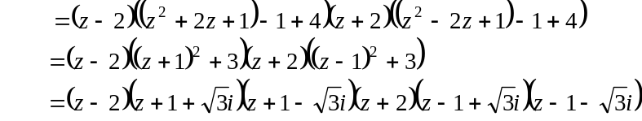
(1 mark)
Question 2
a. 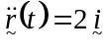
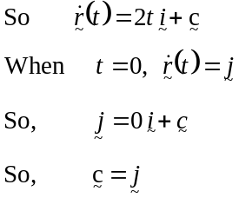
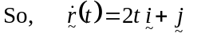 (1 mark)
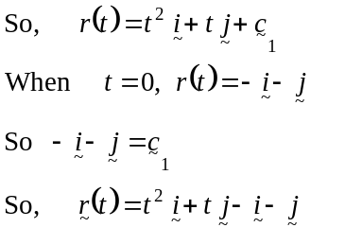
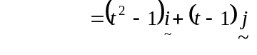 (1 mark)
- Since 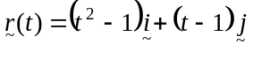
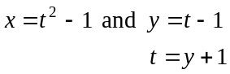
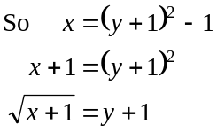
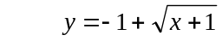 (1 mark)
We know to take the upper branch of the graph of 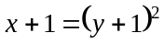 rather than the lower branch since when and so on. By continuing to evaluate points on the graph, we see that the upper branch is the path traced out by the particle.
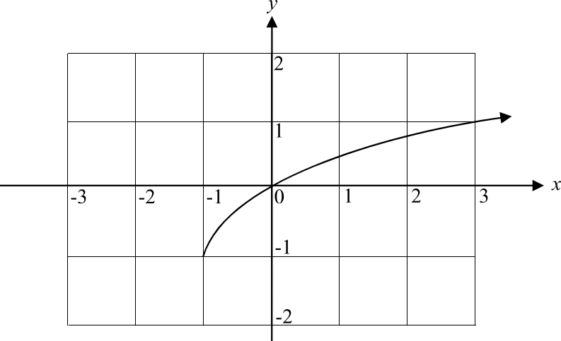

(1 mark)
Question 3

To Prove: 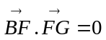

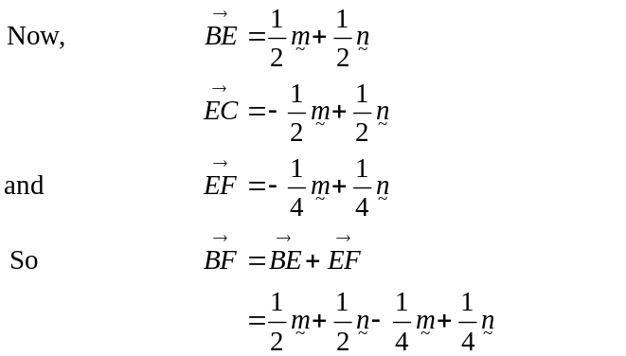
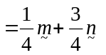 (1 mark)
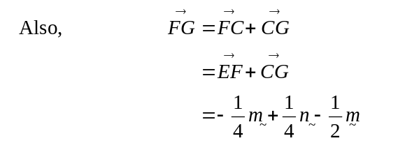
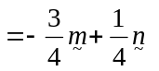 (1 mark)
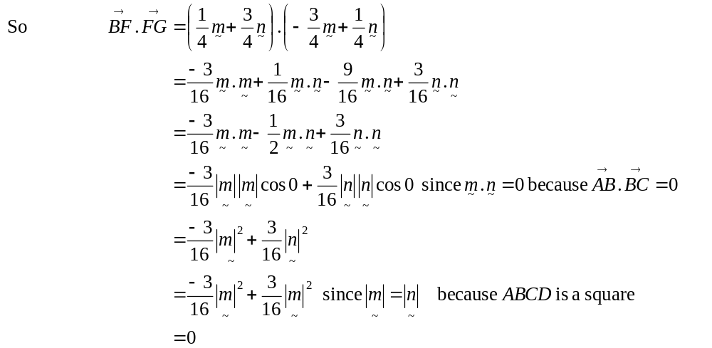
Have proved (1 mark)
Question 4

a.
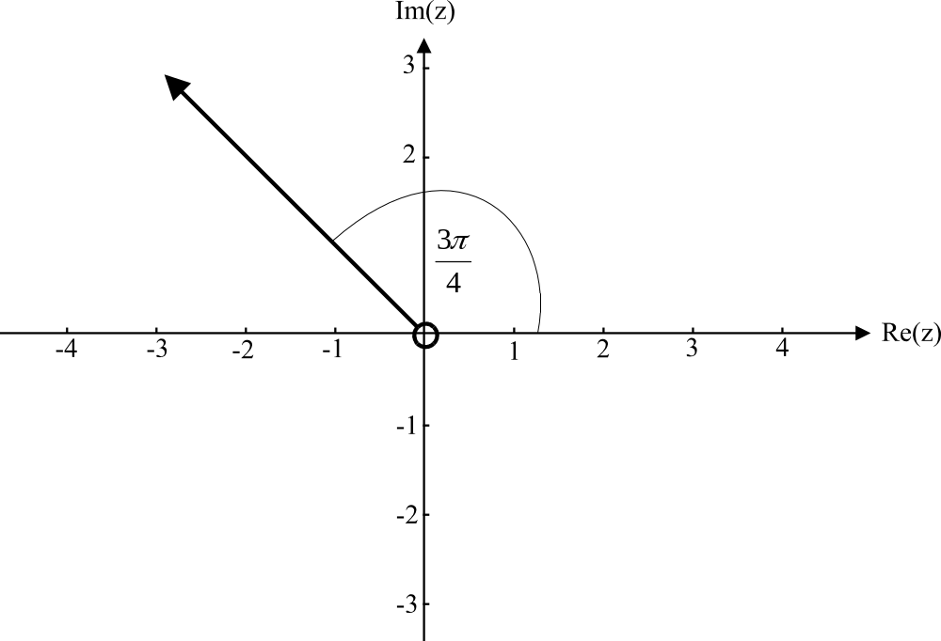

All the points along the ray shown have 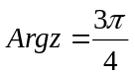. Note that the complex number 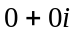 is excluded.
(1 mark)
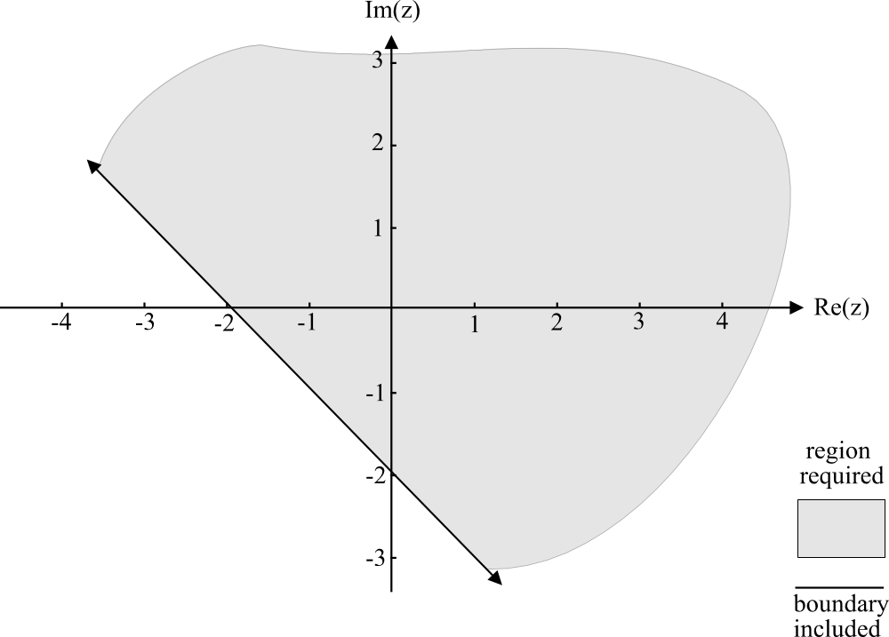
b.

(1 mark) for correct straight line
(1 mark) for correct shading
Method 1- geometrically
We are looking for the perpendicular bisector between 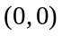 and 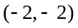 which is 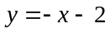. This straight line describes those complex numbers for which the distance between themselves and the origin is the same as the distance between themselves and the point 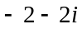.
The complex numbers indicated above the straight line are the complex numbers for which the distance between themselves and the origin is less than the distance between themselves and the point .
Method 2 – algebraically
Let 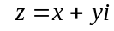
So, 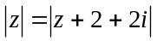
Becomes 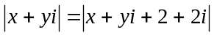
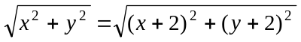
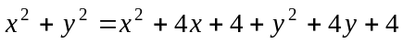
The boundary, which is included, is given by . We also require those points for which 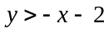 as indicated by the shaded region above.

Question 5

- The required differential equation is
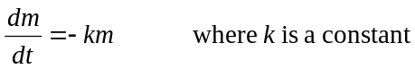 (1 mark)
b.
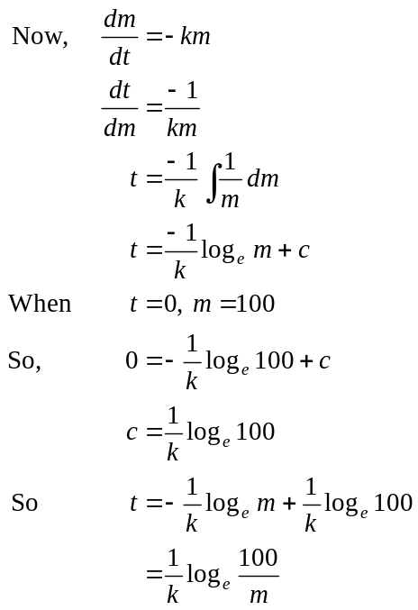
(1 mark)
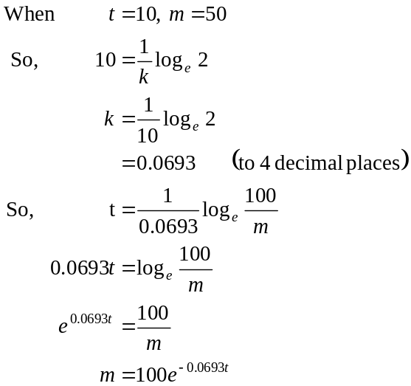
(1 mark)

Question 6

Use your graphics calculator to draw a quick sketch graph.
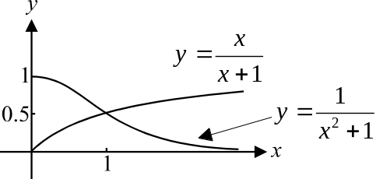

(1 mark)
The point of intersection of the two graphs is 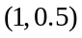.
Area required is given by
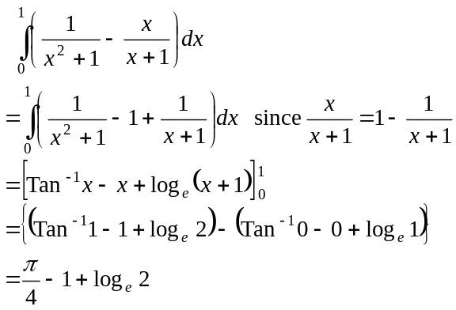(1 mark)
(1 mark)
(1 mark)

