

Students Name:______________________________

SPECIALIST MATHEMATICS

TRIAL EXAMINATION 2

(ANALYSIS TASK)

2002

Reading Time: 15 minutes
Writing time: 90 minutes

Instructions to students
This exam consists of 5 questions.
All questions should be answered.
There is a total of 60 marks available.
The marks allocated to each of the five questions are indicated throughout.
Students may bring up to two A4 pages of pre-written notes into the exam.
The acceleration due to gravity should be taken to have magnitude 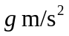where 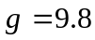
Formula sheets can be found on pages 16-18 of this exam.

This paper has been prepared independently of the Victorian Curriculum and Assessment Authority to provide additional exam preparation for students. Although references have been reproduced with permission of the Victorian Curriculum and Assessment Authority, the publication is in no way connected with or endorsed by the Victorian Curriculum and Assessment Authority.

© THE HEFFERNAN GROUP 2002
This Trial Exam is licensed on a non transferable basis to the purchaser. It may be copied for educational use within the school which has purchased it. This license does not permit distribution or copying of this Trial Exam outside that school or by any individual purchaser.
Question 1
Chris is practicing his goal shooting. He kicks at a goal, which is in the shape of a rectangular prism, 4 metres wide, 1 metre deep and 2 metres high. He kicks from point O, which is 24 metres from point S on the backline and 3 metres to the left of the left hand goal post. OS is perpendicular to the backline.
Chris kicks the ball in a straight line and hits the top right hand corner of the goal at point P. Point Q is the bottom right hand corner of the goal and is vertically below P.

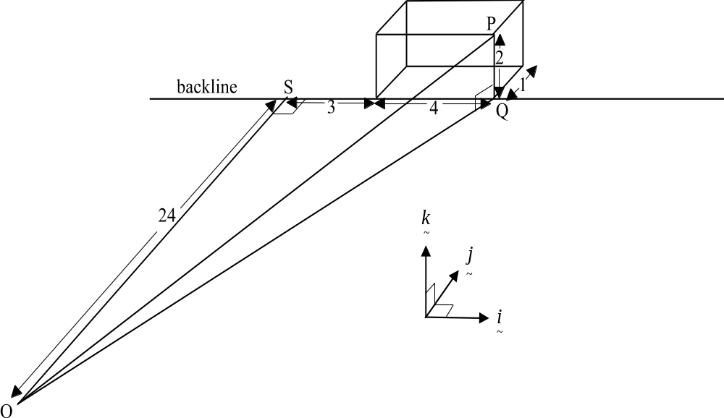

Let be the unit vector which runs parallel with the backline, let be the unit vector which runs parallel to the length of the ground and let be the unit vector which runs vertically upwards. Let point O be the origin.

a. i. Express 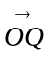 in terms of and .

1 mark

ii. Express 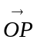 in terms of , and .

1 mark

b. i. Show that the vector component of , perpendicular to , is 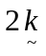.

2 marks

- Hence or otherwise find 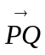.

2 marks

Chris has a second shot at goal from the same point O. This time he plays an identical shot but a team mate makes contact with the ball when it is 1.5 metres vertically above the ground at point R. With his head, this team mate deflects the ball in a straight line to point T, which is in the back left hand corner of the goal.
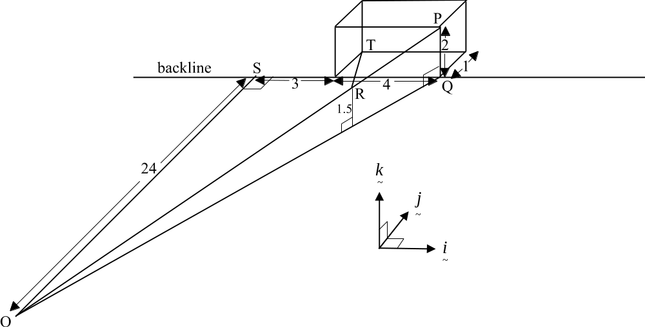

c. Show that 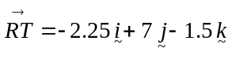

4 marks

d. Hence find the angle of deflection 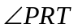, correct to the nearest minute.

3 marks
Total 13 marks

Question 2

A landscape gardener is paving a brick path through a park. The rate at which the path is being laid is given by
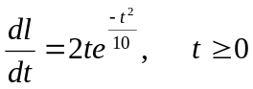

where l is the length of the path that has been laid in metres and t is the time taken to lay the path in hours. The landscape gardener starts laying the path at 7.00am.

a. Find the rate, in metres per hour, at which the path is being laid at 10.00am. Express your answer correct to 2 decimal places.

1 mark

b. i. Find, using calculus, the time at which the rate at which the landscape gardener is laying the path is fastest. Express your answer to the nearest minute.

3 marks

ii. Find the fastest rate at which the landscape gardener lays the path. Express your answer correct to 1 decimal place.

1 mark

c. After 9.00am when did the rate at which the path was being laid drop below 2 metres per hour? Express your answer to the nearest minute.

1 mark

d. Find 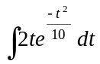.

2 marks

e. Hence find the length of the path laid between 7am and 12 noon. Express your answer correct to 1 decimal place.

2 marks
Total 10 marks

Question 3

a. On the set of axes below, sketch the function of 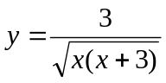.
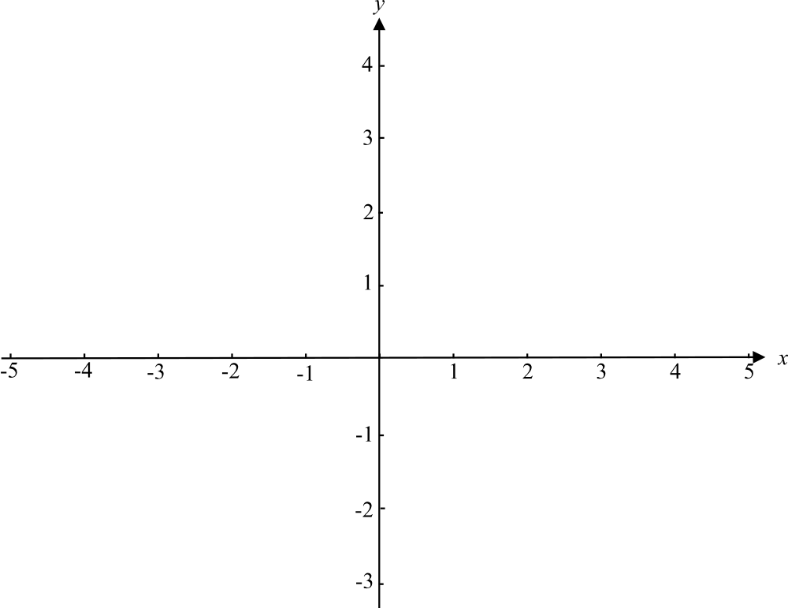

2 marks

b. Hence write down the maximal domain of the function .

1 mark

c. Find an approximation to 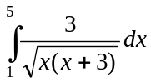 using the midpoint rule and 2 equal
intervals. Express your answer correct to 3 significant figures.

2 marks

d. Find the area bounded by the function 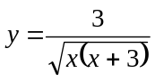 and the lines
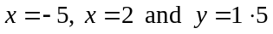. Express your answer correct to 3 significant figures.

3 marks

e. The function between 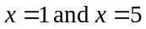 is rotated around the
x-axis to form a volume of revolution.
Find that volume and express it as an exact value.

4 marks
Total 12 marks

Question 4

A father exerts a pulling force of 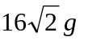newton to pull a child in a toboggan up a rough slope at a constant speed. The slope is at an angle of 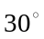 with the horizontal and the pulling force is acting at an angle of 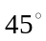 with the slope. The child and the toboggan together, have a mass of 30kg.
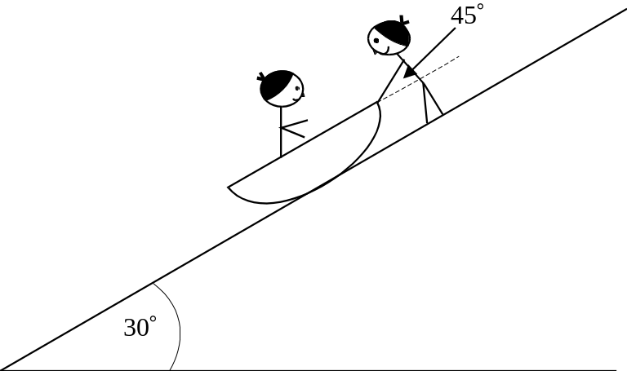

a. i. On the diagram below show all the forces acting on the toboggan with the child in it.

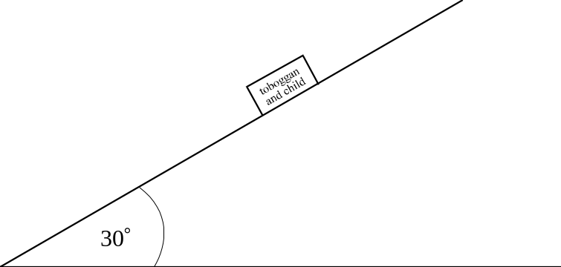

2 marks

- Show that the coefficient of friction between the toboggan with the child in it
and the slope is 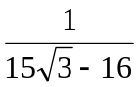.

4 marks

b. The father stops pulling the toboggan so that it becomes stationary. He rests for a minute and adjusts the child’s hat. The father then resumes pulling, this time with a pulling force of 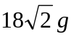 newton which he maintains for 20 seconds.

- Find the acceleration of the toboggan, with the child in it, up the slope once the father resumes pulling. Express your answer correct to 2 decimal places.

2 marks

ii. Hence find the distance covered by the toboggan during this time.

1 mark

iii. Find the speed of the toboggan with the child in it after 20 seconds.

1 mark

c. The father decides to move to a different slope, which is at an angle of 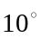 with the horizontal and which has a coefficient of friction of 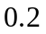. He lets go of the toboggan on this new slope and it remains at rest.

- Show on the diagram below the forces now acting on the toboggan with the child in it.
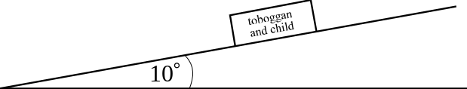

2 marks

ii. Explain with reasons whether or not the toboggan is on the point of sliding down the slope.

2 marks
Total 14 marks
Question 5

a. i. Let 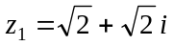. Express 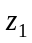 in polar form.

1 mark

ii. Find 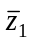 in polar form.

1 mark

iii. Let 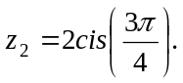 Show that 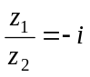.

2 marks

b. 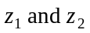are the roots of a quadratic equation in. Find that equation.

3 marks

c. i. Let 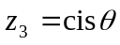. Explain why 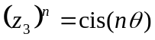.

1 mark

ii. Hence show that 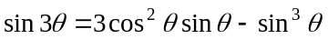.

______________________________________________________________
3 marks
Total 11 marks

Specialist Mathematics Formulas

Mensuration

area of a trapezium: 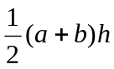
curved surface area of a cylinder: 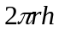
volume of a cylinder: 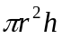
volume of a cone: 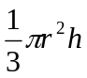
volume of a pyramid: 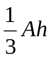
volume of a sphere: 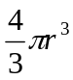
area of a triangle: 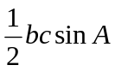
sine rule: 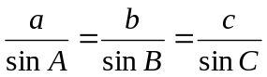
cosine rule: 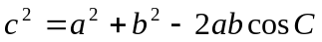

Coordinate geometry

ellipse: 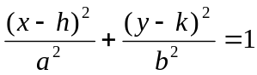
hyperbola: 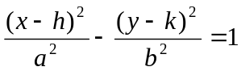

Circular (trigonometric) functions

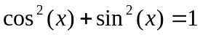
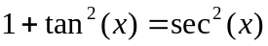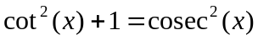
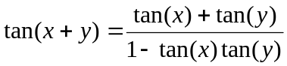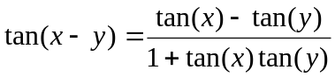
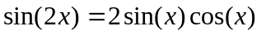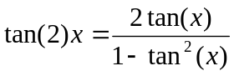
function | 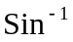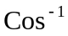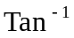
domain  range | 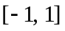  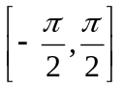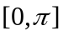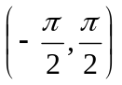
Reproduced with permission of the Victorian Curriculum and Assessment Authority.
(These formula sheets have been copied from the 2001 Specialist Maths Exam 1. Teachers and students are reminded that changes to formula sheets are notified in the VCE Bulletins and on the VCAA website.).
Algebra (Complex numbers)

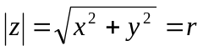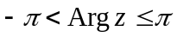
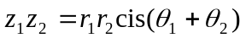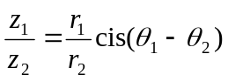
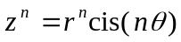 (de Moivre’s theorem)

Calculus

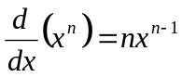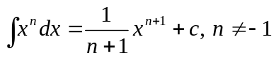
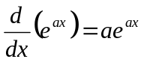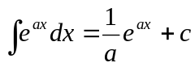
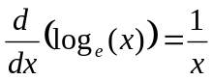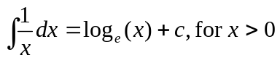
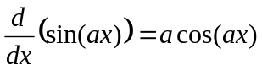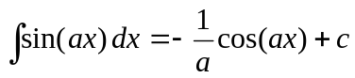
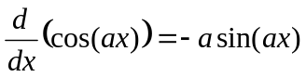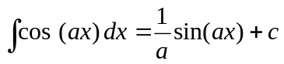
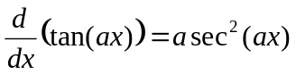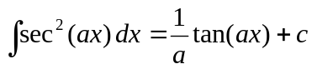
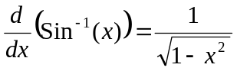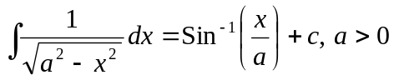
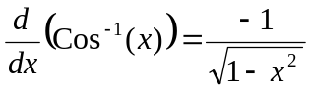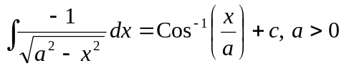
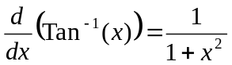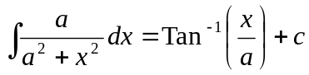

product rule: 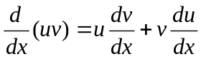
quotient rule: 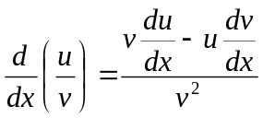
chain rule: 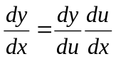

Reproduced with permission of the Victorian Curriculum and Assessment Authority.
(These formula sheets have been copied from the 2001 Specialist Maths Exam 1. Teachers and students are reminded that changes to formula sheets are notified in the VCE Bulletins and on the VCAA website.).
mid-point rule: 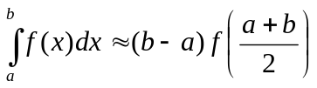
trapezoidal rule: 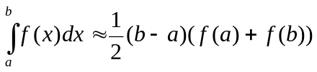
Euler’s method: 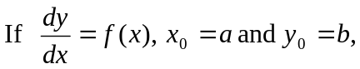
acceleration: 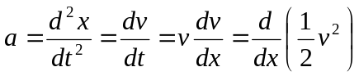
constant (uniform) acceleration: 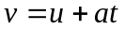 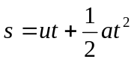 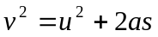 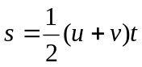

Vectors in two and three dimensions

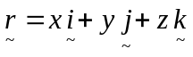
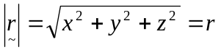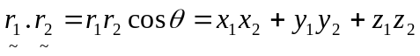
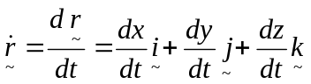

Mechanics

momentum: 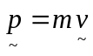
equation of motion: 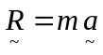
friction: 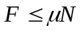

Reproduced with permission of the Victorian Curriculum and Assessment Authority.
(These formula sheets have been copied from the 2001 Specialist Maths Exam 1. Teachers and students are reminded that changes to formula sheets are notified in the VCE Bulletins and on the VCAA website.).

