
SPECIALIST MATHS
TRIAL EXAMINATION 1
2003
SOLUTIONS

_____________________________________________________________________

Part I - Multiple-choice answers

1. D 7. E 13. C 19. A 25. D
2. B 8. E 14. A 20. B 26. E
3. C 9. B 15. B 21. A 27. A
4. D 10. C 16. E 22. C 28. E
5. B 11. D 17. C 23. A 29. D
6. B 12. B 18. E 24. B 30. E
___________________________________________________________________________

Part I- Multiple-choice solutions

Question 1

The ellipse in the diagram has its centre at (0, 1). Its semi-major axis length (parallel to the x- axis) is 3 units and its semi-minor axis length (parallel to the y-axis) is 1 unit. The required equation is 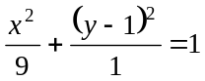.
The answer is D.

Question 2

Options C and E give the equation of an ellipse and hence there would be no asymptote. The equations of the asymptotes of the hyperbola with equation 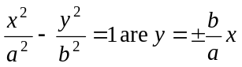. So the required equation would be 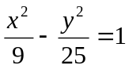.
The answer is B.

Question 3

The graph is that of the function 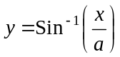.

Method 1
The graph of is produced when the graph of 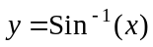 is dilated parallel to the x-axis by a factor of 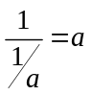.

Method 2
Consider the inverse function of this function which we find by swapping x and y.
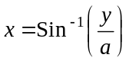
Now rearrange,
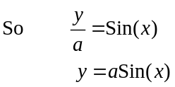
The graph of this function involving the restricted sin (x) function is shown below.
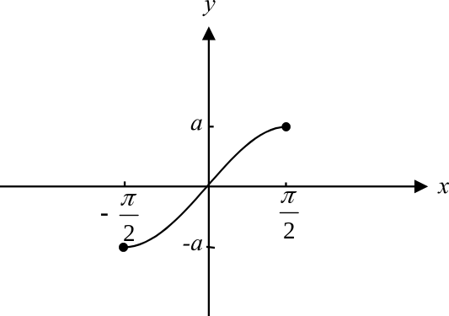

The reflection of this graph in the line 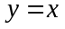 is what is given in the question.
The answer is C.

Question 4

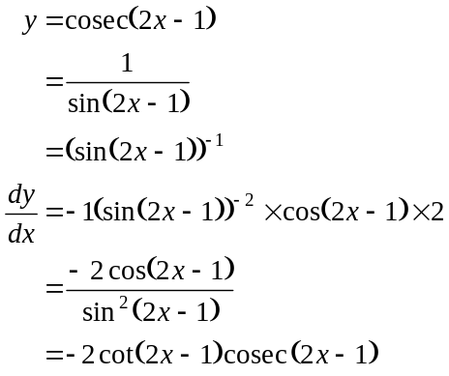
The answer is D.

Question 5

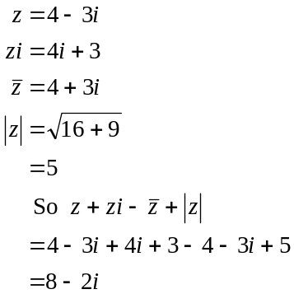
The answer is B.

Question 6

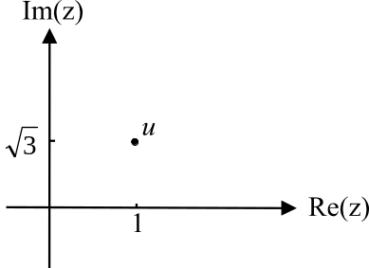

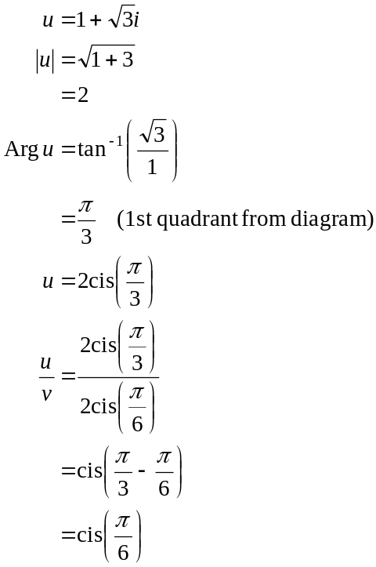
The answer is B.

Question 7

Since the coefficients of the terms in the polynomial equation are real, the complex roots must occur in conjugate pairs. Since 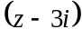 is a factor, 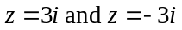 are roots. So options A and B are correct. We have 2 complex roots which are a conjugate pair and the third root must be real since the coefficients of the polynomial are real. So we have two complex roots and 1 real root. Option E is not correct.
The answer is E.

Question 8

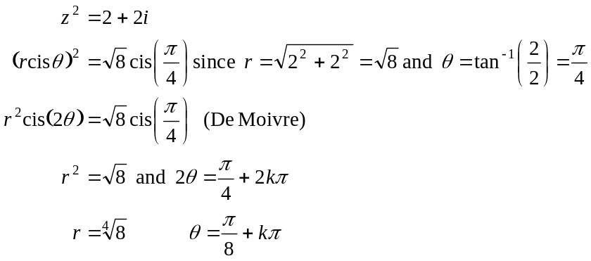
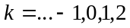
(first quadrant)
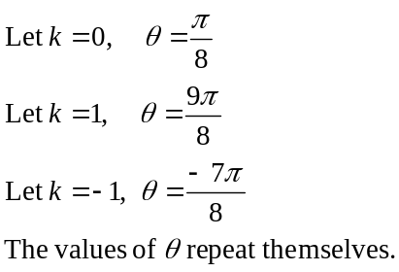
So the two solutions are 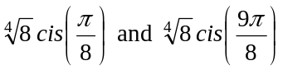.
The answer is E.

Question 9

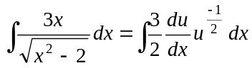
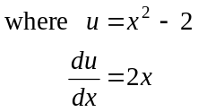
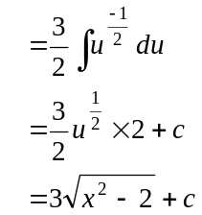
If 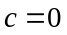, then an antiderivative is 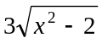.
The answer is B.

Question 10

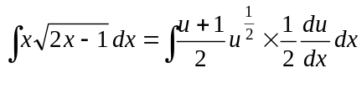
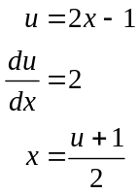
where
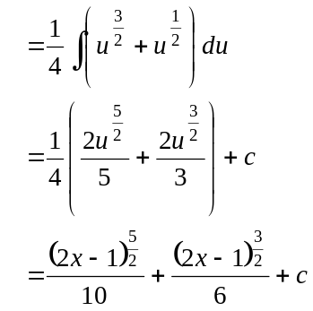
The answer is C.

Question 11

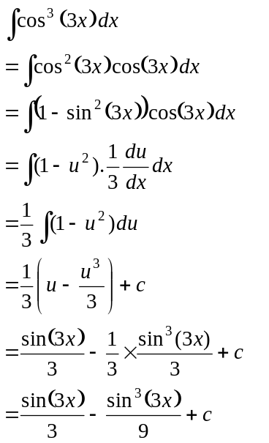
where
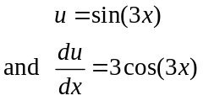
The answer is D.

Question 12

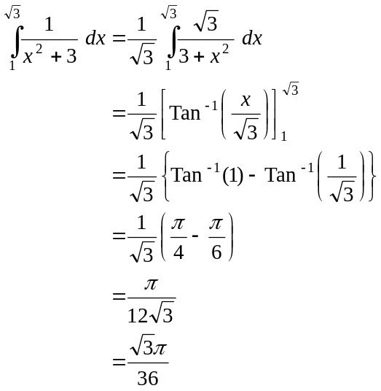
The answer is B.

Question 13

Find the value of this definite integral using your graphics calculator. Note that the decimal approximations given as the alternatives give a clue that a graphics calculator should be involved. Note also that radian mode is required.
The answer is C.

Question 14
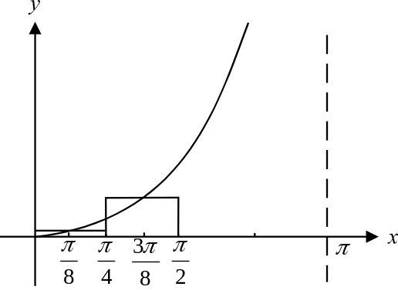

The area of the two rectangles shown is 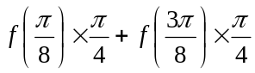
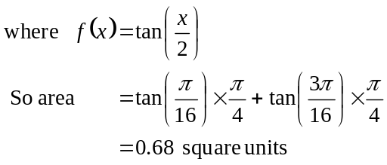
The answer is A.

Question 15

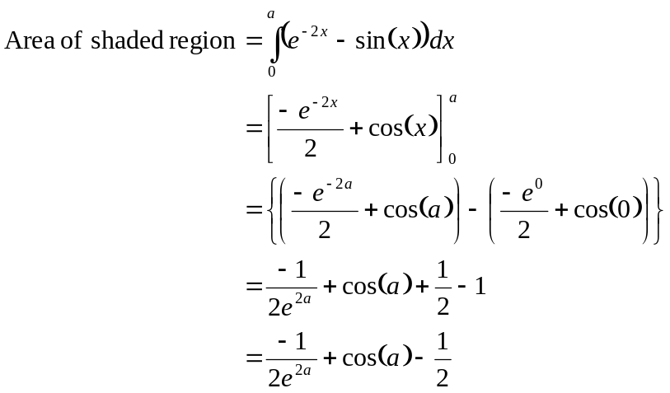
The answer is B.

Question 16

If 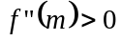 then the graph of 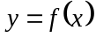 is “concave up” i.e. at .

From the graph of , we see that the graph is concave up for 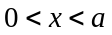, and for . So for these values 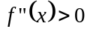.
The answer is E.

Question 17

From the formulae sheet we have, if 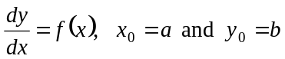,
then
Now, 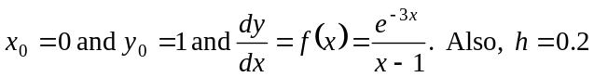

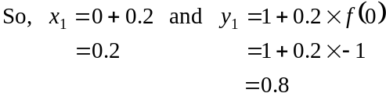
Therefore,

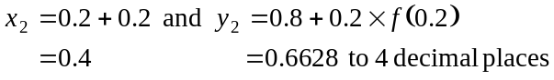
So, the value obtained for y when 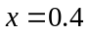 is 0.6628 (to 4 places).
The answer is C.

Question 18

The graph of gives the gradient function of the graph of 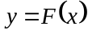.
The gradient of at 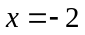 is zero.
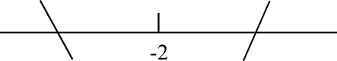
For 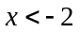 the gradient is negative and for 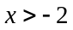
the gradient is positive.
So at , on the graph of
there is a local minimum.
Similarly the gradient of at 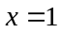 is zero.
For 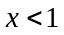 the gradient is positive and for 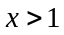 the gradient is positive. So at on the graph of , there is a stationary point of inflection.
The answer is E.

Question 19

The volume of a cone is given by 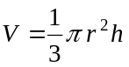. (from formulae sheet)
Since 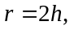 we have
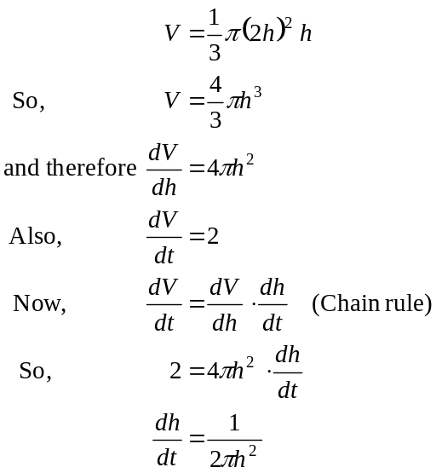
So when 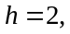 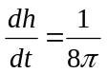
The answer is A.

Question 20

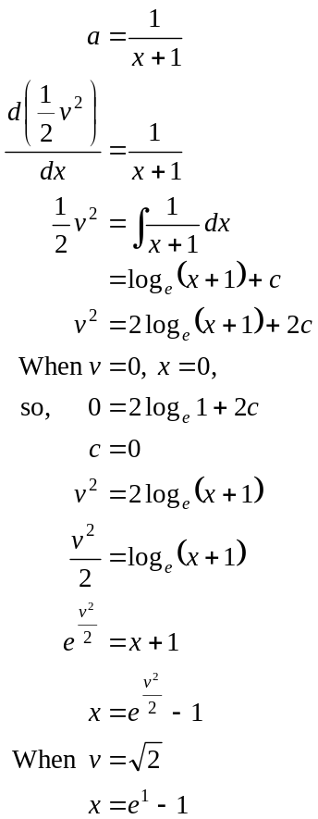

The answer is B.

Question 21

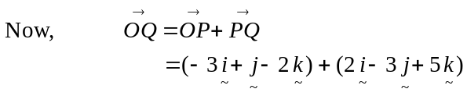
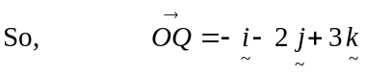
The answer is A.

Question 22

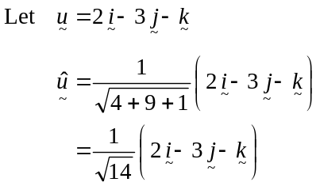
The vector we require is 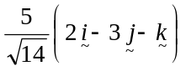
The answer is C.

Question 23

The vector resolute of 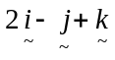 perpendicular to 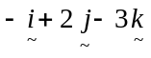 is given by
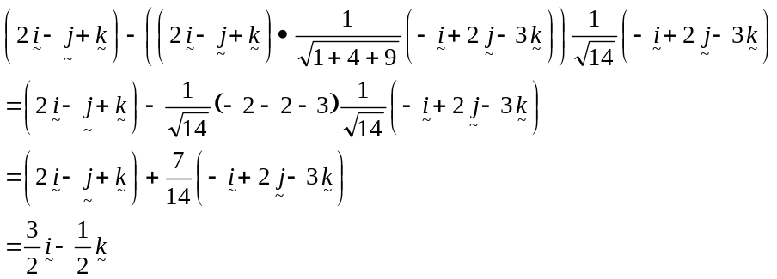
The answer is A.

Question 24

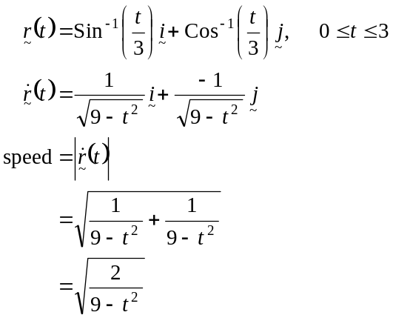
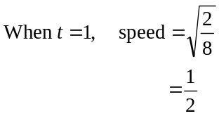
The answer is B.

Question 25

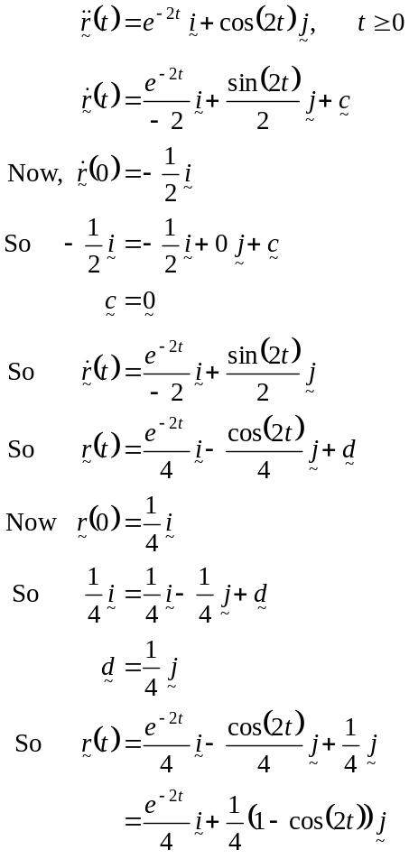
The answer is D.

Question 26
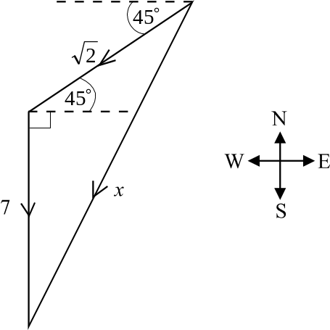

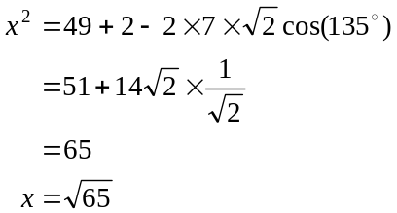
(Cosine rule)
The resulting force has a magnitude of 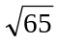 newtons.
The answer is E.

Question 27

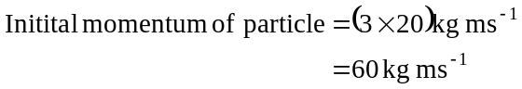
Momentum of particle after 4 seconds
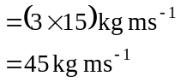
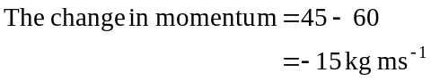
The answer is A.

Question 28

Draw a diagram.
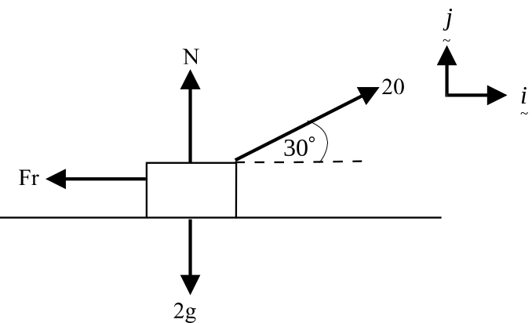

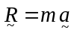
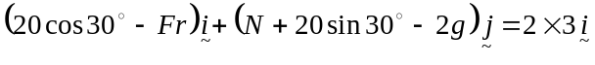
So,
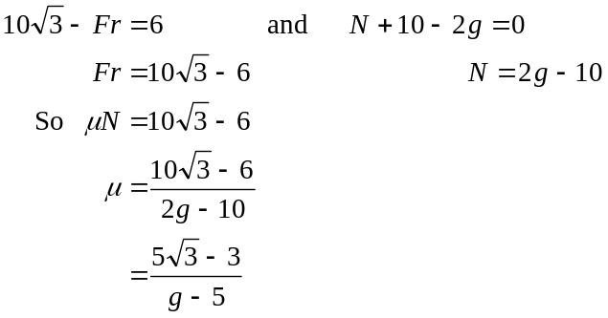
The answer is E.

Question 29

The pulling force P could be acting up or down the plane. The weight force acting vertically downwards has magnitude 10g newtons. Hence eliminate options A and B. The normal force acting perpendicularly from the plane is N not 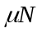so eliminate option C. The frictional force is Fr and not 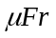 so eliminate option E.
Option D is correct. Note that the pulling force could be quite weak and hence the particle could be on the verge of sliding down the inclined plane which explains why the friction force is directed up the plane opposing the imminent movement.
The answer is D.

Question 30

Draw a diagram.
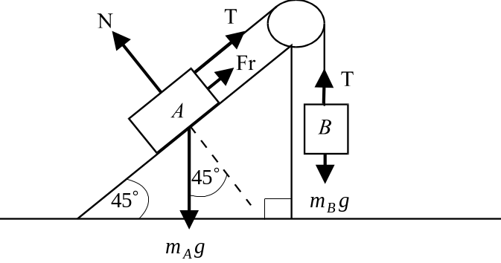

Because the system is on the point of sliding down the slope, the friction force opposes this and acts up the slope.
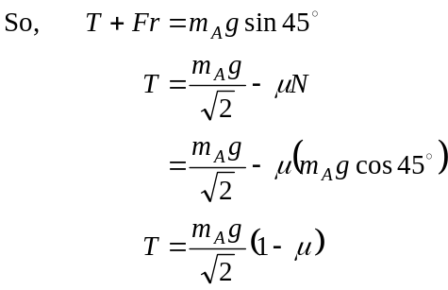
The answer is E.
PART II

Question 1

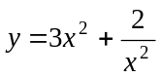
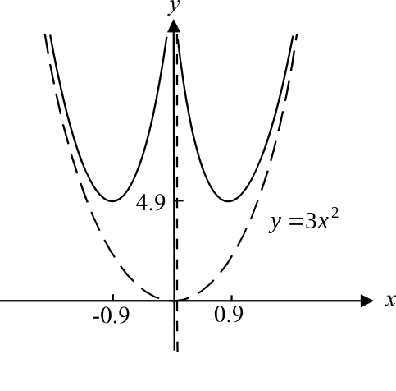

The asymptotes are given by 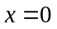 and 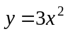.
Using a graphics calculator locate the minimum turning points. These are at 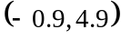
and 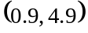 where the coordinates are correct to 1 decimal place.
(1 mark) general shape of graph
including asymptotes
(1 mark) for turning points

Question 2
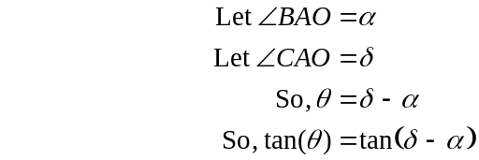
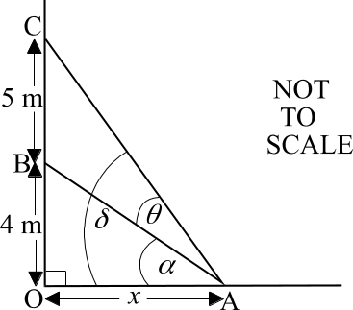
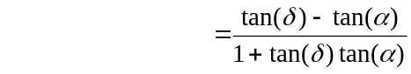 (1 mark)
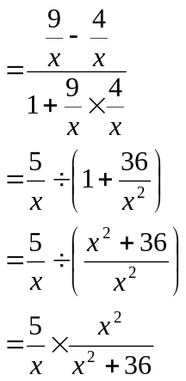
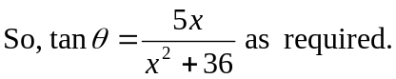 (1 mark)

Question 3
To prove: 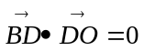 (1 mark)
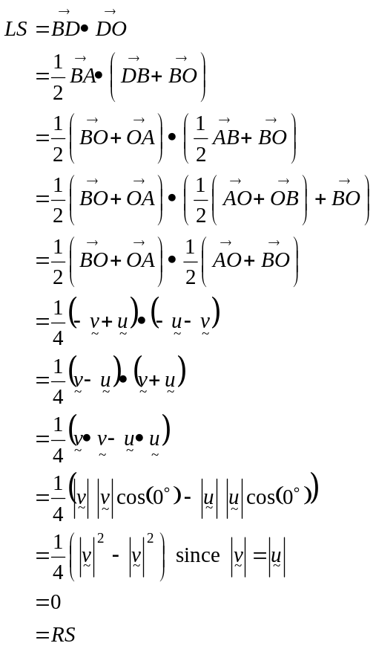
(1 mark)
(1 mark)
Have proved

Question 4
i.
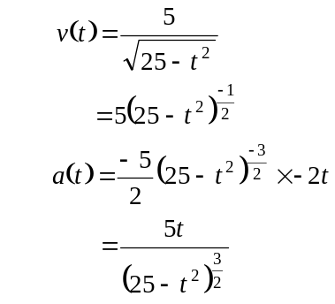
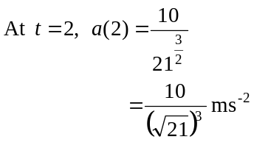
(1 mark)

ii. In this case the distance travelled by the particle is the same as its displacement.
So, distance travelled
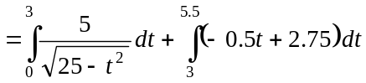 (1 mark)
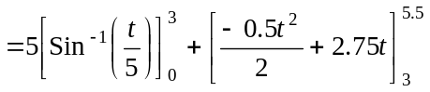 (1 mark)
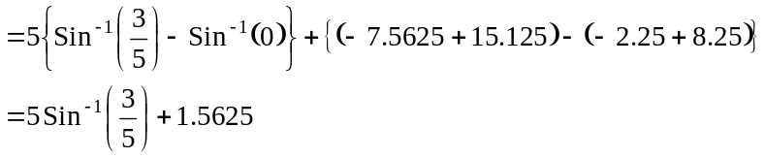
(1 mark)

Question 5

i. 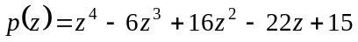
When 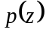 is divided by 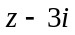, the remainder is given by
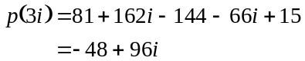
(1 mark)

ii. Since 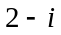 is a solution to the equation 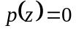 and since the coefficients of the terms in the equation are real, then, by the conjugate root theorem, 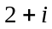 must also be a solution.
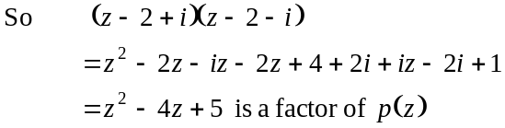
(1 mark)

So
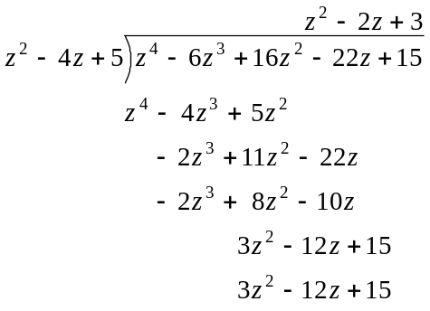
(1 mark)

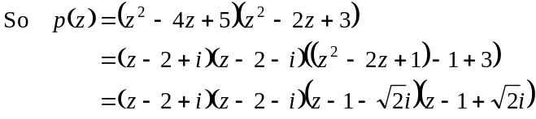
The solutions to are 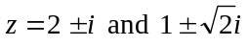.
(1 mark)

Question 6

i. 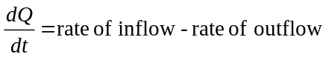
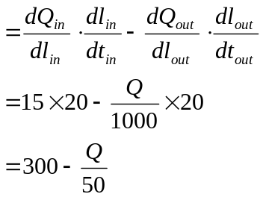
(where l represents litres)
as required.
(1 mark)

ii.
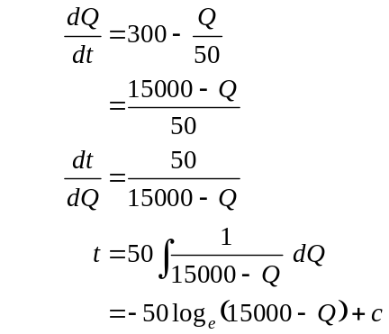
(1 mark)
(1 mark)
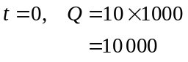

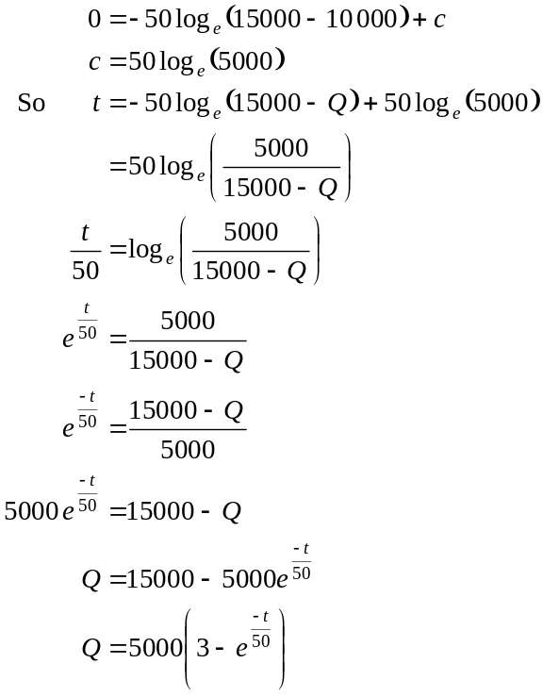
(1 mark)
(1 mark)

