
SPECIALIST MATHS
TRIAL EXAMINATION 2
SOLUTIONS
2004

_____________________________________________________________________

Question 1

- The highest point vertically above the base of the crane when the arm is inclined at its maximum angle is 5 metres. (1 mark)
The coordinate or the vertical component for each of the given points is 5 and we are told that the points A, B, C and D are on the outer ring of the cone. Hence the highest point when the arm is inclined at its maximum angle lies anywhere on this circle. (1 mark)

- Since the edge of the solid shape is a circle, the length of the crane when fully extended is given by 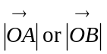 etc.
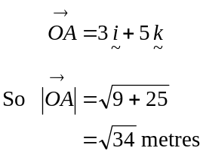
(1 mark)
- i. 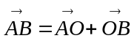
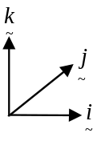
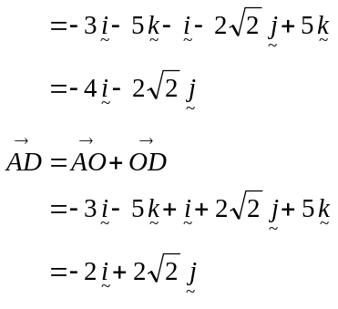
(1 mark)

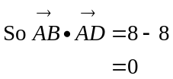
(1 mark)

ii. From part i. 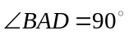.
So points BAD lie on a semicircle with BD the diameter. (1 mark)
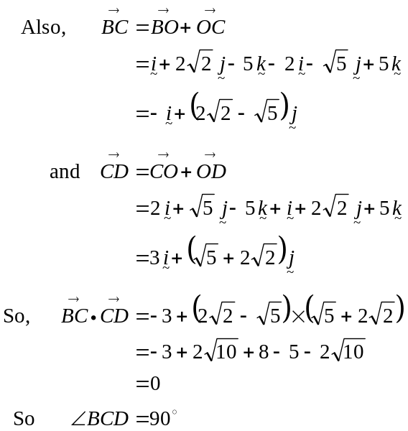
So points BCD lie on a semicircle with BD the diameter. (1 mark)
Since BCD and BAD lie on the same plane, A, B, C, D lie on a circle.(1 mark
- 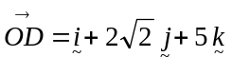
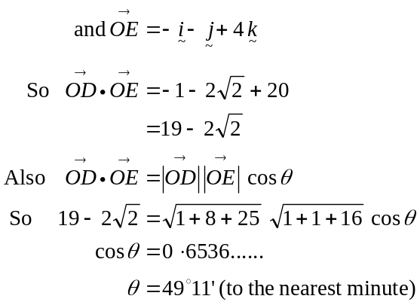
(1 mark)
(1 mark)
The arm of the crane moves through an angle of 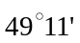.
(1 mark)
Total 11 marks
Question 2
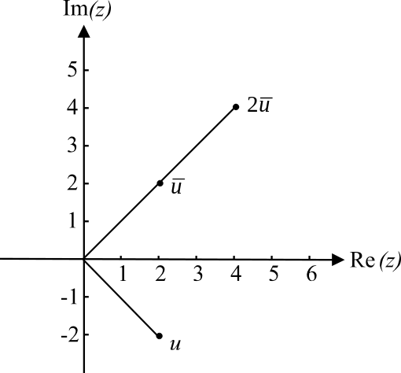

- i. 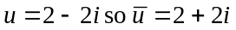
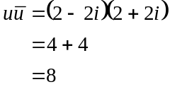
(1 mark)

- 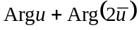
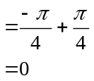
(1 mark)

b. i. If u is a solution then,
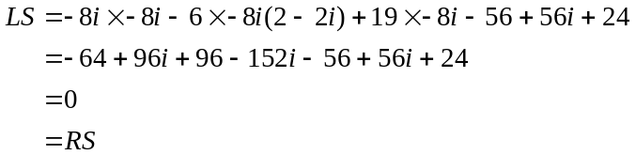
Have shown (1 mark)
  - Since the coefficients of the LHS of the equation are real, 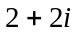 is also a solution (conjugate root theorem).
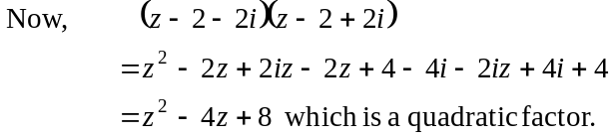
(1 mark)
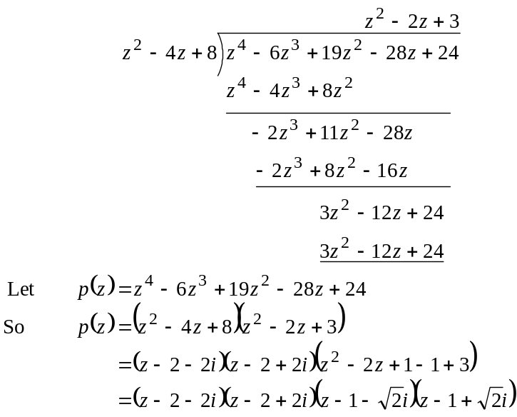
(1 mark)
The other three solutions are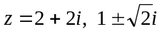 (1 mark)

c. Method 1
Graphing.
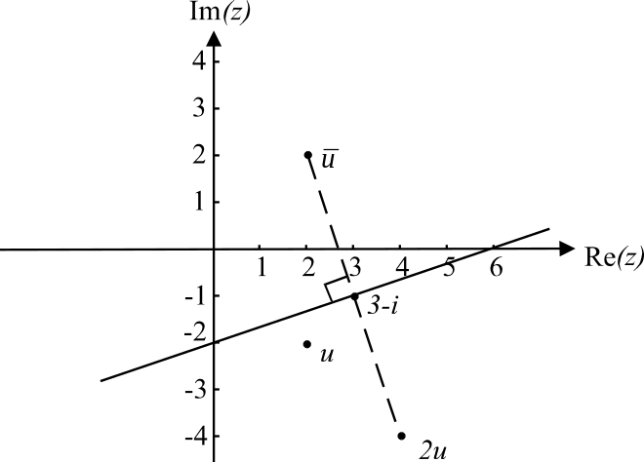

(1 mark)
z is any complex number such that the distance from z to equals the distance from z to 2u.
From the graph, we see that all such numbers z lie on a straight line shown on the Argand diagram.
This line crosses the Real axis at 6. So when 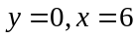.
(1 mark)

Method 2
Algebraically.
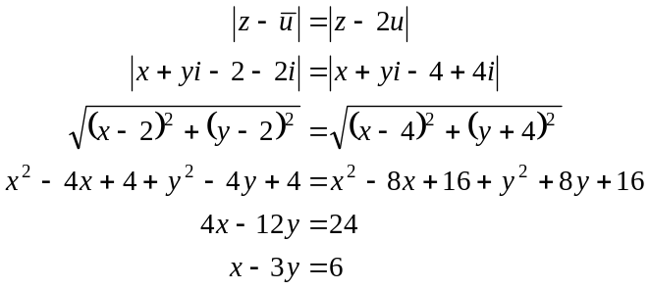
(1 mark)
When 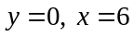
(1 mark)
d.
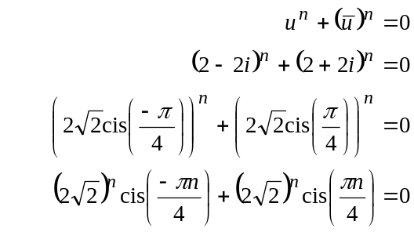
(1 mark)
De Moivres Theorem
(1 mark)
since 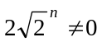
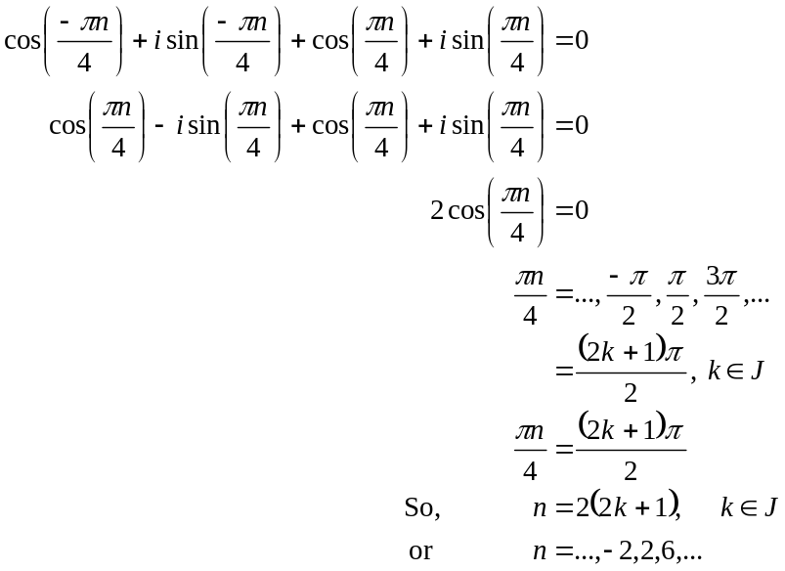
(1 mark)
(1 mark)
Total 12 marks

Question 3

- i.
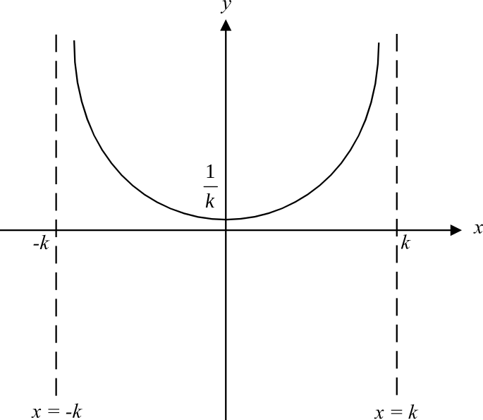

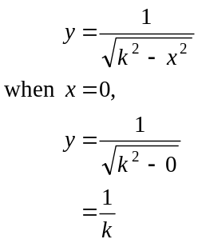
(1 mark) correct shape
(1 mark) labelling clearly
asymptotes and y-intercept

  - From the graph, 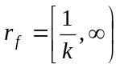.
(1 mark)
- 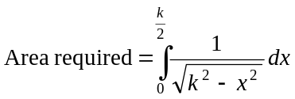 (1 mark)
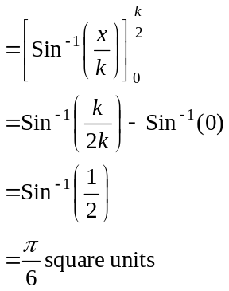
(1 mark)
c. Since we are rotating about the y-axis, the terminals of integration will lie on the
y-axis and the volume of rotation, V, is given by 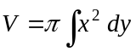.

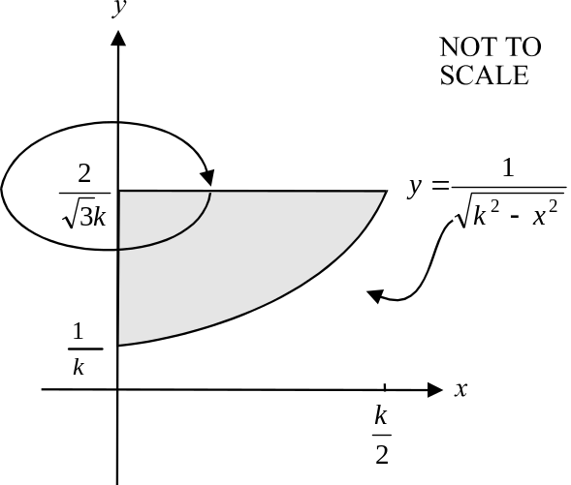

One of the terminals is 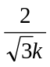 (given in the question).
To find the other let 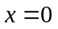.
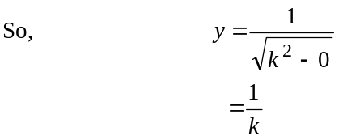
(1 mark) – correct terminals
For the integrand,
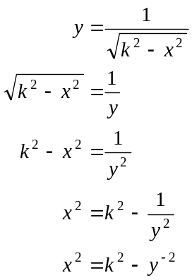
(1 mark) – correct integrand
So required volume
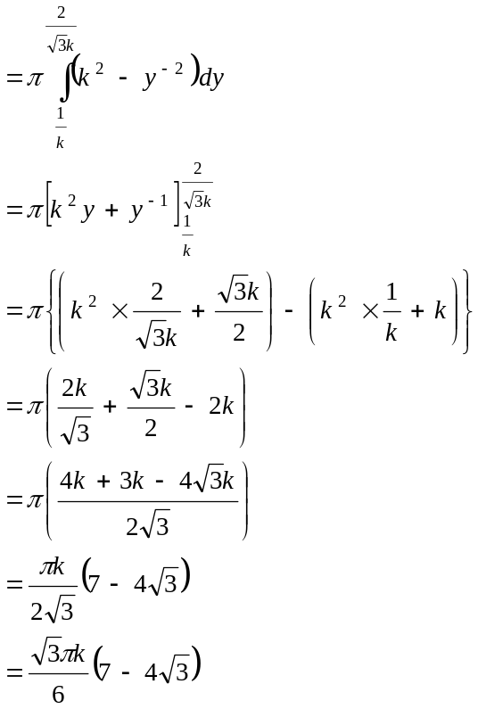
(1 mark) – correct form
i.e. 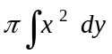
(1 mark)
cubic units
(1 mark)
Total 10 marks

Question 4

- The pump was repaired when 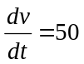.
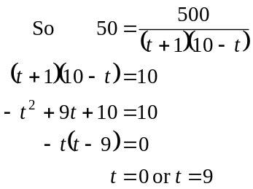
So, 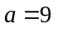.
(1 mark)

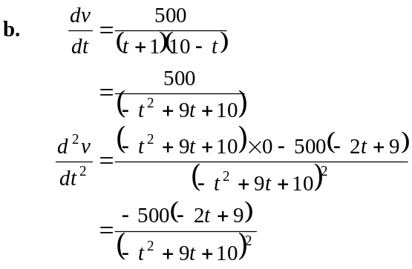
(1 mark)
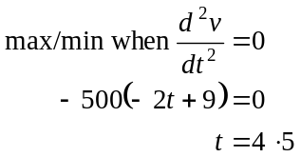
(1 mark)
Check max/min
When 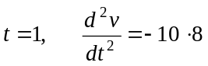
When 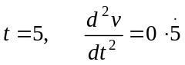
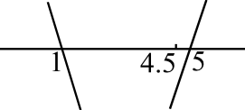

We have a min at 4.5.
(1 mark)
So the minimum rate at which the pump was pumping during its period of malfunction was 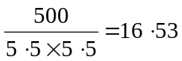 litres per hour (correct to 2 decimal places).
(1 mark)

- For 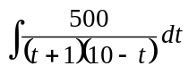 we need to break up the fraction using partial fractions.
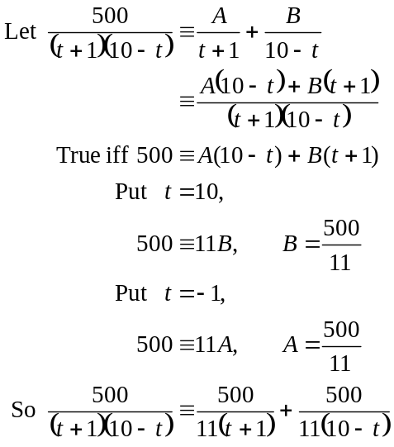
(1 mark)
(1 mark)
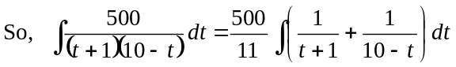
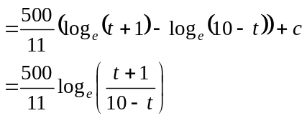
(because we are asked for an antiderivative.)
(1 mark)
- The volume of water in litres, that the malfunctioning pump had pumped t hours after the malfunction began is given by
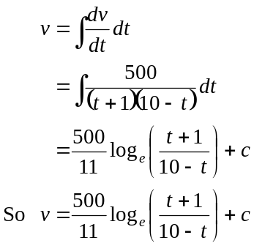
from part c.
(1 mark)
In this case, when 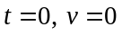, that is, the malfunctioning pump hadn’t yet pumped any water when 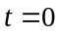 (the functioning pump had though, but we are only interested in the period of malfunction – i.e. domains are crucial).
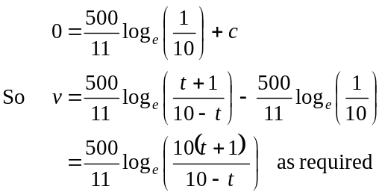
(1 mark)
(Alternatively, you could use the definite integral 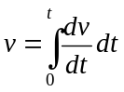.)

- The volume of water pumped by the malfunctioning pump after 2 hours is given by
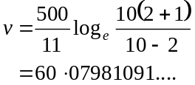
(1 mark)
If the pump had been operating normally, it would have pumped 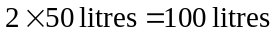. So there were an extra 39.92 litres (correct to 2 decimal places) in the mine.
(1 mark)

- The additional water is the difference between what is normally pumped out and what can be pumped out during the period of the malfunction.
Let A = volume of additional water.
So 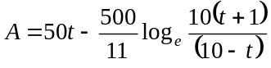
Using a graphics calculator.
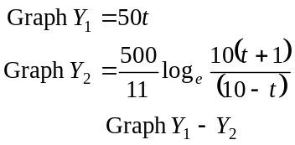
(1 mark)
Look at the graph and the table of values for 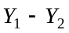.
Note that the largest value of for 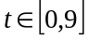 is 240.67 and this occurs at 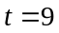.
(1 mark)
Hence during the period when the pump is malfunctioning the limit of additional water that the mine can cope with is not exceeded.
(1 mark)
Total 15 marks

Question 5

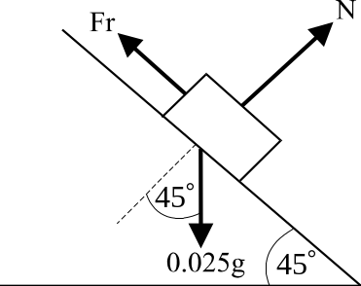

(1 mark)

- Resolve the forces
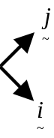
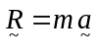
Now 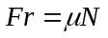
So, 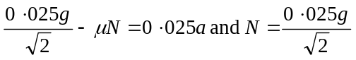
(1 mark) (1 mark)
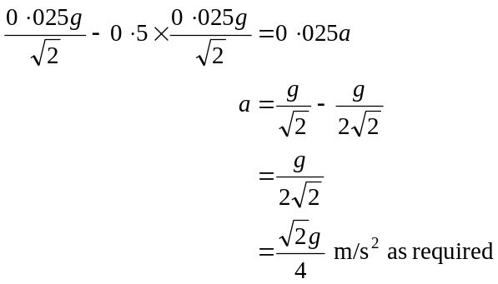
(1 mark)

- From part b., we know that a lolly accelerates at a constant rate down the metal chute hence we can use the formula
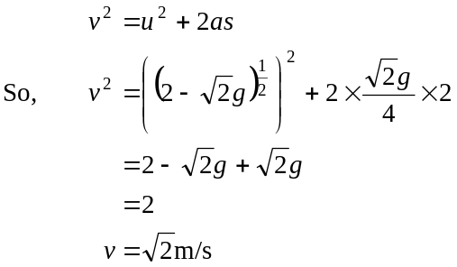
(1 mark) use of correct formula
(1 mark) correct answer

- When a lolly drops off the end of the metal chute, it goes into "freefall” where the only force acting on it is the gravitational force (since there are no resistance forces).
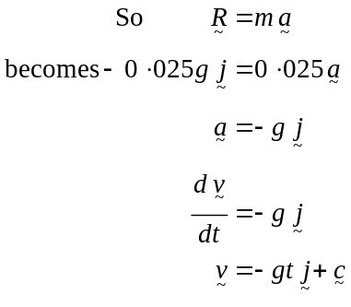
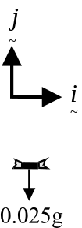
(1 mark)
When , i.e. when the lolly left the end of the metal chute, 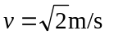
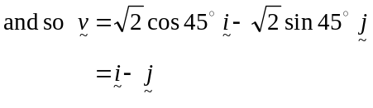
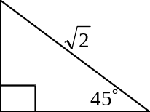
So, 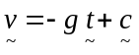
becomes 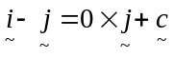
So, 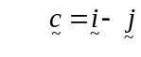
(1 mark) for “initial” conditions
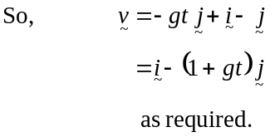
(1 mark)

- From part d.,
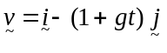
where corresponds to the instant where it left the end of the metal chute and the end of the metal chute corresponds to the origin of motion.
So,
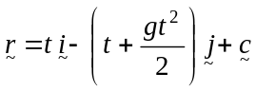
At ,
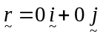
So, 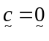
So 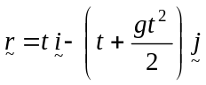
(1 mark)
So, when a lolly lands 0.4m vertically below the origin of motion, (i.e. the end of the metal chute),

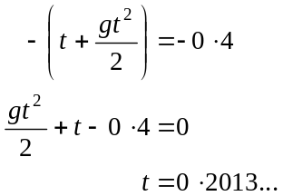
(Take the positive value of t)
(1 mark)
Since the horizontal distance from the end of the metal chute is given by t, that horizontal distance is 0.2m (to 1 decimal place).
(1 mark)
Total 12 marks

