

Students Name:………………………………………

SPECIALIST MATHEMATICS

TRIAL EXAMINATION 2

(ANALYSIS TASK)

2005

Reading Time: 15 minutes
Writing time: 90 minutes

Instructions to students
This exam consists of 5 questions.
All questions should be answered.
There is a total of 60 marks available.
The marks allocated to each of the five questions are indicated throughout.
Students may bring up to two A4 pages of pre-written notes into the exam.
The acceleration due to gravity should be taken to have magnitude 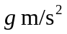where 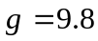
Formula sheets can be found on pages 15-17 of this exam.

This paper has been prepared independently of the Victorian Curriculum and Assessment Authority to provide additional exam preparation for students. Although references have been reproduced with permission of the Victorian Curriculum and Assessment Authority, the publication is in no way connected with or endorsed by the Victorian Curriculum and Assessment Authority.

© THE HEFFERNAN GROUP 2005
This Trial Exam is licensed on a non transferable basis to the purchaser. It may be copied for educational use within the school which has purchased it. This license does not permit distribution or copying of this Trial Exam outside that school or by any individual purchaser.
Question 1

- Let 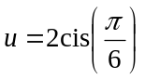.

  - Indicate the complex number u on the Argand diagram below.

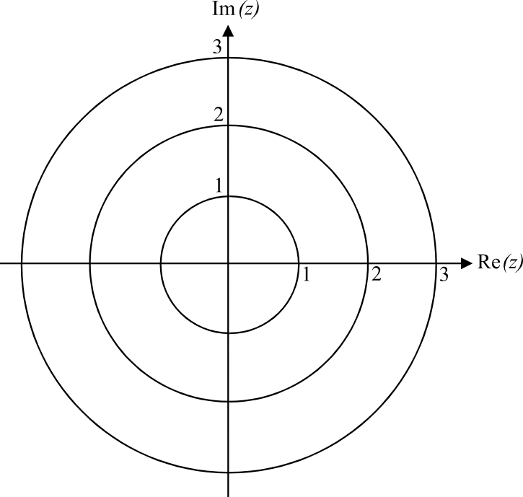

1 mark

  - Given that u is a root of the equation 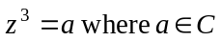, find the other two roots in polar form.

2 marks
iii. Hence find a.

2 marks

- i. Find in Cartesian form.

1 mark

- Show algebraically that if .

2 marks

- Using a diagram, explain why it is that if 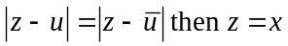.

1 mark
Total 9 marks

Question 2

A box of mass 10kg is being hauled up a 5 metre long ramp that is at an angle of 30° to the horizontal. At the top of the ramp is a horizontal floor.
The box is attached to one end of a rope that passes over a smooth pulley and is held at the other end by a man.
The man exerts a constant pulling force of 200 N on the rope. The coefficient of friction between the box and the ramp is 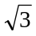.

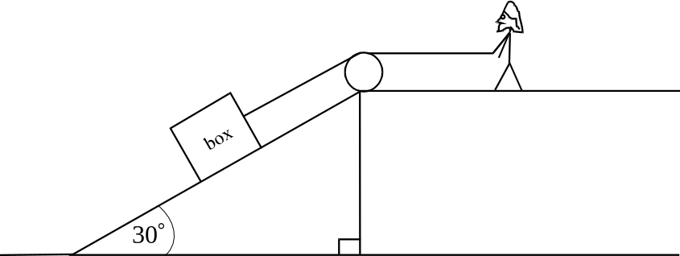

- Find the acceleration of the box up the ramp.

4 marks

- Given that the box started from rest at the lower end of the ramp, how long does it take for the box to be hauled halfway up the ramp? Express your answer as an exact value.

2 marks

- When the box is at this point, halfway up the ramp, the man lets go of the rope and the box becomes stationary.

Draw a diagram showing all the forces acting on the box and explain whether or not the box is at the point of slipping down the ramp.

3 marks

- If the coefficient of friction between the ramp and the box was, the box would slide down the ramp once stationary after the man let go of the rope. How far would the box travel in this situation in the first second after coming to rest? Express your answer to the nearest centimetre.

3 marks
Total 12 marks
Question 3

The rate of change in the temperature T, in degrees C, in a living room, t hours after a heater is switched on is given by
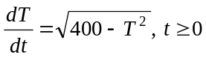
The temperature in the living room at the time that the heater was turned on was 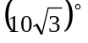(approximately 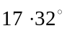).

- Find the function 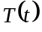.

4 marks

- Find the values of t for which the function is defined.

2 marks

- By considering the sign of the function 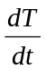, explain why the maximum temperature occurs at 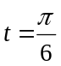.

____________________________________________________________________
2 marks
Total 8 marks

Question 4

Consider the function
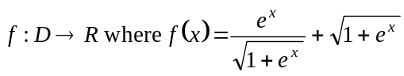

- Given that D is the maximal domain of f, find D.

1 mark

- Sketch the graph of 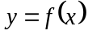 on the set of axes below clearly showing any important features.

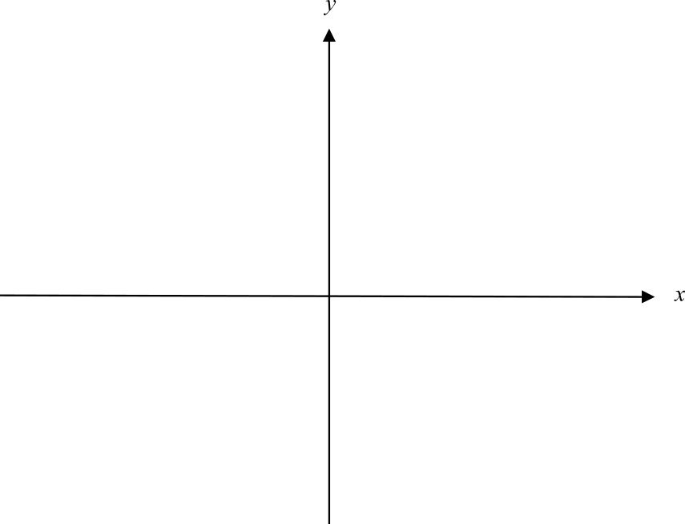

3 marks

- On the same set of axes sketch the graph of the inverse function 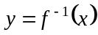.

1 mark

d. Use calculus to show that the graph of has no stationary points.

4 marks

e. i. Show that 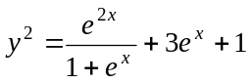.

1 mark

  - If 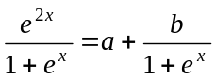, find the terms that a and b represent.

1 mark
f. The area enclosed by the function f, the positive x and y-axes and the line 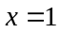 is rotated around the x-axis to create a solid of revolution.
Find the exact volume of this solid of revolution.

5 marks
Total 16 marks

Question 5

A boy drops a feather from the roof of a shed. The boy hopes that the feather will drop on the head of his sister who is lying on the ground directly below the point where he releases the feather.
Instead, the feather is taken by the breeze and floats to the ground away from the boy’s sister.
The position vector 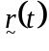 of the feather at time t seconds after the boy releases it is given by

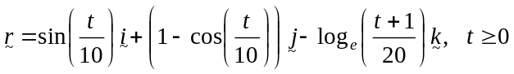

where is a unit vector in the east direction, is a unit vector in the north direction and is a unit vector directed vertically up.

The position of the sister's head can be taken as O, the origin of the coordinate system. All distances are measured in metres.

- Find the height above the ground of the point where the feather was released. Express your answer to the nearest metre.

2 marks

- Show that it takes 19 seconds for the feather to reach the ground.

1 mark

- What is the distance of the feather from the boy’s sister 10 seconds after he releases it? Express your answer in metres correct to 2 decimal places.

2 marks

- Find when the feather is directly north-east of the boy’s sister for 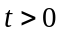. Express your answer in seconds correct to one decimal place.

2 marks

- Find an expression for the velocity of the feather.

1 mark

- Find the exact speed of the feather at 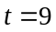 seconds.

2 marks
- At what angle does the path of the feather make with the north direction as it reaches the ground. Express your answer in degrees and minutes to the nearest minute.

3 marks

- What is the furthest distance east of the origin that the feather reaches?

2 marks
Total 15 marks

Specialist Mathematics Formulas

Mensuration

area of a trapezium: 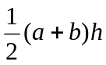
curved surface area of a cylinder: 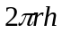
volume of a cylinder: 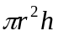
volume of a cone: 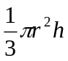
volume of a pyramid: 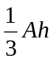
volume of a sphere: 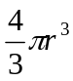
area of a triangle: 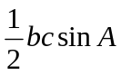
sine rule: 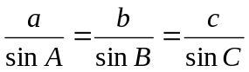
cosine rule: 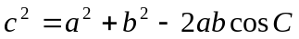

Coordinate geometry

ellipse: 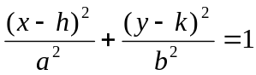
hyperbola: 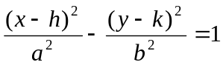

Circular (trigonometric) functions

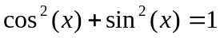
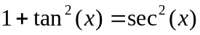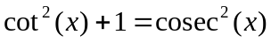
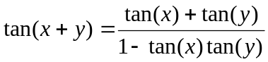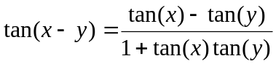
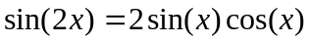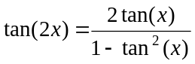
function | 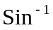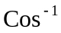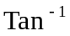
domain  range | 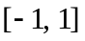  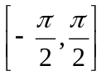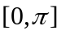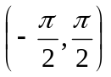
Reproduced with permission of the Victorian Curriculum and Assessment Authority, Victoria, Australia.
These formulae sheets have been copied from the 2004 Specialist Maths Exam 2. Teachers and students are reminded that changes to formulae sheets are notified in the VCE Bulletins and on the VCAA website at www.vcaa.vic.edu.au. The VCAA publish an exam issue supplement to the VCAA bulletin.
Algebra (Complex numbers)

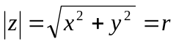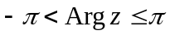
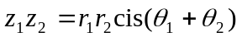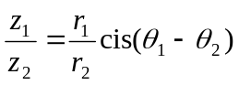
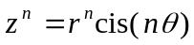 (de Moivre’s theorem)

Calculus

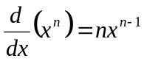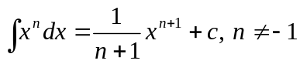
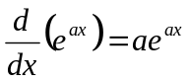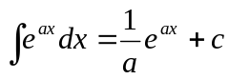
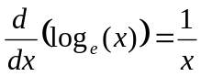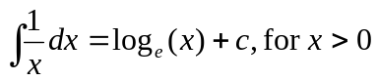
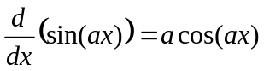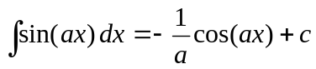
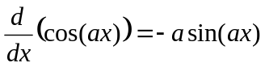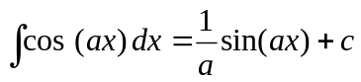
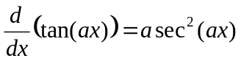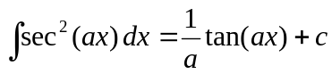
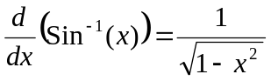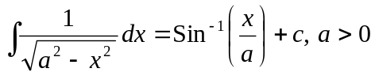
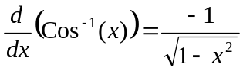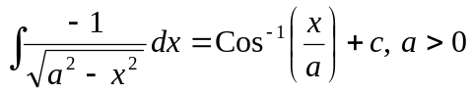
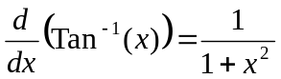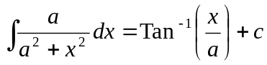

product rule: 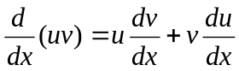
quotient rule: 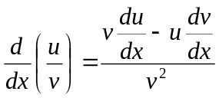
chain rule: 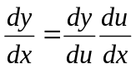

Reproduced with permission of the Victorian Curriculum and Assessment Authority, Victoria, Australia.
These formulae sheets have been copied from the 2004 Specialist Maths Exam 2. Teachers and students are reminded that changes to formulae sheets are notified in the VCE Bulletins and on the VCAA website at www.vcaa.vic.edu.au. The VCAA publish an exam issue supplement to the VCAA bulletin.
mid-point rule: 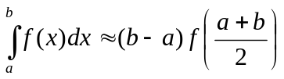
trapezoidal rule: 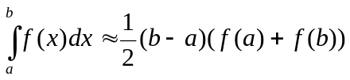
Euler’s method: 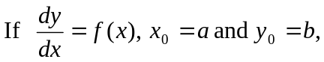
acceleration: 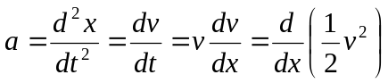
constant (uniform) acceleration: 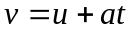 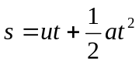 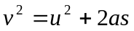 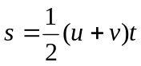

Vectors in two and three dimensions

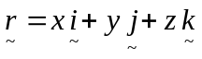
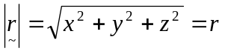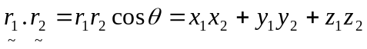
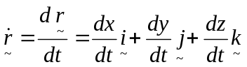

Mechanics

momentum: 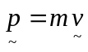
equation of motion: 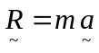
friction: 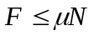

Reproduced with permission of the Victorian Curriculum and Assessment Authority, Victoria, Australia.
These formulae sheets have been copied from the 2004 Specialist Maths Exam 2. Teachers and students are reminded that changes to formulae sheets are notified in the VCE Bulletins and on the VCAA website at www.vcaa.vic.edu.au. The VCAA publish an exam issue supplement to the VCAA bulletin.

