Year 2005

VCE

Specialist Mathematics

Trial Examination 2

Suggested Solutions

© Kilbaha Multimedia Publishing 2005

 | Kilbaha Multimedia Publishing ABN 47 065 111 373  PO Box 2227  Kew Vic 3101  Australia  Tel: 03 9817 5374  Fax: 03 9817 4334  chemas@chemas.com  www.chemas.com

IMPORTANT COPYRIGHT NOTICE

- This material is copyright. Subject to statutory exception and to the provisions of the relevant collective licensing agreements, no reproduction of any part may take place without the written permission of Kilbaha Multimedia Publishing.
- The contents of this work are copyrighted. Unauthorised copying of any part of this work is illegal and detrimental to the interests of the author.
- For authorised copying within Australia please check that your institution has a licence from Copyright Agency Limited. This permits the copying of small parts of the material, in limited quantities, within the conditions set out in the licence.
- Teachers and students are reminded that for the purposes of school requirements and external assessments, students must submit work that is clearly their own.
- Schools which purchase a licence to use this material may distribute this electronic file to the students at the school for their exclusive use. This distribution can be done either on an Intranet Server or on media for the use on stand-alone computers.
- Schools which purchase a licence to use this material may distribute this printed file to the students at the school for their exclusive use.

- The Word file (if supplied) is for use ONLY within the school

- It may be modified to suit the school syllabus and for teaching purposes.

- All modified versions of the file must carry this copyright notice

- Commercial use of this material is expressly prohibited
Question 1
a.

i.
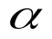
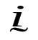
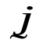
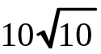
O
A
B
30
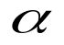
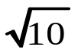
1
3
From Pythagorus
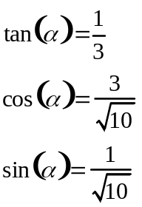

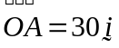
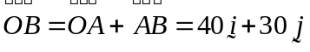
1 mark
ii. Now 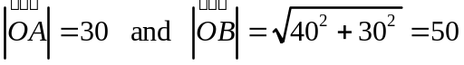 and 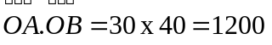
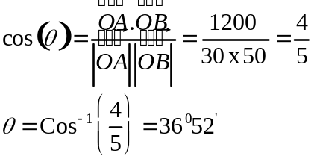
2 marks
b.
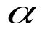
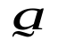
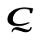
O
A
B
C
S
M
P
R
i. Now 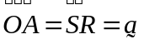 and 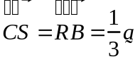 and 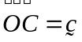
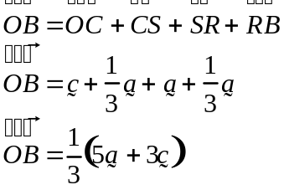
1 mark
ii. Now 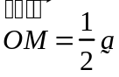 and 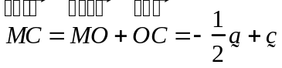 so
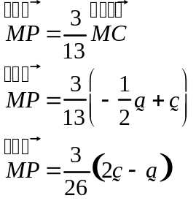
2 marks
iii. 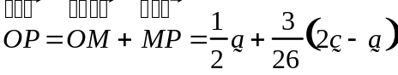
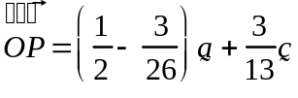
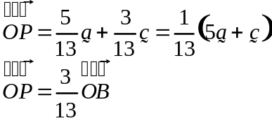 3 marks
Hence the points O , P , B are collinear and 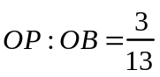

c.
150 cm
50 cm
30 cm
30 cm
h
x
- From the diagram, the cross-section and by similar triangles
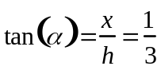 so that 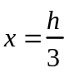
The cross-sectional area ( the area of the trapezium ) 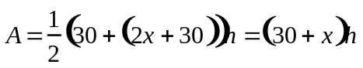
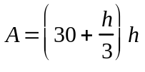 the volume at height h is given by
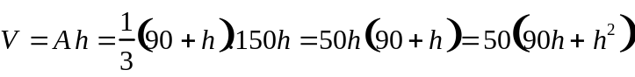
Now 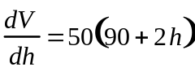 and we are given that 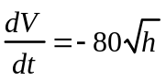
By the Chain rule 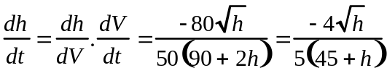
2 marks
ii. Inverting gives 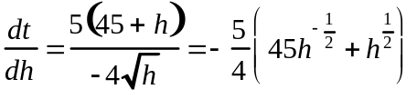 integrating wrt h
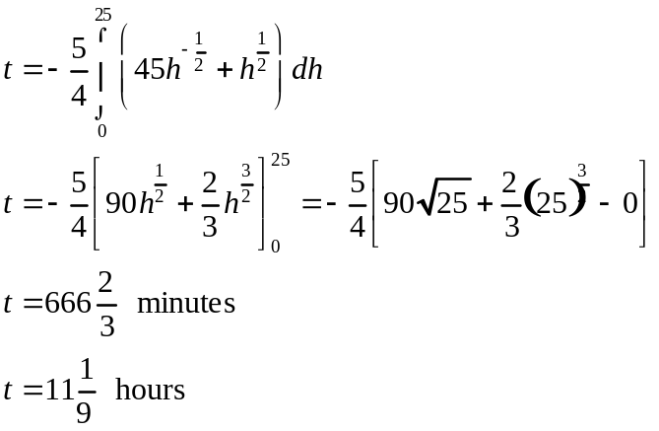
3 marks
Question 2

Let 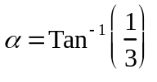 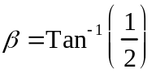 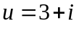 and 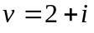
From Pythagorus Theorem

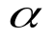
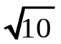
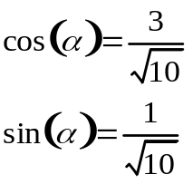
1
3
1
2
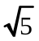

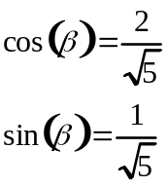

a. 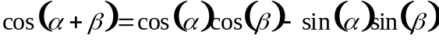
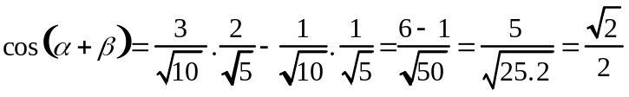
2 marks

b.
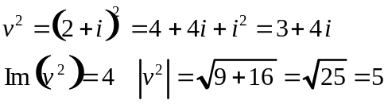
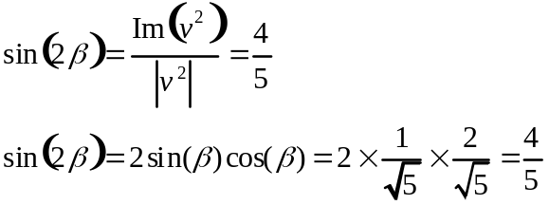

2 marks
c. 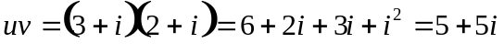
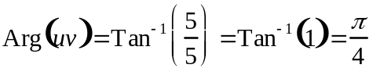 and 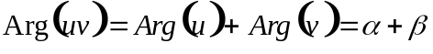 so 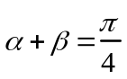
2 marks

d.
Since a and b are real numbers by the conjugate root theorem
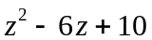 is a factor
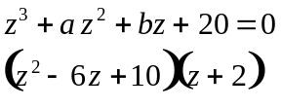
expanding gives coefficient of
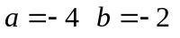 the roots are 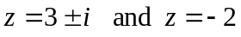
2 marks

e. 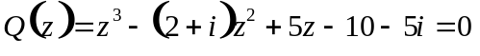
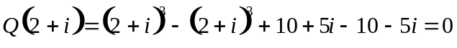 shown
So 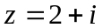 is a root 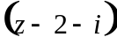 is a factor
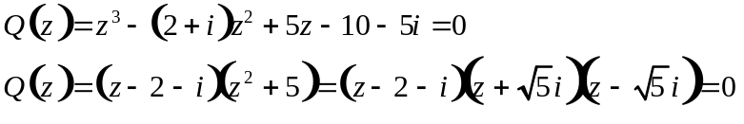
the roots are 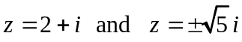

2 marks

Question 3

a.

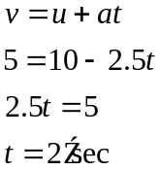 using constant acceleration formulae
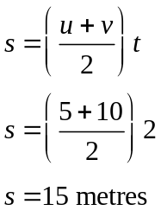
2 marks

b.i. from Newton’s Law 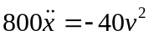
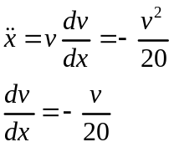
1 mark
ii. 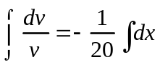
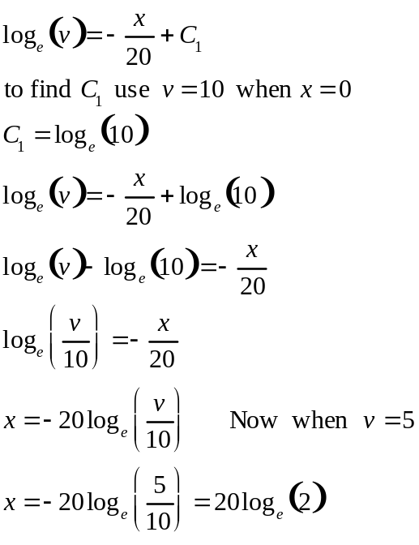
3 marks
iii. 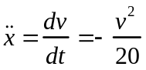
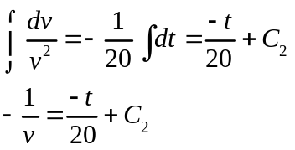
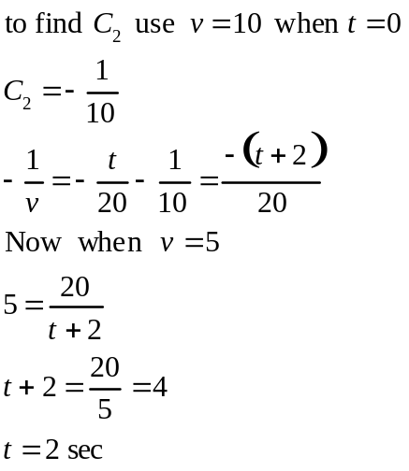
3 marks

iv. 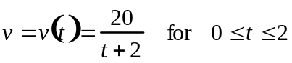
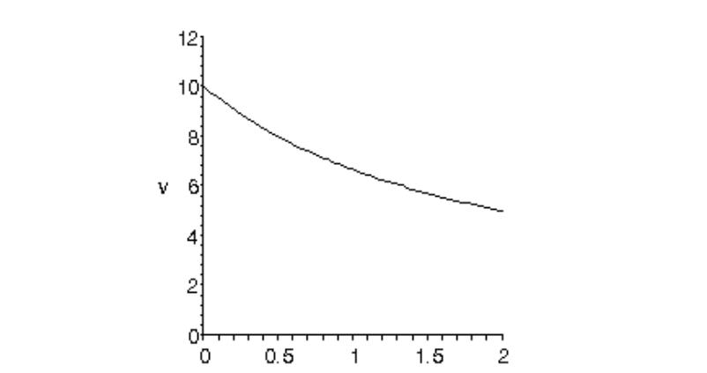

As a check 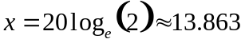
2 marks
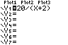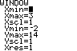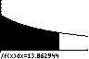
Question 4

a. 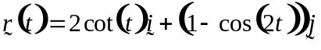 for 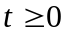
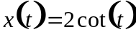 to eliminate t
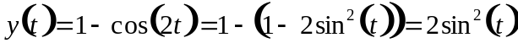
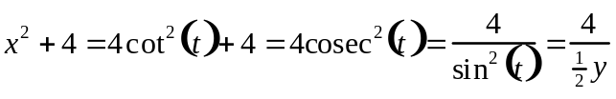
so 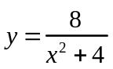

2 marks
b i. 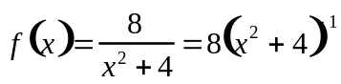 for stationary points
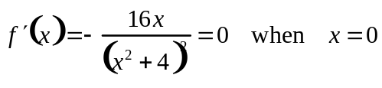 so 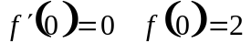
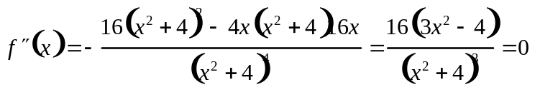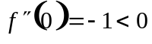
When 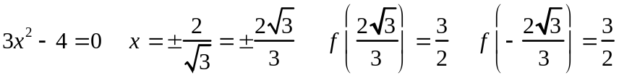
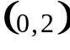 is a maximum 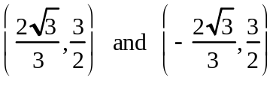 are inflexion points
4 marks
ii.
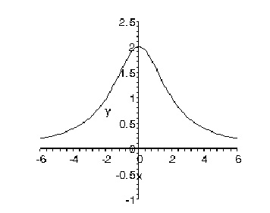
1 mark

iii. The area of the door way is
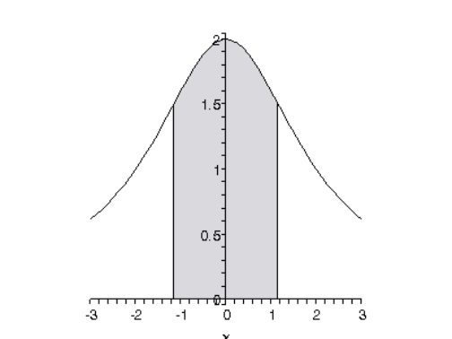
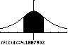
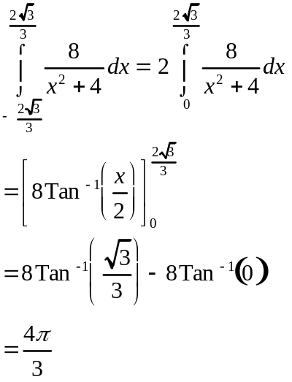

As a check on the TI-83

3 marks
c. i. the domain is 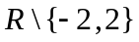 and the graph has a maximum turning point at 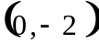range is 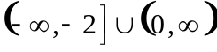 the graph has vertical asymptotes at 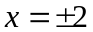 and a horizontal asymptote at 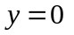 ( the x-axis )

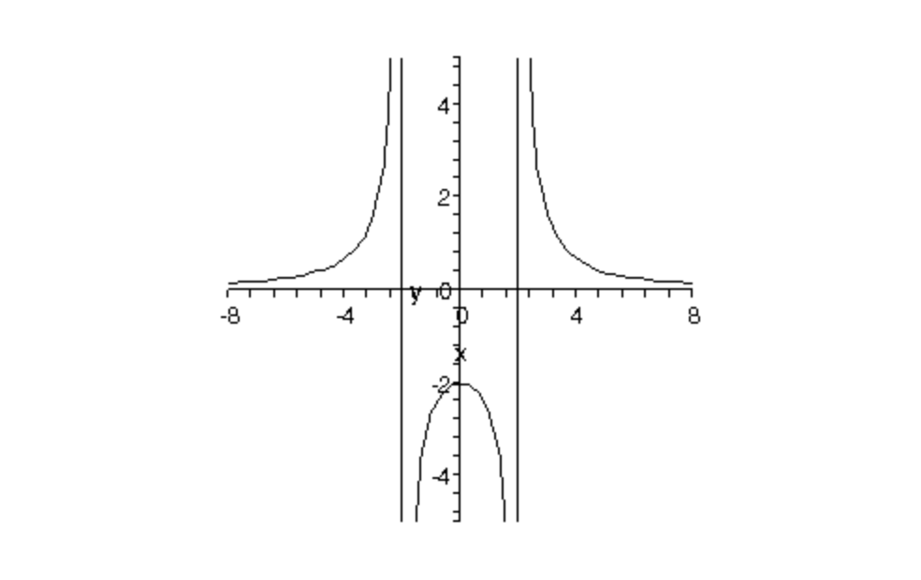
2 marks
ii. The volume formed is given by 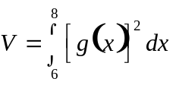
by partial fractions

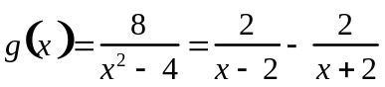
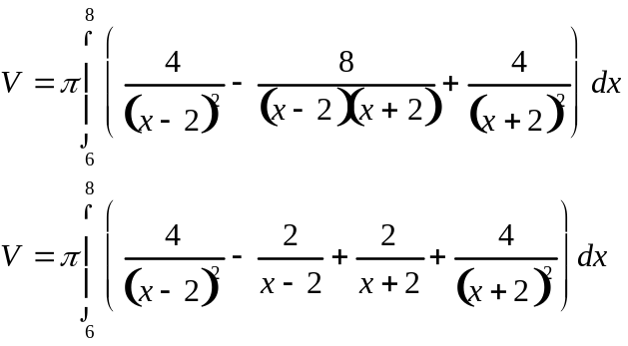
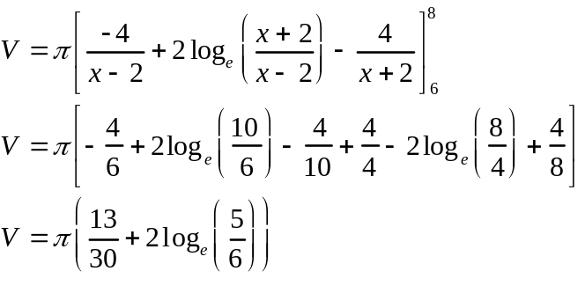
4 marks

Question 5
a.
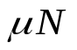
i.
40º
rope
102g
N
P

1 mark

ii. Given that 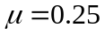 find P
The frictional force is up, since the motion is down
Resolving the forces, using Newtons 2nd law of motion
perpendicular to the plane 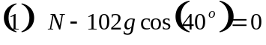
parallel to the plane 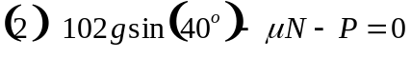
from 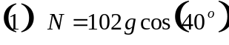
from
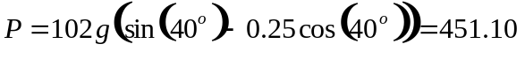 newtons
3 marks

b.

i.
35º
40º
N
52g
300
1 mark

ii. The frictional force is up, since the motion is down
Resolving the forces, using Newtons 2nd law of motion
Perpendicular to the plane 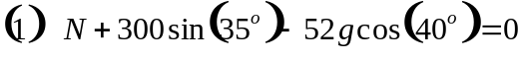
parallel to the plane
from
from so that
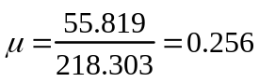
4 marks

End of 2005 Specialist Mathematics Trial Examination 2 Solutions

KILBAHA MULTIMEDIA PUBLISHING  PO BOX 2227  KEW VIC 3101  AUSTRALIA | TEL: (03) 9817 5374  FAX: (03) 9817 4334  chemas@chemas.com  www.chemas.com

