Year 2005

VCE

Specialist Mathematics

Trial Examination 2



KILBAHA MULTIMEDIA PUBLISHING  PO BOX 2227  KEW VIC 3101  AUSTRALIA | TEL: (03) 9817 5374  FAX: (03) 9817 4334  chemas@chemas.com  www.chemas.com

© Kilbaha Multimedia Publishing 2005

IMPORTANT COPYRIGHT NOTICE

- This material is copyright. Subject to statutory exception and to the provisions of the relevant collective licensing agreements, no reproduction of any part may take place without the written permission of Kilbaha Multimedia Publishing.
- The contents of this work are copyrighted. Unauthorised copying of any part of this work is illegal and detrimental to the interests of the author.
- For authorised copying within Australia please check that your institution has a licence from Copyright Agency Limited. This permits the copying of small parts of the material, in limited quantities, within the conditions set out in the licence.
- Teachers and students are reminded that for the purposes of school requirements and external assessments, students must submit work that is clearly their own.
- Schools which purchase a licence to use this material may distribute this electronic file to the students at the school for their exclusive use. This distribution can be done either on an Intranet Server or on media for the use on stand-alone computers.
- Schools which purchase a licence to use this material may distribute this printed file to the students at the school for their exclusive use.

- The Word file (if supplied) is for use ONLY within the school

- It may be modified to suit the school syllabus and for teaching purposes.

- All modified versions of the file must carry this copyright notice

- Commercial use of this material is expressly prohibited
STUDENT NUMBER

Figures
Words

VICTORIAN CERTIFICATE OF EDUCATION
2005

SPECIALIST MATHEMATICS

Trial Written Examination 2
(Analysis Task)

Reading time: 15 minutes
Total writing time: 1 hour 30 minutes

QUESTION AND ANSWER BOOK

Number of questions | Number of questions  to be answered | Number  of marks
5 | 5 | 60

• Students are permitted to bring into the examination room: pens, pencils, highlighters,
erasers, sharpeners, rulers, a protractor, set-squares, aids for curve sketching, up to four
pages (two A4 sheets) of pre-written notes (typed or handwritten) and an approved
scientific and/or graphics calculator (memory may be retained).
• Students are NOT permitted to bring into the examination room: blank sheets of paper
and/or whiteout liquid/tape.
Materials supplied
• Question and answer book of 20 pages with a detachable sheet of miscellaneous
formulas in the centrefold.
• Working space is provided throughout the book.
Instructions
• Detach the formula sheet from the centre of this book during reading time.
• Write your student number in the space provided above on this page.
• All written responses must be in English.

Students are NOT permitted to bring mobile phones and/or any other electronic communication devices into the examination room.
SPECIALIST MATHEMATICS

Written examinations 1 and 2

FORMULA SHEET

Directions to students

Detach this formula sheet during reading time.

This formula sheet is provided for your reference.

Specialist Mathematics Formulae

Mensuration
area of a trapezium: 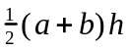
curved surface area of a cylinder: 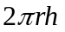
volume of a cylinder: 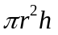
volume of a cone: 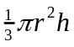
volume of a pyramid: 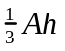
volume of a sphere: 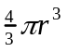
area of triangle: 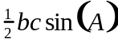
sine rule: 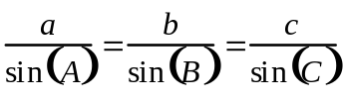

cosine rule: 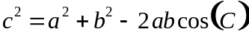

Coordinate geometry
ellipse: 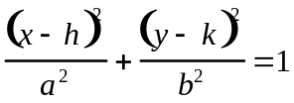

hyperbola: 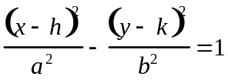

Circular ( trigonometric ) functions

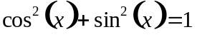
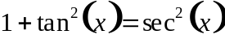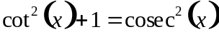

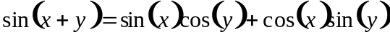
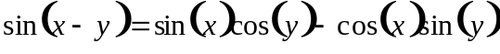
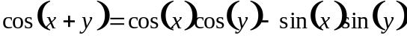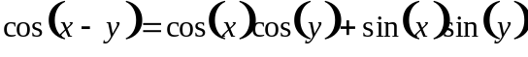
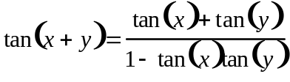
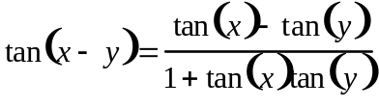

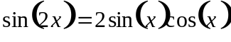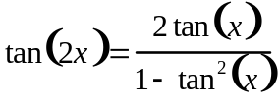

function 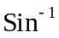 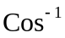 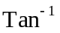
domain 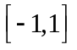 
range 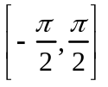 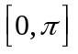 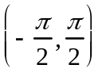

Algebra ( Complex Numbers )

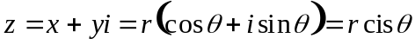
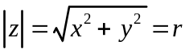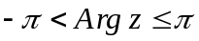
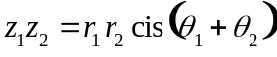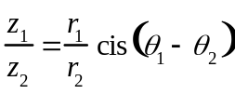
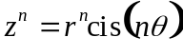 (de Moivre’s theorem )

Vectors in two and three dimensions

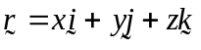
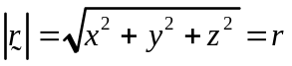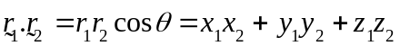

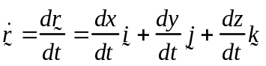

Mechanics

momentum: 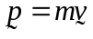

equation of motion: 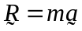

sliding friction: 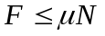

constant ( uniform ) acceleration:
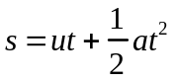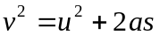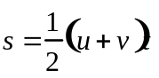

acceleration: 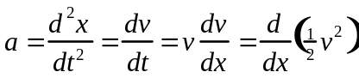

Calculus

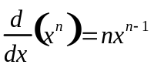
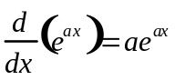
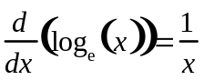
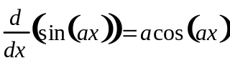
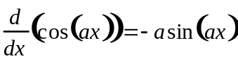

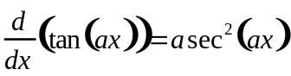
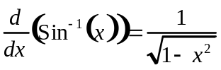
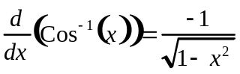
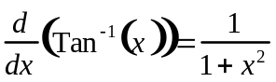

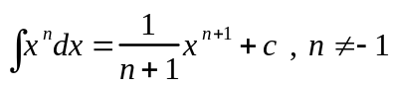
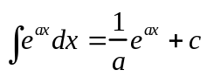
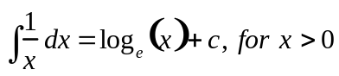
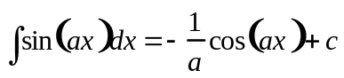

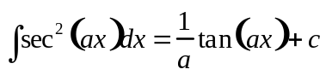
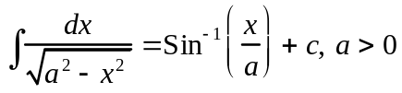
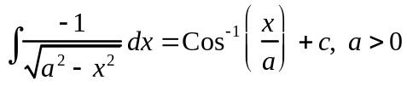
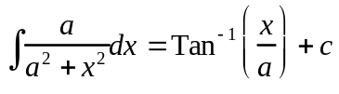

product rule: 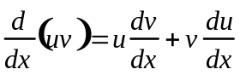

quotient rule: 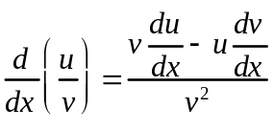

chain rule: 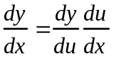

mid-point rule: 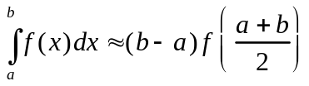

trapezoidal rule: 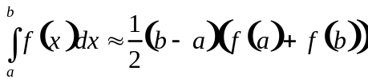

Euler’s method

Take the acceleration due to gravity to have magnitude g m/s², where g = 9.8

Question 1

a. Jared sets out on a walk from a point O and walks 30 metres east to a point A and then 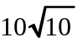 metres on a bearing north east where 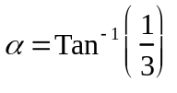to a point B, all the time on horizontal ground.

i. Taking as a unit vector in the east direction, as a unit vector in the north direction, find the vector  in terms of and .

________________________________________________________________________________________________________________________________________________________________________________________________________________________________________________________________________________________________1 mark

ii. Using a suitable scalar product, find the bearing of B from O in degrees and minutes.

________________________________________________________________________________________________________________________________________________________________________________________________________________________________________________________________________________________________________________________________________________________________________

2 marks

Question 1 (continued)

b. OABC is a trapezium and OARS is a square as shown. Both 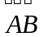 and  are inclined at an angle of to the vertical where
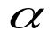

O
A
B
C
S
R

Let 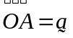 and 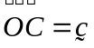.

i. Show that 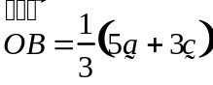.

________________________________________________________________________________________________________________________________________________________________________________________________________________________________________________________________________________________________________________________________________________________________________________________________________________________________________________

1 mark

Question 1 (continued)

b.
ii. Let M be the mid-point of  and P be a point on MC such that the ratio of the distances 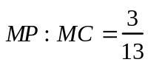. Show that 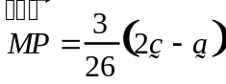.

________________________________________________________________________________________________________________________________________________________________________________________________________________________________________________________________________________________________________________________________________________________________________________________________________________________________________________

2 marks
iii. Hence find the vector  and show that O, P and B are collinear.
What is the ratio of the distances ?

________________________________________________________________________________________________________________________________________________________________________________________________________________________________________________________________________________________________________________________________________________________________________________________________________________________________________________________________________________________________________________________________________________________________________________________________________________________________________________________________________

3 marks

Question 1 (continued)

c. A drinking trough has a length of 150 cm and its cross-sectional face is in the shape of a trapezium, with a height of 30 cm and with lengths 30 and 50 cm.
Both sloping edges are at an angle of to the vertical, where as shown in the diagram below. The trough contains water to a height of h cm. The water, however, leaks out through a crack along the base of the trough at a rate equal to 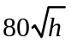 cm³/min.
150 cm
50 cm
30 cm
30 cm
h
i. Show that the differential equation for the height of water h cm in the trough, where 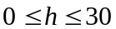, at a time t minutes, is given by 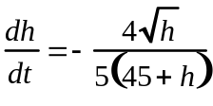
_________________________________________________________________________________________________________________________________________________________________________________________________________________________________________________________________________________________________________________________________________________________________________________________________________________________________________________________________________________________________________________
2 marks

Question 1 (continued)

c.
ii. When the trough is filled with water to a height of 25 cm, the water starts to leak out through the crack along the base of the trough. Hence, find using calculus, the exact time in hours before the trough is empty.

________________________________________________________________________________________________________________________________________________________________________________________________________________________________________________________________________________________________________________________________________________________________________________________________________________________________________________________________________________________________________________________________________________________________________________________________________________________________________________________________________________________________________________________________________________________________________________________________________________________________________________________________________________________________________________________________________________________________________________________________________________________________________________________________________________________________________________________________________________________________________________________________________________________________________________________________________

3 marks

Total 14 marks

Question 2

Let , 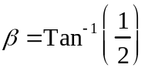 , 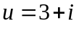 and 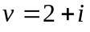

a. Find the exact value of 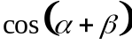.

________________________________________________________________________________________________________________________________________________________________________________________________________________________________________________________________________________________________________________________________________________________________________________________________________________________________________________

2 marks
b. Show that 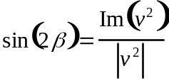.

_________________________________________________________________________________________________________________________________________________________________________________________________________________________________________________________________________________________________________________________________________________________________________________________________________________________________________________________________________________________________________________________________________________________________________________________

2 marks

Question 2 (continued)
c. Find 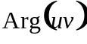 and explain how this shows that 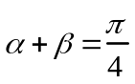.

_________________________________________________________________________________________________________________________________________________________________________________________________________________________________________________________________________________________________________________________________________________________________________________________________________________________________________________________________________________________________________________________________________________________________________________________
2 marks

d. 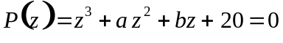, where a and b are real numbers and 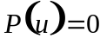. Find the values of a and b and state all the roots of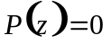.

________________________________________________________________________________________________________________________________________________________________________________________________________________________________________________________________________________________________________________________________________________________________________________________________________________________________________________________________________________________________________________________________________________________________________________________________________________________________________________________________________
2 marks

Question 2 (continued)

e. If 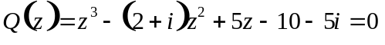, show that 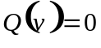 and, hence, find all the values of z where 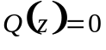.

________________________________________________________________________________________________________________________________________________________________________________________________________________________________________________________________________________________________________________________________________________________________________________________________________________________________________________________________________________________________________________________________________________________________________________________________________________________________________________________________________

2 marks

Total 10 marks

Question 3

a. Ashley is driving his sports car along a straight road at a speed of 10 m/s when he brakes. Assuming a constant retardation of 2.5 m/s² , find how long in seconds and the distance travelled in metres, before the speed of the car is reduced to
5 m/s.

________________________________________________________________________________________________________________________________________________________________________________________________________________________________________________________________________________________________________________________________________________________________________________________________________________________________________________

2 marks

b. Ashley’s sports car has a mass 800 kg and on another day he is moving along a level section of a street at a speed of 10 m/s when he brakes. The total resistance forces are 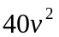newtons, where v m/s is the speed of the sports car at a time t seconds, and x is its distance from the point where Ashley applied the brakes.

i. By choosing an appropriate form for the acceleration, show that a differential equation relating v to x is 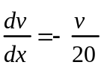.

____________________________________________________________________________________________________________________________________________________________________________________________________________________________________________________________________________________________________________________________________________________________________

1 mark

Question 3 (continued)

b.
ii. In this situation, express x in terms of v and find the exact distance travelled in metres, before the speed of the car is reduced to 5 m/s.

________________________________________________________________________________________________________________________________________________________________________________________________________________________________________________________________________________________________________________________________________________________________________________________________________________________________________________________________________________________________________________________________________________________________________________________________________________________________________________________________________________________________________________________________________________________________________________________________________________________________________________________________________________________________

3 marks

Question 3 (continued)

b.
iii. Find the exact time in seconds to reduce the speed of the car from 10 m/s to 5 m/s.

____________________________________________________________________________________________________________________________________________________________________________________________________________________________________________________________________________________________________________________________________________________________________________________________________________________________________________________________________________________________________________________________________________________________________________________________________________________________________________________________________________________________________________________________________________________________________________________________________________________________________________________________________________________

3 marks

Question 3 (continued)

b.
iv. Express the velocity v in terms of the time t and sketch the velocity time graph on the axes below, marking in suitable scales.

________________________________________________________________________________________________________________________________________________________________________________________________________________________________________________________________________________________________________________________________________________________________________________________________________________________________________________________________________________________________________________________________________________________________________________________________

t
v

2 marks

Total 11 marks

Question 4

a. The position vector of a particle at a time t seconds is given by 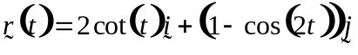 , for 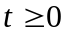.
Find the Cartesian equation of the curve.

________________________________________________________________________________________________________________________________________________________________________________________________________________________________________________________________________________________________________________________________________________________________________________________________________________________________________________________________________________________________________________________________________________________________________________________________________________________________________________________________________

2 marks

Question 4 (continued)
b. Given the function 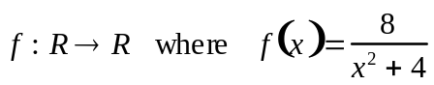,

i. Find the exact coordinates of the turning point and the inflexion points for the function.

________________________________________________________________________________________________________________________________________________________________________________________________________________________________________________________________________________________________________________________________________________________________________________________________________________________________________________________________________________________________________________________________________________________________________________________________________________________________________________________________________________________________________________________________________________
4 marks
ii. Sketch the graph of the function 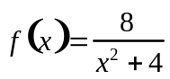 on the axes below, marking in suitable scales.
x
y
1 mark

Question 4 (continued)

b.
iii. An arched doorway at the entrance to a building has the shape given by the area under the curve 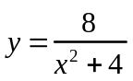 , between the x-axis and the lines 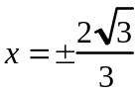.
Find, using calculus, the exact area of the doorway.

________________________________________________________________________________________________________________________________________________________________________________________________________________________________________________________________________________________________________________________________________________________________________________________________________________________________________________________________________________________________________________________________________________________________________________________________________________________________________________________________________________________________________________________________________________________________________________________________________________________

3 marks

Question 4 (continued)

c. Given the function 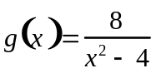 ,
i. State the maximal domain and range of the function 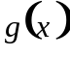 and the equations of all the asymptotes. Sketch the graph of on the axes below, marking in a suitable scale.

________________________________________________________________________________________________________________________________________________________________________________________________________________________________________________________________________________________________________________________________________________________________________________________________________________________________________________

x
y
2 marks

Question 4 (continued)

c.
ii. A section of piping is formed when the area bounded by the curve 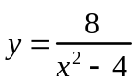 , the x-axis and the lines 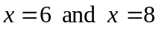 is rotated 360⁰ about the x-axis.
Find, using calculus, the exact volume of this section of piping.

________________________________________________________________________________________________________________________________________________________________________________________________________________________________________________________________________________________________________________________________________________________________________________________________________________________________________________________________________________________________________________________________________________________________________________________________________________________________________________________________________________________________________________________________________________________________________________________________________________________________________________________________________________________________________________________________________________________________________________________________________________________________________________________________________________________________________________________________________________________________________________________________________________________________________________________________________
4 marks

Total 16 marks
Question 5

Lilly is waiting for the delivery of some white goods, which were recently purchased.

a. A refrigerator has a mass of 102 kg and is on a loading bay from a delivery station. The loading bay is inclined at an angle of 40º to the horizontal as shown in the diagram below. When a delivery man exerts a force of P newtons on a rope up and parallel to the loading bay, the refrigerator is just prevented from sliding down the loading bay.

i. On the diagram below mark in all the forces acting on the refrigerator.
40º
rope
1 mark

ii. If the coefficient of friction between the refrigerator and the loading bay is 0.25, find the value of P correct to two decimal places.

________________________________________________________________________________________________________________________________________________________________________________________________________________________________________________________________________________________________________________________________________________________________________________________________________________________________________________________________________________________________________________________

3 marks
b. A dishwasher has a mass 52 kg and is now on the loading bay from the delivery
station. The loading bay is still inclined at an angle of 40º to the horizontal as shown in the diagram below. When the delivery man now exerts an upwards force of 300 newtons on a rope inclined at an angle of 35º to the loading bay, the dishwasher is moving down the loading bay with an acceleration of 0.5 m/s².

i. On the diagram below mark in all the forces acting on the dishwasher.
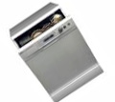
40º
35º

ii. Find the value of the coefficient of friction between the dishwasher and the loading bay giving your answer correct to three decimal places.

________________________________________________________________________________________________________________________________________________________________________________________________________________________________________________________________________________________________________________________________________________________________________________________________________________________________________________________________________________________________________________________________________________________________________________________________________________________________________________________________________________________________________________________________________________
4 marks
Total 9 marks
WORKING SPACE

________________________________________________________________________________________________________________________________________________________________________________________________________________________________________________________________________________________________________________________________________________________________________________________________________________________________________________________________________________________________________________________________________________________________________________________________________________________________________________________________________________________________________________________________________________________________________________________________________________________________________________________________________________________________________________________________________________________________________________________________________________________________________________________________________________________________________________________________________________________________________________________________________________________________________________________________________

End 2005 Specialist Mathematics Trial Examination 2 Question and Answer Book
KILBAHA MULTIMEDIA PUBLISHING  PO BOX 2227  KEW VIC 3101  AUSTRALIA | TEL: (03) 9817 5374  FAX: (03) 9817 4334  chemas@chemas.com  www.chemas.com

