
SPECIALIST MATHS
TRIAL EXAMINATION 2
SOLUTIONS
2006

_____________________________________________________________________

Section 1 – Multiple-choice answers

1. E 7. B 13. D 19. E
2. D 8. C 14. D 20. C
3. E 9. A 15. E 21. B
4. D 10. B 16. C 22. C
5. B 11. C 17. D
6. A 12. A 18. E
___________________________________________________________________________

Section 1- Multiple-choice solutions

Question 1

The equation of the asymptote through 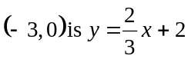.
For the hyperbola 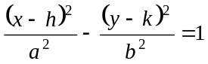 the asymptotes are given by 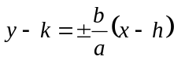.
We require 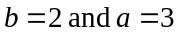.
The required equation is 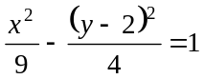
The answer is E.

Question 2

function asymptotes
- 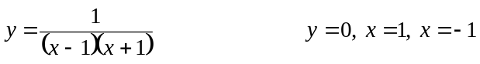
- 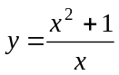
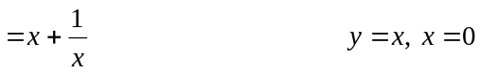
- 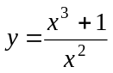
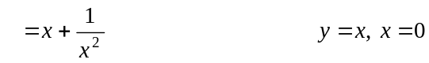
- 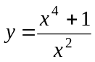
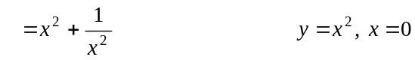
- 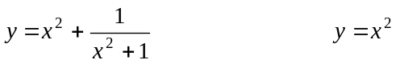

The answer is D.

Question 3

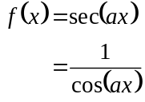
The graph has asymptotes for
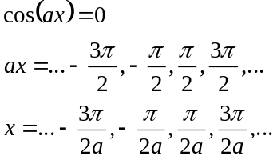
The answer is E.

Question 4

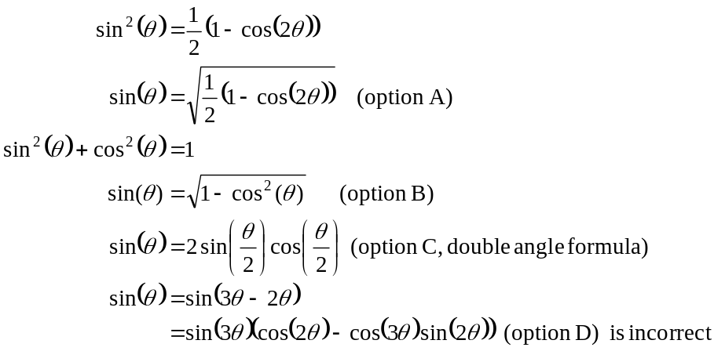

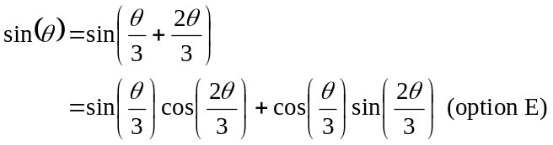
The answer is D.

Question 5

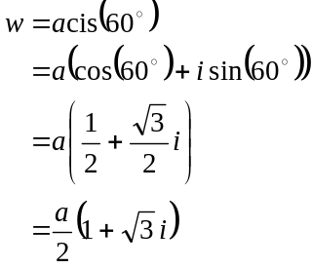
The answer is B.

Question 6
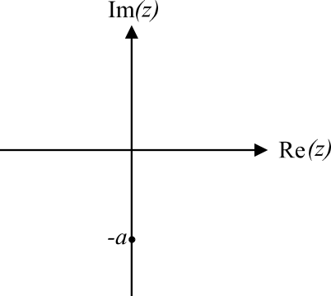

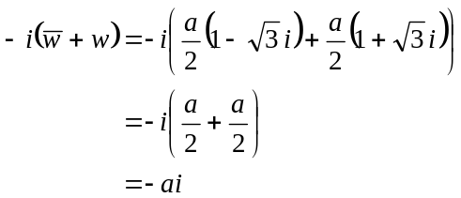
This complex number is located on the negative branch
of the imaginary axis, a units from the origin.
Hence in polar form it can be expressed as 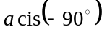.
The answer is A.

Question 7

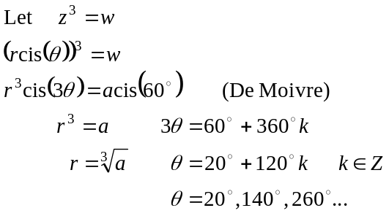
The three cube roots are .
If 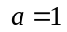, the cube roots lie on the circle with radius a units. If 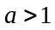, the cube roots lie on a circle with radius 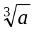 units which is inside the circle with radius a units. So option A is correct.
Option B is incorrect.
Options C, D and E are correct.
The answer is B.

Question 8

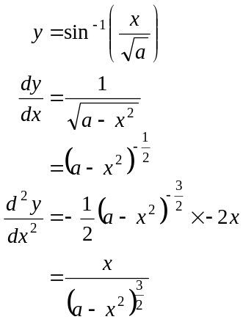
The answer is C.

Question 9

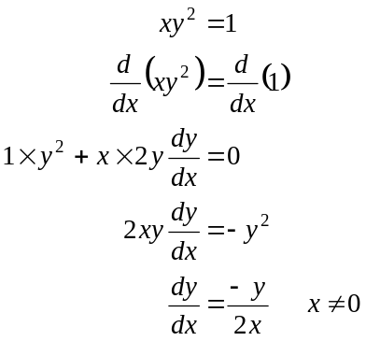
At 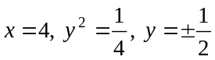
In the fourth quadrant 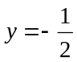
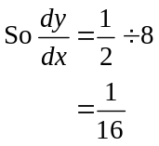
The answer is A.

Question 10

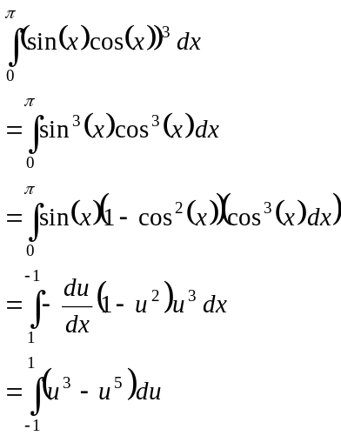
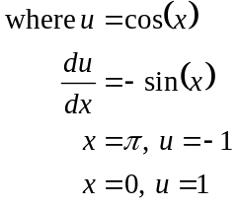

The answer is B.

Question 11

Stationary points on the graph of 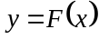 occur at 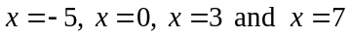.
The gradient (i.e. the value of 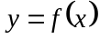) of the graph of is different i.e. positive or negative on either side of each of these stationary points and hence there is no stationary point of inflection.
Since 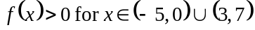, the gradient of the graph of is positive for these values.
At 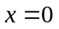, there is a maximum turning point since the gradient is positive to the left of and negative to the right. Therefore, option C is incorrect.
Options D and E are both correct.
The answer is C.

Question 12

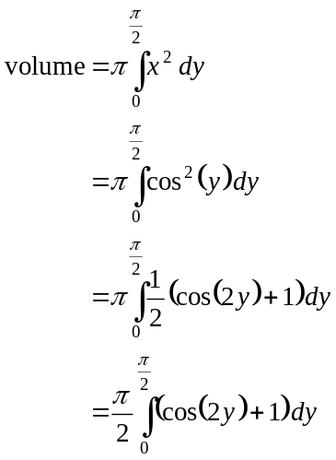
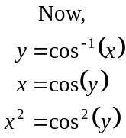
The answer is A.

Question 13

- 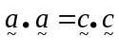
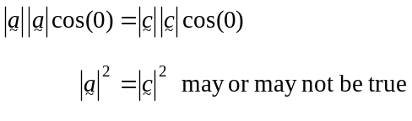
- 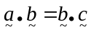 may or may not be true

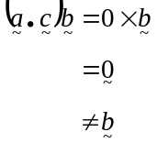
D.
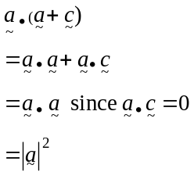
E.
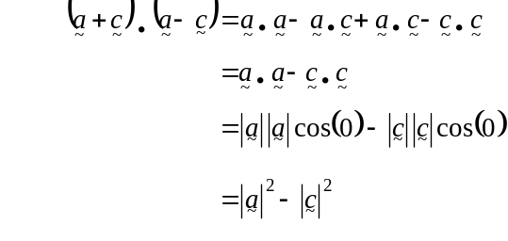
Now 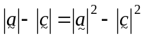 may or may not be true.
The answer is D.

Question 14

is the component of in the direction of .
Hence 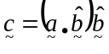.
The answer is D.

Question 15
Draw a diagram.
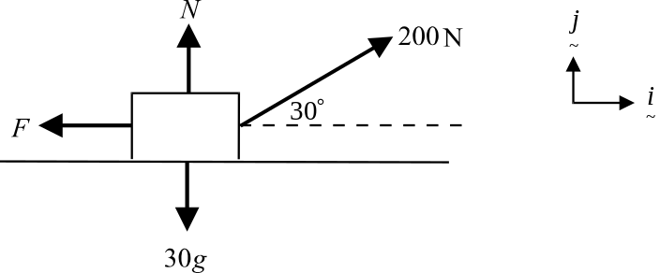

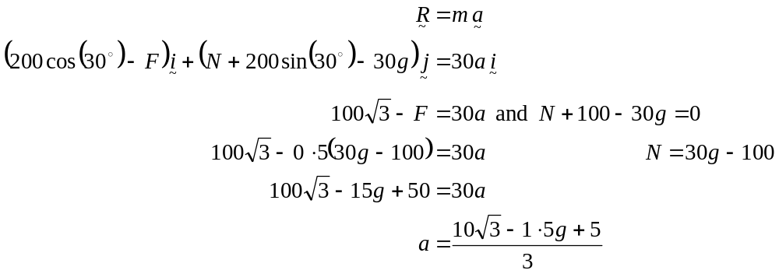
The answer is E.

Question 16
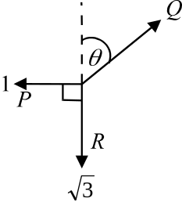
Resolving
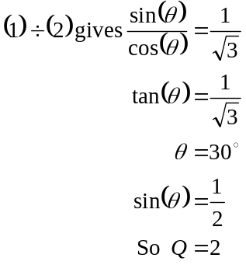
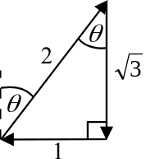
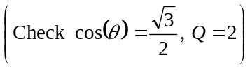.
Q has a magnitude of 2N and acts in a direction of N30°E.
The answer is C.

Question 17
Let be the velocity of the particle. So 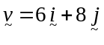 where runs in the horizontal direction and runs in the vertical direction.
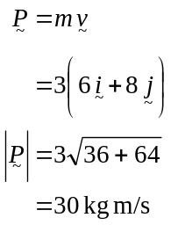
The answer is D.

Question 18

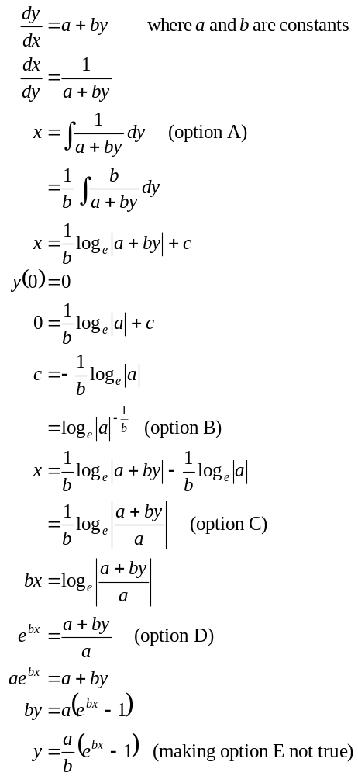
The answer is E.

Question 19

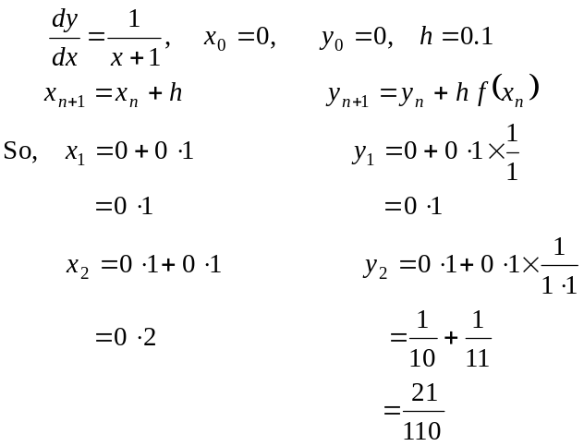
The answer is E.

Question 20

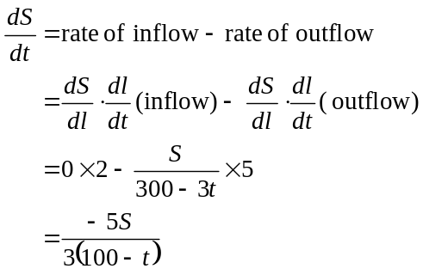
Note that the amount of sugar per litre in the tank is 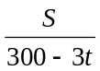 since every second the volume of solution decreases by 3L.
The answer is C.

Question 21
For 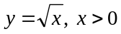 therefore the slope diagram is not appropriate to this function since gradients are assigned for 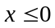.
A similar argument is true for 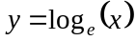.
Note that for 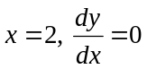.
This is true for 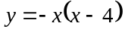 since 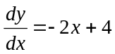 and when 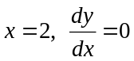.
For 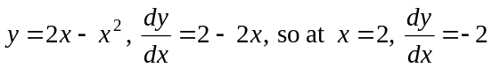 so the slope diagram is not suitable for this function.
Similarly for 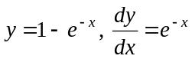.
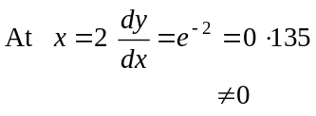
The answer is B.

Question 22

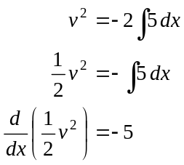
Since 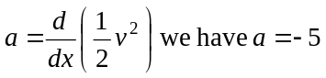.
Since the particle is moving with constant, negative acceleration, the velocity will be decreasing.
The answer is C.

Section 2

Question 1
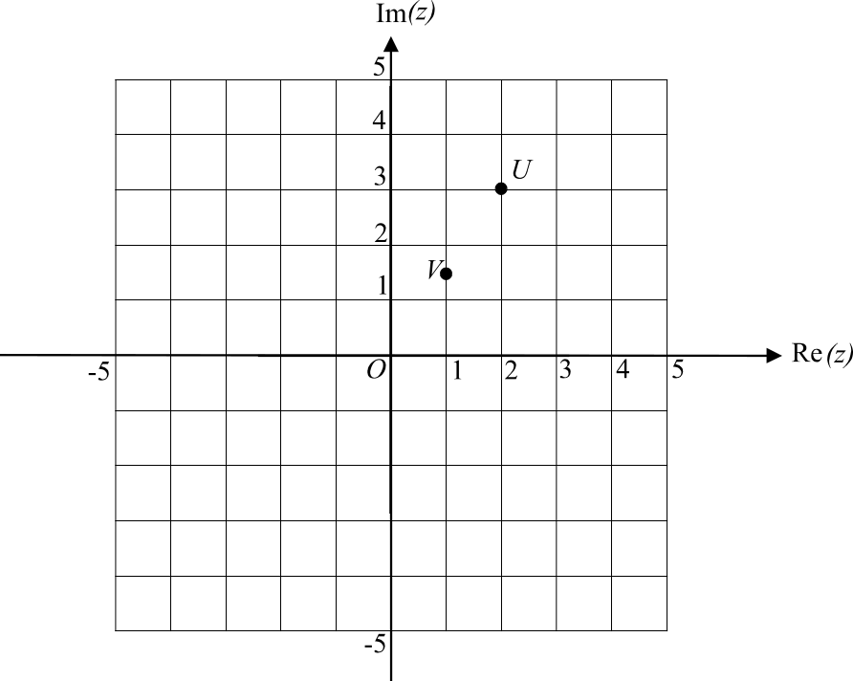

- (1 mark) correctly showing U and V.

- T is a circle with centre at U and radius of 2 units.
Since w lies on the imaginary axis, the circle touches that axis at 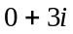 only.
So 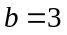.
(1 mark)

- i.
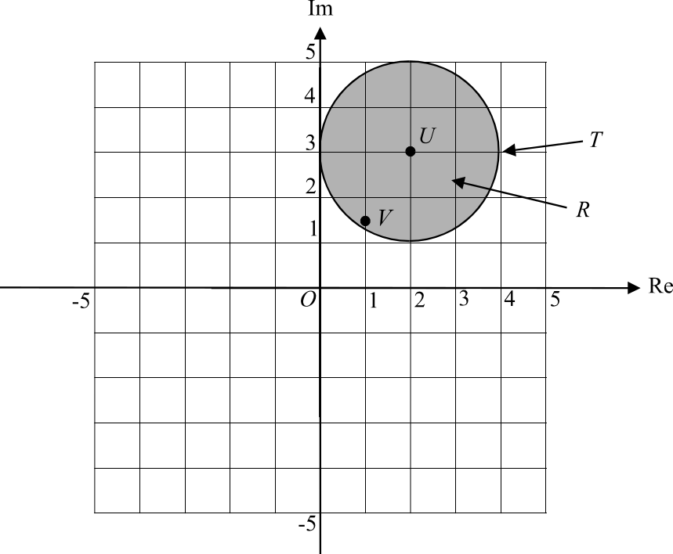

(1 mark)

  - 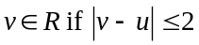
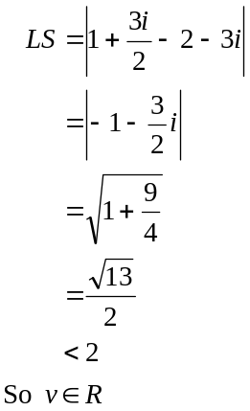
(1 mark)
(1 mark)

- i.
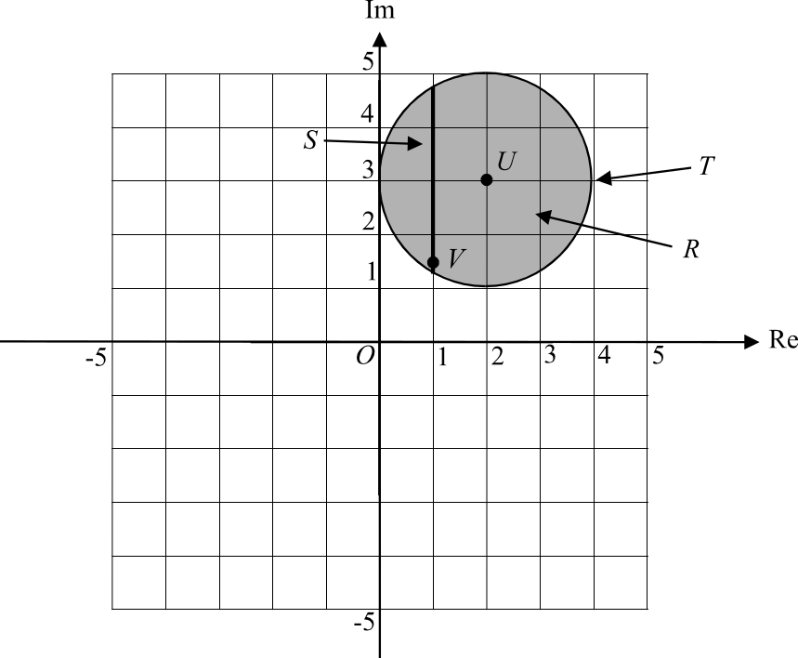

(1 mark)

  - Since 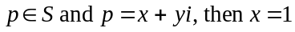 and the maximum and minimum values of y lie on the circle defined by
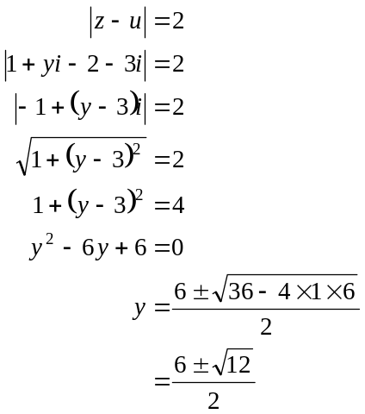
(1 mark)

So the maximum and minimum values of y are given respectively by
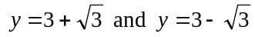 (1 mark)

- Method 1
The vectors 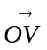 and 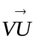are parallel if
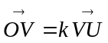 where k is a constant.
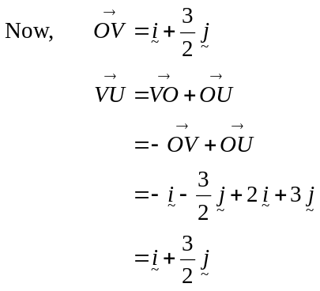
(1 mark)
So 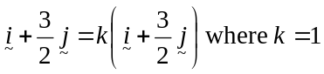 (1 mark)
So 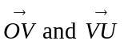 are parallel and since they share the point V, they must be collinear.
(1 mark)
Method 2
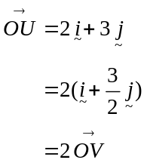
(1 mark)
(1 mark)
So are parallel and since they share the point O, they must be collinear.
(1 mark)

Total 11 marks
Question 2

- i. 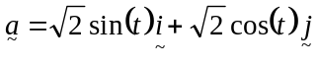
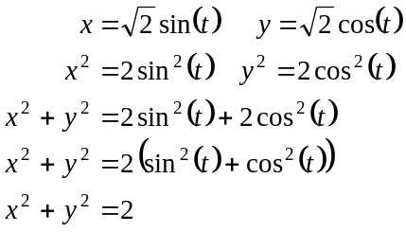
(1 mark)

  - At 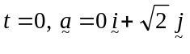
Particle A starts at the point 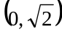 in the 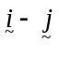 plane.
It moves in a clockwise direction on a circular path with centre at 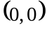 and radius 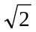.
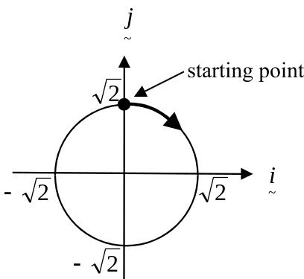
(We know it moves in a clockwise direction
since as t increases from 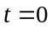,
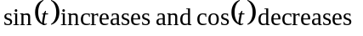
so the component increases and
the component decreases.)

(1 mark) stating starting point
(1 mark) clockwise direction around
a circle with correct centre and radius

- i. 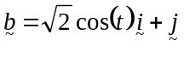
The Cartesian equation of the path of particle B is 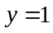.
(1 mark)

  - Since 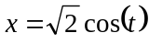, the domain of the Cartesian equation that describes the path of
particle B is 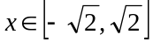.
(1 mark)

- 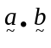
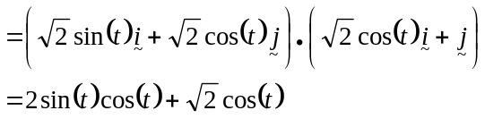
(1 mark)
When A and B are at right angles, 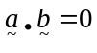 (1 mark)
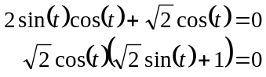

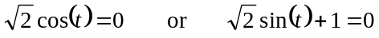
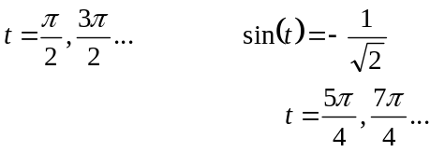
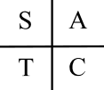
(1 mark)

A and B are first at right angles at 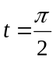 seconds.
(1 mark)

d.
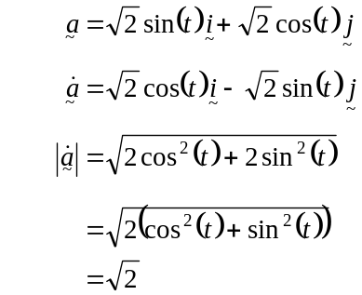 (1 mark)
So particle A moves with a constant speed of units.
(1 mark)
e.
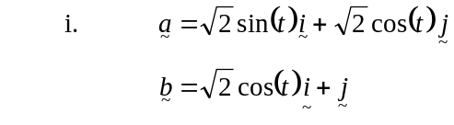
A and B will collide iff
(1 mark)
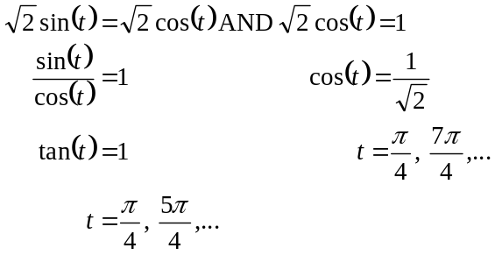
Since A and B will be at the same spot at the same time, that is at 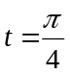, they will collide. (1 mark)

- At , A is at the point on the 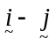 plane.
At , when A collides with B,
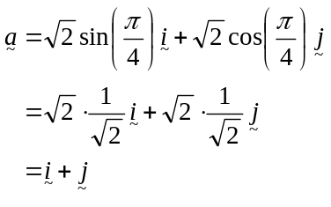
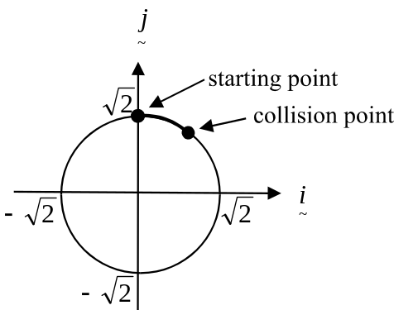
So A is at the point 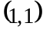 when the
collision occurs.
Particle A has travelled of the way
around the circle with perimeter 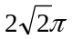.
So particle A has travelled 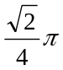 units.
(1 mark)
Total 14 marks

Question 3

- For 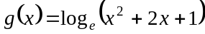,
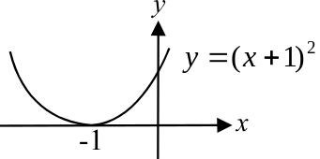
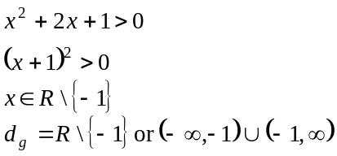
(1 mark)

- i. Let 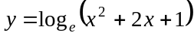
Swap x and y
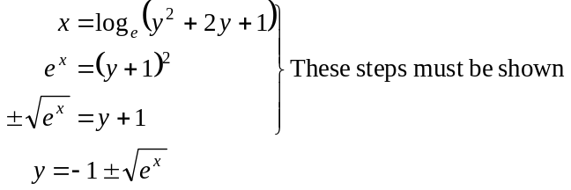
(1 mark)

- 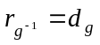
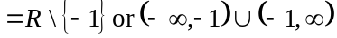
(1 mark)
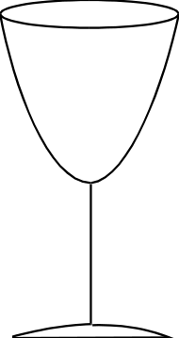

- First find 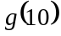.
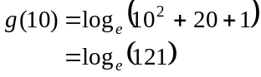
The diameter of the rim is 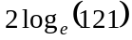 cm.
(1 mark)

- i. 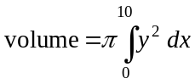
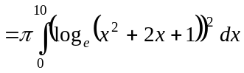
(1 mark) correct integrand
(1 mark) correct terminals

- Using a calculator,
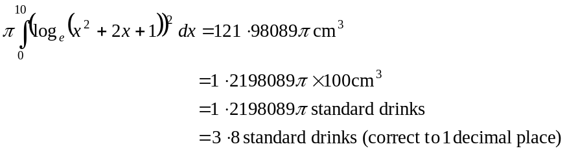
(1 mark)
(1 mark)

- Using a calculator, try different values of a where a is an integer. We require the largest value of a so that the value of y when 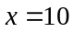 is less than 5.
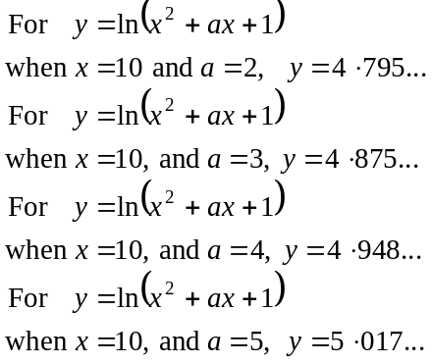
(1 mark) for trying some values of a
So the maximum value of a is 4.
(1 mark)

- For the function
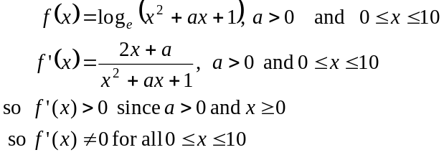
(1 mark)

So for 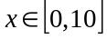 there is no horizontal slope. Hence when the mould is placed upright there is no point where the slope is vertical.
(1 mark)
Total 12 marks
Question 4

- The maximum speed of the train is given by 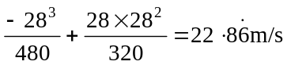.
(1 mark)

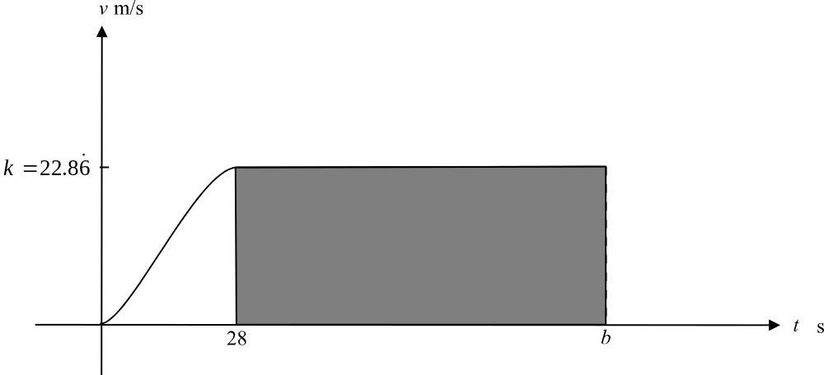

The shaded area on the graph above represents the distance travelled by the train whilst it is travelling at maximum speed.
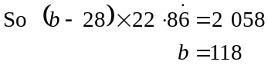
(1 mark)

- i. 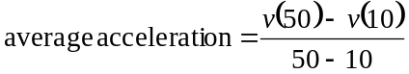
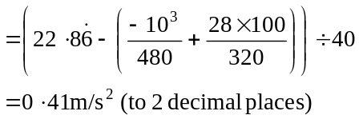
(1 mark)

  - For 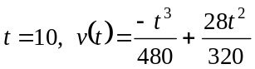
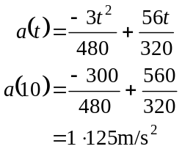
(1 mark)

- Method 1
Use a graphics calculator to solve
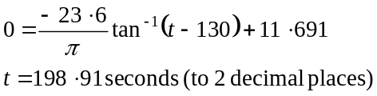
So 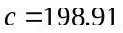 (to 2decimal places).
(1 mark)

Method 2
By hand.
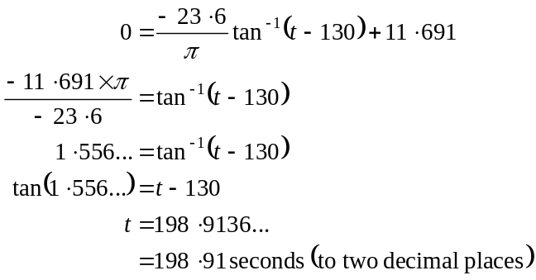
So (to 2decimal places). (1 mark)

- 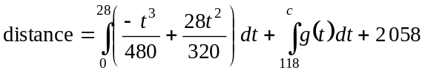
(1 mark) 1 correct integral
(1 mark) 2nd correct integral and including 2 058

- Sketch the function 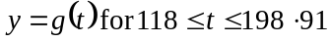.
There is a rapid decrease in the velocity of the train between approximately 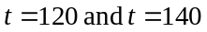 and then there is virtually zero velocity between 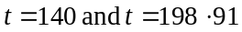 when the train finally comes to rest.
This suggests that the train decelerates quickly but then crawls along for approximately one minute; maybe having to wait for another train already in the station.
(1 mark)

- 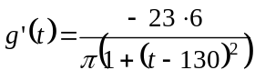
The velocity is constant when 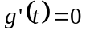.
Now, 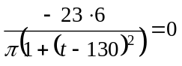 has no real solution since 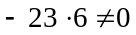.
So the velocity of the train is never constant for 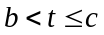.
(1 mark)

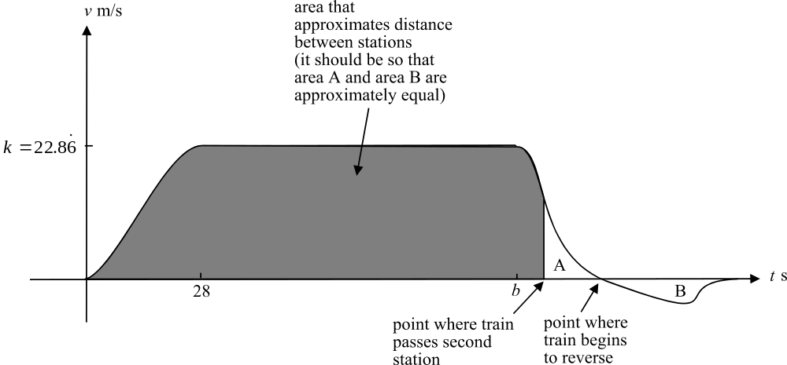

(1 mark) correct graph
(1 mark) showing area
(1 mark) showing reverse point
Total 12 marks

Question 5

- Draw a force diagram.
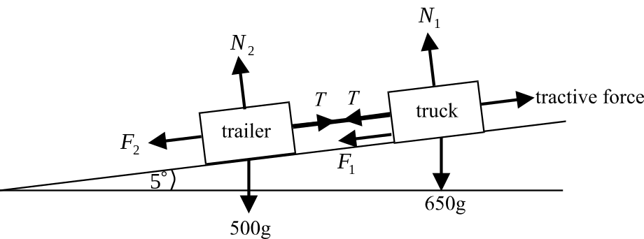

(1 mark) diagram showing forces around the trailer

Around the trailer
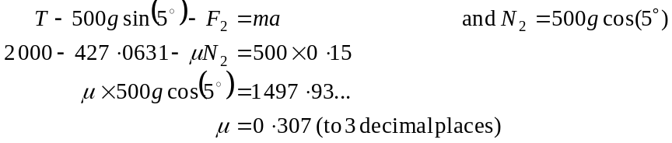
(1 mark)

(1 mark)

(1 mark)

b.
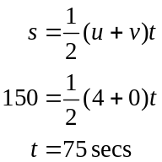
(1 mark)
(1 mark)

c. i.
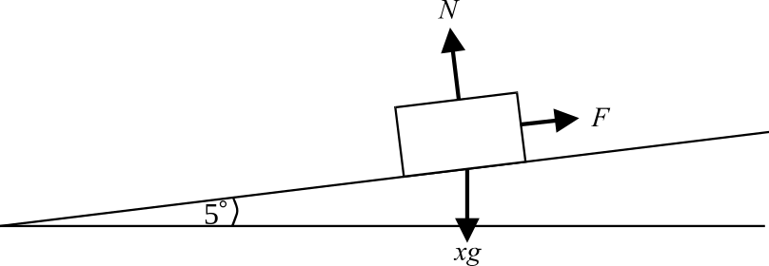

Draw a force diagram.
The mass of the trailer is unknown since it is being loaded with timber. Let the mass be x kg.
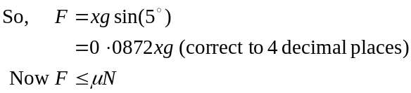
(1 mark)
When 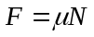, the trailer is on the point of rolling down the track.
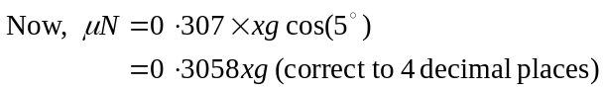
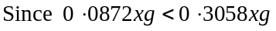, the trailer is not at the point of rolling down the track.
(1 mark)

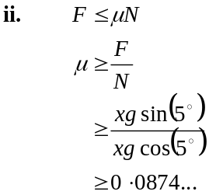
So 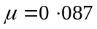 (to 3 decimal places).
(1 mark)
Total 9 marks

Total for Section 2 – 58 marks

