Year 2006

VCE

Specialist Mathematics

Trial Examination 1



KILBAHA MULTIMEDIA PUBLISHING  PO BOX 2227  KEW VIC 3101  AUSTRALIA | TEL: (03) 9817 5374  FAX: (03) 9817 4334  chemas@chemas.com  www.chemas.com

© Kilbaha Pty Ltd 2006

ABN 47 065 111 373
IMPORTANT COPYRIGHT NOTICE

- This material is copyright. Subject to statutory exception and to the provisions of the relevant collective licensing agreements, no reproduction of any part may take place without the written permission of Kilbaha Pty Ltd.
- The contents of this work are copyrighted. Unauthorised copying of any part of this work is illegal and detrimental to the interests of the author.
- For authorised copying within Australia please check that your institution has a licence from Copyright Agency Limited. This permits the copying of small parts of the material, in limited quantities, within the conditions set out in the licence.
- Teachers and students are reminded that for the purposes of school requirements and external assessments, students must submit work that is clearly their own.
- Schools which purchase a licence to use this material may distribute this electronic file to the students at the school for their exclusive use. This distribution can be done either on an Intranet Server or on media for the use on stand-alone computers.
- Schools which purchase a licence to use this material may distribute this printed file to the students at the school for their exclusive use.

- The Word file (if supplied) is for use ONLY within the school.

- It may be modified to suit the school syllabus and for teaching purposes.

- All modified versions of the file must carry this copyright notice.

- Commercial use of this material is expressly prohibited.

Victorian Certificate of Education
2006

STUDENT NUMBER
Letter
Figures
Words

SPECIALIST MATHEMATICS

Trial Written Examination 1

Reading time: 15 minutes
Total writing time: 1 hour

QUESTION AND ANSWER BOOK

Structure of book
Number of Number of questions Number of
questions to be answered marks
9 9 40

- Students are permitted to bring into the examination room: pens, pencils, highlighters, erasers, sharpeners, rulers.
- Students are NOT permitted to bring into the examination room: notes of any kind, a calculator, blank sheets of paper and/or white out liquid/tape.
Materials supplied
- Question and answer book of 13 pages with a detachable sheet of miscellaneous formulas at the end of this booklet.
- Working space is provided throughout the booklet.
Instructions
- Detach the formula sheet from the end of this book during reading time.
- Write your student number in the space provided above this page.
- All written responses must be in English.
Students are NOT permitted to bring mobile phones and/or any other unauthorised electronic devices into the examination room.

Instructions

Answer all questions in the spaces provided.
A decimal approximation will not be accepted if an exact answer is required to a question.
In questions where more than one mark is available, appropriate working must be shown.
Unless otherwise indicated, the diagrams in this book are not drawn to scale.
Take the acceleration due to gravity to have magnitude g m/s², where 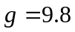

Question 1

Given the vector 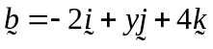 find the value of y if
a. the length of vector is 5.

_______________________________________________________________________________________________________________________________________________________________________________________________________________________________________________________________________________________________________________________________________________________________________________________

2 marks
b. the vector makes an angle of 150º with the y-axis.
________________________________________________________________________________________________________________________________________________________________________________________________________________________________________________________________________________________________________________________________________________________________________________________________________________________________________________________________________________________________________________________________________________________________________________________________________________________
2 marks
Question 2

A tank has a capacity of 300 litres and contains 200 litres of water in which 8 kilograms of salt has been dissolved. A salt solution of concentration 0.5 kilograms per litre is poured into the tank at a rate of 2 litres per minute, and the well-stirred mixture flows out at a rate of 3 litres per minute. If the amount of salt in the tank at a time t minutes is Q kilograms,

a. set up the differential equation, for the amount of salt Q kg in the tank at a time t minutes.

_________________________________________________________________________________________________________________________________________________________________________________________________________________________________
1 mark
b. If 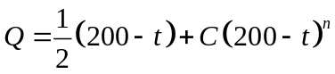 is a solution, where C is a constant,
find the value of n.

______________________________________________________________________________________________________________________________________________________________________________________________________________________________________________________________________________________________________________________________________________________________________________________________________________________________________________________________________________________________________________________________________________________________________________________________________________________________________________________________________________________________________________________________________________________________________________

2 marks
Question 3
a. Show that 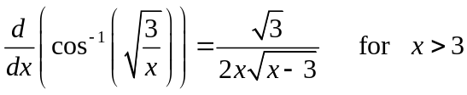

___________________________________________________________________________________________________________________________________________________________________________________________________________________________________________________________________________________________________________________________________________________________________________________________________________________________________________________________________________________________________________________________________________________________________________________________________________________________________________________________________________________________________
2 marks
b. Hence find the exact value of 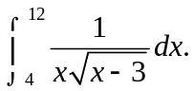

_____________________________________________________________________________________________________________________________________________________________________________________________________________________________________________________________________________________________________________________________________________________________________________________________________________________________________________________________________________________________________________________________________________

2 marks
Question 4
a. If 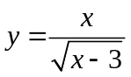 then gradient function can be represented as 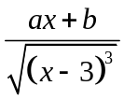
find the exact values of a and b.

_____________________________________________________________________________________________________________________________________________________________________________________________________________________________________________________________________________________________________________________________________________________________________________________________________________________________________________________________________________________________________________________________________________
2 marks
b. Find using calculus the exact area bounded by the curve the x-axis and the lines  and 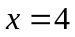.

___________________________________________________________________________________________________________________________________________________________________________________________________________________________________________________________________________________________________________________________________________________________________________________________________________________________________________________________________________________________________________________________________________________________________________________________________________________________________________________________________________________________________

2 marks
Question 5

A block of mass m is projected with a speed U so as to move straight up an inclined slide. The slide makes an angle of with the horizontal and the coefficient of friction between the block and the slide is .

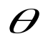

a. On the diagram above, mark in all the forces on the block on its movement up the slide.
1 mark

b. Show that the block travels a distance of 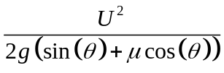 up the slide before coming to rest.

___________________________________________________________________________________________________________________________________________________________________________________________________________________________________________________________________________________________________________________________________________________________________________________________________________________________________________________________________________________________________________________________________________________________________________________________________________________________________________________________________________________________________

3 marks

Question 6

The area enclosed by the curves with the equations 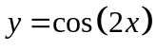 and 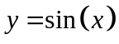 , 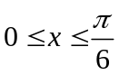 is rotated about the x-axis to form a solid of revolution. Find the exact volume of this solid of revolution.

______________________________________________________________________________________________________________________________________________________________________________________________________________________________________________________________________________________________________________________________________________________________________________________________________________________________________________________________________________________________________________________________________________________________________________________________________________________________________________________________________________________________________________________________________________________________________________
4 marks

Question 7

a. Solve for z if 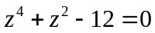

__________________________________________________________________________________________________________________________________________________________________________________________________________________________________________________________________________________________________________________________________________________________________________________________________________________________________________________________________
2 marks
b. Given that 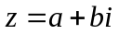 where 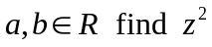.
Show that if .
Hence find in exact Cartesian form the square roots of 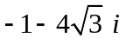

______________________________________________________________________________________________________________________________________________________________________________________________________________________________________________________________________________________________________________________________________________________________________________________________________________________________________________________________________________________________________________________________________________________________________________________________________________________________________________________________________________________________________________________________________________________________________________

3 marks
c. Use the quadratic formula to solve 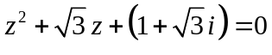
________________________________________________________________________________________________________________________________________________________________________________________________________________________________________________________________________________________________________________________________________________________________________________________________________________________________________________________________________________________________________________________________________________________________________________________________________________________
3 marks
Question 8

OABC is a trapezium. The length of OA is times the length of CB.
P and Q are the midpoints of OC and BA respectively.
Let 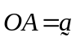

a. Express 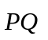 in terms of 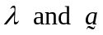

__________________________________________________________________________________________________________________________________________________________________________________________________________________________________________________________________________________________________________________________________________________________________________________________________________________________________________________________________
___________________________________________________________________________
3 marks
b. What is the ratio of the lengths of PQ to OA ?

______________________________________________________________________________________________________________________________________________________
___________________________________________________________________________

1 mark
Question 9
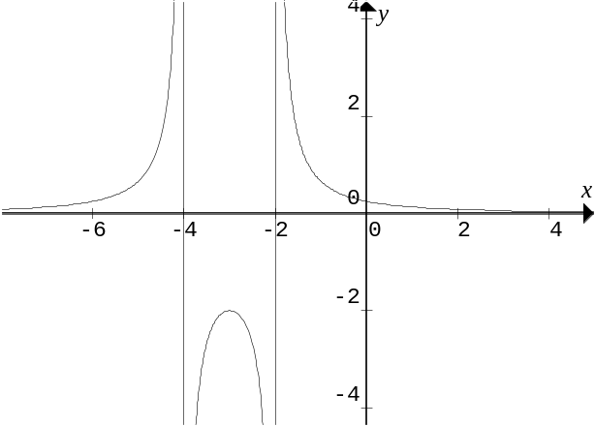
a. The graph shown has the form
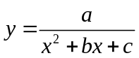

The graph has vertical asymptotes at 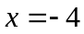 and  and has a range of 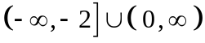.
Prove that 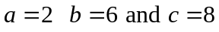

_________________________________________________________________________________________________________________________________________________________________________________________________________________________________
2 marks

b. If the area bounded by the curve 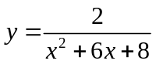 the coordinates axes and  can be expressed in the form 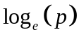 find using calculus the exact value of p.
___________________________________________________________________________________________________________________________________________________________________________________________________________________________________________________________________________________________________________________________________________________________________________________________________________________________________________________________________________________________________________________________________________________________________________________________________________________________________________________________________________________________________
___________________________________________________________________________
___________________________________________________________________________

3 marks

EXTRA WORKING SPACE

________________________________________________________________________________________________________________________________________________________________________________________________________________________________________________________________________________________________________________________________________________________________________________________________________________________________________________________________________________________________________________________________________________________________________________________________________________________________________________________________________________________________________________________________________________________________________________________________________________________________________________________________________________________________________________________________________________________________________________________________________________________________________________________________________________________________________________________________________________________________________________________________________________________________________________________________________________________________________________________________________________________________________________________________________________________________________________________________________________________________

END OF EXAMINATION

SPECIALIST MATHEMATICS

Written examination 1

FORMULA SHEET

Directions to students

Detach this formula sheet during reading time.

This formula sheet is provided for your reference.

Specialist Mathematics Formulas

Mensuration

area of a trapezium: 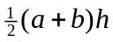
curved surface area of a cylinder: 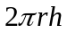
volume of a cylinder: 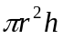
volume of a cone: 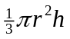
volume of a pyramid: 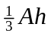
volume of a sphere: 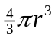
area of triangle: 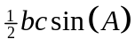
sine rule: 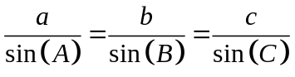

cosine rule: 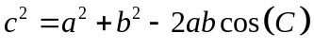

Coordinate geometry
ellipse: 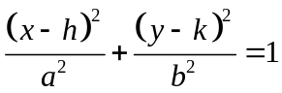 hyperbola: 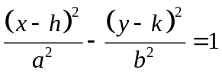

Circular ( trigonometric ) functions

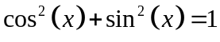
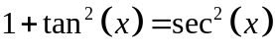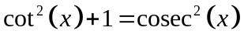
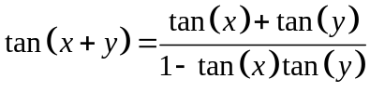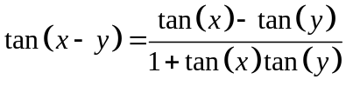
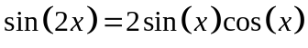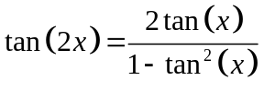

function 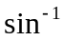 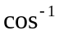 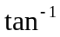
domain 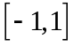 
range 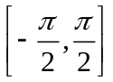 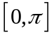 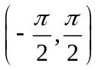

Algebra ( Complex Numbers )

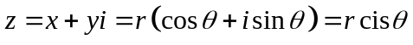
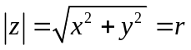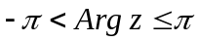
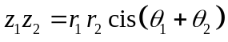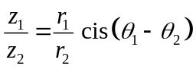
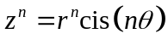 (de Moivre’s theorem )

Vectors in two and three dimensions

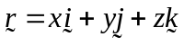
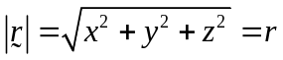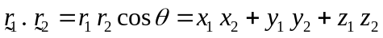

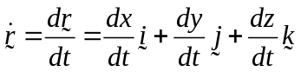

Mechanics

momentum: 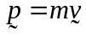

equation of motion: 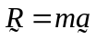

sliding friction: 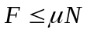

constant ( uniform ) acceleration:
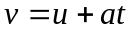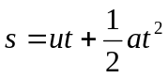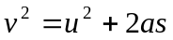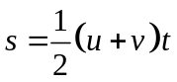

acceleration: 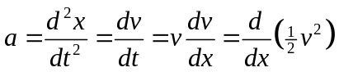

Calculus

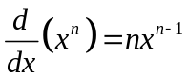 | 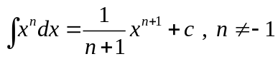
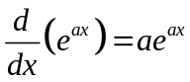 | 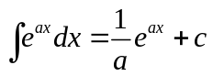
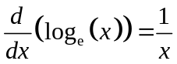 | 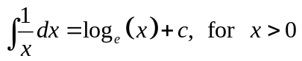
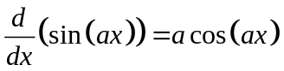 | 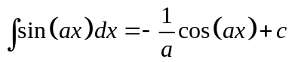
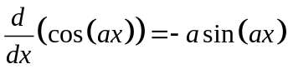 | 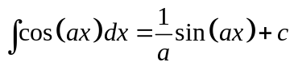
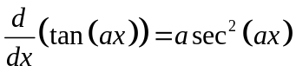 | 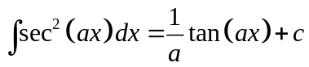
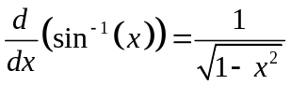 | 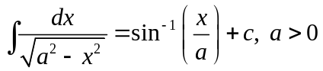
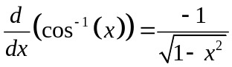 | 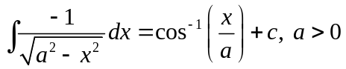
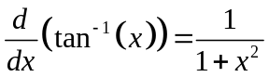 | 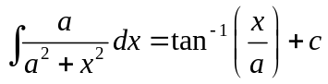

product rule: 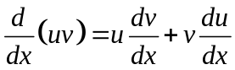

quotient rule: 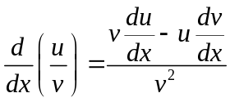

chain rule: 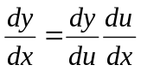

Euler’s method

END OF FORMULAE SHEET

