Year 2006

VCE

Specialist Mathematics
Solutions
Trial Examination 2



KILBAHA MULTIMEDIA PUBLISHING  PO BOX 2227  KEW VIC 3101  AUSTRALIA | TEL: (03) 9817 5374  FAX: (03) 9817 4334  chemas@chemas.com  www.chemas.com

© Kilbaha Pty Ltd 2006

ABN 47 065 111 373
IMPORTANT COPYRIGHT NOTICE

- This material is copyright. Subject to statutory exception and to the provisions of the relevant collective licensing agreements, no reproduction of any part may take place without the written permission of Kilbaha Pty Ltd.
- The contents of this work are copyrighted. Unauthorised copying of any part of this work is illegal and detrimental to the interests of the author.
- For authorised copying within Australia please check that your institution has a licence from Copyright Agency Limited. This permits the copying of small parts of the material, in limited quantities, within the conditions set out in the licence.
- Teachers and students are reminded that for the purposes of school requirements and external assessments, students must submit work that is clearly their own.
- Schools which purchase a licence to use this material may distribute this electronic file to the students at the school for their exclusive use. This distribution can be done either on an Intranet Server or on media for the use on stand-alone computers.
- Schools which purchase a licence to use this material may distribute this printed file to the students at the school for their exclusive use.

- The Word file (if supplied) is for use ONLY within the school.

- It may be modified to suit the school syllabus and for teaching purposes.

- All modified versions of the file must carry this copyright notice.

- Commercial use of this material is expressly prohibited.

SECTION 1

ANSWERS

1 |  | A |  | B |  | C |  | D |  | E
2 |  | A |  | B |  | C |  | D |  | E
3 |  | A |  | B |  | C |  | D |  | E
4 |  | A |  | B |  | C |  | D |  | E
5 |  | A |  | B |  | C |  | D |  | E
6 |  | A |  | B |  | C |  | D |  | E
7 |  | A |  | B |  | C |  | D |  | E
8 |  | A |  | B |  | C |  | D |  | E
9 |  | A |  | B |  | C |  | D |  | E
10 |  | A |  | B |  | C |  | D |  | E
11 |  | A |  | B |  | C |  | D |  | E
12 |  | A |  | B |  | C |  | D |  | E
13 |  | A |  | B |  | C |  | D |  | E
14 |  | A |  | B |  | C |  | D |  | E
15 |  | A |  | B |  | C |  | D |  | E
16 |  | A |  | B |  | C |  | D |  | E
17 |  | A |  | B |  | C |  | D |  | E
18 |  | A |  | B |  | C |  | D |  | E
19 |  | A |  | B |  | C |  | D |  | E
20 |  | A |  | B |  | C |  | D |  | E
21 |  | A |  | B |  | C |  | D |  | E
22 |  | A |  | B |  | C |  | D |  | E

SECTION 1

Question 1 Answer D

The graphs of all alternatives give vertical asymptotes at 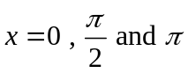
however option D is wrong, it is the reflection in the x-axis

Question 2 Answer D

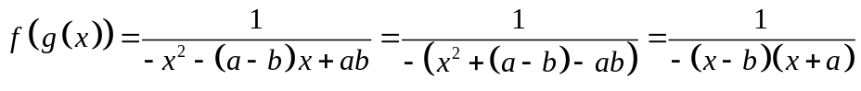
So there are vertical asymptotes at 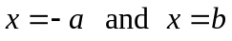

Question 3 Answer A

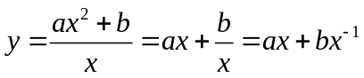
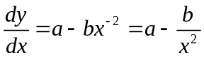 for turning points 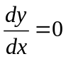
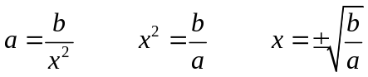 however there are no turning points, so there is no solutions for 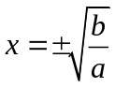 so a and b must have opposite signs the product 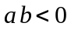 so
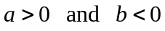

Question 4 Answer B
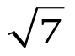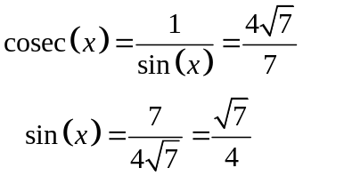
x
4
3
so from the triangles 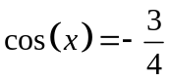 since 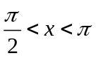 x is obtuse and in the second quadrant 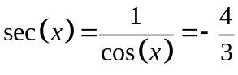
Question 5 Answer E

The ellipse 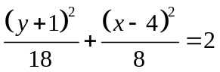 in standard form is 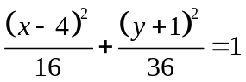
it has centre at 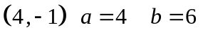 the domain is 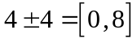
and the range 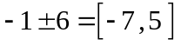

Question 6 Answer C

Given 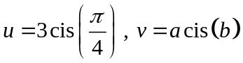 and 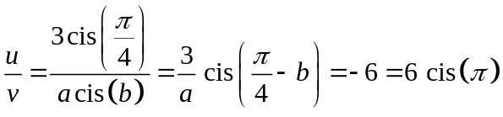
so 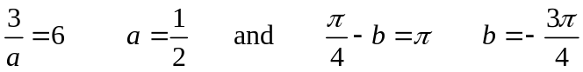

Question 7 Answer E

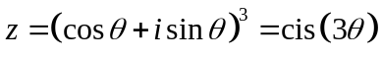 by DeMoivre’s Theorem and 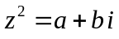
Equating real and imaginary parts respectively gives 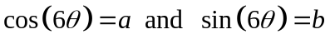

Question 8 Answer C

The circle has radius 2, one of the solutions is 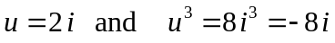
but 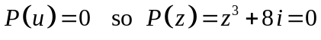

Question 9 Answer A

by the conjugate root theorem 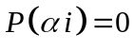 so 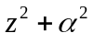 is one factor, the other is 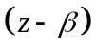 expanding
equating
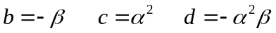

Question 10 Answer C

The inside of the circle of radius 4, can be represented by 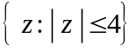 or 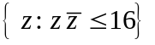 or 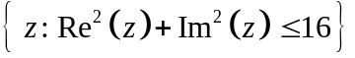 the upper half plane of the Argand diagram can be represented by 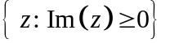 or 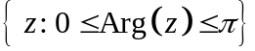 option C is the only correct intersection of all the possible correct representations.

Question 11 Answer E

When we have the repeated factor 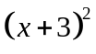 and the non-linear factor 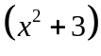 we represent the expression 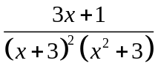 in partial fractions as 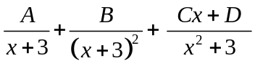

Question 12 Answer E

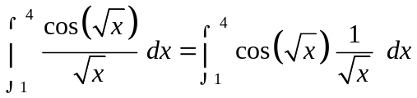
let 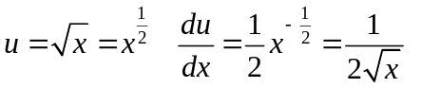 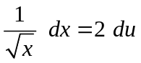
change the terminals when
the definite integral becomes 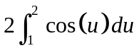

Question 13 Answer D

At 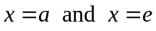 the gradient changes from negative to positive, this gives a minimum at the two points . At the gradient changes from positive to negative this gives a maximum at the point . The graph of 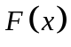 is a quartic and will have two points of inflexions, one somewhere between 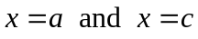 and another somewhere between 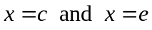.

Question 14 Answer C
A
B
C
P
Option A is true 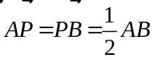 since P is the mid-point of 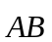
Option B is true since ABC is an equilateral triangle all side lengths are equal 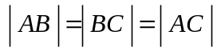
Option C is false  is perpendicular to 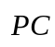 so 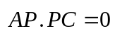
Option D is true the angle CAB is 60⁰ 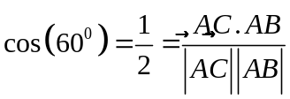
Option E is true the angle PCB is 30⁰ 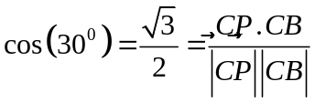

Question 15 Answer A

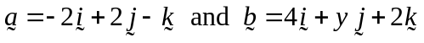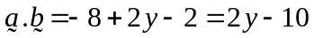
So the angle between 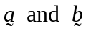 is 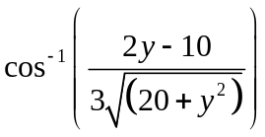
If 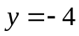 then 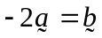 so the vectors 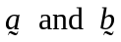 are linearly dependent,
option A is false
All the other alternatives are true.
Option C if 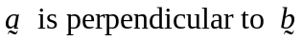 then 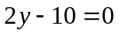 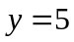
Option D if 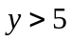 then the angle between the vectors is acute.
Option E if 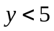 then the angle between the vectors is obtuse.
Question 16 Answer B

The velocity vector is 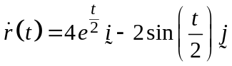 integrating with respect to t to get the position vector 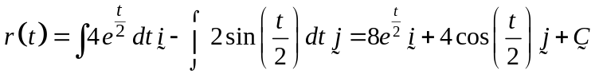 now using the initial conditions and
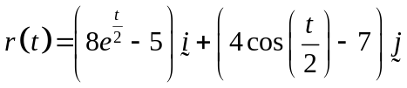

Question 17 Answer A

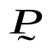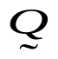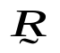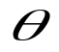
N
S
E
W

Option A is false if 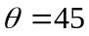 then 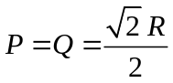
All the other alternatives are true
Option B 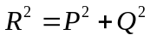
Option C 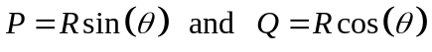
Option D 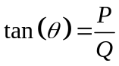
Option E as vectors 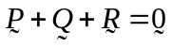

Question 18 Answer E
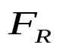
mg

N
F

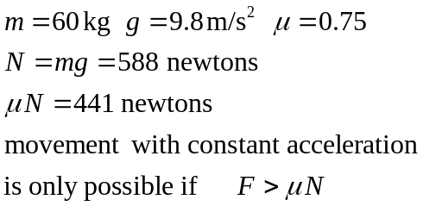

Question 19 Answer B

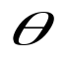
N
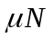

P

mg

resolving the forces, perpendicular to the plane

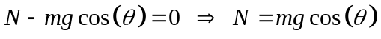
resolving the forces up and parallel to the plane.

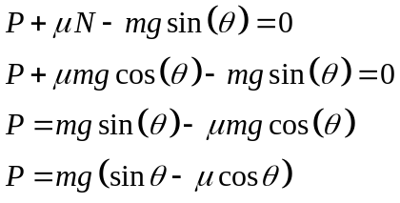
Question 20 Answer A

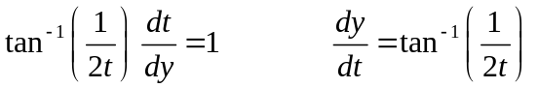 using a calculator program gives

t | y
1.00 | 2.0000
1.25 | 2.1159
1.50 | 2.2110

Question 21 Answer B

The solution curves are of the form 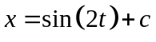 so differentiating,
the differential equation is 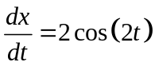

Question 22 Answer B

The volume in the tank is 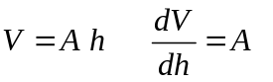
and 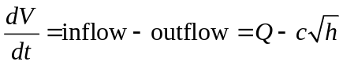
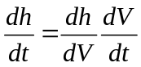 so that 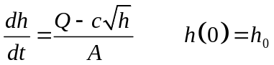

END OF SECTION 1 SUGGESTED ANSWERS

SECTION 2
Question 1

a.i. 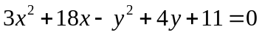
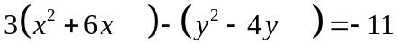
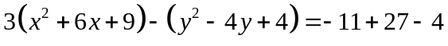 M1
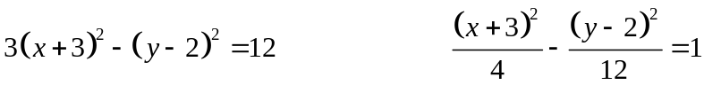 A1
ii.
hyperbola, centre 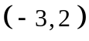 vertices 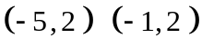 A1
asymptotes 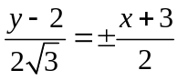 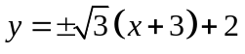
A1

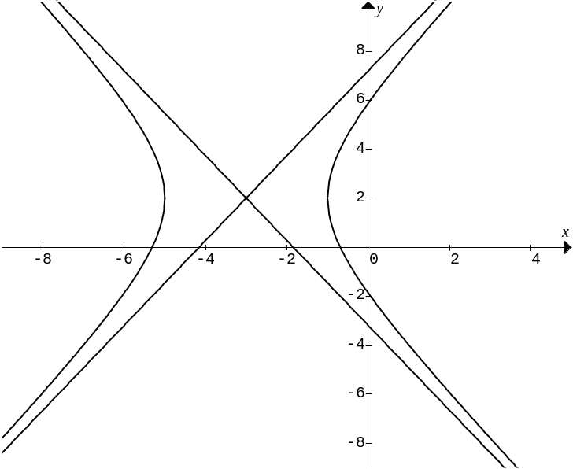
S
C
R

b.i 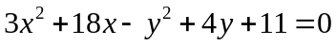
differentiating implicitly
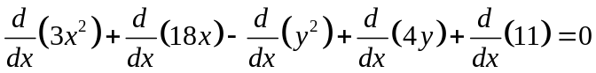
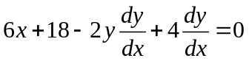
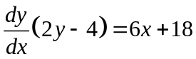
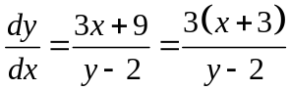 A1

ii. When the tangent is parallel to the y-axis. 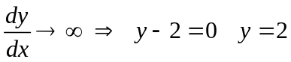
These are obviously the vertices A1
c. 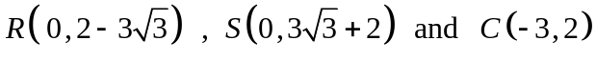
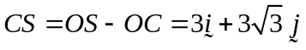 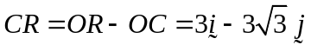 M1
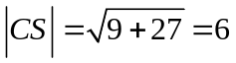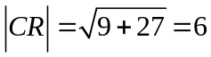
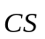 . 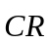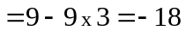
The angle between and is where 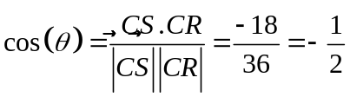
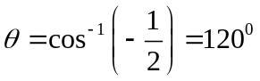 A1
this angle represents the angle between the asymptotes at the centre of the hyperbola. A1

d.
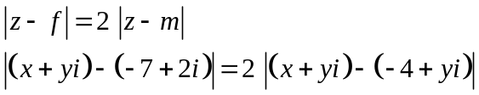
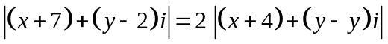 M1
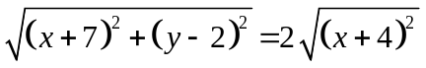 squaring both sides and expanding M1
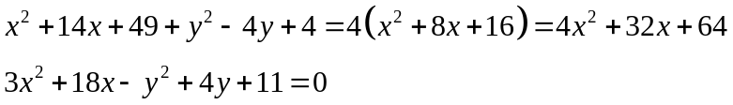
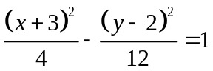 the hyperbola again A1

e. 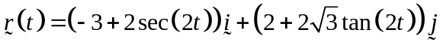
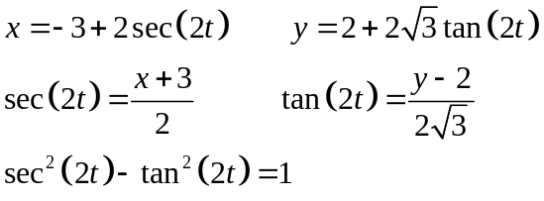 M1
the hyperbola again A1

Question 2

a. domain 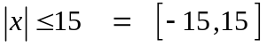 A1

b.
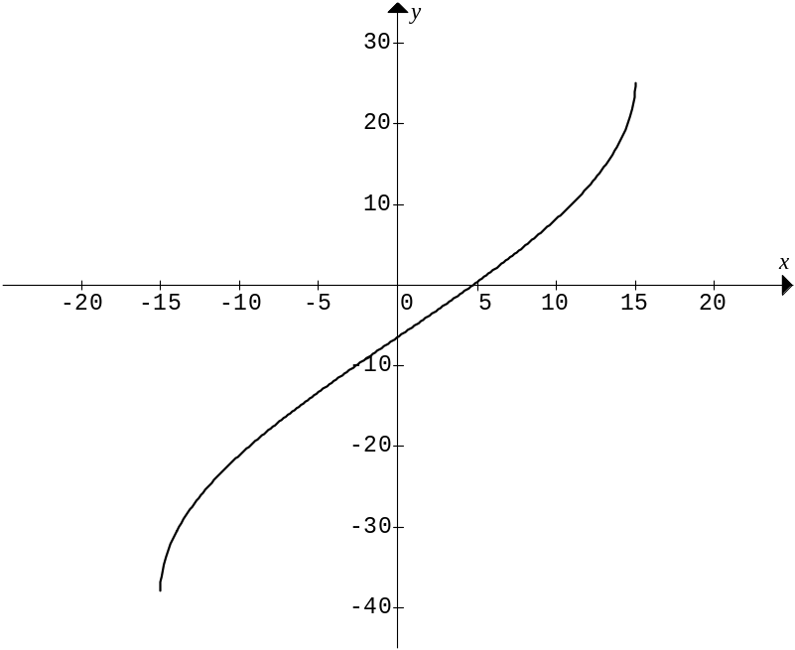 A1
c. 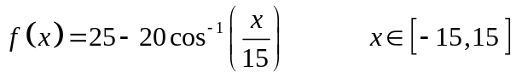
end points 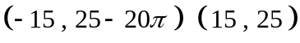
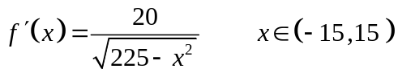
the function is defined at the end-points
but the gradient is not defined at the end-points. A1
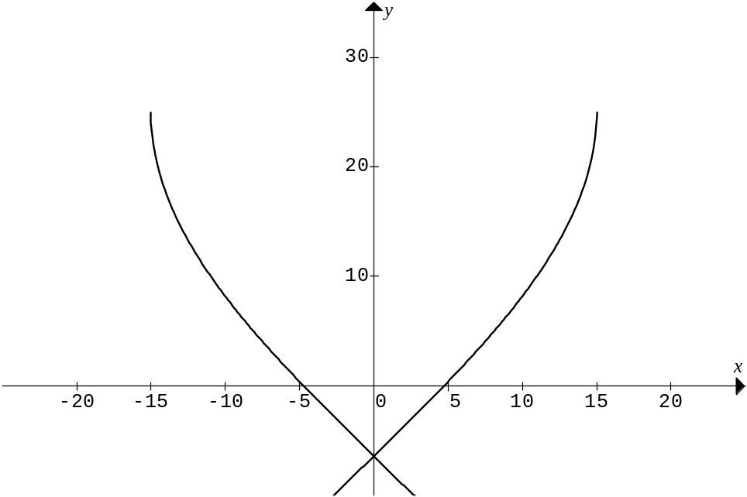

d. when 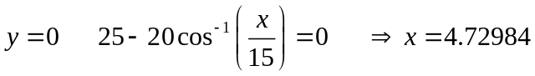
the diameter of the base of the vase is 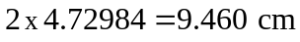 A1

e. 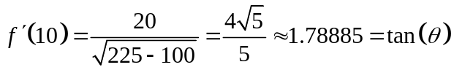 M1
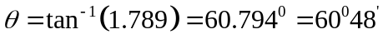 A1

f. i. 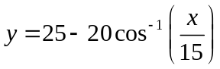
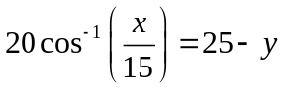
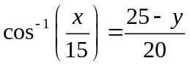 M1
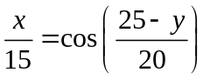
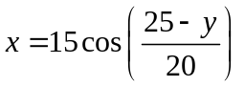 M1
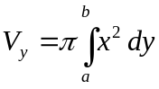
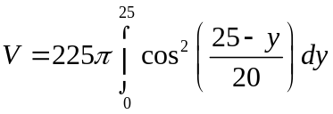 A1
ii. 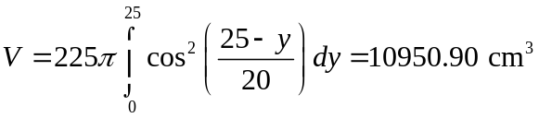 A1

Question 3

a. 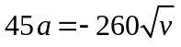
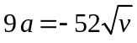 A1

b. 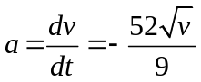 inverting both sides
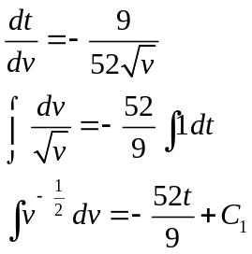 M1
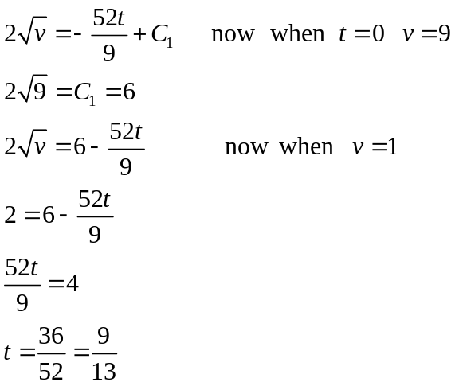
The head-wind blows for 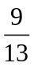 secs A1

c.i. 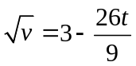
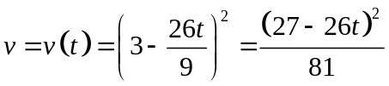 A1

ii.
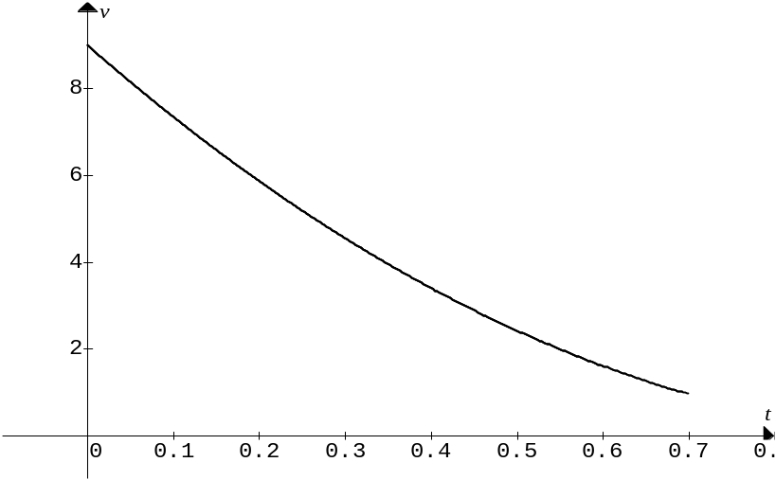
Note the restricted domain for t as 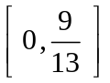, graph passes through the points
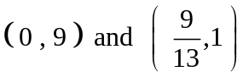 A1
d. Since the area under the velocity time graph represents the displacement
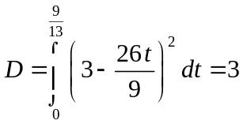 A1
Pete rode his bike exactly 3 metres during the head-wind. A1

e. 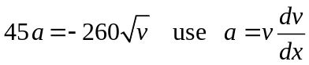
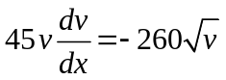
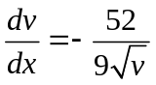 A1

f. 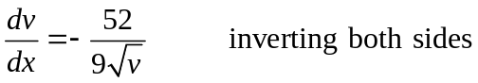
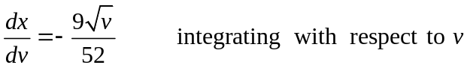 M1
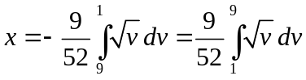 A1
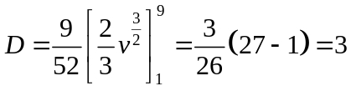 A1
Question 4
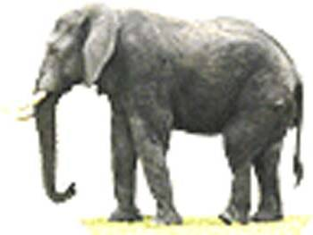
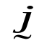
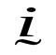
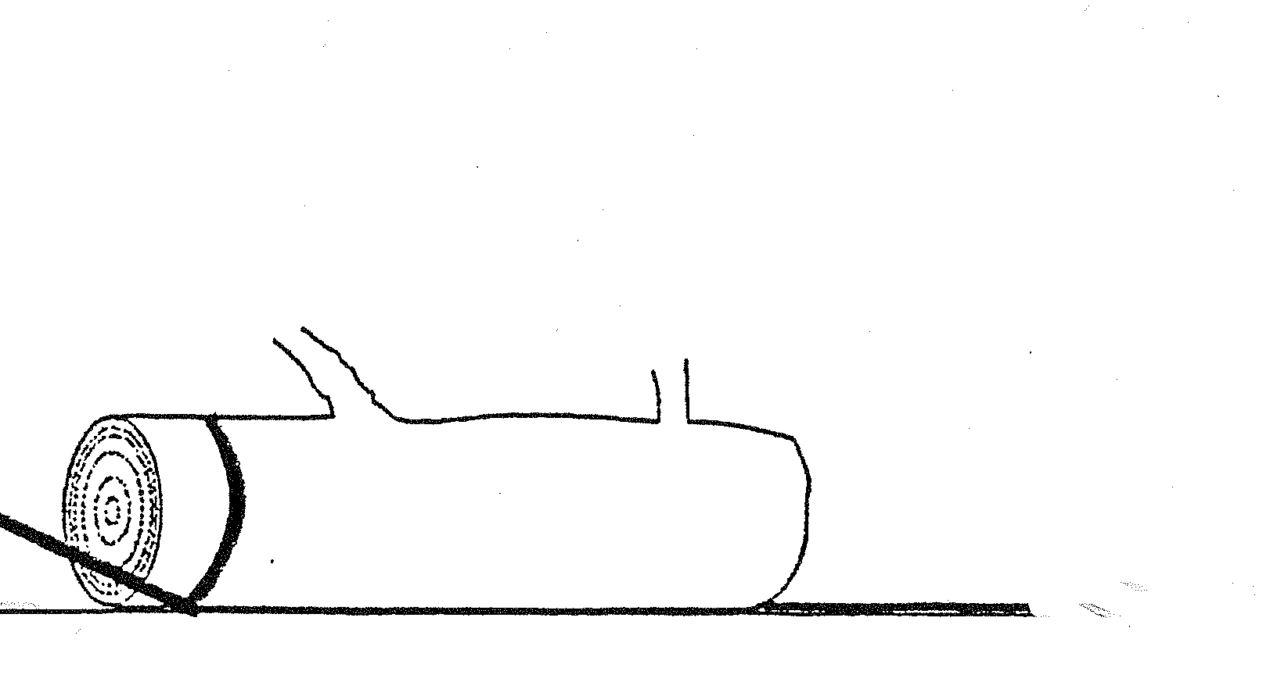
T
P
N_{elephant}
T
N
a. i.

N

0.8 N

35⁰

400 g
5000g
A1
ii Using Newtons 2nd Law of Motion
resolving horizontally around the log in the direction.
(1) 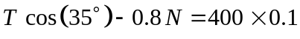
resolving vertically around the log in the direction. M1
(2) 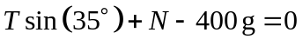
(2) 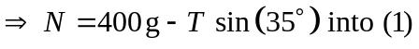 M1
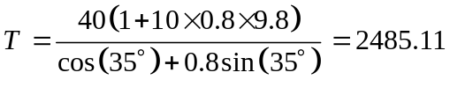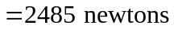 A1
iii. resolving horizontally around the elephant in the direction.
(3) 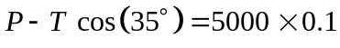
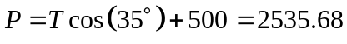
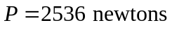 A1

5000g
35⁰
5⁰
N
0.8N
400g
T
N_{elephant}
b. i.
Q
T

A1
ii. constant speed is zero acceleration. Note the 0.1 m/s is not used.
resolving up and parallel to the hill around the log in the direction.
(1) 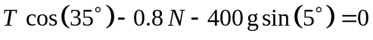
resolving perpendicular to the hill around the log in the direction
(2) 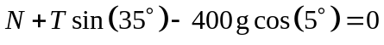 M1
(2)
M1
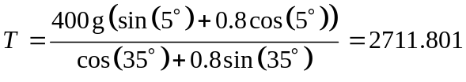
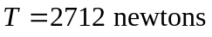 A1
iii. resolving horizontally around the elephant in the direction.
(3) 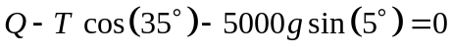
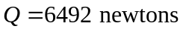 A1
Question 5 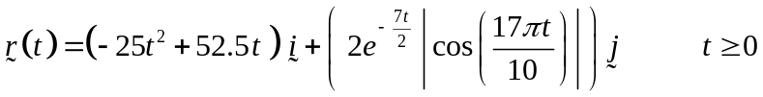
a. 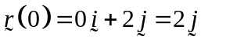
The ball was 2 metres above the ground when it left the bowlers hand. A1

b. differentiating using the product in the component M1
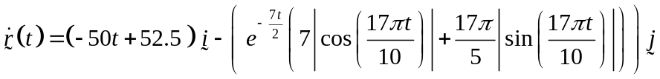 A1

c. M1
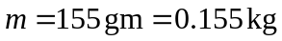
magnitude of the momentum of the ball when it left the bowlers hand 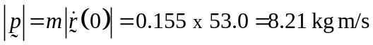 A1

d. The ball hits the ground when 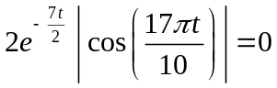
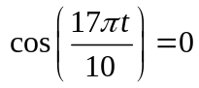 M1
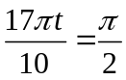
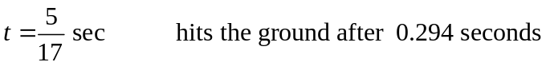 A1
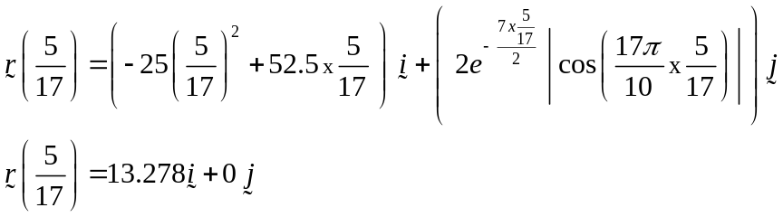
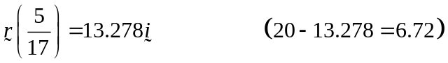
The ball strikes the ground 6.72 metres from the batting stumps A1

e. 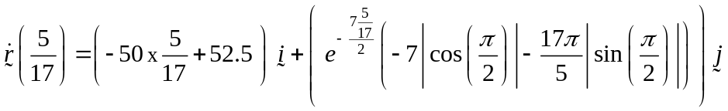
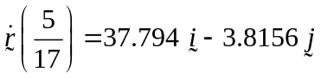 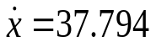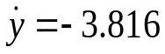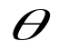 M1

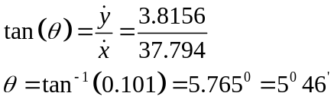
The ball strikes the ground at an angle of 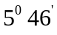 A1

f. when 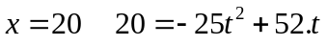

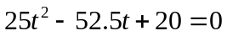
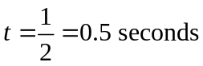
Hits the batting stumps after 0.5 seconds A1
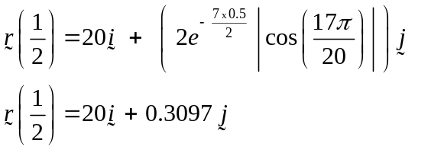
hits the stumps 31 cm above the ground. A1

g. Total distance of 20 metres in 0.5 seconds, gives the average
velocity of the ball as 40 m/s or 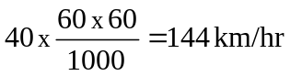 A1

END OF SECTION 2 SUGGESTED ANSWERS

