
SPECIALIST MATHS
TRIAL EXAMINATION 1
SOLUTIONS
2007

Question 1

- Let 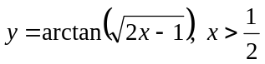
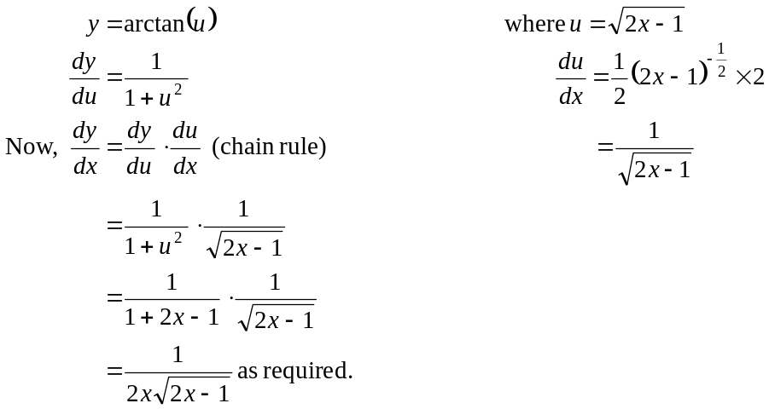
(1 mark)
(1 mark)

- From a. 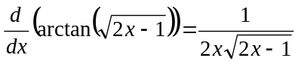
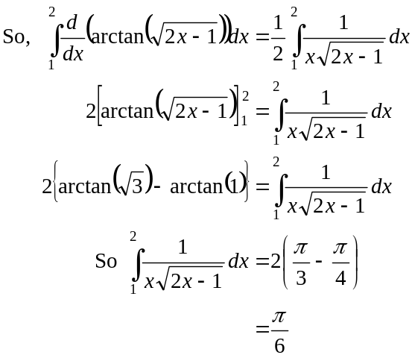
(1 mark)
(1 mark)

Question 2
- 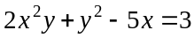
(1 mark)
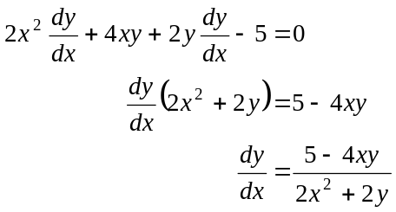
(1 mark)
- 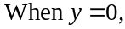
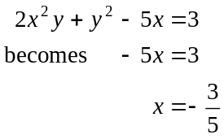
(1 mark)
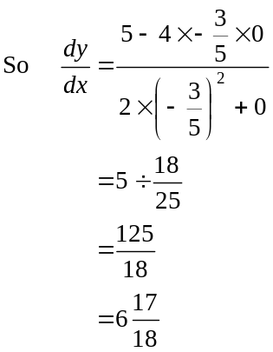
(1 mark)
Question 3
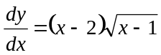
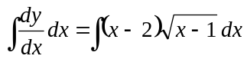
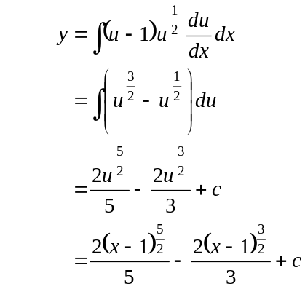
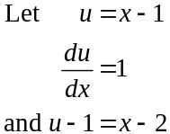
(1 mark)
(1 mark)
When 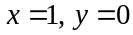
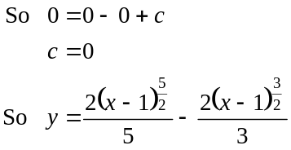
(1 mark)

Question 4

- 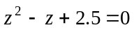 is a quadratic equation so we can use the quadratic formula.
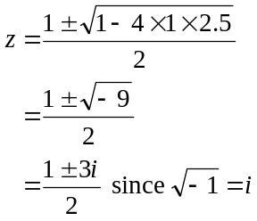
(1 mark)
(1 mark)
- 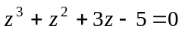
The coefficients of all the terms are real so two of the three solutions form a conjugate pair and the third is a real solution.
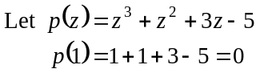
is a factor.

Method 1
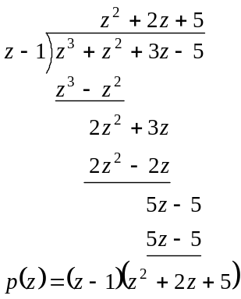
(1 mark)

Method 2

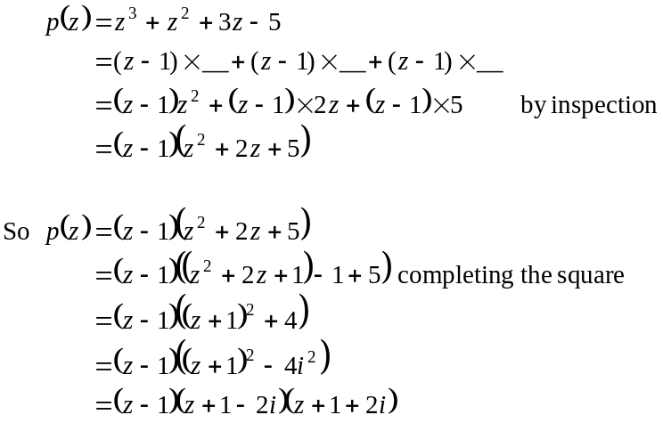
(1 mark)
(1 mark)

So for 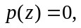
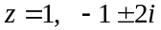
(1 mark)

Question 5

- Method 1 – resolving around each of the containers

Show all the forces on the diagram.
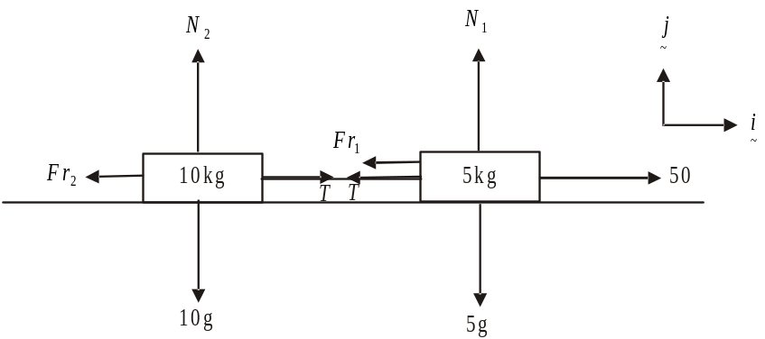

Around the 5kg container
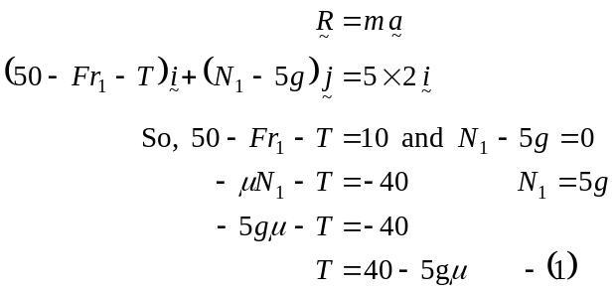
(1 mark)
Around the 10kg container
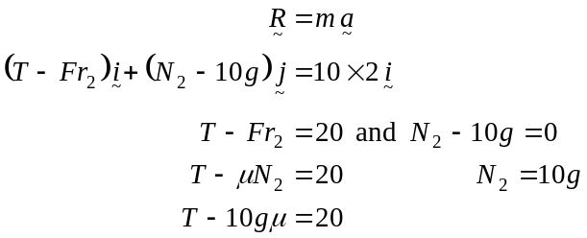
(1 mark)
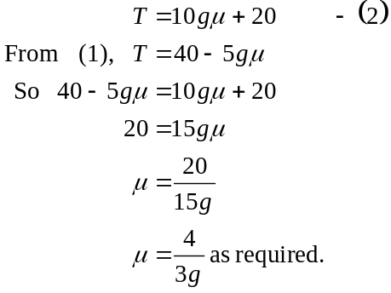
(1 mark)
Method 2 - Combining the containers into a single mass

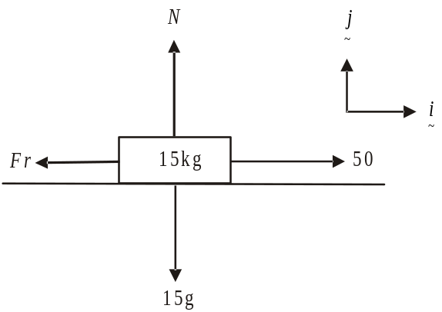

(1 mark)

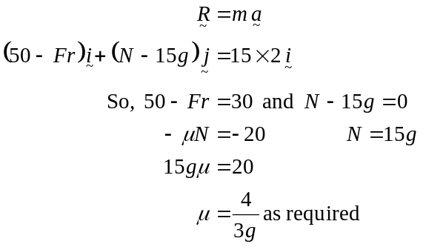 (1 mark)
(1 mark)

b. Method 1 - following on from Method 1 in part a.
Substitute 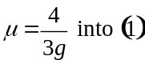
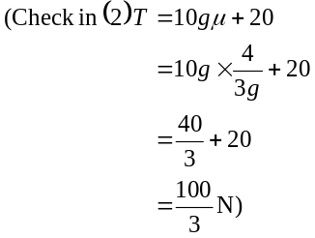
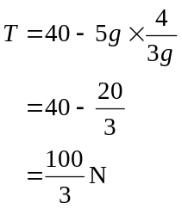
(1 mark)

Method 2 - following on from Method 2 in part a.

Around the 10 kg container
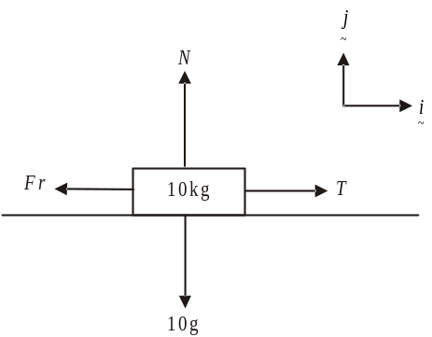
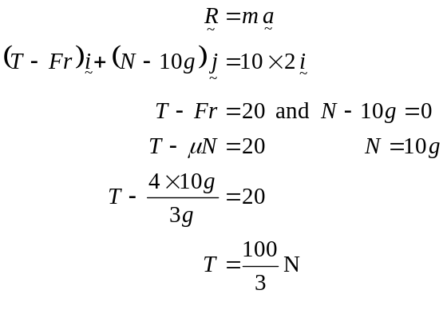
(1 mark)

Question 6
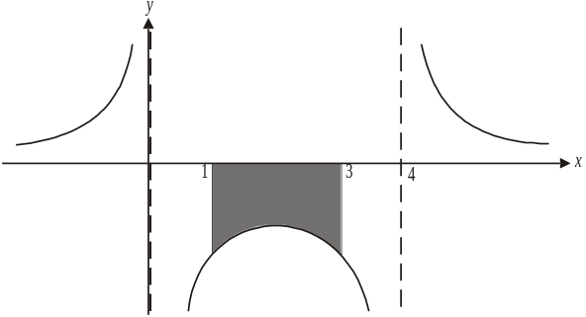
Do a quick sketch.
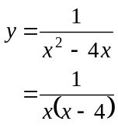
There are vertical asymptotes
(1 mark)
at .
The required area lies below the x-axis.
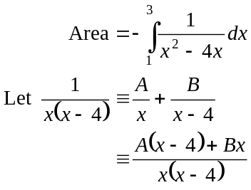
True iff 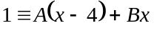
Put 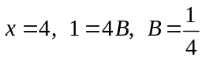
Put 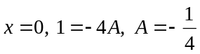
So 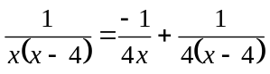
(1 mark)
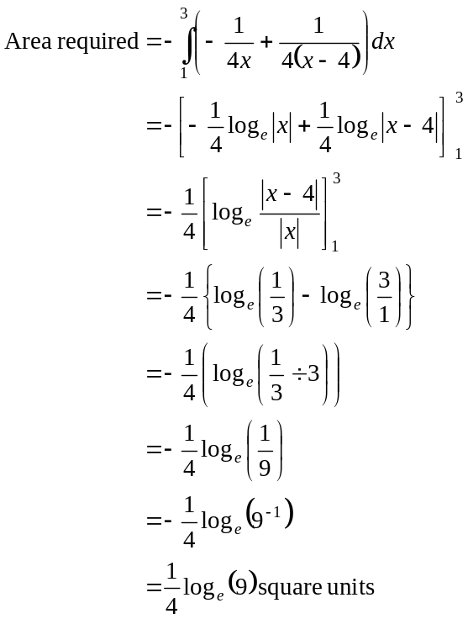
(1 mark)
(1 mark)
So 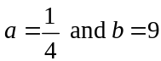
(1 mark)

Question 7

The function is continuous for and also 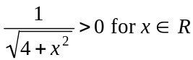.
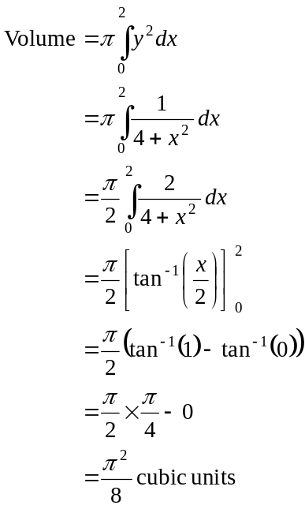
(1 mark)
(1 mark)
(1 mark)

Question 8

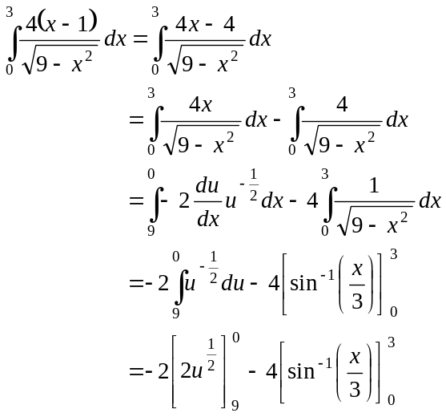
(1 mark)
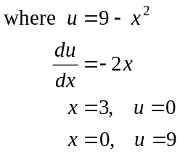
(1 mark) (1 mark)
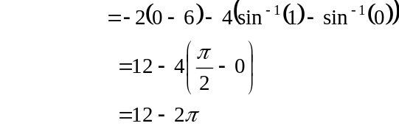
(1 mark)

Question 9

- 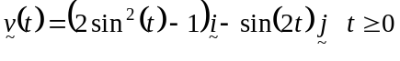
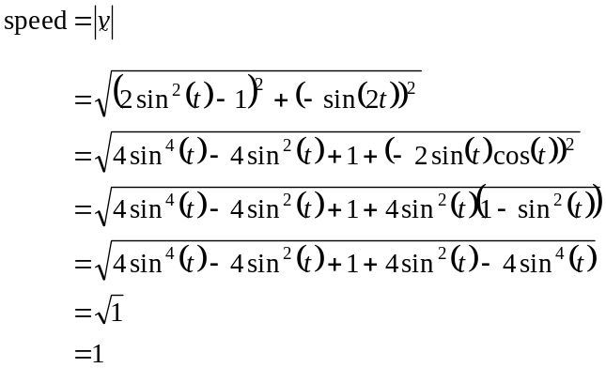
(1 mark)
so speed is constant.
(1 mark)

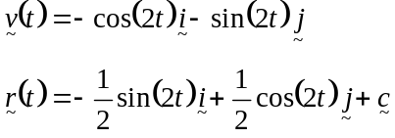
(1 mark)
Now, when 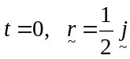
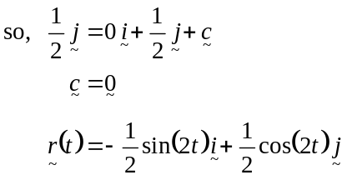
as required. (1 mark)

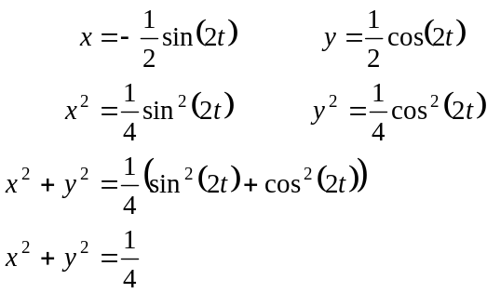

(1 mark)

- i.
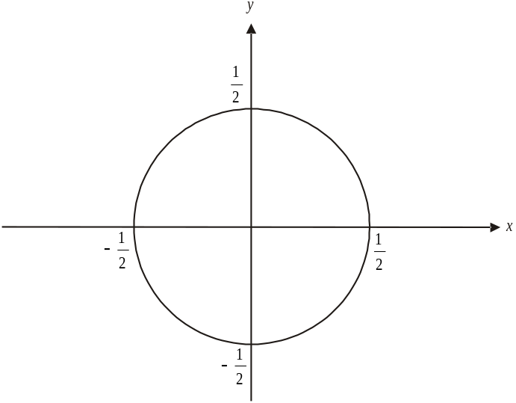

(1 mark)

- At ,
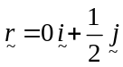
The particle starts at the point 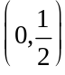. (1 mark)
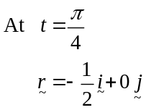
At 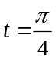 seconds, the particle is at the point 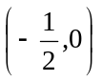.

So the particle moves around the circle indefinitely in an anticlockwise direction having started it’s motion at the point 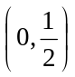.
(1 mark)

