

Students Name:………………………………………

SPECIALIST MATHEMATICS

WRITTEN TRIAL EXAMINATION 1

2007

Reading Time: 15 minutes
Writing time: 1 hour

Instructions to students
This exam consists of 9 questions.
All questions should be answered.
There is a total of 40 marks available.
The marks allocated to each of the nine questions are indicated throughout.
Students may not bring any notes or calculators into the exam.
Where more than one mark is allocated to a question, appropriate working must be shown.
Where an exact answer is required, a decimal approximation will not be accepted.
Unless otherwise indicated, diagrams in this exam are not drawn to scale.
The acceleration due to gravity should be taken to have magnitude 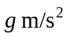where 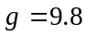
Formula sheets can be found on pages 10-12 of this exam.

This paper has been prepared independently of the Victorian Curriculum and Assessment Authority to provide additional exam preparation for students. Although references have been reproduced with permission of the Victorian Curriculum and Assessment Authority the publication is in no way connected with or endorsed by the Victorian Curriculum and Assessment Authority.

© THE HEFFERNAN GROUP 2007
This Trial Exam is licensed on a non transferable basis to the purchaser. It may be copied for educational use within the school which has purchased it. This license does not permit distribution or copying of this Trial Exam outside that school or by any individual purchaser.
Question 1

- Show that for 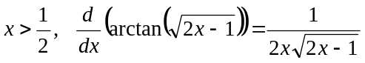.

2 marks

- Hence find the exact value of 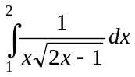.

2 marks

Question 2

Consider the relation given by 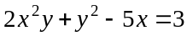.

- Find 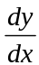 in terms of x and y.

2 marks

- Hence evaluate when 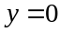.

2 marks

Question 3

Solve the differential equation 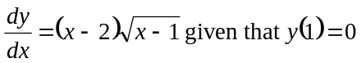.

3 marks

Question 4

Solve the following equations over C

- 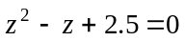

2 marks

- 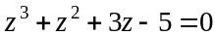

3 marks
Question 5

Two containers of mass 5kg and 10kg are connected by a light rope.
The containers are pulled along a rough horizontal surface by a force of 50N acting horizontally as shown in the diagram below.
The coefficient of friction between each of the containers and the surface is the same. The containers are moving with an acceleration of 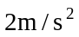.

- Show that the coefficient of friction equals 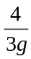.

3 marks

- Hence find the tension in the rope connecting the containers.

1 mark

Question 6

The area enclosed by the graph of 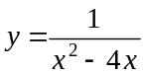, the x-axis and the lines is given by 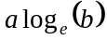 square units where a and b are positive constants.
Find the values of a and b.

5 marks

Question 7

The region enclosed by the graph of the continuous function 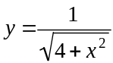, the x-axis, the
y-axis and the line is rotated about the x-axis to form a solid of revolution.
Find the volume of this solid.

3 marks
Question 8

Evaluate 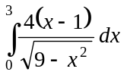.

4 marks

Question 9

The velocity of a particle at time t seconds is given by 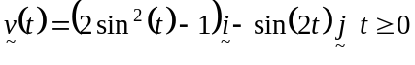.
- Show that the speed of the particle is constant.

2 marks

- Show that the position vector of the particle is given by
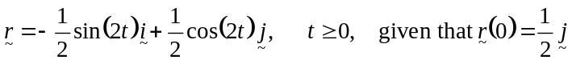.

2 marks

- Find the Cartesian equation of the path of the particle.

1 mark
- i. Sketch the path of the particle on the set of axes below.

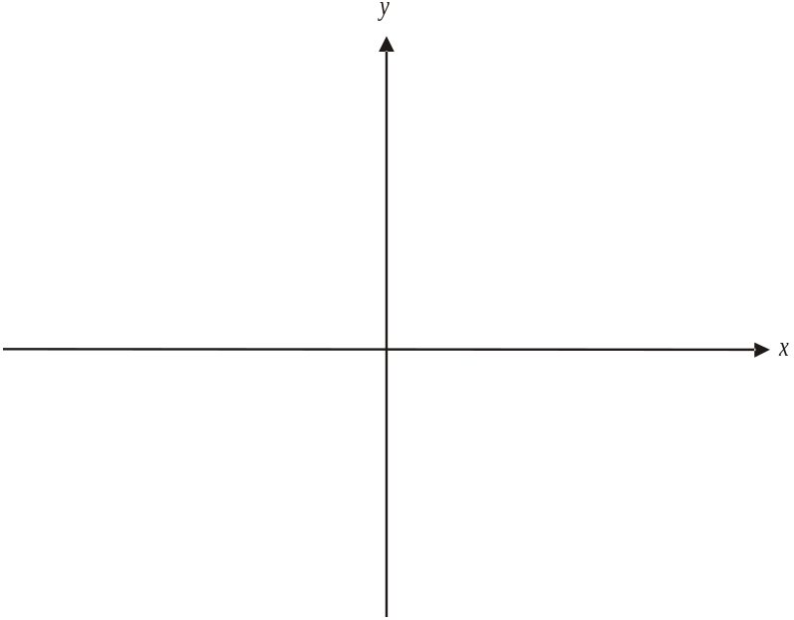

- Describe the path of the particle including it’s starting point and the subsequent direction of movement.

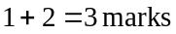

Specialist Mathematics Formulas

Mensuration
area of a trapezium: 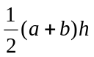
curved surface area of a cylinder: 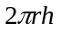
volume of a cylinder: 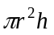
volume of a cone: 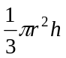
volume of a pyramid: 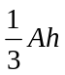
volume of a sphere: 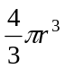
area of a triangle: 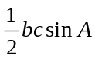
sine rule: 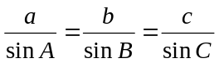
cosine rule: 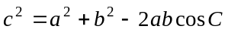

Coordinate geometry
ellipse: 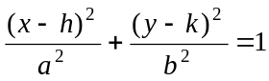 hyperbola: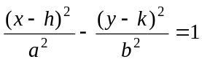

Circular (trigonometric) functions
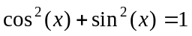
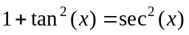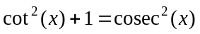
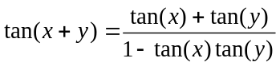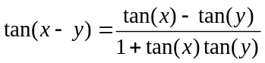
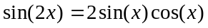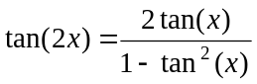
function | 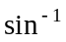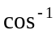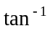
domain  range | 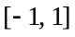  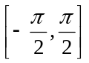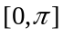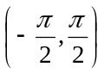

Algebra (Complex numbers)
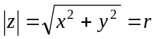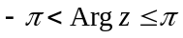
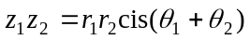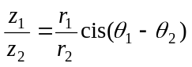
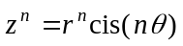 (de Moivre’s theorem)
Reproduced with permission of the Victorian Curriculum and Assessment Authority, Victoria, Australia.
This formula sheet has been copied in 2007 from the VCAA website www.vcaa.vic.edu.au
The VCAA publish an exam issue supplement to the VCAA bulletin.
Calculus

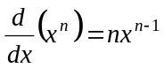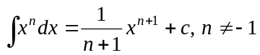
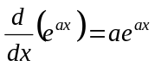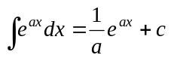
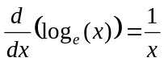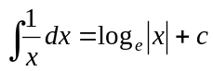
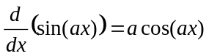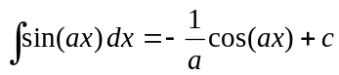
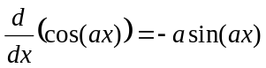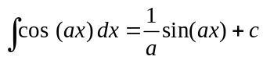
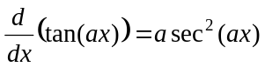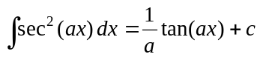
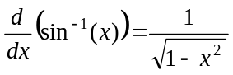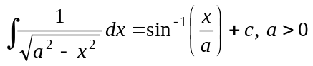
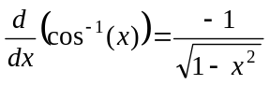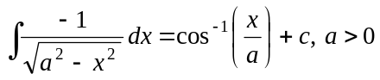
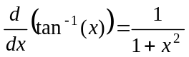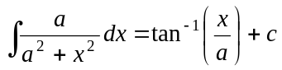

product rule: 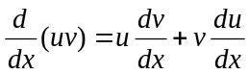
quotient rule: 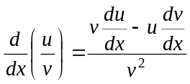
chain rule: 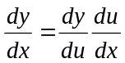
Euler’s method: 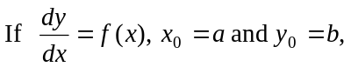
acceleration: 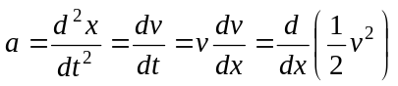
constant (uniform) acceleration: 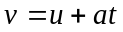 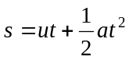 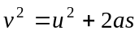 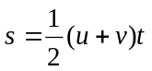

Reproduced with permission of the Victorian Curriculum and Assessment Authority, Victoria, Australia.
This formula sheet has been copied in 2007 from the VCAA website www.vcaa.vic.edu.au
The VCAA publish an exam issue supplement to the VCAA bulletin.

Vectors in two and three dimensions

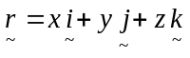
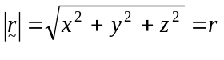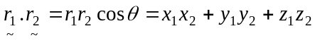
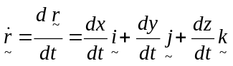

Mechanics

momentum: 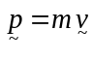
equation of motion: 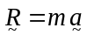
friction: 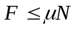

Reproduced with permission of the Victorian Curriculum and Assessment Authority, Victoria, Australia.
This formula sheet has been copied in 2007 from the VCAA website www.vcaa.vic.edu.au
The VCAA publish an exam issue supplement to the VCAA bulletin.

