
SPECIALIST MATHS
TRIAL EXAMINATION 2
SOLUTIONS
2007

Section 1 – Multiple-choice answers

1. D 7. A 13. E 19. A
2. B 8. E 14. B 20. D
3. E 9. B 15. B 21. D
4. B 10. E 16. C 22. B
5. C 11. A 17. E
6. C 12. D 18. C

Section 1- Multiple-choice solutions

Question 1

The hyperbola 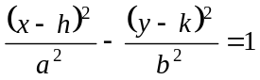 has asymptotes given by 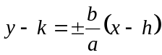.
Now 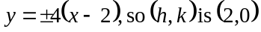 so options A and B can be eliminated.
Also, 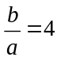. Only option D offers this since 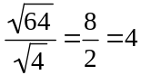.
The answer is D.

Question 2

The graph of 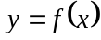 has one vertical asymptote if the equation 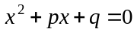 has one solution.
The quadratic equation has one solution if
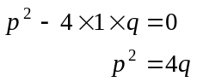
The answer is B.

Question 3
For the inverse circular function 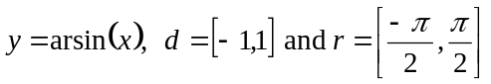.
For the inverse circular function 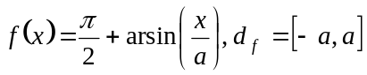
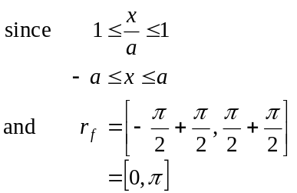
The answer is E.

Question 4
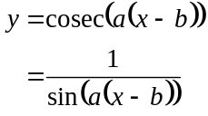
Asymptotes occur at 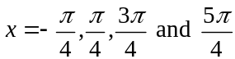.
Consider the graph of 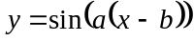 at which 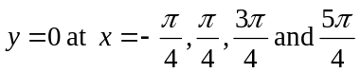.
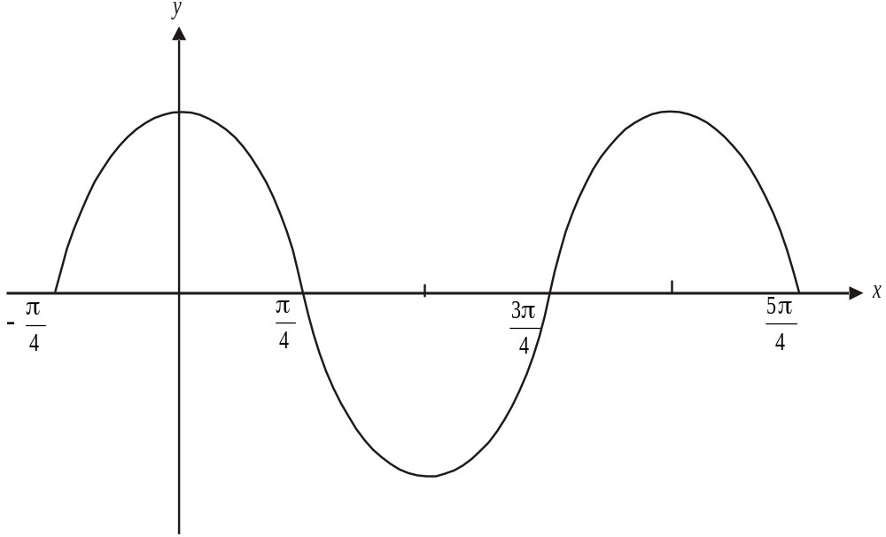

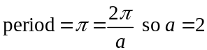 For this graph above, 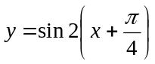.
Also, for the graph of 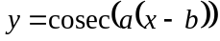, 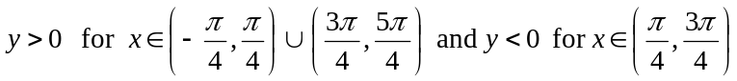. This is true also for the graph of 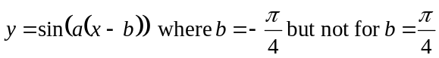. So 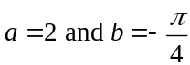.
The answer is B.

Question 5

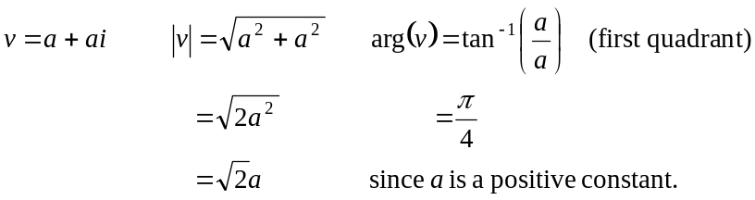
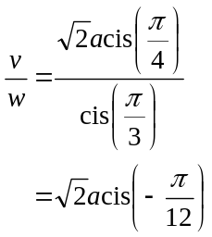
The answer is C.

Question 6

The solutions to the equation 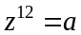 are equally spaced around a circle, 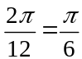 apart.
Since one solution is 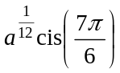, the others that will have an imaginary part that is less than zero; that is, that have an argument that is greater than and less than 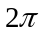are 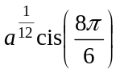, 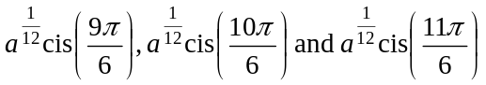.
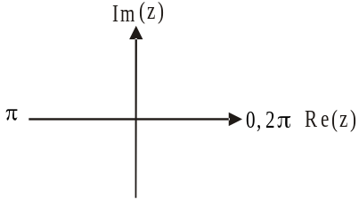

So there are five in total.
Note that the solutions 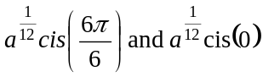 have an imaginary part equal to zero.
The answer is C.

Question 7

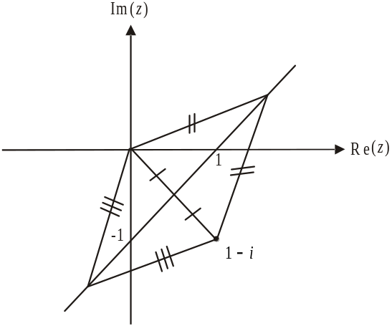

Let z be any point lying on the line.
The distance between any point z on the line and the origin is given by . This is the same as the distance between z and the point ; that is, 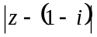
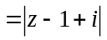.
So the required equation of the line is 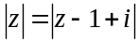.
The answer is A.

Question 8
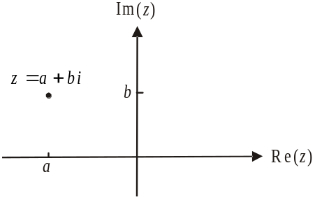
Since z lies in the second quadrant,
.
Multiplying z by i rotates z by 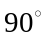 in an
anticlockwise direction which means that
zi lies in the third quadrant.
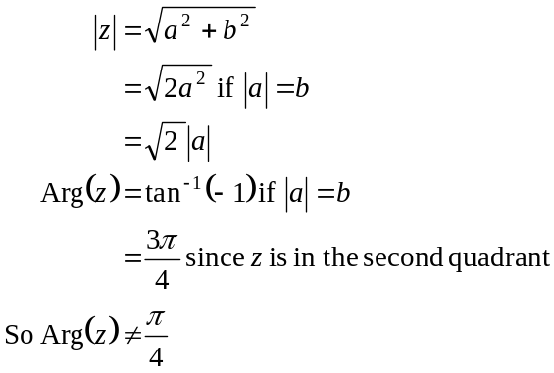
The answer is E.

Question 9

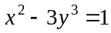
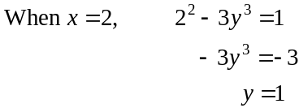
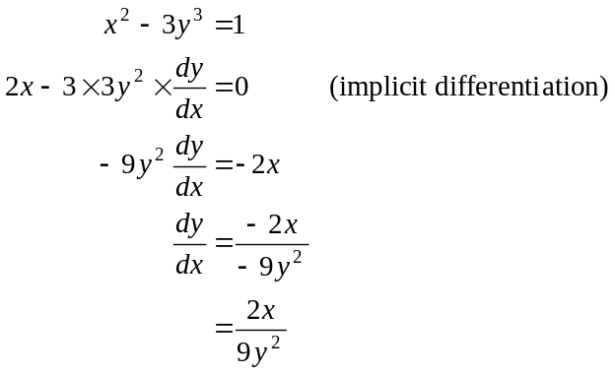
When 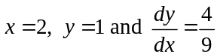.
The answer is B.

Question 10

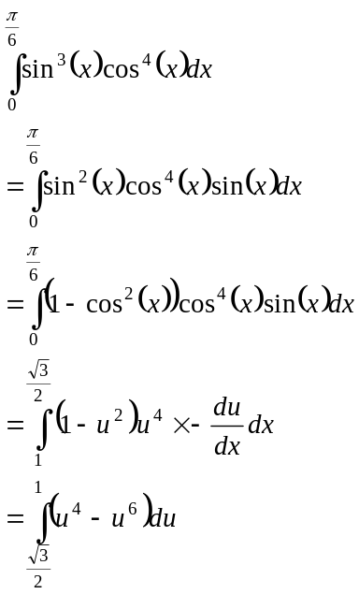
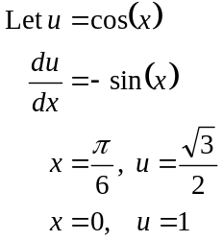
The answer is E.

Question 11

Do a quick sketch of 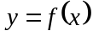.

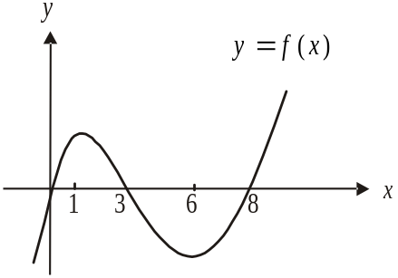

The graph of is the gradient function of the graph of 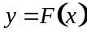.
At 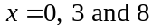, the gradient of is zero, so there must be a turning point or a stationary point of inflection at 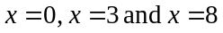.
Only options A and D show this.
The gradient of the graph of is positive for and negative for .
Only option A shows this.
The answer is A.

Question 12

From the slope field when 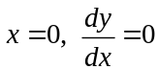. This eliminates options A, B, C and E.
When 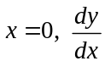 is defined; that is, values of 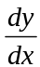 are indicated by the lines. Conversely when 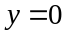, no such lines are apparent because is not defined for . Option D shows this.
Also for a given value of y; for example 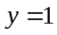, as x increases from zero, the gradient becomes steeper which is indicated by a larger negative number. For another given value of y; for example 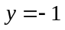, as x increases from zero, the gradient becomes steeper which is indicated by a larger positive number and so on.
The answer is D.

Question 13

The two particles meet iff

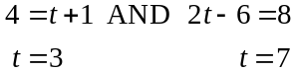

Since the particles are in the same spot at different times, they never meet.
The answer is E.

Question 14

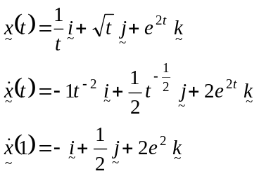
The direction of motion at is given by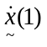.
The answer is B.

Question 15

Sketch the graph of 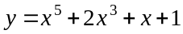 and find the enclosed area.
This area occurs between 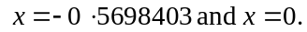
The required area is closest to 0.34905 square units.
The answer is B.

Question 16

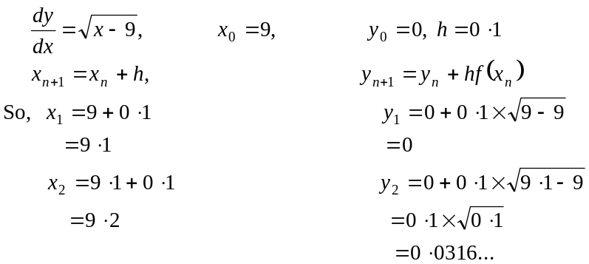
When , the approximation for y is 0.0316…
The answer is C.

Question 17

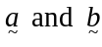 are at right angles because the triangle formed by 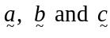 has it’s vertices lying on a semicircle with one side forming the straight edge. So option A is correct. Option B is also correct since
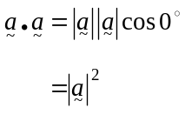
Similarly 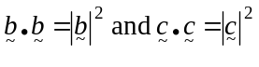.
So because of Pythagoras theorem options B and C are correct.

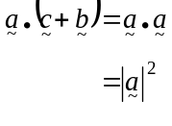
So option D is correct.
Option E is incorrect. The angle is the angle between 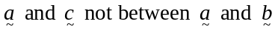.
The answer is E.

Question 18

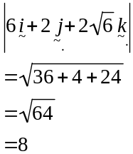
A vector with a magnitude of 4 that is parallel to the vector 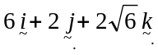 is
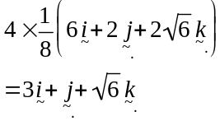
The answer is C.

Question 19

The change in temperature of the cake with respect to time is given by
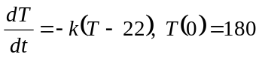
The answer is A.

Question 20

The correct force diagram is given by

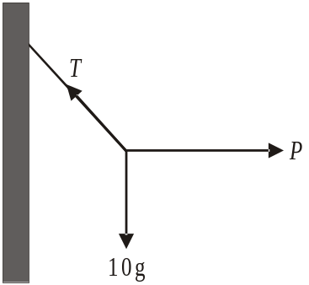

The answer is D.

Question 21

Draw a force diagram.
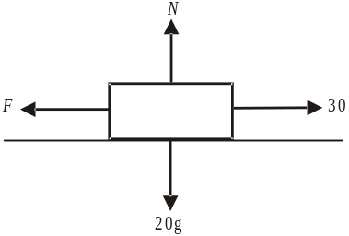

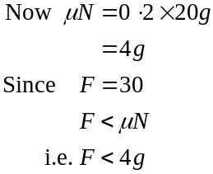
So the box is not at the point of sliding along the surface.
The box remains at rest because 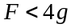.
The answer is D.

Question 22

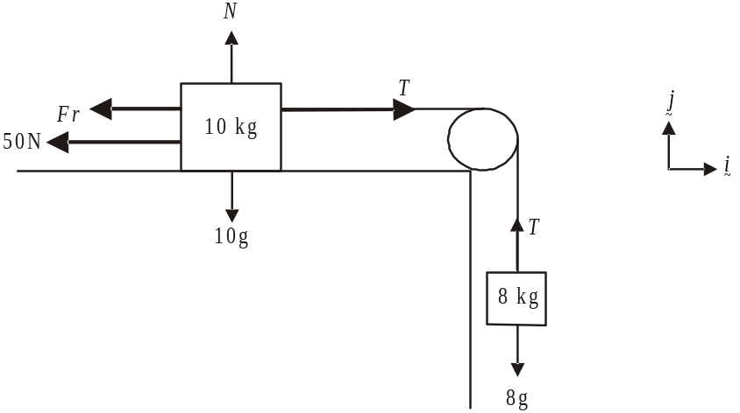

Around the 8kg mass:

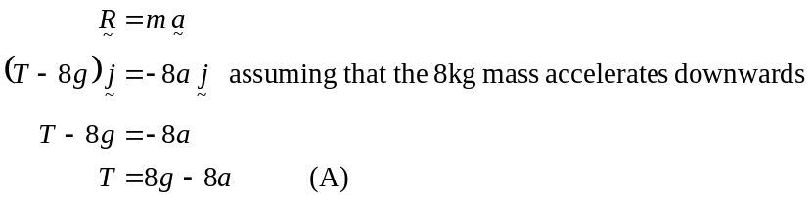

Around the 10kg mass:
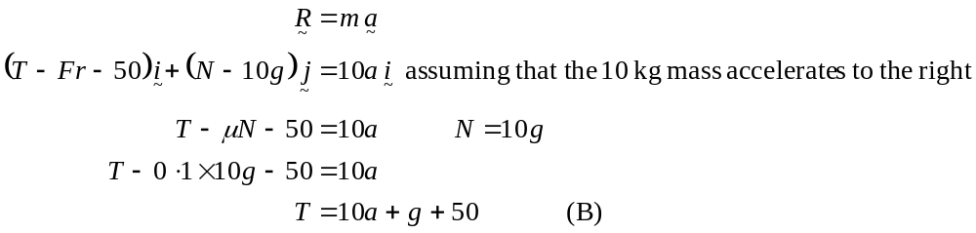

Substitute (A) into (B):
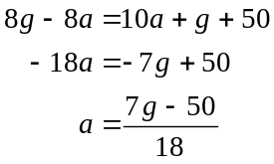
Since 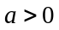, the 10kg mass does move to the right and the 8kg mass does move downwards.

The answer is B.

SECTION 2

Question 1
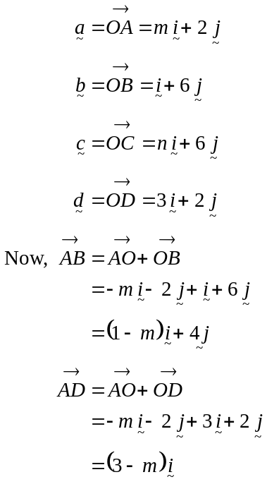

(1 mark)

- If ABCD is a rhombus then 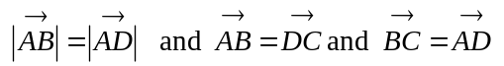.

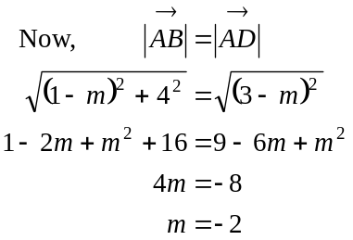
(1 mark)
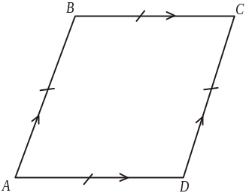
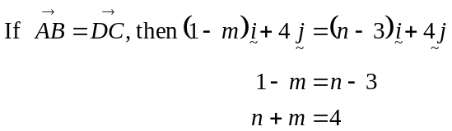
(1 mark)
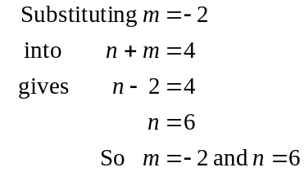
(1 mark)

- To Show 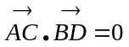
(1 mark)

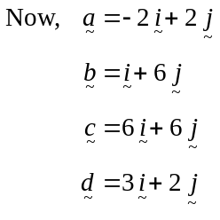
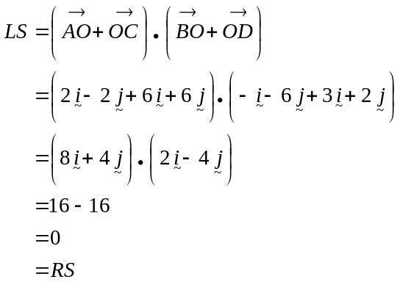
(1 mark)
Have shown.
Since 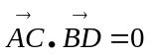, then 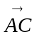 is perpendicular to 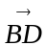.

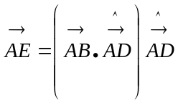
(1 mark)
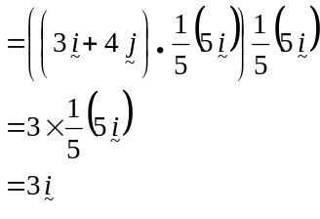

(1 mark)

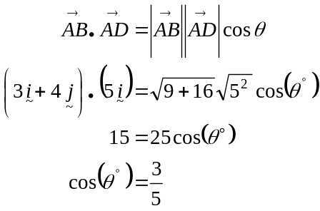

(1 mark)

(1 mark)

In the rhombus ABCD,
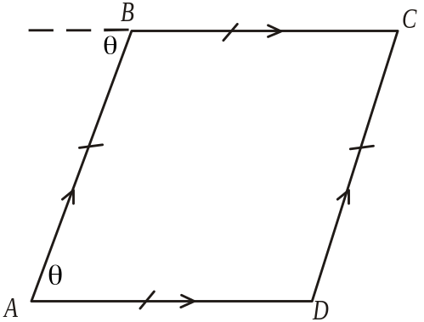
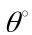 is the angle between 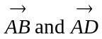
so the angle between 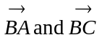 will
be 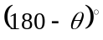 because of alternate
angles in parallel lines. (1 mark)

Now,
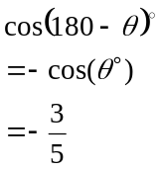(because 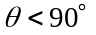 and 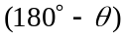 is a second quadrant angle)
(1 mark)
So the angle between is 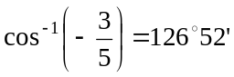 to
the nearest minute.

(1 mark)

Total 13 marks

Question 2

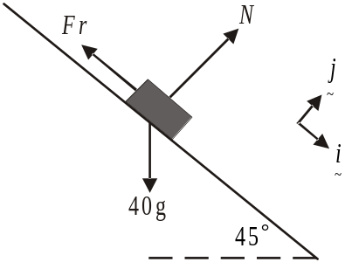

(1 mark)
b.
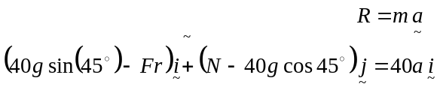
(1 mark)
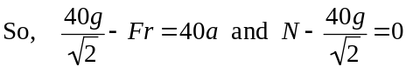
(1 mark)
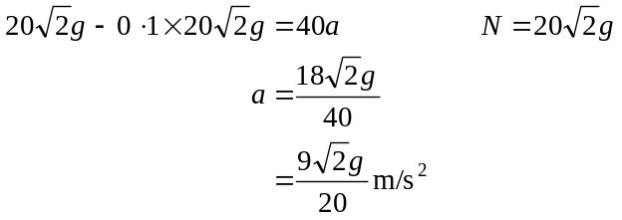
(1 mark)
as required.

c. Let the mass of the person on the slide be m kg.
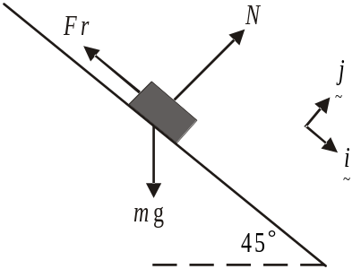

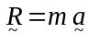
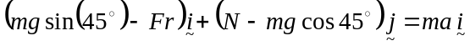
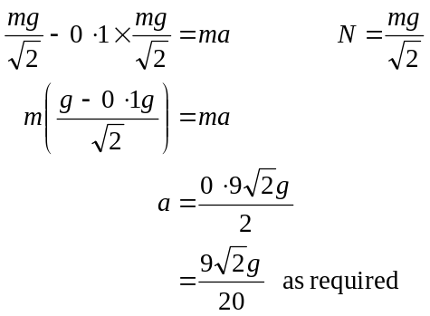
(1 mark)
(1 mark)
d. Since Rhiannon’s acceleration down the slide is constant, and we know that ,
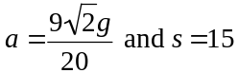, we can use the formula
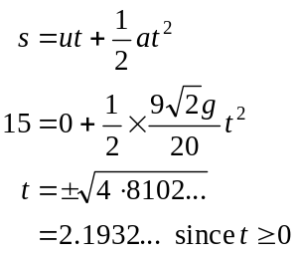
(1 mark)
So Rhiannon is on the slide for 2.19 seconds (correct to 2 decimal places)
(1 mark)
e. Now, a is constant i.e. 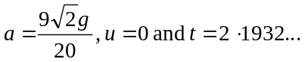 (from part d.). Note that the “unrounded” value of 2.1932… from part d. should be carried through in these calculations.
We have,
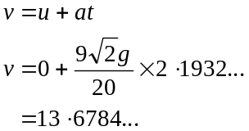
Rhiannon’s speed at the end of the slide is 13.68 m/s (correct to 2 decimal places).
(1 mark)

f. Note that the “unrounded” value of 13.6784… from part e. should be carried through in these calculations.

Method 1
The only force acting on Rhiannon when she leaves the end of the slide is the gravitational force.
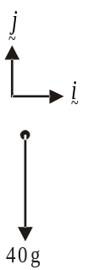
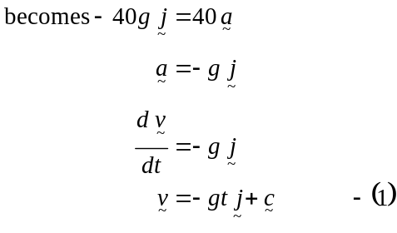
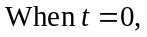which is when Rhiannon leaves the slide,
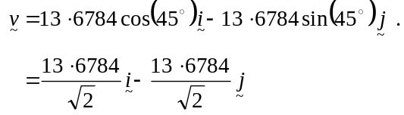
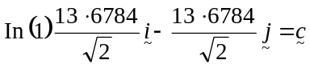
So 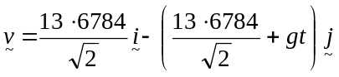 (1 mark)
Note: the above working can be shortened.
It is shown here for explanatory purposes.
Now 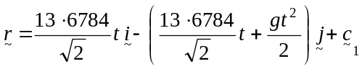
When 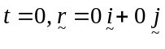, taking the end of the slide as the origin of motion.
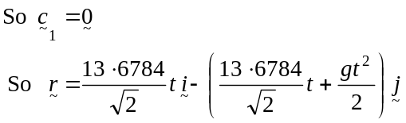
(1 mark)
Rhiannon lands when the component of equals – 3 (3 metres below the origin).
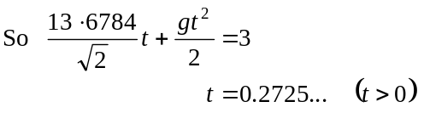
(1 mark)
Rhiannon is in free fall for 0.27 secs (correct to 2 decimal places).

Method 2

Rhianon’s velocity at the end of the slide is 13.6784…m/s at an angle of 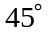 downwards.
Taking the downwards direction as positive and considering the vertical component we have 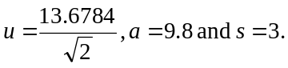
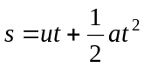 (1 mark)
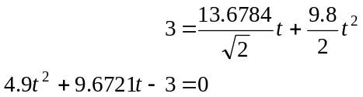
(1 mark)
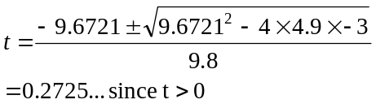

Rhiannon is in free fall for 0.27 secs (correct to 2 decimal places).
(1 mark)

g. Let the angle at which Rhiannon enters the water be .
Note again that the “unrounded” value of 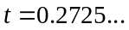 together with the “unrounded” value of 13.6784… from part e. should be carried through in these calculations.

Method 1
The angle is the angle between 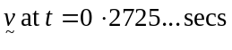 (i.e. when she hits the water) and the vector .
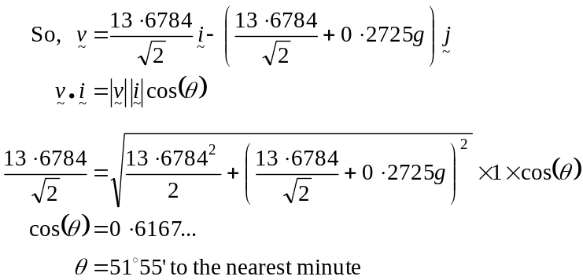
(1 mark)
(1 mark)
Method 2
Calculate the vertical and horizontal velocities at the point of entry.
vertically:
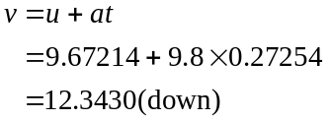
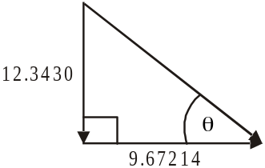

horizontally:
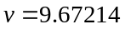(constant)
(1 mark)

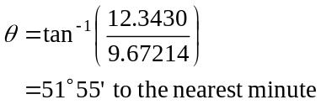
(1 mark)

Total 14 marks

Question 3
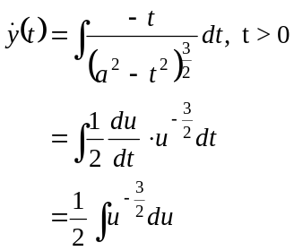
- i.
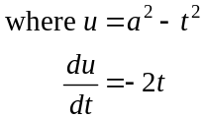
(1 mark)

(1 mark)
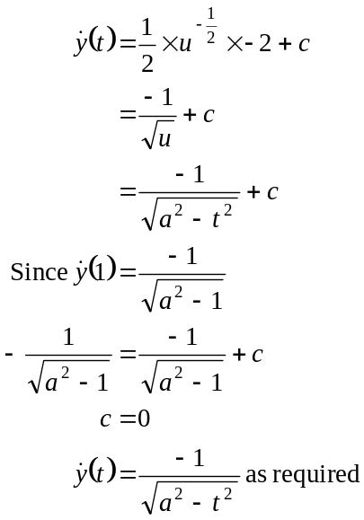

(1 mark)

b.
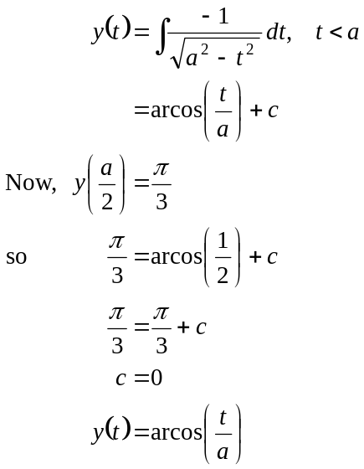

(1 mark)

c.
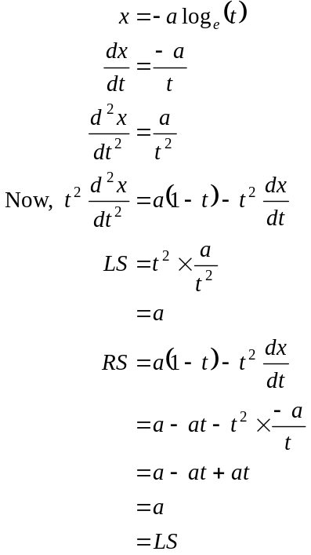

(1 mark)

Have verified.
(1 mark)
d. From part b., 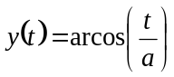.
From part c., 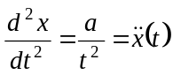.
(1 mark)
So a possible expression for 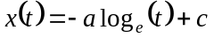.
Given the condition 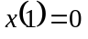, we have
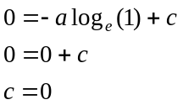
So 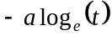 is the actual expression for 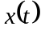.
So, 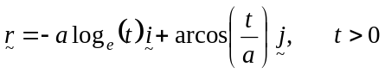
(1 mark)

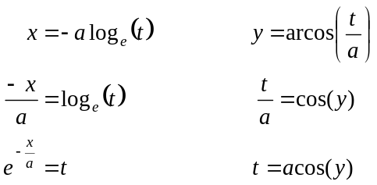
e.

So,
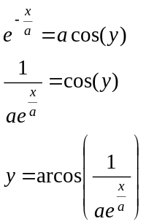
(1 mark)

Total 9 marks

Question 4

- i.
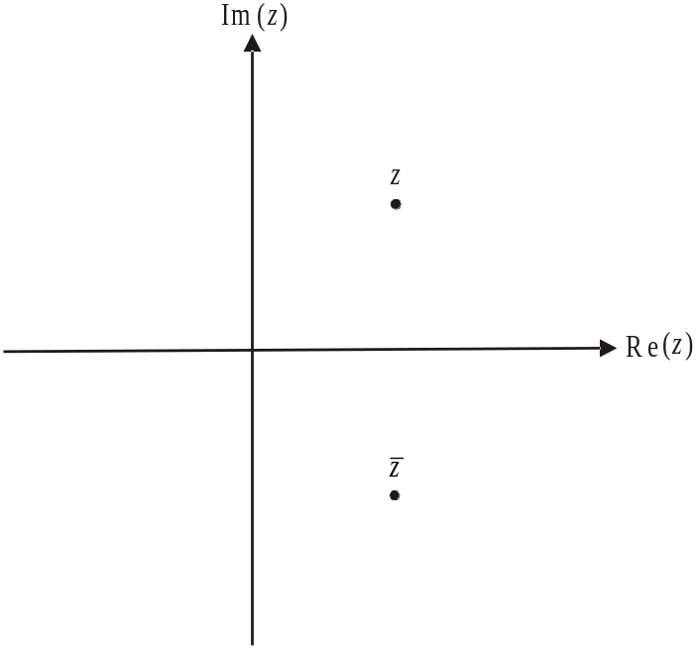

(1 mark)

  - 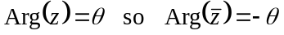
(1 mark)

  - 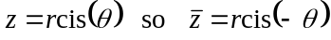
(1 mark)
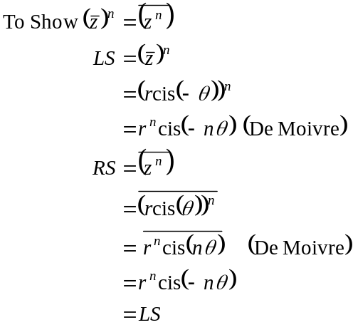

(1 mark)

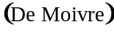

(1 mark)

Have shown.

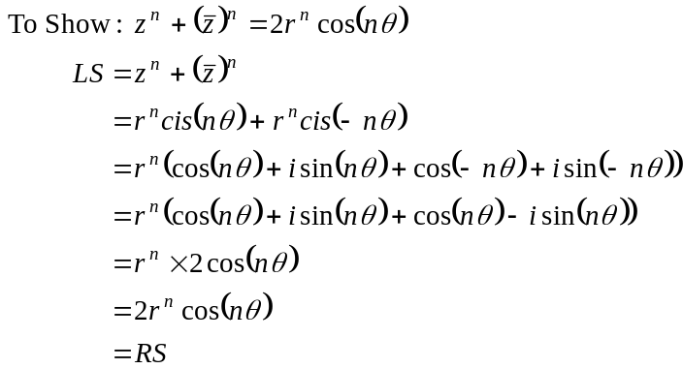
(1 mark)

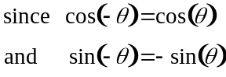

Have shown.
(1 mark)

- Let 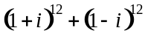
from part b. – because of “hence” this must be shown
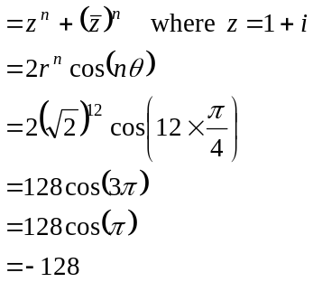
(1 mark)
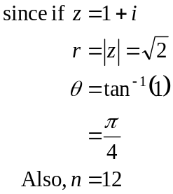
Have shown.

(1 mark)
- From part c. 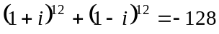
So we require 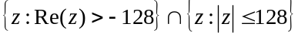
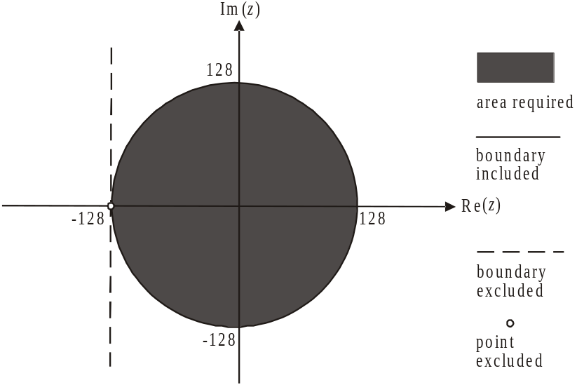

Note that the complex number is not included.
(1 mark) correct area
(1 mark) correct boundary
Total 11 marks

Question 5
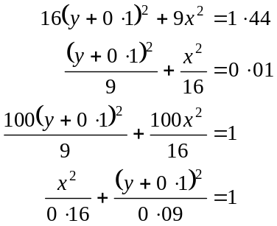

We have an ellipse with centre at 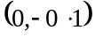, semi-major axis length of units and semi-minor axis length of units.
(1 mark)
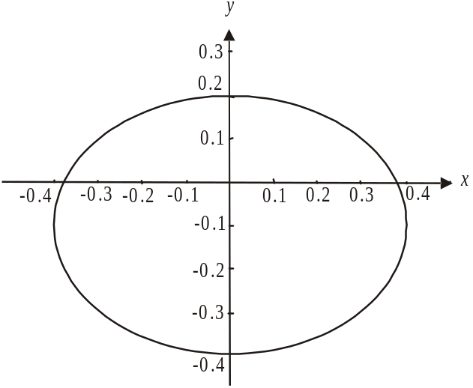

(1 mark)
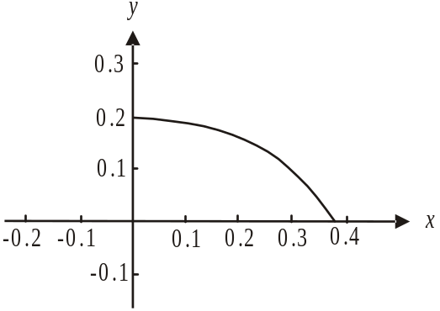

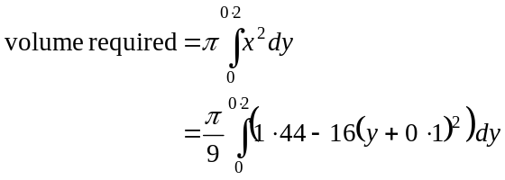
(1 mark) - correct terminals
(1 mark) – correct integrand
c. Using a graphics or CAS calculator and the definite integral above,
(1 mark)
d. i.
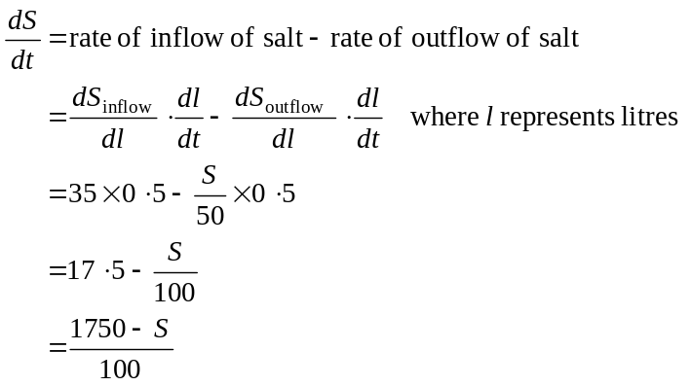
(1 mark)

(1 mark)
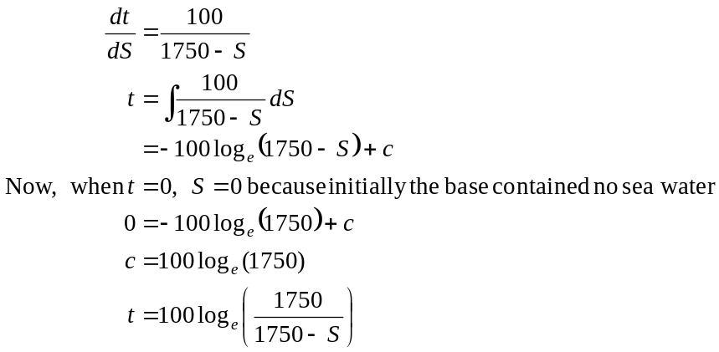.

(1 mark)

(1 mark)
iii. Method 1
The concentration of salt in the base will approach the concentration of the sea water being added which is 35g/l. (1 mark)
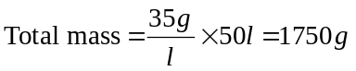. (1 mark)
Method 2
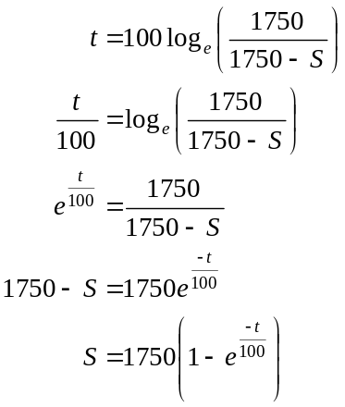

(1 mark)

As 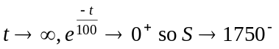. So in the long term the amount of salt in the base would approach 1750g. (1 mark)
Total 11 marks

