
SPECIALIST MATHS
TRIAL EXAMINATION 1
SOLUTIONS
2008

Question 1
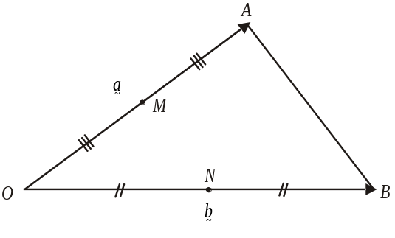

To prove: 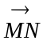 is parallel to 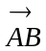
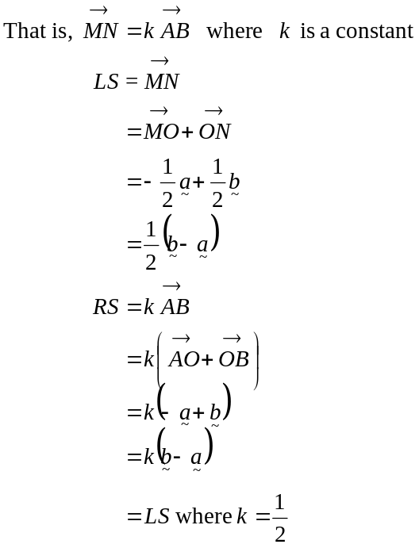
(1 mark)
Have proved. (1 mark)
Question 2

- Draw a force diagram.

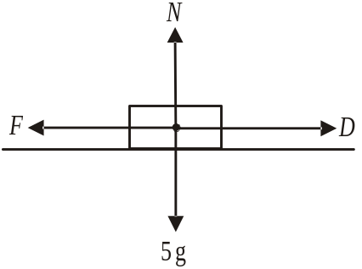

The box is not about to move so,
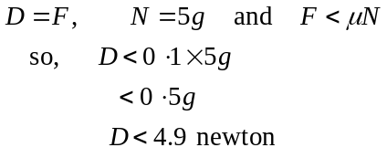
(1 mark)
(1 mark)

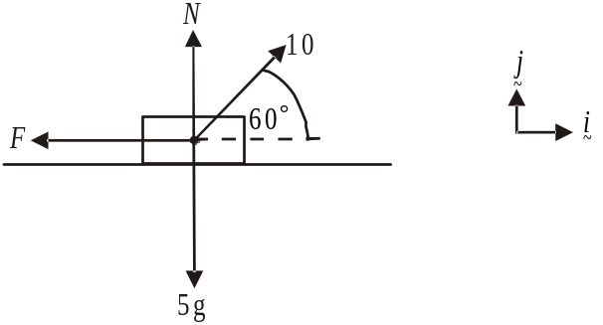

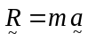
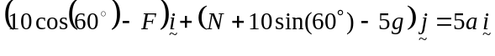
(1 mark)
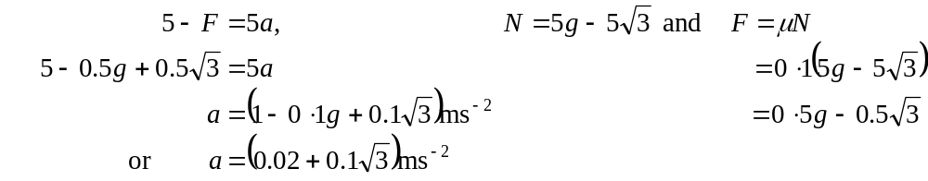
(1 mark)

Question 3

- If – 1 is a solution then

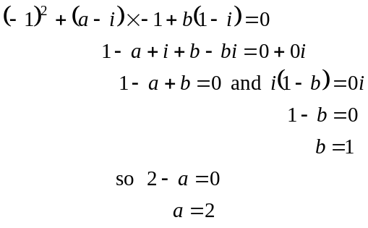
(1 mark)
So, 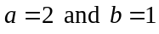. (1 mark)

- Method 1

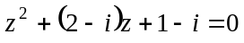 is a quadratic equation

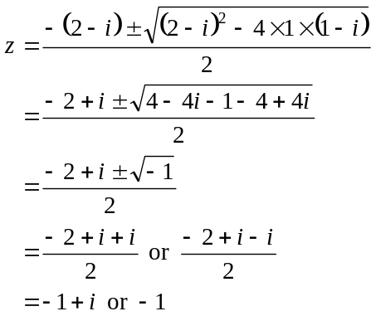
(1 mark)

The other solution is .

(1 mark)
Method 2

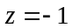 is a solution so 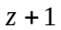 is a factor.

We have .

So, by inspection, 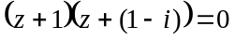 (1 mark)

So 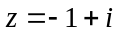 is the other solution.
(1 mark)

Question 4

The coefficients of the terms of the equation are real and hence the conjugate root theorem applies.
Since 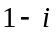 is a solution then its conjugate is also a solution. (1 mark)

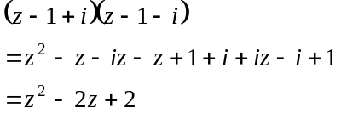

So, 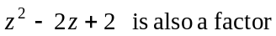.

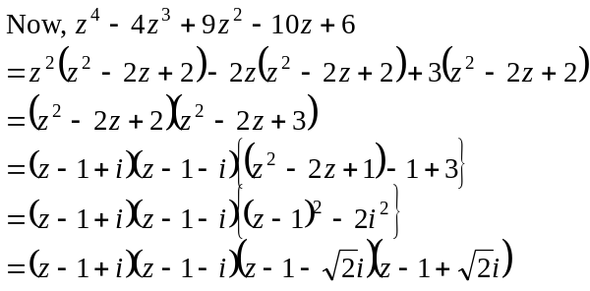
(1 mark)
The solutions to 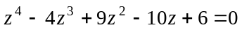 are 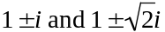.
(1 mark)

Question 5

Using implicit differentiation,
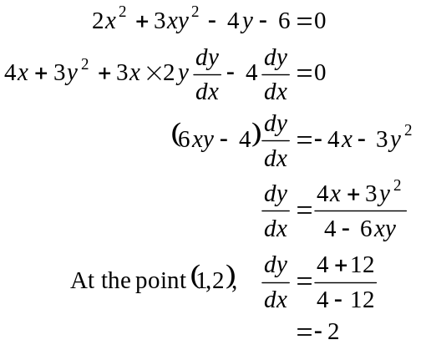
(1 mark)
(1 mark)
Gradient of tangent is 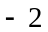.
Gradient of normal is .
Equation of normal is
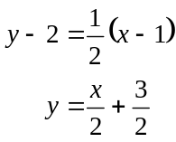
(1 mark)

Question 6

Do a quick sketch.

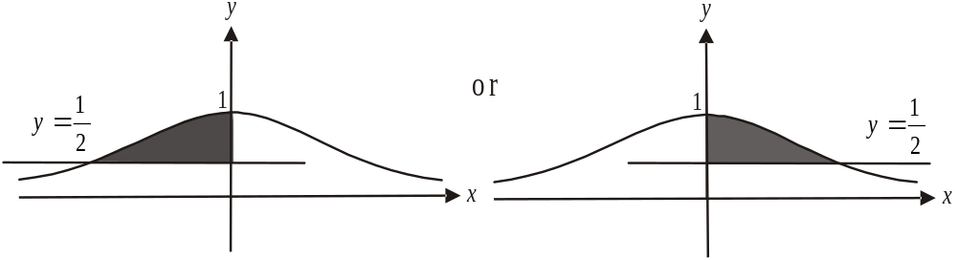

For either of these shaded areas the volume generated will be the same.
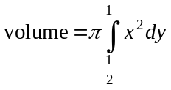
Since 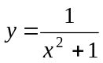
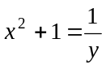
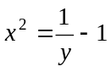

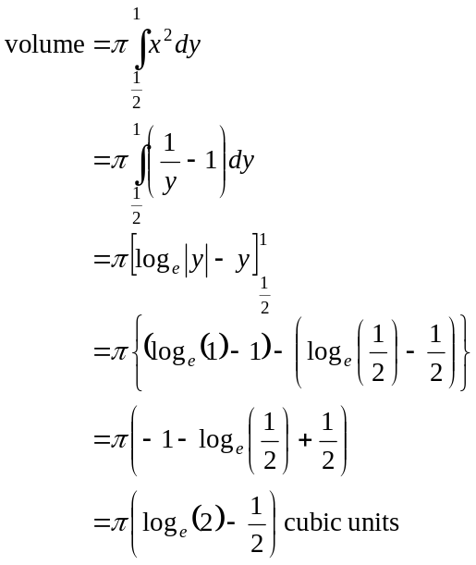
(1 mark)
(1 mark)
(1 mark)
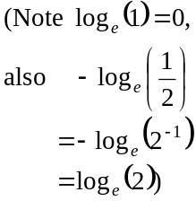

Question 7
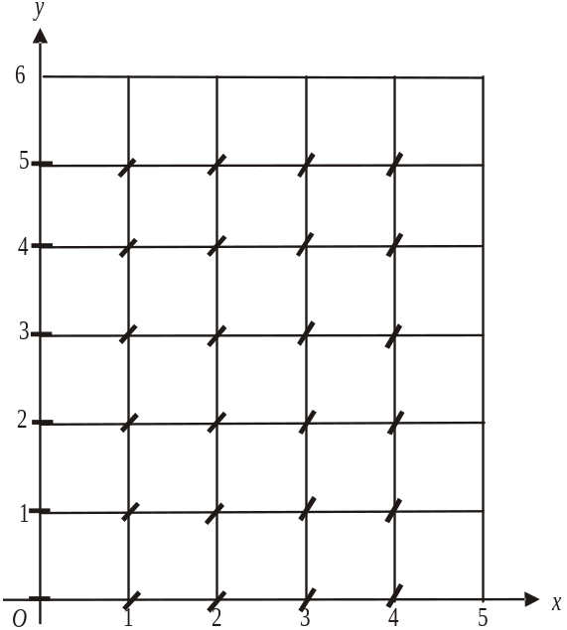

(2 marks)
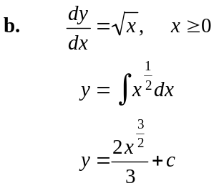
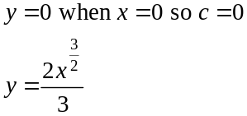
(1 mark)
- The graph of 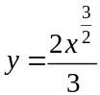 passes
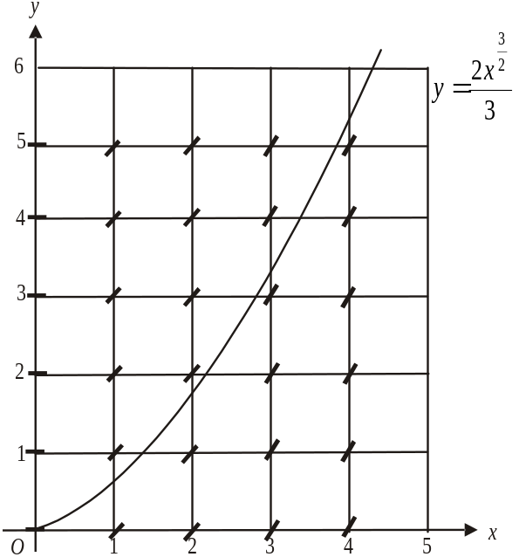
through 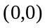 which was given in
part b. as well as passing through
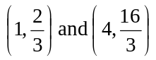.
It follows the gradient field shown
in part a.. The graph is shown on
the slope field.

(1 mark)

Question 8

a. Method 1
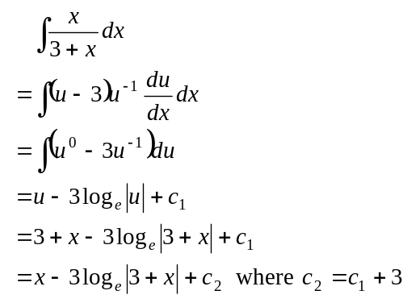
(1 mark)
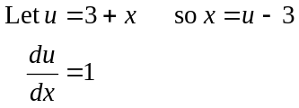
(1 mark) – must include brackets
Method 2
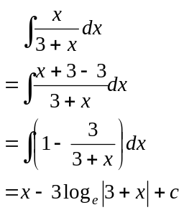
(1 mark)
(1 mark) – must include brackets

b.
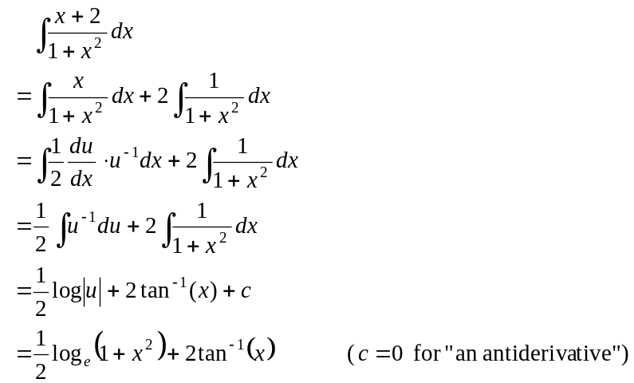
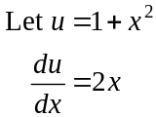
(1 mark) first term (1 mark) second term

- Method 1

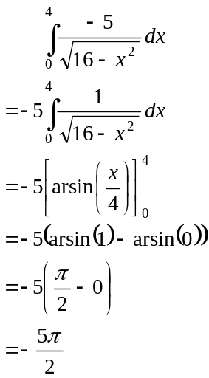 (1 mark)
(1 mark)

Method 2
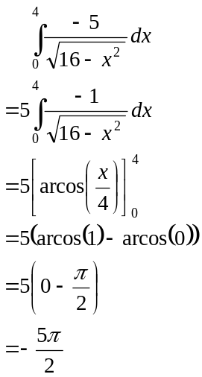

(1 mark)

(1 mark)

Question 9

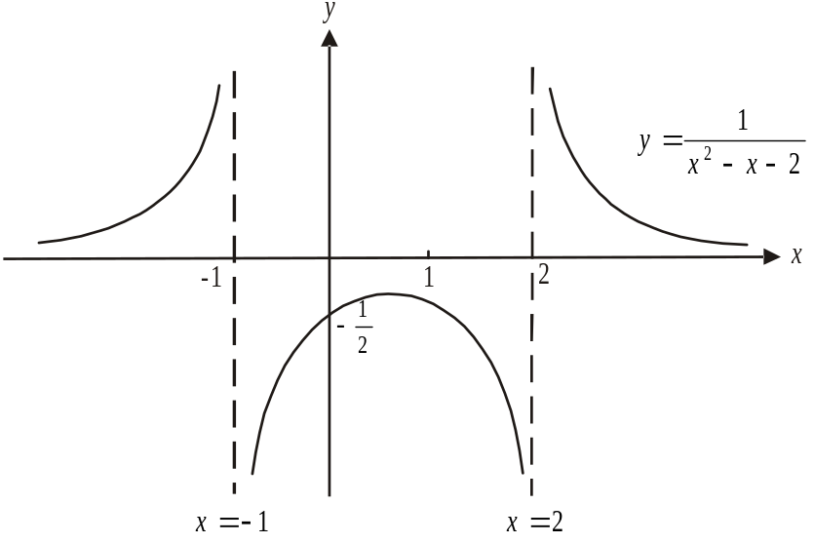

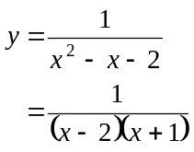
Asymptotes occur at 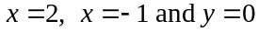.
When 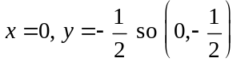 is the only axis intercept (since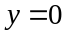 is an asymptote).
(1 mark) correct asymptotes and axis intercept
(1 mark) correct shape
and position of graph

b. The area required is shaded in the graph below.

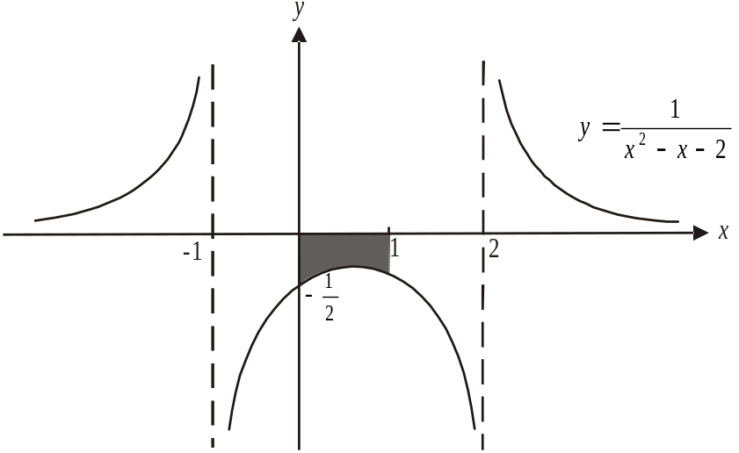

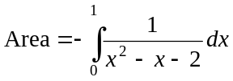
(1 mark)
Note that because the region falls below the x-axis it will be negative so we multiply by – 1.
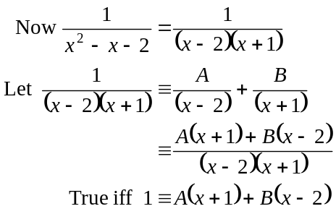
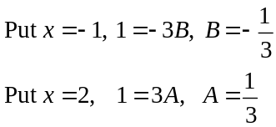
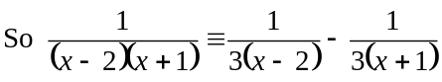

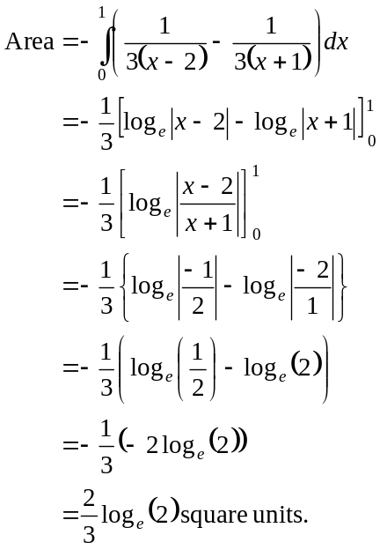
(1 mark)
(1 mark)
(1 mark)

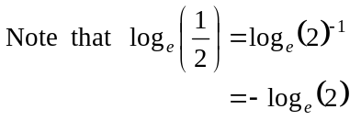

Question 10

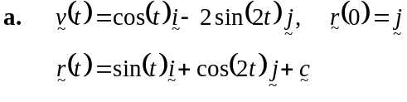
(1 mark)
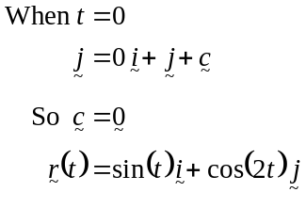
(1 mark)
- From a. 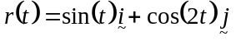
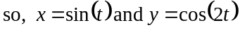
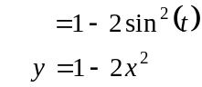
(1 mark)
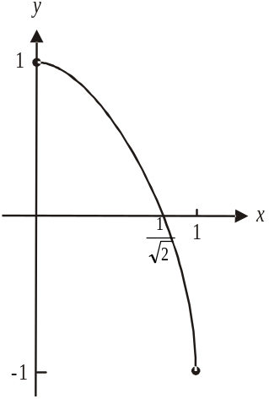

(1 mark) – shape of graph
(1 mark) correct endpoints

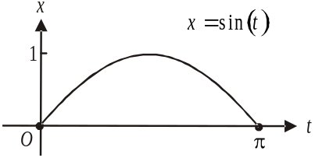
Note the original domain .

Since 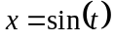 for ,
x can only be positive and has a maximum
value of 1 and a minimum value of 0.

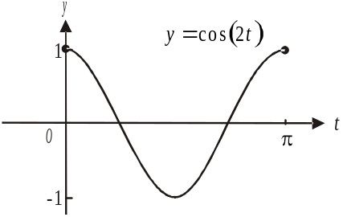
Similarly 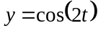 for and so
y can be positive and negative.
It has a maximum value of 1 and a minimum
value of -1.

The particle travels backwards and forwards
along the path shown above.

Total 40 marks

