

Students Name:………………………………………

SPECIALIST MATHEMATICS

TRIAL EXAMINATION 1

2008

Reading Time: 15 minutes
Writing time: 1 hour

Instructions to students
This exam consists of 10 questions.
All questions should be answered.
There is a total of 40 marks available.
The marks allocated to each of the ten questions are indicated throughout.
Students may not bring any notes or calculators into the exam.
Where more than one mark is allocated to a question, appropriate working must be shown.
Where an exact answer is required to a question, a decimal approximation will not be accepted.
Unless otherwise indicated, diagrams in this exam are not drawn to scale.
The acceleration due to gravity should be taken to have magnitude 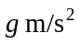where 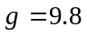
Formula sheets can be found on pages 12-14 of this exam.

This paper has been prepared independently of the Victorian Curriculum and Assessment Authority to provide additional exam preparation for students. Although references have been reproduced with permission of the Victorian Curriculum and Assessment Authority the publication is in no way connected with or endorsed by the Victorian Curriculum and Assessment Authority.

© THE HEFFERNAN GROUP 2008
This Trial Exam is licensed on a non transferable basis to the purchasing school. It may be copied by the school which has purchased it. This license does not permit distribution or copying of this Trial Exam by any other party.
Question 1

OAB is a triangle with 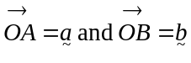. The midpoint of 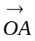 is M and the midpoint of 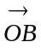 is N.

Prove that 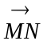 is parallel to 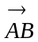.

2 marks

Question 2

A box of mass 5kg rests on a rough horizontal floor. The coefficient of friction between the box and the floor is . A boy applies a horizontal dragging force of D newtons to the box in an attempt to move it.

- Find the values of D if the box is not at the point of moving across the floor.

2 marks

- If the boy now applies a dragging force of 10 newtons at an angle of 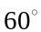 to the horizontal, find the acceleration of the box across the floor.

2 marks
Question 3

- Find the values of a and b given that 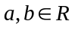 and that 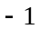 is a solution to the equation

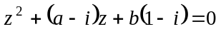.

2 marks

- Hence find the other solution to the equation.

2 marks

Question 4

Given that is a solution to the equation

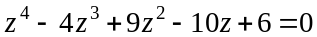,

find the other solutions.

3 marks

Question 5

Find the equation of the normal to the curve with equation 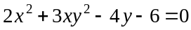 at the point 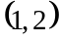.

3 marks

Question 6

The region enclosed by the graph of the function 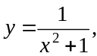 the y-axis, and the line 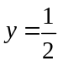 is rotated about the y-axis to form a solid of revolution.

Find the volume generated.

3 marks
Question 7

Consider the differential equation 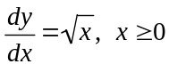.

- Sketch the slope field for this differential equation for 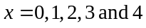 at each of the values 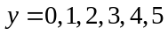 on the axes below.

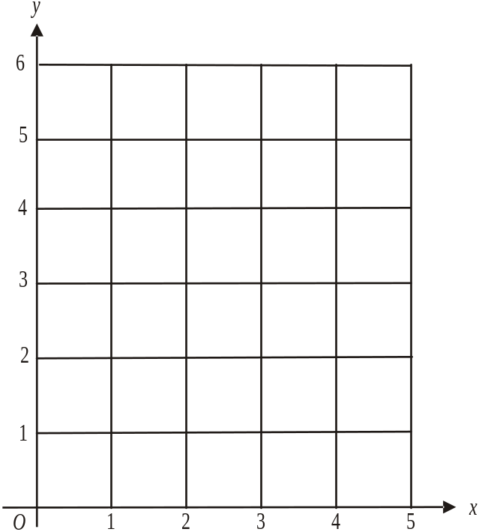

2 marks

- Given that 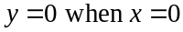, solve the differential equation.

1 mark

- Sketch the graph of the function found in part b. on the slope field in part a.

1 mark
Question 8

- Find 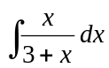.

2 marks

- Find an antiderivative of 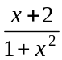.

2 marks

- Evaluate 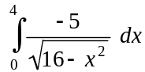.

2 marks
Question 9

- Sketch the graph of 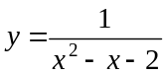, indicating clearly any asymptotes or axis
intercepts.
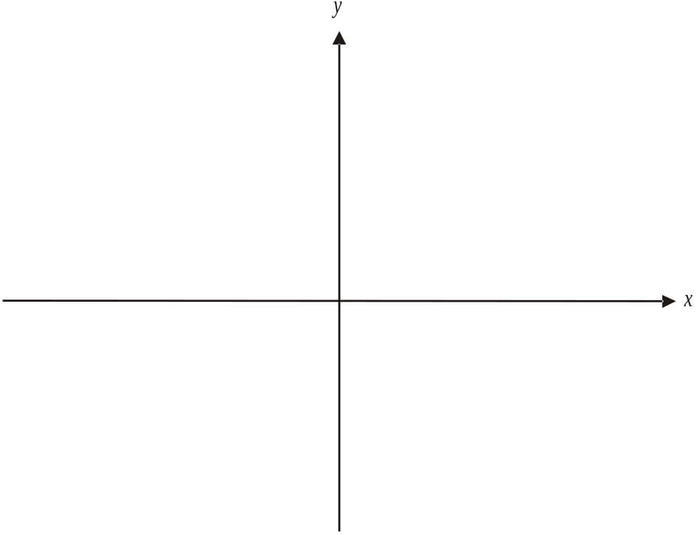

2 marks

- Find the area enclosed by the graph of, the x-axis, the y-axis and the
line .

4 marks

Question 10

At time t seconds the velocity of a moving particle is given by

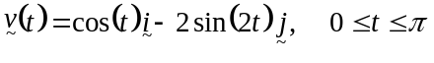

- Find the position vector 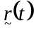 of the particle at time t given that 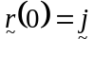.

2 marks

- Hence find the Cartesian equation of the path of the particle.

1 mark

- Sketch the path of the particle on the axes below indicating clearly the coordinates of any endpoints.
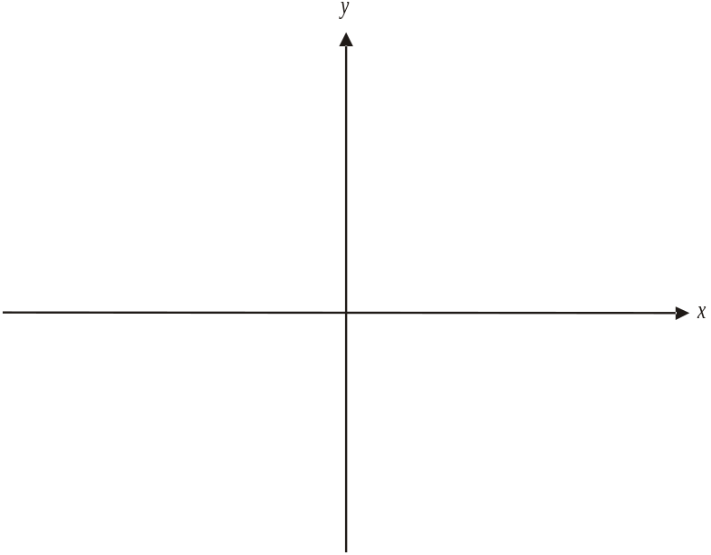

2 marks

Specialist Mathematics Formulas

Mensuration
area of a trapezium: 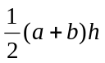
curved surface area of a cylinder: 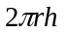
volume of a cylinder: 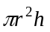
volume of a cone: 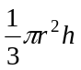
volume of a pyramid: 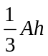
volume of a sphere: 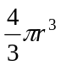
area of a triangle: 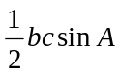
sine rule: 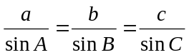
cosine rule: 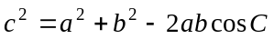

Coordinate geometry
ellipse: 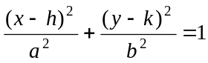 hyperbola: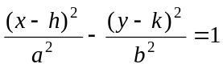

Circular (trigonometric) functions
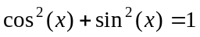
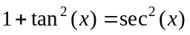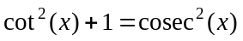
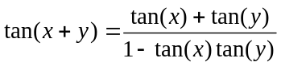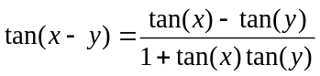
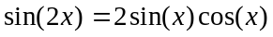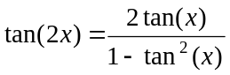
function | 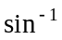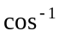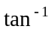
domain  range | 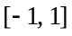  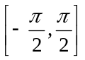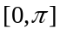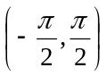
Algebra (Complex numbers)
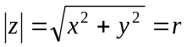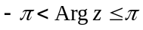
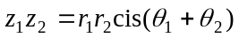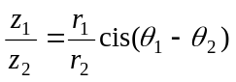
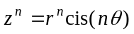 (de Moivre’s theorem)

This formulae sheet has been reproduced with permission of the Victorian Curriculum and Assessment Authority, Victoria, Australia.
This formula sheet has been copied in 2008 from the VCAA website www.vcaa.vic.edu.au
The VCAA publish an exam issue supplement to the VCAA bulletin.
Calculus

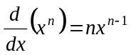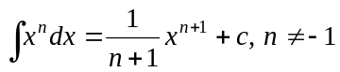
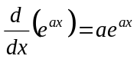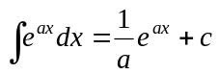
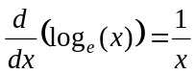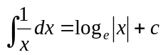
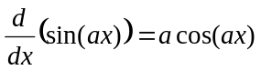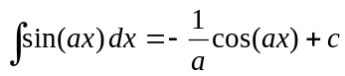
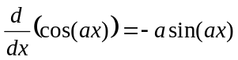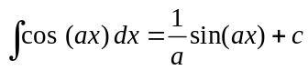
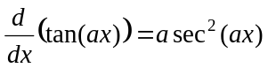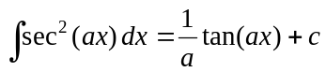
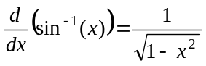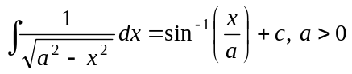
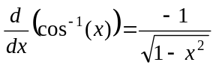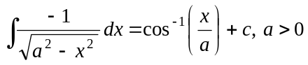
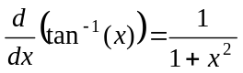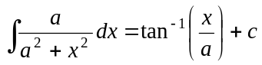

product rule: 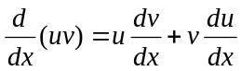
quotient rule: 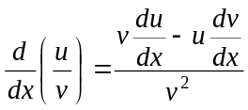
chain rule: 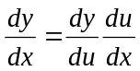
Euler’s method: 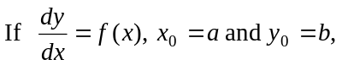
acceleration: 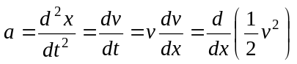
constant (uniform) acceleration: 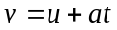 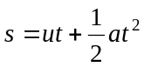 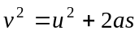 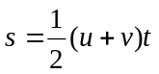

This formulae sheet has been reproduced with permission of the Victorian Curriculum and Assessment Authority, Victoria, Australia.
This formula sheet has been copied in 2008 from the VCAA website www.vcaa.vic.edu.au
The VCAA publish an exam issue supplement to the VCAA bulletin.

Vectors in two and three dimensions

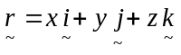
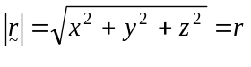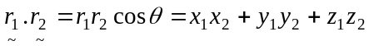
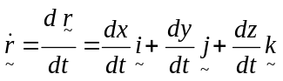

Mechanics

momentum: 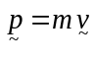
equation of motion: 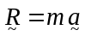
friction: 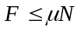

This formulae sheet has been reproduced with permission of the Victorian Curriculum and Assessment Authority, Victoria, Australia.
This formulae sheet has been copied in 2008 from the VCAA website www.vcaa.vic.edu.au
The VCAA publish an exam issue supplement to the VCAA bulletin.

