
SPECIALIST MATHS
TRIAL EXAMINATION 1
SOLUTIONS
2012

Question 1

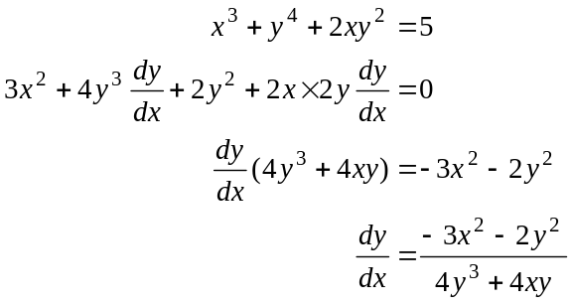
(1 mark)
(1 mark)
Question 2

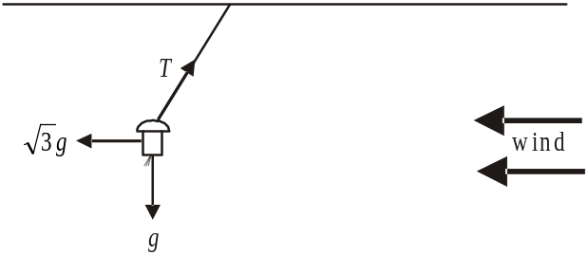

(1 mark)

- Since the magnitude of the force of the wind is constant, the system is in equilibrium.

Method 1 – using triangle of forces

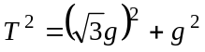 (1 mark)
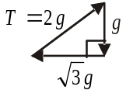
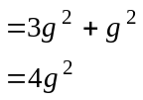
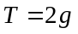
(1 mark)

Method 2 – resolving horizontally and vertically

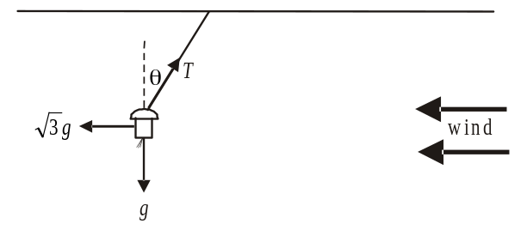

Resolving horizontally
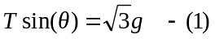

Resolving vertically
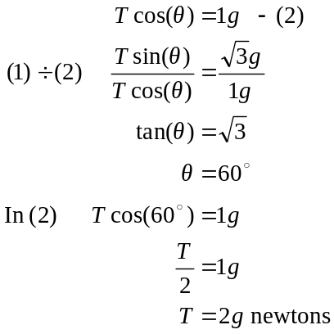
(1 mark)
(1 mark)
Check in (1) if time,
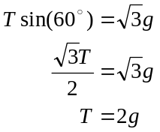

Question 3

Let 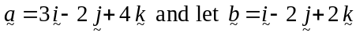.
The vector component of parallel to is given by
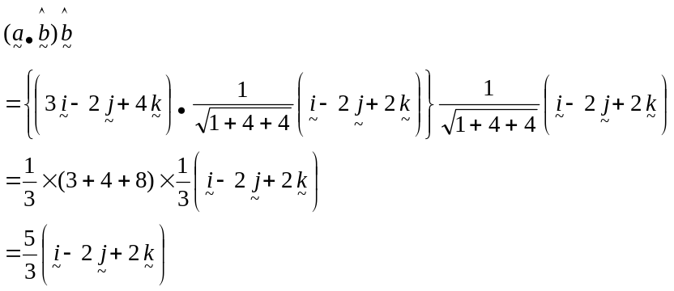
(1 mark)
(1 mark)
The vector component of perpendicular to is given by
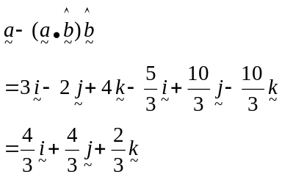
(1 mark)
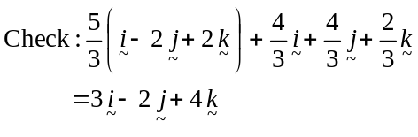

Question 4

- Let 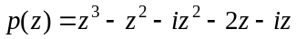
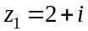 is a solution to the equation 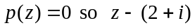 is a factor of 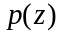.
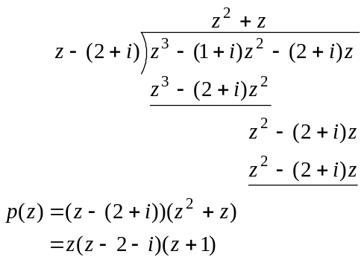
(1 mark)
The other two solutions to 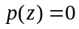 are 0 or – 1.
(1 mark)
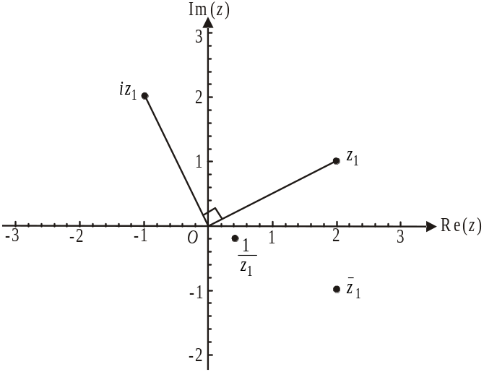

(1 mark) - 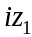
(1 mark) - 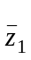
(1 mark) - 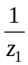
- is located by rotating by 90° in an anticlockwise direction.
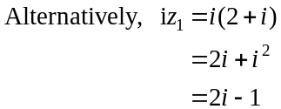
ii. 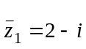

- 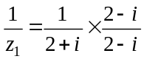
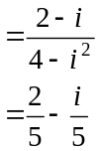

Question 5
- 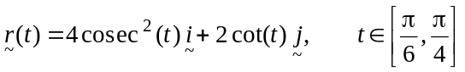
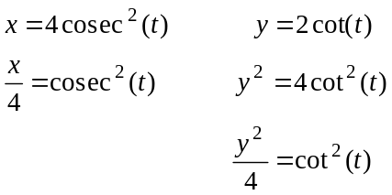
(1 mark)
Since 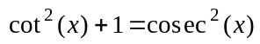 (formula sheet)
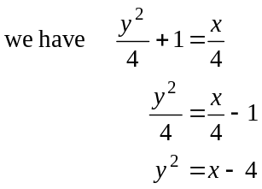
(1 mark)
- Since 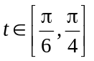
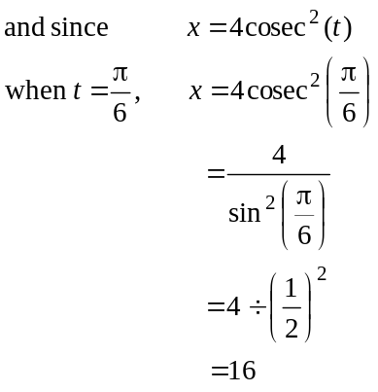
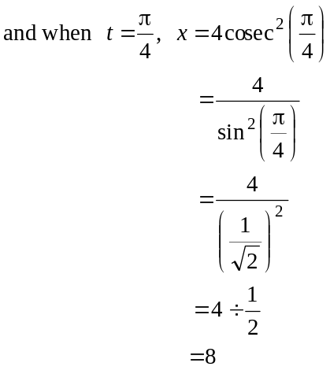
So the required domain is 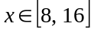

(1 mark) – left endpoint (1 mark) – right endpoint

Question 6

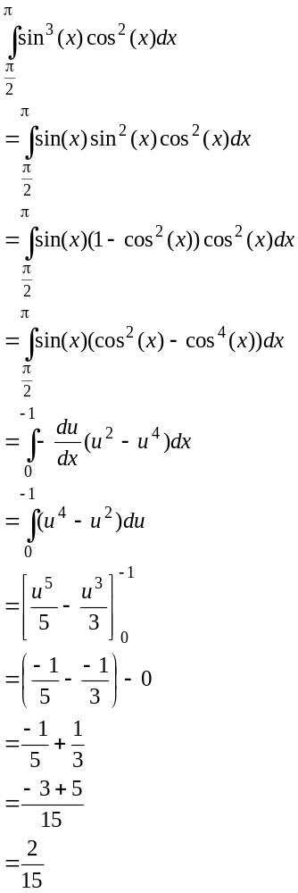
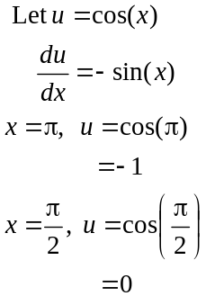
(1 mark) – correct integrand in terms of u
(1 mark) – correct terminals
(1 mark) correct answer
Question 7

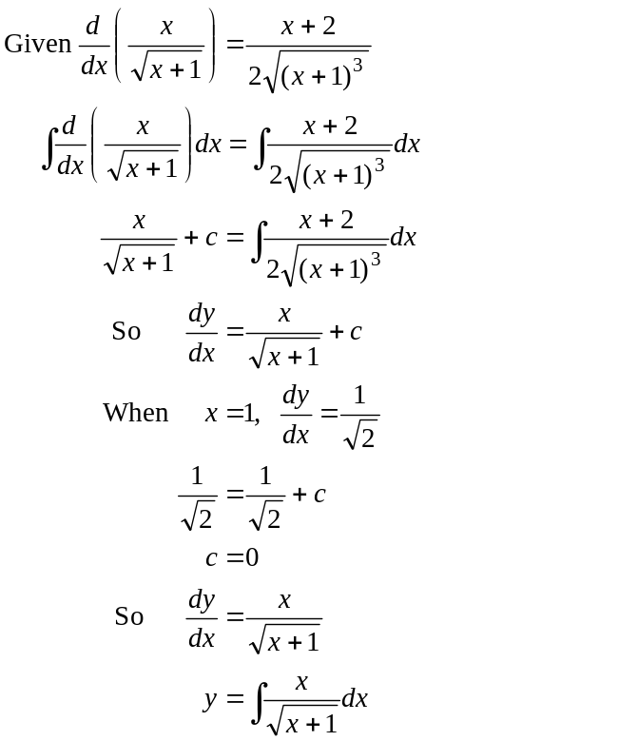
(1 mark)
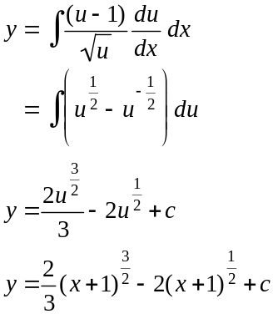
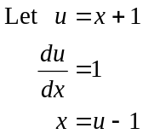
(1 mark)

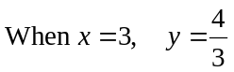
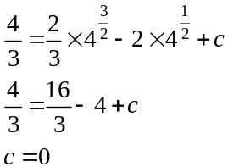
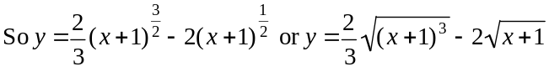
(1 mark)

Question 8
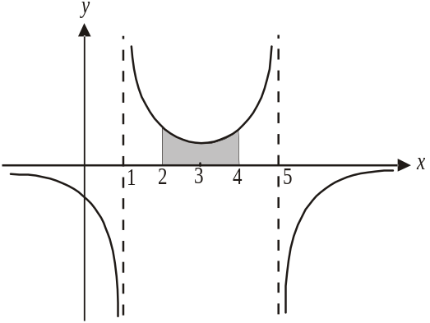
Do a quick sketch.
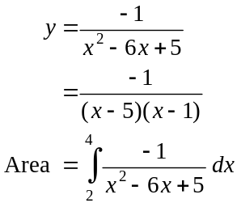
(1 mark)

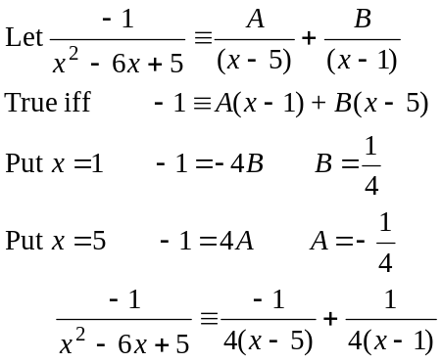
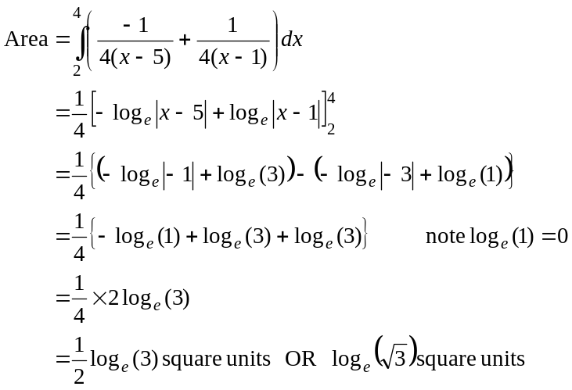
(1 mark)
(1 mark)
(1 mark)

Question 9
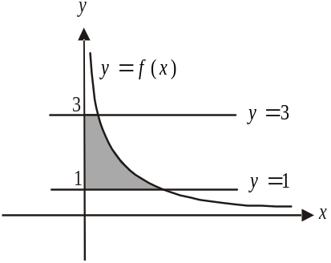
The shaded region shown is rotated about the y-axis.
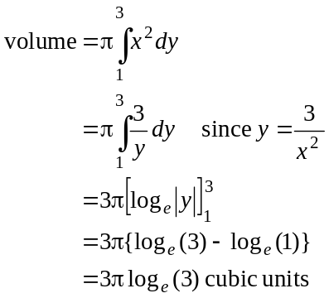
(1 mark)
(1 mark)
(1 mark)
Question 10
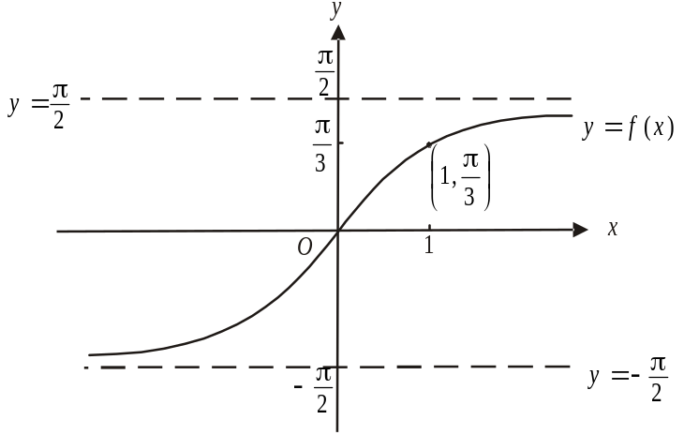

(1 mark) – correct asymptotes
(1 mark) correct shape including
passing through the origin

- 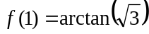
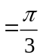
(1 mark)
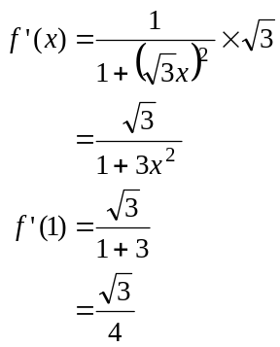 (1 mark)
At the point 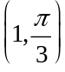, the gradient is 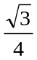.
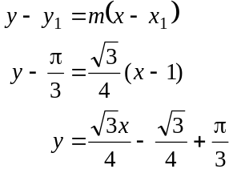
(1 mark)

Question 11

- 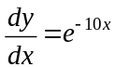

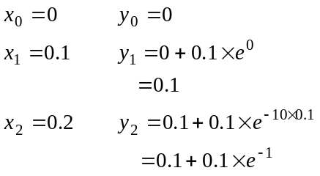
(1 mark)
(1 mark)

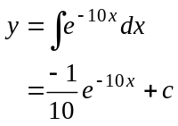
When 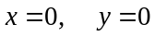
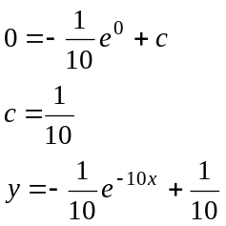
(1 mark)

When
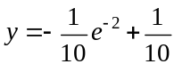
(1 mark)

The difference between the actual value and the estimated value
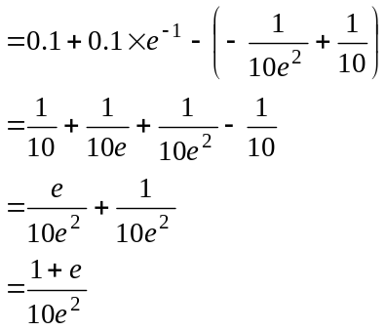

So 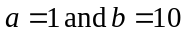.
(1 mark)

