

Student Name:………………………………………

SPECIALIST MATHEMATICS

TRIAL EXAMINATION 2

2013

Reading Time: 15 minutes
Writing time: 2 hours

Instructions to students
This exam consists of Section 1 and Section 2.
Section 1 consists of 22 multiple-choice questions and should be answered on the detachable answer sheet on page 24 of this exam. This section of the paper is worth 22 marks.
Section 2 consists of 5 extended-answer questions, all of which should be answered in the spaces provided. Section 2 begins on page 10 of this exam. This section of the paper is worth 58 marks.
There is a total of 80 marks available.
Where more than one mark is allocated to a question, appropriate working must be shown.
Where an exact value is required to a question a decimal approximation will not be accepted.
Unless otherwise stated, diagrams in this exam are not drawn to scale.
The acceleration due to gravity should be taken to have magnitude 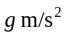where 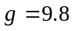
Students may bring one bound reference into the exam.
Students may bring an approved graphics or CAS calculator into the exam.
Formula sheets can be found on pages 21-23 of this exam.

This paper has been prepared independently of the Victorian Curriculum and Assessment Authority to provide additional exam preparation for students. Although references have been reproduced with permission of the Victorian Curriculum and Assessment Authority, the publication is in no way connected with or endorsed by the Victorian Curriculum and Assessment Authority.

© THE HEFFERNAN GROUP 2013
This Trial Exam is licensed on a non transferable basis to the purchasing school. It may be copied by the school which has purchased it. This license does not permit distribution or copying of this Trial Exam by any other party.
SECTION 1

Question 1

The graph of 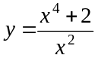 has

- one asymptote
- two straight asymptotes
- two asymptotes, one of which is straight
- three asymptotes, one of which is straight
- three asymptotes, two of which are straight

Question 2

An ellipse has its centre at the point 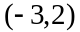 and has a vertical semi-axis length of b where b is a real constant.
The ellipse touches the x-axis only once. The value of b is

- 1
- 2
- 3
- 4
- 9

Question 3

Let 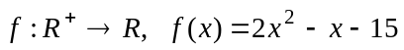. The graph of 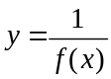 has

- an asymptote at only
- x and y intercepts
- asymptotes at 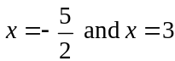
- a local maximum at the point 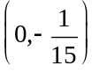
- two asymptotes.

Question 4

The maximal domain and range of the function with rule 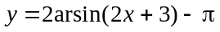 are respectively given by

- 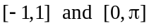
- 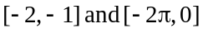
- 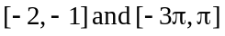
- 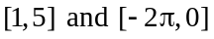
- 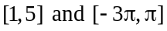
Question 5

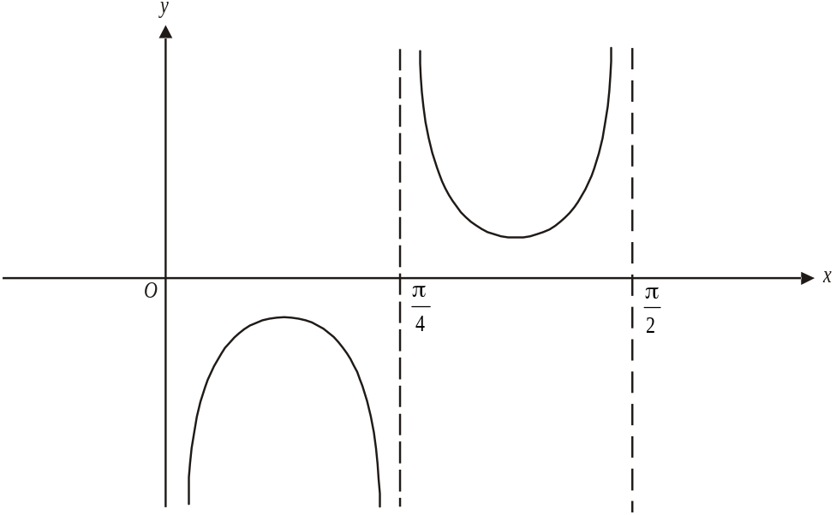

The graph of the function 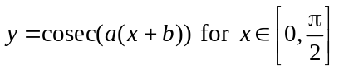 is shown above.
The values of a and b could be

- 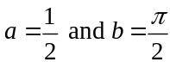
- 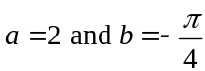
- 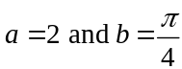
- 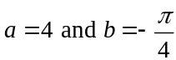
- 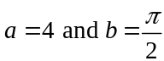

Question 6

If 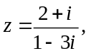 the imaginary part of is

- 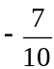
- 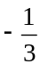
- 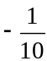
- 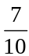

Question 7

Let z be any complex number such that .
The complex number 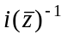 is located in the same position on an Argand diagram as the complex number

- –iz
- iz
- 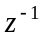
- 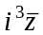

Question 8

On an Argand plane, a complex number that lies in the region defined by 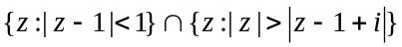 is given by

- 1
- 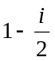
- 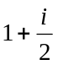

Question 9

The polynomial 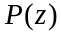 is of degree 6 and has real coefficients.
Which one of the following statements cannot be true?

- 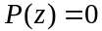 has no real roots
- has no complex roots
- has equal numbers of real and complex roots
- has two repeated complex roots
- has three repeated real roots.

Question 10

In a trial that is being conducted, the rate at which a disease spreads through 200 mice is proportional to the number of mice W, that are well, divided by the number of mice that have the disease t days after the trial begins. Only 5 of the 200 mice have the disease at the start of the trial. A differential equation that could be solved to find the number of well mice, t days into the trial is

- 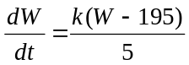
- 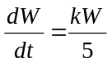
- 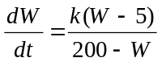
- 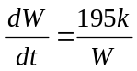
- 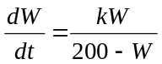

Question 11

For the differential equation 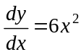, Euler’s formula is used to find 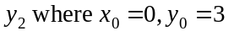
.

The value of 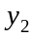

- underestimates 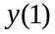 and is equal to 3.75
- overestimates and is equal to 3.75
- underestimates and is equal to 6
- overestimates and is equal to 6
- overestimates and is equal to 7.5
Question 12
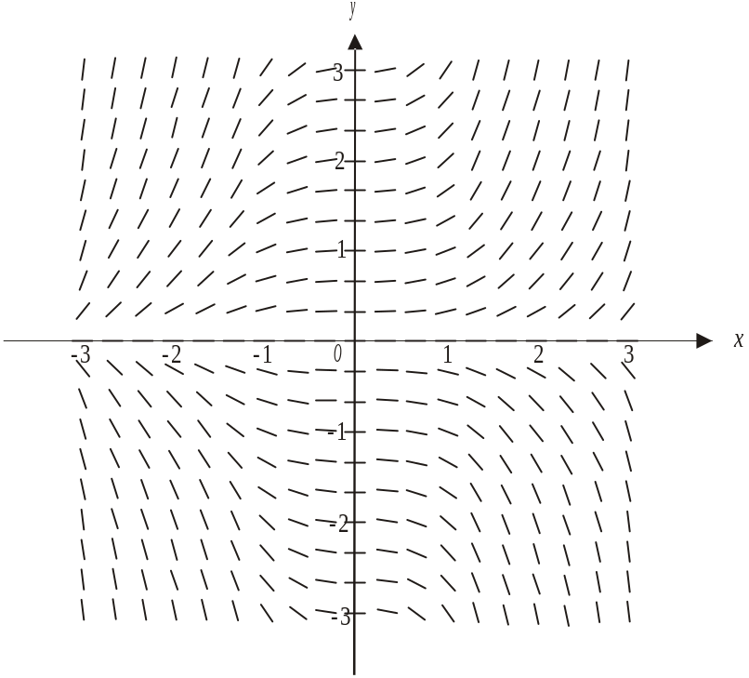

The direction field shown above could be that of the differential equation 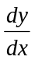 equals

- 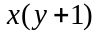
- 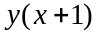
- 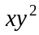
- 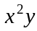
- 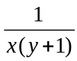

Question 13
Using a suitable substitution, 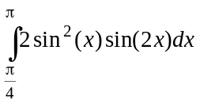 can be expressed as
- 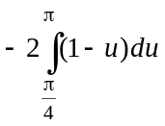
- 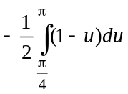
- 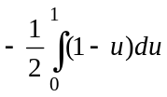
- 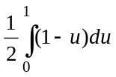
- 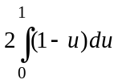
Question 14

The graph of 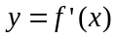 is shown below.
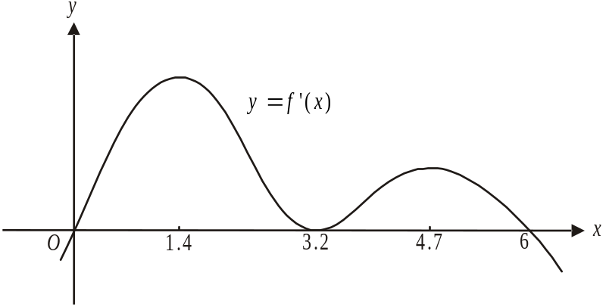

For the graph of the function 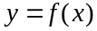, the stationary points could be

- local maxima at 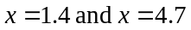 and a local minimum at 3.2
- a local maximum at , a stationary point of inflection at and a local maximum at 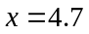
- stationary points of inflection at 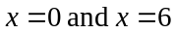 and a local minimum at
- stationary points of inflection at , local maxima at and a local minimum at
- a local minimum at , a stationary point of inflection at and a local maximum at 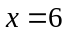.

Question 15

A force of magnitude 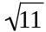 newtons acts on a particle in the direction S30°E. A second force of magnitude 8 newtons acts on the particle in the direction N60°E. The magnitude of the resulting force on the particle, in newtons is

- 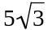
- 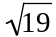
- 10
- 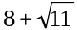
- 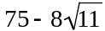

Question 16

The acceleration of a particle t seconds after it leaves its origin of motion O, where it was at rest, is given by 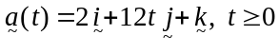 where the magnitude of is in ms⁻².
The magnitude of the displacement, in metres, of the particle from O at is

- 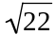
- 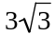
- 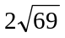
- 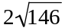
- 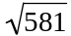
Question 17

Let 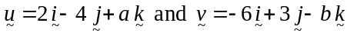 where a and b are real numbers. These two vectors are perpendicular and the magnitude of is 7 units. Possible values of a and b are

- 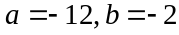
- 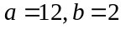
- 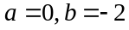
- 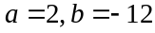
- 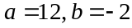

Question 18

Let 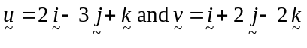. The vector resolute of that is perpendicular to is

- 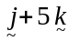
- 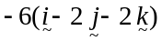
- 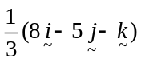
- 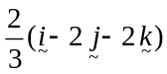
- 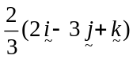

Question 19

ABCD is a parallelogram. The position vectors of A, B, C and D are given respectively by

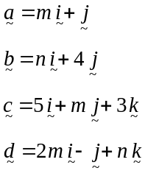

The values of m and n are

- 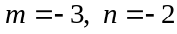
- 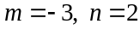
- 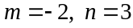
- 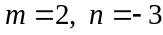
- 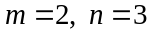
Question 20

A 3kg mass is moving in a straight line when it is acted on by a force that accelerates it at the rate of 4ms⁻² in the same straight line.
After travelling 3m, the velocity of the mass is 8ms⁻¹. The magnitude of the momentum, in kg ms⁻¹, of the mass just as it was acted on by the force is

- 24
- 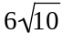
- 72
- 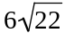
- 120

Question 21

A variable force F newtons, acts on a particle of mass 2kg that is moving in a straight line so that its velocity vms⁻¹, is given by where x is the displacement of the particle from the origin.
When , the value of F is

- 6
- 9
- 12
- 24
- 36

Question 22

A mass of m kg is suspended from a ceiling by two light inextensible strings as shown in the diagram below.
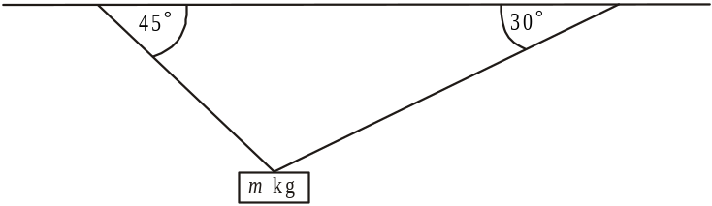

The shorter string makes an angle of 45° with the ceiling and the longer string makes an angle of 30° with the ceiling. The tension in the shorter string is 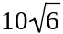 newtons. The value of m is

- 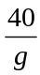
- 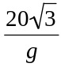
- 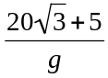
- 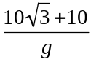
- 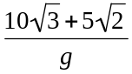
SECTION 2

Question 1 (12 marks)

A curve is defined parametrically by the equations

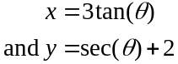

- Show that the Cartesian equation of the curve is given by
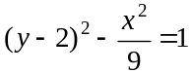
2 marks

- On the set of axes below sketch the graph of the curve. Indicate clearly, all intercepts and the equations of any asymptotes.
4 marks
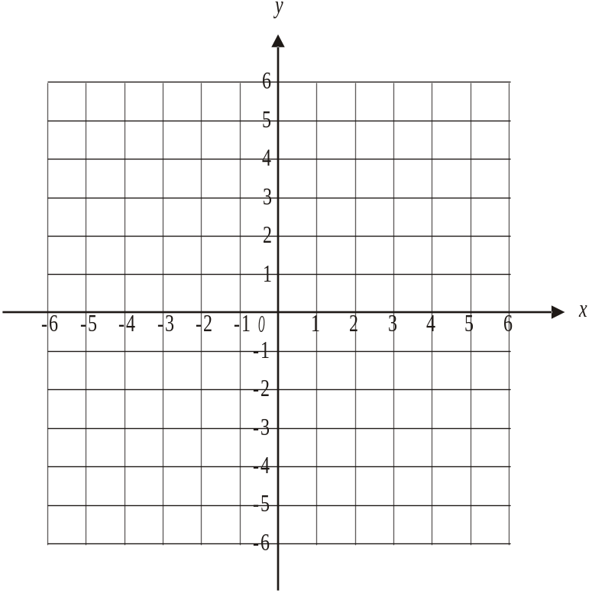

- The region bounded by the curve and the line 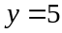 is rotated about the y-axis to form a solid of revolution. Find the volume of that solid.
2 marks

- Find an expression for 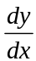 in terms of .
2 marks

- Hence find the coordinates of the points on the curve where the gradient is 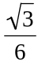.
2 marks

Question 2 (12 marks)

A sightseeing train runs through a tourist park. The position vector of the train in relation to the ticket office at the origin O, at time t hours after the train starts, is given by

,

where is a unit vector in the east direction, is a unit vector in the north direction and a is the time taken for the train to complete one circuit of the track. The unit of measurement for the displacement of the train is the kilometre.

- Find how far due west of the ticket box the train starts its journey.
2 marks

- Find the value of a.
2 marks

- Find the Cartesian equation of the path of the train.
2 marks

- Show that the train travels at constant speed.
2 marks

- The train crosses a road that runs due north from the ticket box. Find how long into the trip the train crosses this road. Express your answer to the nearest minute.
2 marks

- Using an algebraic method, find the furthest distance of the train from the ticket office.
2 marks

Question 3 (12 marks)

- Hugh leans out of his bedroom window which is open. He drops his ball from rest, 2.5 metres to the ground below. Assuming the ball is subject only to gravitational acceleration, and ignoring air resistance, what is the speed of the ball, in ms⁻¹, as it hits the ground?
1 mark

- From the same position 2.5m above the ground, Hugh throws another ball, at a speed of 5ms⁻¹ vertically upwards. This ball rises vertically and then descends vertically until it hits the ground.

  - How long, in seconds, does it take the ball to hit the ground? Express your answer correct to one decimal place.
2 marks

  - What is the speed of the ball as it hits the ground? Express your answer correct to one decimal place.
1 mark

Hugh goes outside to play. He drops his toy truck, of mass 0.2kg, from rest, at water level into a pond. The truck descends vertically through the water which exerts a resistance of 2v newtons to the truck’s motion, where v, in ms⁻¹, is the velocity of the truck t seconds after it enters the water.

- Draw a diagram showing the forces acting on the toy truck.
1 mark

- Show that the acceleration, a in ms⁻², of the truck is given by 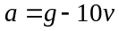
1 mark

- Show that 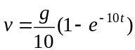.
3 marks

- Find the limiting or terminal velocity of the toy truck.
1 mark

- Hugh’s toy truck takes 2.5 seconds to reach the bottom of the pond. Find the depth of the water in the pond expressing your answer correct to one decimal place.
2 marks

Question 4 (11 marks)

Ashleigh is sitting in her car at a set of traffic lights using her mobile phone. Ashleigh accelerates from rest k seconds after the lights turn green. Her speed, v in 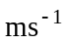, from when she starts to move, is given by 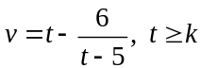, where t is the time in seconds since the light turned green and k is a positive constant.

- Find k.
1 mark

- Sketch the graph of 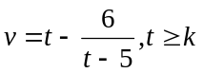 on the set of axes below. Label clearly all features of the graph indicating any asymptotes.
2 marks
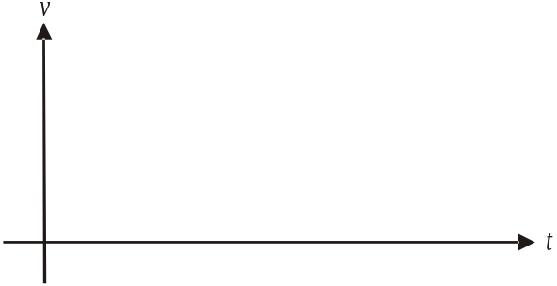

- Find the limiting acceleration of Ashleigh’s car as .
1 mark

- When Ashleigh has travelled 165.752m, she notices the police indicating to her to pull over. How long after the light went green did this occur?
2 marks

- At what speed was Ashleigh travelling when she noticed the police indicating to her to pull over?
1 mark

- Immediately when Ashleigh notices the police, she brakes and her car begins to decelerate until it comes to rest. The speed V ms⁻¹ of the car t seconds after Ashleigh brakes is such that
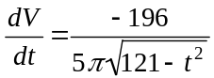.

  - Given that 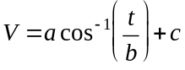, find the values of a, b and c.
2 marks

  - Find the distance Ashleigh travels between first braking and coming to rest. Express your answer in metres correct to one decimal place.
2 marks

Question 5 (11 marks)

Let 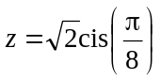.

- Use a double angle formula to show that 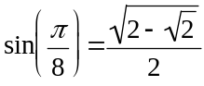.
3 marks

- Given that 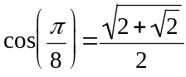, express z in Cartesian form.
1 mark

- Plot and label the complex number 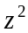 on the Argand diagram below.
1 mark
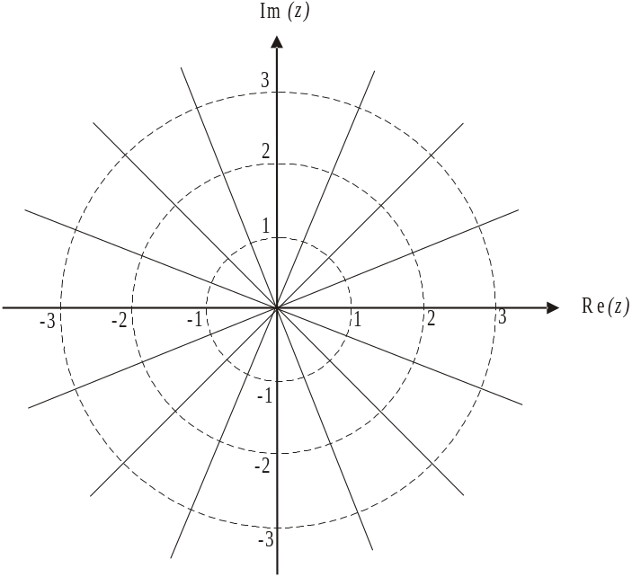

- On the Argand plane, a triangle has corner points represented by the complex numbers 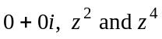. Find the area, in square units, of this triangle.
2 marks

- i. Find the values of n for which 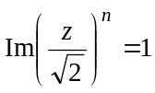.
3 marks

- If 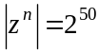, find the value of n.
1 mark

Specialist Mathematics Formulas

Mensuration
area of a trapezium: 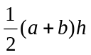
curved surface area of a cylinder: 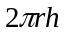
volume of a cylinder: 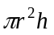
volume of a cone: 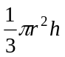
volume of a pyramid: 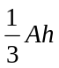
volume of a sphere: 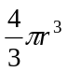
area of a triangle: 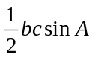
sine rule: 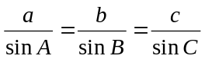
cosine rule: 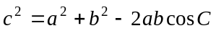

Coordinate geometry
ellipse: 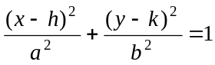 hyperbola: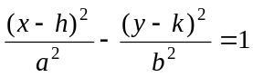

Circular (trigonometric) functions
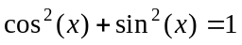
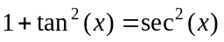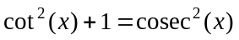
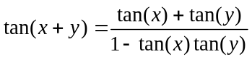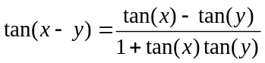
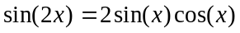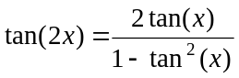
function | 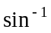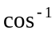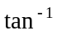
domain  range | 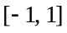  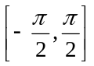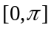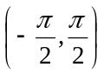

Algebra (Complex numbers)
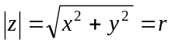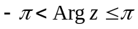
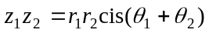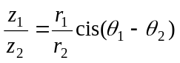
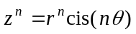 (de Moivre’s theorem)

Reproduced with permission of the Victorian Curriculum and Assessment Authority, Victoria, Australia.
This formula sheet has been copied in 2013 from the VCAA website www.vcaa.vic.edu.au
Calculus

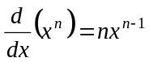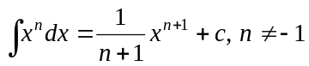
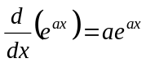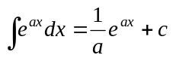
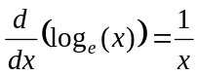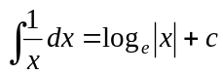
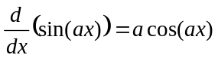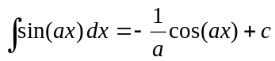
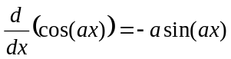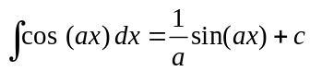
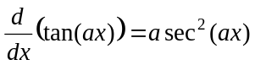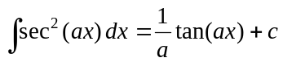
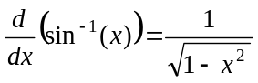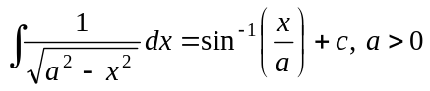
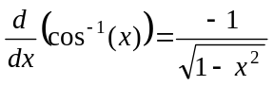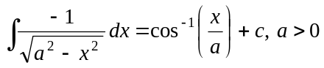
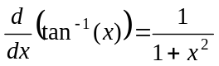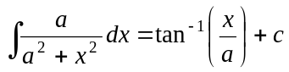

product rule: 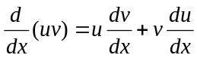
quotient rule: 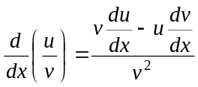
chain rule: 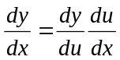
Euler’s method: 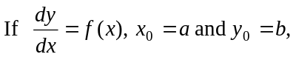
acceleration: 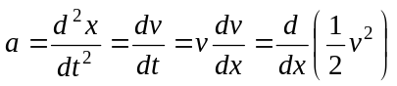
constant (uniform) acceleration: 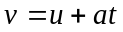 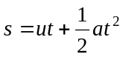 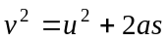 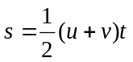

Reproduced with permission of the Victorian Curriculum and Assessment Authority, Victoria, Australia.
This formula sheet has been copied in 2013 from the VCAA website www.vcaa.vic.edu.au

Vectors in two and three dimensions

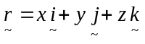
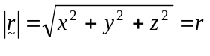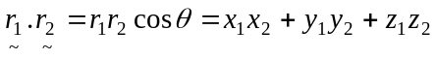
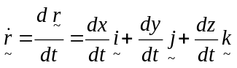

Mechanics

momentum: 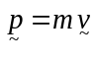
equation of motion: 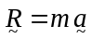
friction: 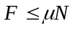

Reproduced with permission of the Victorian Curriculum and Assessment Authority, Victoria, Australia.
This formula sheet has been copied in 2013 from the VCAA website www.vcaa.vic.edu.au

