
SPECIALIST MATHS
TRIAL EXAMINATION 1
SOLUTIONS
2015

Question 1 (3 marks)
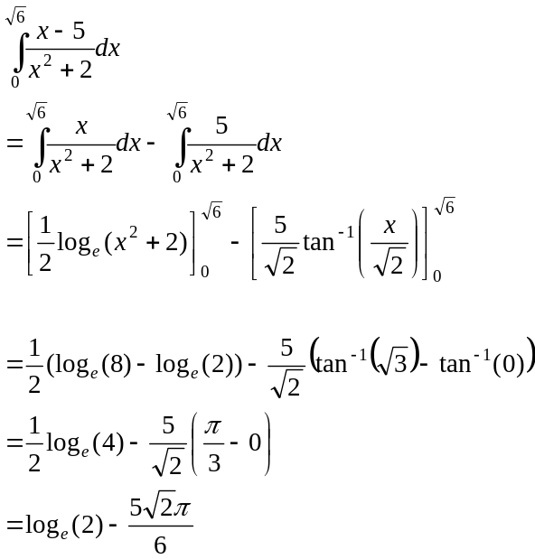
(1 mark)
(1 mark)
(1 mark)
Question 2 (5 marks)
- i. 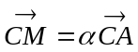 (given in question)
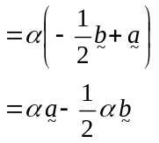
(1 mark)
- 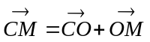
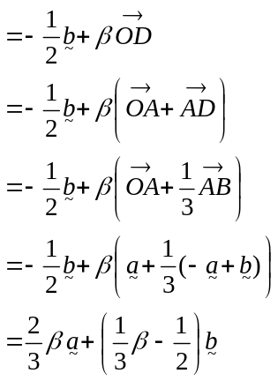
(1 mark)
(1 mark)
b. From part a.,
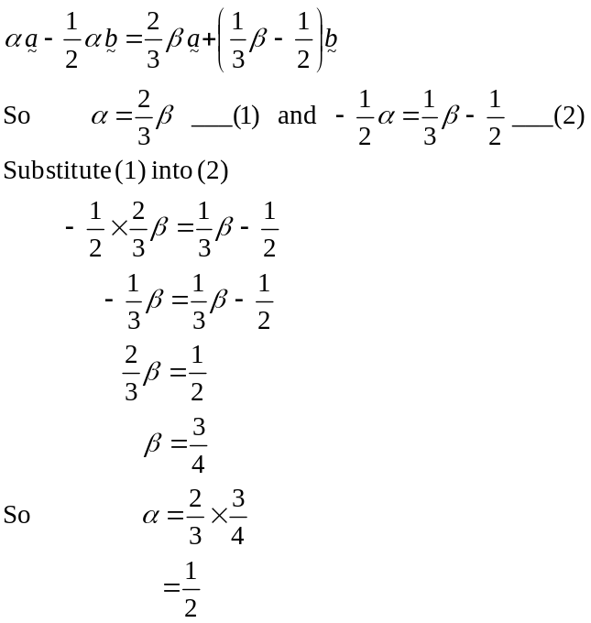
(1 mark)
(1 mark)

Question 3 (3 marks)

The vector resolute of in the direction of
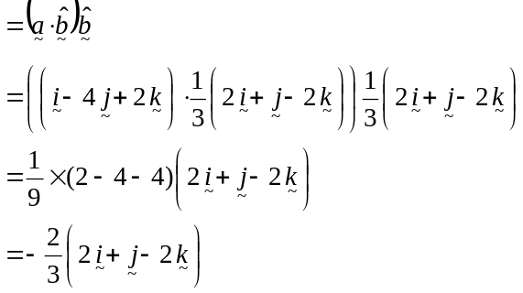
(1 mark)
(1 mark)
The vector resolute of perpendicular to
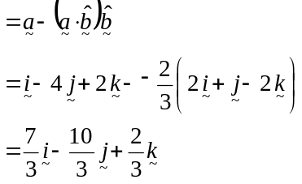
(1 mark)

If you have time, add the two resolutes together to make sure they give .
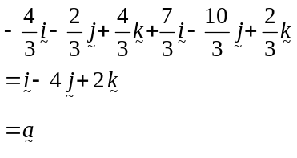

Question 4 (4 marks)

Since is a solution then is also a solution because the coefficients of the terms in the equation are all real (conjugate root theorem).
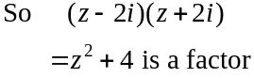
(1 mark)

Method 1 – long division
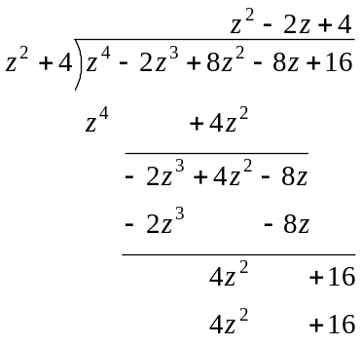

Method 2 – inspection

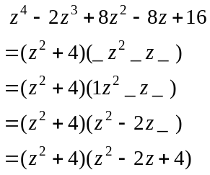

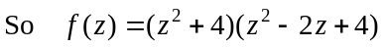 (1 mark)
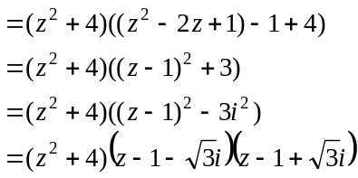
(1 mark)

The other solutions to 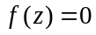 are 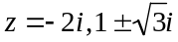. (1 mark)

Question 5 (5 marks)
- 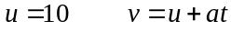 (1 mark)
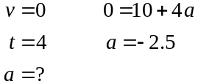
The acceleration is 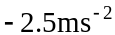. (1 mark)
Method 2

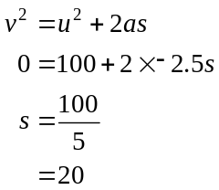
b. Method 1
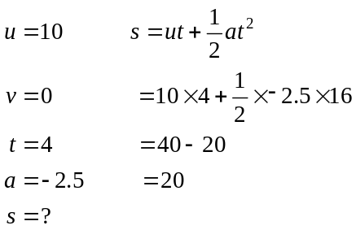
The box travels 20m.
(1 mark)
c. Draw the forces on the diagram.
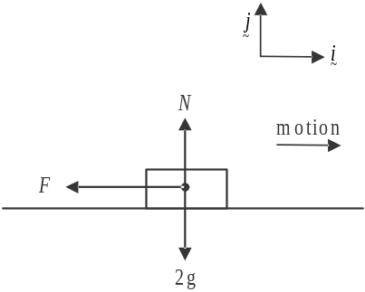
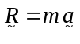
(1 mark)
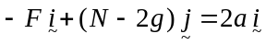
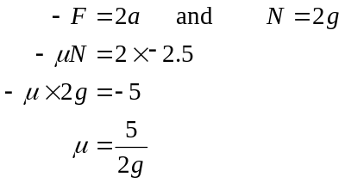
So 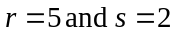. (1 mark)

Question 6 (4 marks)
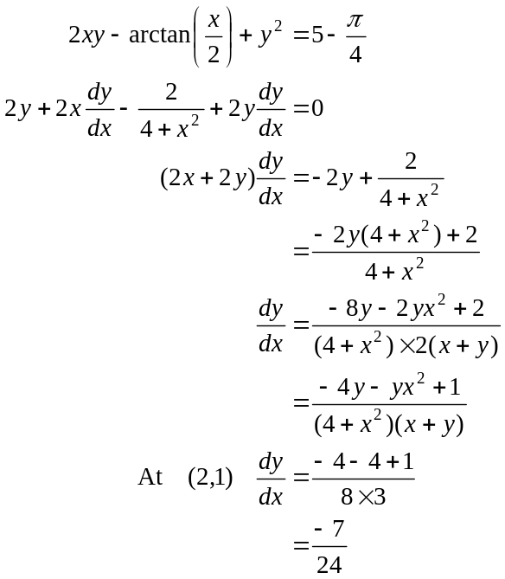
(1 mark) - 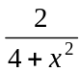 term
(1 mark) - other terms
(1 mark)
(1 mark)
Question 7 (4 marks)
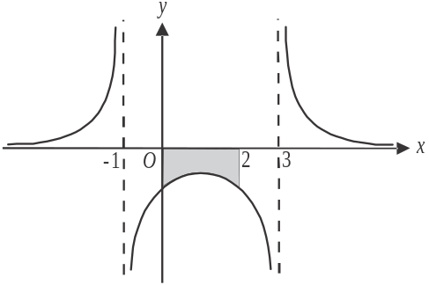
Do a quick sketch.
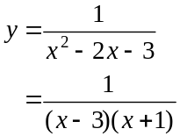

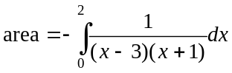
(1 mark)

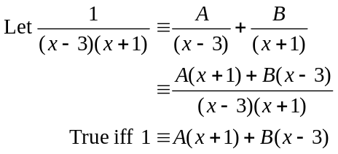
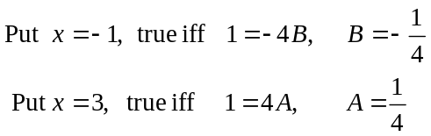

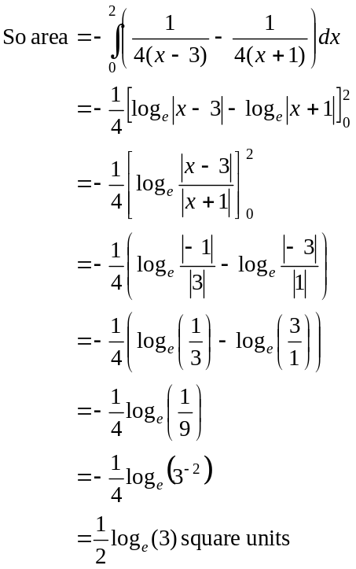
(1 mark)
(1 mark)
(1 mark)

Question 8 (5 marks)
- Method 1
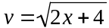
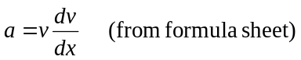 (1 mark)
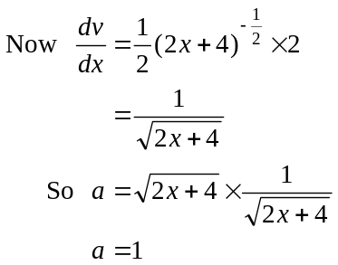
Hence acceleration is constant. (1 mark)
Method 2
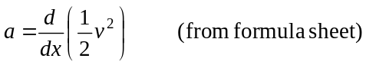 (1 mark)
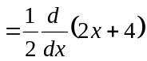
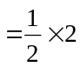
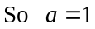
Hence acceleration is constant. (1 mark)
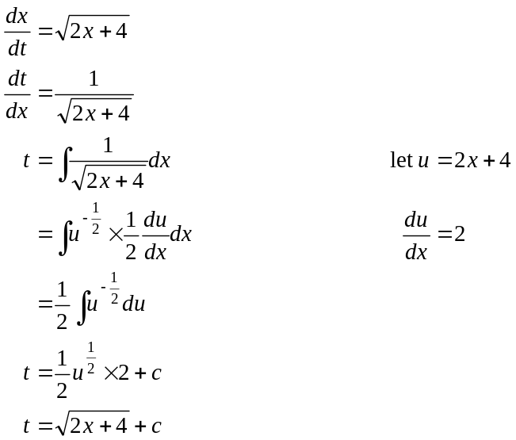
(1 mark)
(1 mark)
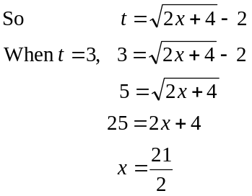
(1 mark)
Question 9 (7 marks)

- 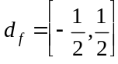 (1 mark)
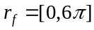 (1 mark)

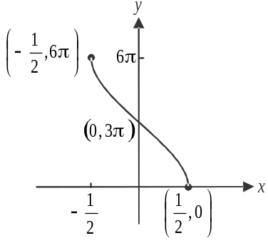

(1 mark) – correct endpoints and y-intercept
(1 mark) – correct shape

- 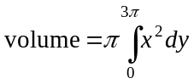 (1 mark)
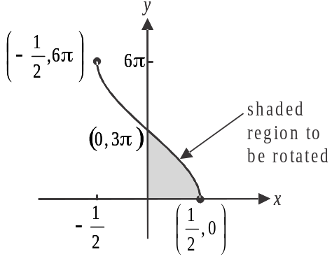
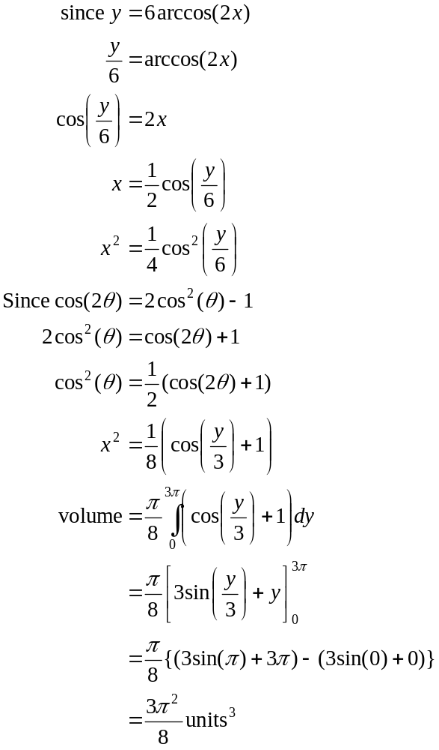
(1 mark)
1 mark

