
SPECIALIST MATHS
TRIAL EXAMINATION 2
SOLUTIONS
2015

SECTION 1 – Multiple-choice answers

1. A 7. E 13. A 19. E
2. C 8. B 14. D 20. A
3. E 9. E 15. D 21. D
4. C 10. B 16. C 22. E
5. B 11. B 17. D
6. C 12. C 18. D

SECTION 1 - Multiple-choice solutions

Question 1

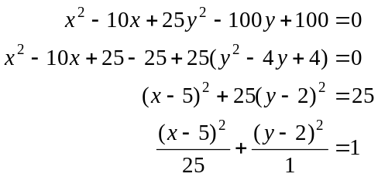
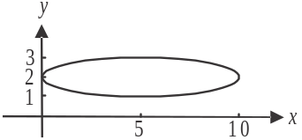
The only axis intercept occurs at 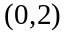.
The answer is A.

Question 2

The graph of 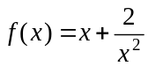 has two asymptotes, one with equation and the other with equation . Immediately we see that option C cannot be true as both the asymptotes
are straight lines.
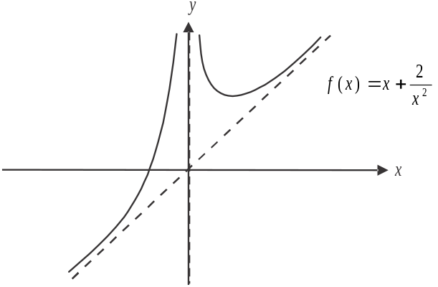

The answer is C.

Question 3

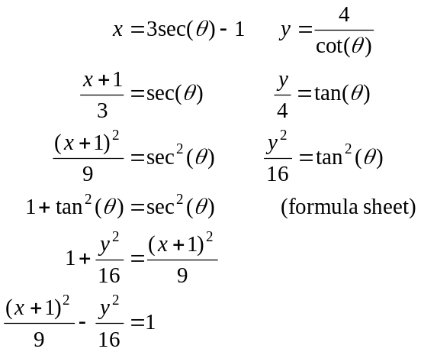
The answer is E.

Question 4

For 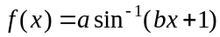

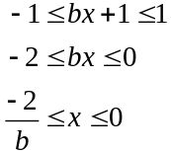
Since 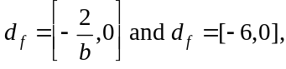
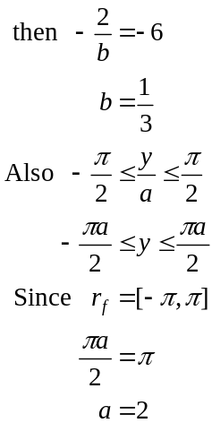
The answer is C.

Question 5

The modulus of z is the distance from the origin
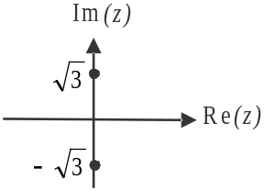
to the point on the Argand diagram represented by z.
Since z lies on the imaginary axis, there are two
possible values of z, as shown on the diagram.
One is 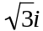 and the other is 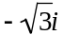.
Only the latter is offered in the answers.
The answer is B.
Question 6

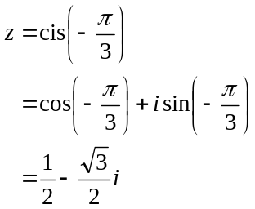
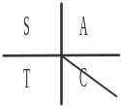
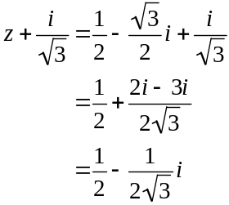
The imaginary part is 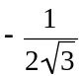.
The answer is C.

Question 7

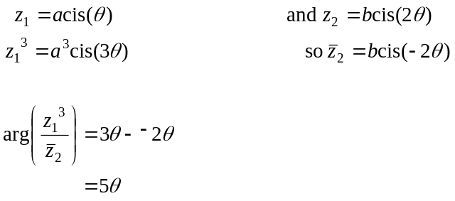
The answer is E.

Question 8

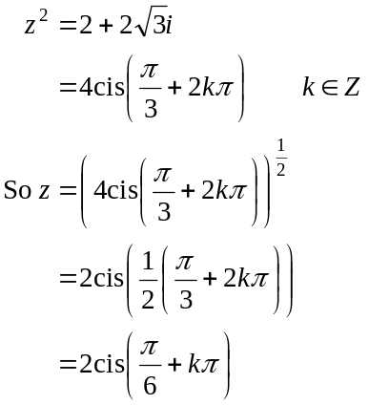
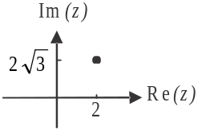
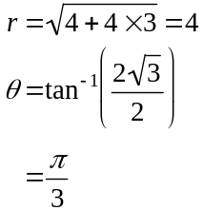
For the principle valued argument, . (formula sheet)
So 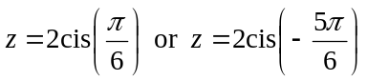.
The answer is B.
Question 9
Do a quick sketch.
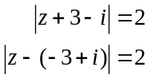
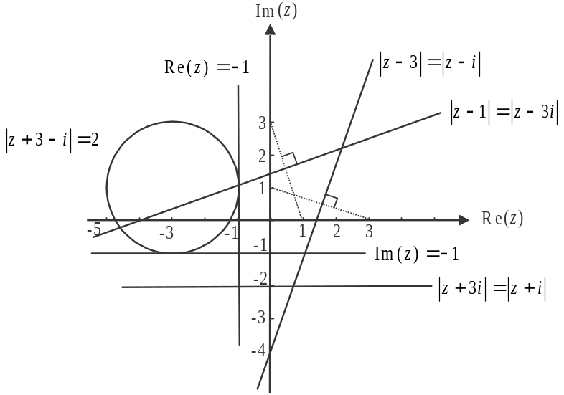

The lines 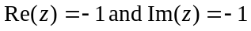 are both tangents to the circle.
The lines given in options B and D don’t intersect with the circle at all.
The line 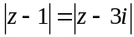 intersects twice.
The answer is E.
Question 10
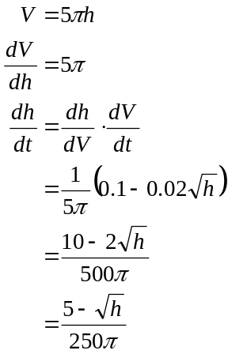
The answer is B.

Question 11
Method 1
At 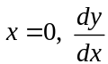 is undefined, so eliminate options C and E.
For 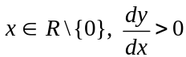, so eliminate options A and D.
The answer is B.
Method 2
The slopes 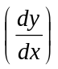 are influenced by x-values only, so A and B are the only possibilities.
The slopes are non-negative so it must be B.
The answer is B.
Question 12

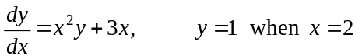
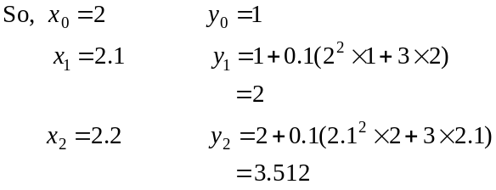
The answer is C.

Question 13

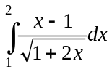
Let
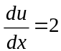
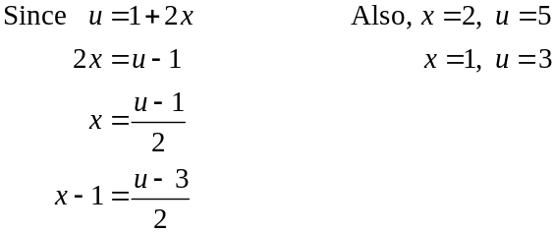
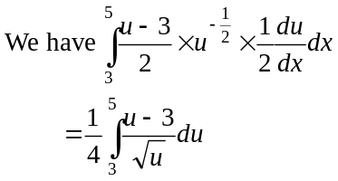
The answer is A.

Question 14
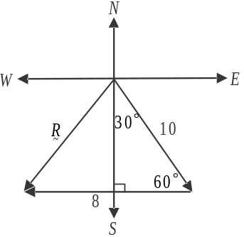

Draw a diagram.
Add tip to tail to get the resultant vector .
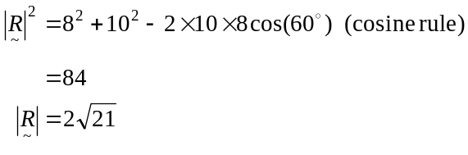
The answer is D.

Question 15

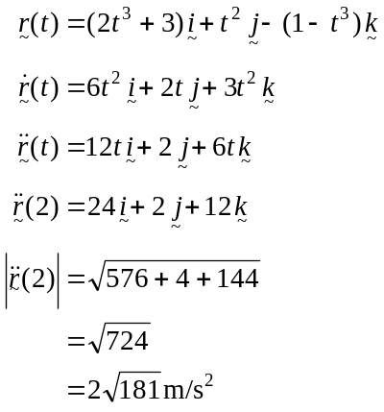
The answer is D.

Question 16

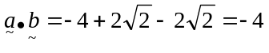
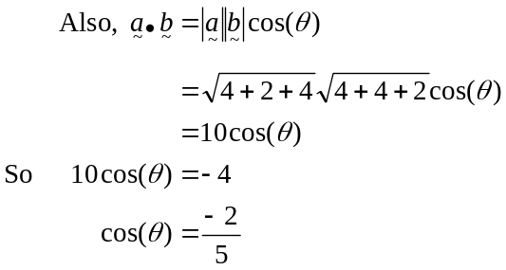
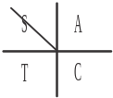
must be a second quadrant angle.
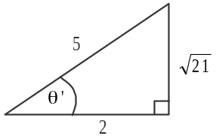

So 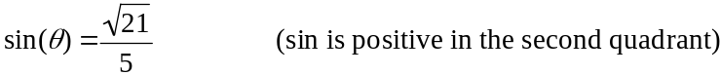
The answer is C.

Question 17

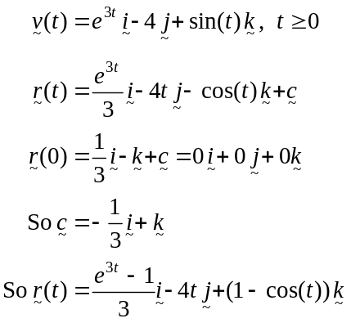
The answer is D.

Question 18

Draw in the forces.
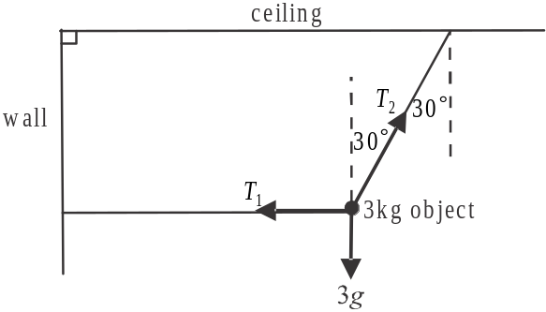
Find .
Resolving horizontally:
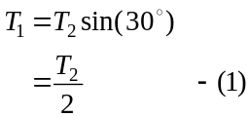
Resolving vertically:
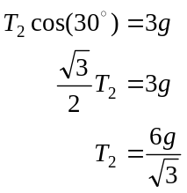
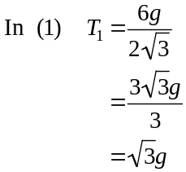

The answer is D.

Question 19

Since , the 3m kg particle will
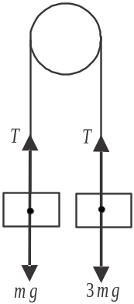
accelerate downwards and so the m kg
particle will accelerate upwards.

For the 3m kg particle,
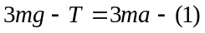

For the m kg particle,
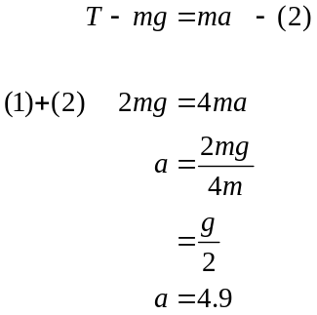

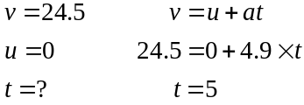
The answer is E.
Question 20

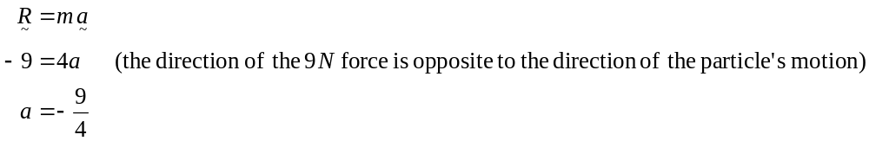
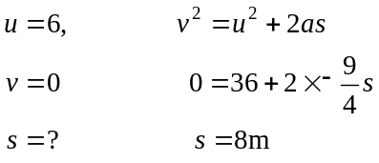
The answer is A.

Question 21

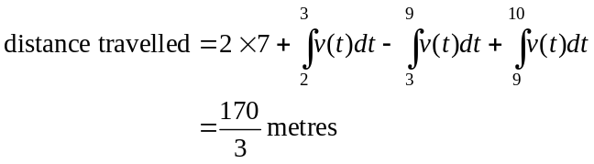
The answer is D.

Question 22

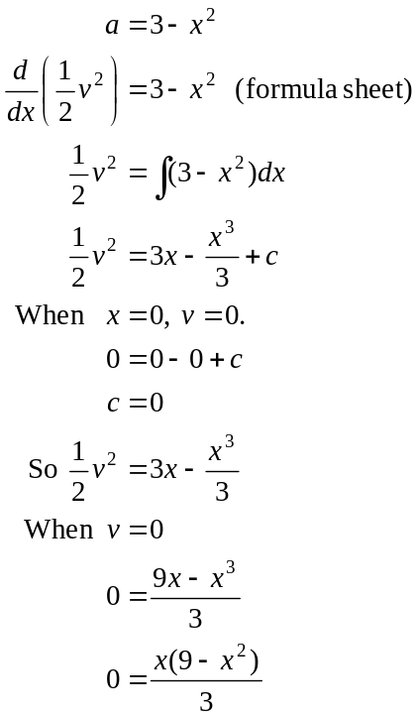
The particle will also be at rest where .

The answer is E.

SECTION 2

Question 1 (11 marks)

- 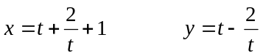
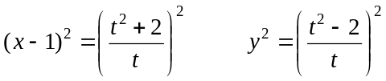
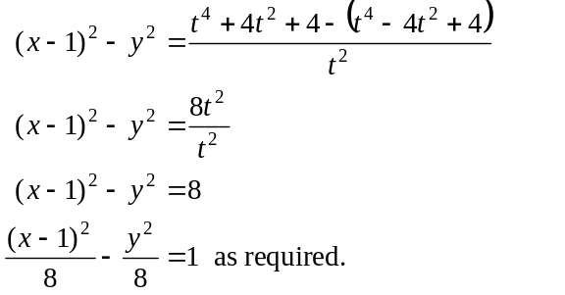
(1 mark)
(1 mark)

- 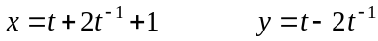
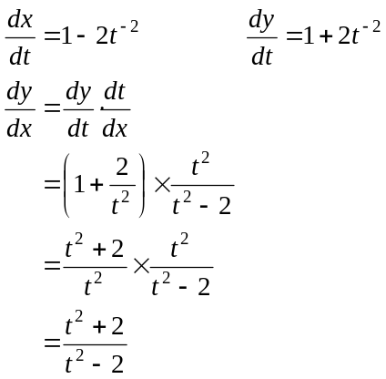
(1 mark)
(1 mark)
When 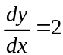,
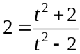
Method 1 - solve for t using CAS
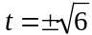
(1 mark)
Method 2 – solve for t by hand
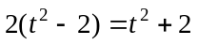
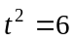
(1 mark)

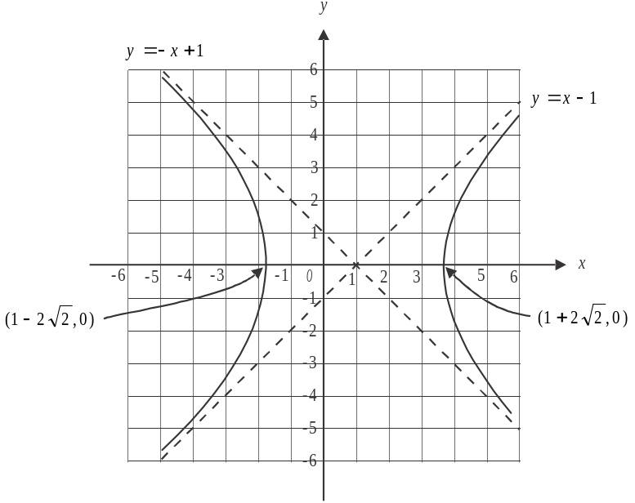

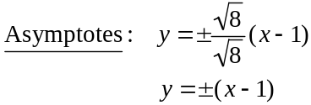
x-intercepts occur when 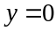
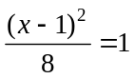
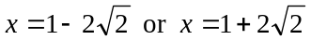
(1 mark) – correct asymptotes
(1 mark) – correct x-intercepts
(1 mark) – correct shape

- 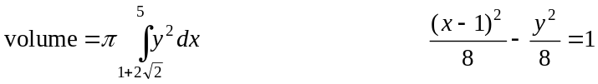
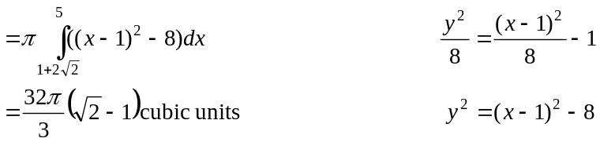

(1 mark) – correct integrand
(1 mark) – correct terminals
(1 mark) – correct answer

Question 2 (13 marks)

- 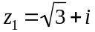
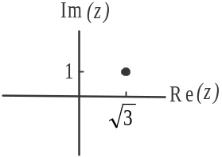
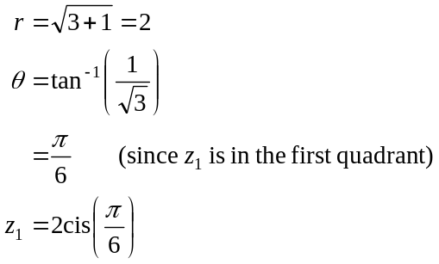
(1 mark) – correct modulus
(1 mark) – correct argument

- 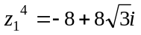
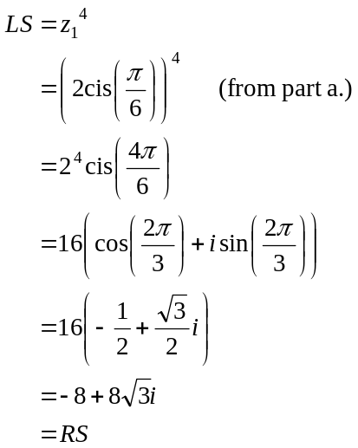
So 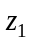 satisfies the equation. (1 mark)
- 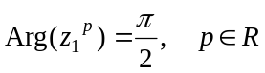
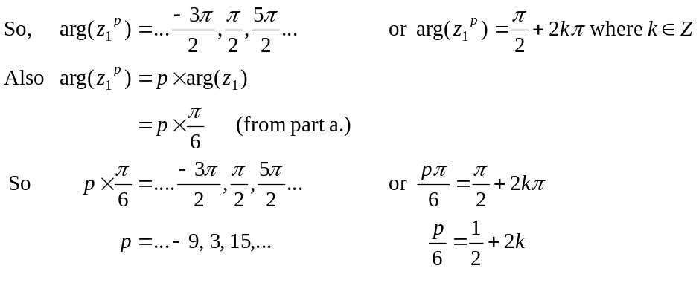
(1 mark)
(1 mark)
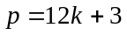
d. i. 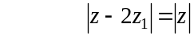
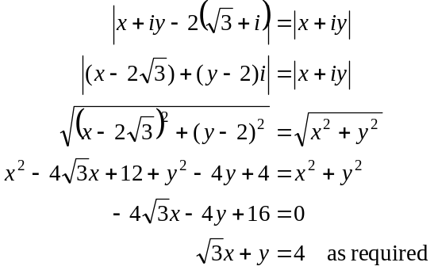
(1 mark)
(1 mark)
- Method 1
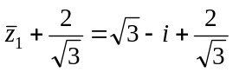
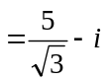
So 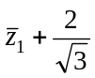 corresponds to the point 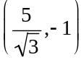 on the Cartesian plane.
(1 mark)
From part i., the Cartesian equation of the relation 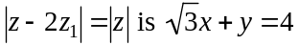.
Substituting the point into this relation gives
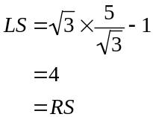
(1 mark)

Method 2
To Show 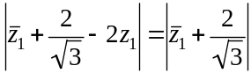
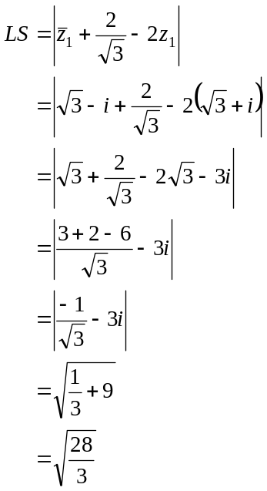
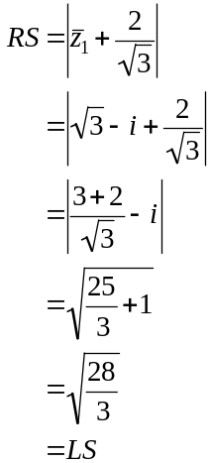
(1 mark) (1 mark)
e. i.
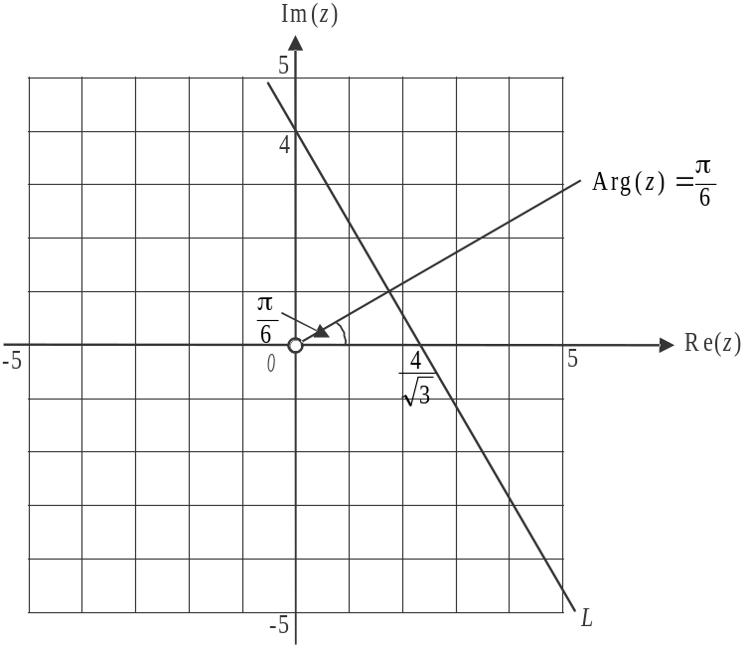

(1 mark) for L including axes intercepts
(1 mark) for 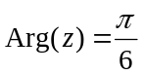 including excluded origin
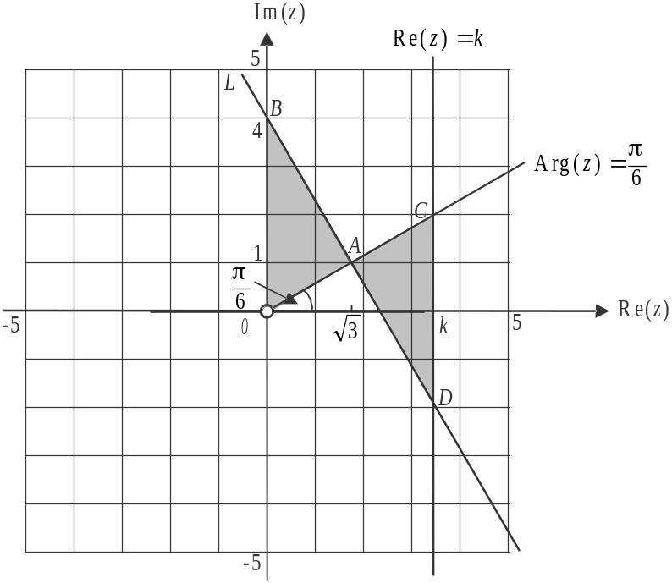

Start by finding the point of intersection of L and .
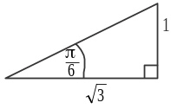
can be expressed in Cartesian form as 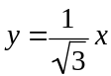.
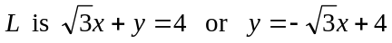
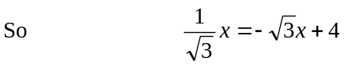
Solve using CAS, 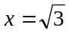 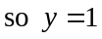.
A is the point 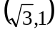. (1 mark)
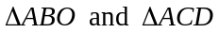 are similar because 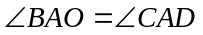 (vertically opposite angles), 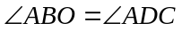(alternate angles) and 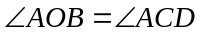(alternate angles). They will be congruent, and therefore have the same area, when 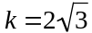.
(1 mark)

Question 3 (12 marks)

- 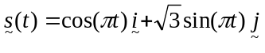
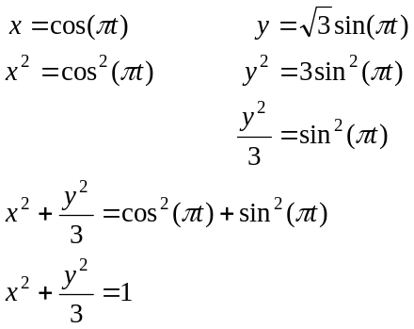
(1 mark)
(1 mark)
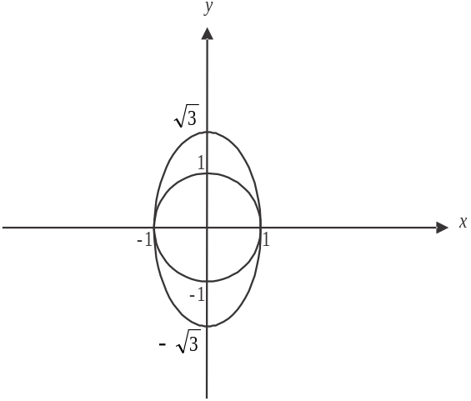

(1 mark) – correct axes intercepts
(1 mark) – correct shape
- 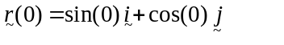
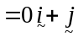
For drone R, the starting position is 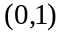. (1 mark)

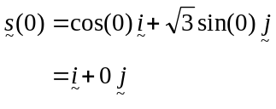
For drone S, the starting position is 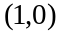. (1 mark)

- For the drones to meet,
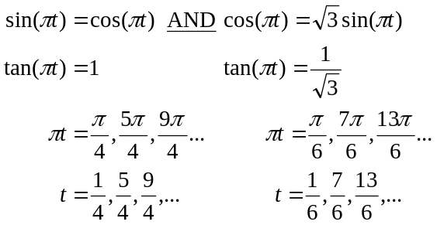
(1 mark)
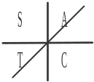
Since the displacement components are not equal at the same time, the drones never meet.
(1 mark)
- 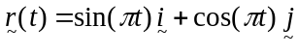
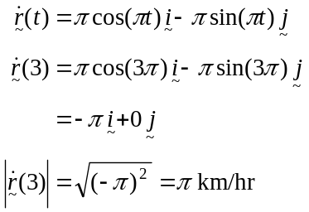
(1 mark)

- 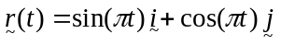
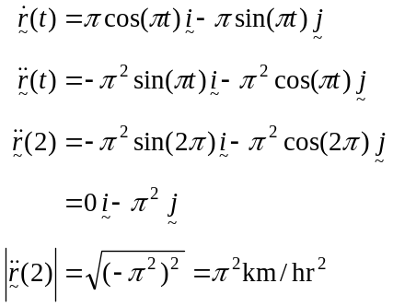
(1 mark)

- 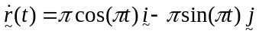
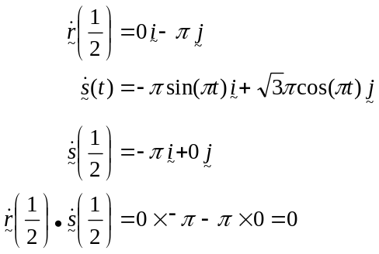
(1 mark)
(1 mark)
Since 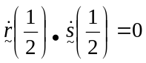, the drones must be travelling in directions that are perpendicular to each other.
Question 4 (10 marks)

- When 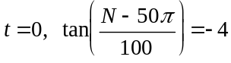
Solve for N using CAS
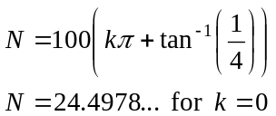
The number of pre-sold apartments is 24 (to the nearest integer).
(1 mark)

- As 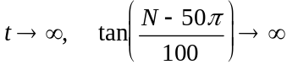
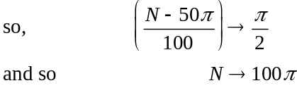
The limiting number is 314 (to the nearest integer).
(1 mark)

- Differentiate the equation
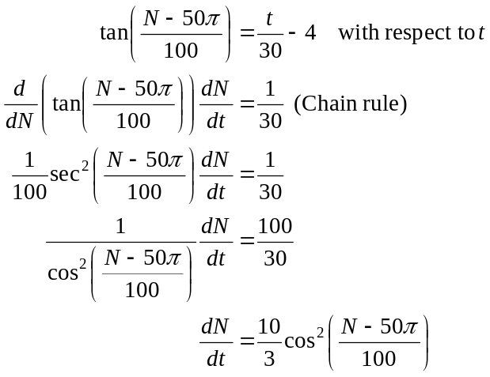
(1 mark)

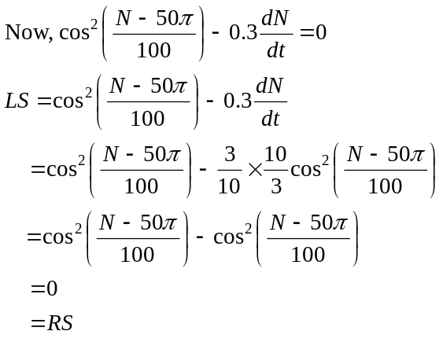
(1 mark)

- Method 1 – using the given expression
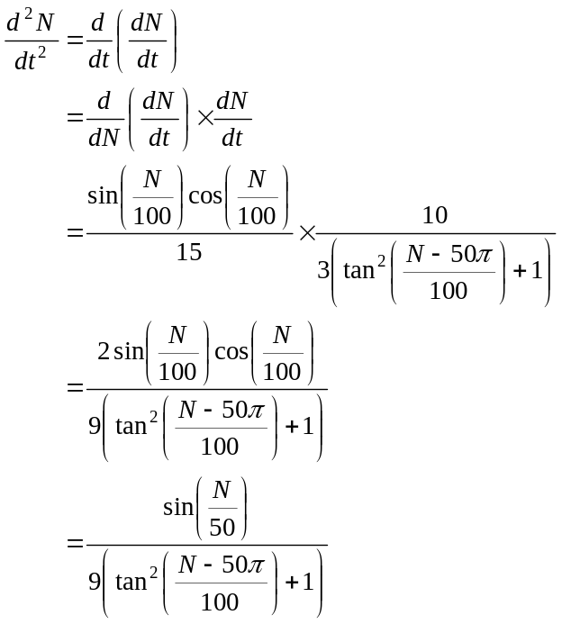
(1 mark)
We are told that the graph has a point of inflection so this occurs when 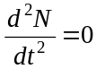.
Solve 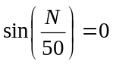 for N.
(1 mark)
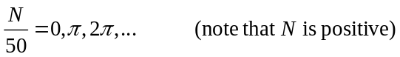
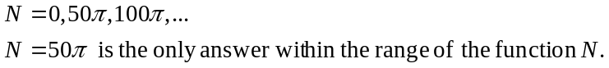

So
Substitute this into
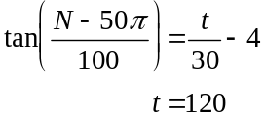
So 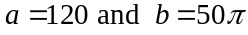
(1 mark) for a
(1 mark) for b

Method 2 – otherwise
From part c., 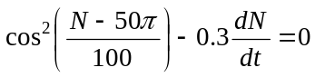
So 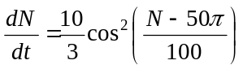
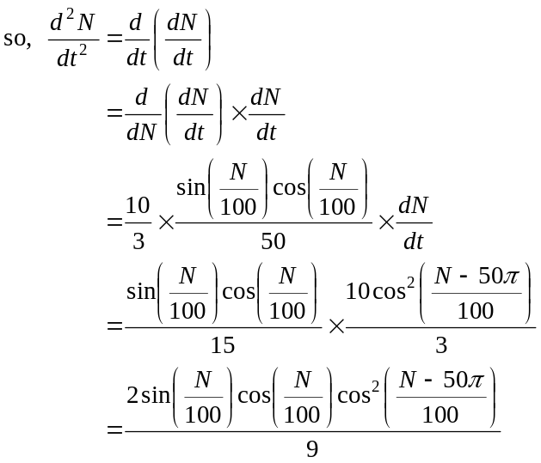
(1 mark)
We are told that the graph has a point of inflection. This occurs when .
Solve 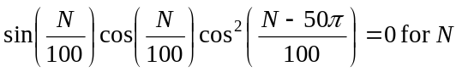 (1 mark)
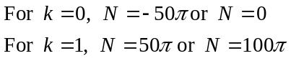
Substitute into 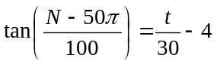, so 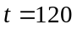.
So as required.
(1 mark) for a
(1 mark) for b
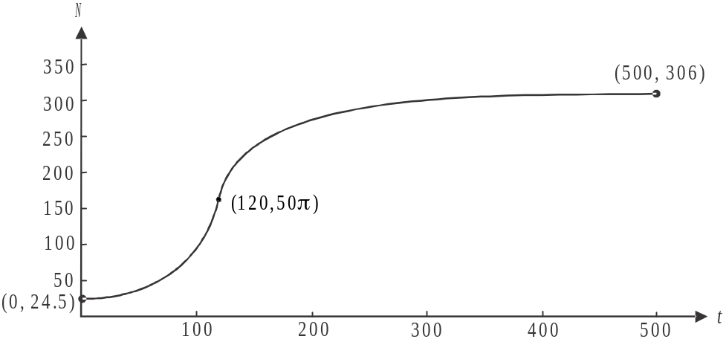

(1 mark) – correct endpoints i.e. 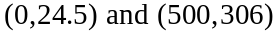
(1 mark) – correct shape including point of inflection located at 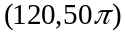
Question 5 (12 marks)

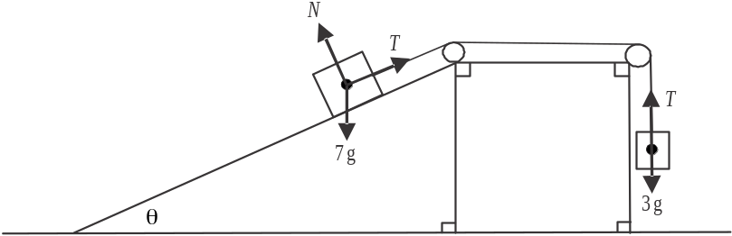

- Around the 7kg mass:
(1 mark)

- Around the 3kg mass:
(1 mark)
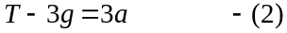

- (1) gives 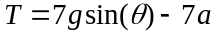
(2) gives 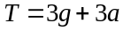
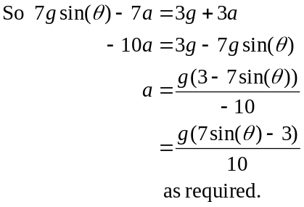
(1 mark)

- If the system is in equilibrium then .
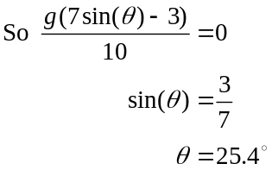
(correct to 1 decimal place)
(1 mark)

- When the 2kg mass is moving vertically upwards, .
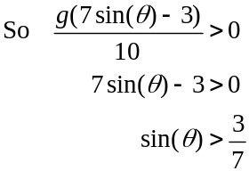
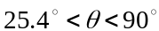
(1 mark)

- Around the 7kg mass:
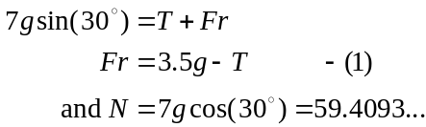
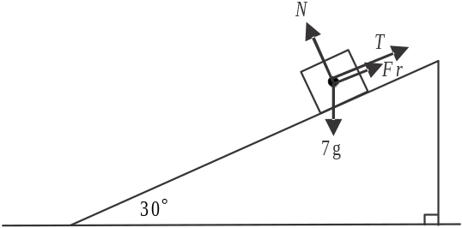

Around the 3kg mass:
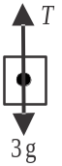
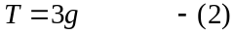
In (1) gives 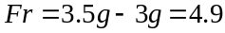 (1 mark)

If the 7kg mass is on the point of moving
then 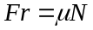.
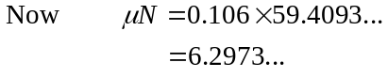
Since 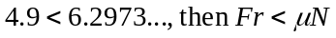 and the mass is not at the point of moving.
(1 mark)
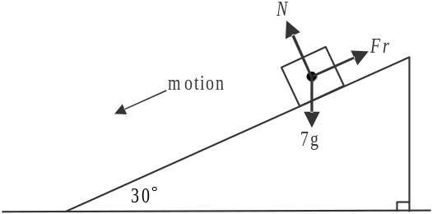
- i. 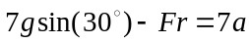
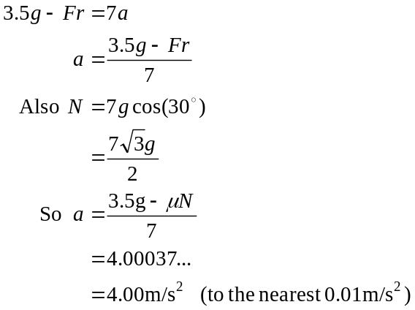
(1 mark)
(1 mark)
- 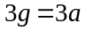

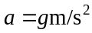
The 3kg mass is subject only to gravitational
force so its acceleration is 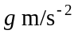 or 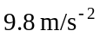.
(1 mark)
- Both masses are travelling with constant acceleration.
So, using 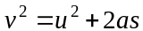
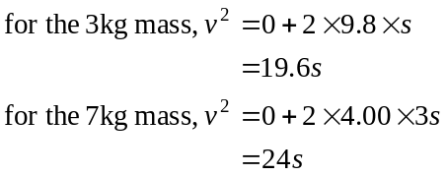 (1 mark)
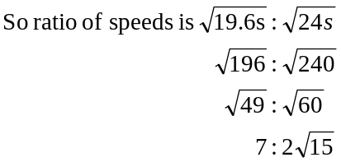
(1 mark)

