
SPECIALIST MATHS 3 & 4
TRIAL EXAMINATION 1
SOLUTIONS
2018

Question 1 (2 marks)

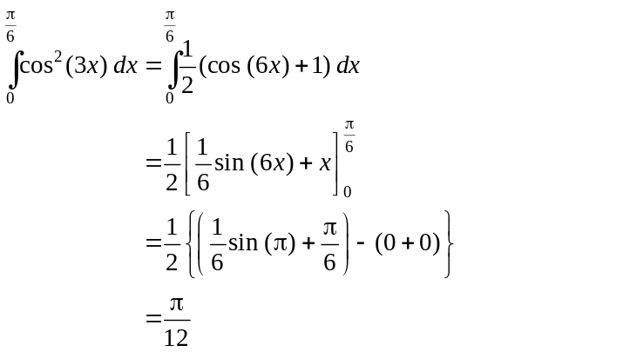
(1 mark)
(1 mark)
Question 2 (3 marks)

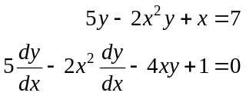
(1 mark)
Method 1 Method 2
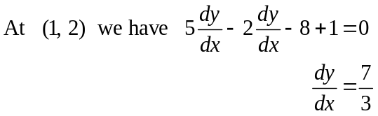 (1 mark)
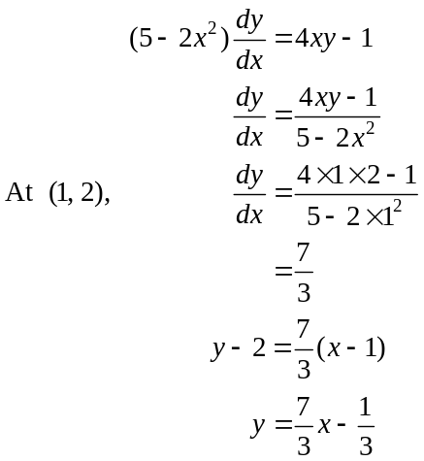
(1 mark)
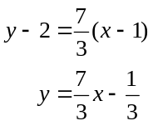
(1 mark)
(1 mark)
Question 3 (3 marks)

Let X be the random variable representing the weight, in grams, of eggs produced at this farm.

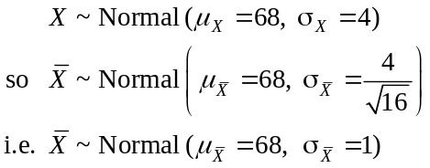
(1 mark)
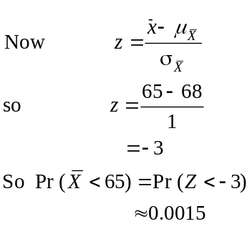 (1 mark)
(1 mark)

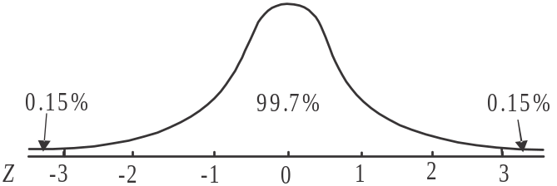

Question 4 (3 marks)

Since is a solution then is also a solution (conjugate root theorem applies because the coefficients of the terms in the equation are real).

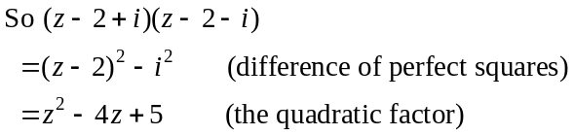
(1 mark)
Comparing the coefficients of the z-squared terms, we have
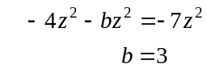
(1 mark)
Comparing the coefficients of the constant terms, we have
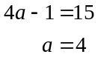

(1 mark)
Question 5 (5 marks)

- 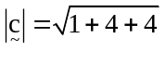
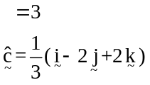
(1 mark)

- vector resolute of perpendicular to is given by
(1 mark)
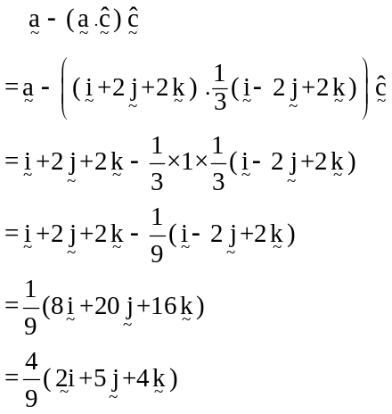
(1 mark)

- If 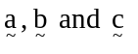 are linearly dependent then 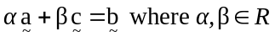.
We require 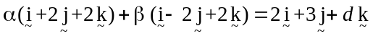
Equating the components:
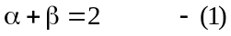
Equating the components:
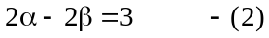
Equating the components:
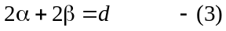 (1 mark)

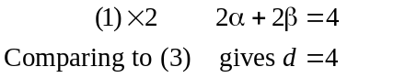
(1 mark)

Question 6 (4 marks)

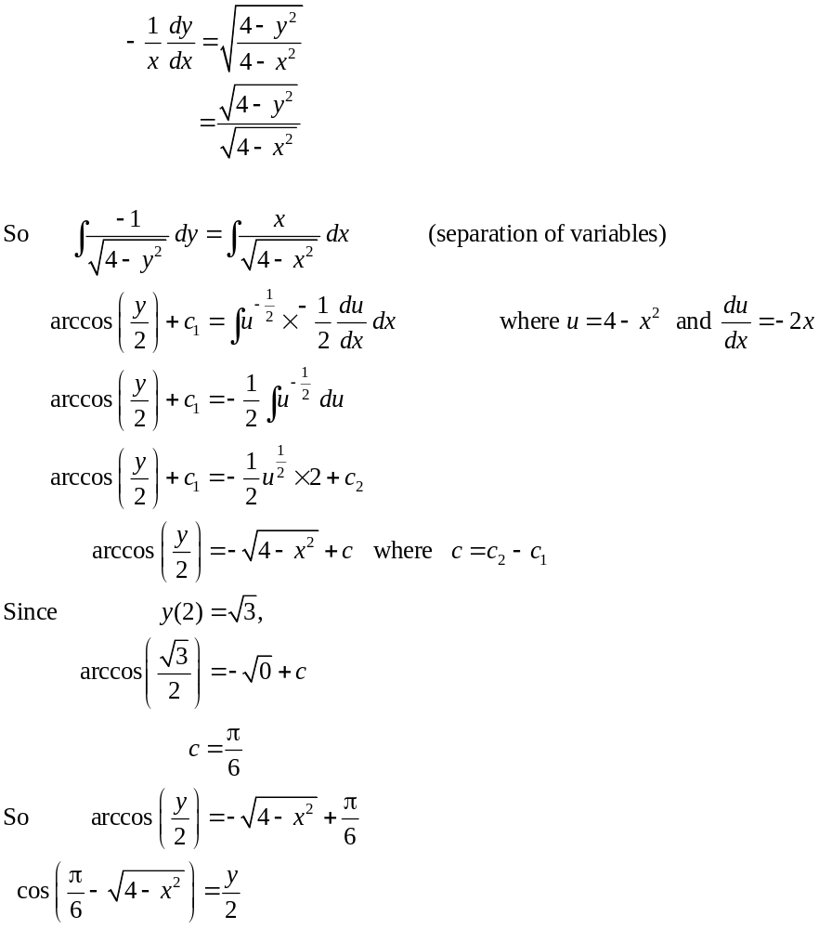
(1 mark)
(1 mark)
(1 mark)
The solution is 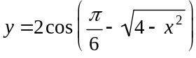.
(1 mark)

Question 7 (3 marks)

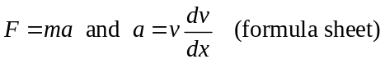
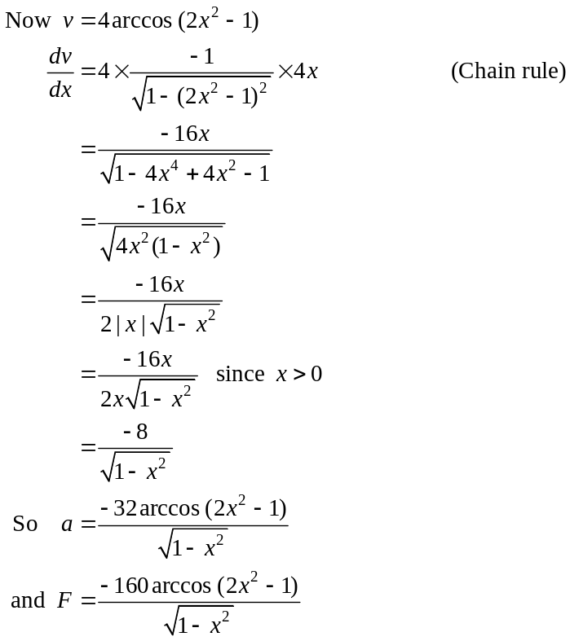
(1 mark)
(1 mark)
(1 mark)
Question 8 (5 marks)
- Do a quick sketch.
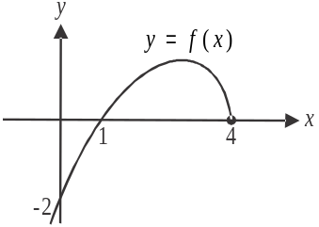
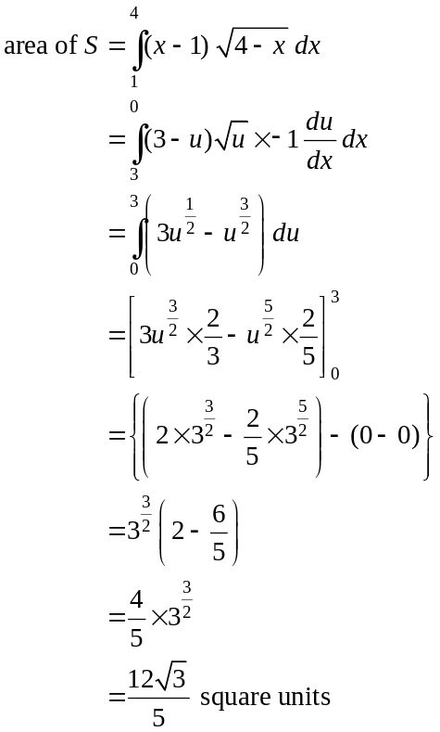
(1 mark)
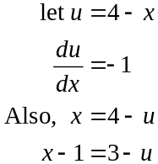
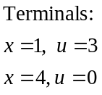
(1 mark)
(1 mark)
b.
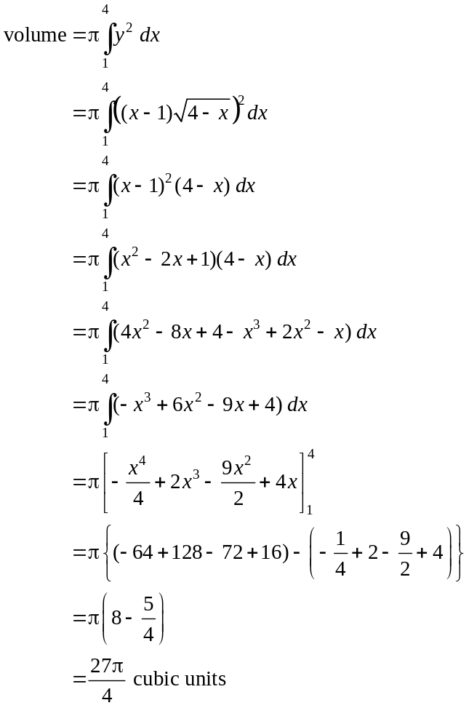

(1 mark)

(1 mark)

Question 9 (4 marks)

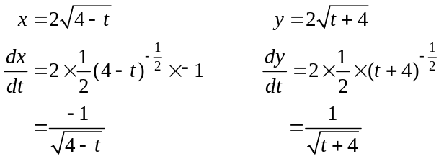
(1 mark)
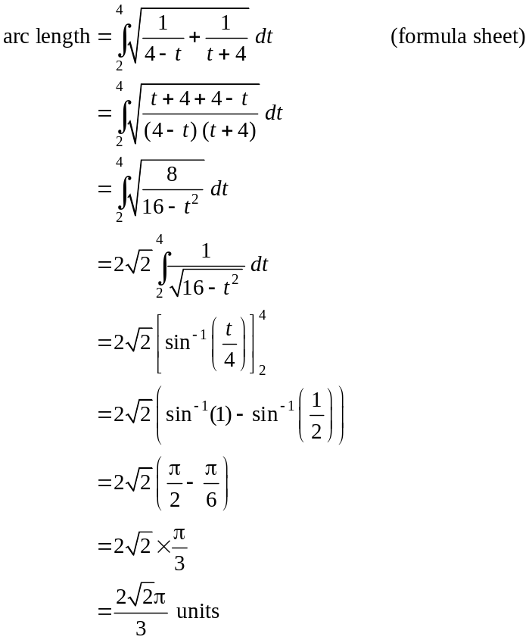
(1 mark)
(1 mark)
(1 mark)
Question 10 (8 marks)
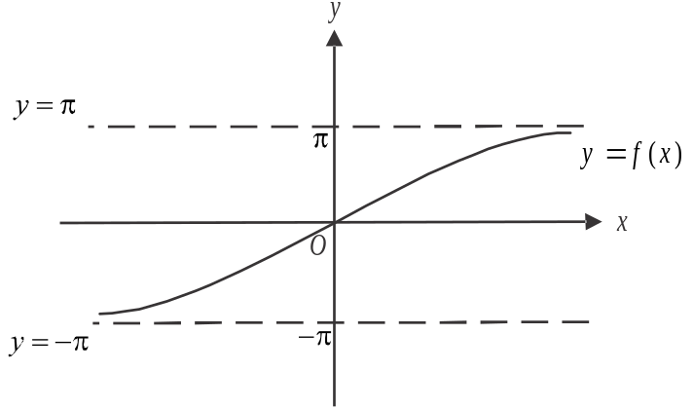

(1 mark) – correct asymptotes
(1 mark) – correct shape

- 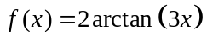
Let 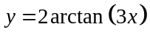
Swap x and y for inverse.
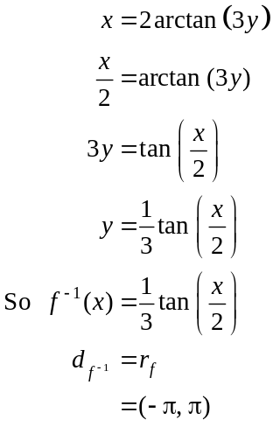
(1 mark)
(1 mark)

c.
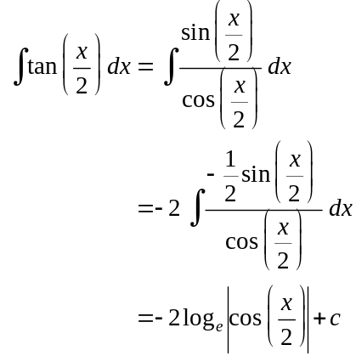

(1 mark)
d. Do a quick sketch of the graph of 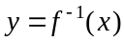 and compare it to the graph drawn in part a. part a.

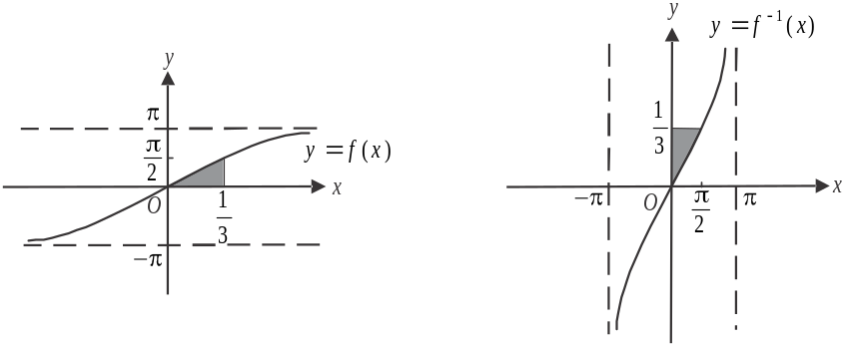

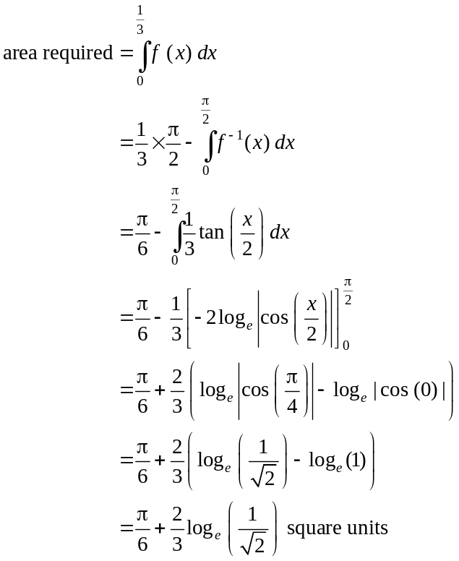
(1 mark)
(1 mark)
(using the symmetry of the graphs of 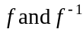)
(1 mark)

