

Student Name:………………………………………

SPECIALIST MATHEMATICS UNITS 3 & 4

TRIAL EXAMINATION 2

2018

Reading Time: 15 minutes
Writing time: 2 hours

Instructions to students
This exam consists of Section A and Section B.
Section A consists of 20 multiple-choice questions and should be answered on the detachable answer sheet which can be found on page 26 of this exam.
Section B consists of 6 extended-answer questions.
Section A begins on page 2 of this exam and is worth 20 marks.
Section B begins on page 10 of this exam and is worth 60 marks.
There is a total of 80 marks available.
All questions in Section A and B should be answered.
In Section B, where more than one mark is allocated to a question, appropriate working must be shown.
An exact value is required to a question unless otherwise directed.
Unless otherwise stated, diagrams in this exam are not drawn to scale.
The acceleration due to gravity should be taken to have magnitude 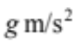where 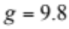
Students may bring one bound reference into the exam.
Students may bring into the exam one approved technology (calculator or software) and, if desired, one scientific calculator. Calculator memory does not need to be cleared. For approved computer-based CAS, full functionality may be used.
A formula sheet can be found on pages 23 - 25 of this exam.

This paper has been prepared independently of the Victorian Curriculum and Assessment Authority to provide additional exam preparation for students. Although references have been reproduced with permission of the Victorian Curriculum and Assessment Authority, the publication is in no way connected with or endorsed by the Victorian Curriculum and Assessment Authority.

© THE HEFFERNAN GROUP 2018
This Trial Exam is licensed on a non transferable basis to the purchasing school. It may be copied by the school which has purchased it. This license does not permit distribution or copying of this Trial Exam by any other party.
SECTION A – Multiple-choice questions

Question 1

The graph of 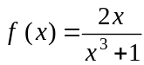 has asymptotes given by

- only
- only
- only
- 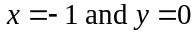 only
- 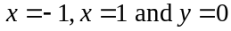 only.

Question 2

The solutions to 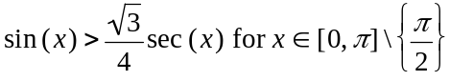 are

- 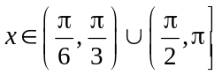
- 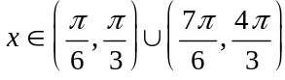
- 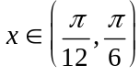
- 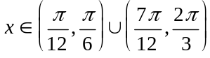
- 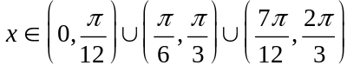

Question 3

The implied domain of 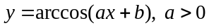, is

- 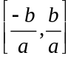

- 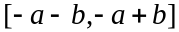

- 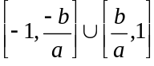

- 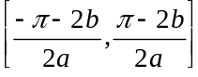

- 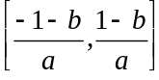

Question 4

If A, B, C and D are non-zero integers, then the expression 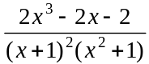 can be written in partial fraction form as

- 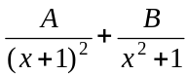
- 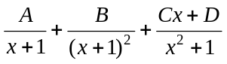
- 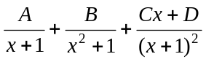
- 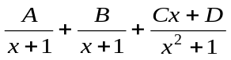
- 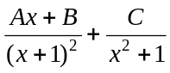

Question 5

In the complex plane, the point lies on the graph of the relation

- 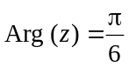
- 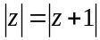
- 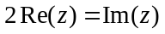
- 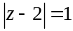
- 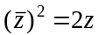

Question 6

The equation 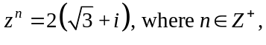 has solutions given by

- 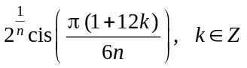
- 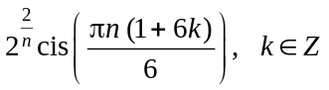
- 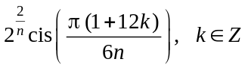
- 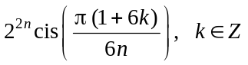
- 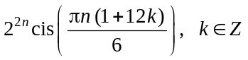

Question 7

One of the solutions to the equation .
One of the other solutions to this equation lies on the graph of 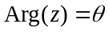 on the complex plane.
The value of could be

- 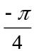
- 0
- 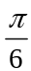

Question 8

Using a suitable substitution, 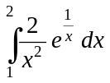 can be written as

- 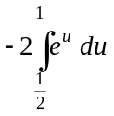
- 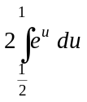
- 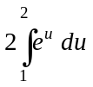
- 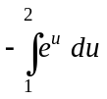
- 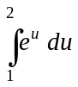

Question 9

Let 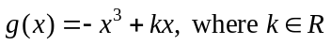.
The gradient of g will always be strictly decreasing for

- 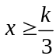
- 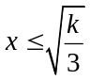
Question 10

Let 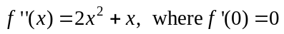.

The graph of f will have

- a stationary point of inflection at 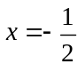.
- a local minimum at and two points of inflection one at 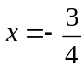 and one at .
- a local minimum at and a stationary point of inflection at .
- a local minimum at and two stationary points of inflection, one at and one at .
- a local minimum at , a point of inflection at and a stationary point of inflection at .

Question 11

A slope field representing the differential equation for 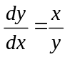 is shown below.
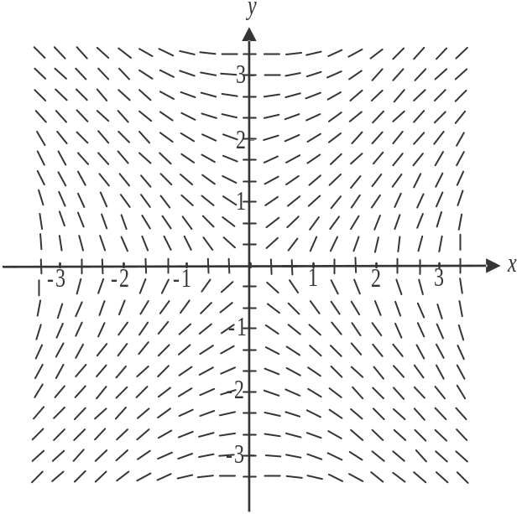

A solution curve of the differential equation is to be drawn corresponding to the condition 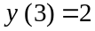. The value of x when 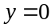 for this solution curve could be

- 1.8
- 2
- 2.2
- 2.8
- 3
Question 12

The velocity-time graph for the first six seconds of motion of a body that is moving in a straight line is shown below.

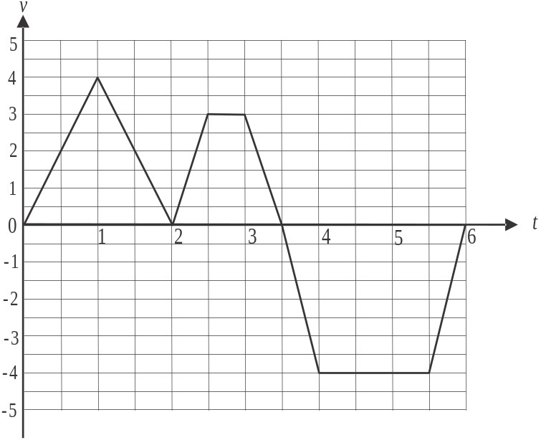

The body will first return to its initial position when

Question 13

The position vectors of points A, B and C are given respectively by 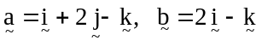 and 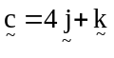.
The cosine of angle ABC is equal to

- 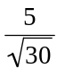
- 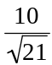
- 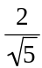
- 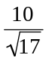
- 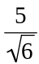
Question 14

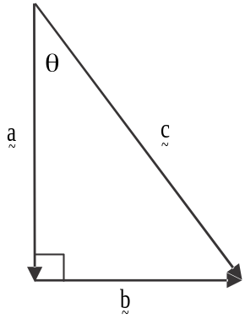

The vectors 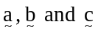 form the sides of the right-angled triangle shown above.
Which one of the following statements is not true?

- 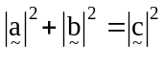
- 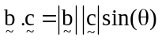
- 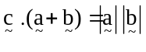
- 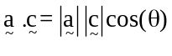
- 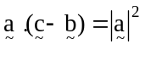

Question 15

Two forces of 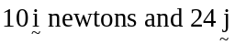 newtons are the only forces acting on a body of mass
2 kg.
The magnitude of the body’s acceleration, in ms⁻², is

- 7.5
- 13
- 26
- 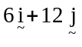
- 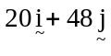
Question 16

A box of mass m kg is dragged across a rough horizontal surface by a force of 65 N acting at an angle of 60° to the horizontal.
The motion is opposed by a friction force of 10 N.
Given that the box accelerates at 2.5 ms⁻², the value of m is

- 5
- 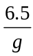
- 9
- 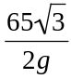
- 17

Question 17

Particles of mass m kg and n kg, where , are attached to a light inextensible string that passes over a smooth pulley as shown below.

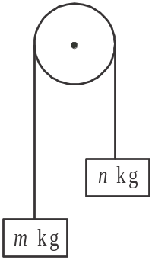

The acceleration of the m kg particle is 2.45 ms⁻². The relationship between m and n is given by

- 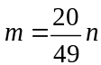
- 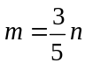
- 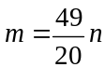
- 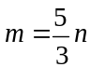

Question 18

Researchers conducted a one-sided statistical test at the 5% level of significance and in their conclusion they made a Type I error.
This means they

- rejected 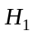 when was true
- rejected 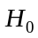 when was true
- accepted when was true
- accepted when was false
- accepted when was true

Question 19

Using a sample mean, a confidence interval is calculated in order to estimate the population mean .
If the sample size were to be quadrupled, the width of the confidence interval would be

- decreased by a factor of 2
- decreased by a factor of 4
- unchanged
- increased by a factor of 2
- increased by a factor of 4

Question 20

The independent random variables S and T are normally distributed where S has a mean of 15 and a standard deviation of 4 and T has a mean of 10 and a standard deviation of 2. The random variable R is defined by .
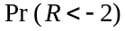 can be expressed in terms of the standard normal variable Z, as

- 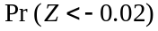
- 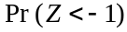
- 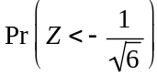
- 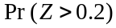
- 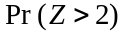
SECTION B

Question 1 (10 marks)

- Use a double angle formula to show that 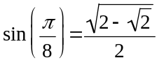.
Give a reason why any values are rejected. 2 marks

Let 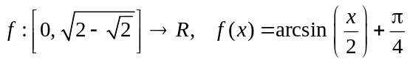.

- Show that 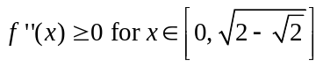. 2 marks

- Hence sketch the graph of f on the set of axes below. Label the endpoints with their coordinates. 3 marks
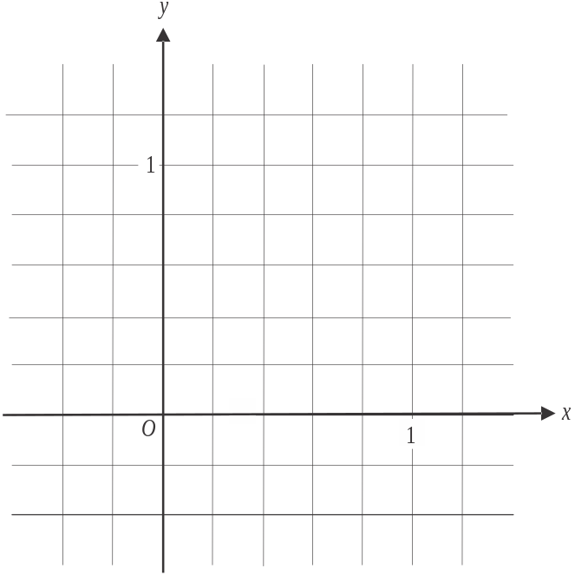

- The region between the graph of f and the y-axis is rotated about the y-axis
to form a solid of revolution.

- Write down a definite integral in terms of the variable y, that gives the volume of this solid of revolution. 2 marks

  - Find the volume of this solid of revolution. Express your answer correct to three decimal places. 1 mark

Question 2 (12 marks)

A tourist ferry and a ship are observed from the harbour master’s office at origin O.
The position vectors of each, t hours after they leave the pier, are given respectively by
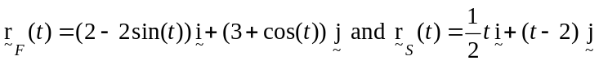 for , where the distances are measured in kilometres.
The two vessels leave the pier at the same time.
The path of the ferry is shown on the graph below.
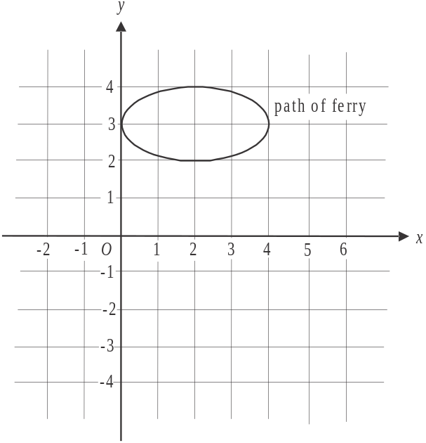

- On the diagram above, sketch the path of the ship. Show clearly its starting position and the direction in which it moves. 2 marks

- Show that the ferry and the ship do not collide. Clearly state your reason. 2 marks

c. When , find the obtuse angle between the path of the ferry and the ship.
Give your answer in degrees, correct to one decimal place. 2 marks

d. Find an expression, in terms of t, for the distance between the ferry and the ship. 1 mark

e. Find the minimum distance, in kilometres, between the ferry and the ship and the valu value of t when this occurs. Give both answers correct to one decimal place. 2 marks

f. The ship first crosses the path of the ferry at . How many hours later does it a again cross the path of the ferry? 3 marks

Question 3 (10 marks)

- Express 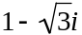 in polar form. 1 mark

- Find the equation of the line that is the perpendicular bisector of the line joining the origin and the point . Express your answer in the form . 2 marks

- Show that the point 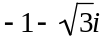 lies on the perpendicular bisector found in part b. 1 mark

d. Plot and label the complex numbers 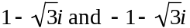 on the Argand diagram below. below. 1 mark
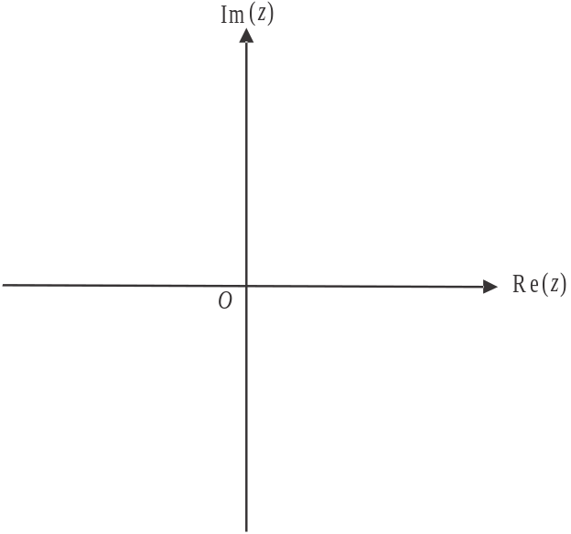

e. The two points plotted in part d. together with the origin, lie on a circle.
Find the equation of the circle expressed in the form 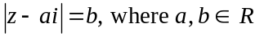. 3 marks

- Find the area of the minor segment bounded by the line 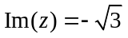 and the minor arc of the circle found in part e.. 2 marks

Question 4 (10 marks)

A 3 kg mass and a 4 kg mass sit on a smooth plane inclined at an angle of 30° to the horizontal. They are connected by a light inextensible string.
The 4 kg mass is also connected by a light inextensible string that passes over a smooth pulley to a 10 kg mass as shown below.
The forces acting on the 3 kg mass include a pulling force of P Newtons which acts parallel to the plane and down the plane.
The tension in the string connecting the 3 kg and 4 kg masses is newtons.
The tension in the string connecting the 4 kg and 10 kg masses is 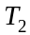 newtons.
The system is released from rest and the 3 kg and 4 kg masses accelerate down the plane at 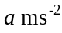.
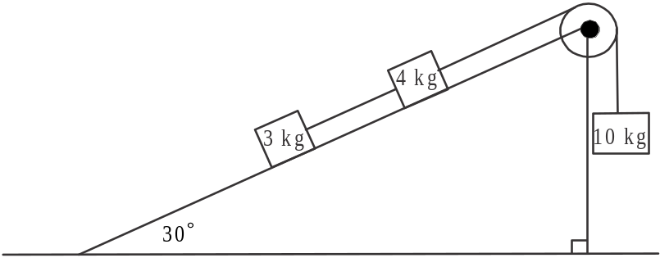

- Write down an equation of motion, in the direction of motion, for the

- 10 kg mass. 1 mark

- 4 kg mass. 1 mark

- 3 kg mass. 1 mark

- Show that the acceleration of the 3 kg mass down the plane is 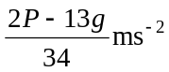 1 mark

- The pulling force P has been set at 15g Newtons.
Find in terms of g, the momentum of the 3 kg mass down the plane, in kg ms⁻¹, two seconds after the system is released from rest. 2 marks

- The pulling force P is reduced so that the system is in equilibrium.
Find the value of P. 1 mark

The pulling force P is now removed completely and the system is released from rest. As a result, the 3 kg and 4 kg masses accelerate up the plane.
Subsequently, the 10 kg mass hits the ground with a velocity of 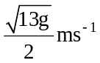.

- How far above the ground, in metres, was the 10 kg mass when the system was released? 3 marks

Question 5 (9 marks)

A free to air television station runs an advertising campaign to promote its evening news bulletin.
The differential equation 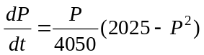 models the relationship between P, the percentage of evening news bulletin viewers (across all free to air stations) who watch this station’s news bulletin and t, the time in weeks after the advertising campaign begins.

- Show that 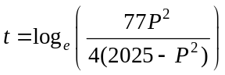 given that . 3 marks

  - Find the limiting value of P, that is, the percentage of evening news bulletin viewers who eventually watch this station’s news bulletin. 2 marks

- Write down a definite integral which, when evaluated, gives the total time taken in weeks after the advertising campaign begins for the television station to have 35% of all free to air evening news bulletin viewers watching their news bulletin. 2 marks

- Use Euler’s method with a step size of 0.5 to estimate the value of P when , given that .
Give your answer correct to two decimal places. 2 marks

Question 6 (9 marks)

A government service provider has offices nationwide. The waiting time for clients attending these offices is published annually and is claimed to be normally distributed with a mean of 23 minutes and a standard deviation of 4 minutes.
As part of a review of services, a random sample of 50 clients is taken and the sample mean is found to be 25 minutes.

- A one-sided test is used to test whether the waiting time is actually greater than the published time claimed by the government.
Write down the two hypotheses that would be used for this test. 1 mark

- Find the p value for this test. Give your answer correct to four decimal places. 2 marks

- State with a reason whether this sample supports the view that the waiting times are greater than those published. Test at the 5% level of significance. 1 mark

As a follow up, a sample of n clients is taken and the sample mean is found again to be 25 minutes.
A one-sided statistical test, again at the 5% level of significance, is performed on this second sample.

- Find the minimum value of n for which the results of this test would support the view that the waiting times are greater than those published. 3 marks

Another government service provider operates a phone helpline. The waiting time for a client using this helpline is normally distributed with a mean of 6 minutes and a standard deviation of 1.5 minutes.
Groups made up of 20 randomly selected clients who use the helpline are regularly surveyed.

- Find the mean and standard deviation of the total waiting time of clients in one such group. 2 marks

Specialist Mathematics Formulas

Mensuration

area of a trapezium | 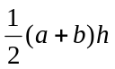
curved surface area of a cylinder | 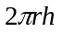
volume of a cylinder | 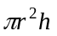
volume of a cone | 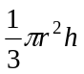
volume of a pyramid | 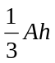
volume of a sphere | 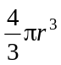
area of a triangle | 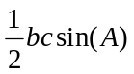
sine rule | 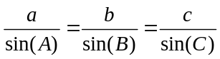
cosine rule | 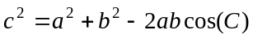

Circular functions

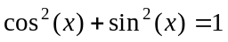
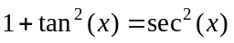 | 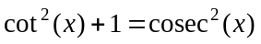
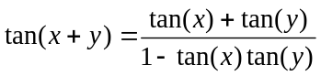 | 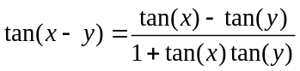
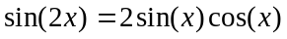 | 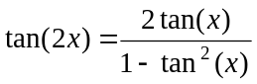

Mathematics Formula Sheets reproduced by permission; © VCAA 2017. The VCAA does not endorse or make any warranties regarding this study resource. Current and past VCAA VCE® exams and related content can be accessed directly at www.vcaa.vic.edu.au

Circular functions – continued

Function | 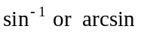 | 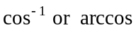 | 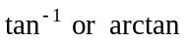
Domain | 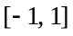
Range | 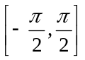 | 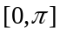 | 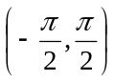

Algebra (complex numbers)

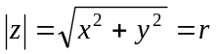 | 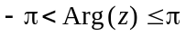
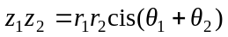 | 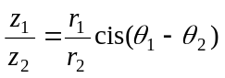
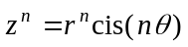 (de Moivre’s theorem)

Probability and statistics

for random variables X and Y | 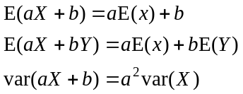
for independent random variables X and Y | 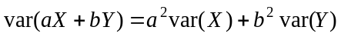
approximate confidence interval for | 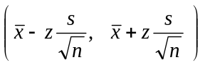
distribution of sample mean 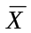 | 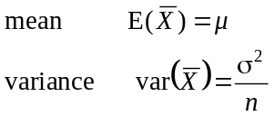

Calculus
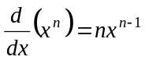 | 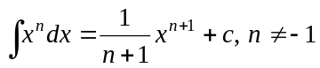
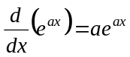 | 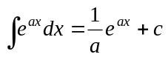
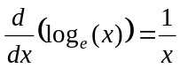 | 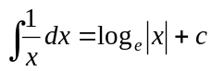
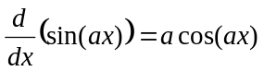 | 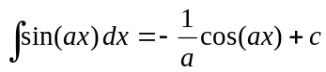
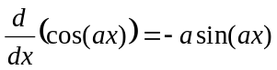 | 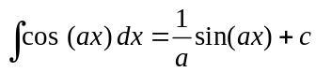
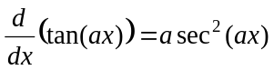 | 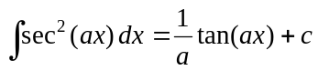
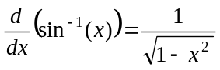 | 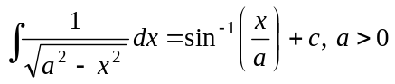
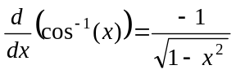 | 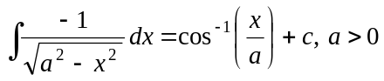
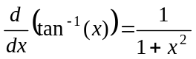 | 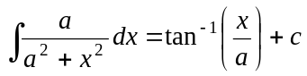
 | 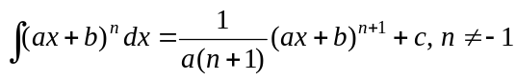
 | 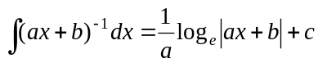
product rule | 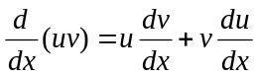
quotient rule | 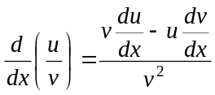
chain rule | 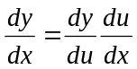
Euler’s method | 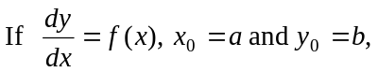
acceleration | 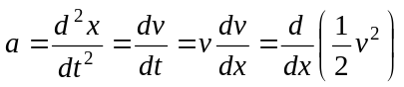
arc length | 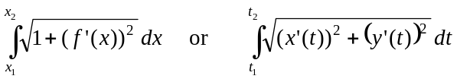

Vectors in two and three dimensions Mechanics
momentum | 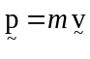
equation of motion | 