

Student Name……………………………………

MATHEMATICAL METHODS UNITS 3 & 4

TRIAL EXAMINATION 1

2007

Reading Time: 15 minutes
Writing time: 1 hour

Instructions to students
This exam consists of 11 questions.
All questions should be answered in the spaces provided.
There is a total of 40 marks available.
The marks allocated to each of the questions are indicated throughout.
Students may not bring any calculators or notes into the exam.
Where an exact answer is required a decimal approximation will not be accepted.
Where more than one mark is allocated to a question, appropriate working must be shown.
Diagrams in this trial exam are not drawn to scale.
A formula sheet can be found on page 12 of this exam.

This paper has been prepared independently of the Victorian Curriculum and Assessment Authority to provide additional exam preparation for students. Although references have been reproduced with permission of the Victorian Curriculum and Assessment Authority, the publication is in no way connected with or endorsed by the Victorian Curriculum and Assessment Authority.

© THE HEFFERNAN GROUP 2007
This Trial Exam is licensed on a non transferable basis to the purchaser. It may be copied for educational use within the school which has purchased it. This license does not permit distribution or copying of this Trial Exam outside that school or by any individual purchaser.
Question 1

Write down the maximal domain of the function 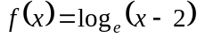.

1 mark

Question 2

Let 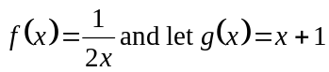.

- Explain whether or not 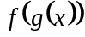 exists.

1 mark

- Find
  - the rule for 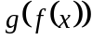

  - the domain of

Question 3

For the function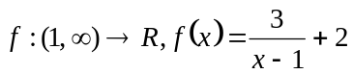,

- find the rule of the inverse function 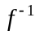.

2 marks

- find the domain of the inverse function .

1 mark

Question 4

- If 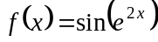, find 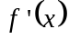.

2 marks

- Find 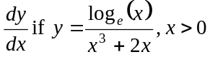

2 marks

Question 5

For the function 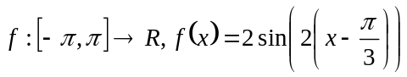

Sketch the graph of the function f on the set of axes below.
Label axes intercepts as well as endpoints with their coordinates.

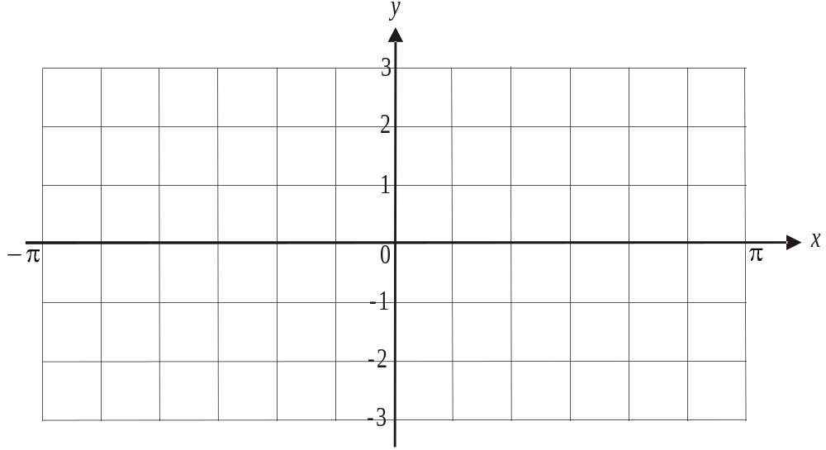

5 marks

Question 6

Let X be a random variable with a normal distribution with a mean of 7 and a standard deviation of 2. Let Z be a random variable with the standard normal distribution and 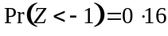.

- Find 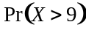.

1 mark

- Find the probability that 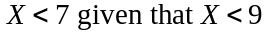. Express your answer as a fraction with whole numbers in the numerator and denominator.

3 marks

Question 7

The probability density function of a continuous random variable X is given by

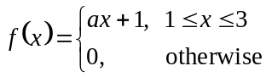

where a is a constant.

- Show that 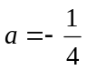.

2 marks

- Find 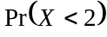.

2 marks

Question 8

The graph of is shown below.
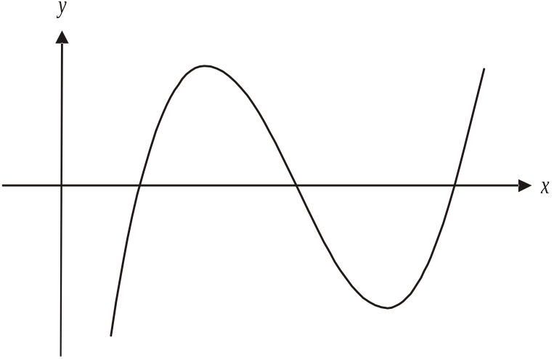

- Sketch the graph of 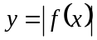 on the same set of axes.

1 mark

- Let the area of the region enclosed by the graph of and the x-axis be A.
Write down an expression for A involving definite integrals in terms of 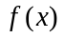.
Do not evaluate A.

1 mark

Question 9

The shaded right-angled triangle in the diagram below has one vertex at 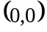, a second at the point 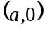 and a third at the point 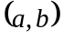 which lies on the line with equation 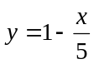.
The coordinates a and b are positive, real numbers.

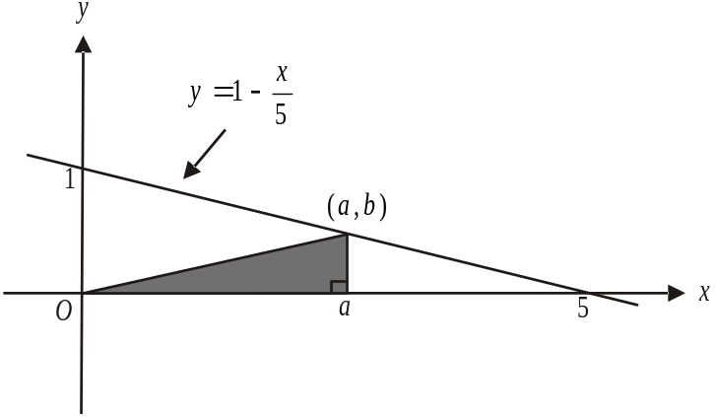

- Show that the area of the shaded triangle can be expressed as 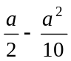.

1 mark

- Find the maximum area of the shaded triangle as well as the value of a for which this maximum occurs.

3 marks
Question 10

The graph of 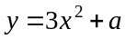; where a is a real constant, has a normal with equation 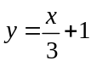.
Find the value of a.

4 marks

Question 11

The graphs with equations 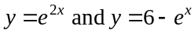 are shown below.

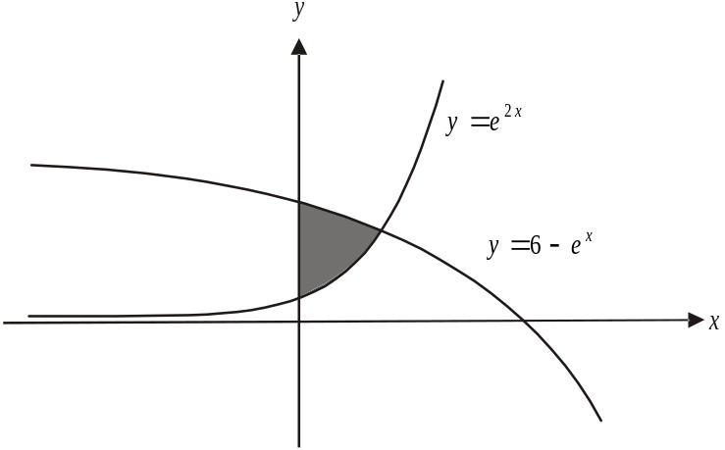

- Find the x-coordinate of the point of intersection of the two graphs.

2 marks

- Find the area of the shaded region in the diagram.

4 marks
Mathematical Methods and Mathematical Methods CAS Formulas

Mensuration

area of a trapezium: 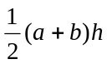 volume of a pyramid: 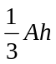
curved surface area of a cylinder: 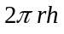 volume of a sphere: 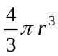
volume of a cylinder: 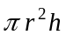 area of a triangle: 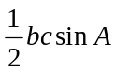
volume of a cone: 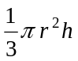

Calculus
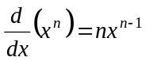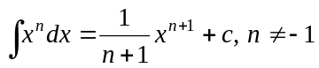
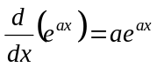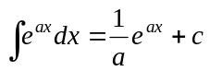
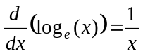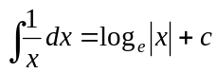
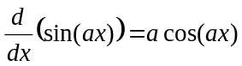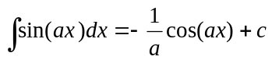
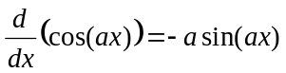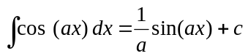
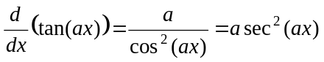
product rule: 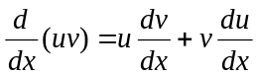 quotient rule: 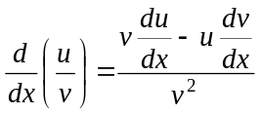
chain rule: 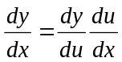 approximation: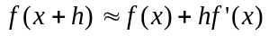

Probability
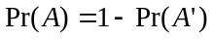
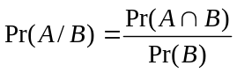
mean: 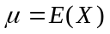 variance:

probability distribution |  | mean | variance
discrete | 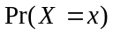=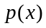 | 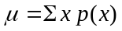 | 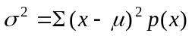
continuous | 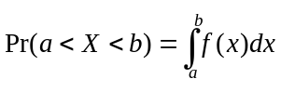 | 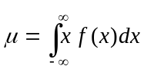 | 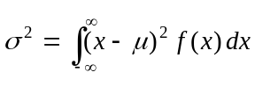
Reproduced with permission of the Victorian Curriculum and Assessment Authority, Victoria, Australia.
This formula sheet has been copied in 2007 from the VCAA website www.vcaa.vic.edu.au
The VCAA publish an exam issue supplement to the VCAA bulletin.

