
Student Name……………………………………

MATHEMATICAL METHODS UNITS 3 & 4

WRITTEN TRIAL EXAMINATION 2

2007

Reading Time: 15 minutes
Writing time: 2 hours

Instructions to students
This exam consists of Section 1 and Section 2.
Section 1 consists of 22 multiple-choice questions, which should be answered on the detachable answer sheet that can be found on page 26 of this exam.
Section 2 consists of 4 extended-answer questions that should be answered in the spaces provided.
Section 1 begins on page 2 of this exam and is worth 22 marks.
Section 2 begins on page 10 of this exam and is worth 58 marks.
There is a total of 80 marks available.
All questions in Section 1 and Section 2 should be answered.
Unless otherwise stated, diagrams in this exam are not drawn to scale.
Where more than one mark is allocated to a question, appropriate working must be shown.
Where an exact answer is required to a question, a decimal approximation will not be accepted.
Where you are asked to use calculus in a question you must show an appropriate derivative or antiderivative.
Students may bring one bound reference into the exam.
Students may bring an approved graphics calculator and if desired one scientific calculator into the exam.
A formula sheet can be found on page 25 of this exam.

This paper has been prepared independently of the Victorian Curriculum and Assessment Authority to provide additional exam preparation for students. Although references have been reproduced with permission of the Victorian Curriculum and Assessment Authority, the publication is in no way connected with or endorsed by the Victorian Curriculum and Assessment Authority.

© THE HEFFERNAN GROUP 2007
This Trial Exam is licensed on a non transferable basis to the purchaser. It may be copied for educational use within the school which has purchased it. This license does not permit distribution or copying of this Trial Exam outside that school or by any individual purchaser.
SECTION I

Question 1

For the function with rule 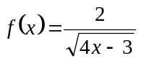, the maximal domain is

- 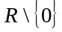
- 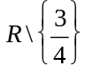
- 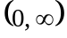
- 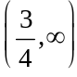
- 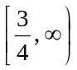

Question 2

The period and amplitude of the function 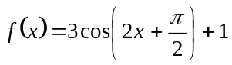 are respectively

- 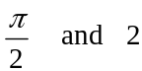

Question 3

The sum of the solutions to the equation 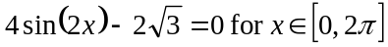 is

- 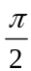

Question 4

Three fair coins are thrown simultaneously. Let X represent the number of heads that come up.
The probability distribution for X is given by

X | 0 | 1 | 2 | 3
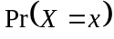

X | 0 | 1 | 2 | 3

X | 0 | 1 | 2 | 3

X | 0 | 1 | 2 | 3
 | 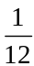 | 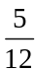

X | 0 | 1 | 2 | 3
 | 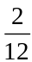 | 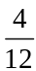

Question 5

The function f has the rule 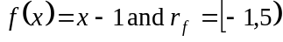.
The domain of f is

- 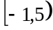
- 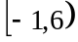
- 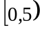
- 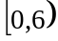
- 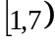

Question 6

The graph of 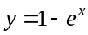 is translated 2 units to the left and reflected in the y-axis. The equation of the resulting graph is given by

- 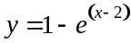
- 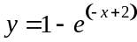
- 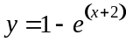
- 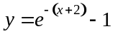
- 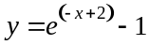

Question 7

The functions g and f both have maximal domains.
If 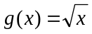 then 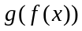 could exist if

- 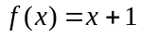
- 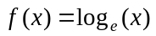
- 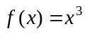
- 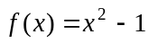
- 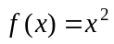

Question 8

The inverse function 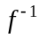 of the function 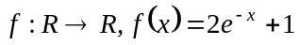 has the rule given by

- 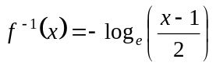
- 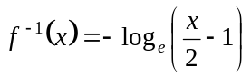
- 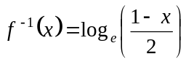
- 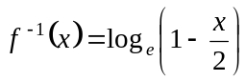
- 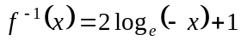

Question 9

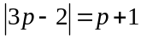 for

- 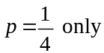
- 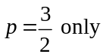
- 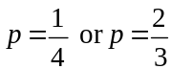
- 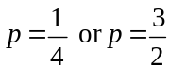
- 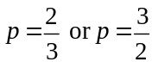

Question 10

If 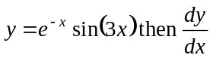 is equal to

- 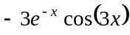
- 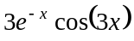
- 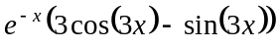
- 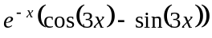
- 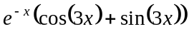

Question 11

If 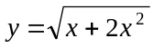, then the rate of change of y with respect to x at is

- 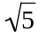
- 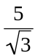
- 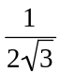
- 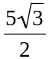
- 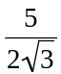

Question 12

Water is filling a cylinder which has a radius of 5cm. The height of the water in the cylinder is changing at the variable rate of 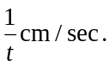 The rate, in 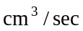, at which the volume of the water in the cylinder is changing at secs is

- 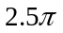

Question 13
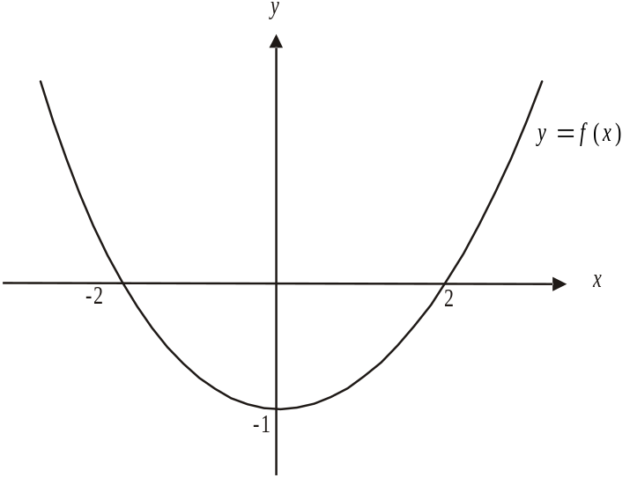

The graph of 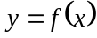 is shown above. The functions 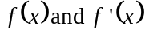 are both positive for

- 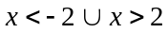

Question 14
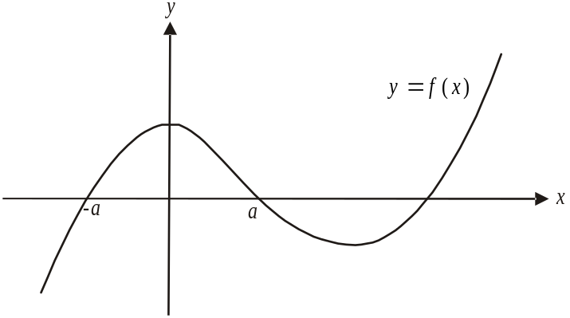

The graph of is shown above. Over the interval 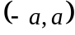, the graph of the antiderivative function of f will have a

- positive gradient
- stationary point
- local minimum value
- local maximum value
- stationary point of inflection
Question 15

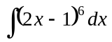 is equal to

- 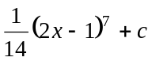
- 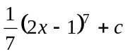
- 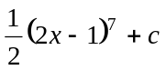
- 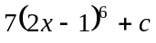
- 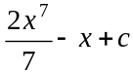

Question 16

Let .
The function 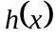 is given by

- 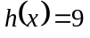
- 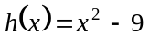
- 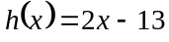
- 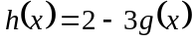
- 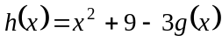

Question 17

The area of the region enclosed by the graph of 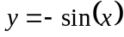, the x-axis and the lines is given by

- 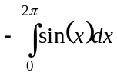
- 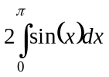
- 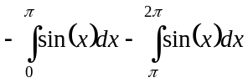
- 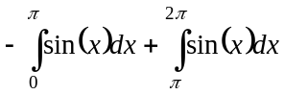
- 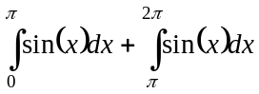

Question 18

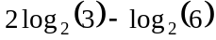 is closest to

- 0
- 0.6309
C. 0.5850
D. 1.5850
E. 1.9727

Question 19

The age, in months, of children starting three-year old kindergarten is normally distributed with a mean of 42 and a standard deviation of 2.
The percentage of children who start three-year old kindergarten who are older than 39 months is closest to

- 68%
- 81.5%
- 93%
- 95%
- 99.7%

Question 20

The probability of a soccer team scoring a goal from a penalty shot is 0.78.
During a particular game the team is awarded four penalty shots. The probability that they score at least three goals from these penalty shots is closest to

- 0.1044
- 0.3702
- 0.4176
- 0.4746
- 0.7878

Question 21

The random variable X has a probability density function f, where

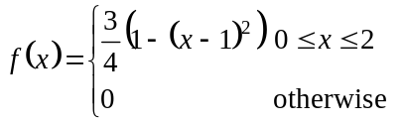

The mode of X is

- 0
- 1
- 2
Question 22

The function f is a cubic function.
The graph of 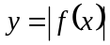 is shown below

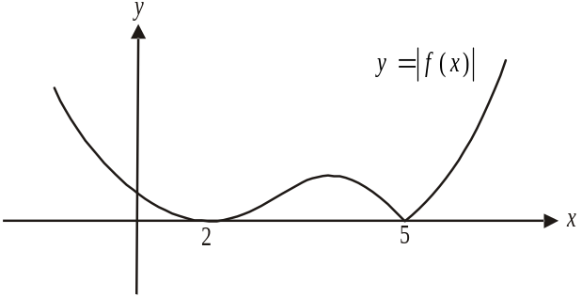

The rule for f could be

- 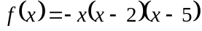
- 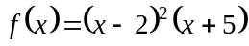
- 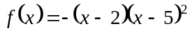
- 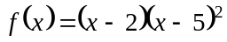
- 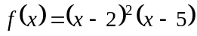

SECTION 2

Answer all questions in this section.

Question 1

Consider the function 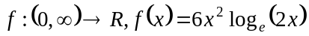.
The graph of f is shown below.
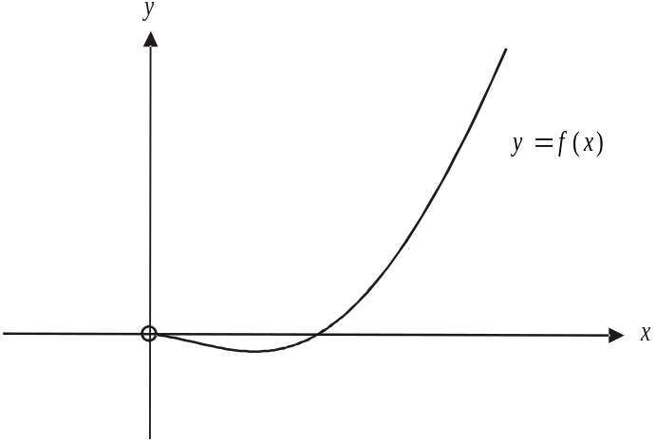

- Show algebraically that the x-intercept occurs at 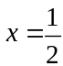.

1 mark

- Explain why the function is only defined for 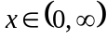.

1 mark

- Find the turning point of the graph of . Express each coordinate correct to 1 decimal place.

1 mark

- Write down the range of the function, expressing numbers correct to 1 decimal place where appropriate.

1 mark

- i. Explain why the function f does not have an inverse function.

- The function 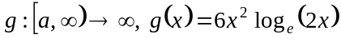 has an inverse function 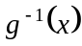.
Find the value of a, correct to 1 decimal place, such that g has a maximal domain.

f. i. Use the right rectangles method with intervals of 0.25 to find the approximate area of
the region bounded by the graph of , the x-axis and the line .
Express your answer correct to 2 decimal places.

- Explain whether the approximation found in part i. will be greater than or less than the exact area.

g. i. If 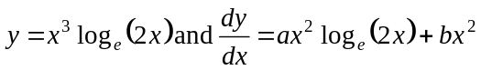, find the values of a and b.

  - Hence find the exact area enclosed by the region enclosed by the function 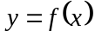, the x-axis and the line .

Total 15 marks

Question 2

At a large suburban restaurant there is one seafood delivery each day. The restaurant has two seafood suppliers; Kingfishers and Sealords. If Kingfishers supplies the restaurant one day then the probability that Sealords supplies the next day is 0.6 and if Sealords supplies one day the probability that Kingfishers supplies the next day is 0.3.

- Suppose that on Wednesday Sealords supplied the seafood.

- What is the probability that Sealords supplies the seafood on the next three days?

- What is the probability that Sealords supplies the restaurant on at least two of the next three days?

- What is the probability that the first time after Wednesday that Kingfisher supplies the restaurant is on Saturday or Sunday?

Marco is a part owner and chef at the restaurant. The time t, in hours, that he spends working in the kitchen of the restaurant each night is a continuous random variable with probability density function given by
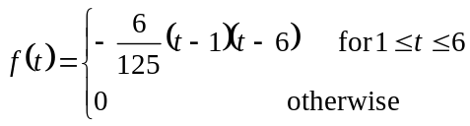

- What is the probability that Marco spends more than 5 hours working in the kitchen on a particular night?

2 marks

- Find the probability that Marco spends more than 5 hours working in the kitchen on three of the next four nights. Express your answer correct to 3 decimal places.

2 marks
- By sketching or otherwise find the median time that Marco spends in the kitchen on a night.

2 marks
Total 12 marks

Question 3
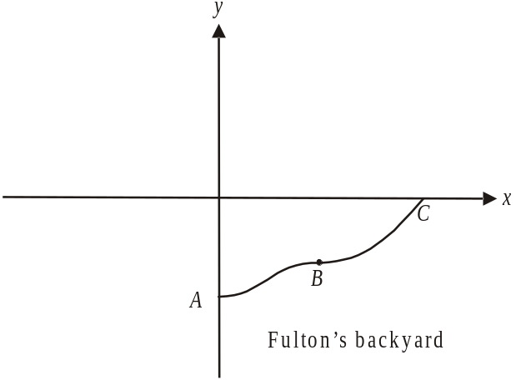

In the Fulton’s backyard a garden border runs from point A, through point B to point C.
The curve of the garden bed is part of the graph of 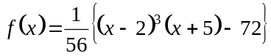.
The positive branch of the x-axis represents the Fulton’s back fence and the negative branch of the
y-axis represents their side fence.

- Find the coordinates of

- point A

- point C

- Evaluate 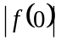.

1 mark

- Show that 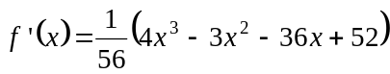.

2 marks

d. At point B, 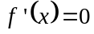.

- Find the coordinates of point B.
Express coordinates as exact values.

ii. State the nature of point B. Give reasons for your answer.

  - Write down a definite integral that gives the area of the Fulton’s garden bed which is enclosed by the garden border and back and side fences.

2 marks

- The Georges live behind the Fultons. Their back fence is represented by the positive branch of the x-axis and their side fence is represented by the positive branch of the y-axis. The Georges have a garden border that is a reflection in the x-axis of the Fulton’s garden border as shown in the diagram below.

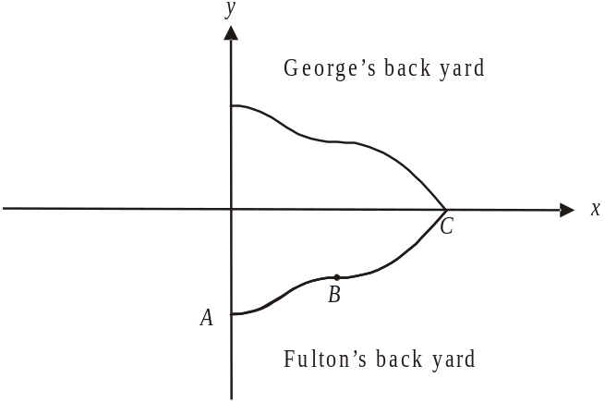

  - The function 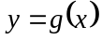 describes the George’s garden border in terms of the x and y axes. Write down the rule of g.

  - Write down the domain of the function as described in part i.

- The Hills live next door to the Fultons. Their garden bed was obtained by reflecting the function in the y-axis and dilating it by a factor of 2 from the x-axis to become 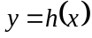.

  - Sketch the graph of the Hill’s garden border on the diagram below labelling clearly the x and y intercepts.

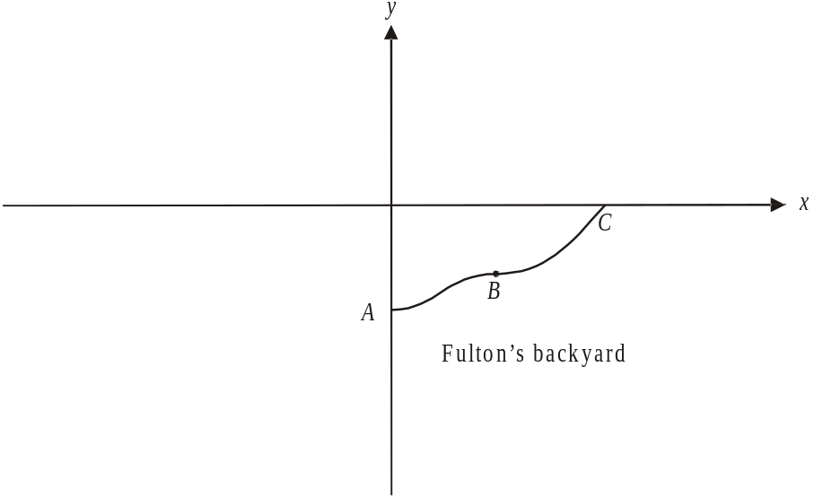

  - Write down the rule for the garden border in the Hill’s yard.

- The Raskuttis live diagonally over the back fence to the Fultons. Their garden border is the same size and shape as that of the Fultons, but in the orientation shown in the diagram below whereby point corresponds to point A, point 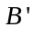 corresponds to point B and so on.

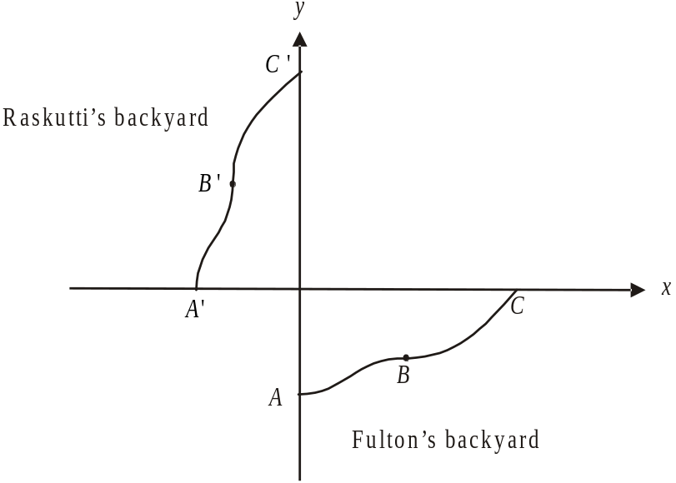

In relation to the x and y axes the Raskutti’s garden border can be described by the function 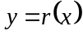.

- Explain the relationship between the function and over the domains shown in the diagram above.

- Write down the coordinates of the point .

Total 16 marks

Question 4

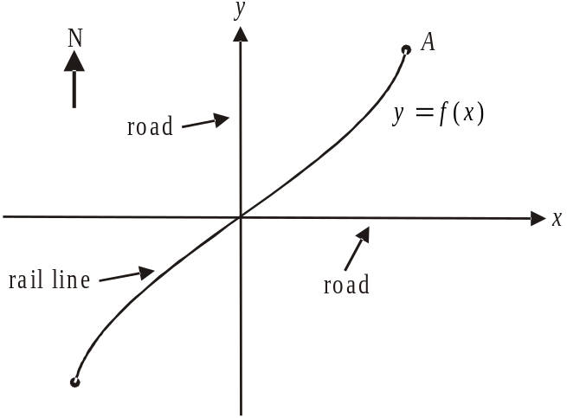

The diagram above shows a dangerous intersection between two roads; indicated by the x and y axes, and a rail line, part of which is represented by the function

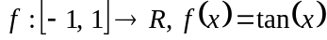.

The dangerous intersection is located at the point 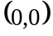. The unit of measurement is the kilometre.

- Find the coordinates of the point A. Express them correct to 2 decimal places where applicable.

1 mark

- Write down a limitation of using the rule of the function f to model the rail line if the diagram was to show an area two kilometres east and west of the dangerous intersection.

1 mark

  - Find the angle that the rail line makes with the road heading north at the point where they intersect.

2 marks

A straight shunting line takes off as a tangent from the main rail line at point B as indicated in the diagram below. The shunting line has a gradient of in relation to the x and y axes.

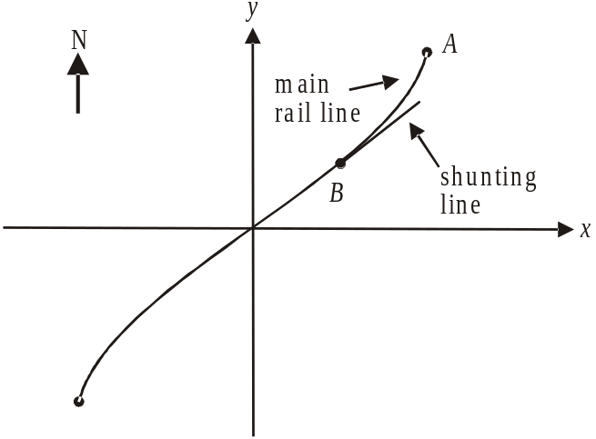

  - Find the coordinates of point B. Explain why some possible values of the x-coordinate of B needed to be rejected.
Express your coordinates as exact values.

4 marks

  - If the shunting line was extended show that it would cross the road running in an east-west direction on the east side of the dangerous intersection.

3 marks

A new route for the rail line is proposed and is shown in the diagram below.
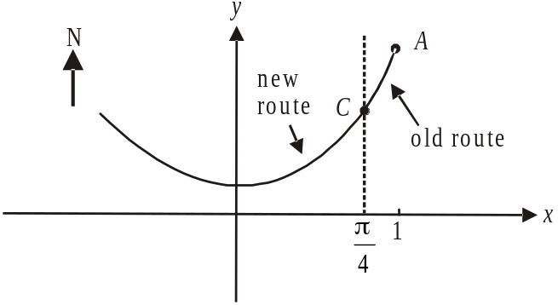

The old route follows part of the graph with equation 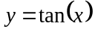. The new route follows part of the graph with equation 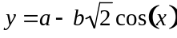. The rail line passes smoothly from the old route to the new route at point C so that the gradients of the curves at point C are equal.

  - i. Show that .

ii. Find how many metres north of the dangerous intersection the new route crosses the road heading north. Express your answer to the nearest metre.

Total 15 marks

Mathematical Methods and Mathematical Methods CAS Formulas

Mensuration
area of a trapezium: 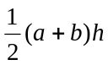 volume of a pyramid: 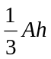
curved surface area of a cylinder: 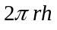 volume of a sphere: 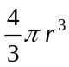
volume of a cylinder: 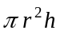 area of a triangle: 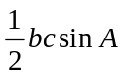
volume of a cone: 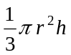

Calculus
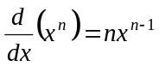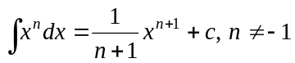
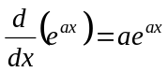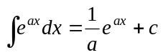
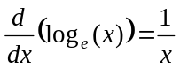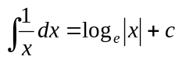
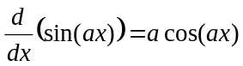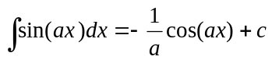
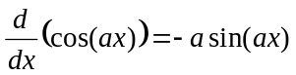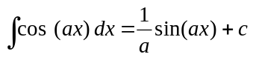
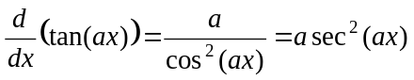
product rule: 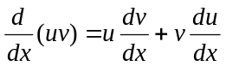 quotient rule: 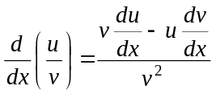
chain rule: 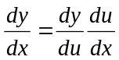 approximation: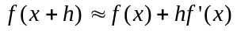

Probability
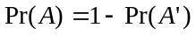
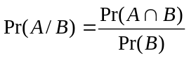
mean: 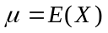 variance:
probability distribution |  | mean | variance
discrete | 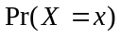=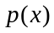 | 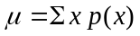 | 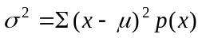
continuous | 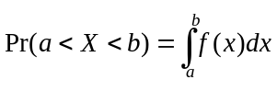 | 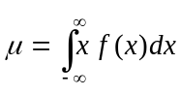 | 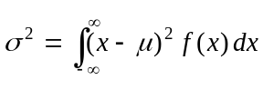

Reproduced with permission of the Victorian Curriculum and Assessment Authority, Victoria, Australia.
This formula sheet has been copied in 2007 from the VCAA website www.vcaa.vic.edu.au
The VCAA publish an exam issue supplement to the VCAA bulletin.
