

Student Name………………………………….

MATHEMATICAL METHODS (CAS) UNITS 1 & 2

TRIAL EXAMINATION 1

2008

Reading Time: 15 minutes
Writing time: 1hour

Instructions to students
This exam consists of 11 questions.
All questions should be answered in the spaces provided.
There is a total of 40 marks available.
A decimal approximation will not be accepted if an exact answer is required.
Where more than one mark is allocated to a question working must be shown.
Students may not bring any notes or any calculators into this exam.
Diagrams in this exam are not to scale except where otherwise stated.

This paper has been prepared independently of the Victorian Curriculum and Assessment Authority to provide additional exam preparation for students. The publication is in no way connected with or endorsed by the Victorian Curriculum and Assessment Authority.

© THE HEFFERNAN GROUP 2008
This Trial Exam is licensed on a non transferable basis to the purchasing school. It may be copied by the school which has purchased it. This license does not permit distribution or copying of this Trial Exam by any other party.
Question 1

Simplify 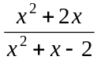

1 mark

Question 2

Find the value(s) of p for which the graph of 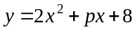 touches the x-axis just once.

2 marks

Question 3

Find the solution(s) to the equation 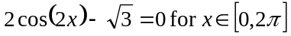.

3 marks

Question 4

The graph of the function 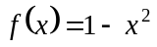 is shown below.
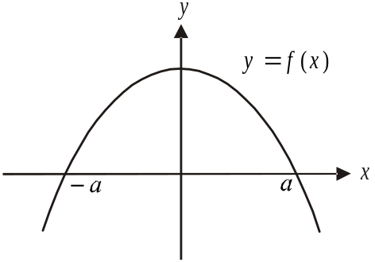

- Evaluate 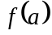.

1 mark

- Find 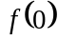.

1 mark

- Find the value of a.

1 mark

- Using the discriminant or otherwise, explain why the graph of 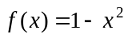 crosses the x-axis twice.

1 mark

- For 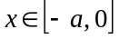 find the value of x for which the gradient of the graph is greatest.

1 mark
Question 5

The graph of 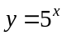 is shown on the set of axes below.
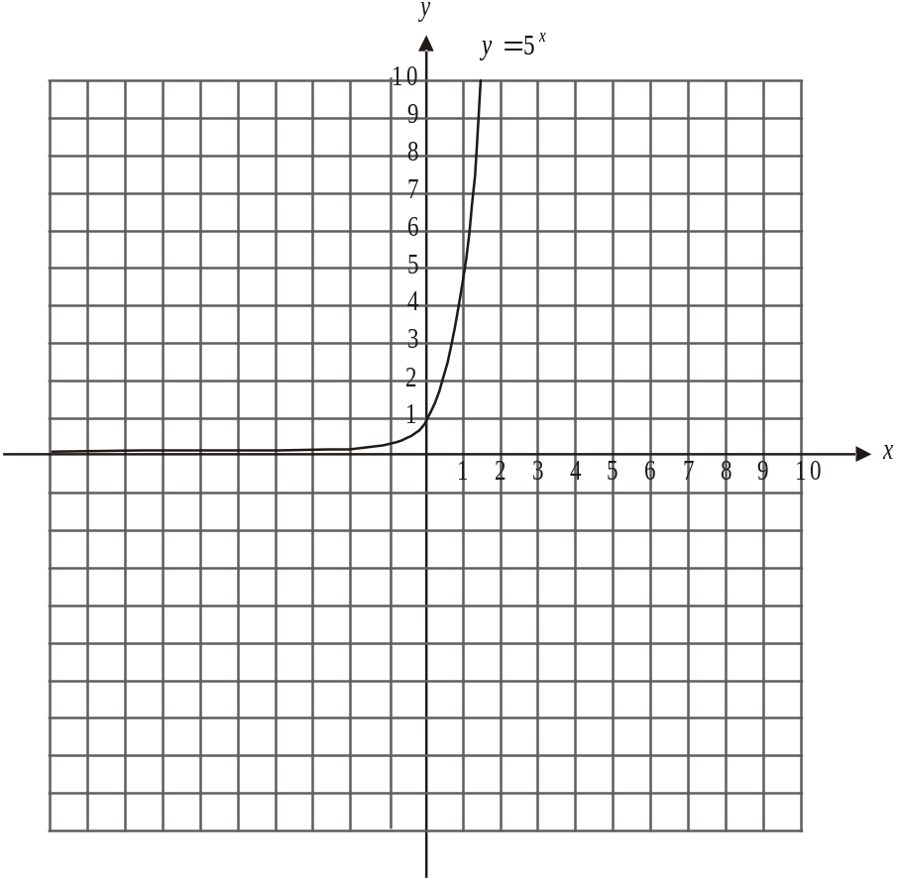

- On the same set of axes, sketch the graph of 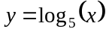.
2 marks

- By referring to the line , explain the relationship between the graph of and the graph of 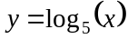.

1 mark

Question 6

At Portvale Secondary College 12% of the VCE students are studying Japanese and 43% of the VCE students are male.

Also, 9% of VCE students at the college are male and studying Japanese.

If a VCE student from Portvale Secondary college is randomly chosen, what is the probability that they are

- male and not studying Japanese?

1 mark

- female and studying Japanese?

1 mark

- female and not studying Japanese?

1 mark

- male or studying Japanese?

2 marks

Question 7

- If 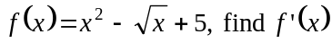.

2 marks

- If 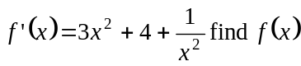.

2 marks

Question 8

Find 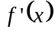 from first principles given that 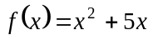and

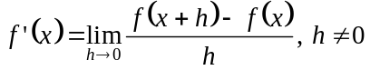.

3 marks

Question 9

The graph below shows the graphs of the functions f and g where

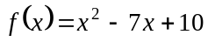

and 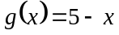
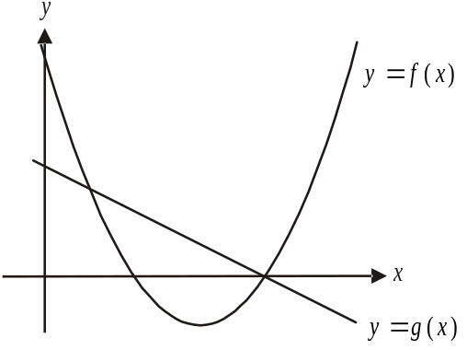

- Show that the graphs of 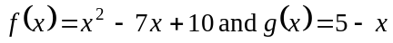 intersect at the points 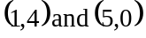.

2 marks

The function h, where 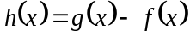, gives the difference between the values of the functions 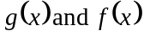.

- Over the domain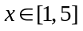, find the greatest difference between the values of and the value of x where this occurs.

3 marks

Question 10

The graphs of 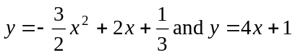 have the same gradient at the point A.
Find the coordinates of the point A.

3 marks

Question 11

The displacement-time graph for a particle moving in a straight line is shown below.

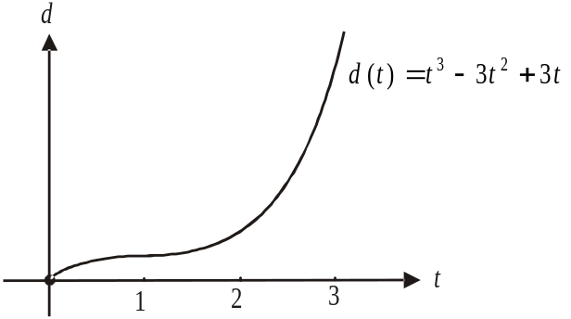

The displacement, d, in metres, of the particle from its origin of motion at time t seconds after it starts to move at , is given by 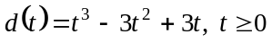.

- How far is the particle from its origin of motion at ?

1 mark

- What is the average rate of change of displacement of the particle between ?

1 mark

- What is the instantaneous rate of change of the particle at ?

2 marks

- Use calculus to find when the particle is stationary.

2 marks

