

MATHS METHODS (CAS) UNITS 1 & 2
TRIAL EXAM 2

SOLUTIONS
2008

Section 1 - Answers
- C 9. E 17. C
- D 10. C 18. D
- E 11. B 19. D
- A 12. D 20. D
- D 13. B 21. A
- D 14. E 22. C
- C 15. C
- E 16. B
SECTION 1 - solutions

Question 1

The minimum value of the function f occurs at the left endpoint of the graph of 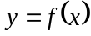.
The minimum value is – 3.
The answer is C.

Question 2

Use your CAS calculator to solve this quartic (degree 4) polynomial equation.
The answer is D.

Question 3

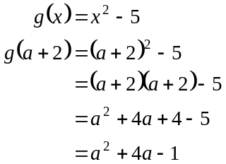
The answer is E.

Question 4

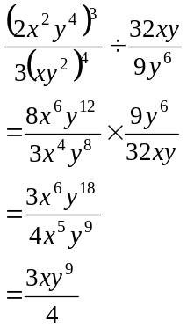
The answer is A.

Question 5

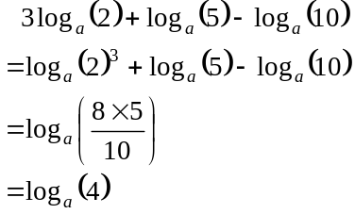
The answer is D.

Question 6

Use a Venn diagram.

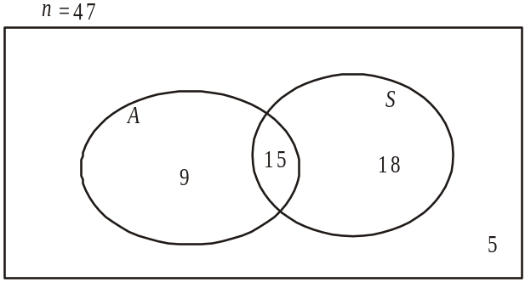

Since 5 try out for neither, there are 42 who try for athletics, swimming or both. Now . So there are who must be trying for both. So the number who try out for the swimming team only is .
The answer is D.

Question 7

Method 1 – by hand
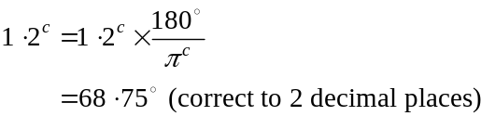
The answer is C.

Method 2 – by calculator
Use your calculator to convert 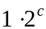 to 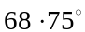 (correct to 2 decimal places). Make sure that your calculator is in the correct mode.
The answer is C.

(Check whether your answer is reasonable, i.e. will be slightly more than one third of 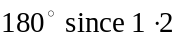 is slightly more than one third of .
This makes 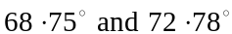 the only reasonable alternatives. Calculation by hand or calculator shows to be the correct answer.)

Question 8

From the diagram,
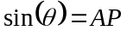 (because we have a unit circle)
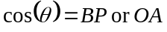 (because we have a unit circle)
Since 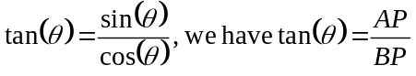.
Also
The answer is E.

Question 9

The number of different subcommittees made up of 5 people that can be selected from a committee of 12 people is given by 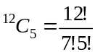
The answer is E.

Question 10

Given that there are no horizontal translations in the listed alternatives, the shape of the graph must be that of the cosine function. It has been translated 1 unit upwards, has an amplitude of 2 and has a period of .
For the graph of 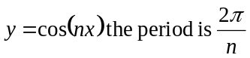.
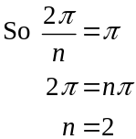
The rule for f is 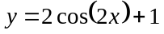.
The answer is C.
Question 11

Method 1
is a fourth quadrant angle.
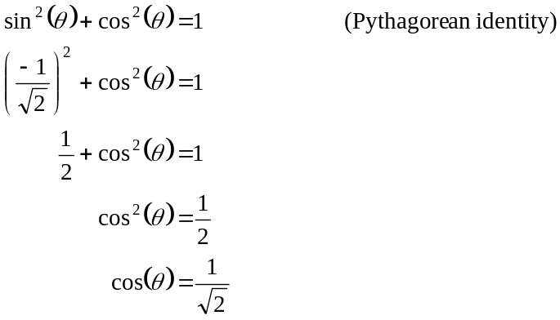
reject 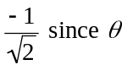 is a 4th quadrant angle and cos is positive in the fourth quadrant
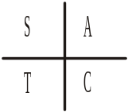
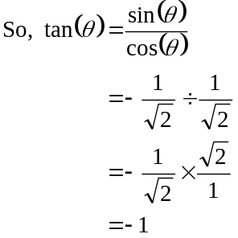
The answer is B.

Method 2
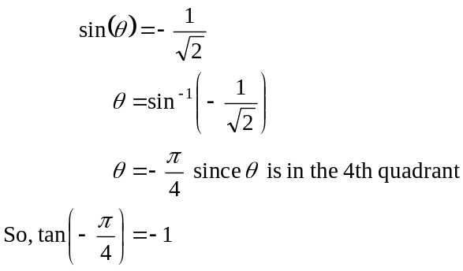
The answer is B.

Question 12

Method 1
Using your calculator, solve 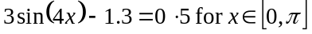.
The solutions are
The closest to these are 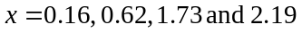.
The answer is D.

Method 2

Using your calculator, sketch the graph of 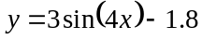 and find its roots for 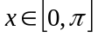.
The answer is D.
Question 13
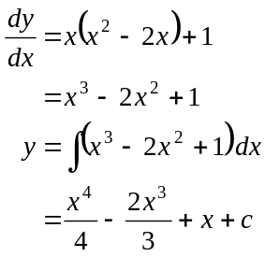
The answer is B.

Question 14
If A and B are independent events then
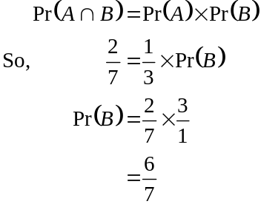
The answer is E.

Question 15
Consider the boys as one unit. We therefore have 4 units; the boys and the 3 girls.
These 4 units can be arranged in
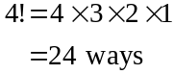
The boys can be arranged in 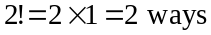.
There are therefore 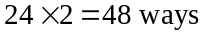 in which the boys can be standing next to one another.
If there were no restrictions there would be
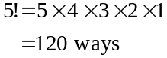
that the students could be lined up.
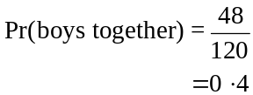
The answer is C.
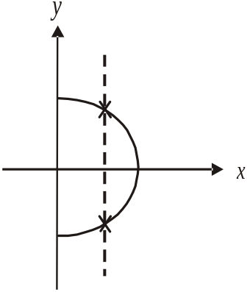

Question 16

Use the vertical line test to test whether a relation is
also a function.
If a vertical line can be drawn anywhere on a relation
so that it touches the relation more than once then it is
not a function.
Option B is an example of this.
A vertical line can be drawn so that it touches
the relation twice.
This relation is not a function.
The answer is B.
Question 17

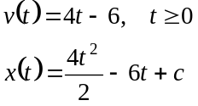
where x represents the position of the particle t secs after it moves
At 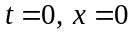 (i.e. at the origin)
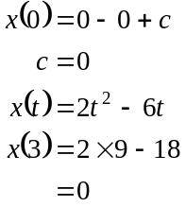
At , the particle is at the origin O.
The answer is C.

Question 18

Method 1
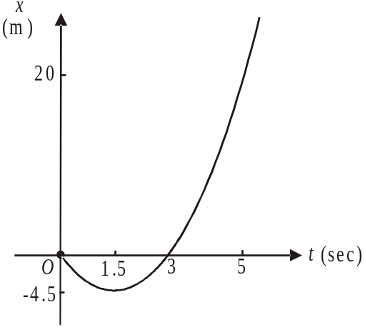
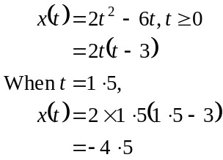
Between , the particle travels to a
position 4.5m to the left of the origin and another
4.5m back to the origin.
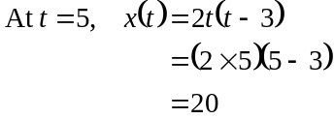
the particle is 20m to the right of the origin.
It has travelled in the first 5 secs a distance of
.
The answer is D.

Method 2
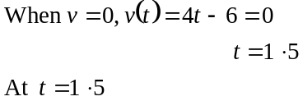
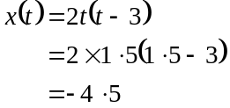
The particle travels 4.5m to the left of the origin in the first 1.5 secs.
In the next 1.5 secs it travels 4.5m to the right and ends up back at the origin.
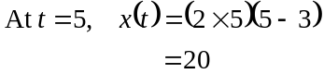
the particle is 20m to the right of the origin.
It has travelled in the first 5 secs a distance of .
The answer is D.
Question 19
Using your calculator,
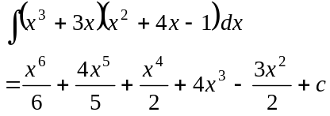
The answer is D.

Question 20
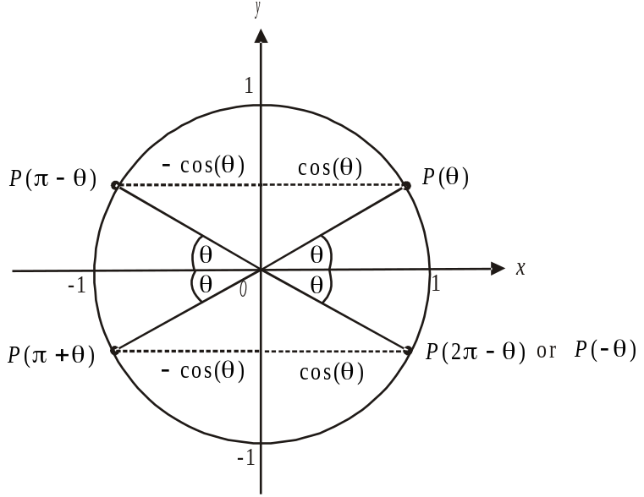

For option A, from the diagram,
For option B, from the diagram, 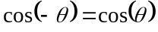.
For option C, from the diagram,
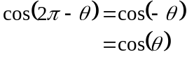
For option D, from the diagram,
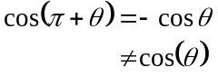
For option E, since sine and cosine are complementary functions, 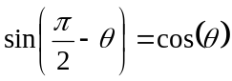.
The answer is D.

Question 21

There are possible outcomes.
Of these the combinations of 1 & 1, 2 & 1 and 1 & 2
are the only ones that give a sum less than 4.
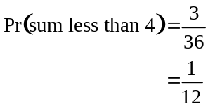
The answer is A.

Question 22

Since the graph of 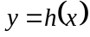 is a tangent to the graph of 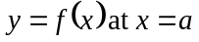, the values of the two functions at are equal so option A is correct.
Similarly the gradient of the graph of is equal to the gradient of the graph of so option B is correct.
The gradient of the function is a variable function because the graph of is not a straight line so 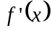 is not a constant and option C is incorrect.
The gradient of the graph of is a constant because the graph is a straight line. So option D is correct.
The gradient of the graph of at the point where is a constant so option E is correct.
The answer is C.

SECTION 2

Question 1
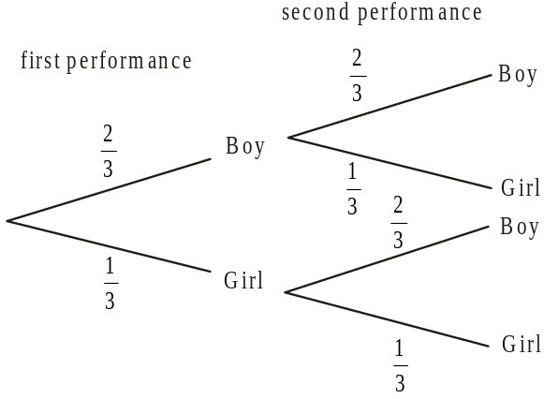

(1 mark) – correct first performance probabilities
(1 mark) – correct second performance probabilities
b. Pr(a boy and a girl)
The outcome of a boy and a girl being chosen can happen in two ways i.e. choosing a boy then a girl OR a girl then a boy
We have 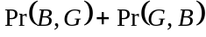
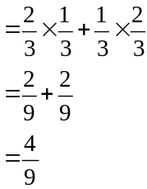
(1 mark)
- Method 1
Pr(boy is chosen on the second performance)
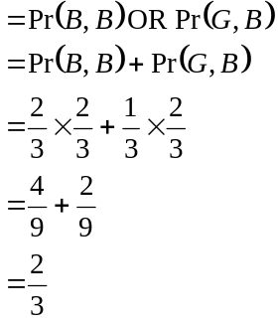
(1 mark)
Method 2

As these events are independent,
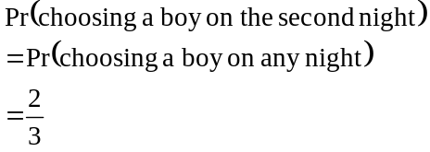
(1 mark)

- Method 1 – using the tree diagram
From the tree diagram we see that for the second performance, the probability that a girl is selected given that a boy was chosen for the first performance is . (1 mark)
Method 2 – using the conditional probability formula.
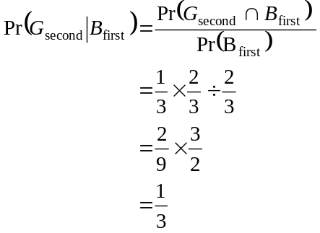
(1 mark)

- this week
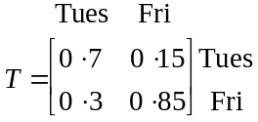 next week
(1 mark) – first column correct
(1 mark) – second column correct

- 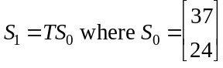
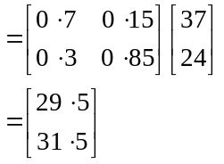
(1 mark)
(1 mark)

- 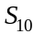 gives the number of students attending dance classes on Tuesday and on Friday in week 10 of term 2.
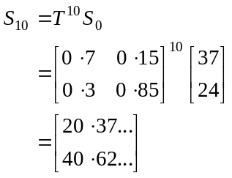
(1 mark)
So in week 10 of term two, 20 students attend dance class on Tuesday and 41 on Friday.
(1 mark)
Total 11 marks
Question 2

- 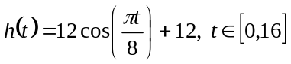
- The amplitude is 12cm.
(1 mark)

- The period is given by 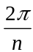 where 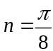.
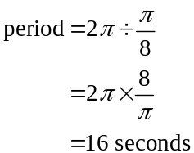
(1 mark)

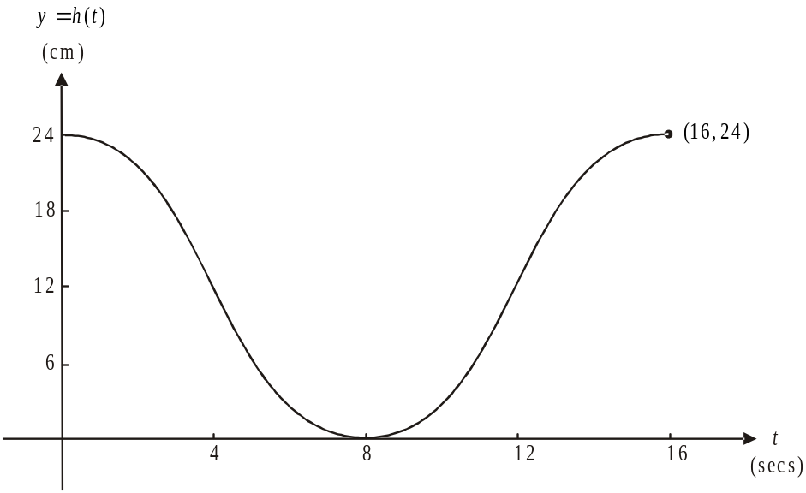

(1 mark) – correct shape
(1 mark) – indicating intercepts & endpoints

- Method 1 – graphically
(1 mark)
From the graph, .

Method 2 – by hand
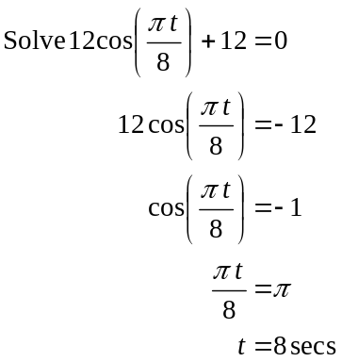
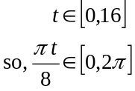
(1 mark)
Method 3 – using CAS
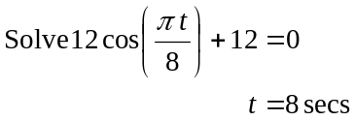
(1 mark)
- The cistern is empty i.e. 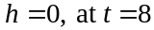 (from part c.).
From the graph, the height of the water in the cistern is increasing; that is, fresh water is being pumped back in, between 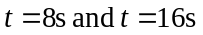.
(1 mark)

- Again from the graph in part c., the maximum height that the water reaches is 24cm.
(1 mark)

- i. The height of the water in the cistern is 18cm when
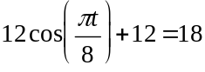
(1 mark)
Solve for t.
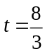 secs gives the first time that the water reaches 18cm.
(1 mark)

- Sketch the graphs of 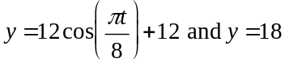.
We see that the height of the water is 18cm at 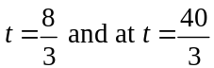. (1 mark)
For the period between these times i.e. for 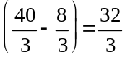 secs the water is less than 18cm.
(1 mark)
- i. The height of the water in the cistern is the same as the height of the water in the basin when 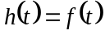 since the button is pushed at the same time as the water is turned on.
So, 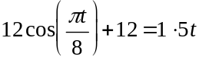 (1 mark)
Solve for t over the domain 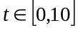 since the function f is only defined for these values of t.

Method 1
Solve the equation.
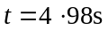 (to 2 decimal places) (1 mark)

Method 2
Sketch the graphs of 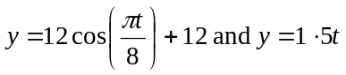. A point of intersection for which the x-coordinate lies within the required domain is 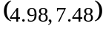 so (to 2 decimal places)
(1 mark)

- Graph the functions h and f.
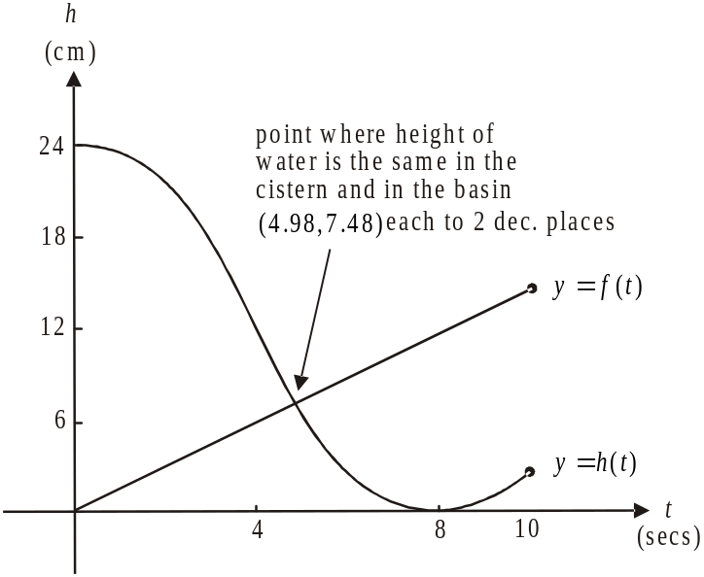

“Hence” means use what you have just found. We found in part i. that the height of the water in the cistern was the same as the height of the water in the basin at 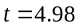 secs correct to 2 decimal places.
Using this together with the graph, we see that the height of the water in the cistern is greater than the height of the water in the basin for 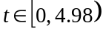 where 4.98 is correct to 2 decimal places.
(1 mark) for identifying 4.98 (1 mark) correct interval
Total 15 marks

Question 3

- c is the x coordinate of the point at which the function “touches” the x-axis. For the function 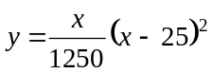, this occurs at 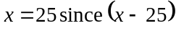 is a repeated factor.
So, .
(1 mark)

- The point 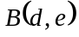 is the right endpoint of the function f. The domain of f is 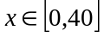. So the right endpoint has an x-coordinate of 40.
So . (1 mark)
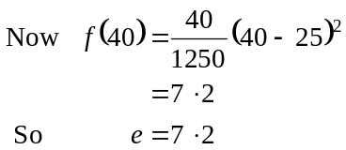
(1 mark)
B is the point 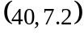

- By looking at the graph of the function we see that over the domain , the maximum value of the function occurs at the right hand endpoint; that is at . Now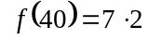 from part b., so the maximum value of the function is 7.2 and therefore the maximum height is 7.2cm.
(1 mark)

- The straight line passes through the points 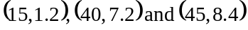. Choose any two of these points to find the gradient.
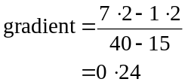
The gradient is . (1 mark)

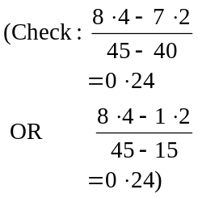

The equation of a straight line is given by
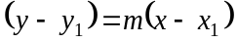
where 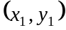 lies on the line. Choose any of the points 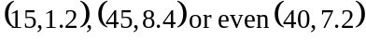 to substitute in.
Using 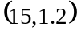, we have
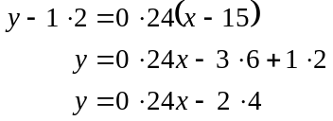
is the required Cartesian equation. (1 mark)

(Check using 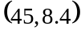,
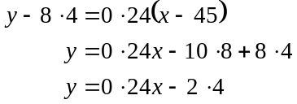
OR using 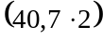
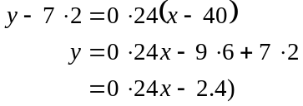

- The domain is 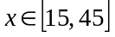.
(1 mark)

- To find the width of the book we need to find the distance between the two points 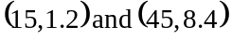.
Use the distance formula
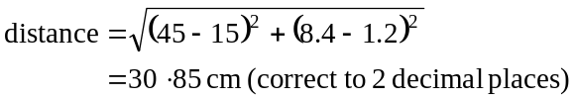
(1 mark)

- From part d. the gradient of the function representing the book is .
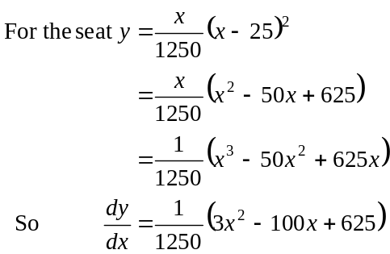
(1 mark)

The gradients are equal when 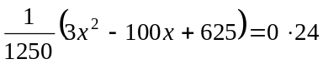. (1 mark)
Simplifying, we obtain 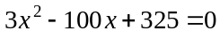.
Solving gives or 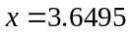.
The required values of x are or 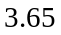where each value is correct to 2 decimal places.
(1 mark)

- The matrix represents a dilation by a factor of from the y-axis.
(1 mark)

- With the new design the point 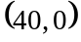 which is a point lying on the back edge of the seat is transformed as follows.
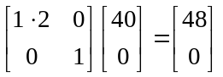
The image point is 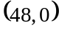. So the depth of the newly designed seat will be 48cm.
(1 mark) – making an attempt to
transform the point 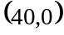
(1 mark) – correct answer

- The required matrix which gives a reflection in the x-axis is
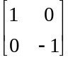
(1 mark)
Total 15 marks

Question 4

- 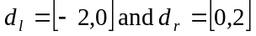.
From these two domains we see that the outer endpoints of the function occur at .
(1 mark)

- Following on from part a. the width of the main entrance at ground level is 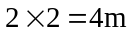.
(1 mark)

- i. From the graph given, the maximum height of the main entrance occurs at .
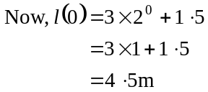
Maximum height is 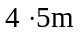.
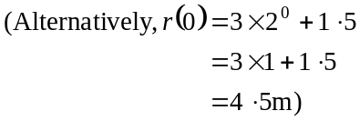
(1 mark)

- Again from the graph given, the minimum height of the main entrance occurs at the outer endpoints; that is at .
Remember that the functions are symmetric about the y-axis so that they will have the same value at .
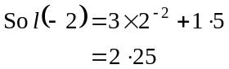
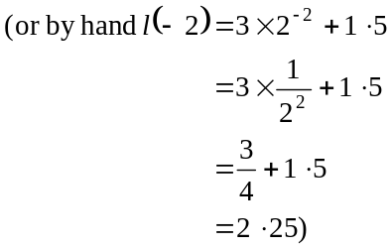
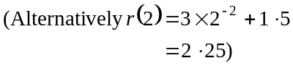
The minimum height is m.
(1 mark)

- The lantern in the centre is hung from a point that is m above the ground. The lanterns closest to the side walls are hung from a point that is m horizontally along from ; that is at .
They are hung from a point with a height given by
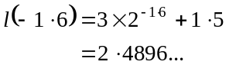
(1 mark)
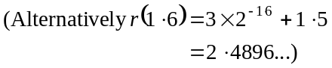
The difference in height then from the points of hanging is correct to 2 decimal places. (1 mark)
- We need to solve (1 mark)
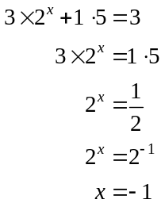
So 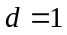. (1 mark)

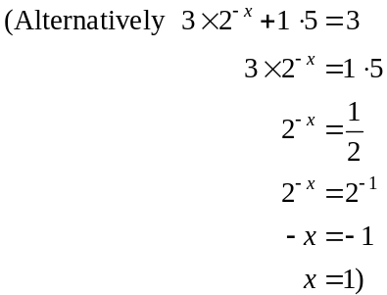

- We need to solve
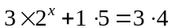
Solving gives 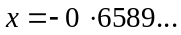
Because of the symmetry of the functions l and r, and looking at the graph, we see that the man on stilts can enter so that he is positioned between m (to 2 decimal places) on either side of the centre of the main entrance.
(Do not round up because 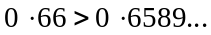. and the man on stilts won’t fit.)
(1 mark) finding
or
(1 mark) correct answer

- The act is m wide and will enter through the centre of the main entrance so its sides will enter where .
The height of the main entrance at 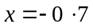 is given by
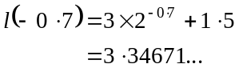
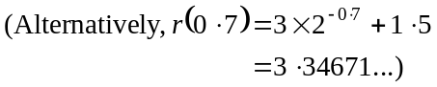
Since the height of the main entrance at and at is less than the height for 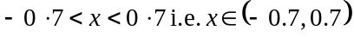 the maximum height that the act can have, to 2 decimal places is m. (Do not round up since if you round up to m, it will not fit i.e.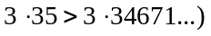.
(1 mark) for finding the height m
(1 mark) correct answer

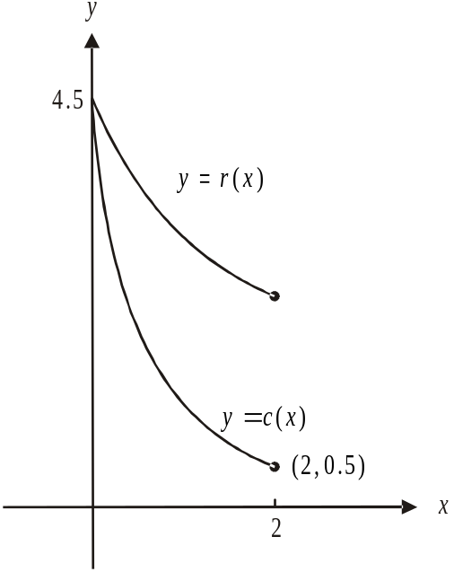

(1 mark) correct shape & position
(1 mark) correctly labelling the intercept
and the endpoint

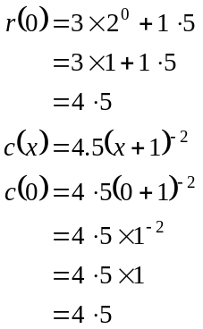
So at 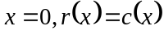 as required.
(1 mark)

j.
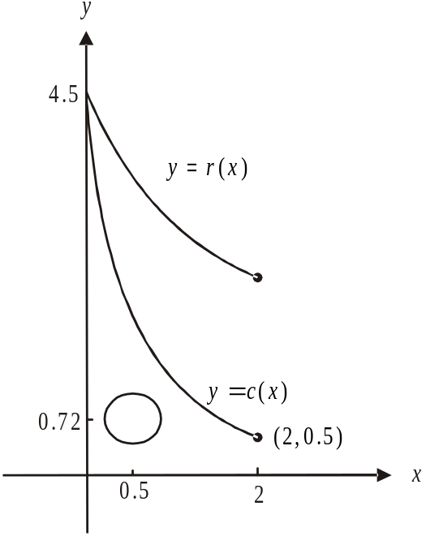

The Cartesian equation of a circle is given by 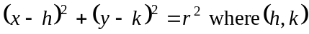 gives the centre and r gives the radius.
The centre of the circle representing the outer edge of the spinning wheel is m above the ground so .
Since the centre is 1m horizontally from the edge of the curtain then we need to find the x-coordinate of the point that lies on the graph of 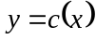 which has a y-coordinate of . That is, we need to solve the equation that is,
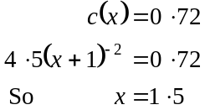
The x-coordinate of the centre of the circle is therefore
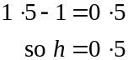
Also the radius is .
The required Cartesian equation is 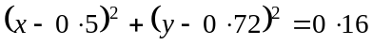
(1 mark) for r and k
(1 mark) for h
Total 17 marks

