
MATHS METHODS (CAS) 3 & 4
TRIAL EXAMINATION 2
SOLUTIONS
2008

- E 9. E 17. C
- D 10. A 18. C
- D 11. A 19. C
- D 12. D 20. C
- A 13. B 21. C
- B 14. C 22. D
7. B 15. D
8. D 16. B

Section 1 – Multiple-choice solutions

Question 1
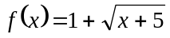
For f to be defined
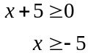
So the maximal domain is given by 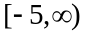.
The answer is E.

Question 2
Method 1 – graphically
Sketch the graph of 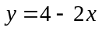. The range
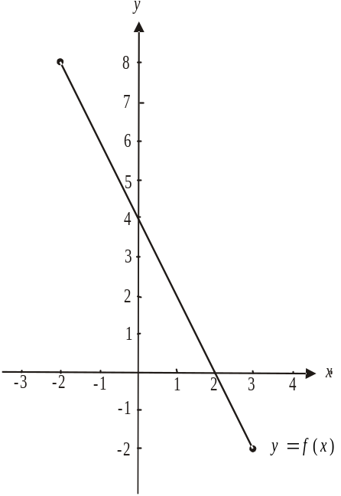
of f is restricted and hence the domain will
be restricted.
From the graph,
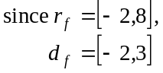
So, 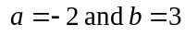.
The answer is D.
Method 2 – algebraically
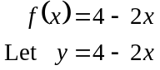
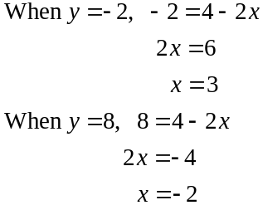
We are dealing with a linear function so 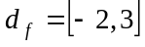 and since 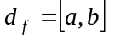 then .
The answer is D.
Question 3
Solve the equation
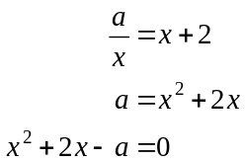
Using a calculator, 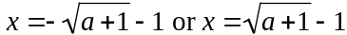.
If and there is only one solution.
If 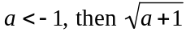 is undefined and there are no solutions.
For two distinct solutions we require that .
The answer is D.

Question 4

Method 1 - use a Venn diagram,

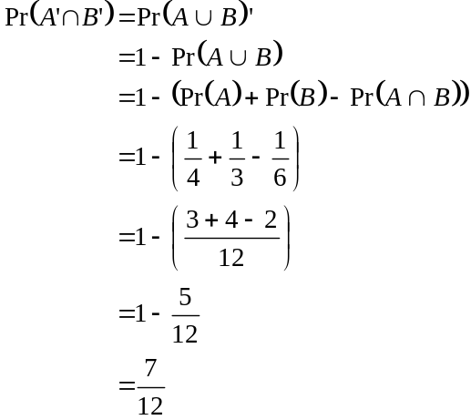
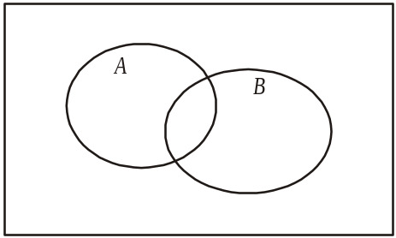
The answer is D.

Method 2 – use a probability table.

 | A | A’
B
B’ | 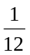 | 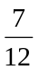
 |  |  | 1

From the table, 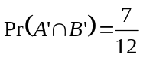.
The answer is D.

Question 5
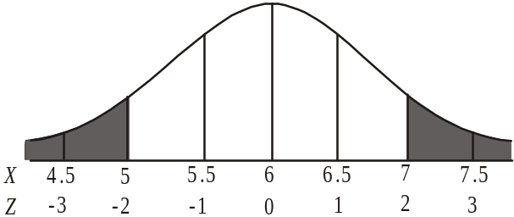
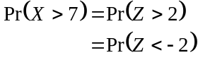
The answer is A.

Question 6

The transformation defined by
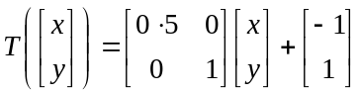
describes a dilation by a factor of 0.5 from the y-axis followed by a translation of 1 unit to the left and 1 unit up.
The image of 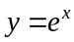 under the dilation described above is given by
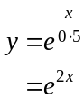
After the translation of 1 unit to the left we have, 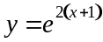 and after the translation of 1 unit up we have 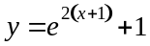.
The answer is B.

Question 7

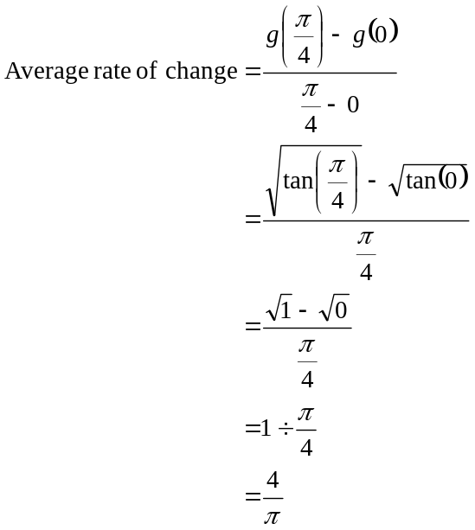
The answer is B.

Question 8

Sketch the graph.
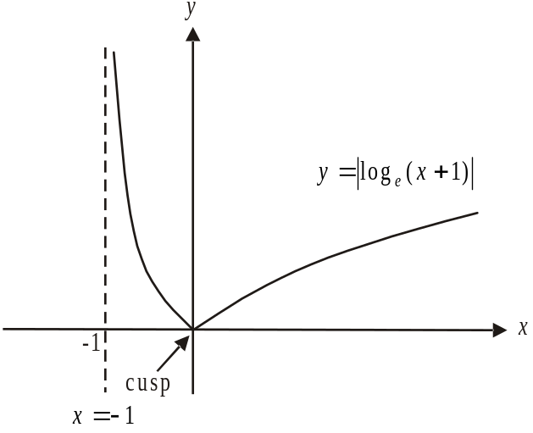

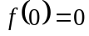 so option A is incorrect.
For , the gradient of the function is negative so option B is incorrect.
At , the graph of 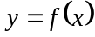 has a cusp, i.e. a “pointy bit”. So whilst the graph is continuous at , it is not smoothly continuous so option C is incorrect.
Option D is correct; that is, 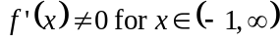, i.e. the gradient of f is not zero over its domain.
Also, the graph of is not 1:1 and therefore an inverse function of f does not exist so option E is incorrect.
The answer is D.

Question 9

The graph of is stretched horizontally; that is, dilated by a scale factor of 2 from the y-axis. For example, the local maximum that occurs at 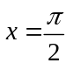, occurs on the graph of 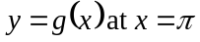.
Also, the graph of is squashed vertically; that is, dilated by a scale factor of from the x-axis. For example the local maximum that has a y value of 2 occurs on the graph of 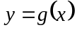 with a y value of 1.
The answer is E.

Question 10

Sketch the graph of 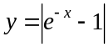.
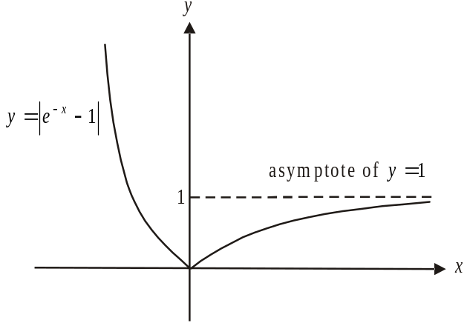

For f to have an inverse function it must be a 1:1 function.
Since 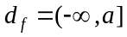, we require that so that the graph of is 1:1.
So .
The answer is A.

Question 11
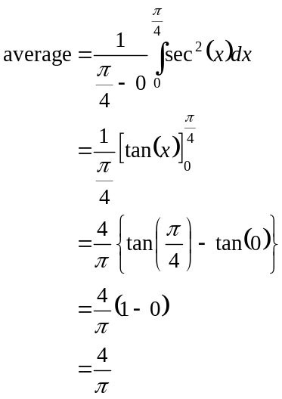
The answer is A.

Question 12

Do a quick sketch of a possible graph of f.
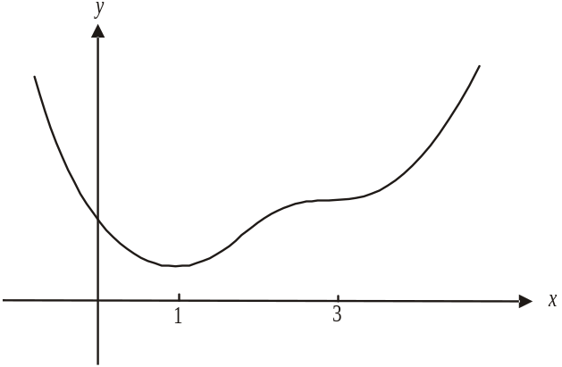

The first clue tells us that we have stationary points at 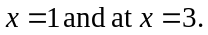 The second clue tells us that the gradient is negative for 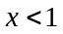. The third clue tells us that the gradient is positive for 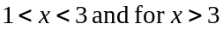.

Whilst we don’t know the exact positioning of points, the gradients given can tell us the approximate shape of the graph. From this rough sketch we see that we have a minimum turning point at and a stationary point of inflection at .
Only option D offers a correct alternative.
The answer is D.

Question 13

For a pyramid, 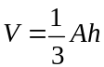 (formulae sheet)
Since the pyramid has a square base with side length x, and a height of 90 we have
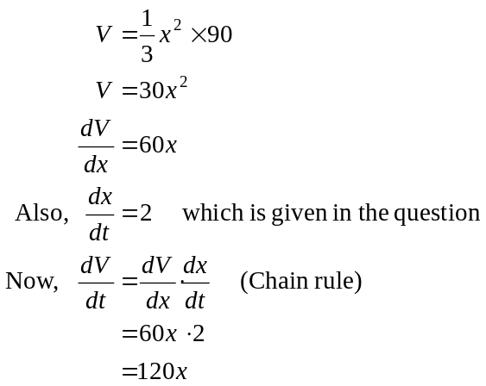
When 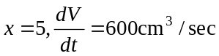
The answer is B.

Question 14

Method 1
Define 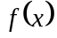 on your calculator as each of the alternatives given and check whether they satisfy the property 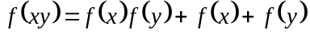.
The answer is C.

Method 2
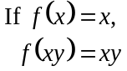
and 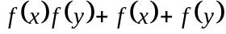
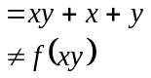
Option A is incorrect.

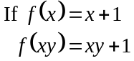
and
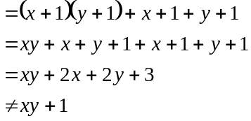
Option B is incorrect.

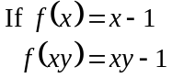
and
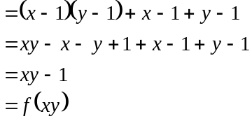
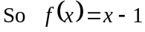.
The answer is C.

Question 15

Sketch the graph.
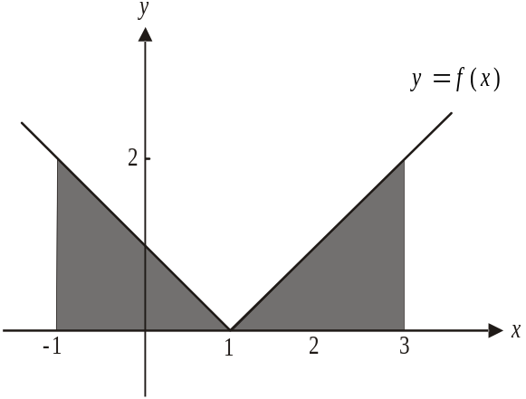

The shaded area gives the required area. The function is symmetrical about the line 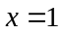.
From the graph,
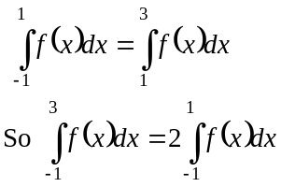
The answer is D.

Question 16

For 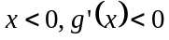.
Between and the local maximum to the right of the origin, 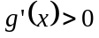.
For x greater than the value of x at the local maximum to the right of the origin, 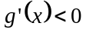.
Only option B shows this.
The answer is B.

Question 17

f is a composite function and so we need to use the chain rule to differentiate it.

Method 1 – quick way
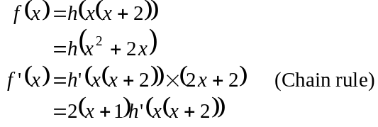
The answer is C.

Method 2 – longer way
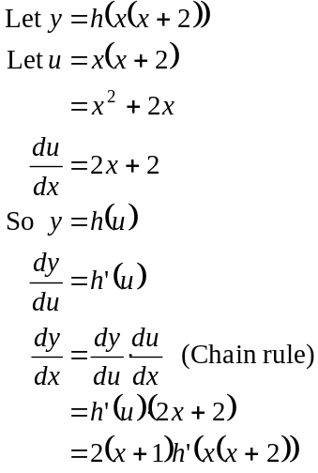
The answer is C.

Question 18

Use your CAS calculator to solve the system.
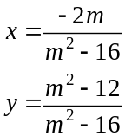
If , there is no unique solution; that is, there could be no solution or an infinite number of solutions.
If , we have
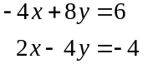
Multiplying the second equation by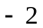, we obtain the system of equations:
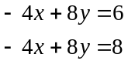
These equations represent parallel lines so there is no solution.
Similarly, if we have
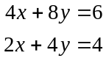
Multiplying the second equation by, we obtain the system of equations:
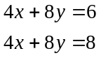
These equations also represent parallel lines so there is no solution.

If , there is no solution.
The answer is C.

Question 19

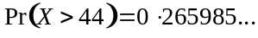
The closest proportion is 27%.
The answer is C.

Question 20

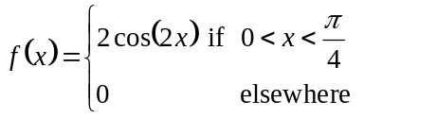
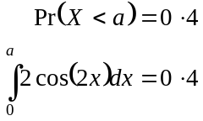
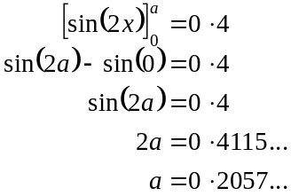
The answer is C.

Question 21

Method 1 – by calculator
Solve 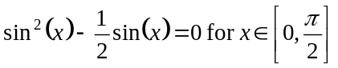.
The solutions are 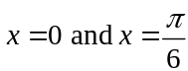.
The answer is C.

Method 2 – by hand
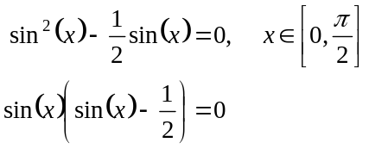
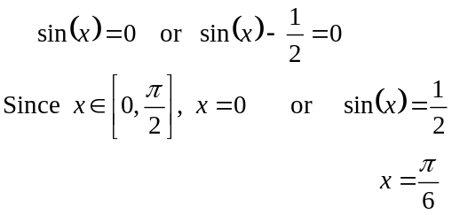
The answer is C.

Question 22

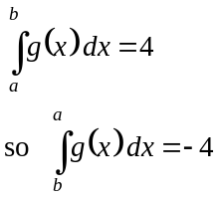
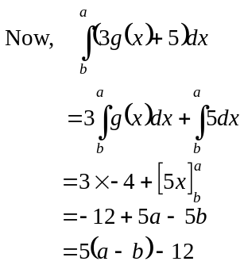
The answer is D.

SECTION 2

Question 1

- 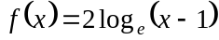
Let 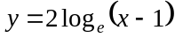
Find inverse using CAS calculator.
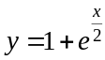
Now, from diagram
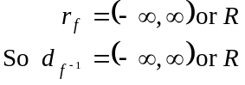
The inverse function is defined by 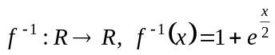
(1 mark) for 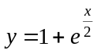
(1 mark) for correct domain

b. 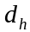 gives the values of x for which both f and g are defined.
Since 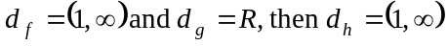.
(1 mark)
c.
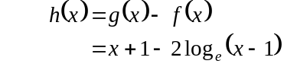
For a min/max 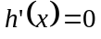 (1 mark)
Solve this equation for x.
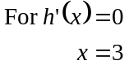
(1 mark)
- From part c. the minimum value of h occurs when . Since 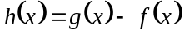, the minimum vertical distance between the graphs of 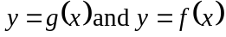 is given by 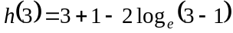
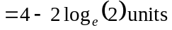
(1 mark)

- Method 1

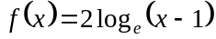

To show: 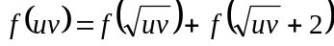

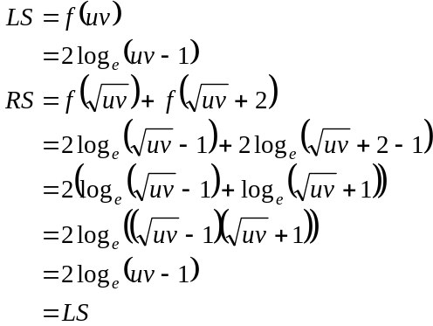
(1 mark)

Method 2

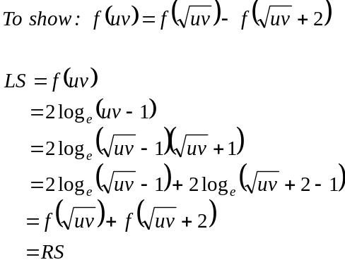
Have shown.
(1 mark)
Total 7 marks

Question 2

- Since the function h is a continuous function,
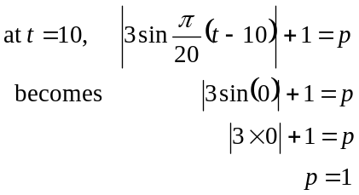
(1 mark)
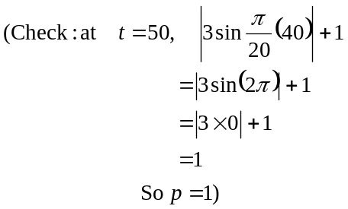

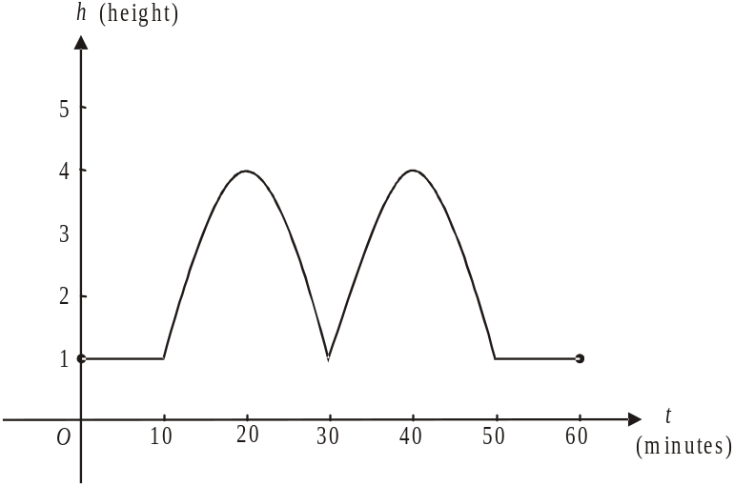

(1 mark) correct linear branches and endpoints
(1 mark) correct period of sine graph
(1 mark) correct amplitude and recognition
of effect of absolute value

- From the graph, and due to the symmetry of the sine curve, we see that the maximum occurs at .
(1 mark)

- We need to solve 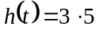
Using a calculator to solve this we have
Since Mal arrives at (i.e. 13 minutes after the hour, i.e. after 8 o’clock), he has to wait minutes (correct to two decimal places).
(1 mark)

- From part d. we found that Mal could first pass through the entrance at . Using the graph below and bearing in mind the symmetry of the graph, we can find the total time Mal can gain entry.
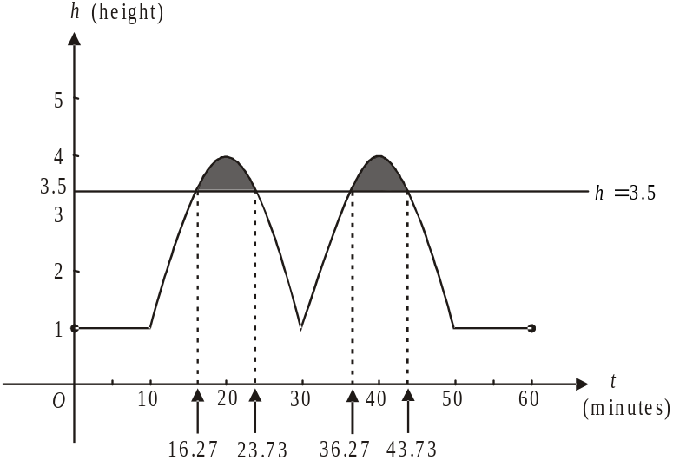

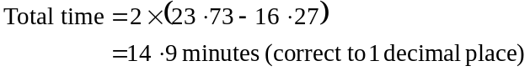
(1 mark)
(1 mark)

- From part d., the first time that Mal can pass through the entrance is at .
Since the mass of his load is 2 tonnes, it will take him
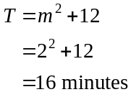
(1 mark)
to be back at the boomgate entrance.
At however the boomgate is not high enough for Mal to pass through. From part e. we see that he can pass through again at . In total, he will be inside for .
(1 mark)

g. Solve 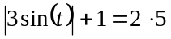
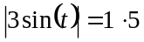
The period of the graph 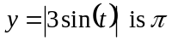 because of the absolute function.
(Note that the period of the function 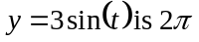). (1 mark)
For 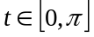, the solutions to the equation 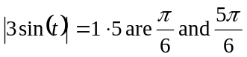.
So the general solution is 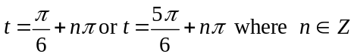.
Alternatively 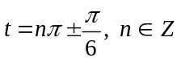.
(1 mark)
Total 12 marks

Question 3

- Method 1 – using a CAS calculator.
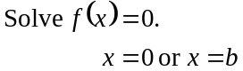
(1 mark)

Method 2 – by hand
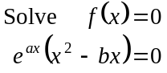
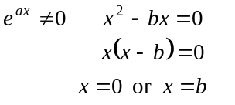
(1 mark)

- From the graph we see that the x-intercepts are located at . From part a. therefore . (1 mark)
Also, the point 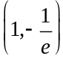 lies on the graph.
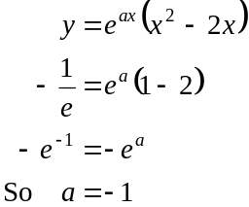
(1 mark)
- The minimum value of f occurs at the turning point between .
The coordinates of that turning point are 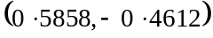 where coordinates are correct to 4 decimal places.
So 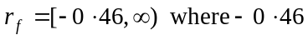 is correct to 2 decimal places.
(1 mark) for and correct bracket
(1 mark) for and correct bracket

- By observing the graph of f for 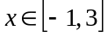 we see that the maximum will occur at the endpoint where .
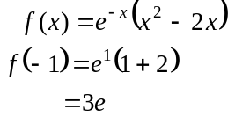
The maximum value of f for 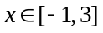is 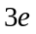.

(1 mark)

- 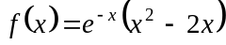
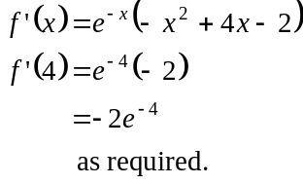
(1 mark)

- Solve for x
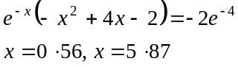
(correct to two decimal places)
(1 mark)

g.
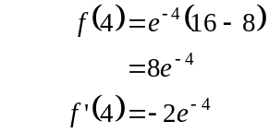
Equation of tangent is
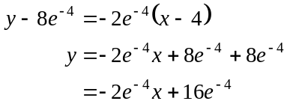
(1 mark)
When 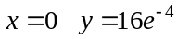.
The y-intercept is 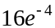.
(1 mark)
Total 10 marks

Question 4

- i. 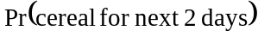
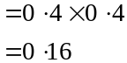
(1 mark)

  - Method 1
Use a tree diagram.
Let 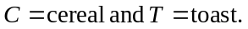
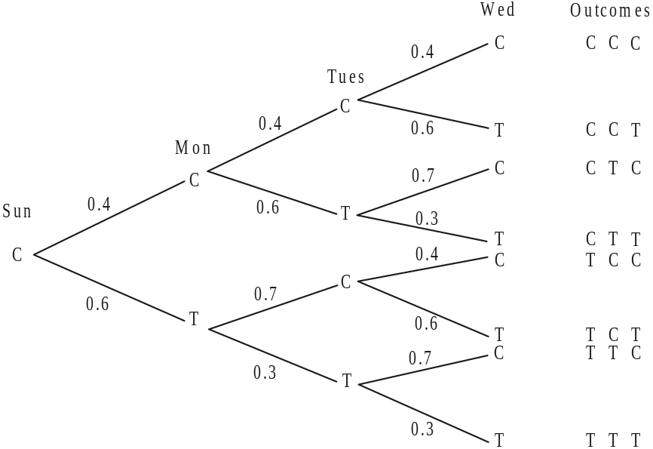

(1 mark)
Pr(cereal just once over next 3 mornings)
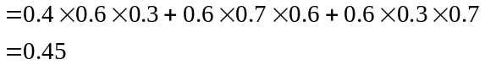
(1 mark)

Method 2
(1 mark)
Pr(cereal just once over next 3 mornings)
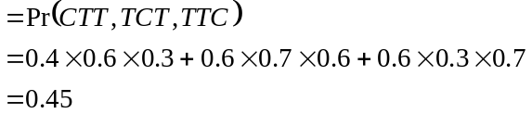
(1 mark)

- Use a transition matrix, T:

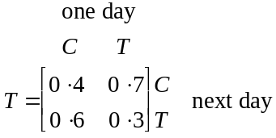
(1 mark)
Method 1
The long term probability of Liv having toast is given by 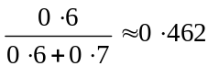 (correct to 3 decimal places).
(1 mark)

Method 2

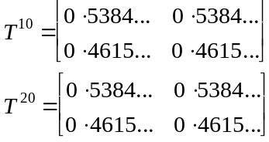

To four decimal places at least, a steady state has been reached. Given that Liv had cereal for breakfast on Sunday morning, the long term probability of Liv having toast
is 0.462 (correct to 3 decimal places).
(1 mark)

(Note: if you use the other possible transition matrix (given below) the result is the same

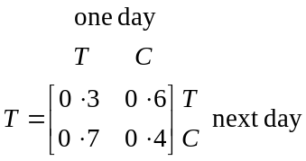

Method 1
The long term probability of Liv having toast is given by (correct to 3 decimal places).

Method 2
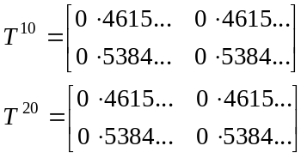
To four decimal places at least, a steady state has been reached.
The long term probability of Liv having toast is 0.462 (correct to 3 decimal places).)
c.
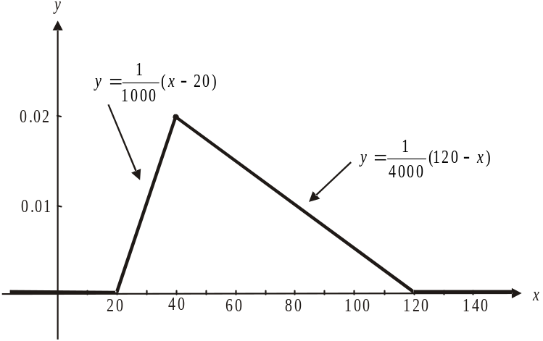

(1 mark) correct branch for
(1 mark) correct branch for
(1 mark) correct branch for

d. Method 1 – using a calculator
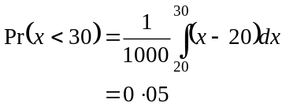
(1 mark)

Method 2 – graphically
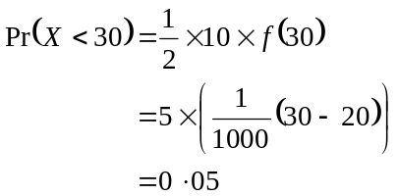
(1 mark)

e. This represents a binomial distribution.
From part d. 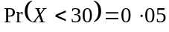; that is, the probability that Liv has less than one cup of cereal for breakfast is 0.05.
Method 1 – by hand
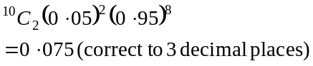
(1 mark)
Method 2 – by calculator
(1 mark)

f. Find 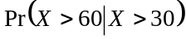
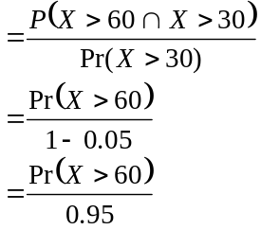
- using the diagram
- using part d.
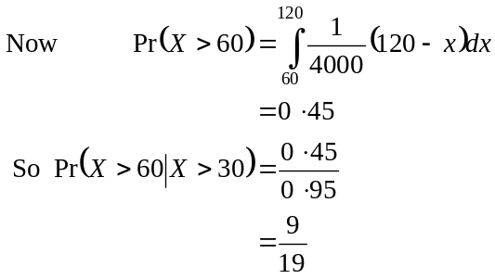
(1 mark)
(1 mark)

g. 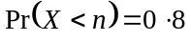
(1 mark)
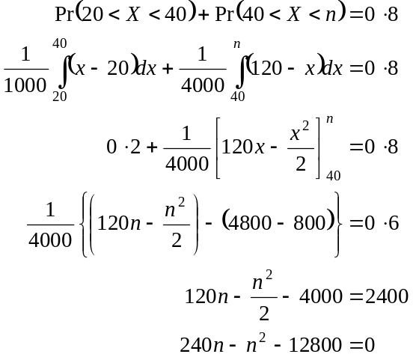
(1 mark)

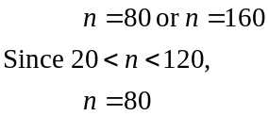

(1 mark)
Total 15 marks
Question 5

- At the point where , the graph of intersects with the graph of 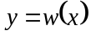.
So solve
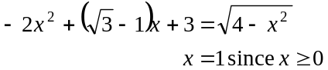
So 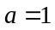.
(1 mark)

- i. From the graph, the two transformations could be a reflection in the x-axis followed by a reflection in the y-axis or vice versa.
(1 mark) reflection in x-axis
(1 mark) reflection in y-axis

  - If the graph of is reflected in the x-axis the rule of the image function is
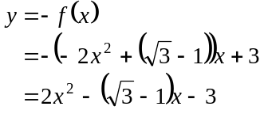
(1 mark)
If the graph of 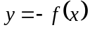 is then reflected in the y-axis it becomes the graph of
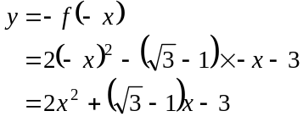
So the rule for g is 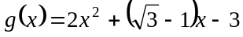.
(1 mark)

  - From the graph, the domain of g is 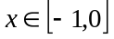.
(1 mark)

    - i. The highest point will occur when 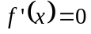.
(1 mark)
( or similar needs to be written to gain this mark.)
Solving this gives 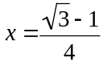
(1 mark)

- 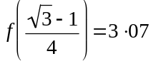 (correct to 2 decimal places).
The maximum height of the machine is above the ground (correct to 2 decimal places).
(1 mark)

d. From part c. the turning point of the inverted parabola described by is 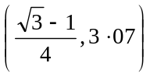.
Hence means use what you have found so we use this rounded value of .
At the point where 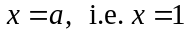 (from part a.), 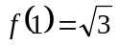.
So 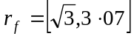.
(1 mark) for 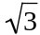 and correct bracket
(1 mark) for and correct bracket

e. i. Cross-sectional area of top bucket
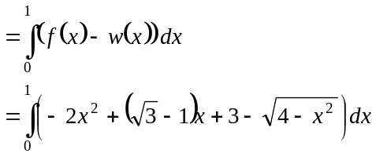
(1 mark) correct integrand
(1 mark) correct terminals

- Evaluate the definite integral in part i.
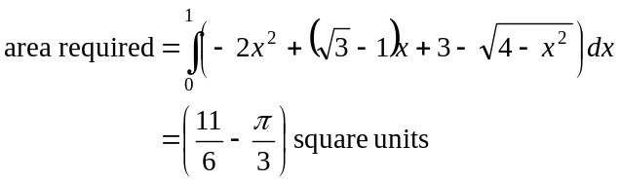
(1 mark)
Total 14 marks

