
Student Name……………………………………

MATHEMATICAL METHODS (CAS) UNITS 3 & 4

TRIAL EXAMINATION 2

2008

Reading Time: 15 minutes
Writing time: 2 hours

Instructions to students

This exam consists of Section 1 and Section 2.
Section 1 consists of 22 multiple-choice questions, which should be answered on the detachable answer sheet that can be found on page 27 of this exam.
Section 2 consists of 5 extended-answer questions that should be answered in the spaces provided.
Section 1 begins on page 2 of this exam and is worth 22 marks.
Section 2 begins on page 11 of this exam and is worth 58 marks.
There is a total of 80 marks available.
All questions in Section 1 and Section 2 should be answered.
Unless otherwise stated, diagrams in this exam are not drawn to scale.
Where more than one mark is allocated to a question, appropriate working must be shown.
Where an exact answer is required to a question, a decimal approximation will not be accepted.
Where you are asked to use calculus in a question you must show an appropriate derivative or antiderivative.
Students may bring one bound reference into the exam.
Students may bring an approved CAS calculator and if desired one scientific calculator into the exam.
A formula sheet can be found on page 26 of this exam.

This paper has been prepared independently of the Victorian Curriculum and Assessment Authority to provide additional exam preparation for students. Although references have been reproduced with permission of the Victorian Curriculum and Assessment Authority, the publication is in no way connected with or endorsed by the Victorian Curriculum and Assessment Authority.

© THE HEFFERNAN GROUP 2008
This Trial Exam is licensed on a non transferable basis to the purchasing school. It may be copied by the school which has purchased it. This license does not permit distribution or copying of this Trial Exam by any other party.
SECTION 1

Question 1

Consider the function f with rule 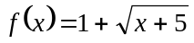.
The maximal domain of f is

- 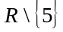
- R
- 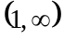
- 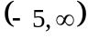
- 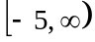

Question 2

The function 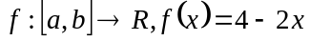 has range 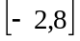.
The values of a and b are

- 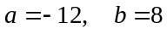
- 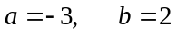
- 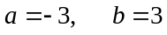
- 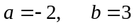
- 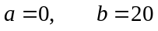

Question 3

The graphs of 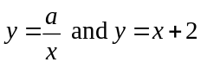 intersect at two distinct points for

Question 4

If 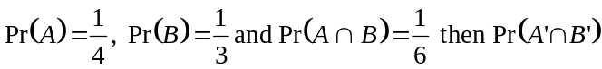 is equal to

- 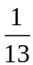
- 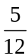
- 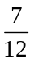

Question 5

A random variable X has a normal distribution with a mean of 6 and a standard deviation of 0.5.
The random variable Z has a standard normal distribution.
The probability that X is greater than 7 is equal to

- 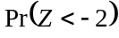
- 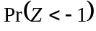
- 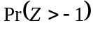
- 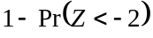
- 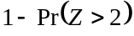

Question 6

The transformation 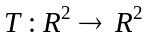 is defined by

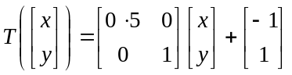

The image of the curve 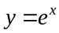 under T has the equation

- 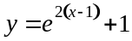
- 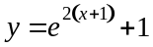
- 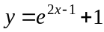
- 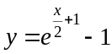
- 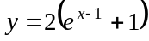
Question 7

The average rate of change of the function 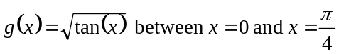 is

- 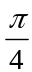

- 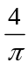

- 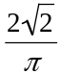

- 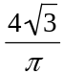

- 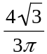

Question 8

For the function 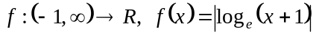, it is true to say that

- 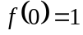
- 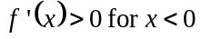
- the graph of 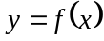 is smoothly continuous at
- 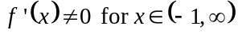
- the function f has an inverse function
Question 9

The graph of and part of the graph of 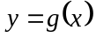 are shown below.
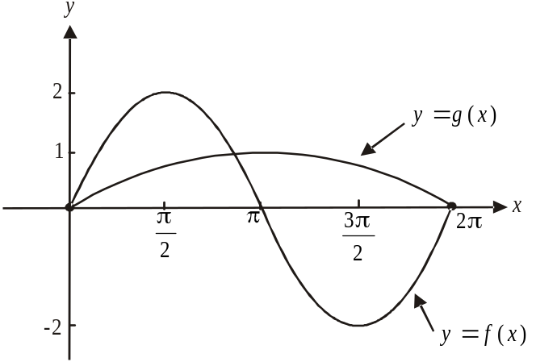

The transformations that the graph of undergoes to become the graph of are

- a dilation by a scale factor of 2 from the y-axis followed by a translation by one unit down.
- a dilation by a scale factor of from the y-axis followed by a translation by one unit down.
- a dilation by a scale factor of from the x and y-axis.
- a dilation by a scale factor of 2 from the x-axis followed by a dilation by a scale factor of from the y-axis..
- a dilation by a scale factor of from the x-axis followed by a dilation by a scale factor of 2 from the y-axis

Question 10

The function 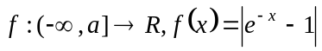 will have an inverse function if

Question 11

The average value of the function 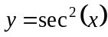 over the interval 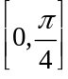 is

- 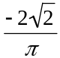

Question 12

The continuous function 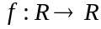 has the following properties:

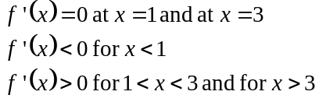

It is true to say that the graph of f has a

- maximum turning point at
- minimum turning point at 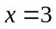
- stationary point of inflection at
- stationary point of inflection at
- stationary point of inflection at and a minimum turning point at

Question 13

In an animation, a pyramid is being shown. The pyramid has a square base of variable side length
x cm and a fixed height of 90cm.
The rate at which the side lengths of the base are increasing is 2cm/sec.
The rate at which the volume of the pyramid is increasing when the side lengths of the base are 5cm is given by

- 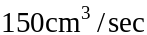
- 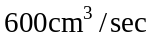
- 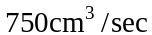
- 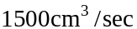
- 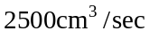

Question 14

The function f satisfies the functional equation

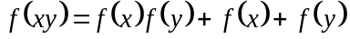

where x and y are real non-zero numbers.

The rule for f could be

- 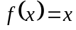
- 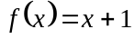
- 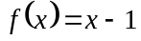
- 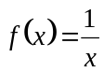
- 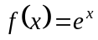

Question 15

Consider the function 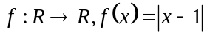.
The area between the graph of , the x-axis and the lines is given by

- 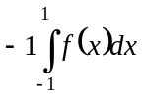
- 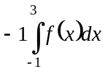
- 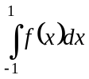
- 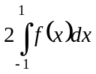
- 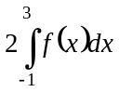

Question 16

The graph of is shown below.

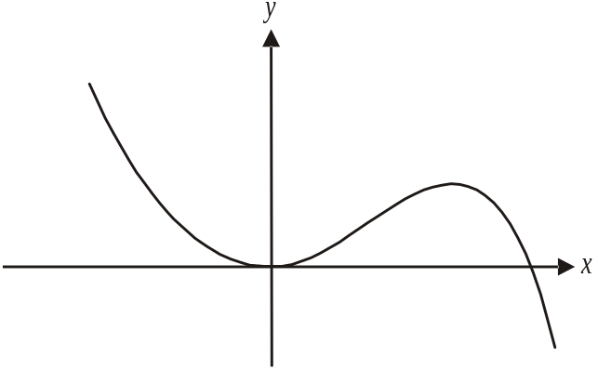

The graph of 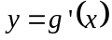 could be represented by

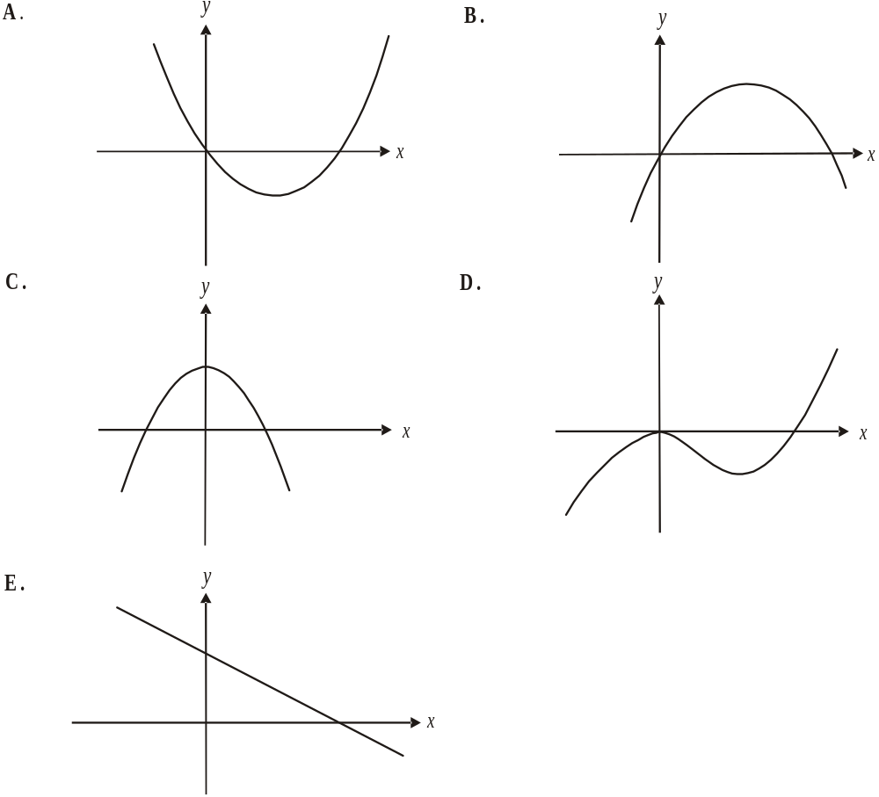

Question 17

If 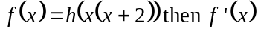 is equal to

- 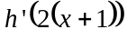
- 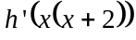
- 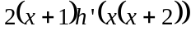
- 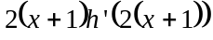

Question 18

The simultaneous linear equations

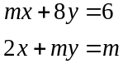

have no solution for

- 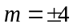
- 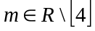
- 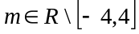

Question 19

The weights of a group of school children are normally distributed with a mean of 42kg and a standard deviation of 3.2kg. For this age group a child of more than 44kg is considered overweight.
The proportion of overweight children in this group is

- 5%
- 10%
- 27%
- 73%
- 90%

Question 20

The continuous random variable X has a probability density function given by

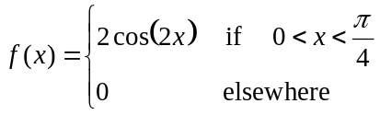

The value of a such that 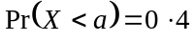 is closest to

- – 0.2
- 0.1
- 0.2
- 0.4
- 11.8

Question 21

If 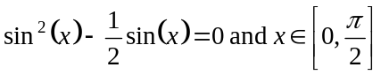 then

- only
- 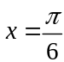 only
- 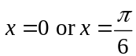
- 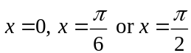
- 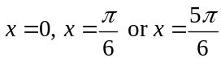

Question 22

If 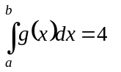then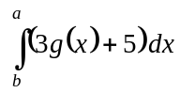 is equal to

- – 7
- 17
- 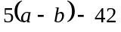
- 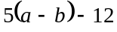
- 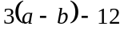

SECTION 2

Answer all questions in this section.

Question 1

The graphs of the functions are shown below.
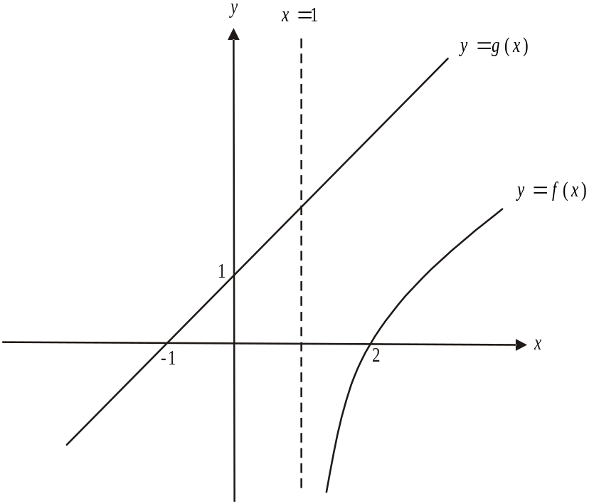

- Find the rule and the domain of the inverse function 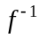.

2 marks

Consider the function h where 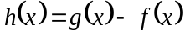.

- Write down the domain of h.

1 mark

- Find the value of x for which 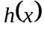 is a minimum. (You are not required to justify that the stationary point is a minimum).

2 marks

- Hence find the minimum vertical distance between the graphs of 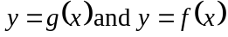. Express your answer as an exact value.

1 mark

- For 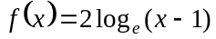, show that 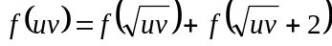 where u and v are positive real numbers.

1 mark

Total 7 marks

Question 2

A boomgate at the entrance to a warehouse is malfunctioning. It is automatically opening and closing in a pattern that repeats each hour and will not respond to being manually opened or closed.

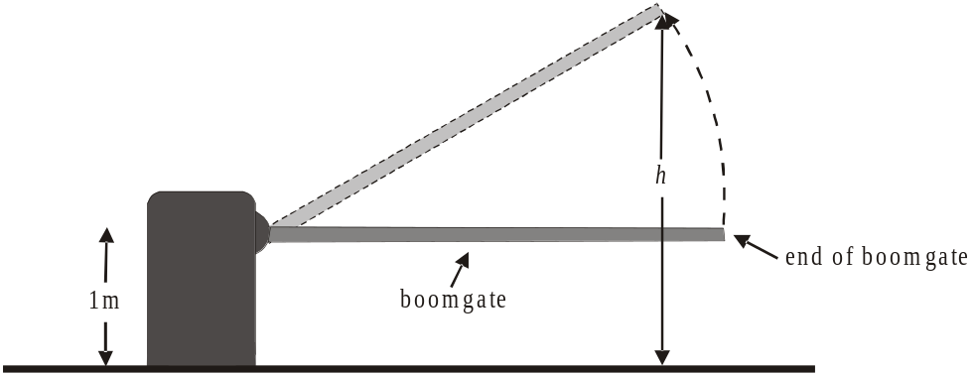

The height above the ground, h, in metres, of the end of the boomgate at time t minutes, is given by the continuous function

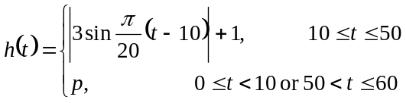

where corresponds to 8am on this particular day.

- Find the value of p.

1 mark

- Sketch the graph of the function h for .
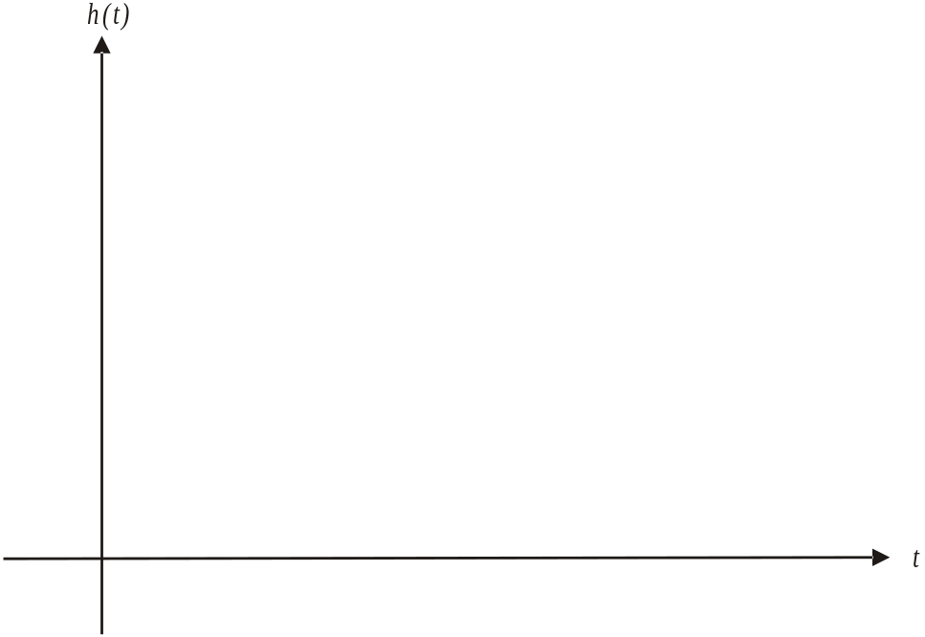

3 marks

- For what value(s) of t does the boomgate reach its maximum height above the ground?

1 mark

A delivery truck can pass through the entrance to the warehouse when the end of the boomgate is 3.5 metres or higher above the ground.
Mal drives a delivery truck and pulls up at the entrance at 8:13am.

- How long does Mal have to wait until he can first drive his delivery truck through the entrance? Express your answer in minutes correct to 2 decimal places.

1 mark

- How many minutes in each hour would Mal be able to pass through the entrance to the warehouse? Express your answer correct to 1 decimal place.

2 marks

The time, T minutes, that Mal takes to pass through the entrance, unload and return to the boomgate is dependent on the mass, m tones, of his load where 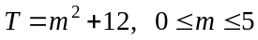.
Assume that Mal could drive through the entrance at the first possible opportunity after his 8:13am arrival.

- Find the total time in minutes that elapses between Mal entering and exiting at the boomgate entrance given that the mass of his load is 2 tonnes.

2 marks

- Let 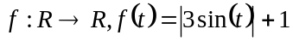. Find the general solution of the equation 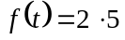.

2 marks
Total 12 marks
Question 3

Consider the function 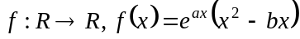 where a and b are constants.

- Find the value(s) of x for which 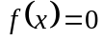.

1 mark

The graph of is shown below.

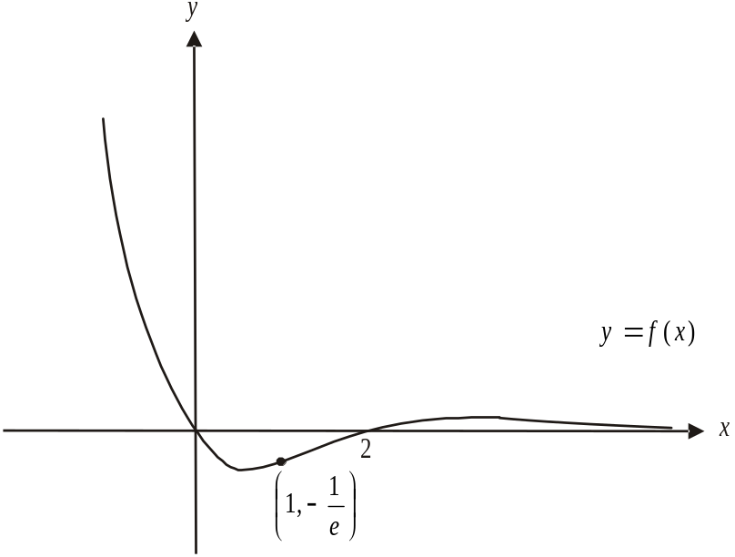

- Explain why .

2 marks

- Find the range of f. Express values correct to 2 decimal places where appropriate.

2 marks

d. Find the maximum value of f for 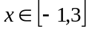. Express your answer as an exact value.

1 mark

- Show that at the point on the graph of 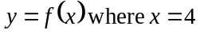, the gradient is 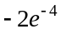.

1 mark

- Find the x-coordinates of the other points on the graph of where the gradient is . Express your answers correct to 2 decimal places.

1 mark

- Find the y-intercept of the tangent to the graph of at the point where . Express your answer as an exact value.

2 marks
Total 10 marks

Question 4

Each morning Liv has either toast or cereal for breakfast.

If she has toast one morning then the probability that she has toast the next morning is 0.3.
If she has cereal one morning then the probability that she has toast the next morning is 0.6.

Liv has cereal for breakfast one Sunday morning.

- i. What is the probability that she will have cereal for the next two mornings?

____________________________________________________________________

____________________________________________________________________

____________________________________________________________________

- What is the probability that she will have cereal just once over the next three mornings?

____________________________________________________________________

____________________________________________________________________

____________________________________________________________________
marks

- Over the long term, what proportion of mornings does Liv have toast for breakfast? Express your answer correct to 3 decimal places.

2 marks

When Liv has cereal for breakfast, the mass, X, (grams) of cereal that she pours into her bowl is a continuous random variable with probability density function given by

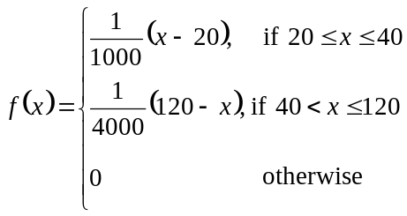

c. Sketch the graph of on the set of axes below.
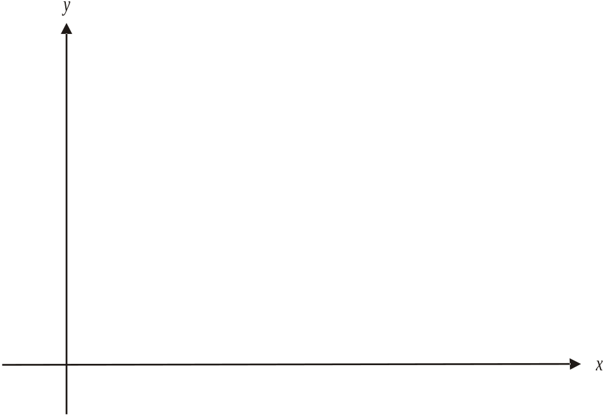

3 marks
d. One cup of Liv’s breakfast cereal has a mass of 30g.
Show that the probability of Liv having less than a cup of cereal for breakfast is 0.05.

1 mark

e. Hence what is the probability that Liv has less than 1 cup of cereal for breakfast on 2 of the next 10 mornings that she has cereal? Express your answer correct to 3 decimal places.

1 mark

f. Find the probability that Liv has more than 2 cups of cereal given that she has more than one. Express your answer as an exact value.

2 marks

g. If 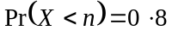, find the value of n.

3 marks
Total 15 marks
Question 5

The cross-sectional view of an earth moving machine at a mine is shown in Diagram 1 below.
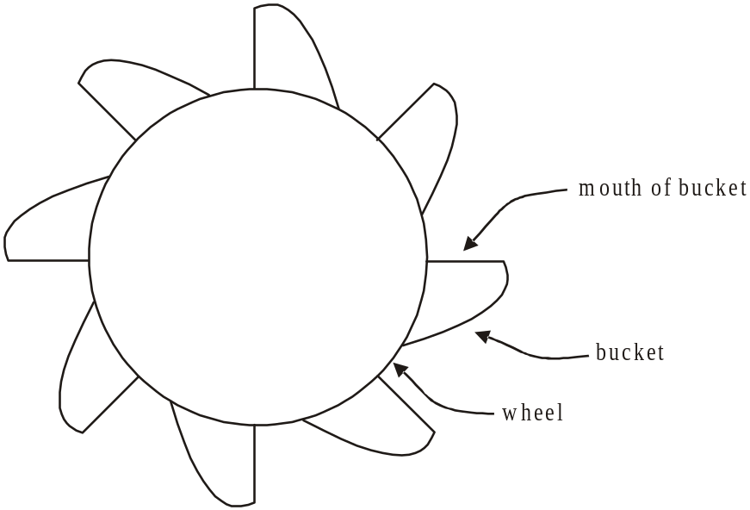

Diagram 1

Eight identically sized buckets; in which the earth is collected, are attached evenly around a wheel that turns anticlockwise. The mouth of the bucket is a straight line of length 1 metre.
Diagram 2 below shows the wheel, with centre located at 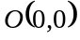 on the Cartesian plane, and two of the buckets. The mouth of both of these buckets is running vertically; that is, along the y-axis.
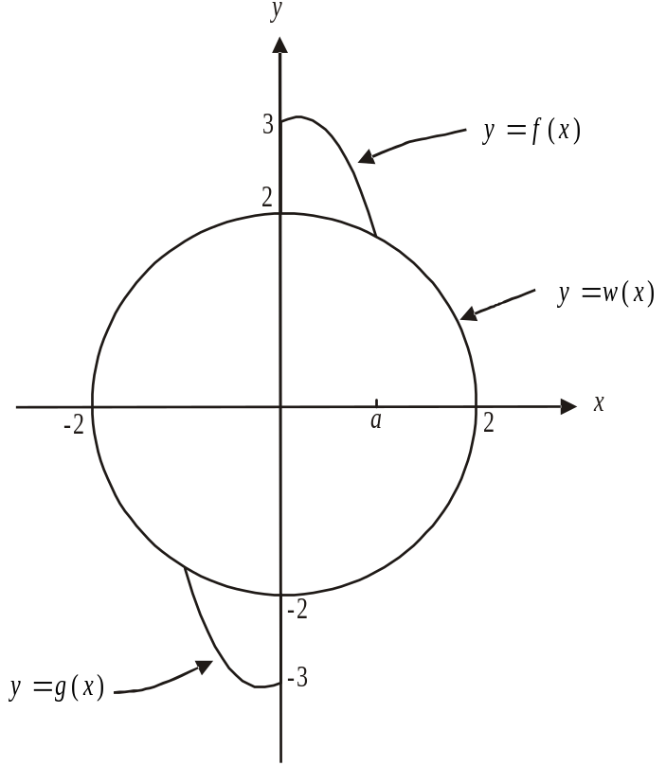

Diagram 2

The right hand edge of the top bucket can be defined by the function

.

The edge of the top half of the wheel can be defined by the function

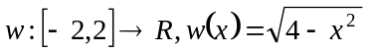.

- Find the value of a.

1 mark
The left hand edge of the bottom bucket can be defined by the function g.

- i. Write down a sequence of two transformations (excluding rotations) that map the graph of on to the graph of .

  - Hence find the rule for g.

  - Write down the domain of g.

marks

The centre of the wheel is 5m above the ground and the machine has its buckets in the position indicated in Diagram 2. Also, the unit of measurement in Diagram 2 is the metre.

    - i. Find the value of x for which the height of the machine above the ground is a maximum. Express your answer as an exact value.

- Hence find the maximum height of the machine above the ground. Express your answer in metres correct to 2 decimal places.

marks

    - Hence write down the range of the function f.

2 marks

The functions f and w are shown in Diagram 3 below.
The cross-sectional area of the top bucket is bounded by the y-axis and the graphs of and 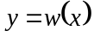.
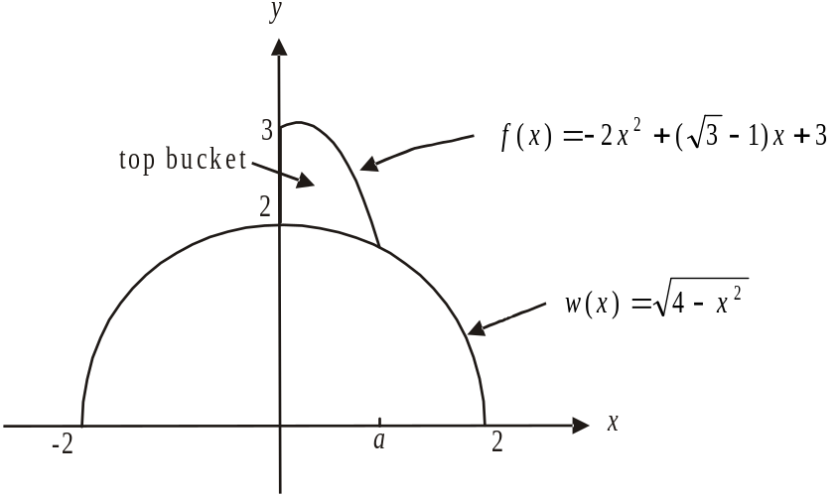

Diagram 3

- i. Write down a definite integral that gives the cross-sectional area of the top bucket shown.

  - Hence find the cross-sectional area of the top bucket. Express your answer as an exact value.

marks
Total 14 marks

Mathematical Methods and Mathematical Methods CAS Formulas

Mensuration
area of a trapezium: 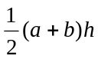 volume of a pyramid: 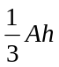
curved surface area of a cylinder: 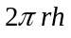 volume of a sphere: 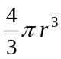
volume of a cylinder: 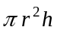 area of a triangle: 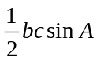
volume of a cone: 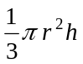

Calculus
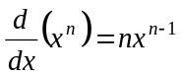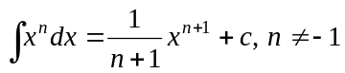
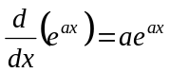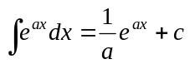
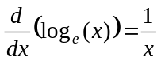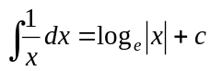
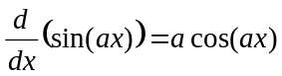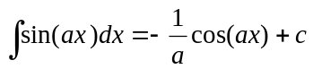
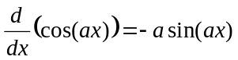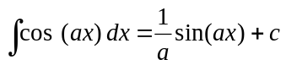
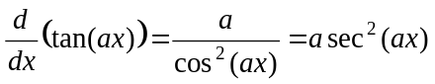
product rule: 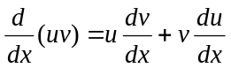 quotient rule: 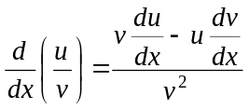
chain rule: 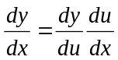 approximation: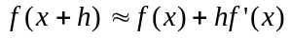

Probability
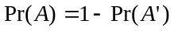
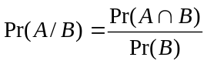
mean: 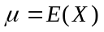 variance:
probability distribution |  | mean | variance
discrete | 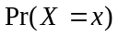=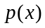 | 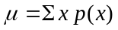 | 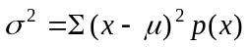
continuous | 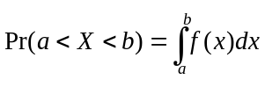 | 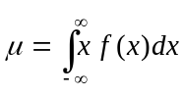 | 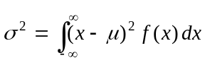
This formula sheet has been reproduced with permission of the Victorian Curriculum and Assessment Authority, Victoria, Australia.
This formula sheet has been copied in 2008 from the VCAA website www.vcaa.vic.edu.au
The VCAA publish an exam issue supplement to the VCAA bulletin.
