
MATHS METHODS (CAS) 3 & 4
TRIAL EXAMINATION 1
SOLUTIONS
2009

Question 1

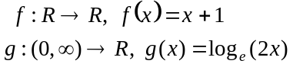

- 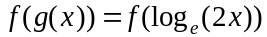
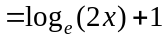
(1 mark)

- 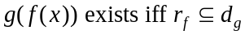.
Now 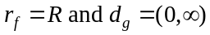
Since 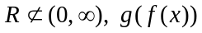 does not exist.
(1 mark)

Question 2

- 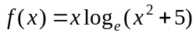
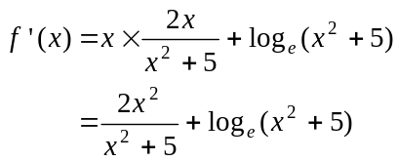
(1 mark) – use of product rule
(1 mark) – correct derivative
- 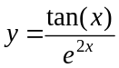
(1 mark) use of quotient rule
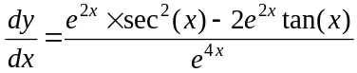
(1 mark) substituting x = 0
When ,
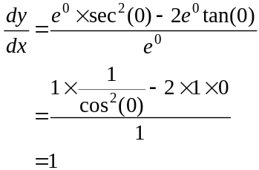
(1 mark) – correct answer

Question 3
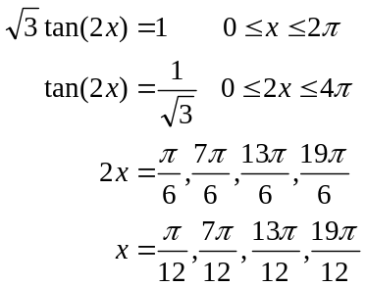
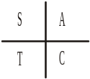
(1 mark) – for 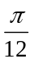
(1 mark) – for remaining 3 correct answers
Question 4

- i. Method 1 – using a probability table or Karnaugh map.

This is what is given. This is what we can work out.
 | A | A’
B | 0.15 |  | 0.4
B’
 | 0.3 |  | 1

 | A | A’
B | 0.15 | 0.25 | 0.4
B’ | 0.15 | 0.45 | 0.6
 | 0.3 | 0.7 | 1

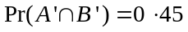 (1 mark)

Method 2 – using a Venn Diagram
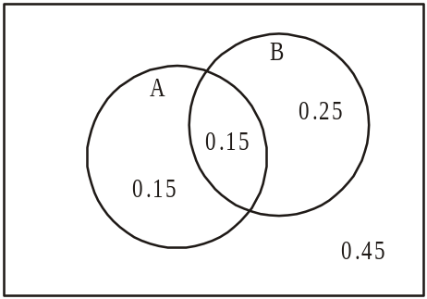

(1 mark)

Method 3 –using Addition rule

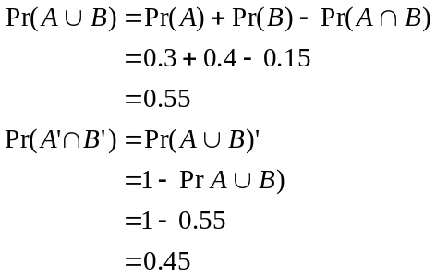
(1 mark)
ii.
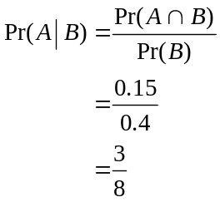
(1 mark)

- If A and B are mutually exclusive then 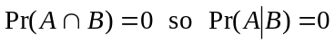. (1 mark)

Question 5

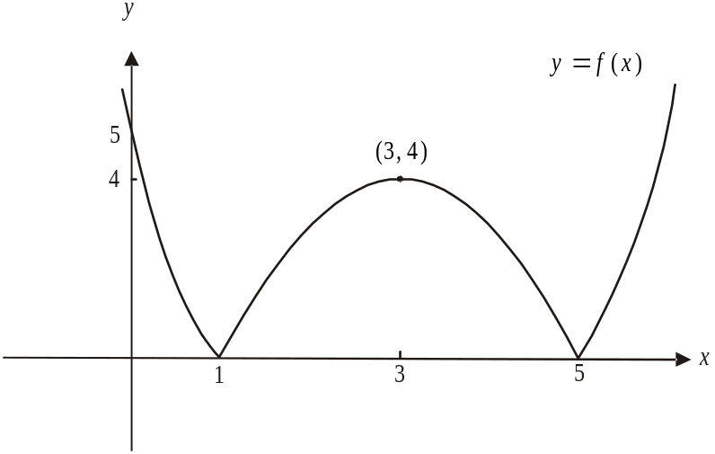

(1 mark) – correct shape including cusps at
(1 mark) correct labelling of intercepts and turning point

- 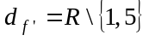 (1 mark)

- 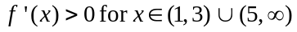 (1 mark)

Question 6

a.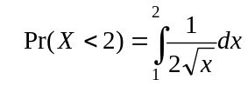 (1 mark)
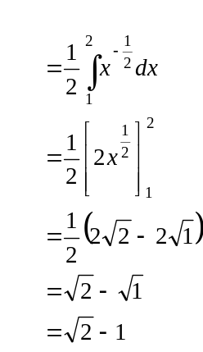
(1 mark)
b.
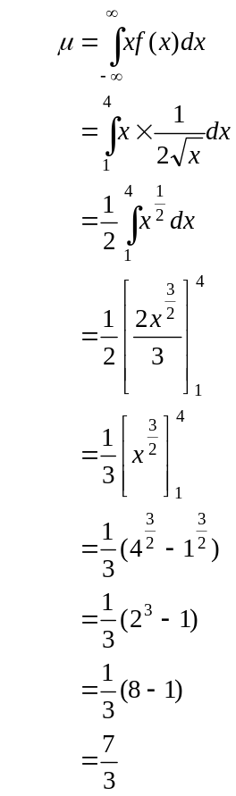
(1 mark)
(1 mark)
Question 7
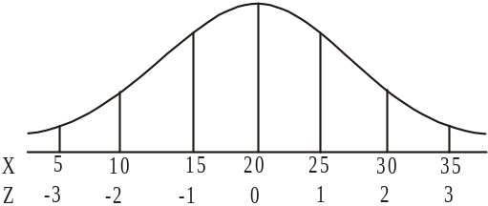
- From the diagram,
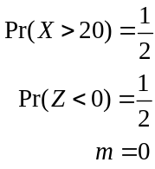

(1 mark)

- 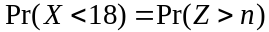

Again from the diagram,
(1 mark)
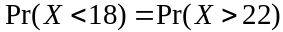 by symmetry
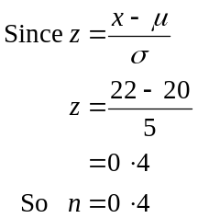
(1 mark)

Question 8

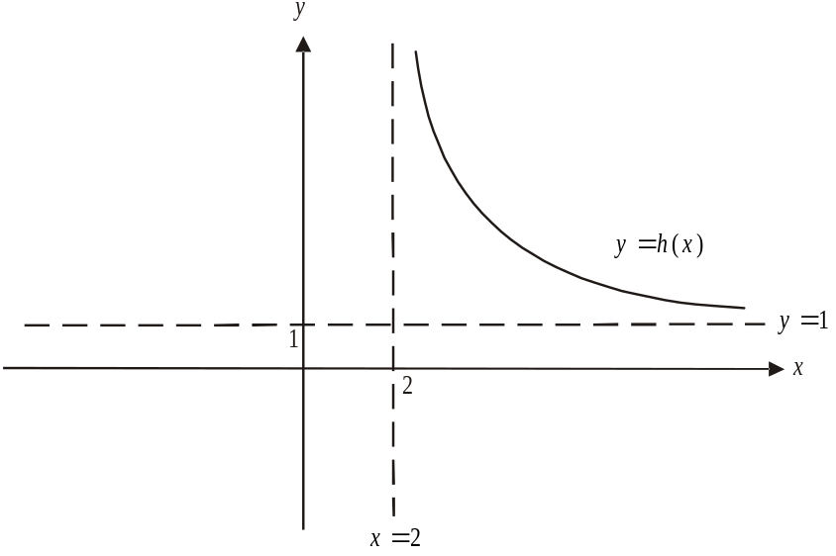

(1 mark) – correct shape of graph
(1 mark) – correct asymptotes

- 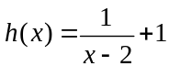
Let 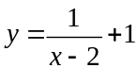
Swap x and y for inverse
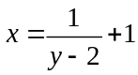
Rearrange
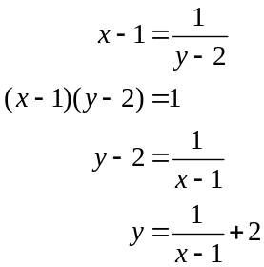
So 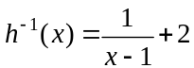 (1 mark) – correct rule
So 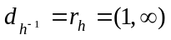 (1 mark) – correct domain

Question 9
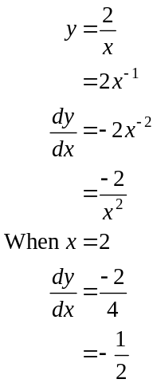

The gradient of the tangent to f at 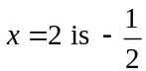.
Therefore the gradient of the normal to f at is 2. (1 mark)

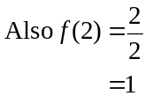
The equation of the normal through 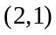 with gradient of 2 is
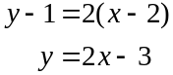
(1 mark)
- The normal crosses the x-axis when 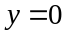.
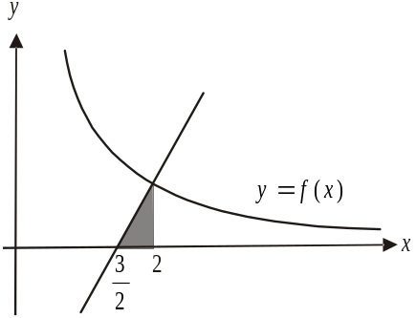
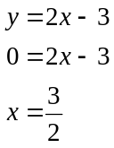
(1 mark)

Method 1
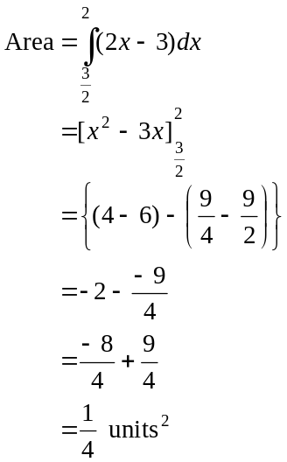
Method 2
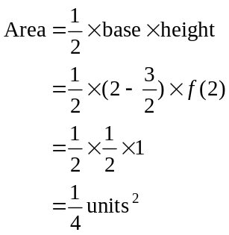

(1 mark) (1 mark)
Question 10

Method 1

Given 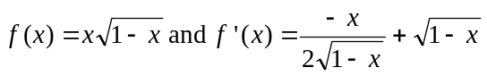
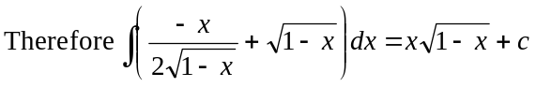 (1 mark)
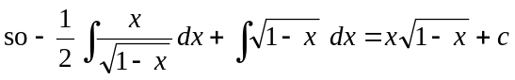
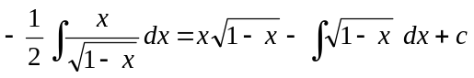
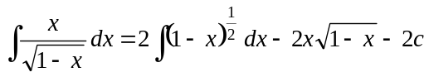
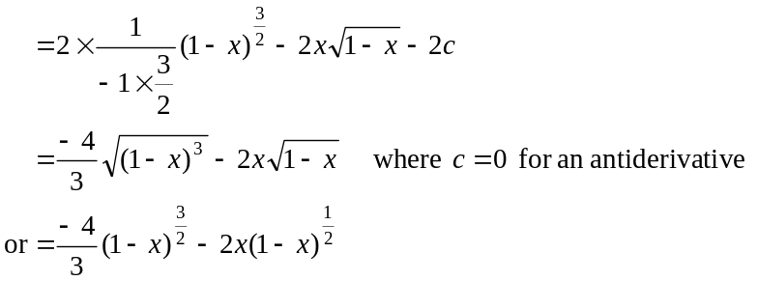
(1 mark) correct antiderivative of 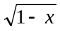 (1 mark) correct answer

Method 2
Given
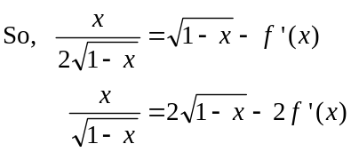
(1 mark)
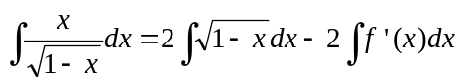
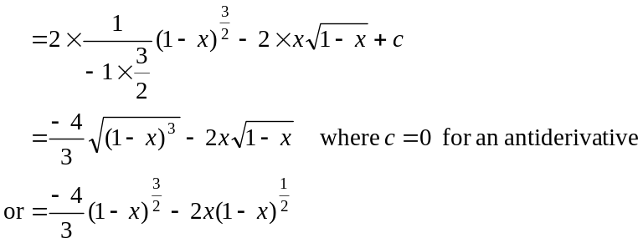

(1 mark) correct antiderivative of (1 mark) correct answer

Question 11
- 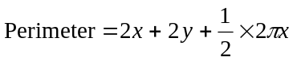
(1 mark)
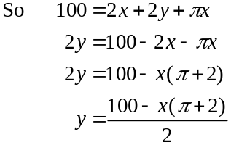
(1 mark)
- 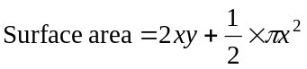
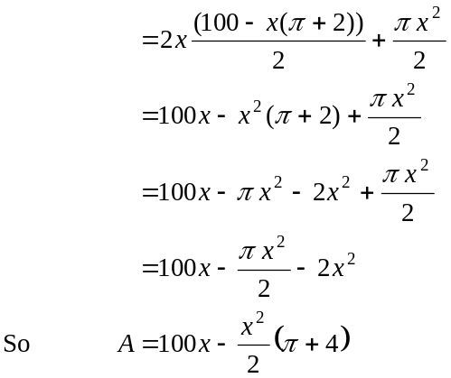
from part a.
(1 mark)
- 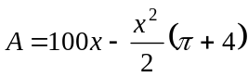
Max/min occur when 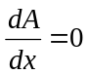.
(1 mark)
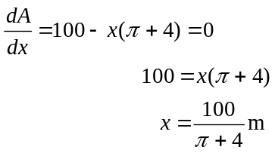
(1 mark)
- Method 1 – using part b.
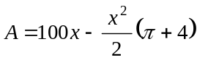
This is the equation of an inverted parabola which has a local maximum and hence there will be a maximum rather than a minimum value to be found.
(1 mark) for reference to inverted parabola
Method 2 – using a sign diagram
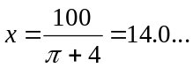
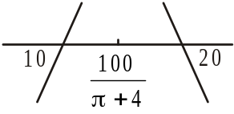
At 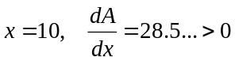.
At 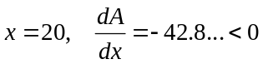
From the sign diagram we see that we have a maximum surface area.
(1 mark)
Total 40 marks

