

Student Name……………………………………

MATHEMATICAL METHODS (CAS) UNITS 3 & 4

TRIAL EXAMINATION 1

2009

Reading Time: 15 minutes
Writing time: 1 hour

Instructions to students
This exam consists of 11 questions.
All questions should be answered in the spaces provided.
There is a total of 40 marks available.
The marks allocated to each of the questions are indicated throughout.
Students may not bring any calculators or notes into the exam.
Where an exact answer is required a decimal approximation will not be accepted.
Where more than one mark is allocated to a question, appropriate working must be shown.
Diagrams in this trial exam are not drawn to scale.
A formula sheet can be found on page 12 of this exam.

This paper has been prepared independently of the Victorian Curriculum and Assessment Authority to provide additional exam preparation for students. Although references have been reproduced with permission of the Victorian Curriculum and Assessment Authority, the publication is in no way connected with or endorsed by the Victorian Curriculum and Assessment Authority.

© THE HEFFERNAN GROUP 2009
This Trial Exam is licensed on a non transferable basis to the purchasing school. It may be copied by the school which has purchased it. This license does not permit distribution or copying of this Trial Exam by any other party.
Question 1

Let 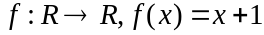 and 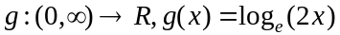.

- Write down the rule of 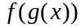.

- Explain why the function 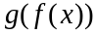 does not exist.

Question 2

- Let 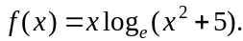 Find 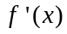.

- Let 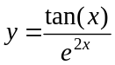. Evaluate 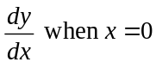.

Question 3

Solve the equation 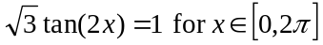.

2 marks

Question 4

From a particular event space, two events A and B are such that .

- If 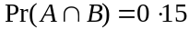, calculate

  - 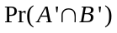

  - 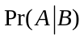

- If A and B are mutually exclusive events find 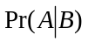.

Question 5

Let 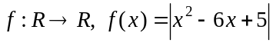.

- Sketch the graph of 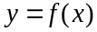 on the set of axes below. Indicate clearly any axes intercepts or turning points.

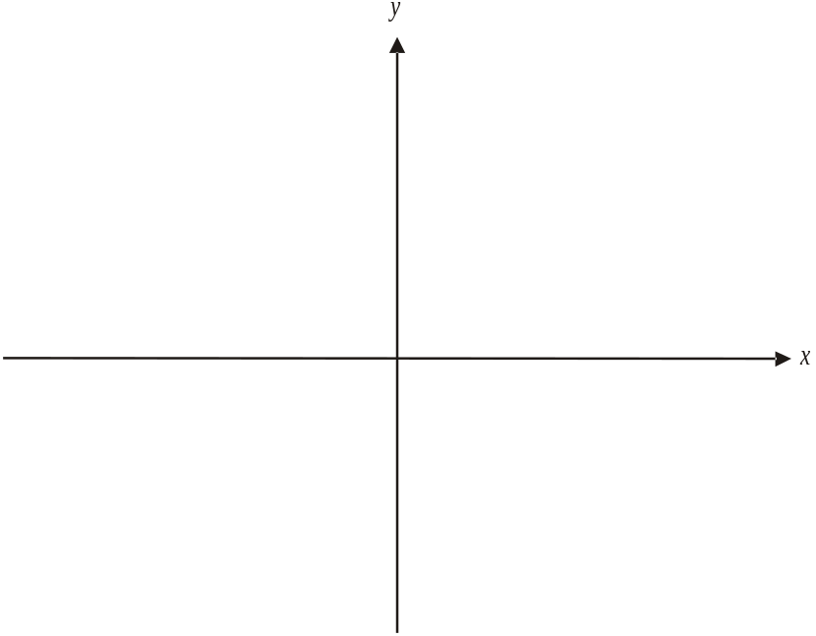

- Write down the domain of the derivative function 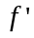.

- Write down the values of x for which 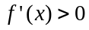.

2 + 1 + 1 = 4 marks

Question 6

The continuous random variable X has a probability density function given by

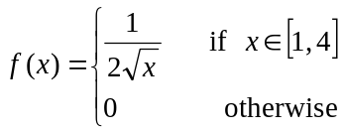

- Find 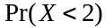.

- Find the mean value of X.

Question 7

Let X be a random variable with a normal distribution.
The mean of X is 20 and the standard deviation is 5.
Let Z be a continuous random variable with a standard normal distribution.

- Find m such that 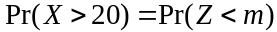.

- Find n such that 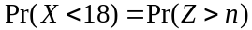.

Question 8

Let 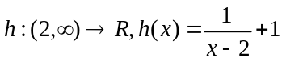.

- On the axes below, sketch the graph of 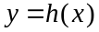. Label any asymptotes with their equation.
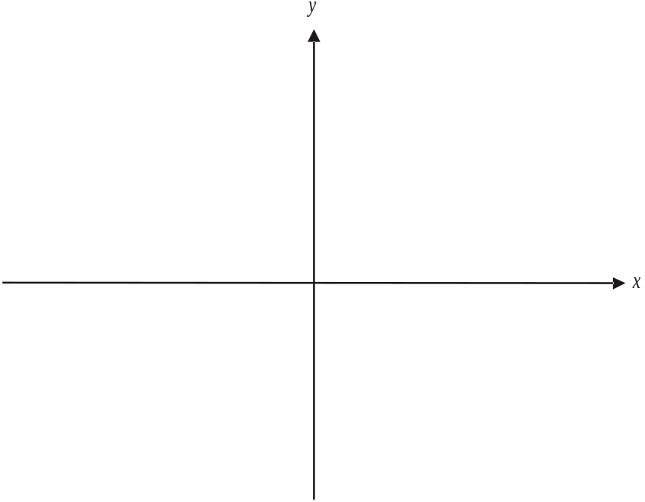

- Find the rule and the domain of the inverse function 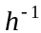.

2 + 2 = 4 marks

Question 9

The graph of 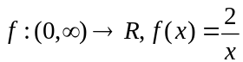 is shown below. The normal to the graph of f at the point where is also shown.

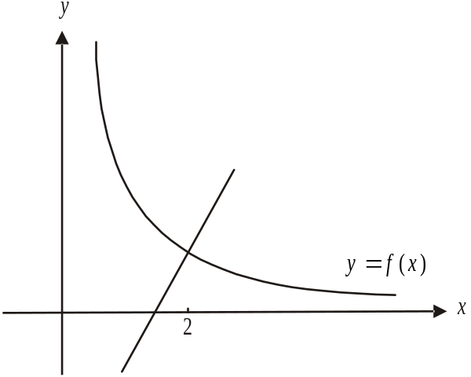

- Find the equation of the normal to the graph of f at the point where .

- Find the area of the region enclosed by the graph of the normal described in part a., the x-axis and the line .

Question 10

Given that 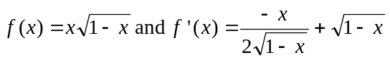, find an antiderivative of 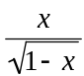.

3 marks

Question 11

A pool complex is made up of a rectangular swimming pool with side lengths 2x m and y m attached to a semi-circular spa of radius x m.

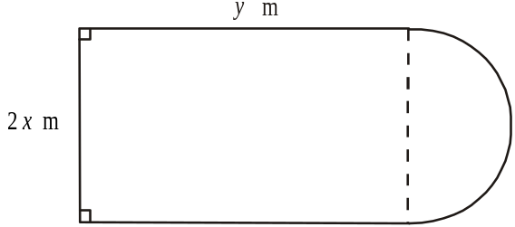

The perimeter of the pool complex is 100m.

- Express y in terms of x.

- Show that the surface area of the pool complex is given by

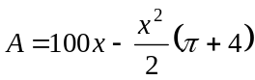.

- Find the value of x for which the surface area of the pool complex is a maximum. It is not necessary to find this maximum surface area.

- Using the result from part b. or otherwise, explain why the value of x found in part c. gives a maximum rather than a minimum surface area.

END OF EXAM 1

Mathematical Methods and Mathematical Methods CAS Formulas

Mensuration

area of a trapezium: 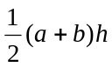 volume of a pyramid: 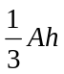
curved surface area of a cylinder: 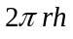 volume of a sphere: 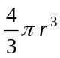
volume of a cylinder: 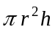 area of a triangle: 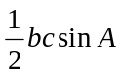
volume of a cone: 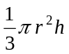

Calculus
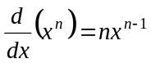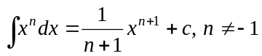
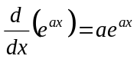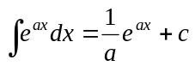
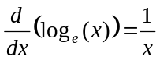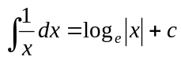
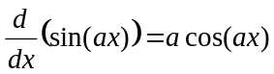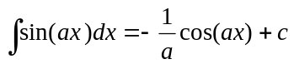
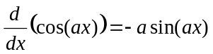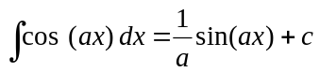
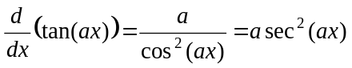
product rule: 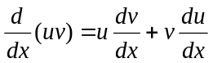 quotient rule: 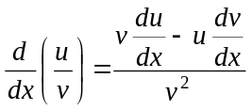
chain rule: 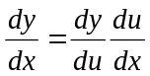 approximation: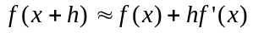

Probability
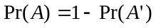
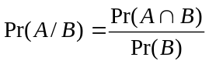
mean: 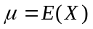 variance:

probability distribution |  | mean | variance
discrete | 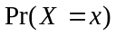=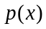 | 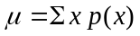 | 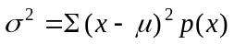
continuous | 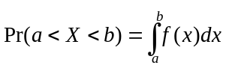 | 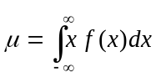 | 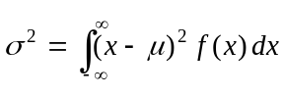

Reproduced with permission of the Victorian Curriculum and Assessment Authority, Victoria, Australia.
This formula sheet has been copied in 2009 from the VCAA website www.vcaa.vic.edu.au
The VCAA publish an exam issue supplement to the VCAA bulletin.

