

Student Name……………………………………

MATHEMATICAL METHODS (CAS) UNITS 3 & 4

TRIAL EXAMINATION 2

2009

Reading Time: 15 minutes
Writing time: 2 hours

Instructions to students
This exam consists of Section 1 and Section 2.
Section 1 consists of 22 multiple-choice questions, which should be answered on the detachable answer sheet which can be found on page 27 of this exam.
Section 2 consists of 4 extended-answer questions.
Section 1 begins on page 2 of this exam and is worth 22 marks.
Section 2 begins on page 11 of this exam and is worth 58 marks.
There is a total of 80 marks available.
All questions in Section 1 and Section 2 should be answered.
Diagrams in this exam are not to scale except where otherwise stated.
Where more than one mark is allocated to a question, appropriate working must be shown.
Students may bring one bound reference into the exam.
Students may bring a CAS calculator into the exam.
A formula sheet can be found on page 26 of this exam.

This paper has been prepared independently of the Victorian Curriculum and Assessment Authority to provide additional exam preparation for students. Although references have been reproduced with permission of the Victorian Curriculum and Assessment Authority the publication is in no way connected with or endorsed by the Victorian Curriculum and Assessment Authority.

© THE HEFFERNAN GROUP 2009
This Trial Exam is licensed on a non transferable basis to the purchasing school. It may be copied by the school which has purchased it. This license does not permit distribution or copying of this Trial Exam by any other party.
SECTION 1
Question 1

The discrete random variable X has the following probability distribution.

x | 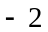 | 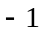 | 0 | 1
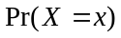 | 0.3 | 0.2 | 0.4 | 0.1

The mean of this distribution is

- – 1.1
- – 0.9
- – 0 .7
- – 0 5
- – 0.175

Question 2

Let . If the inverse function 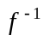exists then the largest value that a can take is

- 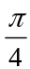
- 1
- 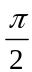
- 2

Question 3

If 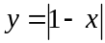, then the rate of change of y with respect to x at is

- – 2
- – 1
- 0
- 1
- 2
Question 4

The simultaneous linear equations

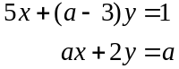

where , will have no solutions for

- 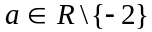
- 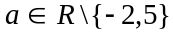
- 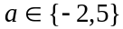

Question 5

At a particular school, ten per cent of Year 11 students have unpaid library fines. If 8 Year 11 students are selected at random, the probability that at least 2 of them have an unpaid library fine would be closest to

- 0.1869
- 0.2669
- 0.3792
- 0.7331
- 0.8722

Question 6

The average value of the function 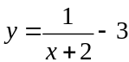 over the interval 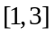 is

- 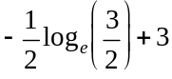
- 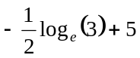
- 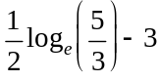
- 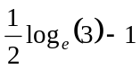
- 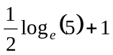
Question 7

If 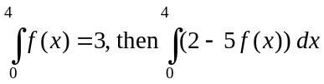 is equal to

- – 7
- – 9
- – 11
- – 13
- – 15

Question 8

Let 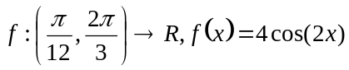.

The range of f is

- 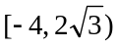
- 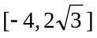
- 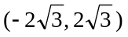
- 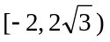
- 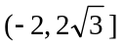

Question 9

The random variable X has a normal distribution with mean 10 and standard deviation 2. The probability that X is less than 5, given that it is less than 10, is closest to

- 0.0062
- 0.0124
- 0.4969
- 0.5
- 0.9938

Question 10

For the graph of 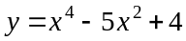, the values of x for which the gradient of the graph is positive are closest to

- 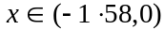
- 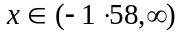
- 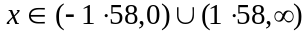
Question 11

The average rate of change of the function is

- 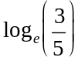
- 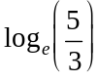
- 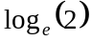
- 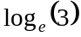
- 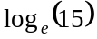

Question 12

The graph of the function h is shown below.

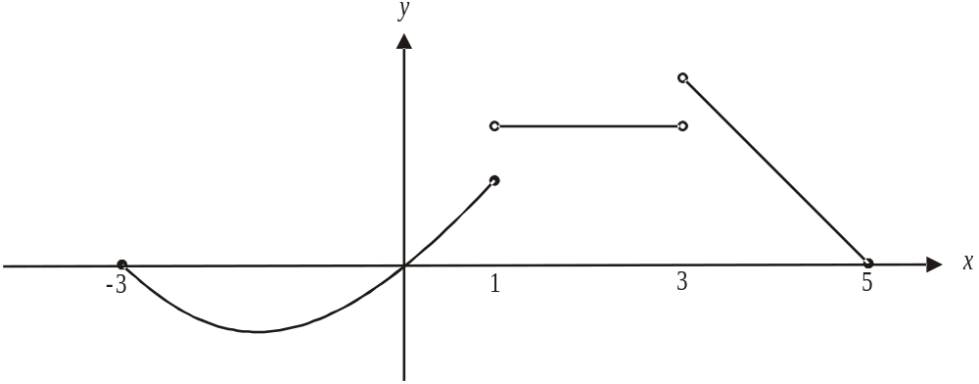

Which one of the following statements is true about the function h?

- h is a continuous function for 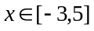
- h exists for 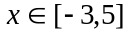
- 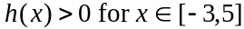
- 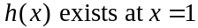
- 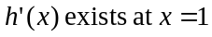
Question 13

The transformation 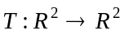 is defined by

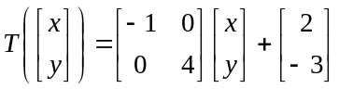

The image of the curve with equation 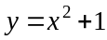 is given by

- 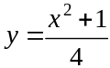
- 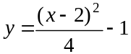
- 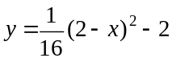
- 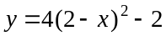
- 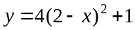

Question 14

The volume of a spherical object is increasing at the rate of 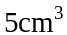/hour.
The rate, in cm/hour, at which the radius of the sphere is increasing is given by

- 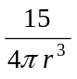
- 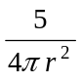
- 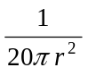
- 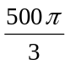
- 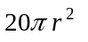
Question 15

Let 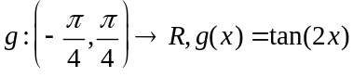.
The graph of 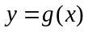 is transformed by a dilation by a factor of 3 from the x-axis followed by a reflection in the x-axis.

The resulting function h, is given by

- 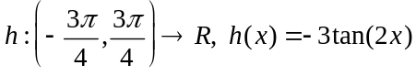
- 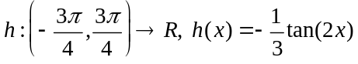
- 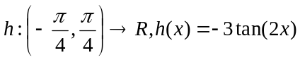
- 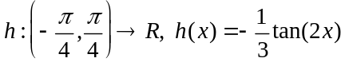
- 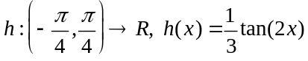

Question 16

If a random variable X has probability density function

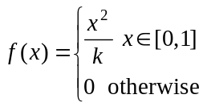

then the value of k is

- 1
- 3
Question 17

If then y is equal to

- 3
- 3x
- 6x
- 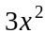
- 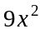

Question 18

The weights of the members of a junior swimming squad are normally distributed with a mean of 46kg and a standard deviation of 3.2kg. Ten percent of these children are not allowed to enter an endurance event because their body weight is too low.
The minimum weight; in kg, of a child permitted to enter the endurance event is closest to

- 41.899
- 42.121
- 42.155
- 42.800
- 50.101

Question 19

An approximation to an area under a curve between 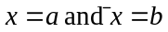is to be found by summing the area of n rectangles of width h units that lie under the curve 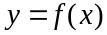 between and as shown below.
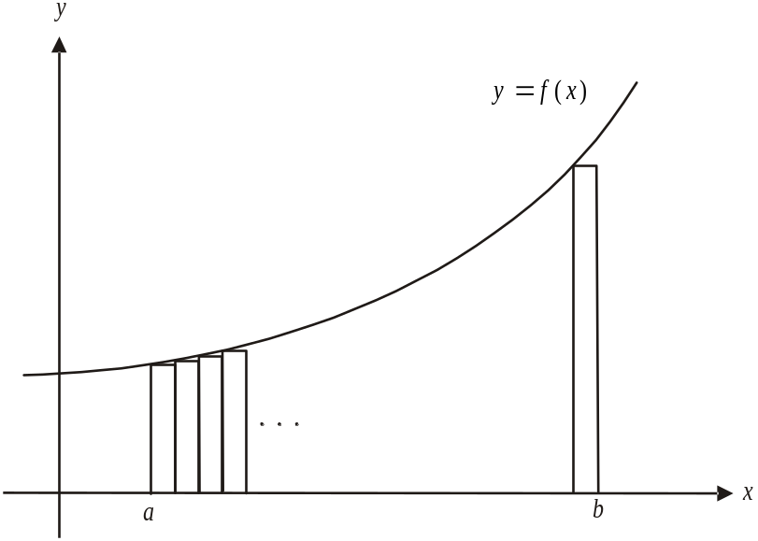

The approximation will be most accurate if the value of

- n is small
- a is small
- b is small
- h is small
E. 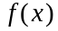 is small
Question 20

The graph of the derivative function 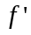 for 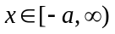 is shown below.

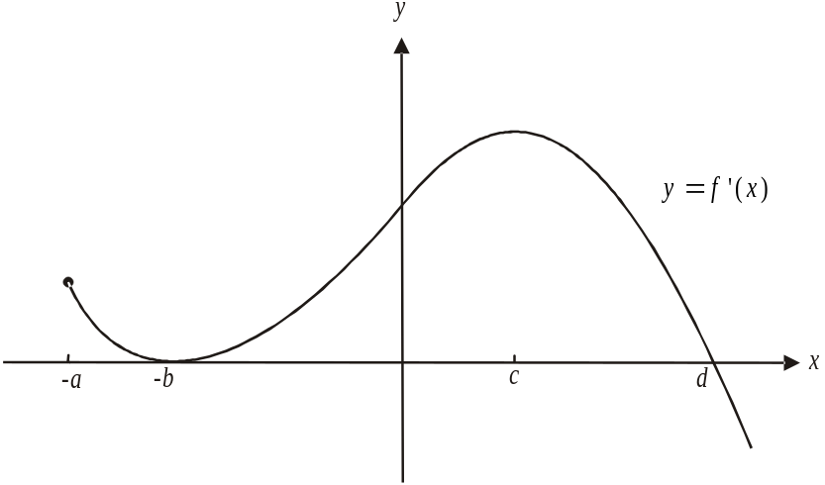

On the graph of the function f, a stationary point of inflection would occur at

Question 21

The function f where 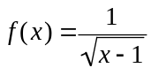 has a maximal domain.

Let 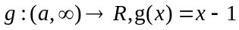.

If 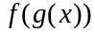 exists then a could equal

- – 2
- – 1
- 0
- 1
- 2

Question 22

Let 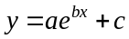, where 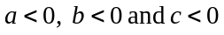.

Which one of the following could show the graph of this function?

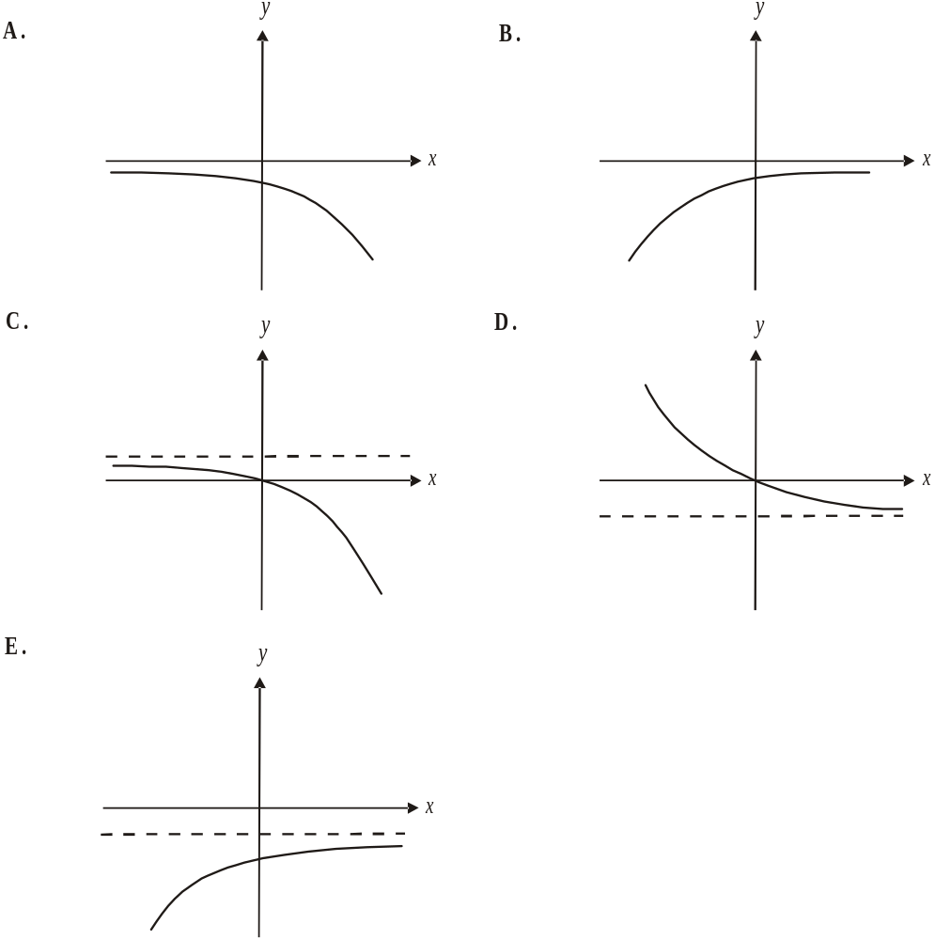

SECTION 2

Answer all questions in this section.

Question 1

The graph of the function 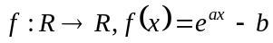 has a horizontal asymptote and passes through the origin.
The graph of is shown below.
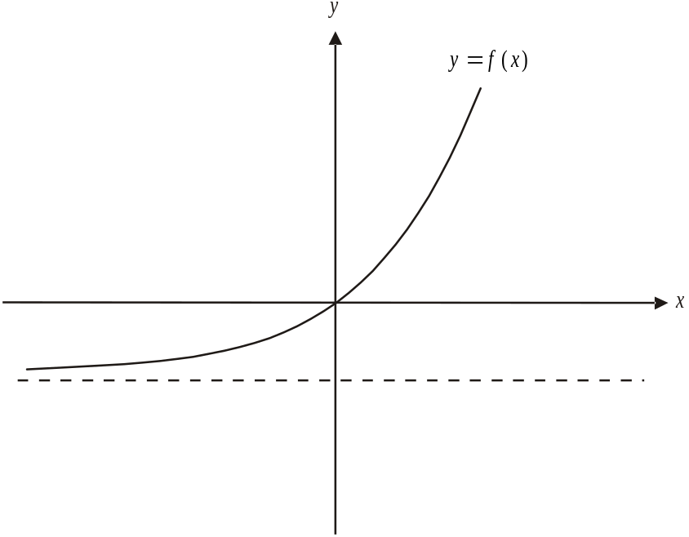

- Show that .

1 mark

- Given that 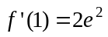, show that .

2 marks
The graph of the function undergoes two transformations. The graph of the original function , together with the graph of the final function 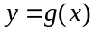, are shown below.
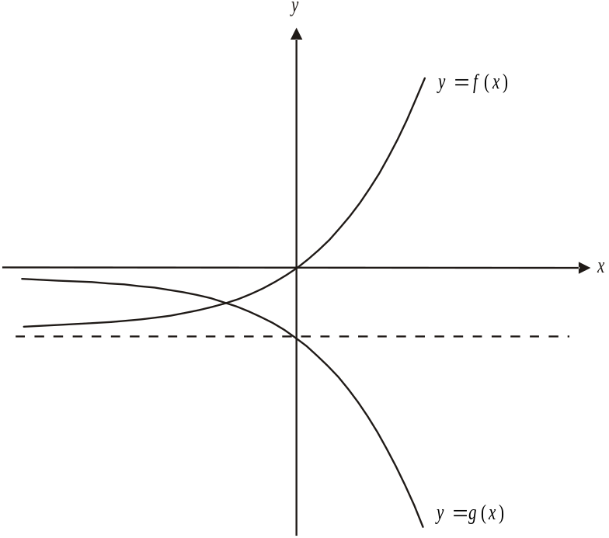

- i. Describe the two transformations that the graph of has undergone.

- Show that 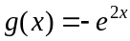.

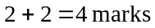

The graphs of 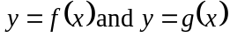 intersect at the point where as shown below.
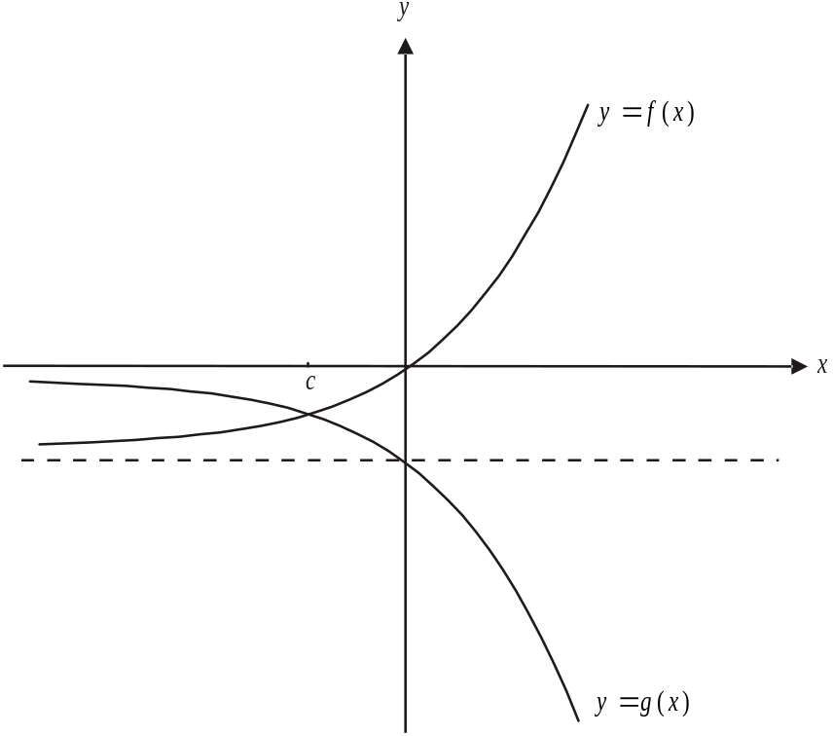

- Show that 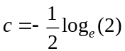.

2 marks

- Write down, but do not evaluate, an expression involving 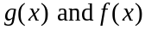 that gives the area enclosed between the graphs of , and the lines .

2 marks
f. i. Show that 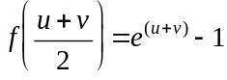 where u and v are real numbers.

  - Hence show that 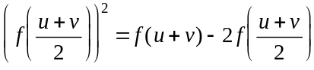.

1 + 3 = 4 marks

Total 15 marks

Question 2

Rafael can either ride his bike to school or catch a bus. His decision as to how he gets to school one day is independent of his decision the next day.
Over time it works out that he rides his bike to school sixty percent of the time.

- i. What is the probability; correct to four decimal places, that Rafael rides his bike to school on the next 5 consecutive days?

- What is the probability that Rafael rides his bike to school on exactly 2 of the next 5 days?

Rafael’s friend Jordan either walks to school or goes by car. If Jordan walks to school one day then the probability that he walks the next day is 0.4. If Jordan goes by car one day then the probability that he walks the next day is 0.3.
On Monday, the first day of term, Jordan walked to school.

- i. What is the probability that Jordan walked to school on the next 4 days?

- What is the probability that Jordan walked to school on exactly 1 of the next 3 days?

iii. What is the probability, correct to four decimal places, that Jordan walked to school
on the tenth day of term?

iv. What percentage of days will Jordan walk to school over the long term? Express your answer correct to 2 decimal places.

When Rafael rides his bike to school, the time; t minutes, it takes him is a continuous random variable with a probability density function given by

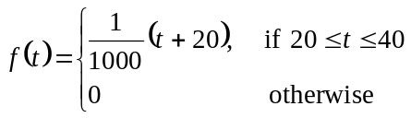

- i. Sketch the graph of the discontinuous function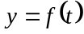 on the set of axes below. Label endpoints appropriately.
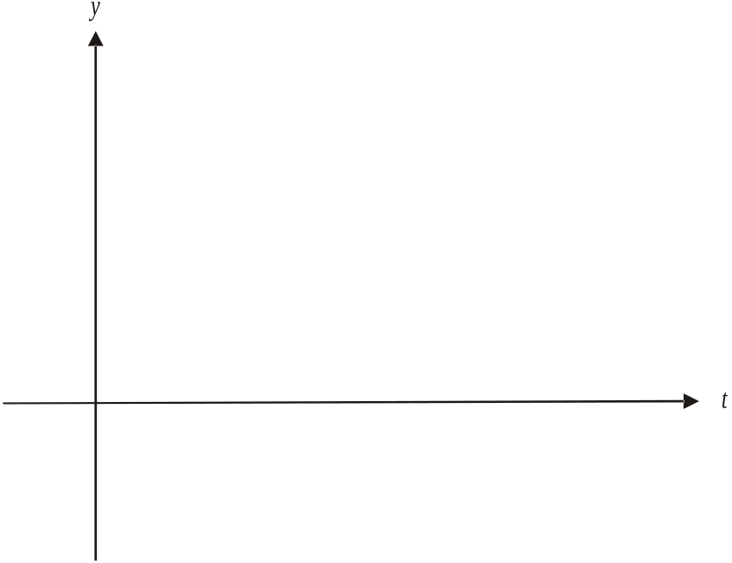

- What is the mode of this distribution?

- Find the median time, to the nearest minute, that Rafael takes to ride to school.

marks
Total 17 marks
Question 3

The graph of the function 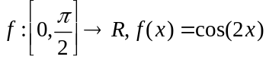 is shown below.

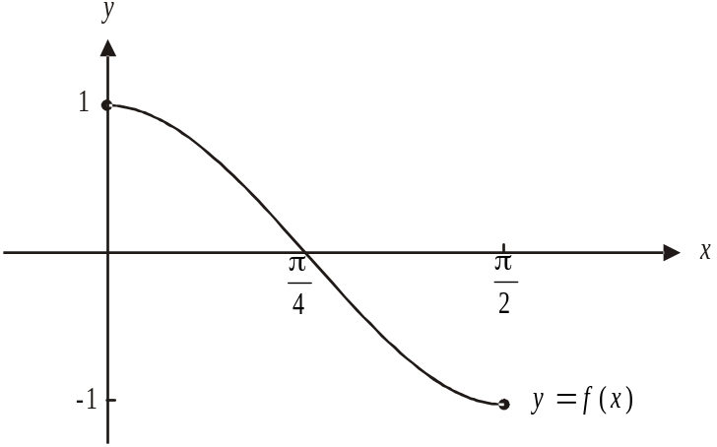

- Find 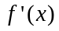.

1 mark

- Find the coordinates of the point(s) where the gradient of the tangent to the graph of is – 1. Express the coordinates as exact values.

2 marks

A tangent to the graph of has an x-intercept of 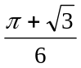 and a y-intercept of 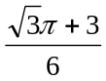.

- i. Show that the gradient of this tangent is 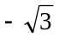.

____________________________________________________________________

____________________________________________________________________

____________________________________________________________________

____________________________________________________________________

____________________________________________________________________

ii. Using your answer to part a. find the values of x where the function f has a gradient of .

____________________________________________________________________

____________________________________________________________________

____________________________________________________________________

____________________________________________________________________

iii. Hence find the coordinates of the point of tangency.

____________________________________________________________________

____________________________________________________________________

____________________________________________________________________

____________________________________________________________________

____________________________________________________________________
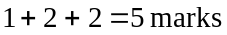

  - Find the maximum and minimum values of 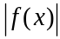.

2 marks

e. Let 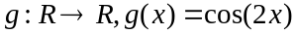.
Find the general solution for x of the equation 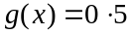.

2 marks

Total 12 marks
Question 4

Victoria James is a spy. She is attempting to flee enemy territory and begins her escape at the point 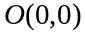 shown on the diagram below.
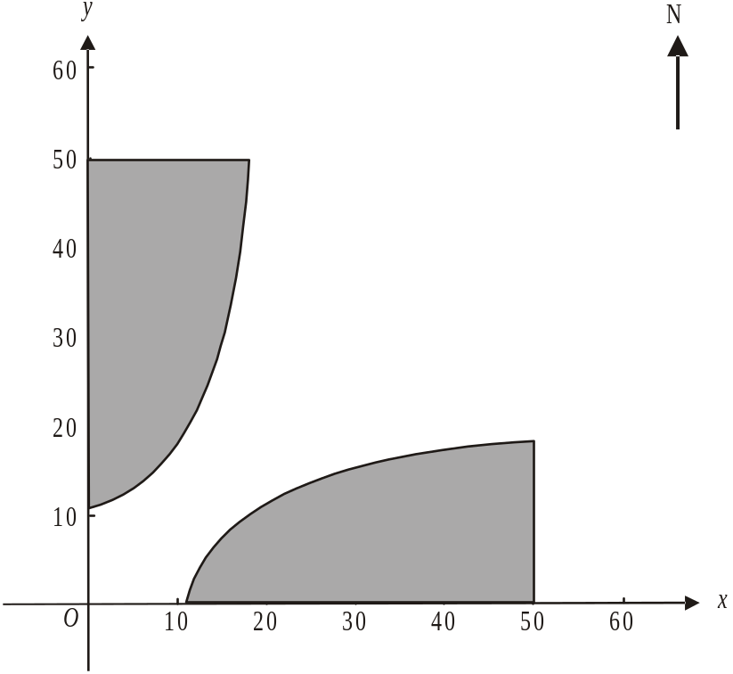

The x-axis runs in an east-west direction. Part of the ground she must run through is floodlit and this floodlit area is shaded in the diagram above.

The floodlit area to the east of 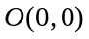is enclosed by the x-axis, the line and the function

.

The unit of measurement is the metre.

- Show that

1 mark
The floodlit area to the north of is enclosed by the y-axis, the line 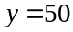 and the graph of the function 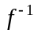; the inverse function of f.

- Find the rule and the domain of . Express values correct to 1 decimal place where appropriate.

2 marks

- Find the total area; to the nearest square metre, of the ground that is floodlit.

2 marks
Victoria moves in a straight line from and without knowing, passes over a sensor wire that runs in an east-west direction along the line 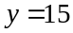 in the area that is not floodlit.
The point where she passes over the sensor wire is given by 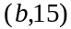.

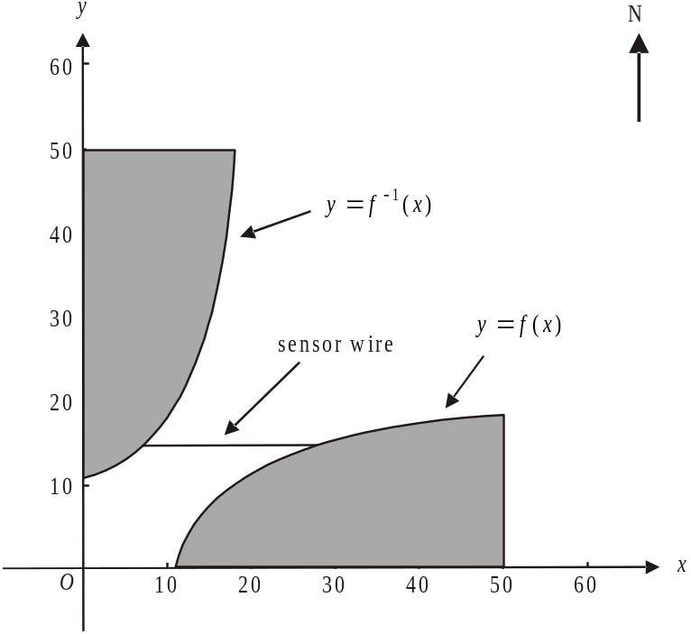

- Given that Victoria can move through the floodlit area if necessary, find the possible values of b correct to 2 decimal places where appropriate.

2 marks

Victoria continues to move in a straight line from her starting point at until she is at a point 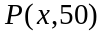. From this point she moves due east to a waiting helicopter at 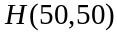.
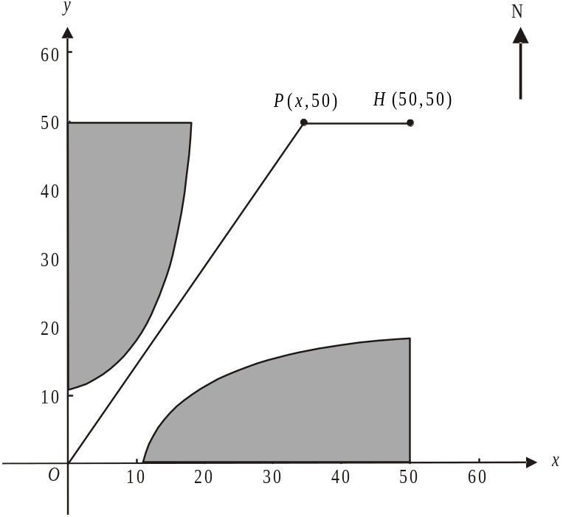

The time T, in seconds, taken by Victoria to move from O to H via P is given by

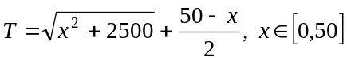.

e. i. Find the value of x, correct to 2 decimal places, for which Victoria reaches the
helicopter in the minimum time.

  - Hence find the minimum value of T correct to 1 decimal place.

Assume that Victoria moves along the path that takes the minimum time.

f. Explain whether or not taking this path will mean Victoria has to pass through any floodlit area.

2 marks

One minute after Victoria escapes from the point , guard dogs are released from the same point. They run in a straight line at 7 m/s towards the helicopter at 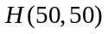.

Assume that Victoria will take the minimum time possible to reach the helicopter at H having passed through point P, and that the helicopter will take off at the instant she reaches it.

g. Explain whether or not Victoria escapes the dogs.

2 marks
Total 14 marks

Mathematical Methods and Mathematical Methods CAS Formulas

Mensuration
area of a trapezium: 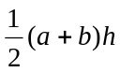 volume of a pyramid: 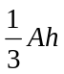
curved surface area of a cylinder: 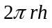 volume of a sphere: 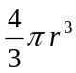
volume of a cylinder: 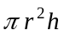 area of a triangle: 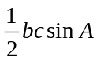
volume of a cone: 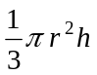

Calculus
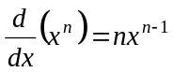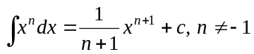
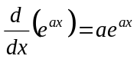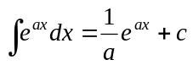
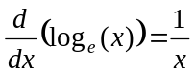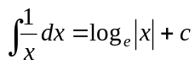
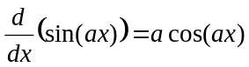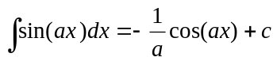
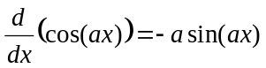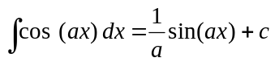
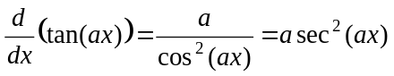
product rule: 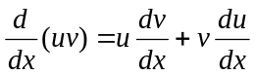 quotient rule: 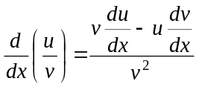
chain rule: 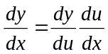 approximation: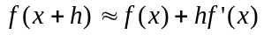

Probability
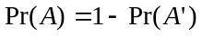
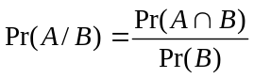
mean: 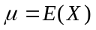 variance:
probability distribution |  | mean | variance
discrete | 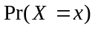=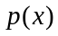 | 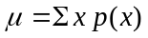 | 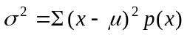
continuous | 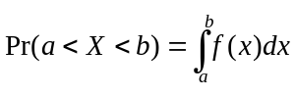 | 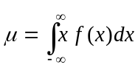 | 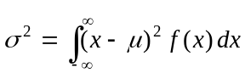
Reproduced with permission of the Victorian Curriculum and Assessment Authority, Victoria, Australia.
This formula sheet has been copied in 2009 from the VCAA website www.vcaa.vic.edu.au
The VCAA publish an exam issue supplement to the VCAA bulletin.
