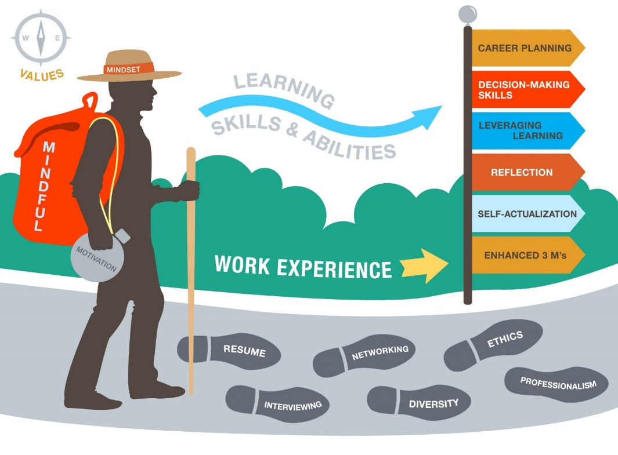

**Graduate Cooperative Education Seminar—CS 6949, Section 9 and 10**

**Syllabus – Fall 2018**

**Successful completion of this course is required before you are permitted to seek a co-op or internship.**

**Please note: The instructor reserves the right to make adjustments to the syllabus as needed.**

|  |  |
| --- | --- |
| **Course Information** | |
| **Section 9 | CRN: 18784**  **Online**  **September11 – December 13** | **Section 10 I CRN: 18785**  **Online**  **September 11 – December 13** |
| **Instructor Information** | |
| **Smajl Cengic**  [**s.cengic@northeastern.edu**](mailto:s.cengic@northeastern.edu)  **Meserve 315, Boston, MA** | **Ethan Selinger**  [**e.selinger@northeastern.edu**](mailto:e.selinger@northeastern.edu)  **Meserve 317, Boston, MA** |
| Office hours for instructors vary: Please schedule via email or via myNeu. | |

**Textbooks, Readings, and Tools**

**Required:**

* *Mindset: The New Psychology of Success*. Carol S. Dweck, Ph.D., ISBN 978-0-345-47232-8

**Recommended:**

* *The Power of Mindful Learning.* Ellen J. Langer, ISBN 978-0-201-33991-8

**Tools:**

* Headset (headphones plus microphone). This course contains audio material in presentations as well as assignments. A headset will allow you to hear and record audio (if and when needed).
* Webcam. One assignment, in particular, will require you to record yourself interviewing; access to a webcam is required for this assignment.

**Course Resources**

**Blackboard:** This is the primary tool for content including lessons, assignments, and grading. If you cannot access Blackboard, inform me within the first week of class.

**Big Interview:** This is the tool you will use to help you practice interviewing: <https://neu.biginterview.com/>.

|  |
| --- |
| **COURSE CONTENT** |

**Course Overview**

The Co-op Seminar is designed to prepare you for the Co-op/internship. Because this is an online course, how you go through the material is mostly self-paced and guided. The course covers a wide array of topics broken into six sessions. Each session contains lessons and assignments; some sessions have online discussions between you, your classmates and the instructor. All expectations for this course are similar to ones you can expect to encounter while on co-op and/or internship.

**Course Description and Learning Outcomes**

This course is intended to help you prepare for and get the most out of a co-op experience[1]. By the end of the course, you should be able to:

1. Develop a robust resume

2. Prepare for an interview

3. Develop a LinkedIn profile

5. Have a better understanding of working in a professional work environment

**Course Methodology**

For each session you are allotted two weeks to complete the following:

1. Review the week's learning objectives.
2. Complete all assigned lessons, assignments, and readings.
3. Complete and submit all assignments and activities by each session’s due date.

Reminder: Some sessions have a Discussion Board and you are required to do following:

* + 1. Initiate one post on your own and provide at least two (2) comments on your classmates’ posts.

**Participation/Discussion Board**

As stated earlier, some sessions will have discussion forums in which students are required to participate. These discussions count for 15% of your final grade. Students are expected to do the following in these instances:

* In sessions where there is a discussion board, students must post at least one “primary response” (answering a discussion question) and two secondary responses (responses to other students’ posts) for EACH discussion in that respective session.
* Responses are required to have content, tone, quantity, and quality. One sentence responses will not be considered complete answers.

**Policies & Expectations**

**Classroom Policies:**

* **Missed or late assignments and activities:** All session assignments and activities are due by the last day in the two weeks allotted for each session; ***see the Course Schedule for details***. *Late assignments will receive an immediate 20% penalty*. You need to plan ahead to accommodate any unexpected circumstances (including technology problems). ***Assignments are worth 85 percent of your final grade*.**
* **Classroom inclusivity:** We rely heavily on your online activity in the class and in interactions with your classmates; we hope you take the opportunity to get to know your classmates virtually in online discussions built into the course material. We expect you to treat your classmates and instructors respectfully at all times. Discrimination and harassment will not be tolerated and if you have any concerns about a violation of this policy, you should report it to an instructor as soon as possible.

# Academic Integrity Policy

The University views academic dishonesty as one of the most serious offenses that a student can commit while in college and imposes appropriate punitive sanctions on violators. Here are some examples of academic dishonesty. While this is not an all-inclusive list, we hope this will help you to understand some of the things instructors look for. The following is excerpted from the University’s policy on academic integrity; the complete policy is available on the [Office of Student Conduct and Conflict Resolution web page](http://www.northeastern.edu/osccr/academic-integrity-policy/).

*Cheating* – intentionally using or attempting to use unauthorized materials, information or study aids in an academic exercise

*Fabrication* – intentional and unauthorized falsification, misrepresentation, or invention of any data, or citation in an academic exercise

*Plagiarism* – intentionally representing the words, ideas, or data of another as one’s own in any academic exercise without providing proper citation

*Unauthorized collaboration* – instances when students submit individual academic works that are substantially similar to one another; while several students may have the same source material, the analysis, interpretation, and reporting of the data must be each individual’s independent work.

*Participation in academically dishonest activities* – any action taken by a student with the intent of gaining an unfair advantage

*Facilitating academic dishonesty* – intentionally or knowingly helping or attempting to violate any provision of this policy

For more information on Academic Integrity, including examples, please refer to the [Office of Student Conduct and Conflict Resolution web page](http://www.northeastern.edu/osccr/academic-integrity-policy/).

**Academic dishonesty:** Academic dishonesty will not be tolerated, and any violations will be reported to the Office of Student Conduct and Conflict Resolution (OSCAR) and subject to CCIS internal investigation.

**Communication/Submission of Work**

Each session will have a **Lessons,** **Assignments, and Resources** folder where each entry has detailed instructions. In addition to that some lessons will have **Discussion Board**. Below are the guidelines of these folders:

* + 1. **Lessons** are required readings before you can do your homework. If you complete your assignment before youcomplete your readings your assignment is not going to be graded.
    2. **Assignments** have a hard due date which is the session end date noted on the Course Calendar on page 5 of this syllabus. For example, Assignments for Session 1 should be submitted no later than 3:00 AM on September 27th. That said, it is recommended you get started sooner rather than later in the session. In the table below there is a suggested timeline for completing course requirements.
    3. **Discussions** are meant to be interactive, that is, between you and your other classmates, so you should begin working on discussion questions within the first week of the session. For example, you should have completed your first Discussion Response on the first Discussion board of Session 1 between September 12th and September 19th.   
       ***You*** ***are expected to initiate at least one post on your own AND comment on at least two of your classmates’ posts.***

See table below for a suggested timeline.

Suggested Timeline for Completing Assignments and Discussions

|  |  |  |  |  |  |  |
| --- | --- | --- | --- | --- | --- | --- |
| Wednesday | Thursday | Friday | Saturday | Sunday | Monday | Tuesday |
| Log in to check session assignment(s) and discussion)s) | Complete lesson(s)  Begin Assignment(s) | Make first Discussion post  Continue Assignment(s) | Read all additional resources and supplemental materials | Comment on classmates’ posts on Discussion(s) | Complete assignment(s) | Review and complete assignment(s)  Post additional comment(s) |

The above table is a **suggested timeline**. You will have at least two weeks (on average) to complete assignments and discussions, but to reiterate, because of the interactive nature of discussions, in particular, it is STRONGLY suggested you begin these within the first week in order to provide time for your classmates and yourself to respond to discussions.

* + 1. **Resources** are additional information that can help you further develop your skills. It is not required to go over these materials but it’s highly recommended to read or watch the resources provided.

**Seeking Other Resources**

**Students with Disabilities Accommodations***:* If you have a disability-related need for reasonable academic accommodations in this course and have not yet met with a Disability Specialist, please visit [www.northeastern.edu/drc](http://www.northeastern.edu/drc) and follow the outlined procedure to request services. If the Disability Resource Center has formally approved you for an academic accommodation in this class, please present us with your “Professor Notification Letter” during the first week of the semester so that your specific needs can be addressed as early as possible. *Accommodations to assignments cannot be made without official notification from the DRC prior to the assignment’s due date*.

**Office of Institutional Diversity and Inclusion (OIDI):** Northeastern University is committed to providing equal opportunity to its students and employees, and to eliminating discrimination when it occurs. If you have any concerns about bias acts or harassment, contact OIDI (<http://www.northeastern.edu/oidi/>). Please note that OIDI will make all reasonable efforts to maintain confidentiality whenever possible.

**Health Services:**In the event that you have a major physical or mental health issue that is impacting your studies, you should seek support at University Health and Counseling Services (<http://www.northeastern.edu/uhcs/>). *You are required to have formal documentation from UHCS should you wish to be excused from coursework because of a health concern*.

**Employer Engagement and Career Design:** *O*ffers a variety of workshops, events, and appointments. If you find that you would like to learn more about a career topic we covered in class, or learn about a topic we weren’t able to cover in class, Employer Engagement and Career Design is a great resource (<http://www.northeastern.edu/careers/>).

**Title IX: Office of Gender Equality and Compliance provides support to all students exposed to any of claims covered by Title IX.** "Title IX makes it clear that violence and harassment based on sex and gender are Civil Rights offenses subject to the same kinds of accountability and the same kinds of support applied to offenses against other protected categories such as race, national origin, etc. If you or someone you know has been harassed or assaulted, you can find the appropriate resources here: [http://www.northeastern.edu/oidi/titleix/".](http://www.northeastern.edu/oidi/titleix/)

|  |
| --- |
| **GRADING & COURSE ACTIVITIES** |

**Grading/Evaluation Standards**

This is a self-paced, 6-Session course. You can take as little time as needed to complete the sessions in full however, you will have specific timeframes to complete the assignments in each session; ***please see the Course Schedule on page 6 for the session assignment due dates***. Successful completion of each session’s lessons, assignments and reading materials will give you access to the next module. ***The course is complete when you finish Session 6***. Assignments will be graded within 1 week of the submission deadline. Please do not send emails requesting assignments be graded any sooner.

**Grade Itemization**

A = Assignments (85% of final grade); D = Discussions (15% of final grade) **Course Activities**

|  |  |  |
| --- | --- | --- |
| **Item** | **%** | **Points (out of 300)** |
| Session 1: |  |  |
| Introduce Yourself (D) | 5 | 15 |
| Accomplishment Stories, Skills Grid (A) | 5 | 15 |
| Session 2: |  |  |
| CCIS Resume Trainings Module (A) | 10 | 30 |
| Accomplishment Statements (A) | 10 | 30 |
| Resume- Draft (A) | 15 | 45 |
| Session 3: | 5 | 15 |
| Job Search Professionalism (D) | 5 | 15 |
| Mindset Quiz | 5 | 15 |
| Session 4: |  |  |
| LinkedIn Profile Assignment (A) | 5 | 15 |
| Big Interview Assignment (A) | 5 | 15 |
| Resume-Final (A) | 5 | 15 |
|  |  |  |
| Session 5: |  |  |
| Professionalism in the work place:  Scenarios and Ranking (D) | 5 | 15 |
| Tech. Interviewing Quiz | 5 | 15 |
| Session 6: |  |  |
| Kick Off Module | 10 | 30 |
| Get Informed – Title IX - Training | 5 | 15 |
|  |  |  |
| **Total** | **100%** | **300** |

|  |
| --- |
| These are *MANDATORY* assignments that do not carry a numeric value BUT ARE required to pass the seminar: |
| Upload Your Picture to Blackboard |
| Course Survey and Evaluation |
| Kick Off Module |
| Get Informed – Title IX - Training |
| Watch all 5 Modules |

**In order to pass the course, you need to have at least 255 points (B).**

|  |
| --- |
| **COURSE SCHEDULE** |

|  |  |  |  |
| --- | --- | --- | --- |
| **Session Number** | **Session Dates** | **Topics** | **Assignments and Discussions** |
| 1 | September 12 September 26 | Co-op Course Introduction Accomplishment Storytelling | All Assignments Due September 27 (3.00 AM)   * Introduce Yourself * Upload your Picture * Accomplishment Stories and Skills Grid * Watch Interviewing Module |
| 2 | September 26 October 10 | Accomplishment Statements and Professional Resume | All Assignments Due October 11(3:00 AM)   * Accomplishment Statements Training * Accomplishment Statements Assignment * CCIS Resume Trainings Parts 1 & 2 * Resume – First Draft * Watch Receiving Offers Module |
| 3 | October 10 October 24 | Strategic Job Search, Motivation, and Mindset | All Assignments Due October 25 (3:00 AM)   * Read Chapter 2 & 3 of “Mindset” * Mindset Quiz * Professionalism during a job search post and discussion * Read co-op advisors ranking and responses * Watch Accepting a Job Module |
| 4 | November 7 November 21 | Interviewing  Networking | All Assignments Due November 22 (3:00 AM)   * LinkedIn Profile * Big Interview Mock Interview Assignment * Resume – Final * Watch CCIS Acceptance Procedures Module * Watch Technical Interviewing Video |
| 5 | November 21 December 5 | Technical Interviewing  Professionalism, Work Culture, and Enculturation | All Assignments Due December 6 (3:00 AM)   * Professionalism in the workplace: Scenarios Ranking and Discussion * Read co-op advisors ranking and responses * Tech. Interviewing Quiz * Watch Beyond Co-op /Internship Module |
| 6 | December 5 December 19 | Nest Steps & Course Wrap Up  Title IX: Get Informed!  Kick-Off Module | All Assignments Due December 20 (3:00 AM)   * Title IX: Get Informed! * Course Reflection Evaluations and Survey * Kick Off Module * CCIS co-op/internship policy and resources Database |

**Note: The instructor reserves the right to make adjustments to the syllabus as needed.**

1. Throughout the course we may use the term co-op to refer to both co-op and internship experiential learning opportunities. Although some logistics differ, the preparation and expectations for co-ops and internships are the same.