2/8/2021
Submitted by:
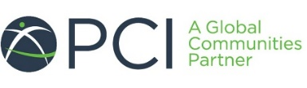
Project Concern International (PCI) India

STEM EDUCATION FOR TRIBAL GIRLS OF JHARKHAND
Proposal
Contents
1. Background 2
1.1. What is STEM Education? 2
1.2. What is the need for stem education? 2
1.2.1. How wide is the gender gap? 3
1.3. What are the factors for poor performance of girls? 5
1.4. Opportunity under National Education Policy 2020, but a far sight 5
1.5. Burning effects of COVID-19 on girls’ education 6
2. Rationale 6
2.1 About PCI 6
2.2 Our Expertise (sectoral/thematic) 6
2.3 PCI in Jharkhand and STEM Education for girls 8
3. Approaches 8
4. Gender and social norms through stem education 9
5. Geography, target group and reach: 10
6. Objectives 10
7. Timeline 11
8. Pathway of progress 12
9. Proposed intervention structure 12
9.1 STEM Clubs (Engagement with girls in class 6th to 8th): 12
9.2 Engagement of parents: 13
9.3 Capacity building of mentors: 13
9.4 Learning and Sharing: 14
10. Key success indicators: 14
11. Key events in the project: 14
12. Quality Control Mechanism and project monitoring system 14
13. What’s thereafter: 15
14. reports and devliverables: 16
15. Proposed team structure: 16
16. Budget: 16
17. Key personnel: 17

Background

What is STEM Education?
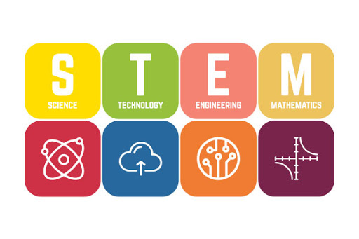
STEM is an inter-disciplinary and applied approach towards educating students in Science, Technology, Engineering and Mathematics. It includes learning theories, experiencing through hands-on and exploratory activities to further enhance the scientific temperament. The overall purpose of STEM education is to develop a society where individuals have the knowledge, attitude and skills to explain the world around them and address real life situations based on evidence (Kennedy, T.J. and Odell, M.R.L., 2014).
Image Source: mentalup.co
STEM education has been a topic of discussion worldwide for more than a decade. The importance of STEM education is driven by the evolving global economy and workforce requirement, that indicates there will be a soon be a shortage of STEM prepared workers around the world. In an increasingly competitive world, it has been proved that invention, development, and profusion of new technologies through science and technology are the fundamental source of economic progress. Furthermore, National Science Foundation has predicted that 80% of the jobs created in the coming decade will require some form of math and science skills. In a country like India which has a large youth demographic, STEM education is bound to become a major driver of future economic growth. The global economy has seen a massive increase in STEM-related jobs, a 44 per cent increase was reported in job postings related to STEM between 2016 and 2019 in India (The future of jobs report, 2018). These skills are thus appropriately labelled as 21st-century skills or STEM skills.

What is the need for stem education?
A very broad perspective of the current Indian educational system is that we are well behind in adapting to the changes in global educational arena. Rote learning through textbooks and marks secured in examinations is given major emphasis in our school education system to assess a student’s knowledge and learning abilities. Critical thinking, problem solving, inquiry based and hands-on learning is far from implementation in a majority of K-12 educational institutions. These skills are crucial to instil curiosity, innovation and thirst for knowledge towards STEM in children in a more engaging environment (Malti, D., 2017). However, over the past few years the Indian government is working hard to foster scientific temperament among school students through various interesting programmes and providing them research training opportunities to build the skilled workforce that our country requires. The major science and technology programmes implemented by the Indian government for school students are National children’s science congress (NCSC), Innovation in Science Pursuit for Inspired Research (INSPIRE), the Initiative for Research and Innovation in Science (IRIS), Science Express, Atal tinkering laboratories, national level science exhibitions, and the Skill India programme, among others.
Despite various programs launched by the Indian government to promote STEM education, the students face more challenges in comparison to other nations, due to its cultural diversity and population size. Poor infrastructure, lack of science curriculum reforms, shortage of quality teachers, a wide gender gap in STEM education, are among the top challenges that students face today. Moreover, the Indian education system puts tremendous focus on Class 10 board examinations without permitting students tso choose the level (higher to lower level) at which they wish to write it. These are added reasons for the increased failure and dropout rates in early high schools, which can be attributed with poor performance in mathematics and science subjects in the Indian education system.

How wide is the gender gap?
According to the Global Gender Gap Index 2020, a study covering 153 economies, India has slipped to the 112th spot from its 108th position in 2018. The report also says it would take nearly a hundred years to close the gender gap in various fields, including education, in India. That poses a serious concern for the status of STEM education of women in India. Including more women in science is not only important from the human rights perspective; it also impacts the quality of science and the advancement of society itself. According to United Nations, about 43 per cent of science, technology engineering and mathematics (STEM) graduates in India may be women, which is the highest in the world, but women’s share in STEM jobs in India is a mere 14 per cent. In terms of school education, the 2020 ASER report reveals that percentage of children not enrolled in school has increased from 2018 to 2020 from 4% to 5.5%. Currently, more girls (11.1%) are out of school in comparison to boys (8.8%) in the age of group of 15 to 16 years.
A 2016-17 NITI Aayog report compared female enrolment in various disciplines over five years, until 2015-16.
- In 2015-16, 9.3% of female students in undergraduate courses were enrolled in engineering, compared to 15.6% across genders. Then, at master’s and doctoral levels, female enrolment remained lower than overall enrolment.
- Broadly, women showed a preference for arts; however, female enrolment in science streams rose from 2010-11 to 2015-16. The report found that in over 620 institutes and universities, including IITs, NITs, ISRO, and DRDO, the presence of women was 20.0% among Scientific and Administrative Staff, 28.7% among Post-Doctoral Fellows, and 33.5% among PhD scholars.
Most of the women STEM graduates in India either pursue another career or do not work at all.

THE case OF Jharkhand
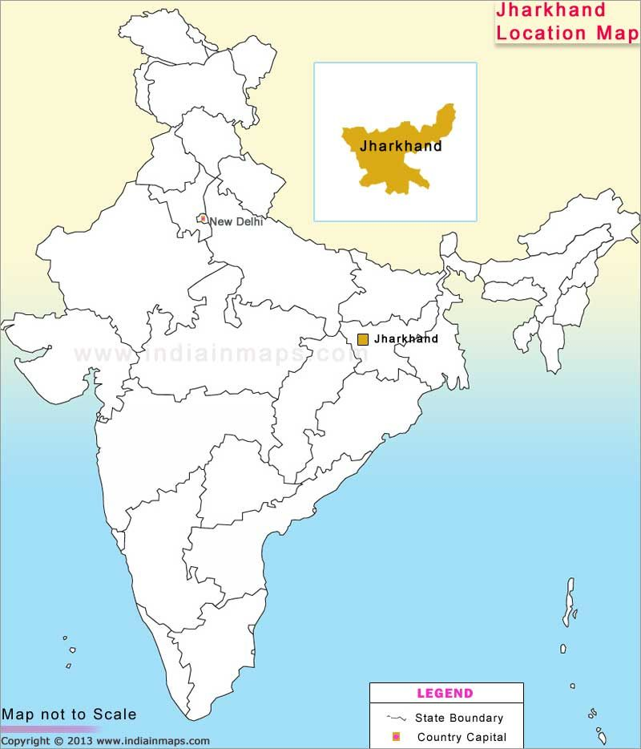
Jharkhand came into being as a separate state in 2000, only about half of the population of Jharkhand was literate at the time of its formation. As per census 2011, Jharkhand has a state population of 33 million and 76 percent population is in rural areas, of which 12 percent is scheduled caste and 26 percent is scheduled tribe. By 2011 the literacy-rate of Jharkhand had increased to 66.4 per cent and by 2017- 18 to 71.8 per cent. The gender-parity in the literacy rate was 0.78 in 2017- 18, higher than all India level of 0.83.
Poverty, female literacy and maternal mortality are one of the worst performing indicators for Jharkhand. State also has a very poor female labour force participation. As per the world bank survey (2015), nearly 62% of the women and girls are neither in education, nor receiving any training or involved in any employment. This all reflects poor on the status of women and girls of the state in terms of their quality of adult life and any contribution to country’s economy and development. Thus interventions aiming at adolescents can be seen as giving larger returns later in life and time.
- DISE (2013-14), secondary education statistics shows that only 68% of girls aged 14-15 and 44% of girls aged 16-17 are enrolled in schools.
- ASER Learning trends (2012-2018) highlight that only 54% children in government schools who can at least read a Std. II level test at all India level in class VI, and the number increases to 63% in Class VII. In Jharkhand, only 42.5% can read Std. II text in Class VI, and 56% in Class VII.
- As per NFHS-4, only 20% of its rural women completed 10 or more years of schooling in 2015-16.
- Moreover, National Sample Survey in its 72nd edition of education survey in 2018 revealed that 48% of rural women in Jharkhand are not literate and 22% have never been enrolled in school, with only 9.5% having completed secondary education, and 3.5% completed higher secondary.
- In the Annual Reports of Education Report (ASER) Survey, 2016 Jharkhand was to be one of those states that have very low attendance of students in the primary school, i.e. 66 per cent, was unable to cross the national average. Net Attendance Ratio drops from 46.6% at secondary level to 18.9% in higher secondary level among rural girls, the lowest in the country.
There is a striking difference between caste categories, with more percentage of children who belong to Scheduled Caste and Scheduled Tribes having poorer education outcomes. Hence, the state with mix population and varied concentration of tribal and non-tribal communities across different districts needs a sustained attention towards girls’ education, particularly towards STEM (Joshi K.M., 2010).
Lack of adequate education infrastructure in terms of access, quality and friendliness cost girls by their level of learning abilities, knowledge and understandings which is minimum to pursue STEM education. Given that tribals are further disadvantaged community in all this; it becomes more essential to invest on them to make efforts for them to be part of the development. It is essential to have strategies that are not only targeted but also inclusive, sensitive to their contexts and able to transform their lives in a smooth manner.

What are the factors for poor performance of girls?

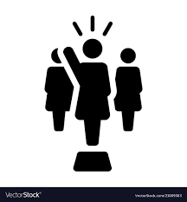
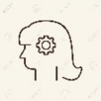
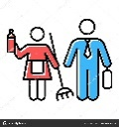
In a society as deeply stratified as India, disparities in education can be observed through various distributions, such as economic status, religion, caste, among others. It is interesting, however, that even within such disadvantaged communities, a consistent feature is widespread gender disparity in educational attainment. A deep dive into the factors of poor performance of girls highlights the following:

Opportunity under National Education Policy 2020, but a far sight
With the aim to lay the foundation of a ‘New India’, the recently approved National Education Policy (NEP) 2020 has proposed several progressive reforms in the education system. NEP’s inclusive emphasis on flexibility of curriculum and STEM (Science, Technology, Engineering and Mathematics) courses is a welcome step.
It tries to address the glaring issue of gender disparity in education and brings in a new approach. Most importantly, it has equity as one of its founding goals, and gender as an important theme inducing initiatives like gender sensitisation in schools that will break stereotyped gender roles. It also harps on the importance of harassment-free environments and equal treatment of genders. In addition to this, the NEP advocates for having female role models for girls, in order to strengthen their ambition and change societal mind-sets of women’s role. This move will ensure that there is a positive multiplier effect on girls and their families and more girls will be encouraged to pursue education and complete the cycle.

However, the implementation and achievement of goals laid under the NEP remains a far sight, with no actual plan in place till date.

Burning effects of COVID-19 on girls’ education
According to UNESCO, the countrywide closure in India has affected 320 million children enrolled in schools. It has been estimated that of these, about 158 million are girl students.
In the wake of COVID-19, challenges of gender disparity and inclusion seem to have taken a back seat. Even before the COVID-19-crisis, it was found that girls who were engaged in housework for more than two hours a day had less chance of completing school. Several studies show that during the pandemic, the girls have become fully engaged in household chores of cooking, cleaning and looking after younger siblings and most unlikely to go back to school once it opens. It is estimated that 10 million secondary-aged girls are likely to drop out by this process.

India’s Digital Divide will increase the education gap that already exists. While internet penetration in India is pegged at around 36%, only 12% of households with school-going students in India have internet access at home. And in marginalized homes, the percentage is abysmally low. We have always been confronted with glaring data of how far behind the students from government schools are, as compared to students from private schools. While online classes have started during the pandemic for the students of private schools, the government schools continue to be in limbo. The children going to government schools have lost important learning hours because they do not have Internet access at home and some do not even have phones. So the idea of inclusion in education is getting even further remote and then to compound it is the story of girls who are getting pushed further behind. In homes where there are both girls and boys going to school and the access to devices is limited, the first priority is always given to the boys. If this practice continues, the concept of “equal opportunity", especially for STEM education, might remain just a pipe dream until serious action is taken in this direction.

Rationale

2.1 About PCI
PCI is an Indian non-governmental organization, registered under the Societies Registration Act (1860) and has been in operation in the country since 1998. Globally its affiliated to PCI, a Global Communities partner. Our mission is to empower people to enhance health, end hunger, overcome hardship and advance women and girls. Since last two decades PCI has reached over 10 million over across over on-fifth of the total districts of India. PCI’s health, gender, and community development programming focuses on low-income, vulnerable and hard-to-reach populations, especially adolescent girls, women of reproductive ages and children. By integrating its community mobilization and empowerment approaches into the government strategies and systems, PCI is helping to ensure that millions of vulnerable women, children, families, and communities throughout India have the ability to advocate for, access and utilize quality health, nutrition, and empowerment services and information for generations to come.

2.2 Our Expertise (sectoral/thematic)
PCI works across multiple thematic domains. Please find a snapshot here below:
Taking Maternal and Child Health to Scale: Integration of Health and Nutrition (HN) interventions with women’s Self-Help Group (SHG) platform is a hallmark approach conceptualized and implemented by PCI in India, which has shown outstanding results influencing millions of marginalized lives. Impressed by its success, JEEViKA with technical partnership of PCI has integrated Health and Nutrition in its system and has brought substantial changes in the lives of women and children of marginalized families by bringing significant differences in several critical HN outcome indicators. Supported by BMGF since 2012, this is considered as one of the most effective and proven scale-approaches for community-centric and demand-side intervention for HN which has strong and scientific evidence of bringing outcome-level changes at scale. Our success has enabled other states to approach us for similar support and now PCI is technical partner for NRLM at national level and directly supporting states of UP, MP, Jharkhand and Rajasthan.
Elimination of Neglected Tropical Diseases: PCI is supporting the National Vector Borne Disease Control Program, Ministry of Health & Family Welfare, Government of India to establish a social and behavior change system to eliminate Lymphatic Filariasis (LF) from 155 endemic districts across 14 states and Visceral Leishmaniasis (VL) from 4 states. With support from BMGF, the social behavior change strategy designed by PCI focuses on social mobilization and active community engagement for promoting the demand for available and free government health services among the affected and at-risk population in the endemic areas. PCI India holds the largest NTDs portfolios among all the PCI country offices and its work is highly acknowledged at the national and international levels.
Polio Eradication and Routine Immunization: Since 2001, PCI has been at the forefront of India’s polio eradication efforts through the USAID funded CORE Group Polio Project (CGPP). Under the leadership of CORE Secretariat and in close coordination with the Government of India, the World Health Organization, other international and national NGOs, and local district authorities and communities, PCI contributed significantly to improve the acceptance of the polio vaccine through community mobilization in high-risk areas of Uttar Pradesh (UP), India. PCI’s efforts through CGPP for more than a decade had been instrumental in eradicating the poliovirus from India. Building upon the grand success of polio eradication in 2013, in the next phase, CGPP focused on strengthening the routine immunization (RI) and hygiene in 250 high-risk areas of UP covering more than 270,000 households through a group of 550 dedicated Community Mobilization Coordinators (CMCs) and other supervisory staff. Currently, the program is passing through a transitional phase.
Girls’ leadership: PCI with support from Gap Inc. and BMGF implementing PACE program with 1200 rural adolescent girls in Bihar. We are supporting adolescent girls in enhancing their leadership and life skills to facilitate their continuation of education and take control of their lives and decide for their future.
Addressing child marriage: PCI is working with JSLPS to address issue of child marriage in Jharkhand. Using a socio-ecological model, curated by ICRW, PCI is working to empower mothers and women’s’ collectives to support adolescent girls to attain higher education and aspire for an economic independence in their future course of lives. Thus, reject the practice of early and child marriage and allow the girls to choose their own future life options. The model engages with mothers and girls in both in-school and out of school context. This project is being piloted in Godda and Jamtara districts of Jharkhand.
Engaging men in health and nutrition status of the family: In collaboration with Dalberg Design, PCI is designing and piloting prototypes to enhance men’s participation towards Child Nutrition and Family Planning in Bihar. This project is being piloted in Bihar leveraging the JEEViKA platform.
Child protection: PCI India’s legacy program Children Home situated in Mewat, Haryana is designed to take care of such socially and economically deprived boys providing them with shelter, nutrition, clothing, health care, psychological support, and access to formal and non-formal education in a supportive and cooperative rural community. The Children Home presently caters to 21 boys between the ages of 5-17 years.
Emergency response: PCI’s long-standing expertise of working with the communities and command over designing social behavior change communication (SBCC) models was extended in supporting the Government in responding to the COVID19 pandemic. PCI is actively supporting the Government of Bihar and Uttar Pradesh in responding to the pandemic through the community platforms. PCI has also supported the NRLM to design and facilitate COVID19 behaviour change training sessions to reach the rural populations using the SHG networks across the country.
Gender is cutting across strategy for PCI and is essentially integrated in all projects and initiatives of PCI.

2.3 PCI in Jharkhand and STEM Education for girls
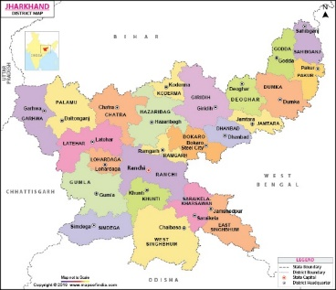
Given this context, PCI is pleased to submit a concept note towards enhancing scientific temperament among school going girls from tribal households in selected panchayats of tribal blocks of district Godda in Jharkhand. The proposed intervention builds on PCI’s work in the state, complementing the efforts to empower adolescent girls to reject some of restrictive social norms like child marriage.
Map of Jharkhand, showing Godda (in red circle)
PCI has been working in Godda and Jamtara districts of Jharkhand to empower women and girls to address the issue of child marriage. Partnering with Jharkhand State Livelihood Promotion Society (JSLPS), PCI works with women’s collectives to ensure an enabling environment for girls to complete their school education and aspire for higher education and an economically independent life. PCI leverages on its experience of working with women collectives to engage with adolescent girls, to minimize the community and family level back lashes. The engagement with federated structure of SHGs also ensures a comprehensive community pressure for families to support girls’ education.
Promotion of STEM education for girls, will not only reflect in terms of number of girls in science stream but also benefit to breakdown the myth that girls cannot do maths and science and would enable the efforts towards gender equality and equity for the girls. Hence, PCI proposes this note with strategies promoting STEM education for girls.
Recognizing the current level of education with its quality and access to girls, along with social structures, the STEM education promotion will need longer term/multiple year continued efforts and support, to show its effectiveness and girls’ participation in STEM in a meaningful way.

Approaches
PCI would use a multi-pronged approach as delineated below:
- Child centred, social constructivist and experiential approach of learning: Child friendly learning would be the core to our programming, using social constructivist and experiential approaches of learning to enhance scientific temperament among girls who face so many challenges discussed above, its first and foremost essential to enhance their likeness for education, towards studying and enabling them to aspire for themselves. We propose to adopt the ‘start-early’ strategy by starting with students in class 6th and gradually walk with them in their learning journey year on year so that they can pursue STEM in higher classes. Starting with class 6th will be help to develop a strong base.
Integrated approaches for STEM education for girls

- Engagement of parents, mentors and learners: Our program would be increasing parental participation in daughter’s education. Parents due to their socio-cultural ways of living remain far from educational activities of their children, particularly of their daughters. We would like to engage more with mothers to increase their abilities to support their daughters’ education. We would develop multiple events and opportunities for parents to engage with the daughter’s education, observe them doing activities and thereby supporting them in their exploratory works and future aspirations. On the other hand, each village will have a trained female mentor who will engage with leaners during the course the intervention.

- Learning and Knowledge Sharing: Learning and sharing is key to ensure our mentors are learning from each other and other experts. In addition, PCI would also share the knowledge with the state government education department to advocate for actions to promote STEM education initiatives especially for girls.

Gender and social norms through stem education
Girls have been primarily disadvantaged in their overall upbringing, which also reflects in their poor attainment of education and options for future life. We have discussed these factors in the previous sections in this document.
This proposed project is an attempt to touch upon few basic gender norms by encouraging girls’ participation in STEM education:
- Relative value of girls’ and boys’ education – Son preference in our societies have always led to families prioritizing educating their boys over girls. Boys are perceived to be able to get good jobs and take care of parents and girls to be the homemakers and take care of families. Our project will encourage girls to demonstrate their temperament towards STEM and overall education, which will trigger the thoughts for change and identify girls’ education as equally important as of boys.
- Early marriage for young girls – adolescent girls soon after puberty and lack of attention towards education are pushed for early marriage. Our project will enable girls to retain in schools, aspire for higher education and thus avoid the chances for early marriage. Our project will work towards building girls’ agency along with close engagement of parents. These together will allow girls and parents to take decisions for higher education and skilling for economic independent life in future.
- Girls’ involvement in domestic chores – Girls are generally assigned household chores, which completely disables their learning and education space at homes. As a result, their education gets deprioritized and they start missing schools. Our STEM project will adopt attractive methodologies to keep the girls’ attracted towards learning, attending sessions regularly. Engagement with parents and especially mothers will further boost the regular attention of parents towards girls’ education at home and in schools.
Given that the proposed project in its first phase targeted to engage girls and mothers primarily; it does in its approaches and methodology, takes into consideration the social construct of gender and the contextual situation. These will be factored in towards developing the curriculum, teaching learning materials and the overall sessions timings and place of interventions in the villages.
Gender Assessment Scale for programmes (WHO)
As per the gender assessment scale of WHO we identify this proposed model to be gender sensitive.

Geography, target group and reach:
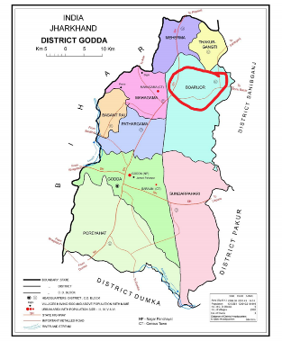
PCI proposes to cover 12 villages of Boarijor block of Godda district. Boarijor is a tribal dominating block and hence, this proposed intervention will allow the tribal girls get the opportunity to learn and be part of STEM education. Boarijor is 43Km from Godda district headquarters. According to the 2011 Census of India, Boarijor CD block had a total population of 138,330, all of which were rural. There were 70,106 (51%) males and 68,224 (49%) females. Scheduled Castes numbered 4,409 (3.19%) and Scheduled Tribes numbered 76,935 (55.62%). The final panchayat and villages for the intervention will be selected in consultation with JSLPS who would be faciliating the rapport and village entry exercise for this proposed project. School going girls of class 6th to 8th will be engaged for the STEM education intervention. Parents and especially mothers will also be reached through this intervention. A minimum of 1000 girls would be reached through this intervention, over 3 years.

Objectives
- To facilitate access to improved learning environment, participation and temperament towards STEM education for girls
- To inculcate leadership skills among girls to enable them to become agents of change in their communities
- To facilitate parental support towards girls’ education by engaging parents in the education of their daughters
- To facilitate knowledge and experience sharing and learning among mentors and learners.

Timeline
PCI initially proposes a 3-year timeline, which will enable to establish the model and be able to demonstrate a shift in the scientific temperament among female learners. This will allow us to have at least one complete round of students progressing from class 6th to class 8th receiving all the inputs of the program. This will also allow us to demonstrate the shift in the needle across different measurement indicators.
 | Class 6 | Class 7 | Class 8
Academic session 1 | Batch A | Batch B | Batch C
Academic session 2 | Batch D | Batch A | Batch B
Academic session 3 | Batch E | Batch D | Batch A
As represented through the table above, Batch A will be able to receive complete package of intervention for their journey from class 6th to 8th. Batch B and Batch D will receive two years of inputs; however, batch B would receive middle-level and advance inputs (primarily aligned to class 7th and 8th curriculum) and batch D would receive beginners and middle level inputs (aligned to the class 6th and 7th curriculum) as per their classes. Batch E would receive one year of inputs as per their classes.
The time period of the 3 years, would also include the activities towards launching and establishing the program on ground, baseline and measurement related activities at the beginning and towards the end of this proposed project. The key events and deliverables is illustrated in the diagram below-
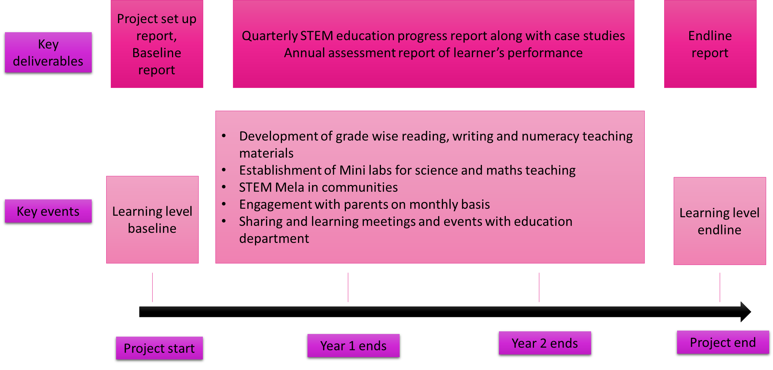

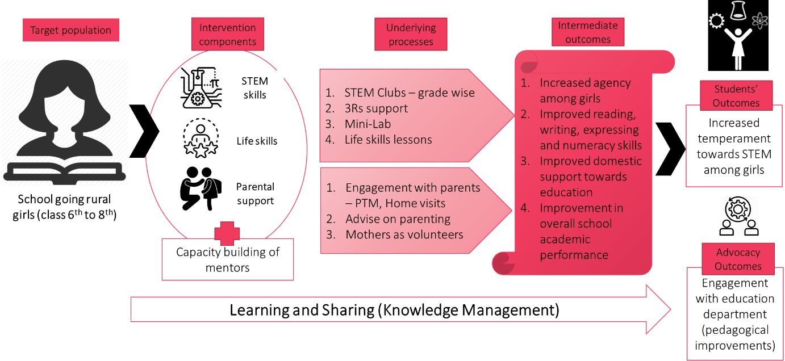
Pathway of progress

Proposed intervention structure
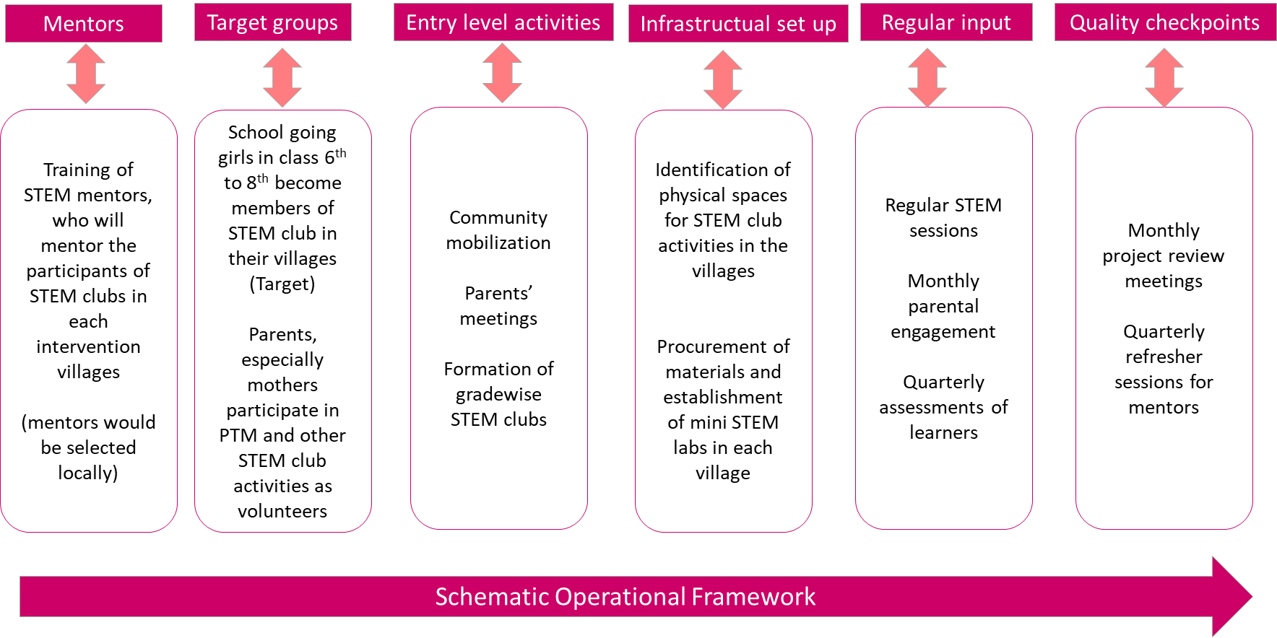
The proposed intervention to improve STEM literacy for girls studying in classes from 6th to 8th will revolve around the operational framework below-

STEM Clubs (Engagement with girls in class 6th to 8th):
- Girls from the class 6th to 8th would be grade-wise collectivised into STEM Clubs. Along with coaching in basic reading, writing and numeracy skills, there would be regular mentoring on themes aligned to the science and mathematical curriculum respective grades. The focus will be to enhance their level of conceptual understanding, articulation/expression and hands-on doing the things for lasting effects. Mentoring sessions will be transacted separately to each clubs. Our aim would be to actually demonstrate an enhancement in the scientific temperament among learners by the end of three years of regular comprehensive inputs. The baseline will be administered to assess the individual levels of learning of each learner, which would enable to take the final decision on the final package of inputs for each STEM club.
- STEM clubs will also be the platform to train girls on life skills. This will supplement to the overall need of performance enhancement in STEM education. Communication, critical thinking, decision making, creative expression would be emphasised in these sessions. Focus would be to support in enhancing their levels of self-esteem and confidence which severely impacts their mental growth, attentiveness and performance in education.
- STEM Mela would be organized in the academic year 3, to showcase the learning and leadership skills of girls to the larger community. This will an effort to demonstrate ‘Girl Power’ through STEM as a step towards changing the attitude of the larger society towards girls’ education and girls in STEM.
In addition, there would be entry level activities which will be part of setting up the project with following major events:
- On-boarding and training of mentors
- Development of Teaching Learning Materials and learners’ handouts
- Procurement of STEM labs equipment
- Setting up the physical space in the intervention villages.
- Community mobilization and formation of clubs.

Engagement of parents:
  - Parents teacher’s engagement: Each month mentors will interact with individual parents of the girls and update them about the performance and participation of their daughters in the club. Parents will be counselled on parenting of adolescent girls so that they become the best supporter for their daughter’s education. A score card will be generated on quarterly basis which will be shared with parents to allow them understand in easy terms about their daughters’ engagement in STEM.
  - Mothers would be especially invited to observe STEM club sessions and activities during the week as well. Mothers would be invited as volunteer particularly during practical learning and doing sessions. Mothers would also be invited as volunteers to administer periodic assessments along with mentors in the STEM clubs. This will allow mothers to observe their daughters into STEM action in real time.

Capacity building of mentors:
- Each village will have a mentor for its STEM clubs. Preferably female mentors will be on-boarded to have minimise any gender/sex based hesitation among learners. Each mentor will go through a set of capacity building sessions spread throughout the project period. This will include their engagement in developing tools for assessment and evaluation of learners at different points of learning cycle.
- Each mentor would be establishing a Mini-Lab for STEM education in each village. Mentors will be prior oriented on the different apparatus and models prior to taking relevant discussions with the learners.
- Mentors will also be guided for parental engagement and organizing STEM Mela in their respective villages.
- Mentors will be connected to different online and off-line resources and networks for them to develop innovative techniques of teaching and improvise on their pedagogies on their own.
- During the monthly project review meetings, mentors will get an opportunity to share and learn from each other. Mentors would be otherwise remain connected via WhatsApp or other social media platforms to keep sharing and learning from each other.

Learning and Sharing:
- PCI would develop a knowledge management plan with a focus to generate learning from its experience which can be advocated with the education department for implementing the advanced teaching pedagogies in the mainstream education processes.
- PCI would strive to essentially share the technical know-how and capacity with the education department so that the systemic improvement for STEM education can be facilitated to benefit a larger population.
- PCI would also develop its knowledge base to further advance its model to cater to the STEM education for girls in higher classes like class 9th onwards.

Key success indicators:
- Enhanced levels of learning and understanding among learners in reading, writing, numeracy and scientific (STEM) conceptual understanding.
- Enhanced agency among girls to negotiate for their continued participation in STEM clubs
- Enhanced support of mothers towards girls’ education.

Key events in the project:
- Annual Learning levels baseline and endline
- Development of grade wise reading, writing and numeracy teaching materials
- Establishment of Mini labs for science and maths teaching
- STEM Mela in communities
- Engagement with parents on monthly basis
- Sharing and learning meetings and events with education department

Quality Control Mechanism and project monitoring system
Project measurement areas:
- Number of girls who complete the package of life skills and STEM sessions – Girls enrolled in the STEM clubs in each intervention village will receive a package of STEM sessions and life skills sessions. These sessions will be transacted by PCI designated mentors. The sessions will be transacted at a mutually agreed upon safe and secure place in the village itself. The timings of the session will be fixed in consultation with STEM club members, preferably in the post school hours so that they are able to continue their schooling as well. The completion status for each beneficiary would be tracked on a monthly basis for programmatic improvement purpose and would be compiled annually, after the completion of the annual package.
  - Target –
    - Year 1 – 300,
    - Year 2 – 350,
    - year 3- 350
- Number of parent teachers’ meetings – Parents would be encouraged every month on one designated day to visit the STEM club premise and have an interaction with the mentor about the performance of their daughter. Attendance of parents would be recorded and reported on monthly basis.
  - Target –
    - Year 1 – 9 Parent Teachers’ Meetings (PTMs);
    - Year 2 – 9 PTMs,
    - Year 3 – 9 PTMs
- Number of volunteer mothers – Mothers would be invited to the STEM club over a quarter to volunteer in the activities of STEM club; including supporting students on hands on exercises. This data would be compiled on a quarterly basis.
  - Target –
    - Year 1 – 30 mothers,
    - Year 2 – 35 mothers,
    - Year 3 – 35 Mothers
- STEM mela – this would be a community event only in third year.
  - Target – Year 3 – 1
- Baseline/learning assessments – Learning assessments would be done twice in a year, at the beginning of the STEM sessions and at the end of year. These would be undertaken generally in July (baseline) and February (endline). The data would be recorded and analysed annually.
For keeping a check on the quality of implementation on ground, following measures would be put in place:

What’s thereafter:
System strengthening through improved pedagogy and teaching approaches will allow sustainability of the entire efforts and encouraging girls to pursue STEM education in higher classes as well. PCI will take its learning to advocate with education department for a mainstream school and system based intervention. The details of this phase where PCI will act as technical agency along with continuing to have a demonstration of actions; will be developed nearer to the time taking the learning and finer gaps in the system into consideration.

reports and devliverables:
- Project set up report
- Quarterly STEM education progress report along with case studies
- Annual assessment report of the learners’ performance

Proposed team structure:
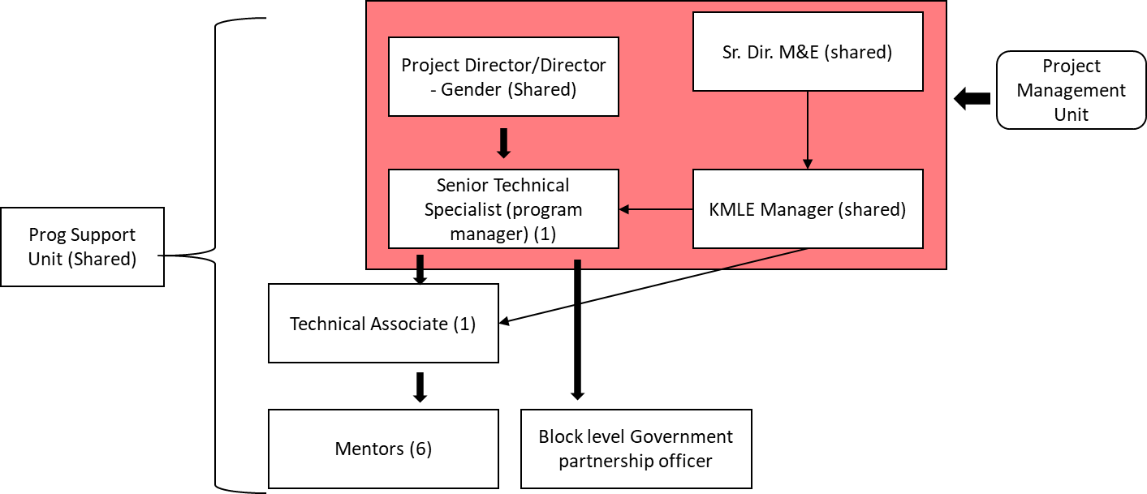
PCI proposes a very thin structure for this proposed project. Project director (shared position) based at PCI national office at New Delhi, will provide overall direction and management of the project along with gender and behavioral change communication directions to the project and team development. Senior technical specialist, based at Ranchi, will manage the project in day to day basis along with providing the STEM and 3Rs pedagogical inputs to the project. State level advocacy with the state education department will also be the responsibility of the senior technical specialist. Technical associate based at Ranchi, will provide day to day guidance and mentoring to the mentors and will be the lead on ground for monitoring and documentation works. This position would be guided by KMLE manager and senior director M&E based at PCI national office at New Delhi. Block level government partnership officer would undertake the local networking and sharings with education department officials alongwith maintaining the village level stakeholder engagement and field operations support to mentors. This position will be based in Godda. Program support unit comprises of finance, admin and procurement etc.. which will provide support to the team from New Delhi.

Budget:
PCI estimates the budget to be around INR 4.38 Crore for the proposed 3-year intervention. We expect a total support to the program, as this is going to generate a new opportunity for tribal girls to pursue STEM education. Given that all the components and strategies are inter-linked, it would be essential to get supported for the entire program cost. The budget will include support for development of teaching learning modules and materials, establishment of mini-labs, community engagements, monitoring and evaluation, human resource and a certain percentage of it towards overall management support cost of PCI. Given that the primary approach is through mentor to learner’s interactions the budget is heavily tilted towards supporting the human resources expenses.

Key personnel:
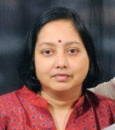
- Sushmita Mukherjee – Director Gender and Adolescent girls. Sushmita Mukherjee has more than 20 years of experience in development sector working on issues related to gender and adolescents. Sushmita has experience in the field of research, designing and implementing programming under Sexual and reproductive health rights (SRHR), including HIV, STDs, Family planning, maternal and child health and nutrition, social norms like leadership, child marriage etc.. Sushmita has also led implementation of STEM projects in Uttar Pradesh in her previous employments and have strong experience of education system strengthening for higher education and STEM education for girls. A masters in community resource management and extension (Home Science) from Delhi University has worked in many national and international agencies including CARE, ICRW, Restless Development etc…

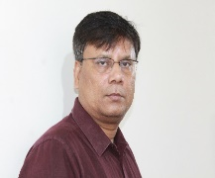
- Dr. Sudipta Mondal – Senior Director Monitoring, Learning and Evaluation. Dr. Sudipta Mondal is a seasoned Measurement, Learning and Evaluation (MLE) practitioner having more than 20 years of progressive experience in the sector. Dr. Mondal has served in a number of international agencies in various capacities. Before moving to PCI India 5 and a half year back, he served as Results and Evaluation Adviser in the Department for International Development (DFID) India. At PCI India he provides high level technical support on measurement for PCI’s large-scale donor supported projects in health, nutrition and gender. His substantive experience includes program evaluation, operational research and strategic information. He has years of practical experience of using diverse approaches and methods, especially in relation to development research and impact evaluations for policy influence, and knowledge management. Dr Mondal is Master’s in Economics, M. Phil and Ph. D in Population Studies from the International Institute for Population Sciences (IIPS), Mumbai and Diploma in Management from Indira Gandhi National Open University (IGNOU), New Delhi. He is also part of the Senior Management Team in PCI India and members of a number of professional bodies. He has contributed to a number research papers and knowledge products. He is well versed in English, Hindi and Bengali.
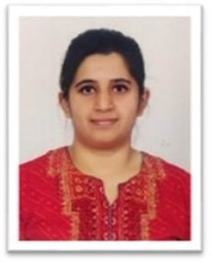
- Pooja K. Kini – Manager Research and Knowledge Management. Pooja comes with more than four years of experience in monitoring and evaluation of development programs. Pooja Kini specializes in planning, designing, and implementing systems, and providing evidence based on research for policy and decision making. She has worked in domains like sustainable development, gender rights, governance, among others with international and government agencies. Previously, Pooja has worked as a National Program Associate (MEL) with The Hunger Project India and as a Project Lead in Catalyst Management Services Pvt. Ltd. Pooja has completed her Masters in Sustainable Development Practice from TERI School of Advanced Studies and a bachelor's degree in Anthropology from the University of Delhi.


- Prasann Thatte – Head Monitoring Learning and Evaluation. In a career of over two decades, Prasann has worked with a number of reputed international organizations in corporate and non-profit sector such as Nielsen, Save the Children and Aga Khan Foundation besides working with governments of Andhra Pradesh and Madhya Pradesh for 5 years. His last engagement was with Reliance Foundation, India’s largest corporate spender on philanthropy, as a member of senior management team. His areas of work are impact evaluation, intervention design and grant monitoring. Prasann is a post graduate in economics and holds PG Diploma in Management from IRMA.

- Ankita Kashish – Program Manager Umang. Ankita has done her post-graduation studies from XISS Ranchi. She has experience of working with CSR initiatives of Adani Wilmar group and also with government bodies like JSLPS; which gives her a right mix of skills and capacities to work on the juncture of CSR projects contributing to benefit communities and strengthen policy implementations on ground. She leads the state based projects on gender and adolescent girls in Jharkhand.

Census of India, 2011
Bill and Melinda Gates Foundation
Social constructivism means that the students join a knowledge-generating community; a community of practice (CoP), and in collaboration with others solve real problems and assignments in an authentic context as part of their study.
https://censusindia.gov.in/2011census/dchb/2006_PART_B_DCHB_GODDA.pdf

