Yläjyrsinjärjestelmä – Router set
Makita RT0700CX2J

Packaging list
After use make sure this case contains the listed items and this list and nothing else
Router | 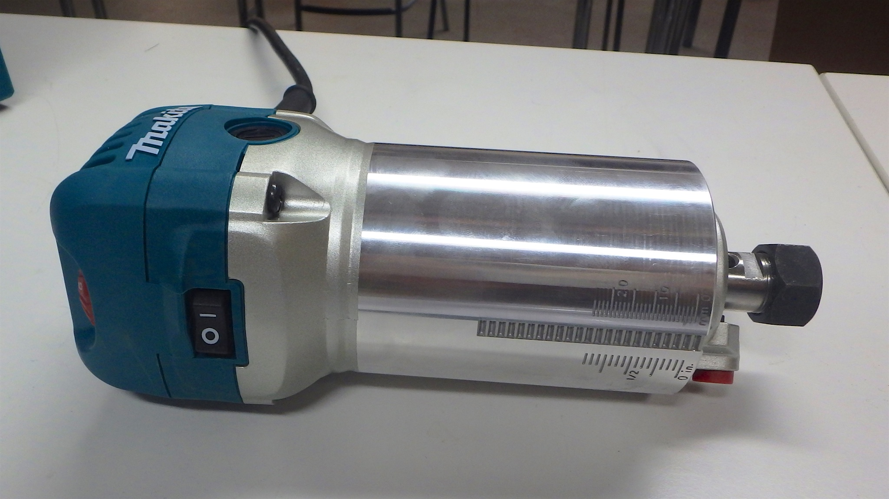
Three router bases  - Plunge base  - Tilt base  - Trimmer base | 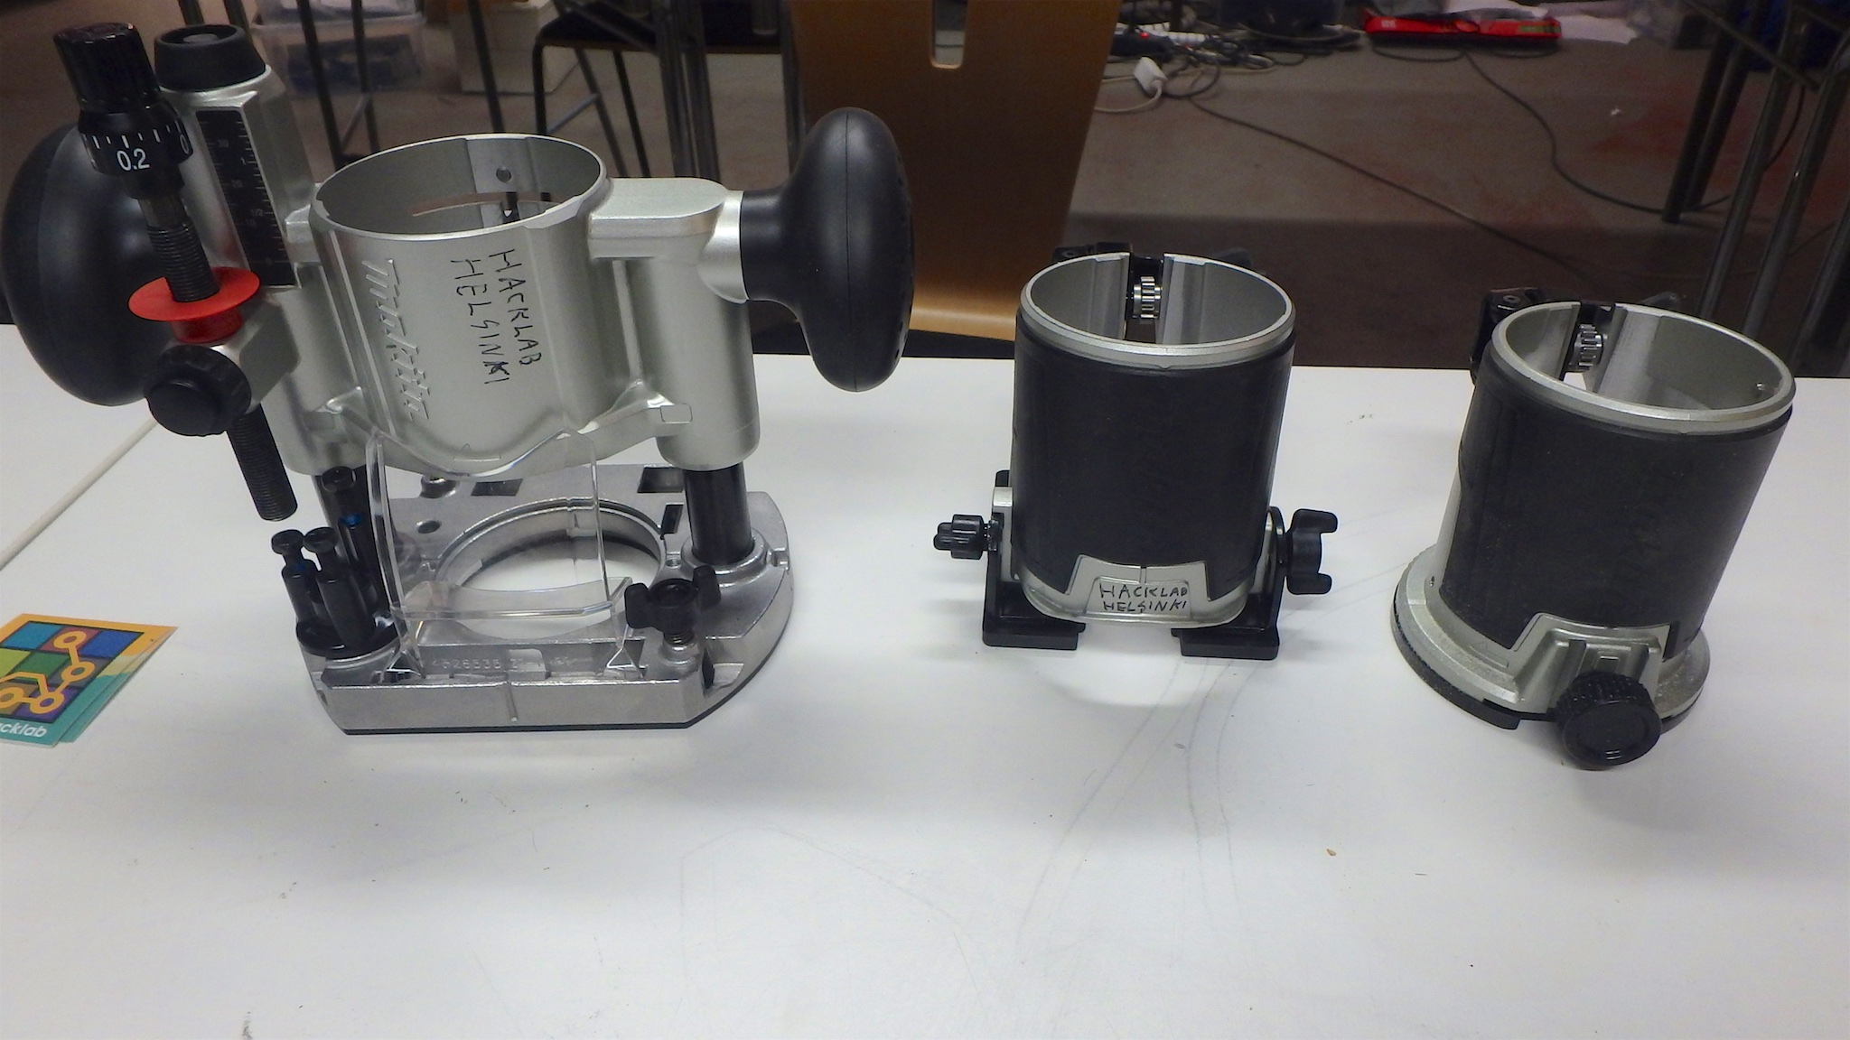
Trimmer guide, straight guide, guide adapter for the plunge base and handle for the plunge base | 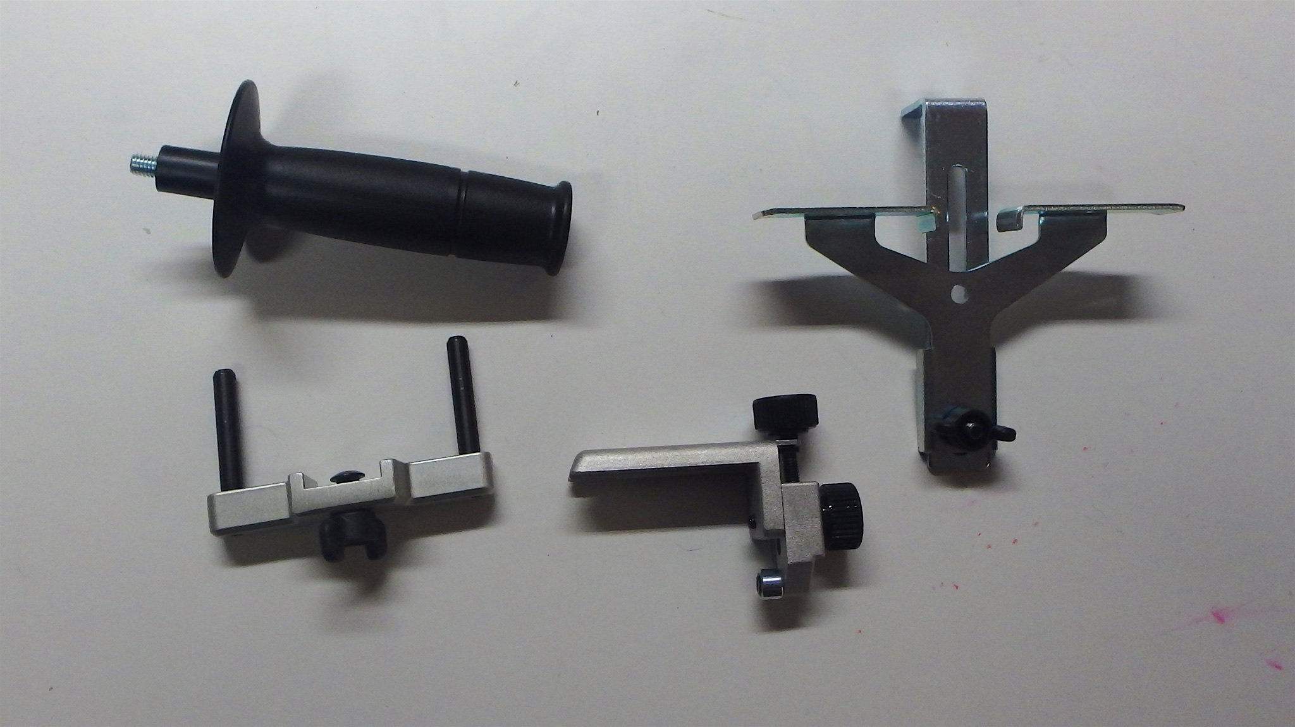
Two wrenches, 22mm and 13mm | 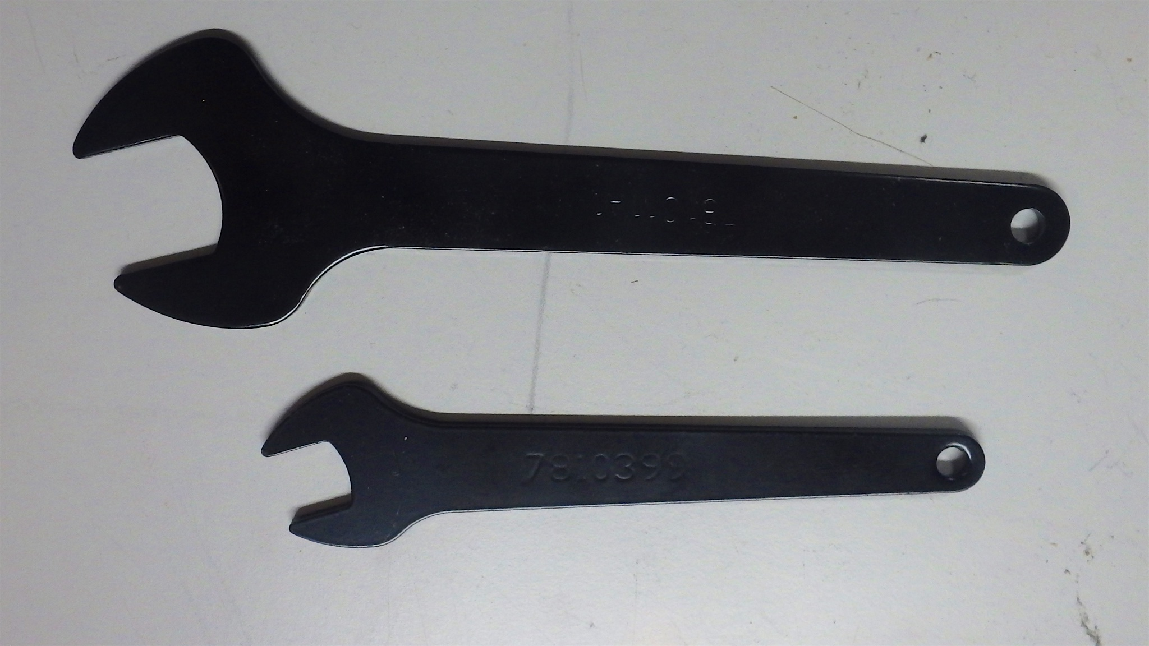
Dust nozzles for the trimmer base and the plunge base | 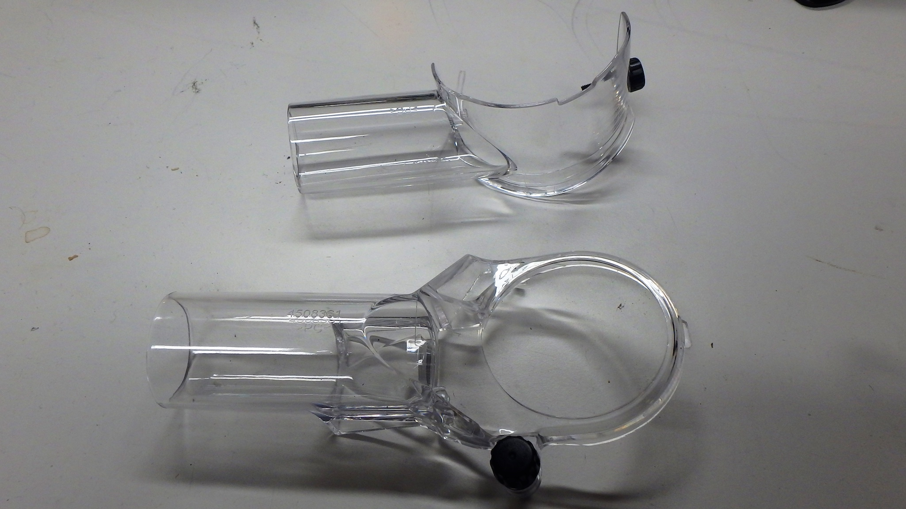
Zip lock bag containing  - The manual  - Two template guides  - 6mm collet  - Thumb screw for trimmer base dust nozzle | 